**Application Name: Evaluation System**

**Problem Statement:**

Create application for maintaining data of interviews conducted in organization.

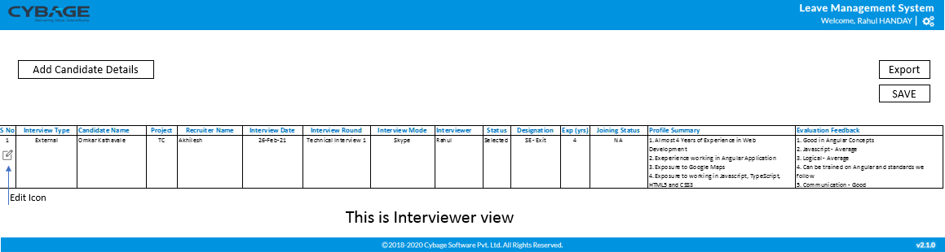

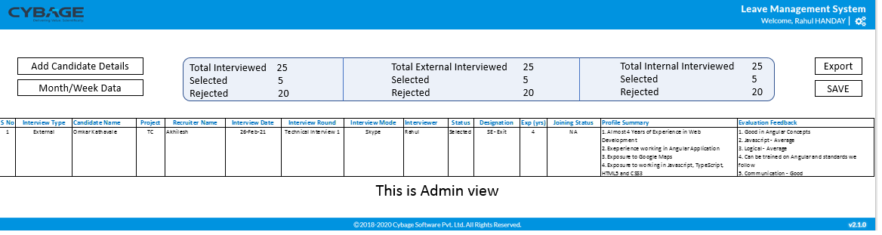

* The application must provide following functionalities:
* Interviewer view – Display all candidates in Tabular format. Table to have filters and Pagination
* Add Candidate Detail – Click will add a new row to the Table so that Admin can add details
* Edit Icon/Button to allow Admin to change the details of the previously added details
* Save button will trigger the API call to save details in DB
* Display a summary on top
  1. Total Interviewed
  2. Selected, Rejected per Candidate
  3. Selected, Rejected overall
  4. Filter this by interview Type(External/Internal)

**Architecture Diagram:**

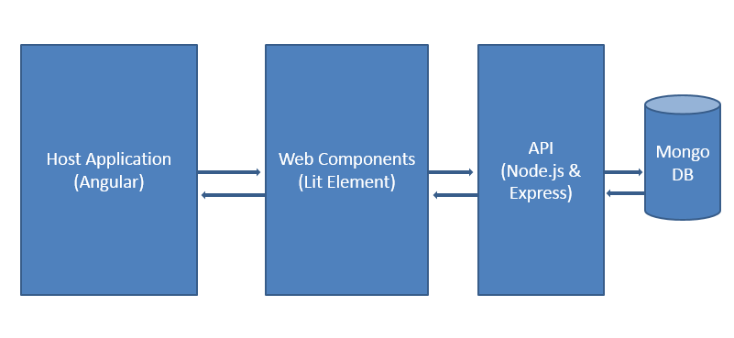

**Host Application to Web Component Communication:**

* Host application is based on angular 8+
* We deploy Web component bundle files to angular application
* Login module is part of angular application(host).
* After Login based on response, using angular routing either Admin/Interviewer Dashboard gets loaded.

**Technologies used:**

* Angular 8
* Web components
* MongoDB

**Angular:**

Following components are created:

* Dashboard component
* Dashboard-interviewer component

**Web-component:**

Following web-components are created:

* candidate-list-component: This component contain table for displaying candidate information.
* candidate-list-summary: This component shows information for total interviews conducted, total internal/external interviews, total selected/rejected counts.
* add-candidate-details: This component displays form for entering candidate details.
* Interview-status: This component shows ratio of selected candidates by interviewer to total interview conducted by interviewer.

**MongoDB:**

There are 4 tables in database:

1.Users: This table used to store interviewer and admin information

Table structure:

|  |  |  |  |  |
| --- | --- | --- | --- | --- |
| Fields | Name: string | Email: string | Password: string | isAdmin: boolean |
| Description | Name of user | Email of user | Password of user | Store boolean value indicating user is admin or not |

2.Recruiter: This table store recruiter information

Table structure:

|  |  |  |
| --- | --- | --- |
| Fields | EmployeeId: Number | Name: string |
| Description | Employee id of recruiter | Name of recruiter |

3.Skills:This table stores skill names

Table structure:

|  |  |
| --- | --- |
| Fields | Skill_name: string |
| Description | Stores name of skill |

4. candidates: this table stores interview details for candidates

Table structure:

|  |  |  |
| --- | --- | --- |
| Interview  Type | Data type | Description |
| Name | string | Name of candidate |
| Project | string | Project name |
| Recruiter | string | Recruiter name |
| Interview Date | date | Interview date |
| Interview Round | string | Interview round |
| Interview Mode | String | Interview mode |
| Interviewer | String | Interviewer name |
| Status | String | Selected/ rejected status |
| Designation | String | Designation |
| Experience | number | Years of experience |
| Phone | number | Phone number |
| Joining status | String | Joining status of employee |
| skills | Array of string | Skill detils |
| Flag | Boolean | Flag maintained for update function |
| Feedback | String | Feedback for candidate |
| Profile summary | string | Profile summary |

**Functionalities implemented:**

This application has two roles:

1. Interviewer
2. Admin

**Interviewer:**

Interviewer can perform following task:

* Add details of candidate for whom he/ She conducted interview
* Edit records entered by him/ her only
* Filter data shown in table
* Export data in form of excel sheet

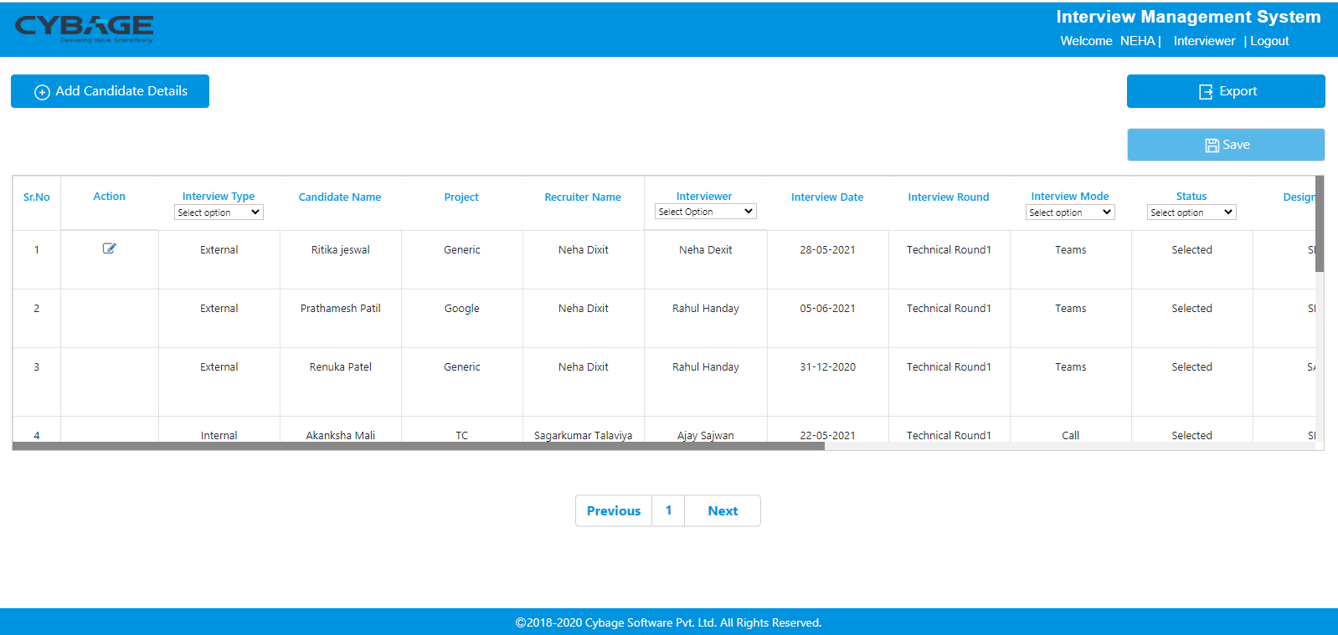

**Admin:**

Admin can perform following tasks:

* Add details of candidate for whom admin / interviewer conducted interview.
* Filter data shown in table
* Export data shown in table in form of excel sheet.
* Filter data based of date, last week.
* View summery of interview (Total interviews conducted, total internal/external interviews, total selected/rejected counts).
* View interviewer’s status (Ratio of selected candidates by interviewer to total interview conducted by interviewer).

