**SmartBook: Online Bookstore Management System**

**Description:**

SmartBook is a web-based application designed to manage book sales, customers, authors, and orders in an online bookstore. It supports admin operations, customer interactions, reviews, payments, and book categorization.

**Scope:**

* Admin Manage books, authors, categories, and Customers .
* User registration (Admin & Customer).
* Customer add books into cart.
* Customers place orders and make payments.
* Allow customers to review books.
* Maintain order history and delivery addresses.

**Customer Module and Functionality**

1. **Authentication**

* Register
* Login
* Logout

1. **Profile Management**

* View Profile
* Update Profile details

1. **Book Searching**

* View Books
* View/add/update/delete Review

1. **Cart and Orders**

* Add to cart
* Place order
* View orders
* Cancel orders

1. **Address Management**

* Add Multiple Address
* View addresses
* Update address
* Delete address

1. **Payment**

* Make payment
* View payment details

**Admin Module and Functionality**

1. **Authentication**

* Login
* Logout

1. **Customer Management**

* View customer Details
* Block/Unblock Customers

1. **Category Management**

* Add Category
* View Categories
* Update Category
* Delete Category

1. **Book Management**

* Add Book
* View Books
* Update Book
* Delete Book

1. **Review Management**

* View Review
* Delete Review

1. **Order Mangement**

* View Order details

1. **Payment Mangement**

* View payment details

1. **Flow Diagrams**

**1.1 Customer flow diagram**

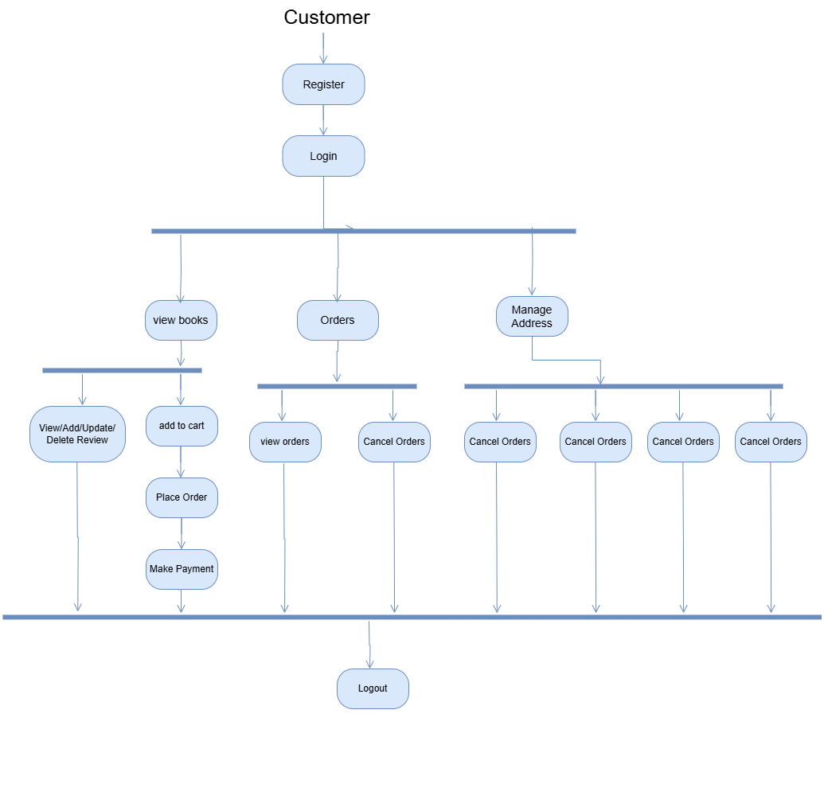

**1.2 Admin flow Diagram**

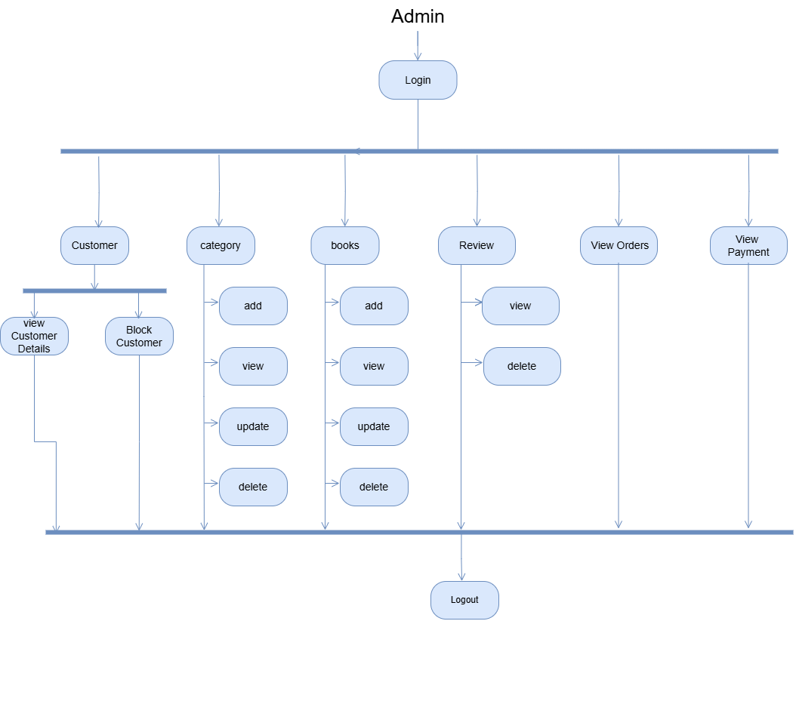

1. **Entity Relationship Diagram**

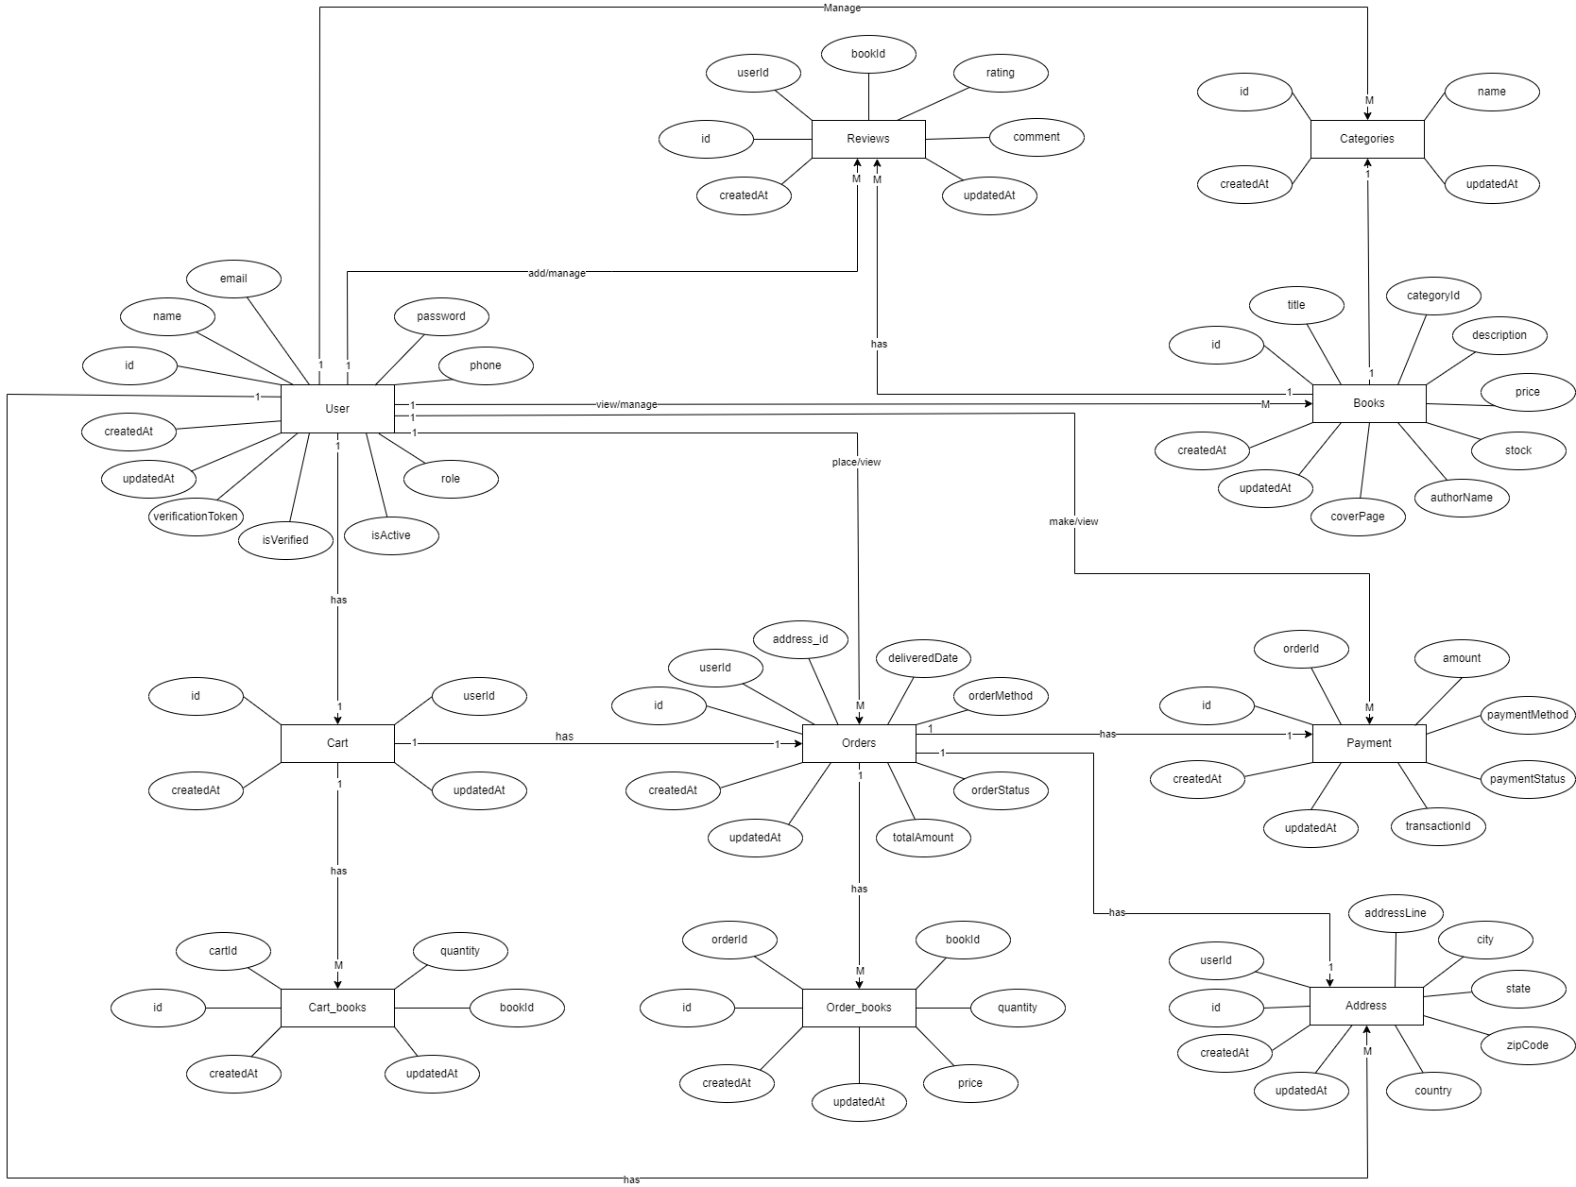

1. **Class diagram**

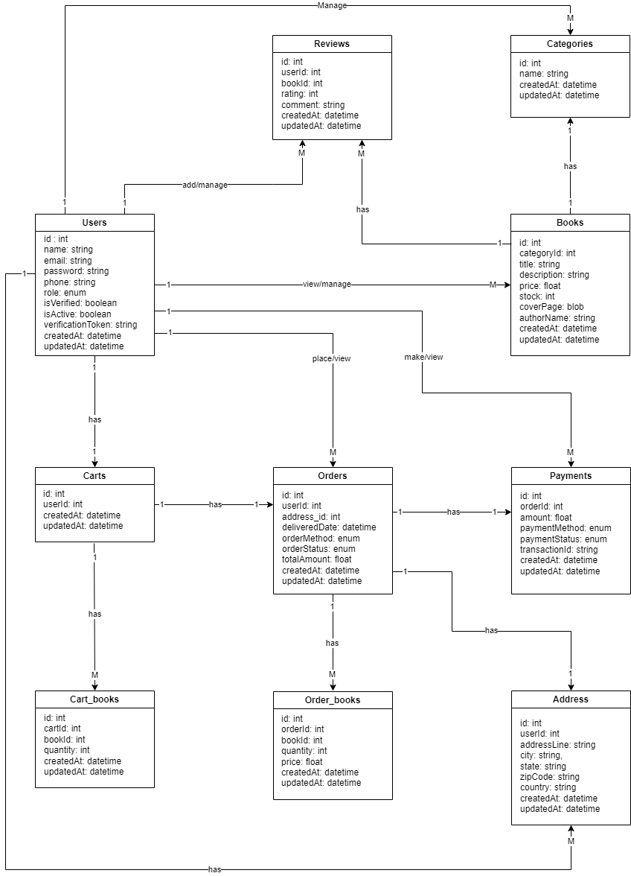

1. **Flow chart**
   1. **Login and Register**

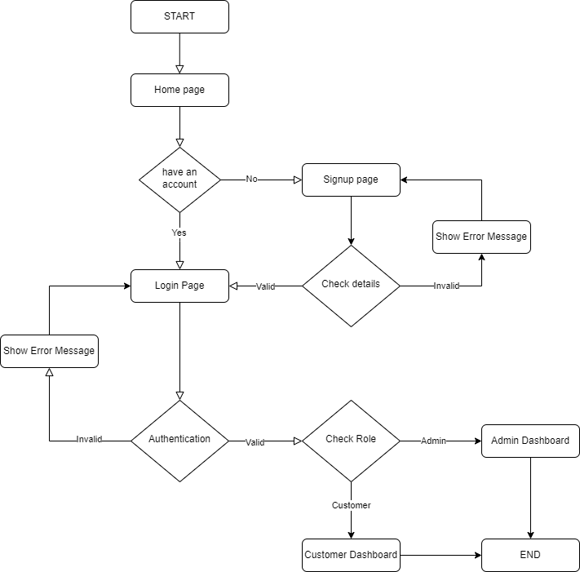

* 1. **Add to cart**

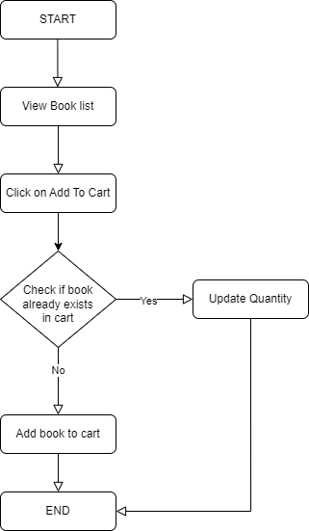

* 1. **Order**

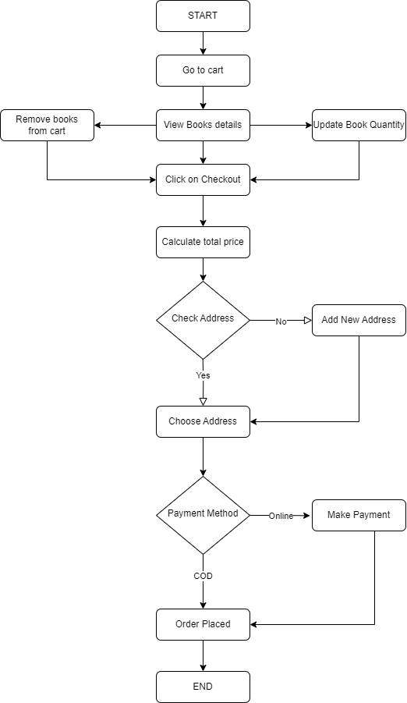

* 1. **Add Review**

