Can You Trust Your Local AI?
Building an AI Assurance Pipeline for GRC, SOC & Cybersecurity
You ask a local LLM a question. It answers instantly, confidently, fluently.
But here's the question almost nobody asks next: how do you know that answer is right?
For most people, the chain stops at “it sounds correct.” In a GRC report, a SOC triage note, or a pentest write-up, “sounds correct” isn't good enough. If AI is going to sit anywhere near a security or compliance decision, its output needs the same scrutiny we'd apply to any other unverified source — because right now, that scrutiny mostly doesn't exist.

Everyone benchmarks AI. Very few validate it.
Benchmarks tell you how a model performs on a fixed test set. They don't tell you whether this specific answer, right now, on your data, is trustworthy. Those are different questions, and the industry has mostly only been answering the first one.
Between “answer” and “trust it” sits a gap almost nobody fills. That gap is where hallucinations, quiet bias, and inconsistent outputs live — and it's exactly the gap this project is built to close.

The hidden risks nobody benchmarks for
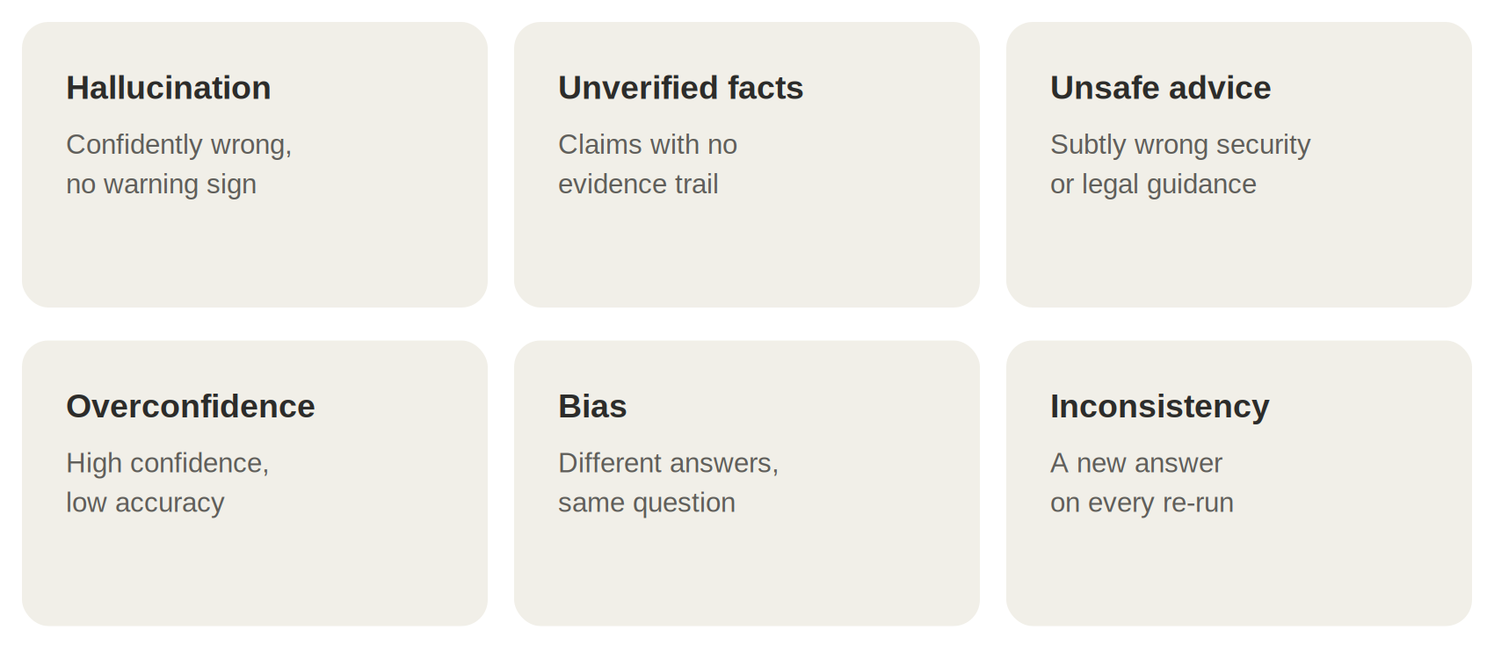
Any one of these, quietly present in a compliance summary or an incident report, can be expensive. Together, they're the reason “the AI said so” should never be the end of a sentence in a security or audit context.

An AI Assurance Framework
If we accept that raw model output can't be trusted by default, the fix isn't “use a better model” — it's “add a layer that checks the model.” That's the core idea behind an AI Assurance pipeline: a primary model produces an answer, and a separate evaluation layer scores that answer across multiple dimensions before it reaches a person or a report.
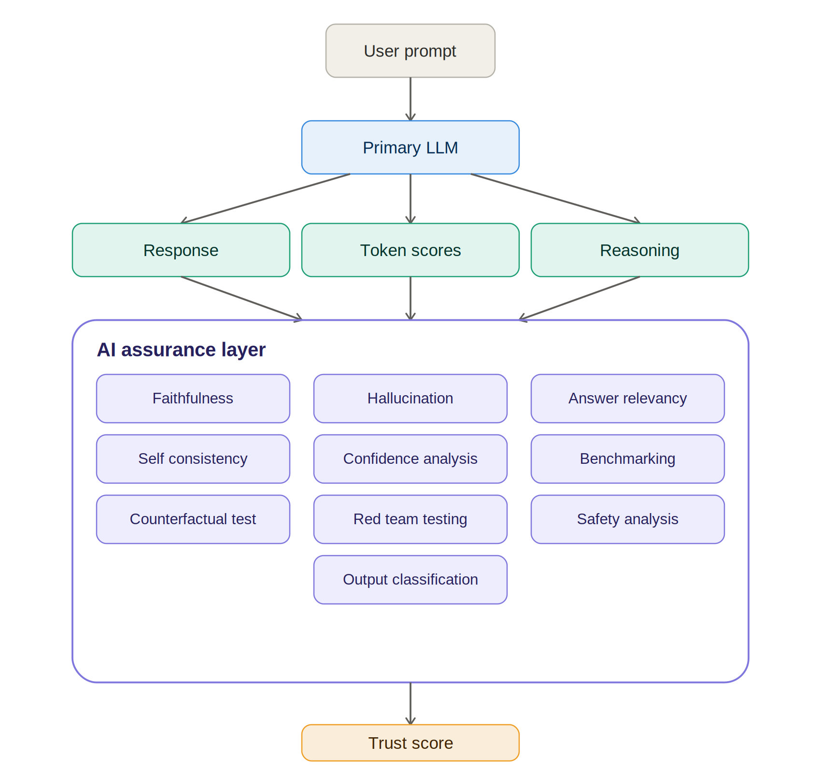
The AI assurance pipeline: primary model output feeds a multi-dimensional evaluation layer, producing a single trust score.

Why an uncensored model, specifically
This is the part people misread fastest, so it's worth being direct about it.
The uncensored model in this pipeline is not the thing answering the user's question. Using an uncensored model as a direct, unfiltered chat partner would be the wrong design — that's the mistake people assume is happening.
What actually happens: an aligned model produces the answer the user sees. Separately, an uncensored model is used purely as an evaluator — because a model with refusal behaviour stripped out won't dodge or soften an assessment of hallucination, bias, safety issues, or red-team probes. Guardrails are still applied to the final output — the uncensored model just does honest grading in between.
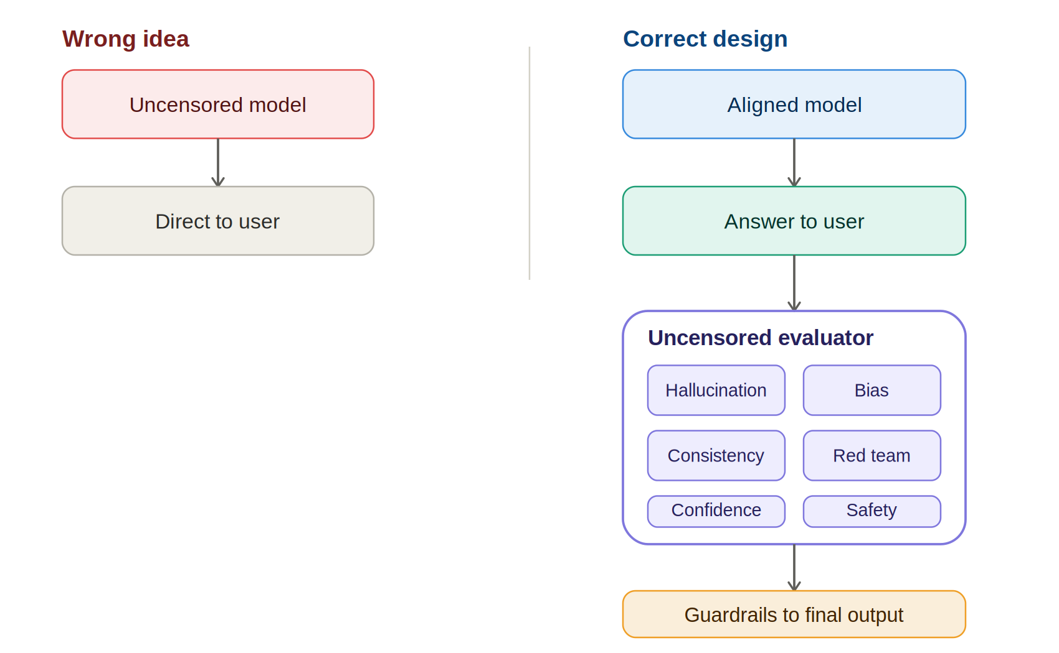
Wrong idea vs. correct design: the uncensored model evaluates in the background; it never talks to the user directly.

What the metrics look like
A working assurance layer surfaces something like:
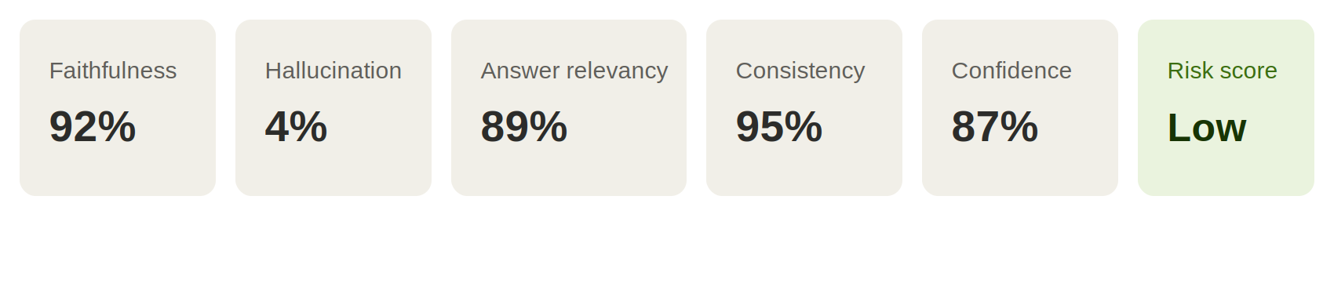
Numbers like these turn “I think this answer is fine” into something you can actually put in a compliance artifact.

The security layer
Underneath the scoring sits a straightforward pipeline. Each stage is a cheap, well-understood check — the value is in chaining them, not in any single step being clever.
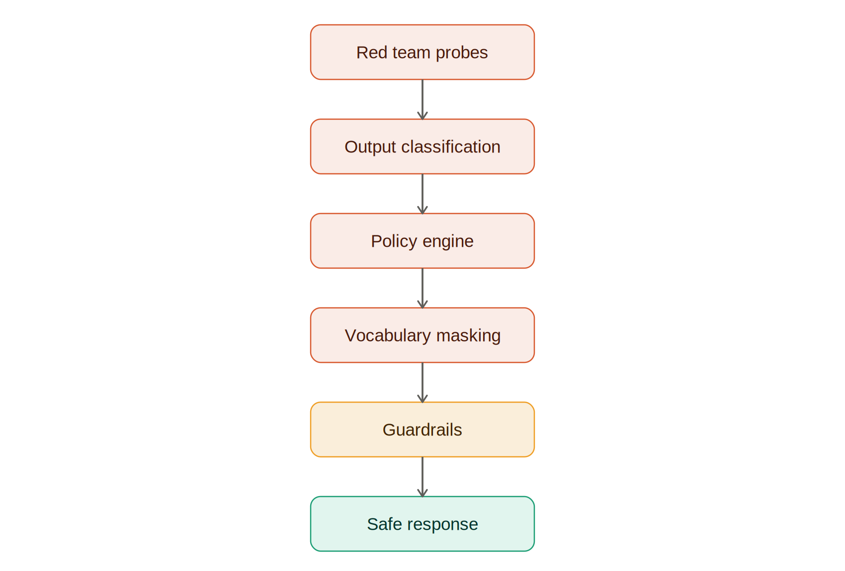

Where PortableAI-USB fits
This is the part where the tooling stops being abstract. PortableAI-USB is the portable, offline implementation of the pipeline above — everything running from a single USB drive, with no cloud dependency and nothing leaving the machine it's plugged into.
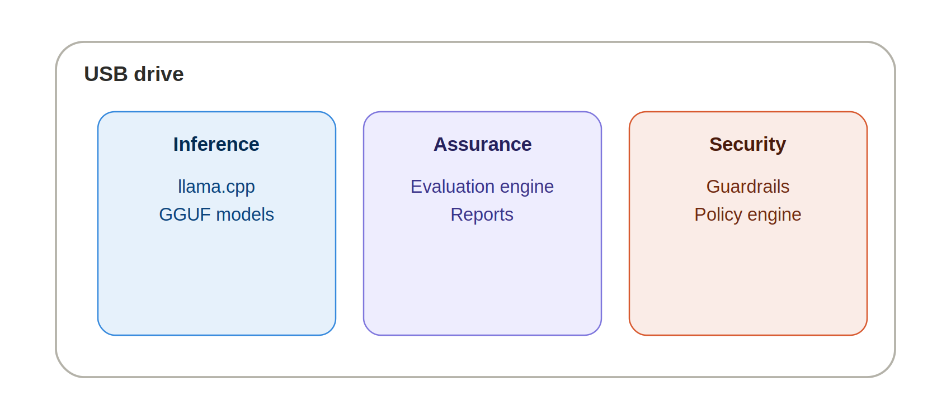
That air-gapped, plug-and-run design is exactly what makes it usable inside environments that can't send data to a cloud API in the first place.

Who this is for
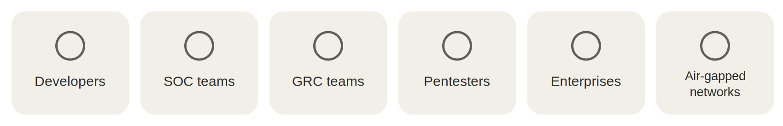

What's built, and what's next
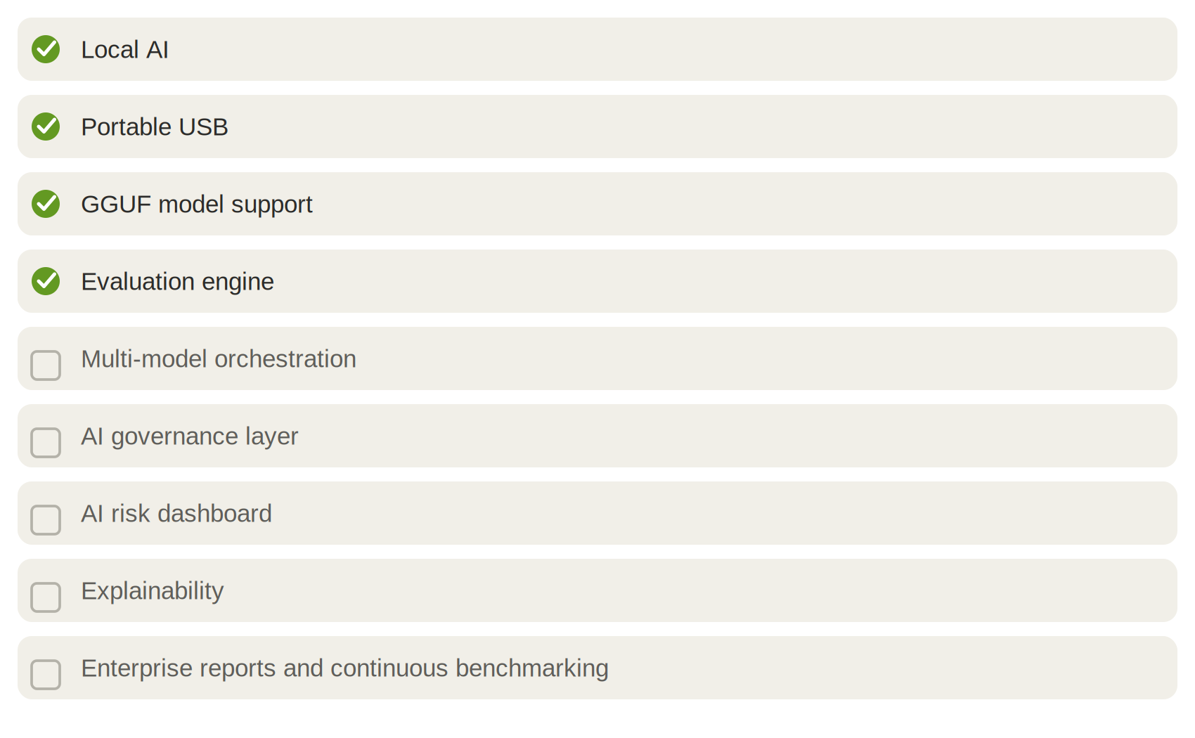

I need your help validating this framework
Not “download my repo” — genuinely: help stress-test whether this holds up.
- Run it on different hardware and tell me where it breaks
- Compare results across different GGUF models
- Report hallucinations you catch that the framework missed
- Suggest evaluation metrics I haven't thought of
- Contribute benchmarks from your own domain
- Bring real GRC, SOC, or pentest use cases the framework should handle
If AI is going to assist in security and compliance decisions, evaluating its trustworthiness matters as much as evaluating its intelligence. If that resonates, I'd genuinely appreciate your feedback and contributions.

