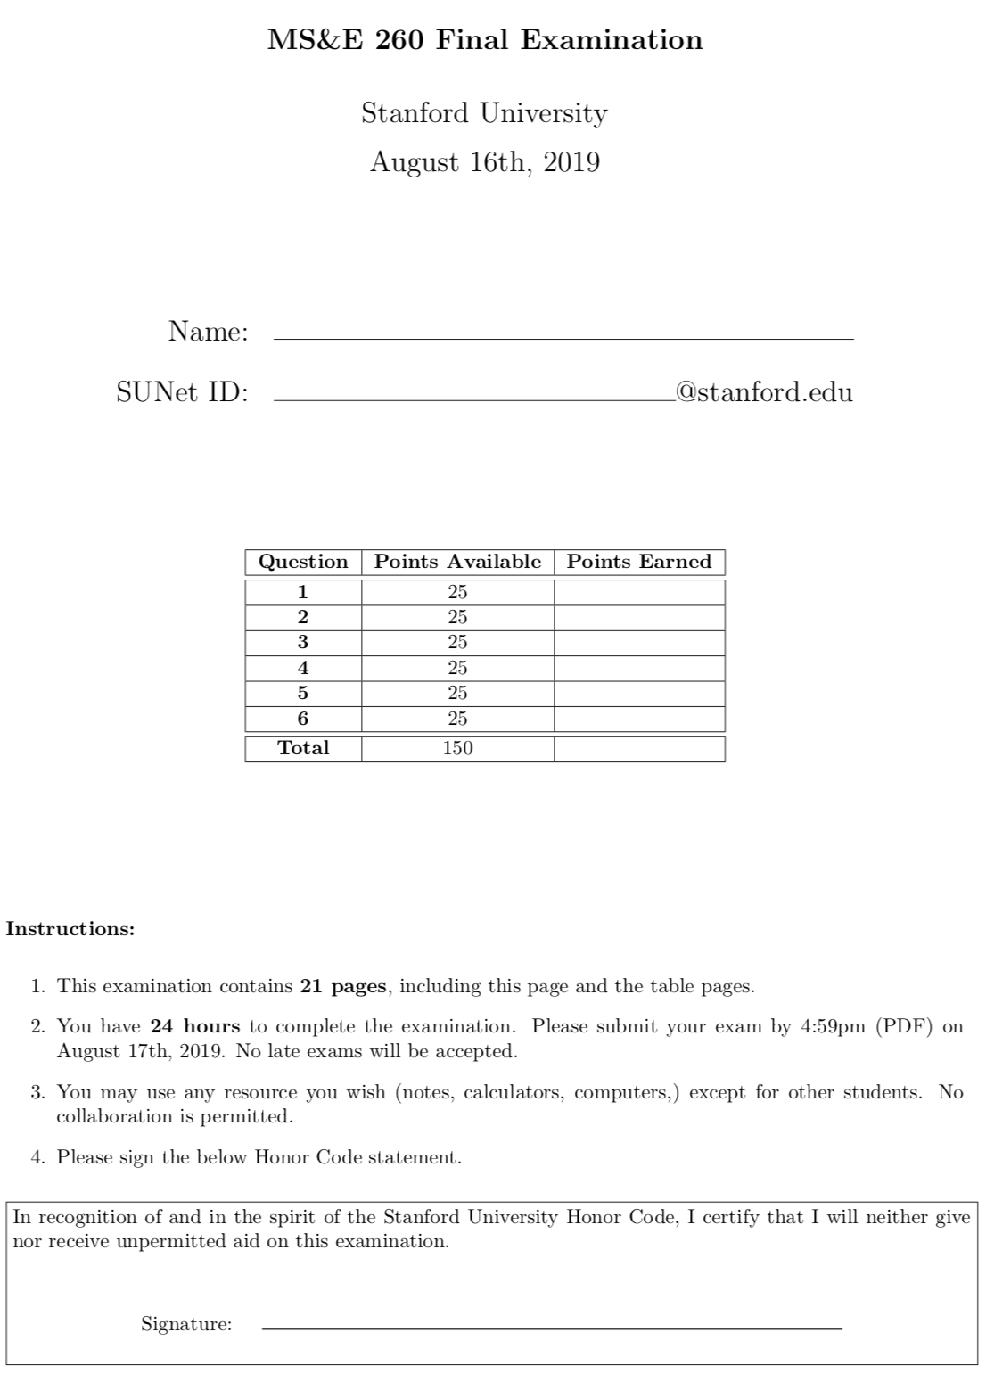

vpmittal

Vishal Mittal

Question 1: Don’t Get Clogged

[25 pts] ClogsAreUs is a company that builds and designs clogs for the American market. The clogs are made from spruce wood sent directly from a supplier in Canada. The wood costs ClogsAreUs $85 to purchase per pair of clogs, and each order ClogsAreUs places costs $750. The lead time to receive each order is 0.25 years. The annual demand for clogs is normally distributed with a mean of 2,000 and a standard deviation of 40. The holding costs is calculated using an annual interest rate of 20%. Assume that clogs are backordered when out of stock with an associated cost of $40.

c = 85 k = 750 τ = 0.25 years = 1/4 year λ = 2000 demand standard deviation = 40

i = 20% = 0.2 p = 40 h = i.c = 17

1. [4 pts] Compute the mean and standard deviation of demand during the lead time.
$$μ= \frac{2000}{4}= 500, σ= \frac{40}{\sqrt{4}}= 20$$

2. [5 pts] Find the optimal (Q, R) policy.   
   ------------ Step 1 -------------

R1 = σ z + μ = 20 * 1.3453 + 500 = 526.906 ≅ 527

------------ Step 2 -------------

N(R1) = σ L( = 20 * L (1.3453) = 20 * 0.0413 = 0.826

R2 = σ z + μ = 20 * 1.3335 + 500 = 526.67 ≅ 527

---------------------------------

Since R2 = R1, our values have converge and we can say

Optimal (Q, R) = (429, 527)

1. [4 pts] Determine the safety stock.

s = R* − μ = 527 − 500 = 27 units

1. [3 pts] What is the expected annual holding, setup, and penalty costs associated with this product?

$$Holding cost=h\left(s + \frac{Q}{2}\right)=17\left(27+\frac{429}{2}\right)=\$4105.5$$

$$fixed/setup cost=\frac{k}{T}=\frac{k λ }{Q}=\frac{750 * 2000 }{429}=\$3496.503$$

$$shortage cost=p\left(\frac{n(R)}{T}\right)=p\left(\frac{ σL(z_{2}) λ}{Q}\right)=40\left(\frac{20 L(1.3335) 2000}{429}\right)=40\left(\frac{ 20*0.0423*2000}{429}\right) = 157.762$$

Total Cost = Holding cost + fixed cost + shortage cost = 4105.5 + 3496.503 + 157.762 = 7759.765

1. [3 pts] What is the proportion of order cycles in which no stock-outs occur?

This can also be interpreted as proportion of demand satisfied on time, which is the Type II service P(D<=R),

F(R*) = 0.90883 = 90.88%

1. [3pts] What is the proportion of demand that is unmet?
$$demand that can not be met at once=\frac{loss function }{quantity}=\frac{n(R^{*})}{Q^{*}} =\frac{σL(z_{2})}{429}= \frac{20 * 0.0423}{429}= 0.00197 = 0.197\%$$

2. [3pts] If ClogsAreUs aims for a 98% Type 2 service level, does it over or under-estimate the penalty cost?

$F\left(R\right)=0.98 => z = 2.0537$ => L(z) = 0.00734

$$penalty cost=p\left(\frac{ σL(z_{2}) λ}{Q}\right)=40\left(\frac{20 *0.00734* 2000}{429}\right)= 27.3752$$

Thus the penalty cost 27.3752 in case of 98% type 2 service level, is under the penalty cost 157.762 for 90.88 % service level.

Question 2: Let it Slide!

[25 pts] At a water park there is a 250-meter slide that is the main attraction. Enthusiastic children (of age 7 and above) and adults alike line up to experience the thrill and they arrive as a Poisson process of rate 8 people per 10 minutes. The water slide is wide enough for one person at a time, and for safety the park does not allow an adult accompanying a child. The duration of each slide taken (consider the time from person starting the slide till the next person could slide) is exponentially distributed with a rate of 10 people every 10 minutes. Assume that the queue can build to infinite.

1. [5pts] What is the average number of users of the slide in the system? What is the average waiting time in the system?

M/M/1 queue

𝜆 = arrival rate into system = 48 people per hour

𝜇 = service rate per server ~ exp(60) people per hour

𝜌 = 𝜆 / 𝜇 = 48 / 60 = 0.8

$$Average no. of people in the system = Length of the queue = L_{s}= \frac{ ρ}{1-ρ }=\frac{λ }{μ - λ }= \frac{48 }{60 - 48 } = 4 \\ W_{s} = \frac{1 }{μ - λ } = \frac{1 }{60 - 48 } = 0.08333 hrs = 4.9998 mins 5 mins$$

1. [5 pts] What is the average number of users in the queue? What is the average time in the queue?
$$No. of people in queue = L_{q} = \frac{ρ^{2}}{1 - ρ} = \frac{λ^{2} }{μ(μ - λ) } = \frac{{48}^{2} }{60 (60-48) } = 3.2 \\ W_{q}=\frac{λ }{μ (μ-λ) } =\frac{48 }{60 (60-48) }=0.06667 hr = 4 mins$$

2. [5 pts] Now consider the situation where the inter-arrival time is constant and is given by 1 minute. The slide time required by each user is also constant and equal to 30 seconds. What is the mean waiting time per user in this case?

𝜆 = arrival rate into system = 60 people per hour

𝜇 = service rate per server = 120 people per hour

The arrival rate and service rate are both definitive here, so this is a D/D/1 queue  
Since service time is shorter than the arrival rate there will be no wait time per user in this case.

Ws = 0

1. [5pts] Suppose that there is increased popularity in the water slide, now with an arrival rate of 10 people per 10 minutes. As a result, the water park builds another identical slide. The slides are now side by side and customers take a single flight of stairs to get to the platform where they would randomly choose to go to either slide with equal probability. Due to other efficiencies, the slide times are now exponentially distributed with rate 12 people every 10 minutes for each slide. What is the average waiting time in the system?

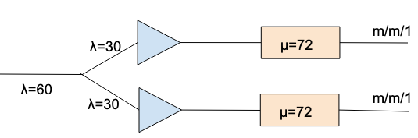

M/M/2  
𝜆 = 60 people per hour

𝜇 = 72 people per hr per slide

so for each of the queue, average wait time in the system is

$$W_{s} = \frac{1 }{72 -30 } = \frac{1 }{42 } hr=1.428 mins$$

1. [5 pts] The water park is so successful with two slides that they are considering opening an entirely new water park where they would have six slides that serve users in one line. The management estimates that the inter-arrival time of users follows a uniform distribution between 3 and 9 minutes. The slide time will also follow a uniform distribution, but between 0.5 minute and 2 minutes. What will be the average time in the new water park six-slide system?

N = 6

$$arrival standard deviation σ [A]= \frac{b - a }{\sqrt{12}}= \frac{6 }{\sqrt{12}}$$

mean arrival time E[A] = (3 + 9) / 2 = 6

$$C_{A}^{2}=\frac{σ_{A}^{2}}{{E[A]}^{2}}= \frac{1}{12} = 0.08333$$

𝜆 = 10 people per hour = 1/6 per min

$$service standard deviation σ [S]= \frac{b - a }{\sqrt{12}}= \frac{3 }{2 . \sqrt{12}}$$

mean service time E[S] = (1/2 + 2) / 2 = 5/4 mins

$C_{S}^{2}=\frac{σ_{S}^{2}}{{E[S]}^{2}}= \frac{\frac{3^{2}}{2^{2} * 12}}{\frac{5^{2}}{4^{2}}}= \frac{3 * 3 * 4}{12 * 5 * 5} =$ 0.12

𝜇 = 48 people per hr per slide = 4/5 per min

𝜌 = 𝜆 / (𝑁 𝜇) = 10 / (6*48) = 0.03472

$$ρ' =ρ^{\sqrt{2(N+1)}-1} = {0.03472}^{\sqrt{2(6+1)}-1}= 0.0000997$$

$$W_{q} = \frac{1 }{μ N }×\frac{ρ^{\sqrt{2(N+1)}-1}}{1 - ρ}×\frac{C_{A}^{2} + C_{S}^{2} }{2} = \frac{5 }{4*6 }×\frac{0.0000997}{0.96528}×\frac{0.2033 }{2}=0.00000218729 mins 0 mins$$

$$W_{s} = W_{q} +\frac{1 }{μ }= 0+\frac{5 }{4 } = 1.25 mins$$

Question 3: All About the Air

[25 pts] When the deadly Northern California wildfire was burning in November 2018, it was hard to get hold of an air purifier in stores or online. Rajiv operated a small electronic appliance store in Mountain View and was left with one GermGuardian AC4825 model. He recognizes that it is a business opportunity and would like to, within acceptable moral bounds, adjust the price according to demand a little bit. He expects that one customer will arrive in the next hour with a willingness to pay that is uniformly distributed between 0 and 200. He also expects that, in the next hour, a different customer will show up whose willingness to pay is distributed uniformly between 0 and x.

1. [10pts] How should Rajiv price the air purifier for each hour?

p1 price on day1

p2 price on day2

v1 ~ U [0, 200] customer willingness to pay on day 1

v2 ~ U [0, x] customer willingness to pay on day 2

$$\max_{p_{1}p_{2}}{ }p_{1 }.P_{r}(v_{1}≥p_{1 }) + P_{r}(v_{1}<p_{1}) .p_{2 }. P_{r}(v_{2}≥p_{2 })$$

$$\max_{p_{1}p_{2}}{ }p_{1 }.\left(1 - \frac{p_{1 }}{200}\right) + \left(\frac{ p_{1}}{200}\right) .p_{2 }. \left(1 - \frac{p_{2 }}{x}\right)$$

1. Solving for p2

1. Solving for p1

1. [8 pts] For what value of x is the price during the first hour lower than the price during the second hour?

equating the price for p1 and p2 :

For x < 266.667; p1 > p2

For x > 266.667; p1 < p2

Suppose that Rajiv found a second identical air purifier (unused) from the back of his storage room at home. During the first hour, he expects one customer to arrive whose willingness to pay is drawn independently from U [0, 100]. During the second hour, a different customer is expected to show up whose willingness to pay is drawn independently from U[0,300]. During the third hour, yet another different customer is expected to show up whose willingness to pay is drawn independently from U[0,200]. If he doesn’t find a customer after the first three hours, he will sell it at the regular price of pr = $85.

1. [7pts] How should Rajiv price the second air purifier in this case? It is enough to give the formula. Do NOT try to solve the optimization problem numerically.

v1 ~ U [0, 100], v2 ~ U [0, 300], v3 ~ U [0, 200], p4 = 85

Question 4: Farm to Bakery

[25 pts] Imagine a two-firm supply chain that consists of a grain farmer and a bakery. The farmer produces top of the range grain and you oversee and manage the operations of the company. Currently the demand for grain is uniformly distributed between 0 and 1,000 pounds per year. The production and distribution cost of the grain is $4,000 per pound. As it stands now, the farmer sells his grain to the Kings Bakery at a cost of $6,000 per pound and the Bakery sells to hungry customers at a retail price of $9,000 per pound. Assume there is no salvage value.

1. [10pts] What is the optimal order quantity from the baker’s perspective? What are the expected profits for the farmer and the retailer?

c = 4000, w = 6000, p = 9000, s = 0, D ~ U[0, 1000], 𝜇 = 500

cu= 9000 - 6000 = 3000, co= 6000

$$critical ratio = \frac{c_{u}}{c_{u} + c_{o}} = \frac{3000}{3000 + 6000} = \frac{1}{3}$$

Q* = critical ratio * upper limit of uniform distributed demand = 1/3 *1000 = 333.33 ~ 333

E[ProfitS] = (wholesale cost – production cost ) Q* = (6000 – 4000) 333 = 666,000

$E[Lost_Sales]= \int_{333}^{1000 }{\frac{x - 333 }{1000} dx= \frac{1}{1000} {\left[\frac{1}{2} x^{2} - 333 x\right]}_{333}^{1000}}$

$$=\frac{1}{1000}\left[\left(\frac{1}{2} {10}^{6} - 333 *{10}^{3}\right) - \left(\frac{1}{2} {333}^{2} - {333}^{2}\right)\right]= 111.555 ≅ 112$$

E[SalesR] = 𝜇 – E[Lost_Sales] = 500 – 112 = 388

E[ProfitR] = (sale price * expected sales) – (wholesale cost * Q*)

due to high overage cost we have ordered less number of items than expected sales, thus our expected sales will be also Q*

E[ProfitR] = (sale price – wholesale cost) Q* = (9000 – 6000) 333 = 999,000

E[ProfitSC] = 999000 + 666000 = 1,665,000 = 1.665 M

1. [10 pts] How do your answers to part (a) change if the farmer decides to stop selling to the baker and instead sets up his own bakery, i.e. have a vertical integration?

c = 4000, p = 9000, s = 0, D ~ U[0, 1000], 𝜇 = 500

cu= 9000 - 4000 = 5000

co= 4000

$$critical ratio = \frac{c_{u}}{c_{u} + c_{o}} = \frac{5000}{5000 + 4000} = \frac{5}{9}$$

Q* = critical ratio * upper limit of uniform distributed demand = 5/4 *1000 = 556

$E[Lost_Sales]= \int_{556}^{1000 }{\frac{x - 556 }{1000} dx= \frac{1}{1000} {\left[\frac{1}{2} x^{2} - 556 x\right]}_{556}^{1000}}$

$$=\frac{1}{1000}\left[\left(\frac{1}{2} {10}^{6} - 556 *{10}^{3}\right) - \left(\frac{1}{2} {556}^{2} - {556}^{2}\right)\right]= 98.56 ≅ 99$$

E[Sales] = 𝜇 – E[Lost_Sales] = 500 – 99 = 501

E[Profit] = (sale price * expected sales)–(product cost * Q*) = 9000*501 – 4000*556 = 2,285,000

= 2.285 M

1. [5pts] Returning to the two-firm model from part (a), if you were given the opportunity to set up a revenue-sharing model, what is the optimal relation between the up-front fee and the revenue-sharing percentage value?

$$critical ratio without revenue sharing=\frac{p-c}{p-c +c-s}$$

$$critical ratio under revenue sharing=\frac{θ p - f }{θ p-f +f-s }$$

Equating the two:

$$\frac{p-c}{p-s} = \frac{θ p - f }{θ p-s } => \frac{9000-4000}{9000-0} =\frac{θ 9000 - f }{θ 9000-0 }=>\frac{5}{9}=1-\frac{f }{9000 θ }=>\frac{f }{9000 θ }=\frac{4}{9}$$

$$f = 4000 θ$$

Question 5: Map it Out

[25 pts] You are the manager of a technology company that provides detailed urban maps, including high-fidelity images of buildings, trees, and other structures. You are considering a novel method of using industrial drones, with a suite of hyper-spectral cameras mounted on its underbelly. These cameras (and advanced post-processing algorithms) will provide high quality images. You hope to deploy the camera system before your primary competitor, Google, does so first.

After buying a stabilization-control component for the camera, you discover that the component’s manufacturing quality is questionable. The component has two possible manufacturing quality levels (weak or strong). If the component is weak, it will cause the camera to fail before the data collection is completed. You believe there is a 30% chance the component is weak. If the component is strong, the camera will work successfully through the full data collection campaign.

In this problem, your only concern is the stabilization control component. You face the decision of whether to use or discard the component in two cases: with or without the benefit of a test. If you discard the component, you can obtain only a fraction of the image data (an outcome valued at $500K). If you use the component, and it fails, you’ll get no useful image data (an outcome valued at $0). However, if you use the component, and it survives the full data collection campaign, you will get a complete set of image data (an outcome valued at $1M). You are risk neutral.

Jiaming, employed in an aviation systems group within the aero-astro department of a local university, has offered to help by providing a test for the component. Jiaming can provided a set of flight tests:

Component Testing: The camera component has two possible states (weak or strong). For a strong component, the test will correctly predict the state of the component with a probability of 0.7, and incorrectly predict the component’s state with a probability of 0.3. For a weak component, the test will correctly predict the state of the component with a probability of 0.9, and incorrectly predict the component’s state with a probability of 0.1. The test costs $10K.

1. [10 pts] Before considering the stabilization control component test, build a decision tree to determine whether you should use the component or discard it without testing it. What is the best alternative?

Since the expected value is 700K when component is used vs. 500K when component is discarded. Thus the component must be used.

1. A close up of a map

   Description automatically generated[10 pts] Now assume that you can obtain the component test before deciding whether to use or discard the stabilization-control component. Draw the full set of decision trees for your decision of whether to purchase the component test. Should you buy the test? If so, what is the most you would be willing to pay for it? If not, by how much would the aviation systems group have to reduce the price for you to consider it?

Cost of test = estimated value with test – estimated value without test

= 729.996 - 700

= 29.996 K

Since Aviation systems is charging 10K for the test which is less than the estimated value 29.996K of the test, we should definitely buy the test.

Aviation systems does not need to reduce the price as their quoted price is already lower than what we are willing to pay.

(c) [5 pts] If the aviation systems group offered a perfect test for the component, how much would you be willing to pay for it?

Thus for a perfect test we would be willing to pay

= 850 – 700 = 150 K

Question 6: OM++

[25 pts] Answer briefly the following questions.

1. [5 pts] List the 5 principles of Lean Manufacturing

Five principles of Lean manufacturing are:

1. Specify value
   1. Customer defines the value for a product
   2. Is there a product or service that meets the customer’s needs at a specific time and price?
   3. Anything which valued to customer will add the value to you
2. Intensify the values stream  
   Value stream is the set of all specifications requires to bring a product though the three critical management tasks
   * 1. Problem Solving task (design – concept)
     2. Information management task (order taking- scheduling -delivery)
     3. Physical transformation task (raw materials – goods)
3. Flow
   1. Things are constantly moving
   2. Flow requires re-engineering the organizations from departments (traditionally batch and queue) to process based
   3. Arrange production steps into a sequence and product moves without creating WIP inventory
   4. Have the entire support staff by the side of production staff
   5. Make sure machine setups are almost instant
4. Pull
   1. Fulfilling to customer order
   2. Make small batches to keep doing continues production
5. Perfection
   1. There is no finish line for perfection
   2. You keep improving the process to optimize the process
   3. 80% of value should come from 20% of efforts
   4. Transparency is key for perfection
6. [10 pts] Describe how you would move your furniture to a new house using a Flow proc

In a traditionally batch and queue moving process we would want to get all the boxes, pack all the boxes, load everything to truck, move the big truck, unload truck, open all the boxes and arrange stuff at new place.

While in a flow proc we will do one piece flow at a time instead of batch processing. We would wrap the couch, load it in truck, move it to new place, unload the couch and arrange it at the new place. We than repeat the same process with coffee table, TV, armoire, bed, study table, etc.

In this particular case flow might not be the optimal way of moving as you have to do too many round trips to the new house. But if you batch everything, you are doing all the lifting work together and all the wrapping/unwrapping work together. This will cause fatigue and also wastage of packing material. Thus it might be useful to make small batches of mixed size, mixed weight and needs and then follow the flow proc for each small batch.

1. [5 pts] Explain why implementing supply chain contracts, like real options, revenue sharing contracts or buy-back contracts can be difficult in practice.

As most of the organization doesn’t collected the data or either don’t interpret it into useful insights, it’s difficult to implement supply chain contracts, like real options, revenue sharing contracts or buy-back contracts in practice. Following are the reasons:

* In supply chain there are multiple sources of uncertainty with complex, time varying characteristics. It could be due to uncertainty in product life cycles, technology change, competition, lead time and availability contrasts.
* In supply chain industry business decisions are complex and directly impacted by the structure and execution of supply chain relationships. These decisions can be based on customer and supplier relationships, channels, inventory, production, procurement, logistics, capacity, etc.
* Lack of data availability and most of the information are company proprietary, so not accessible.
* Also, there are only a small number of counterparties available and the contracts will be impacted by  price, quantity, lead time, other terms and relationship with them.

1. [5 pts] When evaluating the trade-offs between the charge-coupled device (CCD) imagers versus complementary metal-oxide-semiconductor (CMOS) imagers for space imaging, the differences in the CCD versus CMOS industrial base result in relative differences in both fixed cost and marginal unit cost. What are those relative differences?

|  |  |
| --- | --- |
| **Charge-coupled device (CCD) imagers** | **Complementary metal oxide semiconductor (CMOS) imagers** |
| -       Great image quality  -       Used for high quality astronomical images  -       Image in form of local charge in silicon  -       Very expensive  -       Require special foundries to build these devices  -       Low market demand  -       Manufactured on demand and highly specialized  -       High fixed cost  -       High marginal cost  -       High ordering cost | -       Low image quality  -       Analog to digital conversion at each pixel  -       Cheap as cost of eggs  -       Commonly used in various devices (cell phone, CCTV etc.)  -       High market consumption  -       Mass production  -       Low ordering cost (K)  -       Low fixed cost  -       Low marginal cost (c) |

As the demand for CCD is very low there is a high fixed and marginal costs for it. CMOS on the other hand has a very high demand thus low fixes and marginal cost for it. Considering the performed task value we need very high num of CMOS than num of CCD. Not only more CMOS are needed we need to put them at multiple physical locations and there is maintenance of each camera/telescope. The overall cost will need to include all those factors.