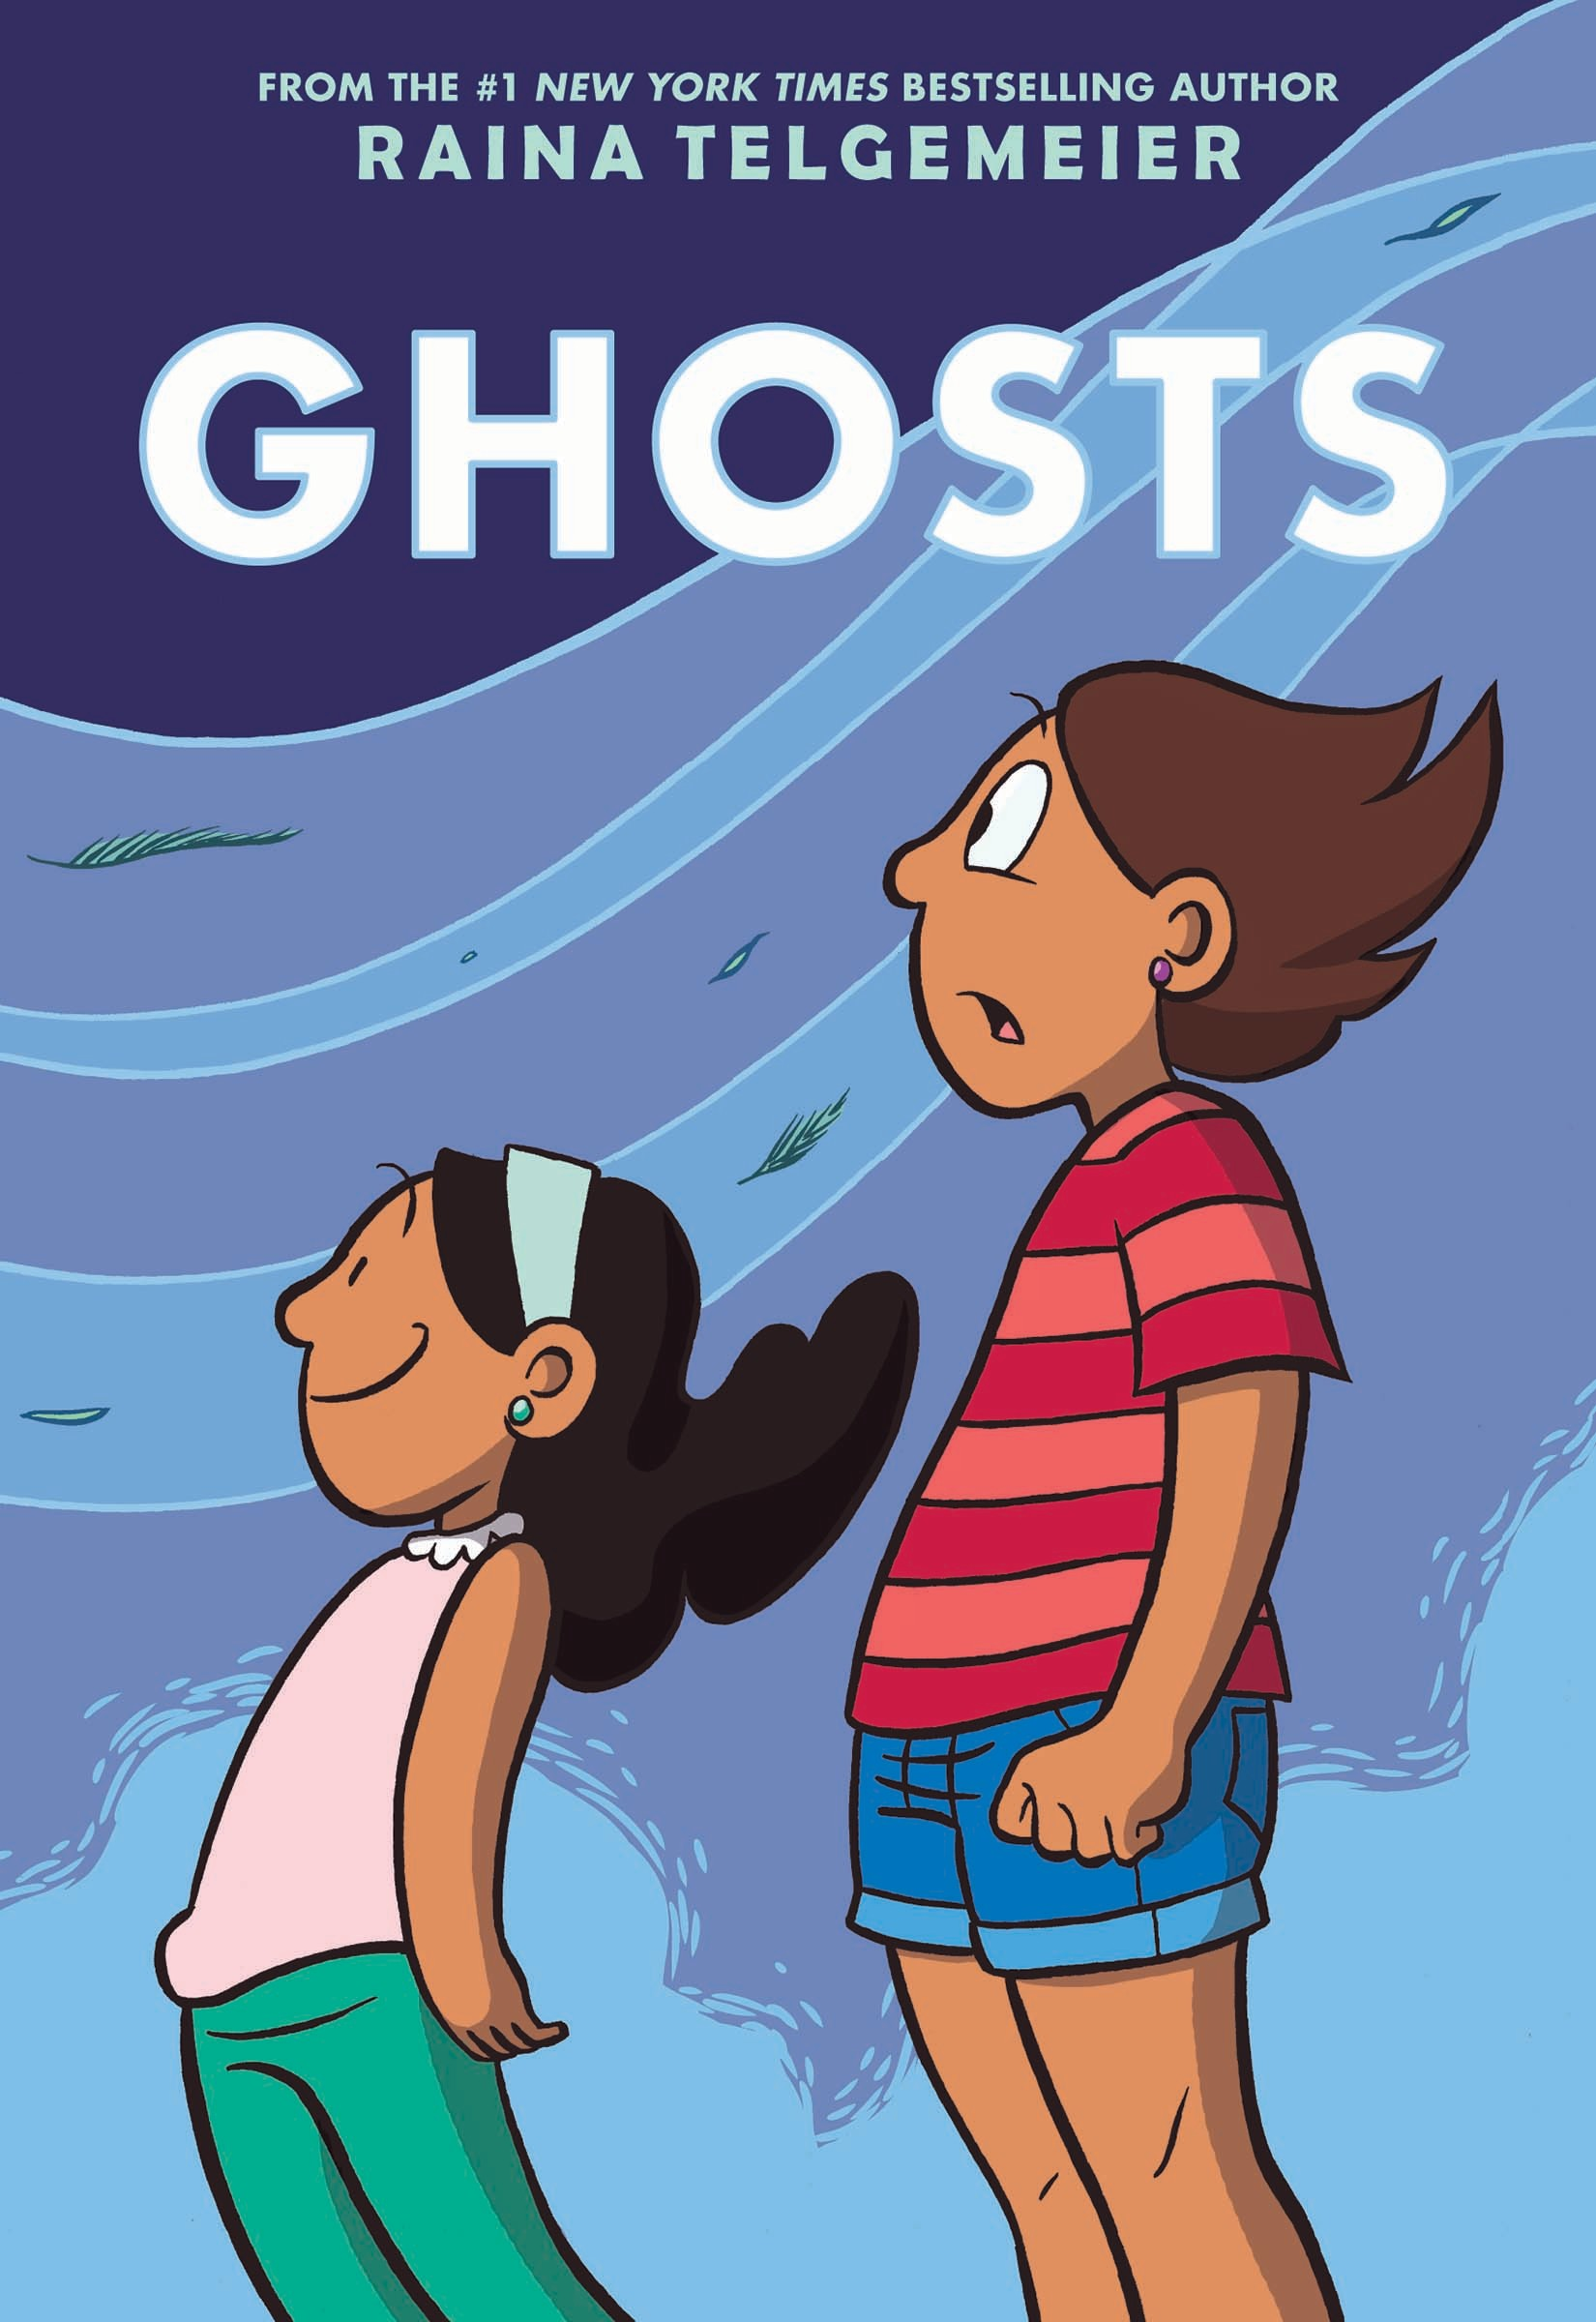

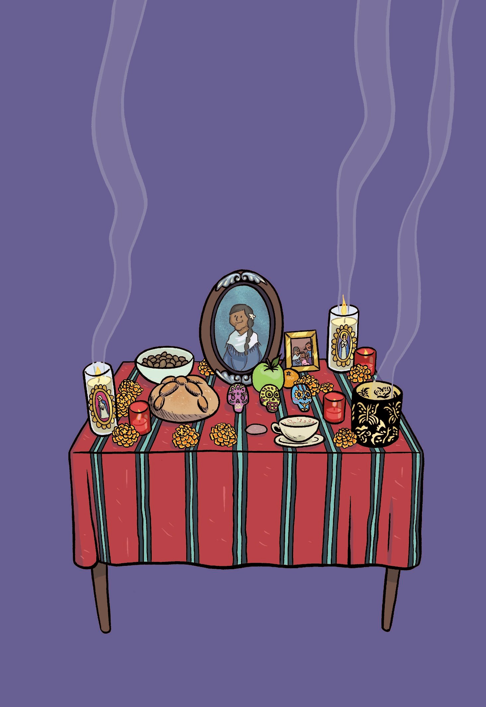
R A I N A T E L G EM E I ER

HOS S
G
T
WITH COLOR BY BRADEN LAMB


An lmprint of



Copyright © 2016 by Raina Telgemeier

All rights reserved. Published by Graphix, an imprint of Scholastic Inc., Publishers since 1920. SCHOLASTIC, GRAPHIX, and associated logos are trademarks and/or registered trademarks of Scholastic Inc.

The publisher does not have any control over and does not assume any responsibility for author or third-party websites or their content.

No part of this publication may be reproduced, stored in a retrieval system, or transmitted in any form or by any means, electronic, mechanical, photocopying, recording, or otherwise,
without written permission of the publisher. For information regarding permission, write to Scholastic Inc., Attention: Permissions Department, 557 Broadway, New York, NY 10012.

This book is a work of fiction. Names, characters, places, and incidents are either the product of the author’s imagination or are used fictitiously, and any resemblance to actual persons,
living or dead, business establishments, events, or locales is entirely coincidental.
Library of Congress Cataloging-in-Publication Data Names: Telgemeier, Raina, author, illustrator.
Title: Ghosts / Raina Telgemeier ; with color by Braden Lamb.
Description: First edition. | New York : Graphix, an imprint of Scholastic, 2016. | © 2016 | Summary: Catrina and her family have moved to the coast of Northern California for the sake
of her little sister, Maya, who has cystic fibrosis—and Cat is even less happy about the move when she is told that her new town is inhabited by ghosts, and Maya sets her heart on meeting one. Identifiers: LCCN 2016004672 | ISBN 9780545540612 (hc) | ISBN 9780545540629 (pb)
Subjects: LCSH: Sisters—Comic books, strips, etc. | Sisters—Juvenile fiction. | Ghosts—Comic books, strips, etc. | Ghost stories. | Moving, Household—Comic books, strips, etc. | Moving, Household— Juvenile fiction. | Families—California, Northern—Comic books, strips, etc. | Families—California, Northern—Juvenile fiction. | California, Northern—Comic books, strips, etc. | California, Northern— Juvenile fiction. | CYAC: Graphic novels. | Sisters—Fiction. | Ghosts—Fiction. |
Cystic fibrosis—Fiction. | Moving, Household—Fiction. | Family life—Fiction. | California, Northern—Fiction. Classification: LCC PZ7.7.T45 Gh 2016 | DDC 741.5/973—dc23
LC record available at http://lccn.loc.gov/2016004672 10 9 8 7 6 5 4 3 2 1 16 17 18 19 20
Printed in the U.S.A. 88 First edition, September 2016 Edited by Cassandra Pelham Lettering by Jenny Staley Book design by Phil Falco
Creative Director: David Saylor

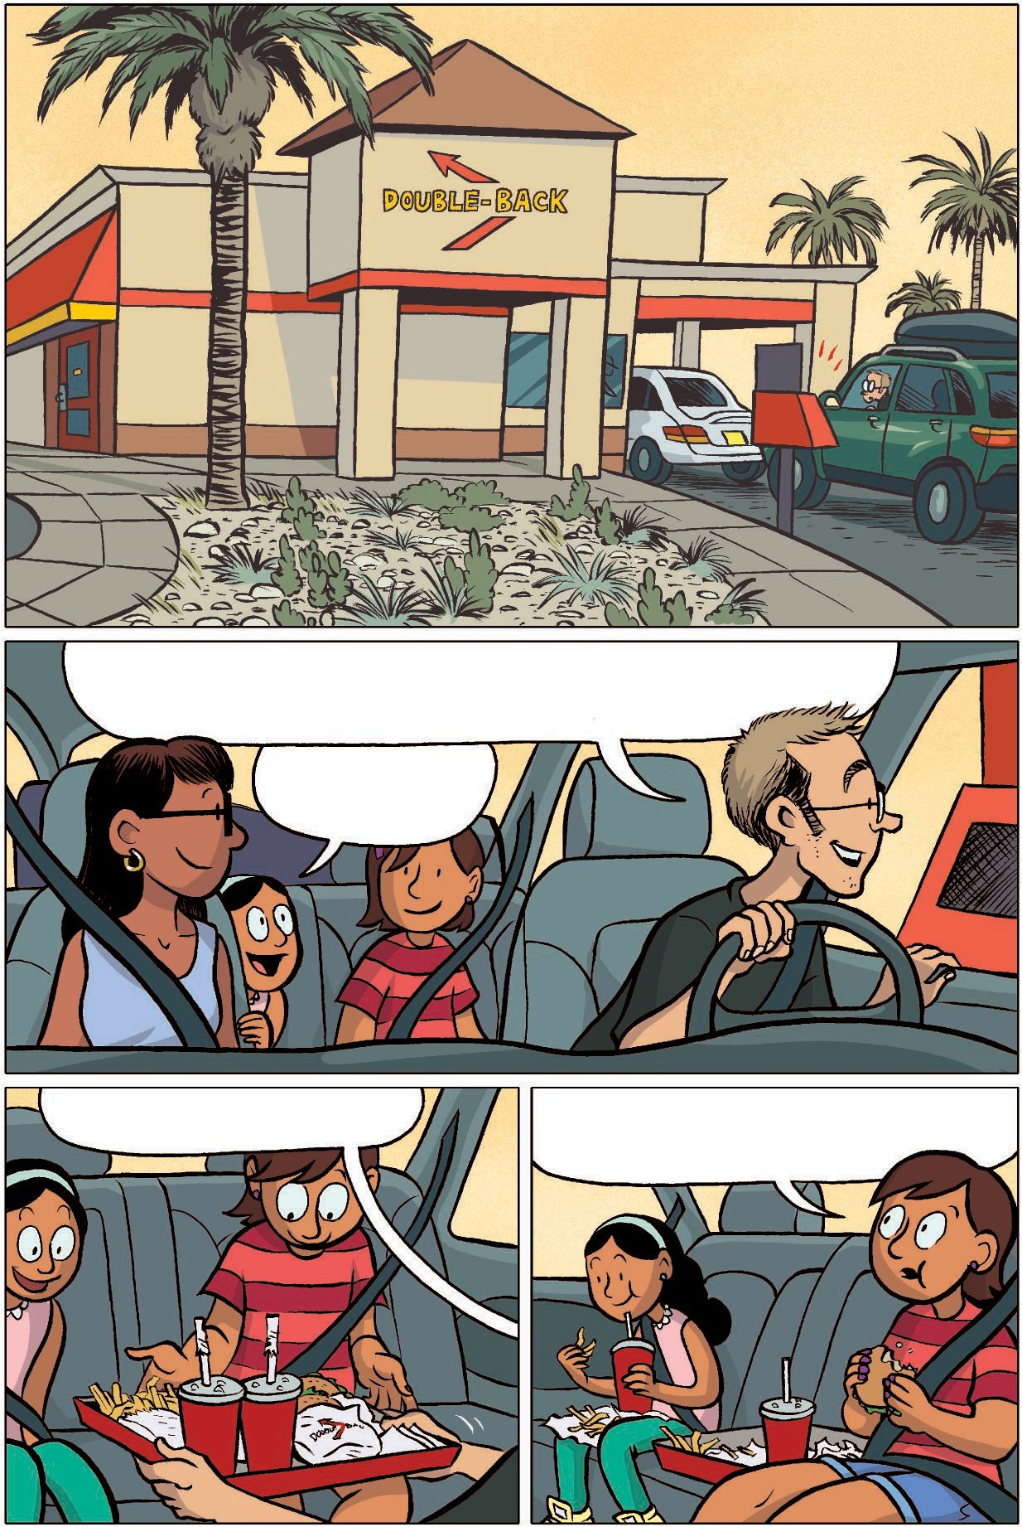

One Double-BAck combo, one Cheese-BAck wiTh fries, A double NAPoleon shAke . . .

Don’T forGeT my orAnGe sodA!

Here you Go, Girls. Do They hAve Double-BAck BurGer in our new
Town, DAd?

I don’T Think so, CAT. They only hAve Them down here in SouThern CAliforniA.

WhAT Are we even going To eat in our new Town?

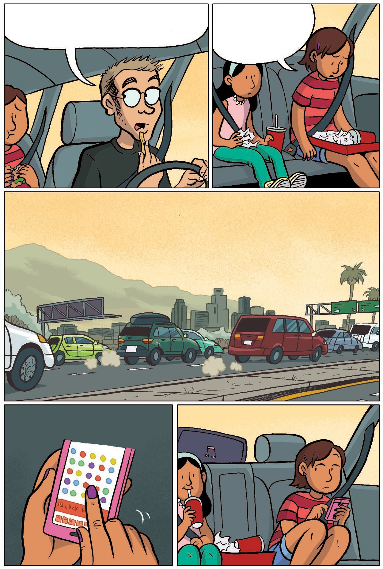

We Are moving. UP norTh And To The coAsT.

DAd goT A new job, buT we All know The reAl reAson we’re going.
My liTTle sisTer, MAyA. She’s noT A heAlThy kid.

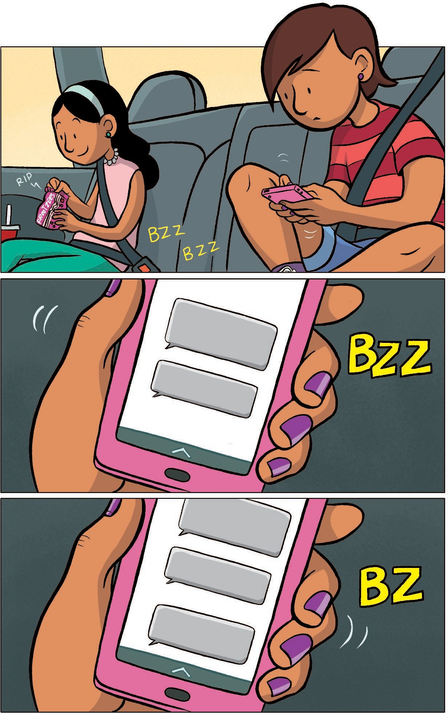

I’m Trying noT To be selfish.

BuT iT’s hArd.

You okAy bAck There, CAT?
YeAh.

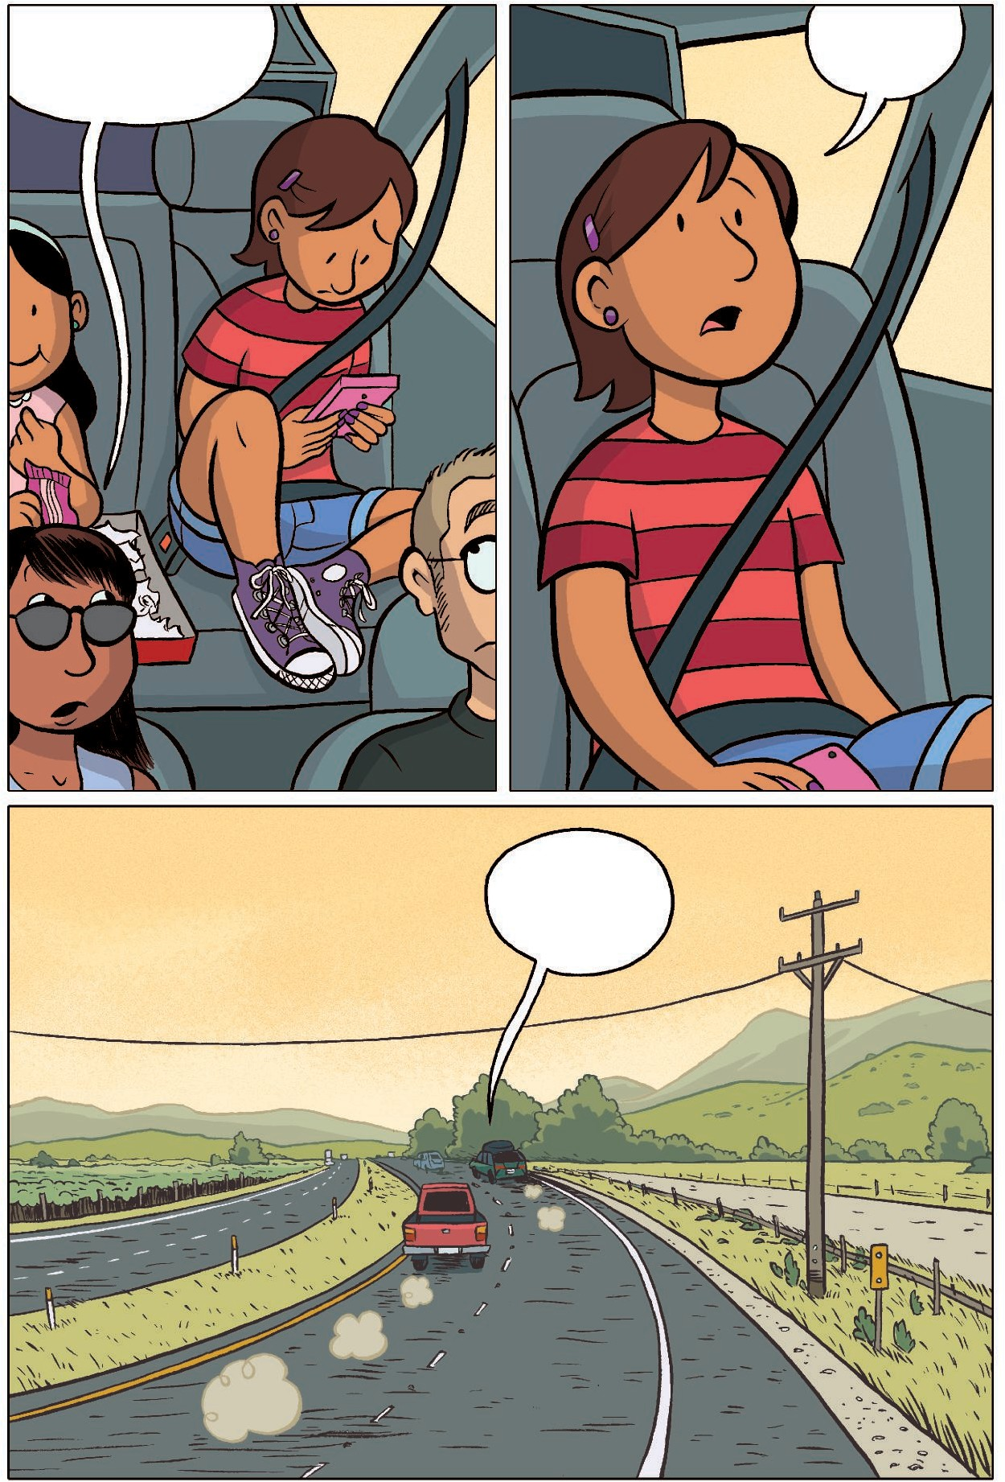

I’m okAy.

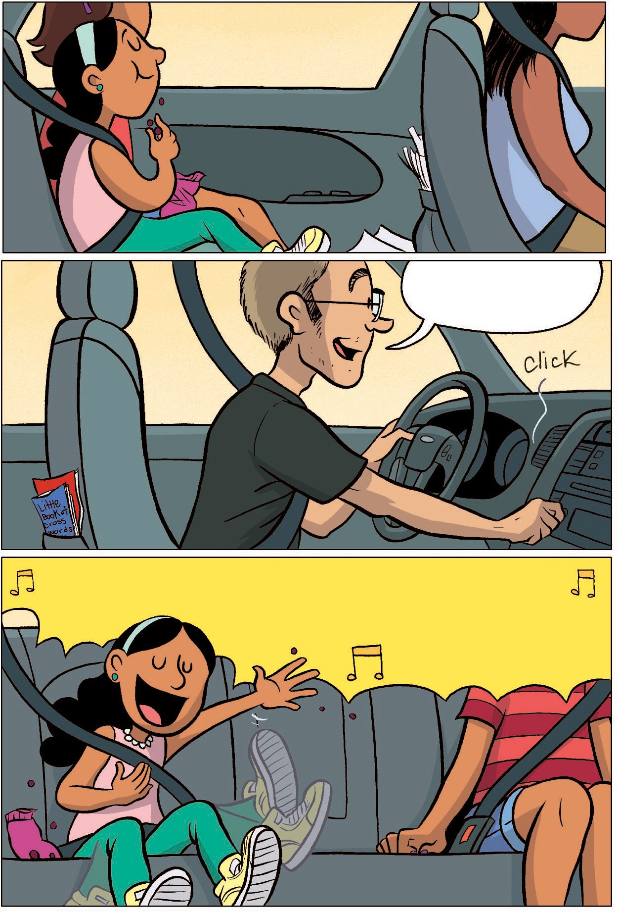
MAyA hAs cysTic fibrosis. IT’s A Thing you’re born wiTh.

How ’bouT A liTTle music?
IT AffecTs breAThing And digesTion.

LeT iT oooooouT . . . leT iT ooooouT . . . CAn’T hold iT in3
goTTA shouT . . .

And There’s no cure.

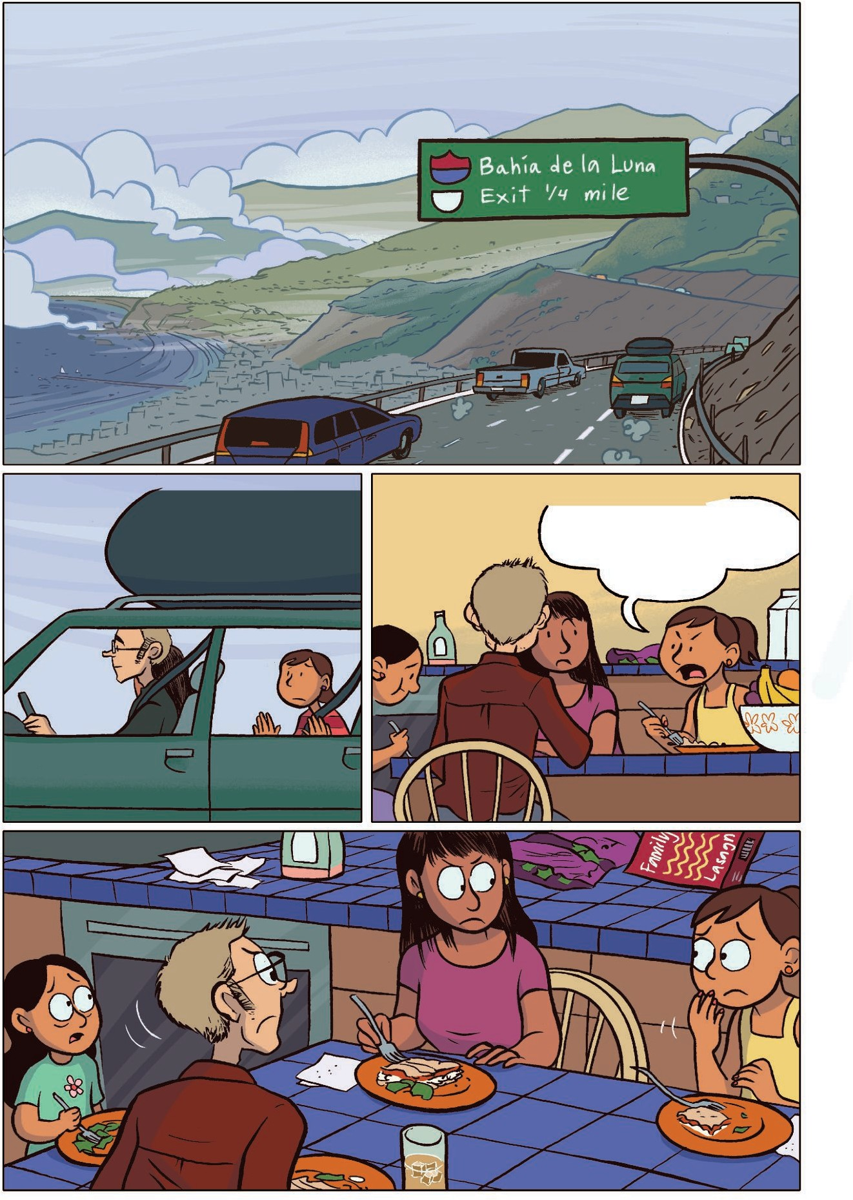
Mom And DAd Are drAgging us To this
gloomy PlAce, BAhíA de lA LunA, CAliforniA.

When I heArd ThAT, I’d sAid:

Ew, I’d rATher
Die!
They sAy The sun only shines here sixTy-Two dAys of The yeAr.

Which didn’T go over very well.

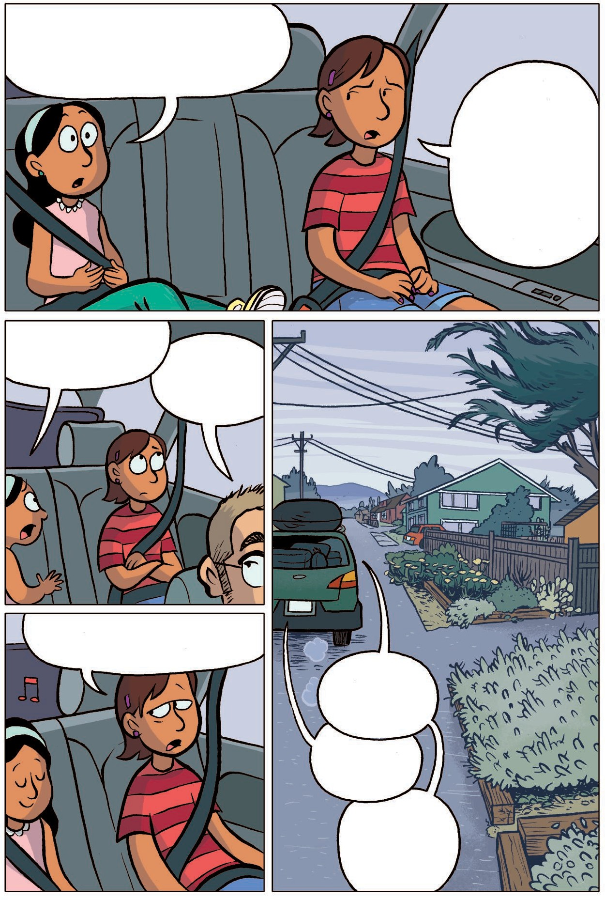

I’m gonnA miss Ari And MAddie And HibAh . . .

You meAn All of my friends? WhAT AbouT your friends?
Of course I don’T wAnT To die. And I wAnT MAyA To be As heAlThy As Possible. Duh!

They’re my friends, Too!
CAAAT . . . ?

Yes, MAyA, They’re your friends, Too.

This is iT, girls!

The green one?

No, The liTTle red one.

CAT! Isn’T This PlAce so cool?!?

Mmmm.

I cAn’T believe we geT To live here!

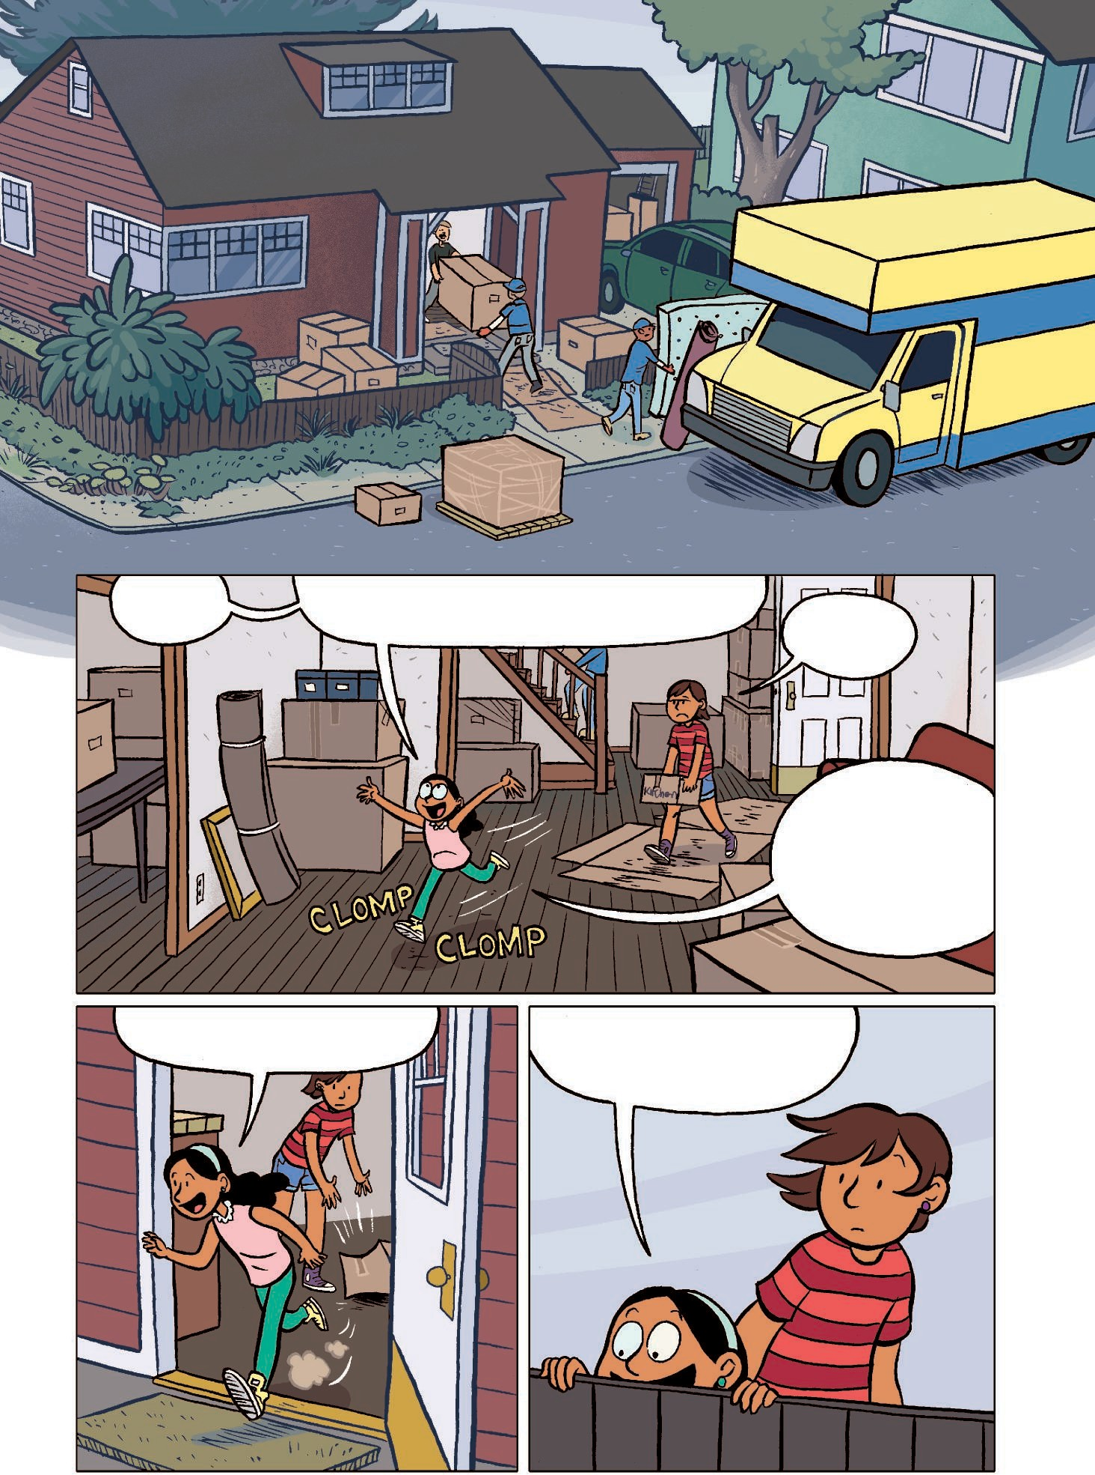

Look look look . . . The oceAn is
so close!!

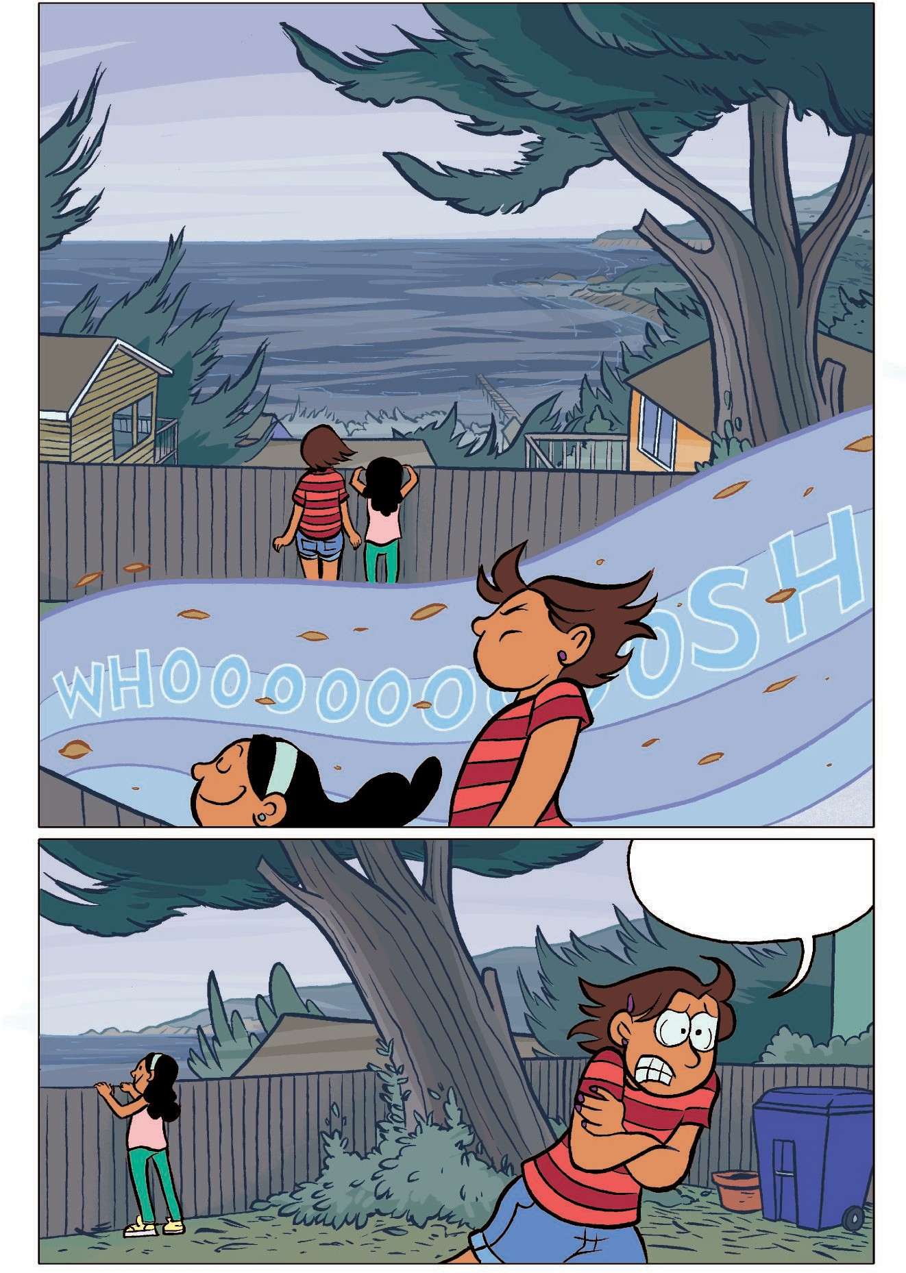

IT’s freezing.
I’m going inside.

So dArk in here . . .

WhAT do you Think, CAT?

IT’s dArk.

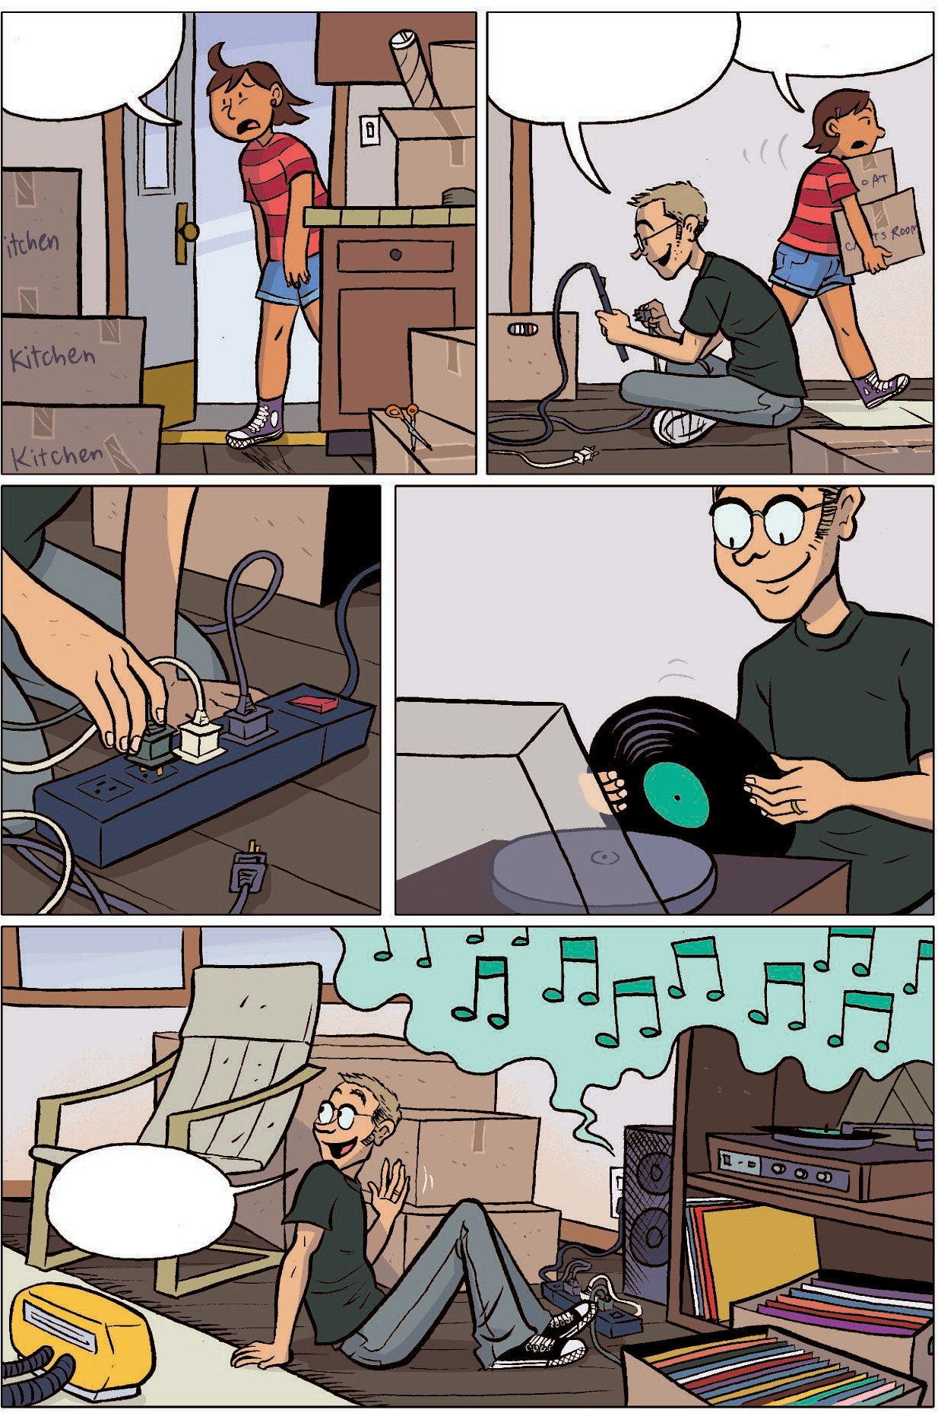

IT’s

PerfecT!

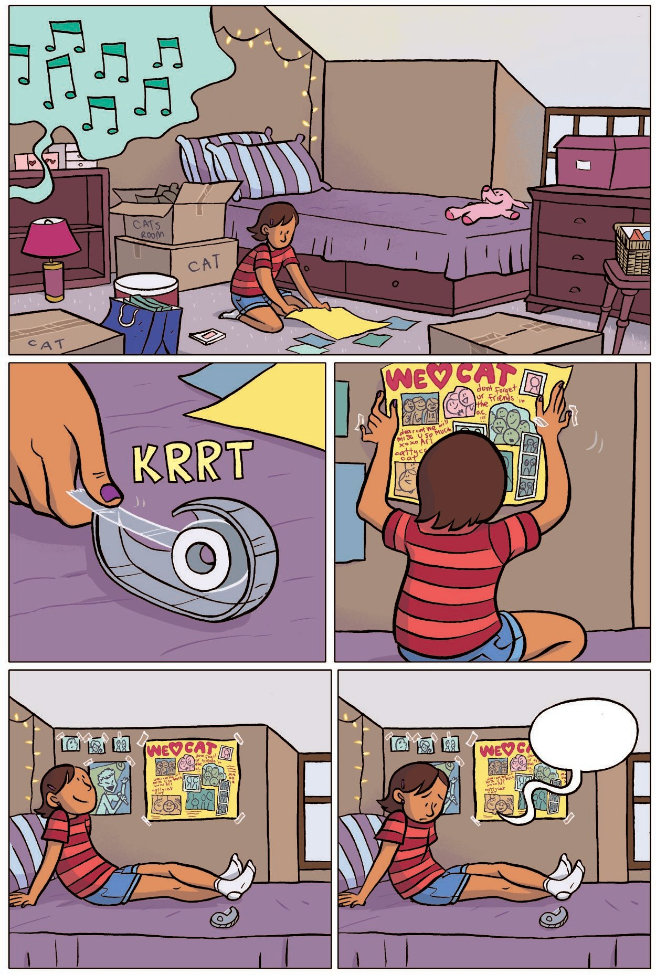

Sigh.

CAT!

Come downsTAirs!
Come see my new room!!

OkAy, I’m coming.

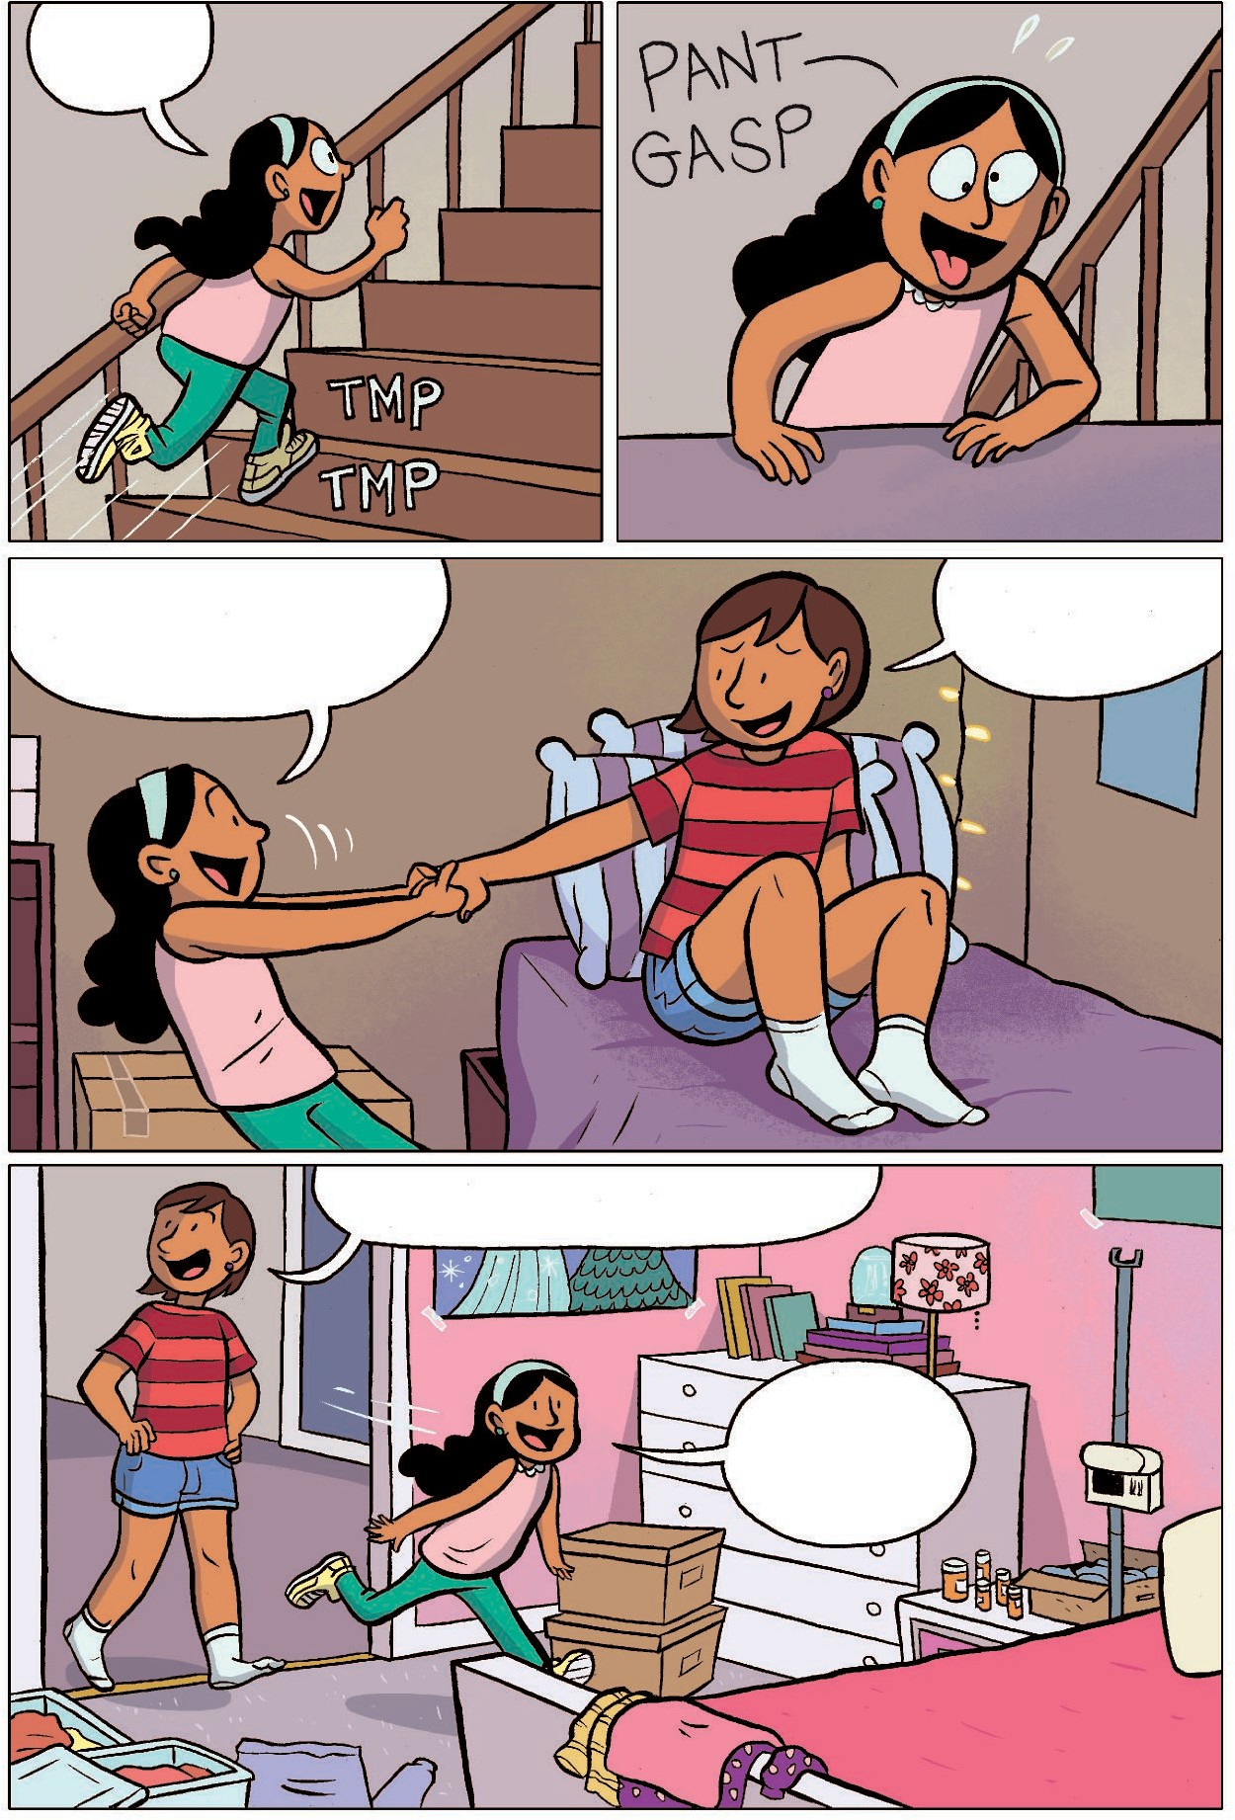

Hey, iT’s cozy in here!

WATch This!

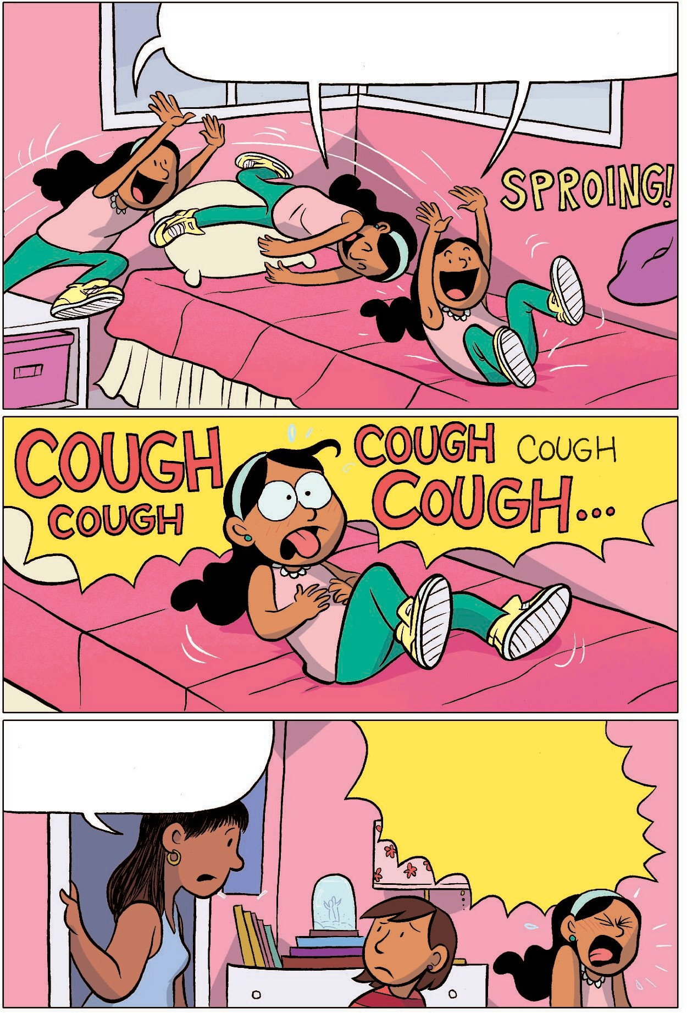
CAnnonbALLLLLLLLLLLLLLLLLL!!

IT’s AbouT Time for your breAThing
TreATmenT, MAyA . . . * HAck cough

cough cough*

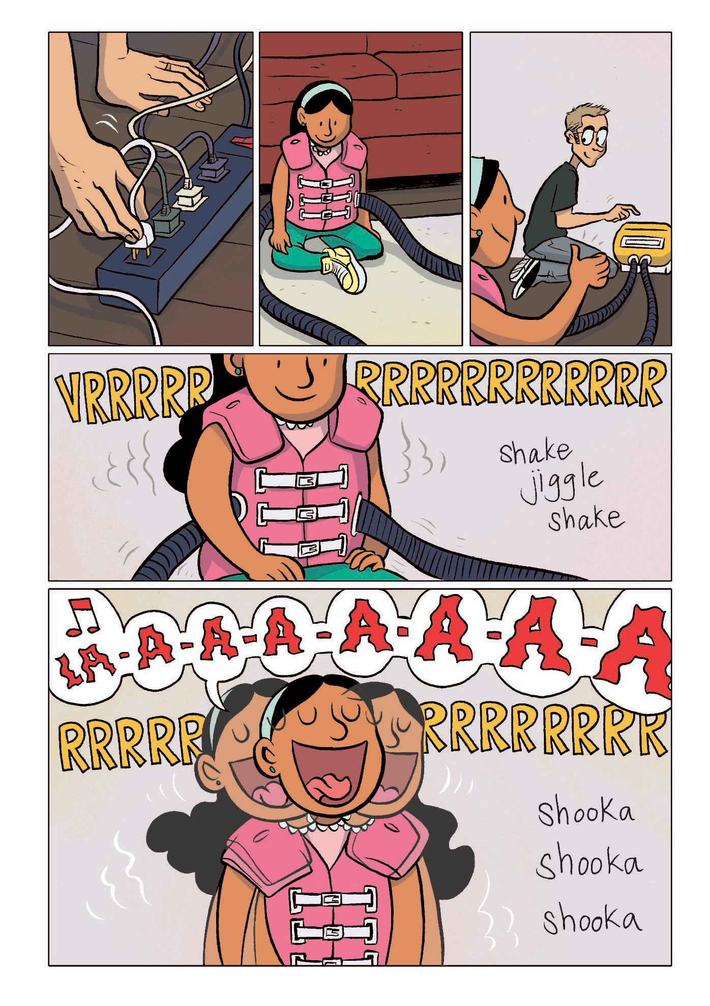

14

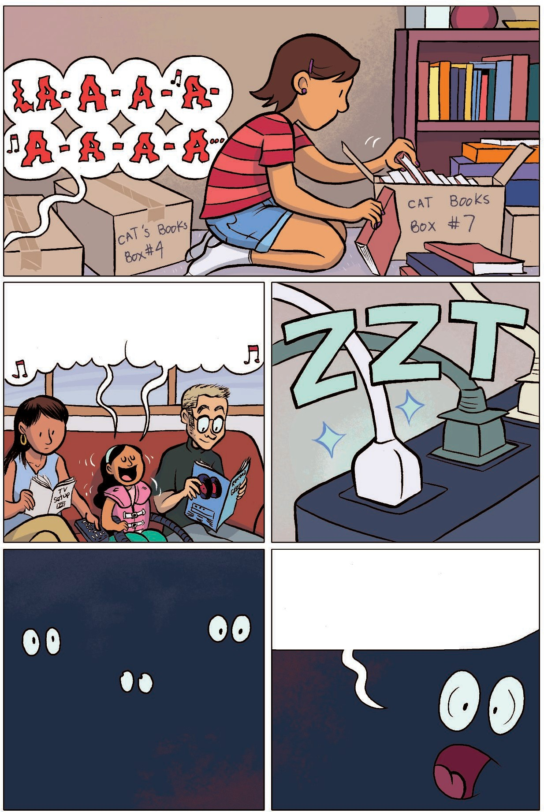
The vesT helPs loosen The mucus in her lungs.

Her soul doesn’T need Any loosening, Though.
LA-A-A-A LA-A-A-A

MOMMMMMMM??!

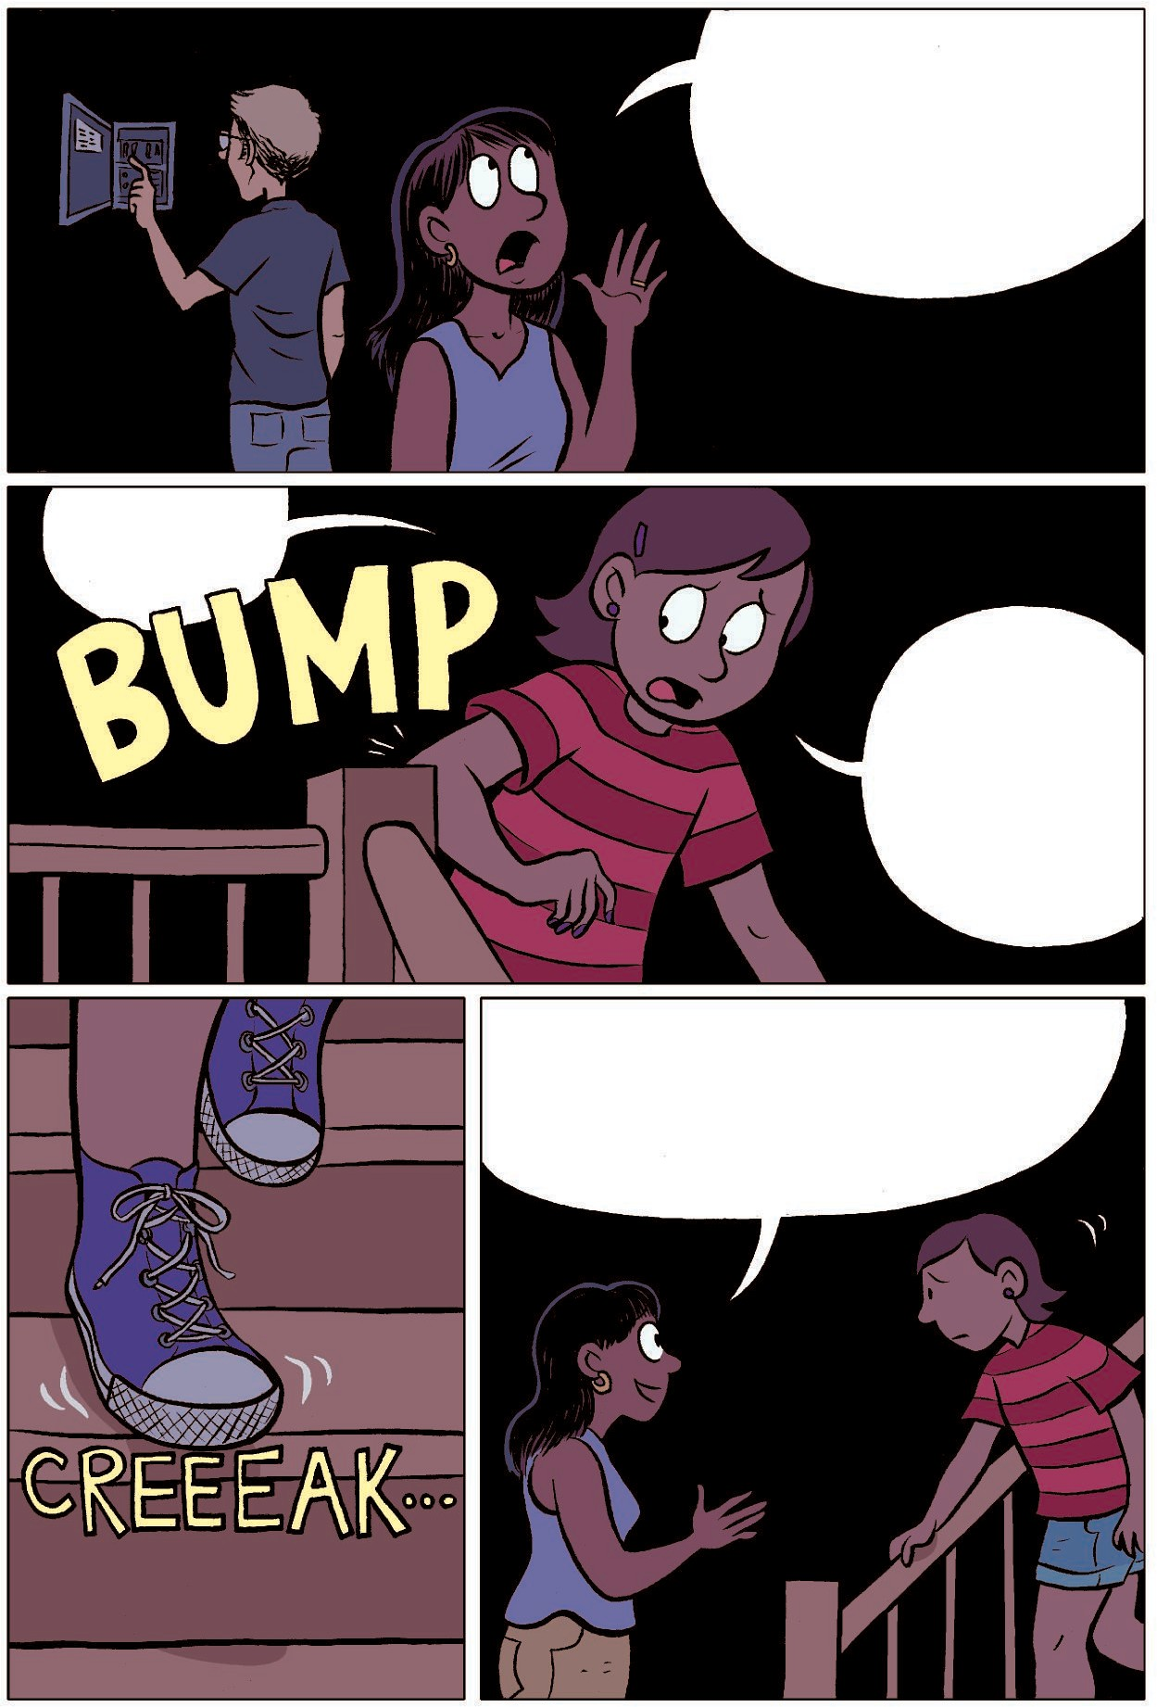

MAyA’s vesT jusT blew A fuse,
sweeTie . . . you okAy uP There?

YeAh,
I jusT . . .

I jusT don’T know This house very well yeT.

Why don’T you TAke your sisTer To exPlore The Town while we work on geTTing The Power bAck?

Ooh, A secreT PAThwAy . . .

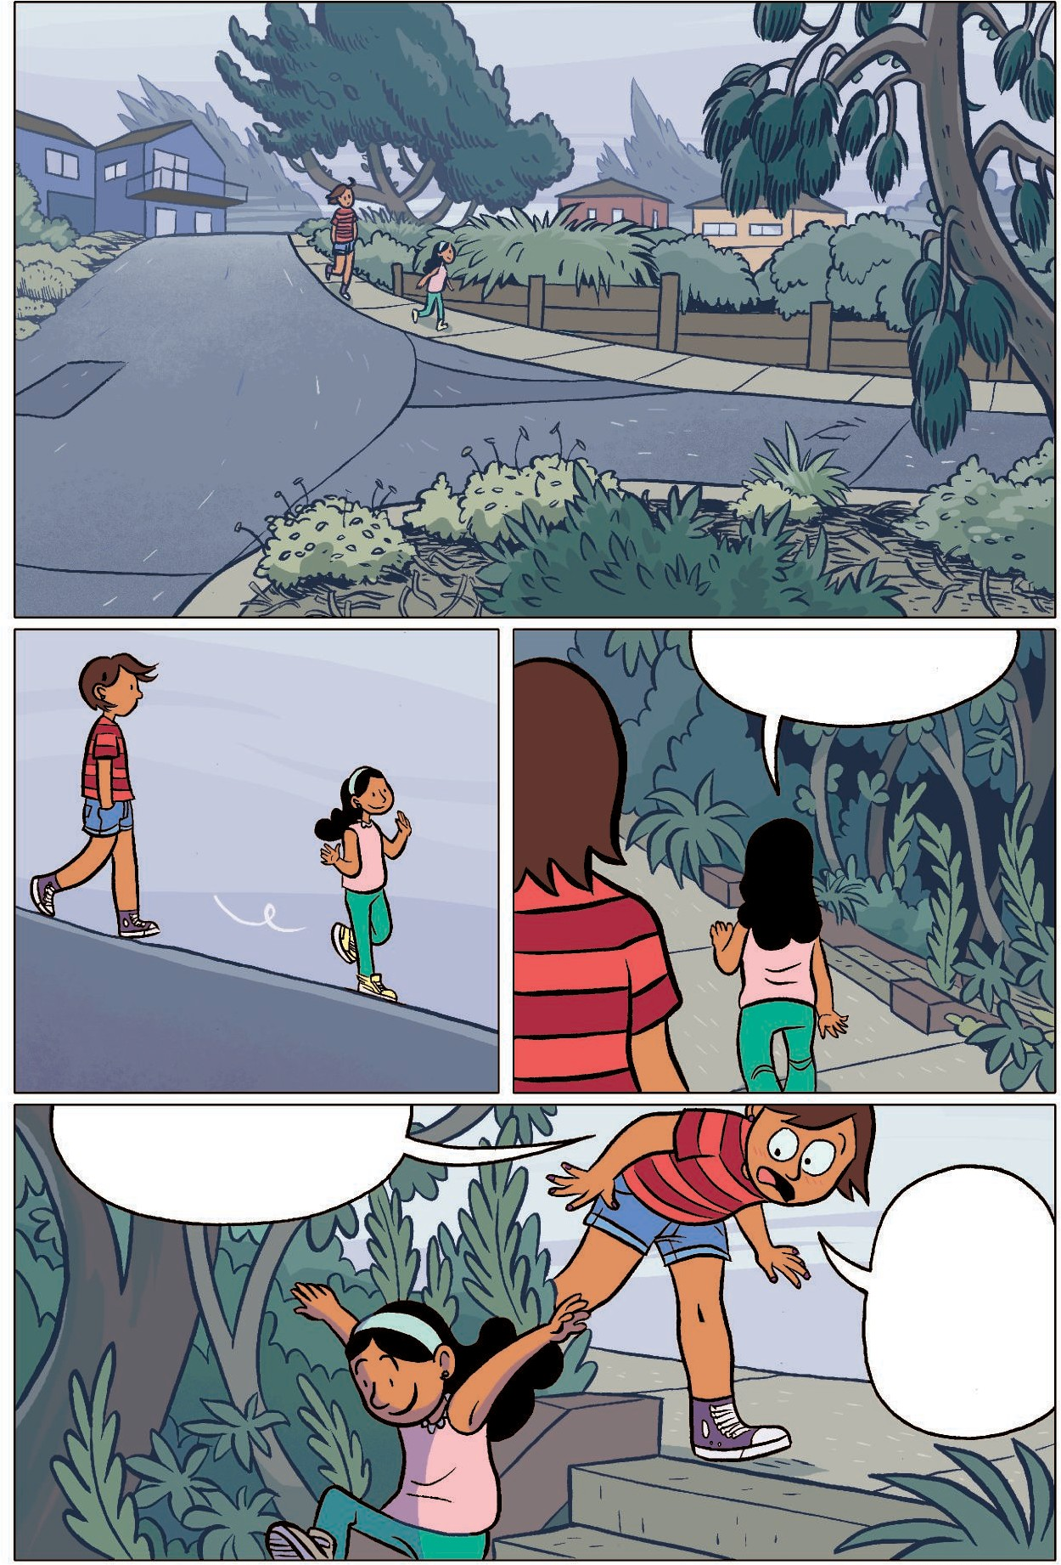
MAyA!

We don’T know whAT’s down There!

Sigh . . .

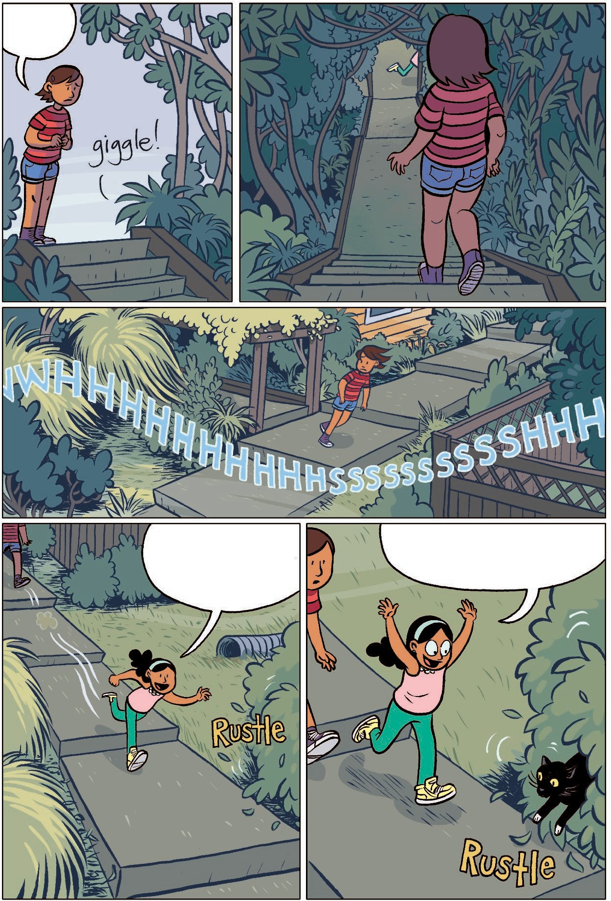
MAybe This PATh will leAd us To --
Kitty!!

Don’T Touch iT!!

Why noT?! IT’s so cuTe!

BecAuse you know whAT They sAy AbouT leTTing A blAck cAT cross your PATh . . .

IT’s
bAd luck!

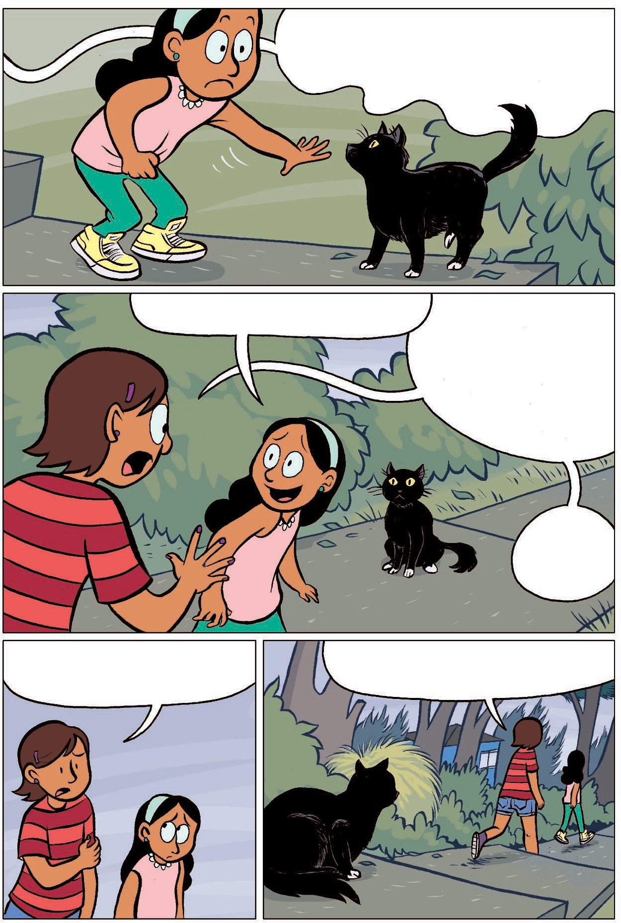
And you’ve hAd enouGh

bAd luck lATely.
Come on . . . leT’s see where This Thing leAds.

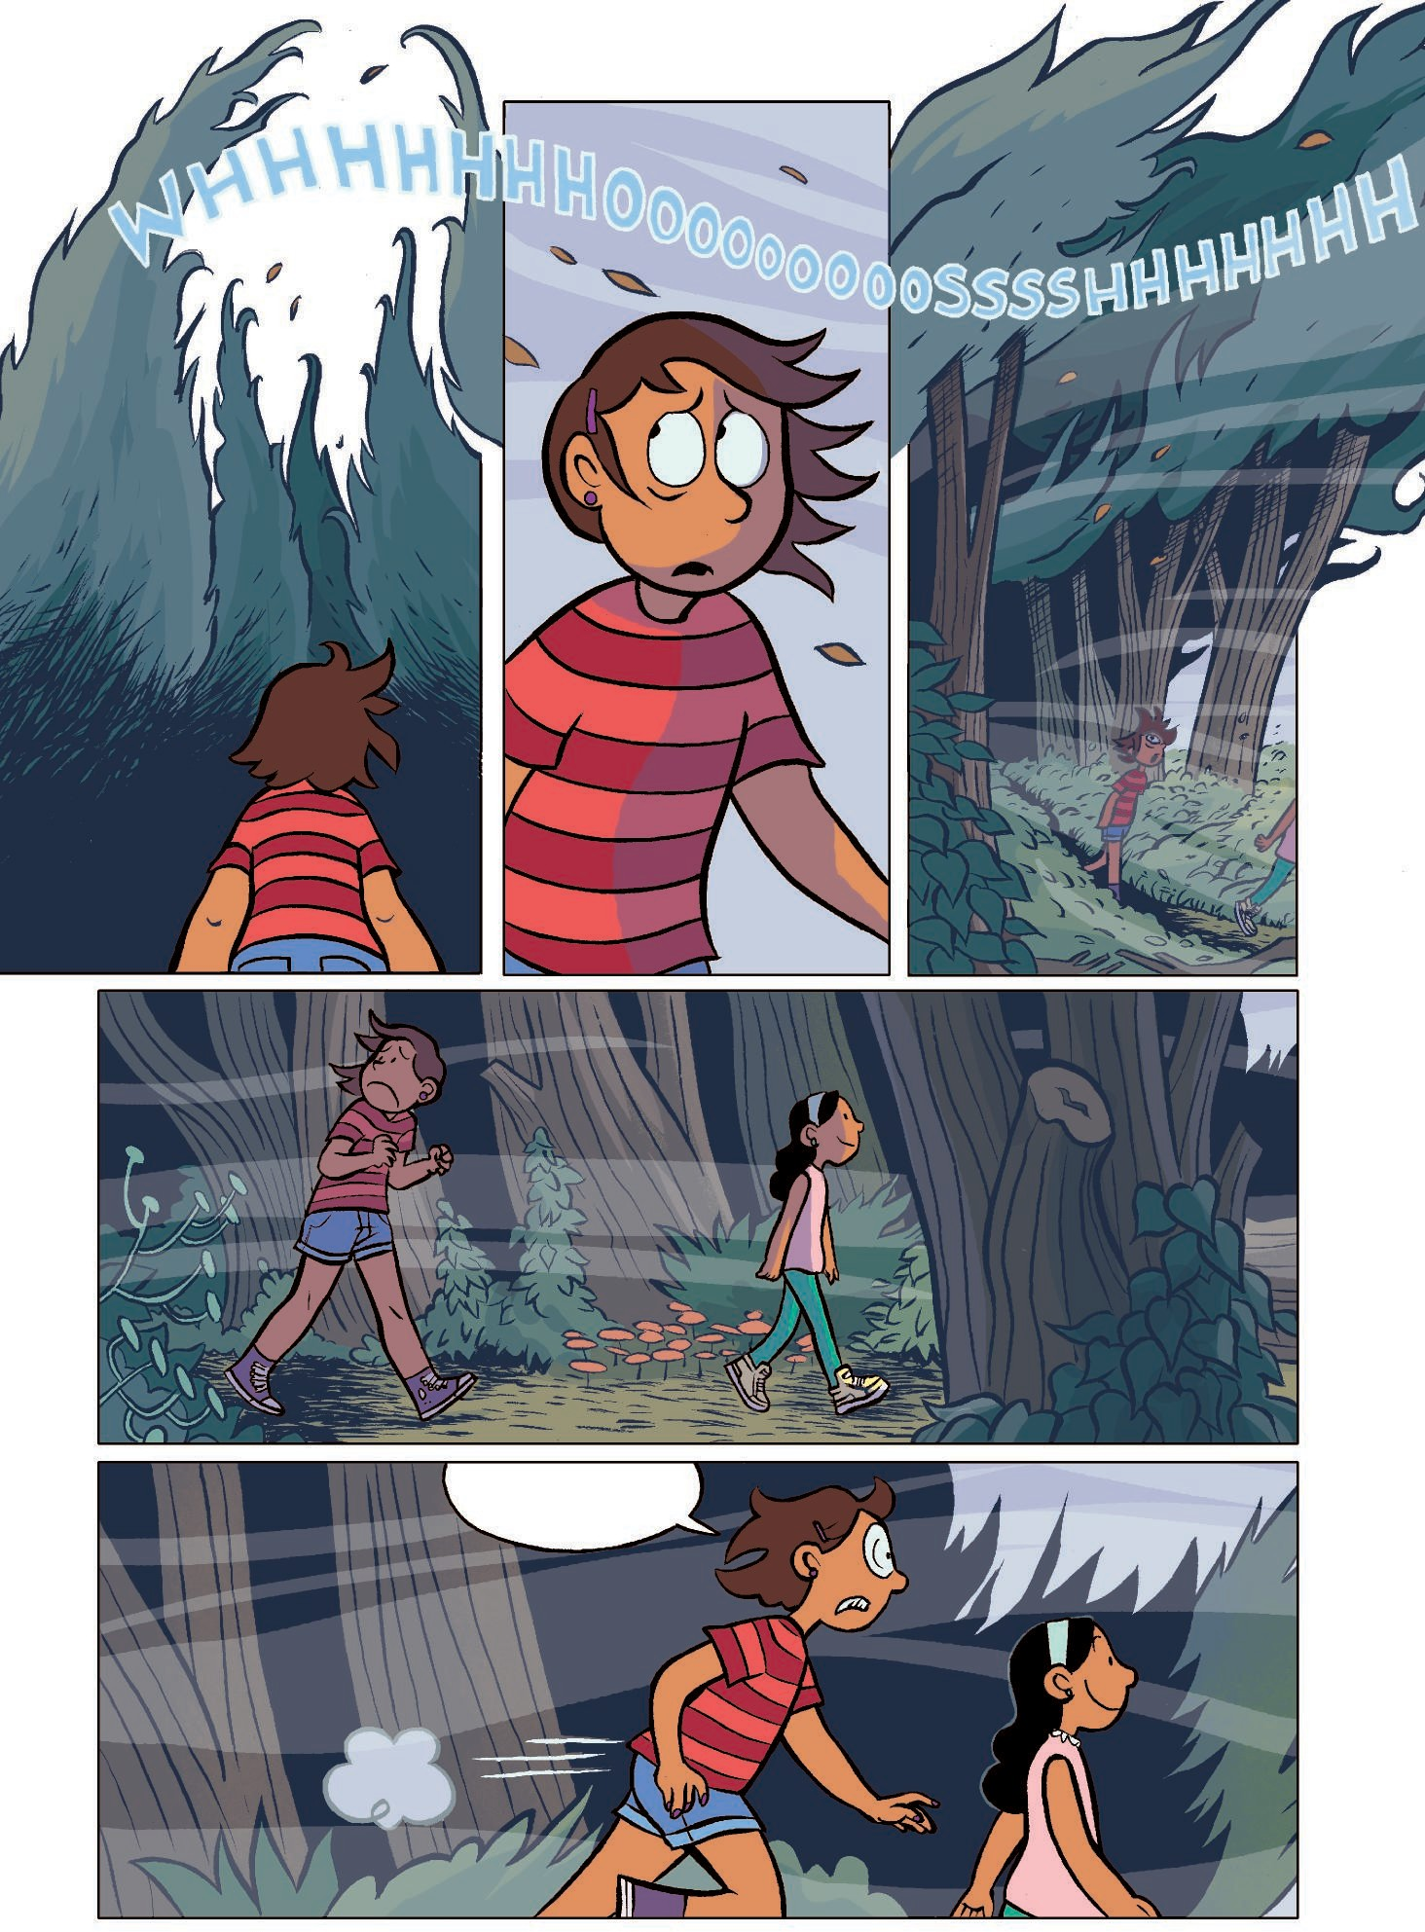

Brrr!

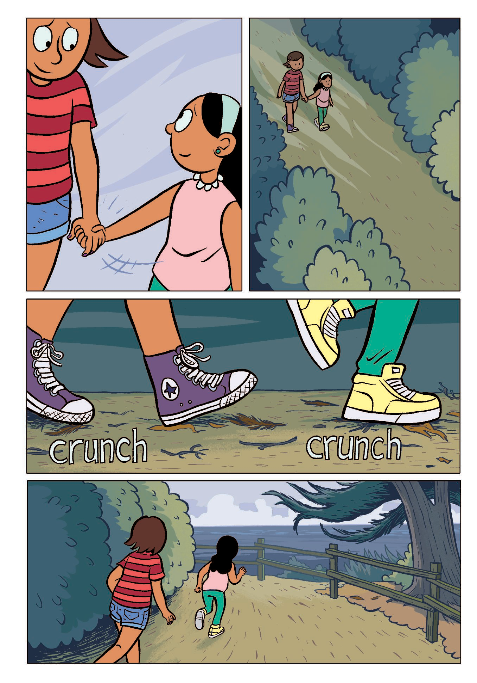

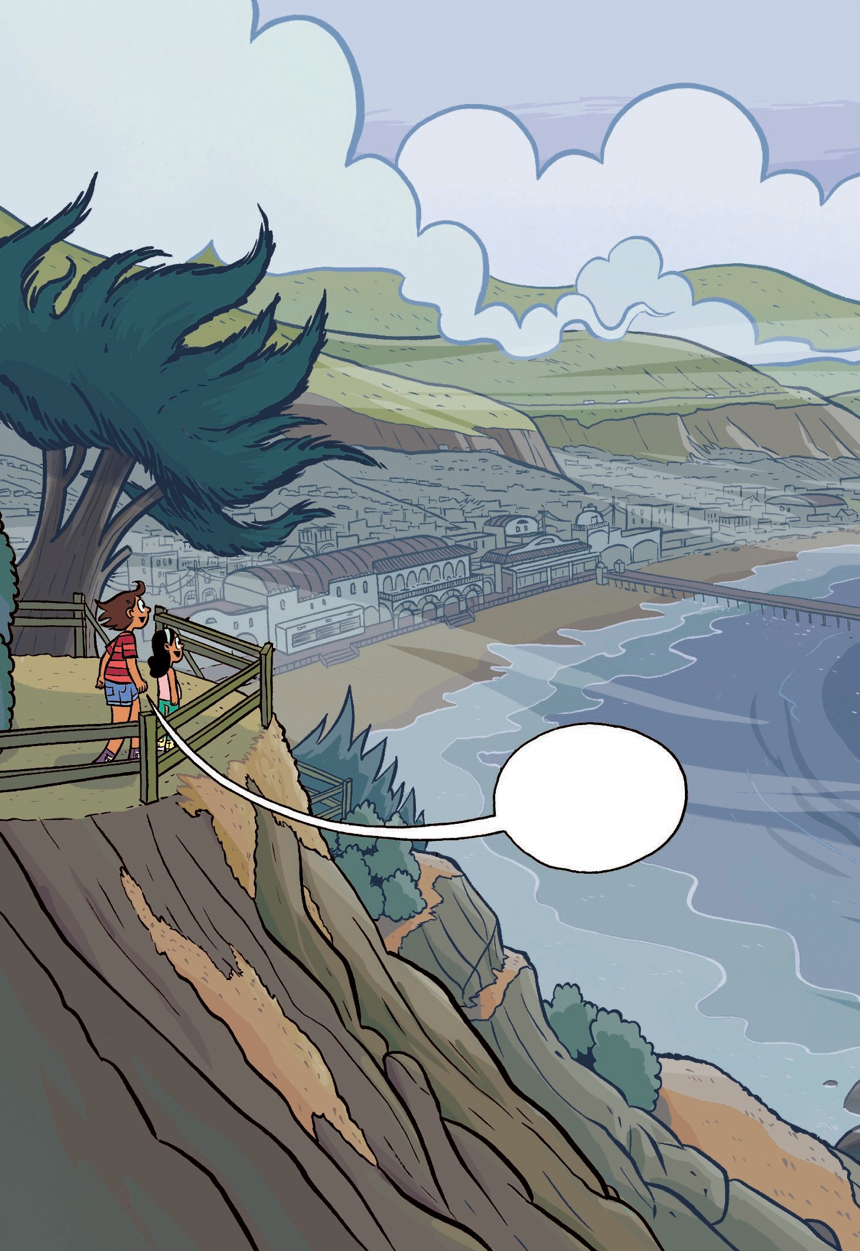

WhoA.

