Scenario 2

Implementation steps -

Step 1 - Below are the list of artifact required –

1. Azure Key Vault – Create the Key vault using Arm template to store the Key and values like passwords in secure access.
2. Virtual Network – Create the Virtual network using Arm template. Vnet enables many type of resources to securely communicate with each other.
3. NSG – Create the NSG using Arm template. Mainly it is used activate the rule or access control.
4. Network Interface – Create the NIC using Arm template. It is mainly used is an interconnection between a Virtual Machine and the underlying software network

Step 2 – Below are the list of tool –

1. Visual Studio Code – For creating the Arm template.
2. Arm template – It is Json files which is having template and parameter file which is saving in local desktop. After that it is push to Github.

Step 3 -

1. First of all Arm templates (related the Vnet, Subnet, NIC , VM etc) are checking into Github in the Master branch ( or Feature branch).
2. Create the project in Azure DevOps.

e.g. MerskDemo.

Create the CI Pipeline -

c. Goto Pipeline -> Create Pipeline -> Choose the Repository or goto classic editor.

d. Select the Source and repository.

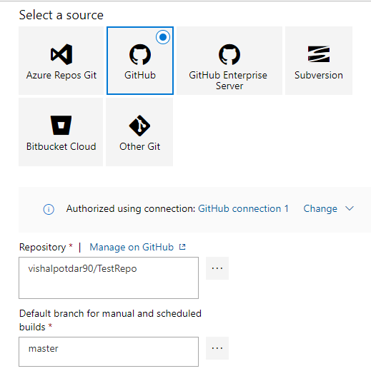

1. Create the Empty Job and select the agent (here I choose Vs2017)
2. Then the add the task in the Agent Job by clicking on + symbol.
3. Add the task – Publish Artifact in which fill the details of the parameters.

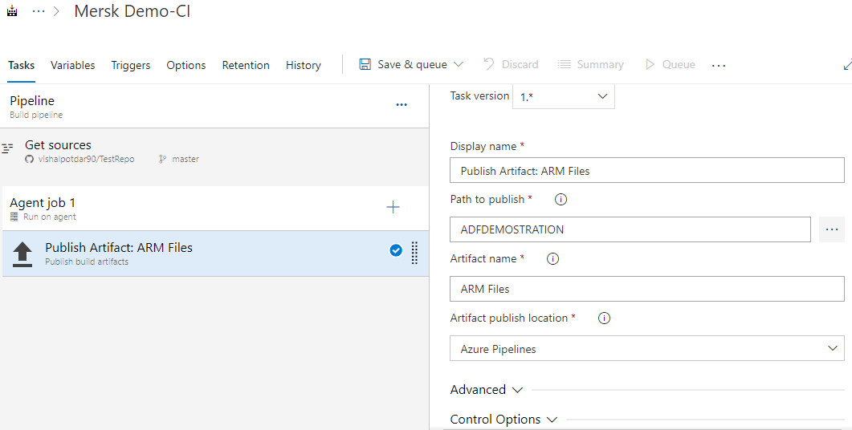

In this way the Files which are on the repository are kept on thr Azure repository side.

Create the CD Pipeline –

1. In this click on release and create the CD pipeline.

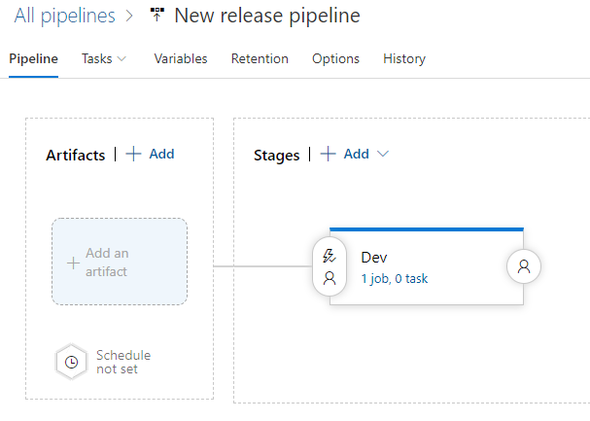

1. Choose the Add and artifact to pull the publish artifacts from Azure Repository ( which was done in the CI section).

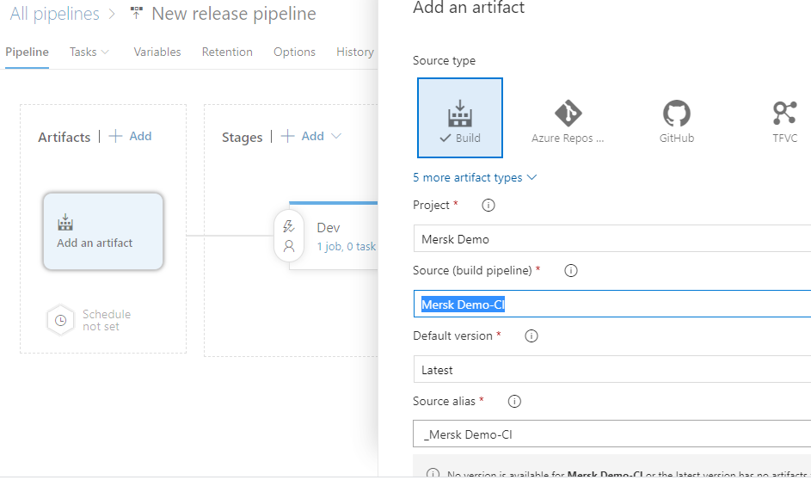

1. Goto Stages (Dev) – Add the Azure template deployment task.

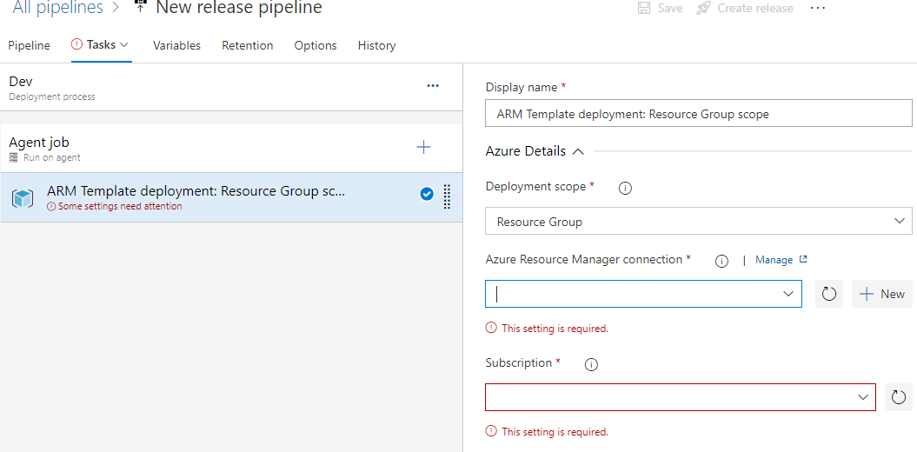

Choose the below option –

aa. Resource Group

ab. Location

ac. Template – It is ARM Template Json present in the Github path

ad. Template Paramerters – if you have any parameters file then attached it.

After filling details you can save the changes.

Note – Please run the CI pipeline to getting the artifacts to Azure repository. After successful run of CI pipeline run the CD pipeline.

Note – To automate the pipeline on every checkin into repository. Follow the below steps –

CI Pipeline –

1. Enable the continuous Integration option in the Trigger section. In which mentioned the branch from which the integration will be happen.

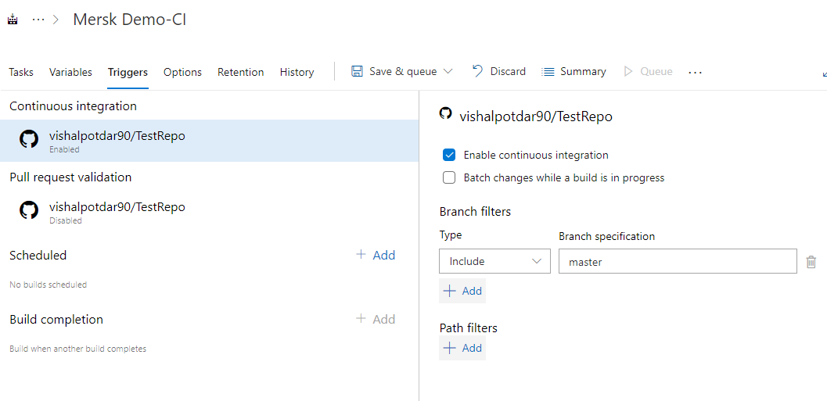

CD Pipeline-

1. In the Artifacts please enable the Continuous deployment trigger for every check in process.

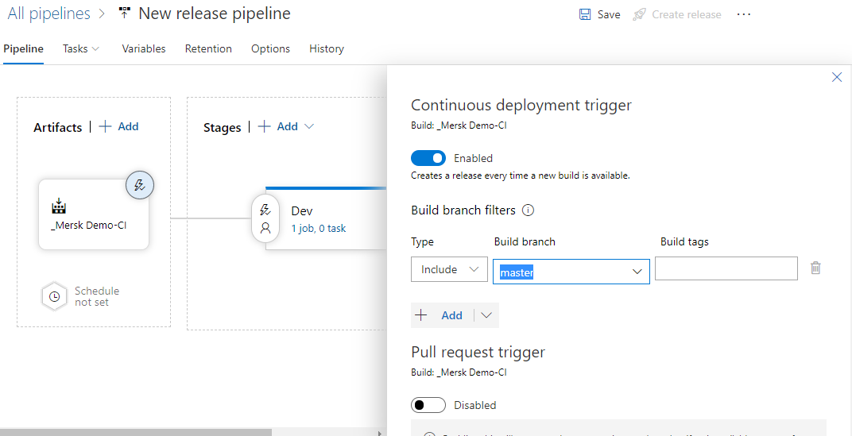

Step 4 – Please find the attached ARM template for VM creation in Github repository.

Step 5 – For accessing the password stored in Key vault below steps are follows -

1. In CD pipeline search the task – Azure Key Vault and add it.

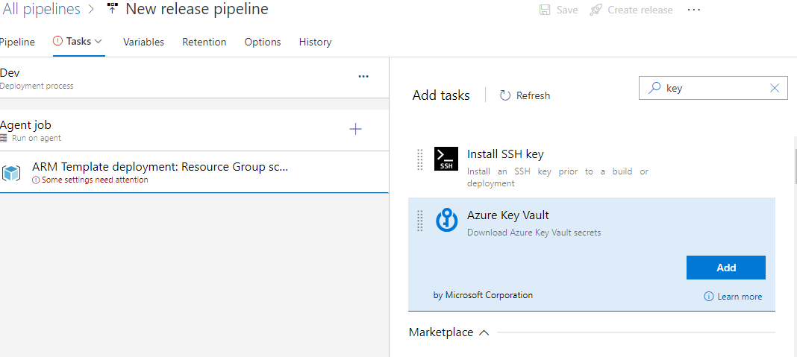

1. In which fill the required details like

Azure Subscription, Key Vault Name, Secrets filter (Note - \* means all values in key vaults are pull).

Note – Check the option make secrets available to whole job which will help us to use secrets are as a variable in the Override template in the other task like Azure resource template.

