FUTURE INTERNS | CYBER SECURITY TASK 2 (2026)
Phishing Detection & Awareness Report
Email header analysis, risk classification and staff guidance
Prepared by: [Your Name]
Report date: 28 September 2026
Role perspective: Security Analyst / Security Awareness
Emails analysed: 5 (4 phishing-corpus samples, 1 legitimate reference email)
Classification of this document: Public. Study and awareness use.

1. Executive Summary
Phishing succeeds far more often because people cannot spot a fake email than because systems are weak. This report analyses five emails the way a security analyst would: by reading the message headers, checking sender domains and authentication results, identifying red flags, and assigning each email a risk rating. It then turns the findings into plain-language guidance that any employee can follow.
Headline results: three of the five emails were classified as Phishing, one as Suspicious, and one as Safe. In every malicious or suspicious case, the sender domain did not match the brand or person being presented, and at least two of the three email authentication checks (SPF, DKIM, DMARC) either failed or were missing.

# | Email | Type | Risk | Key reason
1 | Fake Bradesco / Livelo rewards alert | Brand impersonation | Phishing | Look-alike domain, "expiring today" pressure, no authentication passed
2 | Fake Microsoft "unusual sign-in" | Credential harvesting | Phishing | Non-Microsoft look-alike domain, DMARC permerror, fear-based subject
3 | Solar-panel price offer | Unsolicited spam | Suspicious | Mismatched domains, all authentication missing, unsolicited bait
4 | "Donation For You" | Advance-fee scam | Phishing | Name/address mismatch, DMARC fail, forged timestamp, bulk send
5 | Google Community Team tip | Legitimate newsletter | Safe | SPF, DKIM and DMARC all pass; Google-only delivery path

2. Scope, Tools and Approach

2.1 Scope
Four emails were taken from the public phishing_pot sample collection (samples sample-1, sample-10, sample-100 and sample-1004, from the repository's email folder). A fifth email, a genuine message received in the analyst's own mailbox, was added as a "known good" comparison. All analysis was passive: no links were clicked and no attachments were opened.

2.2 Tools used
Tool | Purpose
Google Admin Toolbox – Messageheader | Decoding raw email headers into sender, SPF/DKIM/DMARC results, timestamps and the server path
phishing_pot (GitHub, study only) | Source of real phishing email samples in .eml format
Email client (viewing .eml files) | Opening saved messages safely for review
Screenshots (PNG) | Preserving evidence for each analysed header
Microsoft Word / PDF | Writing the client-ready report

2.3 Analysis workflow
- Collect the sample emails and save them as .eml files.
- Extract headers and paste them into the header analyzer.
- Inspect the sender: compare the display name, the address, and the domain against the real organisation.
- Check authentication: read the SPF, DKIM and DMARC results.
- Trace the route: review the "Received" hops and timestamps for anything unusual.
- Identify indicators (urgency, mismatches, lookalike domains, bulk delivery).
- Classify the email as Safe, Suspicious or Phishing, then document and write the guidance.

2.4 Limits of this analysis
The findings are based on header and sender metadata and on the subject lines. They are strong indicators, but they are not a substitute for detonating links in a sandbox or inspecting attachments. Where the headers alone cannot prove malicious intent, the report says so and uses the cautious "Suspicious" rating.

3. Reading Email Authentication Results
Three checks help receiving servers decide whether an email really comes from the domain it claims. In simple terms:
Check | What it means in plain language
SPF | "Is the server that sent this email allowed to send for this domain?" Like checking a delivery van is on the company's approved list.
DKIM | "Does the email carry a valid digital seal, and is it unbroken?" Proves the message was not changed on the way.
DMARC | "What should happen if SPF or DKIM fail, and do they match the visible From address?" The domain owner's rulebook.

Result | Meaning
pass | The check succeeded. This is good, but it only proves the sender is who they say they are, not that the content is harmless.
fail / softfail | The sender was not authorised (fail) or was probably not authorised (softfail). A strong warning sign.
none | The domain published no rules or no signature. Anyone could imitate it.
temperror | A temporary problem prevented the check. The sender is unverified, so treat it as not passed.
permerror | A permanent error, meaning the domain's record is broken or invalid. Legitimate large brands normally get this right.

4. Risk Classification Criteria
Rating | Typical evidence | Recommended action
Safe | Sender domain matches the organisation; SPF, DKIM and DMARC pass; expected route; no pressure or credential requests. | Treat as normal, but still hover over links before clicking.
Suspicious | Some warning signs (unsolicited, mismatched domains, missing authentication) but no direct proof of credential theft or malware. | Do not click or reply. Report to IT/security and delete.
Phishing | Impersonates a brand or person, uses urgency or fear, fails or lacks authentication, and asks for action, money or credentials. | Do not interact. Report immediately, then delete. Block the sender.

5. Detailed Email Analysis

5.1 Email 1: Fake bank rewards alert (Bradesco / Livelo)
CLASSIFICATION | PHISHING | Risk level: High

A Portuguese-language email pretending to come from a Brazilian bank, warning that 92,990 reward points are "expiring today".

Header findings
Field | Observed value | Analyst assessment
From | BANCO DO BRADESCO LIVELO <banco.bradesco@atendimento.com.br> | The display name imitates a bank, but the address uses a generic "customer service" domain (atendimento.com.br) rather than the bank's own domain (bradesco.com.br).
Subject | "CLIENTE PRIME - BRADESCO LIVELO: Seu cartão tem 92.990 pontos LIVELO expirando hoje!" | Reward bait plus a "today" deadline pushes the reader to act without thinking.
Date | 20 Sep 2023, 12:05:49 AM (GMT+5:30), delivered after 56 sec | Normal delivery time; nothing unusual.
SPF | temperror (IP unknown) | The receiving server could not confirm the sender. Not a pass.
DKIM | none | No digital signature, so the message cannot be proven authentic.
DMARC | temperror | The domain owner's policy could not be applied.
Message-ID | ...@ubuntu-s-1vcpu-1gb-35gb-intel-sfo3-06 | Generated on a generic cloud virtual server (default hostname), not on a bank's mail system.

Phishing indicators identified
- Sender domain does not belong to the organisation being impersonated.
- Urgency and reward language ("expiring today").
- No authentication passed: SPF temperror, DKIM none, DMARC temperror.
- Message was created on a throwaway cloud server, not corporate mail infrastructure.
- Impersonates a well-known bank and loyalty brand to borrow trust.

How the attack works (plain language)
The attacker sends thousands of copies of a "your points are about to expire" message. A victim who believes they will lose something valuable clicks the button, lands on a copy of the bank or rewards login page, and types in their card, ID number or password. The attacker collects those details and uses them to empty accounts or commit fraud.

Evidence
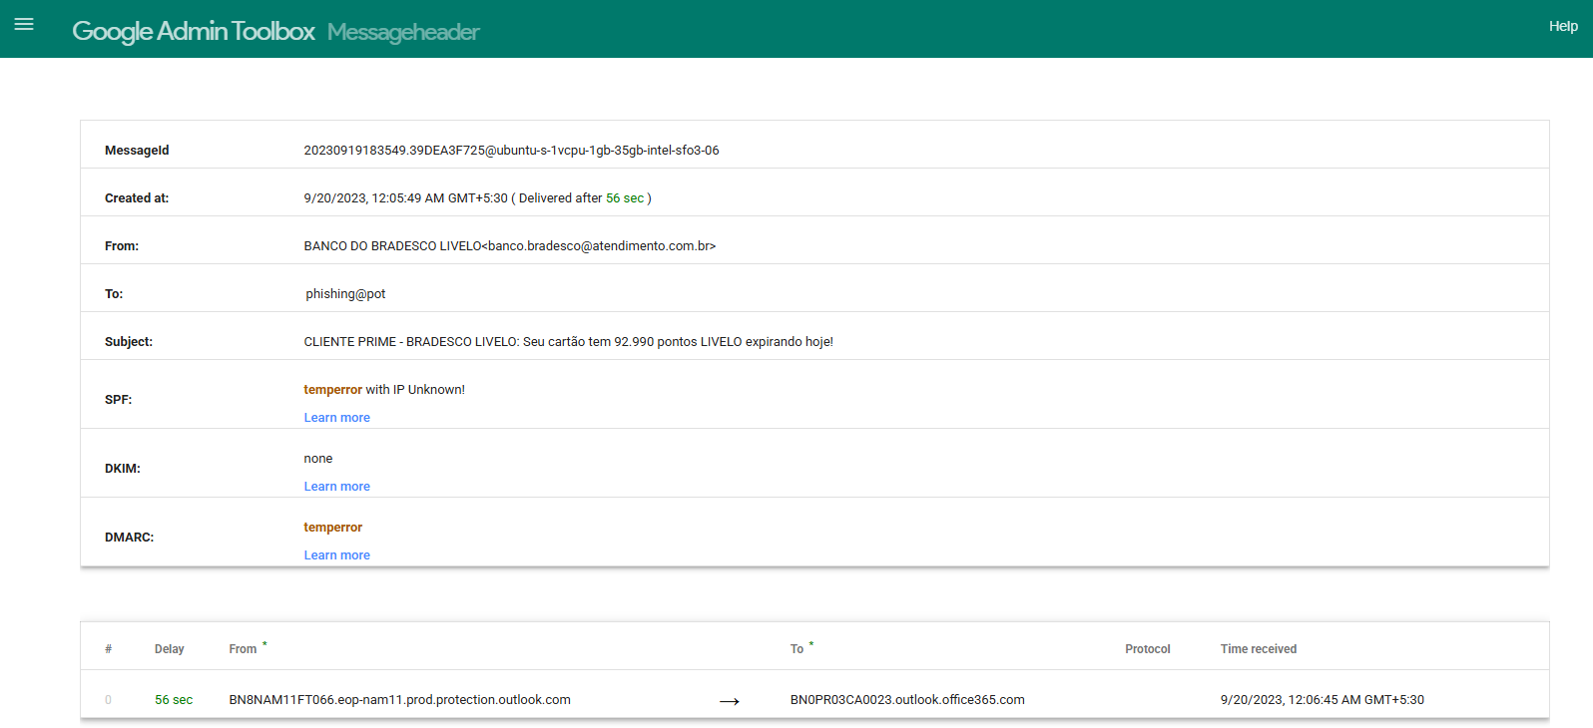
Figure 1: Google Admin Toolbox Messageheader output for Email 1 (file: evidence/email1_bradesco_header.png)
5.2 Email 2: Fake Microsoft "unusual sign-in" alert
CLASSIFICATION | PHISHING | Risk level: High

A message posing as the Microsoft account team, claiming there was unusual sign-in activity on the recipient's account.

Header findings
Field | Observed value | Analyst assessment
From | Microsoft account team <no-reply@access-accsecurity.com> | "access-accsecurity.com" is not a Microsoft domain. It is a look-alike built from security-sounding words. The display name also contains stray characters.
Subject | "Microsoft account unusual signin activity" | Fear-based, and worded awkwardly. Real notices use consistent, polished wording.
Date | 8 Sep 2023, 11:17:04 AM (GMT+5:30) | Delivered instantly; no delay data.
SPF | none | The sending domain publishes no sender rules.
DKIM | none | No digital signature.
DMARC | permerror | The domain's DMARC record is invalid or broken (a permanent error). A genuine large brand would not have this.
Received path | Only Microsoft Exchange Online Protection hops | Shows the mail simply passed through Microsoft's filtering service. That does not mean Microsoft sent it.

Phishing indicators identified
- Look-alike sender domain that is not owned by Microsoft.
- Fear-based subject about a "security problem" with the account.
- SPF none, DKIM none, DMARC permerror.
- "no-reply" address with a display name imitating an official team.
- Classic credential-harvesting theme.

How the attack works (plain language)
The email claims someone signed in from an unfamiliar place and urges the reader to "review activity" or "secure the account". The button leads to a fake Microsoft sign-in page. When the victim types their email and password, the attacker captures them, logs into the real account, reads the mailbox and often sends further phishing emails to the victim's contacts.

Evidence
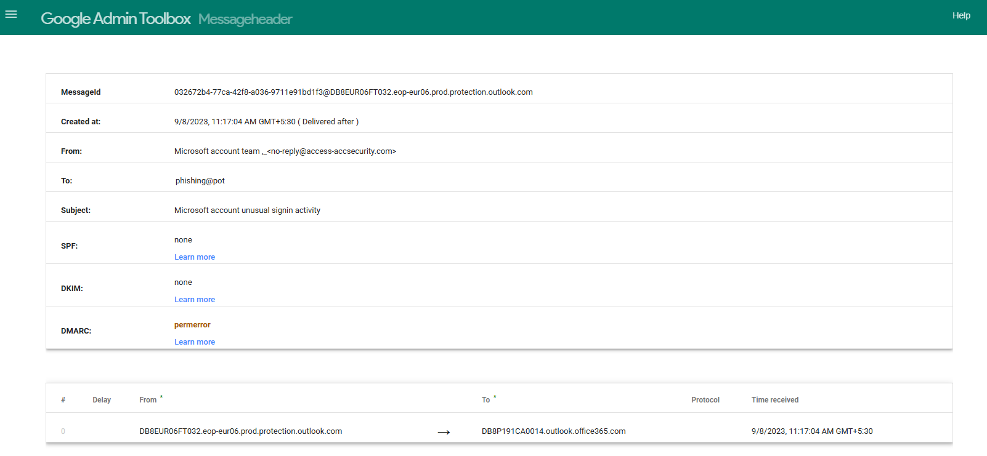
Figure 2: Google Admin Toolbox Messageheader output for Email 2 (file: evidence/email2_microsoft_header.png)
5.3 Email 3: Unsolicited solar-panel offer
CLASSIFICATION | SUSPICIOUS | Risk level: Medium

A Dutch-language advert ("Solar panels for a good price") sent from an unrelated French domain.

Header findings
Field | Observed value | Analyst assessment
From | "Zonnepanelen installateur" <zonnepaneel@appjj.serenitepure.fr> | The name says "solar panel installer" (Dutch), but the address is a French sub-domain of an unrelated-looking site (serenitepure.fr). This suggests a hijacked or throwaway domain.
Subject | "Zonnepanelen voor een goede prijs" (starts with an emoji) | Cheap-offer bait typical of bulk spam.
Date | 3 Nov 2022, 10:26:15 AM (GMT+5:30) | No delivery delay recorded.
SPF | none | No sender verification.
DKIM | none | No digital signature.
DMARC | none | No domain policy, so anyone could send as this domain.
Message-ID | 0.0.0.0.1D8EF...@dturm.de | Created by a German domain that does not match the sender domain. The mail did not originate from the system it claims.

Phishing indicators identified
- Unsolicited commercial email sent to a recipient who never requested it.
- Sender name, sender domain and message-generating domain all point to different places.
- All three authentication checks (SPF, DKIM, DMARC) are missing.
- Too-good-to-be-true pricing used as bait.

How the attack works (plain language)
This is mostly mass-marketing spam, but it carries real risk. The link inside may lead to a form that harvests personal details, to a fake quote page, or to a site that pushes malware. Even opening or replying tells the sender that the address is active, which leads to more junk. Because the headers alone do not prove a credential-theft attempt, it is rated Suspicious rather than Phishing.

Evidence
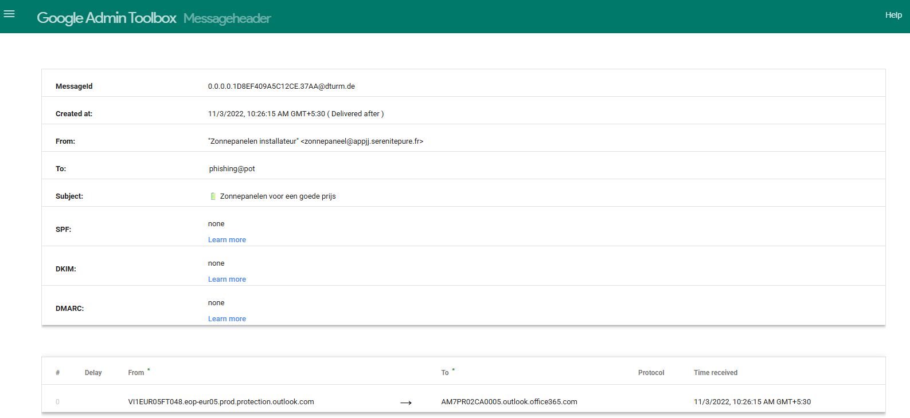
Figure 3: Google Admin Toolbox Messageheader output for Email 3 (file: evidence/email3_solar_header.png)
5.4 Email 4: "Donation for you" advance-fee scam
CLASSIFICATION | PHISHING | Risk level: High

A mass-mailed message offering a "donation", sent under a personal name that does not match the sending address.

Header findings
Field | Observed value | Analyst assessment
From | "Philip Fredrick" <ghulammustafa@cyber.net.pk> | The name on display does not match the person in the address. The tool also shows the message was written in "Microsoft Outlook Express 6.00", an obsolete program from the early 2000s.
To | Undisclosed recipients | The message was sent in bulk to many people at once. It was not written for you.
Subject | "86RE: Donation For You" | Junk characters and a fake "RE:" make it look like a reply to an earlier conversation that never happened. "Free money" is the bait.
SPF | softfail (IP unknown) | The sending server was not authorised by the domain, but was not fully blocked.
DKIM | none | No digital signature.
DMARC | fail | Explicit failure: the message does not align with the sender domain.
Timing | Date header says 7:57:50 AM; received 12:57:40 AM (delivery shown as -6 hours) | A message cannot arrive before it was written. The Date header is forged or the sending clock is wrong.
First hop | from "unknown" to mail.mail04.zhanlingol.com (SMTP) | The originating server is unidentified and unrelated to the sender domain.

Phishing indicators identified
- Display name and email address do not match.
- Bulk "undisclosed recipients" delivery.
- Fake "RE:" subject prefix and an offer of free money.
- SPF softfail and DMARC fail.
- Impossible timestamp and an unidentified originating server.
- Very old email software named in the headers.

How the attack works (plain language)
This is an advance-fee (or "donation") scam. The attacker promises a large gift, prize or inheritance and waits for a reply. Once the victim responds, the attacker asks for personal details, a copy of an ID, bank information, or a "small fee" to release the money. The money never exists; the victim loses whatever they send and may become a target for identity theft.

Evidence
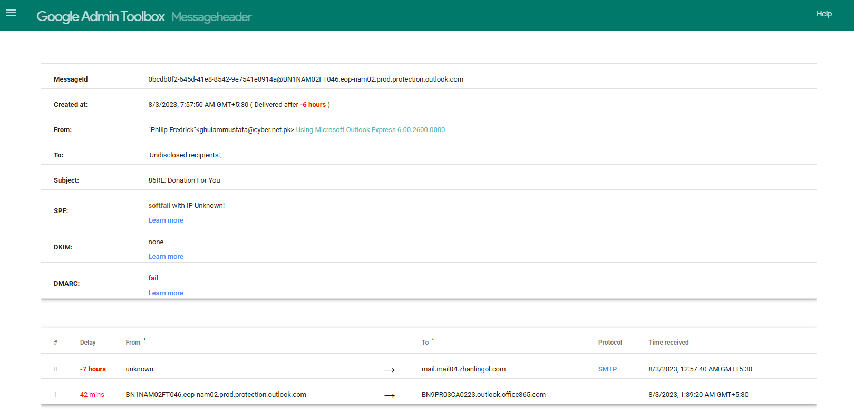
Figure 4: Google Admin Toolbox Messageheader output for Email 4 (file: evidence/email4_donation_header.png)
5.5 Email 5: Google Community Team newsletter (own mailbox)
CLASSIFICATION | SAFE | Risk level: Low

A legitimate Google marketing tip received in the analyst's own inbox, used as a comparison ("known good") example.

Header findings
Field | Observed value | Analyst assessment
From | Google Community Team <googlecommunityteam-noreply@google.com> | Sender address is on google.com, and the name matches the organisation.
To | Analyst's own address (redacted) | Sent to the real account holder.
Subject | "Business Tip: Show up on Google Search and Maps" | Informational tone. No threat, no deadline, no request for credentials.
Date | 16 Mar 2026, 3:32:50 PM (GMT+5:30), delivered after 1 sec | Normal delivery.
SPF | pass (IP 209.85.220.69) | The sending server is authorised by google.com.
DKIM | pass (domain google.com) | A valid digital signature confirms the message was not altered.
DMARC | pass | The sender domain, SPF and DKIM all line up.
Received path | mail-sor-f69.google.com to mx.google.com, then Google servers | Every hop is a Google server. There are no unknown relays.

Why it is considered safe
- All three authentication checks pass and agree with the visible sender domain.
- Entire delivery path stays inside Google's own infrastructure.
- Content is informational: no urgency, threats or requests for passwords.

How the attack works (plain language)
Nothing malicious here. This email is included so readers can see what a healthy header looks like: the sender is who they claim to be, the message was signed, and it travelled through the expected servers. Note that "safe" describes the sender and route. It is still good practice to hover over links before clicking any email, even a genuine one.

Evidence
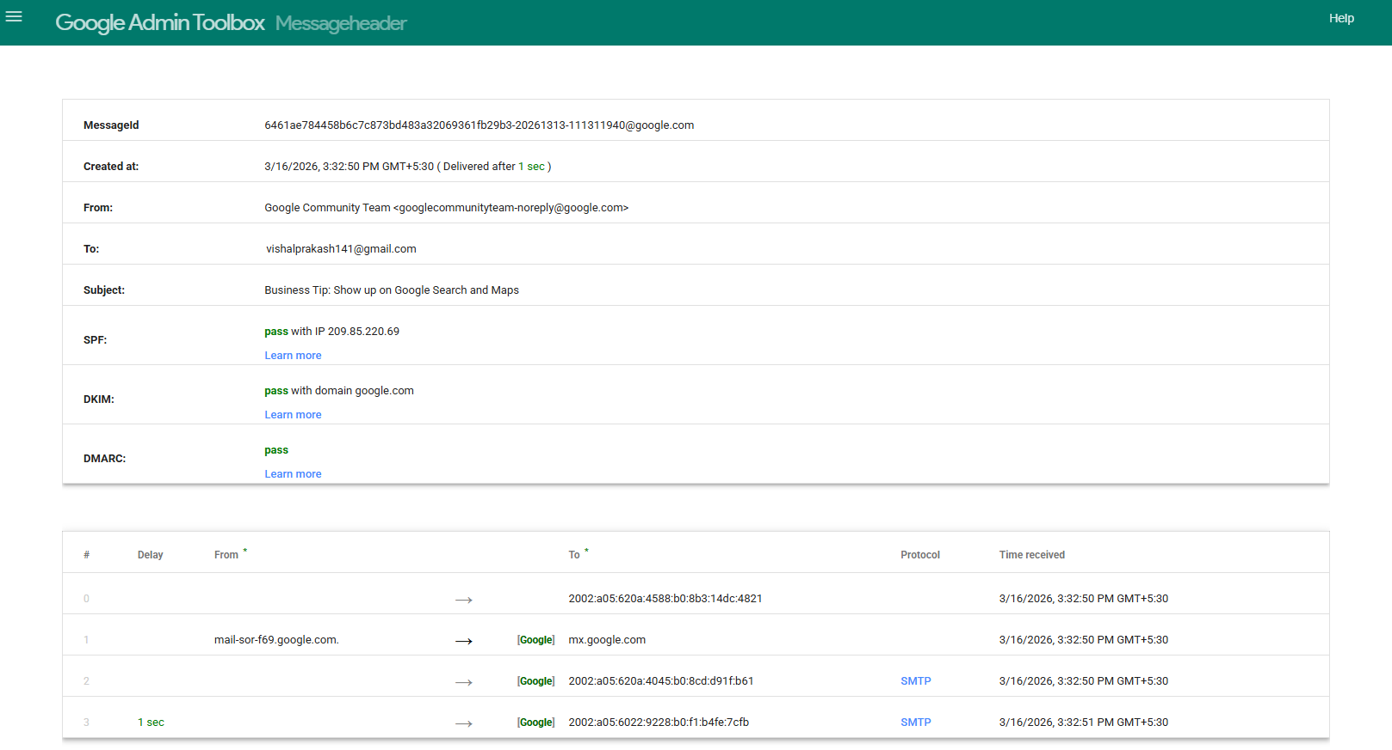
Figure 5: Google Admin Toolbox Messageheader output for Email 5 (file: evidence/email5_google_safe_header.png)

6. Indicator Comparison Across All Emails
Indicator | Email 1 | Email 2 | Email 3 | Email 4 | Email 5
Sender domain unrelated to claimed brand / name | Yes | Yes | Yes | Yes | No
Urgency, fear or reward bait | Yes | Yes | Price bait | Yes | No
SPF | temperror | none | none | softfail | pass
DKIM | none | none | none | none | pass
DMARC | temperror | permerror | none | fail | pass
Sending server does not match sender | Yes | Not seen | Yes | Yes | No
Timestamp anomaly | No | No | No | Yes | No
Bulk / undisclosed recipients | Not seen | Not seen | Not seen | Yes | No
Final classification | Phishing | Phishing | Suspicious | Phishing | Safe

Pattern: the safe email is the only one where the visible sender, the authentication results and the delivery route all agree with each other. Every risky email shows at least one mismatch between what the email claims to be and what its technical details reveal.

7. Anatomy of a Typical Phishing Email
The example below is the standard training sample used in this task. It contains the four most common red flags. Note that the web address is written in "defanged" form ([.]) so it cannot be clicked by accident.

Email content | Red flag
Subject: Urgent: Your Account Will Be Locked | Urgency and fear. Designed to make you react before you think.
Sender: "Security Team" from an unfamiliar or look-alike domain | Fake or suspicious sender domain.
"Dear User, we noticed suspicious activity on your account." | Generic greeting. A real provider usually uses your name.
"Verify Now: http://secure-account-verify[.]com" | Suspicious link. The domain is not the real company's domain.
"Failure to verify within 24 hours will result in permanent account lock." | Threat with a deadline, a hallmark of social engineering.

How a phishing attack unfolds
- Bait: the attacker sends a convincing email (bank alert, account warning, prize or offer).
- Pressure: urgency, fear or greed pushes the victim to act fast.
- Hook: the victim clicks a link, opens a file, or replies.
- Capture: a fake page steals the password or OTP, a file installs malware, or a reply leads to a scam.
- Abuse: the attacker uses the stolen access to take money, steal data, or send more phishing from the victim's account.

8. Prevention Guidelines

8.1 The S.T.O.P. check
Before you click, reply or open anything, run this quick four-step check:
Step | Ask yourself
Sender | Does the address really belong to the organisation? Look at the domain after the @, not just the display name.
Tone | Is it rushing me, scaring me, or promising a reward? Real organisations rarely do this.
Offer / link | Where does the link really go? Hover to preview it. Is anything asking for a password, OTP or payment?
Proof | Can I confirm it another way? Open the official website or app yourself, or call a number you already know.

8.2 Practical tips for everyone
- Type the website address yourself or use a saved bookmark instead of clicking email links.
- Never share passwords, OTPs, PINs or card details by email, chat or phone call that you did not start.
- Turn on multi-factor authentication (MFA) for email and banking so a stolen password is not enough.
- Be extra careful with unexpected attachments, especially .zip, .html, .exe, and Office files asking to "enable macros".
- Treat "unusual sign-in", "account suspended" and "reward expiring" messages as suspicious until verified.
- Keep your browser, operating system and antivirus up to date.
- Use a password manager. It will not auto-fill on a fake look-alike site, which is an early warning.
- When unsure, ask. Reporting a false alarm costs nothing; a real attack can cost a lot.

8.3 Guidance for organisations
- Enforce SPF, DKIM and DMARC on the company's own domains to stop others from spoofing them.
- Enable email filtering that flags external senders and look-alike domains.
- Run regular phishing simulations and short awareness sessions.
- Provide a one-click "Report phishing" button or a clear mailbox (for example, security@company).
- Have a written incident process for people who click by mistake, and reward reporting instead of blaming.

9. Do's and Don'ts for Employees
DO | DON'T
Check the sender's full email address and domain | Don't click links or buttons in unexpected emails
Hover over links to preview the real destination | Don't open unexpected attachments
Go to the official website or app directly | Don't enter your password on a page you reached from an email
Report suspicious emails to IT/security | Don't share OTPs, PINs or passwords with anyone
Use MFA and a unique password for each account | Don't reply to unknown senders or "prize / donation" offers
Slow down when an email says "urgent" | Don't let a deadline or threat rush you
Verify money or data requests by phone using a known number | Don't forward suspicious emails to colleagues (report them instead)
Delete confirmed phishing after reporting it | Don't assume an email is safe because it uses a logo or a familiar name

If you already clicked or replied
- Disconnect from the network if you opened a file, and tell IT immediately.
- Change the password of the affected account (and any account that shares it) from a clean device.
- Report the email and what you did. Speed matters far more than embarrassment.
- Watch your accounts for unfamiliar sign-ins or transactions; contact your bank if financial details were shared.

10. Conclusion
The analysis shows that phishing emails can usually be told apart from legitimate mail by comparing three things: who the email says it is from, what the technical headers prove, and what the message is asking the reader to do. The safe reference email lined up on all three. Each phishing email broke at least one, and most broke several.
Technology such as SPF, DKIM and DMARC catches many attacks, but the last line of defence is always a person who pauses, checks and reports. The S.T.O.P. check and the Do's and Don'ts in this report are designed to be shared with staff as a one-page reminder.

Appendix A: Evidence Index
Email | Evidence file (in /evidence) | Source
Email 1 | email1_bradesco_header.png | phishing_pot sample
Email 2 | email2_microsoft_header.png | phishing_pot sample
Email 3 | email3_solar_header.png | phishing_pot sample
Email 4 | email4_donation_header.png | phishing_pot sample
Email 5 | email5_google_safe_header.png | Analyst's own mailbox (address redacted)
Samples list | sample_files_list.png | Screenshot of saved .eml files used

Appendix B: References (study only)
- phishing_pot – real phishing email samples: github.com/rf-peixoto/phishing_pot
- Google Admin Toolbox Messageheader: toolbox.googleapps.com/apps/messageheader
- MXToolbox Email Headers: mxtoolbox.com/EmailHeaders.aspx
- autinerd/phishing-mail-examples, sadat1971/Phishing_Email, Phishing-Database/Phishing.Database (learning references)
All sample emails are third-party material used for education. No content from the reference repositories has been reproduced or claimed as original work beyond the analysis and writing in this report.

