Used Car Price Prediction
Full-Stack Machine Learning Application
Project Report
Backend | Frontend | ML Model
Flask 3.0 (Python) | Streamlit | Linear Regression scikit-learn

1. Project Overview
This project is a full-stack machine learning application that predicts used car selling prices based on vehicle attributes: age, kilometers driven, fuel type, seller type, transmission, and ownership history. The application follows a client-server architecture where a Flask REST API serves predictions from a trained scikit-learn model, and a Streamlit frontend provides an interactive, browser-based user interface.

1.1 Objectives
- Train a Linear Regression model on the Kaggle "Vehicle dataset from Cardekho" dataset.
- Expose predictions via a RESTful API using Flask.
- Build an interactive frontend using Streamlit with charts and analytics.
- Provide dataset exploration and model insight visualisations.

1.2 Technology Stack
Layer | Technology | Purpose
ML Training | scikit-learn, numpy, pandas | Model training, encoding, scaling, data handling
Model Persistence | joblib | Save and load the trained pipeline
Backend API | Flask 3.0 | REST endpoints for predictions
Frontend UI | Streamlit | Interactive Python-native web app
Visualisation | Plotly, matplotlib, seaborn | Charts in UI and diagnostics plot
HTTP Client | requests | Frontend calls backend API

2. Project Structure
File / Folder | Description
car_price_project/ | Project root
data/car_data.csv | 4,340 records: name, year, selling_price, km_driven, fuel, seller_type, transmission, owner
model/model.pkl | Trained scikit-learn Pipeline (preprocessor + LinearRegression)
model/metrics.json | Saved evaluation metrics
model/diagnostics.png | Actual vs Predicted plot
backend/app.py | Flask REST API (port 5000)
frontend/ui.py | Streamlit frontend (port 8501)
train_model.py | Training script — runs the full model pipeline
requirements.txt | All Python dependencies
README.md | Run instructions

3. Dataset
Dataset: Vehicle dataset from Cardekho (Kaggle)
Source: https://www.kaggle.com/datasets/nehalbirla/vehicle-dataset-from-cardekho
The dataset contains 4,340 used car listings scraped from CarDekho, with columns for name, year, selling_price, km_driven, fuel, seller_type, transmission, and owner. After removing duplicates and missing values, a car_age feature was engineered (2024 minus year of manufacture).

3.1 Dataset Statistics
Statistic | year | selling_price (INR) | km_driven
count | 4,340 | 4,340 | 4,340
mean | 2013.09 | 504,127.30 | 66,215.78
std | 4.22 | 578,548.70 | 46,644.10
min | 1992 | 20,000 | 1
25% | 2011 | 208,749.80 | 35,000
50% | 2014 | 350,000 | 60,000
75% | 2016 | 600,000 | 90,000
max | 2020 | 8,900,000 | 806,599

3.2 Sample Records
Name | Year | Selling Price | KM Driven | Fuel | Transmission
Maruti 800 AC | 2007 | ₹60,000 | 70,000 | Petrol | Manual
Maruti Wagon R LXI Minor | 2007 | ₹135,000 | 50,000 | Petrol | Manual
Hyundai Verna 1.6 SX | 2012 | ₹600,000 | 100,000 | Diesel | Manual
Datsun RediGO T Option | 2017 | ₹250,000 | 46,000 | Petrol | Manual
Honda Amaze VX i-DTEC | 2014 | ₹450,000 | 141,000 | Diesel | Manual
Maruti Alto LX BSIII | 2007 | ₹140,000 | 125,000 | Petrol | Manual
Hyundai Xcent 1.2 Kappa S | 2016 | ₹550,000 | 25,000 | Petrol | Manual
Tata Indigo Grand Petrol | 2014 | ₹240,000 | 60,000 | Petrol | Manual

4. Machine Learning Model
A Linear Regression model was trained using scikit-learn inside a single Pipeline. Numeric features (car_age, km_driven) were standardised with StandardScaler; categorical features (fuel, seller_type, transmission, owner) were one-hot encoded with the first category of each dropped to avoid multicollinearity. An 80/20 train-test split was used with random_state=42 for reproducibility.

4.1 Model Pipeline
- Load CSV -> pandas DataFrame, drop duplicates and missing rows
- Feature engineering: car_age = 2024 - year
- Feature/target split: car_age, km_driven, fuel, seller_type, transmission, owner -> X; selling_price -> y
- Train/test split: 80% train / 20% test (random_state=42)
- Preprocessing: ColumnTransformer(StandardScaler on numeric, OneHotEncoder(drop='first') on categorical)
- Model fitting: LinearRegression() inside the same Pipeline
- Evaluation: MAE, RMSE, R2 on test set
- Persistence: joblib.dump(model) — preprocessor and regressor saved together

4.2 Model Equation
The fitted pipeline has 12 input features after encoding (2 scaled numeric + 10 one-hot categorical columns), with baseline categories fuel=CNG, seller_type=Dealer, transmission=Automatic, owner=First Owner (dropped by OneHotEncoder):
Price = 1,091,303.16
+ (-142,916.56) × car_age_scaled
+ (-33,519.81) × km_driven_scaled
+ 266,645.99 × fuel_Diesel + 33,801.72 × fuel_LPG + 8,570.74 × fuel_Petrol
+ (-36,680.13) × seller_Individual + 83,598.60 × seller_TrustmarkDealer
+ (-779,405.87) × transmission_Manual
+ (-34,084.46) × owner_Fourth&Above + (-48,348.25) × owner_Second
+ 235,305.15 × owner_TestDrive + (-59,729.01) × owner_Third
Transmission has the single largest effect in magnitude: holding everything else constant, a Manual transmission is associated with a ₹779,405.87 lower predicted price than Automatic — consistent with Automatic cars in this dataset skewing toward newer, higher-end listings.

4.3 Evaluation Metrics
Metric | Value | Interpretation
R2 Score | 0.3927 | Proportion of variance explained (0-1, higher is better)
MAE | ₹213,071.18 | Average absolute prediction error in INR
RMSE | ₹442,304.97 | Root mean squared error, penalises large errors
Note: An R2 of 0.39 is modest for Linear Regression on this dataset. The model deliberately excludes brand/model (a strong price driver) and present_price (which would leak most of the answer, since it is close to the original showroom price). RMSE (₹442,305) is notably larger than MAE (₹213,071), indicating a small number of high-value luxury listings pull the error up — visible as the outlier point near ₹8M in the price distribution and scatter charts below.

5. Backend API (Flask)
The Flask backend runs on port 5000 and exposes four REST endpoints. The frontend communicates with these endpoints using HTTP requests.
Method | Endpoint | Description
GET | /health | Health check — confirms API is live
POST | /predict | Predict selling price from car attributes JSON body
GET | /dataset | Return dataset records as JSON
GET | /model_info | Return model metrics and feature list

5.1 Sample API Call — /predict
Request (POST /predict):
{ "year": 2018, "km_driven": 45000, "fuel": "Petrol", "seller_type": "Individual", "transmission": "Manual", "owner": "First Owner" }
Response:
{
"predicted_selling_price": 585,153.00,
"currency": "INR"
}

6. Frontend UI Output (Streamlit)
The Streamlit frontend runs on port 8501 and consists of three navigable pages, all communicating with the Flask backend API in real time.

6.1 Page 2 — Dataset Explorer
The Dataset Explorer page fetches records from the /dataset endpoint and displays them as interactive charts.
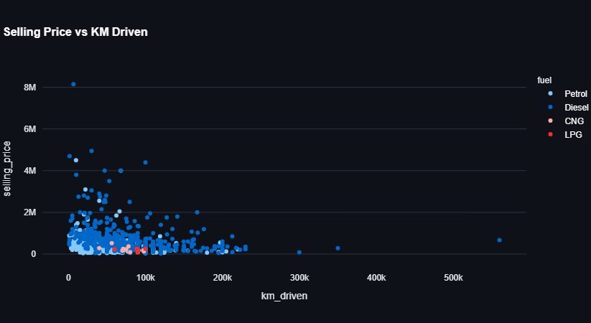
Selling price vs. kilometers driven, coloured by fuel type — price falls as mileage rises, with Diesel and Petrol dominating the listings.
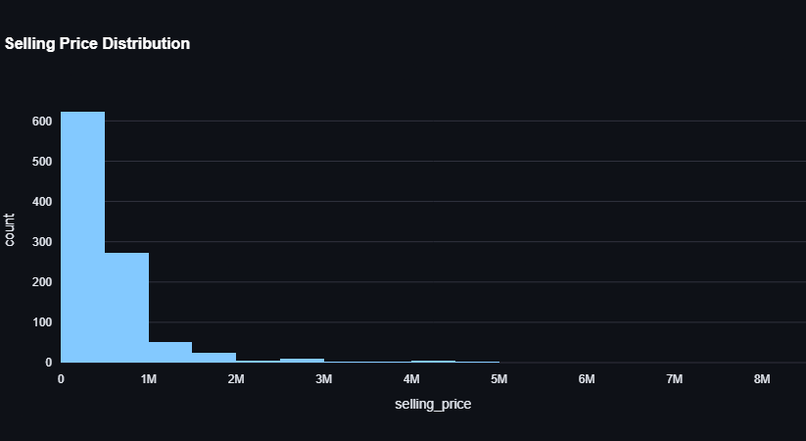
Selling price distribution — heavily right-skewed, with most cars under ₹1M and a long tail of premium listings.
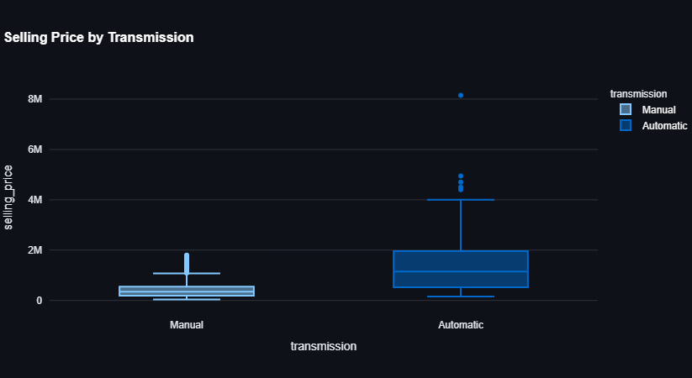
Selling price by transmission — Automatic cars command a visibly higher median price and wider spread than Manual.
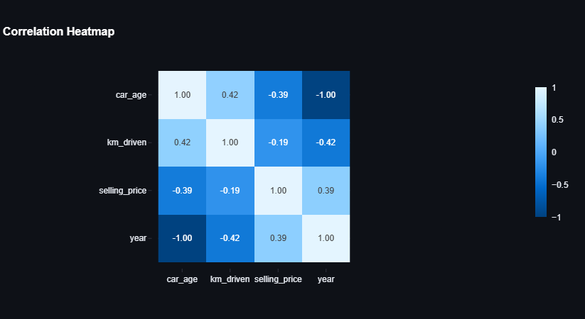
Correlation heatmap — car_age is negatively correlated with selling_price (-0.39), confirming depreciation is a key driver.

6.2 Page 3 — Model Insights
The Model Insights page fetches /model_info and displays R2, MAE, and RMSE metric cards along with a price-vs-age trendline.
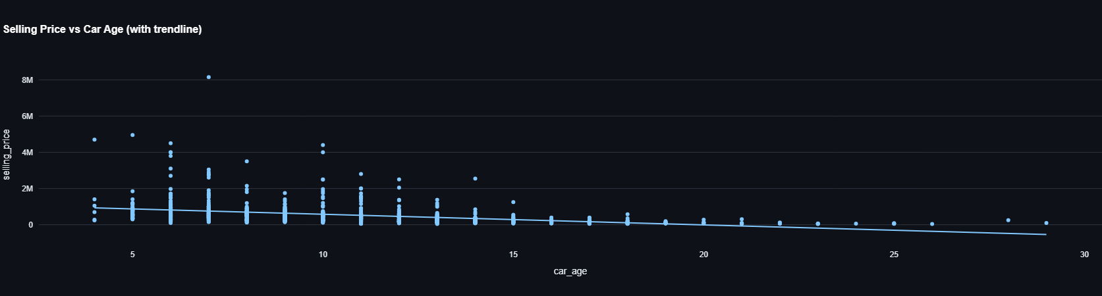
Selling price vs. car age with an OLS trendline — price declines steadily with age, flattening out after roughly 15 years.

7. Sample Prediction Results
The following table shows model predictions for a range of car configurations, computed from the fitted coefficients above:
Age (yrs) | KM Driven | Fuel | Transmission | Owner | Predicted Price (INR)
3 | 20,000 | Petrol | Manual | First Owner | ₹585,153
5 | 45,000 | Diesel | Manual | First Owner | ₹757,455
7 | 70,000 | Petrol | Manual | Second Owner | ₹401,938
10 | 100,000 | Diesel | Manual | Second Owner | ₹500,063
12 | 120,000 | Petrol | Manual | Third Owner | ₹148,426
15 | 150,000 | Diesel | Automatic | First Owner | ₹1,242,645
9 | 90,000 | Petrol | Manual | Fourth & Above | ₹297,341
2 | 15,000 | Petrol | Automatic | First Owner | ₹1,438,736

8. How to Run the Project
Step 1: Install Dependencies
pip install -r requirements.txt
Step 2: Train the Model
python train_model.py
Step 3: Start Flask Backend (Terminal 1)
python backend/app.py # runs on http://localhost:5000
Step 4: Launch Streamlit Frontend (Terminal 2)
streamlit run frontend/ui.py # opens http://localhost:8501

Used Car Price Prediction Project — Vishal Rajbhar

