**ABBREVIATIONS AND ACRONYMS**

|  |  |  |
| --- | --- | --- |
| CdTe | - | Cadmium Telluride |
| CIGS | - | Copper Indium Gallium (di)Selenide |
| CSP | - | Concentrated Solar Power |
| DC | - | Direct Current |
| EMF | - | Electromotive Force |
| I | - | Current |
| I/O | - | Input/Output |
| ICSP | - | In-Circuit Serial Programming |
| IDE | - | Integrated Development Environment |
| LCD | - | Liquid Crystal Display |
| LDR | - | Light Dependent Resistor |
| LUX | - | Luminous Flux |
| MCU | - | Microcontroller |
| MPPT | - | Maximum Power Point Tracking |
| PV | - | Photovoltaic |
| R | - | Resistor |
| RPM | - | Rotations per Minute |
| USB | - | Universal Serial Bus |
| V | - | Voltage |

|  |  |  |
| --- | --- | --- |
|  | **LIST OF FIGURES** |  |
| Figure No. | Figure Name |  |
| Figure 2.3 | Concept of Using Two LDR |  |
| Figure 3.1 | Earth Rotation |  |
| Figure 3.2 | Earth Rotation and Revolution |  |
| Figure 3.3 | Angle of elevation and zenith angle |  |
| Figure 3.4 | Single Axis Tracker |  |
| Figure 3.5 | Dual Axis Tracker |  |
| Figure 3.6 | Fixed collector |  |
| Figure 3.7 | Sun path diagram for Calcutta |  |
| Figure 3.8 | Conversions taking place inside the Solar charge controller |  |
| Figure 4.1 | Solar Panel |  |
| Figure 4.2 | Aurdino UNO ATMega 328 Micro-controller |  |
| Figure 4.3 | Photosensitive Resistors |  |
| Figure 4.4 | Servomotor |  |
| Figure 4.5 | Block Diagram of Aurdino Based Solar Tracking System |  |
| Figure 4.6 | Single Axis Tracker Pin Diagram |  |
| Figure 4.7 | Dual Axis Tracker Pin Diagram |  |

|  |  |  |
| --- | --- | --- |
|  | **LIST OF TABLES** |  |
| Table No. | Table Name |  |
| Table 1.1 | Types of Solar cell based on the material |  |
| Table 3.1 | Types of Solar Tracker |  |
| Table 5.1 | PV array outputs for bright sunny day on 4th December 2021 |  |
| Table 5.2 | LDR output for cloudy day on 7th December 2021 |  |
| Table 5.3 | LDR output for bright sunny day on 2nd December 2021 |  |

**TABLE OF CONTENTS**

Content

**ACKNOWLEDGEMENT**

**CERTIFICATE OF APPROVAL**

**RECOMMENDATION**

**ABBREVIATIONS AND ACRONYMS**

**LIST OF FIGURES**

**LIST OF TABLES**

**ABSTRACT**

**CHAPTER 1: INTRODUCTION**

1.1 Introduction

2.2 Literature Review

**CHAPTER 2: METHODOLOGY**

2.1 Theory of using Two LDR

2.2 Research Design

### CHAPTER 3: THEORITICAL BACKGROUND OF SOLAR TRACKER

|  |  |  |
| --- | --- | --- |
| 3.1 The Earth: Rotation and Revolution |  | |
| 3.2 Types of Tracker |  | |
| 3.3 Fixed Collector |  | |
| 3.4 Maximum Power Point Tracking |  | |
| 3.5 Advantages & Pitfalls of Solar Energy |  | |
| 3.5.1 Advantages |  | |
| 3.5.2 Pitfalls |  | |
| **CHAPTER 4: HARDWARE PROTOTYPE** |  | |
| 4.1 Solar Panel |  | |
| 4.2 Aurdino UNO Microcontroller |  | |
| 4.3 Light Dependent Resistors |  | |
| 4.4 Servomotor |  | |
| 4.5 System Interface | |  |
| 4.6 User interface | |  |
| 4.7 Operation | |  |
| 4.8 Algorithm | |  |
| 4.9 Flowchart | |  |

### CHAPTER 5: EXPERIMENTAL RESULTS & ANALYSIS

5.1 Experimental Result

5.2 Analysis

### CHAPTER 6: CONCLUSION, FUTURE SCOPE

6.1 Conclusion

6.2 Future Scope

### 

**Abstract**

Of all the renewable energies, solar energy is the only energy gained its popularity and importance quickly. Through the solar tracking system, we can produce an abundant amount of energy which makes the solar panel’s workability much more efficient. Perpendicular proportionality of the solar panel with the sun rays is the reason lying behind its efficiency. Pecuniary, its installation charge is high provided cheaper options are also available. This project is discussed all about the design and construction mechanism of the prototype for the solar tracking system having a single axis of freedom.

The main control circuit is based upon NodeMcu microcontroller. Programming of this device is done in the manner that the LDR sensor, in accordance with the detection of the sun rays, will provide direction to the DC Motor that in which way the solar panel is going to revolve. Through this, the solar panel is positioned in such a manner that the maximum amount of sun rays could be received. In comparison with the other motors, DC motor is the simplest and the suave one, the torque of which is high and speed of which is slow enough. We can program it for changing the direction notwithstanding the fact that it rotates only in one direction subject to exception as far as programming is concerned. 1985, first time ever it was witnessed for production of the silicon solar cells with an efficiency of 20%. Though a hike in the efficiency of the solar panel had a handsome increase still perfection was a far-fetched goal for it. Below 40%, most of the panels still hover to operate. Consequently, peoples are compelled to purchase a number of panels in order to meet their energy demands or purchase single systems with large outputs. Availability of the solar cells types with higher efficiencies is on provided they are too costly to purchase. Ways to be accessed for increasing solar panel efficiencies are a plethora in number still one of the ways to be availed for accomplishing the said purpose while reducing costs, is tracking. Tracking helps in the wider projection of the panel to the Sun with increased power output. It could be dual or single axis tracker.

Duality ragged up with better compatibility as far as tracking of the sunlight from both the axis is concerned. But,Commercially single tracker is cheaper to use.

## CHAPTER 1: INTRODUCTION

### GENERAL BACKGROUND

Bustling civilization is the vein through which modern civilization is operated. Energy day by day is put to use at its best to fulfil the desires and ambition of the peoples at large. Each and every corner of our life is caged with various layers of impediment and in this response, energy is becoming an indispensable factor. Therefore, the source of energy needs to be endless/ perpetual in order to carry this colossal population ahead. Human beings being evolutionary in nature are perhaps the best ever creation of nature is always in the race of envisaging the probable and available comforts and benefits in every possible angle in this perilous world. The evidential matrix manifests that in a dichotomy of various opinions what options best expedite the scarcity of energy in an immensely heterogeneous society like ours. Our motto is to endeavour in forwarding such noble goal of energy conservation.

Taking a look at the present scenario it is evident that conventional sources of energy such as coal, natural gas, oil, etc. are at the edge of extinction. Being in mortal combat with time itself to fulfil every demand for energy the demand for these resources for energy has escalated to its zenith. The conventional use of energies due to the burning of fossil fuels like coal, oil and natural gas, the whole environment is getting polluted. The present project, therefore, is orchestrated with components like LDR module, DC Motor, Photovoltaic array etc. according to which while the functioning of, unlike other use of the conventional energies, would not emit any pollution and in turn act as a reservoir of energy taken from the Sun itself. As adumbrated no other energy is more abundant than solar energy as per as its availability and freeness are concerned, utilization of which, compounded with rest of the fact of its conversion into electrical energy. Historically if counted, in the year 1881 for the first time ever solar panel was invented. Later on, all through the hands of Russell Ohl in the year, 1941 concept of the solar cell was conceived and subsequently workability of a solar panel has also advanced in comparison with the earlier span. Though it is improbable still it is not impossible as per as tracking of the mother energy is concerned in furtherance to which attempt has been taken through this project to confine every drop of energy from being left out. The DC Motor adjacent with the system with the help of LDR module by measuring the intensity of the sun rays fixed on the upper edge of the solar panel will help the solar panel to revolve around proportionately with the movement of the Sun itself in order to grab and store the maximum amount of energy as it can. In pursuance of such objectivity, this project comes forth into existence.

When heat is the source of every creation, Sun produces the biggest ever energy in this solar system to produce and transcend life from one organism to the other. In this response, the project called "Automatic Solar Tracking System" serves the purpose of utilizing the maximum amount of energy taken from the Sun and to convert such energy into some other production. The basic endeavour is crooned to scoop out from this project in making this system an economically convenient subject, accessibility of which is easy and functioning of which is optimum in the end. In the wake of technological advancement when the pace of time is at its best to pass by, this system is a time worthy production, produced to create the best of its kind. In a stretch, it could be signified that this project which is an extension of solar energy, is a renewable source of energy, never-ending phenomena. It's only 10 to 20 per cent of the solar cells that are being used commercially out of which the best potential of the cells gets reflected and therefore scope for better use of the solar cells exist.

In the world of pollution, this system is an eco-friendly alternative, hence a valuable asset. When the ocean of pollution is encumbering every corner of life, this system would be able to create ripples of hope in the midst of this bustling civilization. The survivability of this system lies upon its workability. In the trend of comparison with other mind-boggling systems, it could be a trailblazer.

### LITERATURE REVIEW

The paucity of available resources has forced contemporary society to look for measures to consummate the demands of the latter. With the nurturing civilization, the depletion of conventional fuels, due to human practices has been an alarm to sustainable development issues. The scarcity of energy and its source guided us towards the optimistic approach of using the alternative resources bestowed to humankind–Solar, tidal etc.

The Sun has been looked upon as an imperative source of energy. Solar energy is an eco-friendly resource as compared to its counterparts. The advancement of technology has out-turn foster techniques to utilize this energy into its own good use. Be it as thermal energy, electricity, fuel production and many more. Photovoltaic or concentrated solar power (CSP) systems are operated to transfigure the solar power expropriated by the earth into electricity. Solar tracking device utilizes this expropriated solar power through the channel of photovoltaic arrays, an oriented scaffolding of photovoltaic/solar cells.[1]

**Solar cells**, also known as photovoltaic cells are used to convert light energy into electricity. Photovoltaic cells work on the principle of the photovoltaic effect, which is similar to the photoelectric effect. Differences being that the electrons in photovoltaic are not emitted instead contained in the material around the surface, creating a voltage difference. Solar cells are forged with crystalline silicon. It is the most commonly used material in a solar cell. The use of silicon in the solar cell has been very efficient and low cost. Two forms of crystalline silicon can be used to make solar cells. Other than silicon, solar cells can be fabricated with cadmium telluride (CdTe), Copper indium gallium (di)selenide (CIGS) etc. the fabrication of solar cells with materials other silicon is slightly expensive, thus making silicon the best material to be used in solar tracking systems.[2]

One of the finest and extensively used material, monocrystalline silicon has an efficiency of about 15-20%. While under high temperature the performance of the cell material drops by 10-15% of the initial.

Polycrystalline silicon is another form, cheaper than the latter but has the same band gap as that of monocrystalline silicon. Though it has the same band gap energy, it lags in efficiency, hence this material is used in low-cost products.

Amorphous silicon cells can work under extremely high temperatures, but the efficiency of these cells is comparatively lower than the other silicon forms. [3]

The technologies which use CdTe, CIGS, Amorphous Thin-Film Silicon (a-Si, TF-Si) in the fabrication of solar cells are known as thin film photovoltaic modules. These thin-film solar cells are relatively cost-effective than the solar cells of crystalline silicon. [4]

|  |  |  |  |
| --- | --- | --- | --- |
| **Cell Technology** | **Crystalline Silicon** |  | **Thin Film Silicon** |
| Types | * Mono-crystalline   silicon (c-Si)   * Poly-crystalline silicon   (pc-Si/ mc-Si) | •  •  • | Amorphous Silicon (a-Si)  Cadmium telluride (CdTe)  Copper indium gallium  (di)selenide (CIG/CIGS) |
| Temperature resistivity | Lower |  | Higher |
| Module Efficiency | 13-19% |  | 4-12% |

#### Table 1.1: Types of Solar cell based upon the material

There are several other factors on which the efficiency of a solar cell depends.

* Cell temperature
* Energy Conversion Efficiency
* Maximum power point tracking [5]

**Solar panels** are a cumulative orientation of photovoltaic cells. The PV cells are arranged in a solar panel or a PV array such that is serves the purpose of exciting the electron of the material consisting inside the solar cells using photons. The average amount of sunlight received by solar panels particular depends on the position of the sun. [6]

Being a repository of energies, Sun witnessed to be the eminent and ever continuing source of emitting radiation from it. A part of this source of natural energy is received by the solar panel. Certain ways have been developed to utilize this energy source as an alternative to other nonrenewable sources. Considering its multitudinous flourishing ways in which it can be applied to bring about the change in conserving other resources, the manipulation of the energy source is encouraged. [7]

Solar panels are hence used to utilize solar power in electrical means. They are aligned different arenas to collect maximum solar power. Though, solar panels can be used to absorb or collect solar power, there work is bounded to certain hours of the day and the sunlight pouring directly on them, i.e. the angle between the sunrays and the panel is orthogonal. While at other hours of the day, the angle of the sunrays is different, hence the amount of the solar power captured is very less. To overcome such pitfalls, and encapsulate the maximum available of solar energy the solar tracking systems were introduced. A solar tracking system is designed with the intention of keeping the angle between the sunrays and the solar array 90°. The solar tracking system have three different modules-

* The mechanism
* Driving motors
* The tracking controller.

**The mechanism** is accountable to furnish with accurate movements, in the sake of following the footsteps of the sun throughout the day. The prototype of the device is made durable enough to withstand unfavorable weather condition. This mechanism of the solar tracking systems classifies themselves into two segments single axis tracker, dual axis tracker.[8]

Single axis tracking can be considered as one of the handy systems or prime solution in terms of small-scale photovoltaic power plants. Single axis tracking can be done using three different arrangements, which are based on the different axes of tracking-

* Inclined shaft installation
* South-North axis horizontal installation
* East-West axis horizontal installation.

Single axis tracker tracks in a single cardinal direction. The tracker has a single row tracking configuration. The above maintained methods are the different arrangements in which single axis tracker can be implemented. The working mechanism of all the maintained methods is at par with each other. The angle of the sun with the surface of the collector is computed and examined, the collectors are thus charged to track down the movement of the sun to meet the expectations of captivating a greater percentage of solar radiance.[9]

There are numerable other imposition of single axis tracking tracker, including-

* Horizontal Single Axis Tracker (HSAT)
* Horizontal Single Axis Tracker with Tilted Module (HTSAT)
* Vertical Single Axis Tracker (VSAT)
* Tilted Single Axis Tracker (TSAT)
* Polar Aligned Single Axis Tracker (PSAT)

The rotational axis in the dual axis tracker are orthogonal to each other. One of the axes is fixed in accordance with the ground level. This axis is known as the primary axis and the other axis is hence called the secondary axis. Dual axis trackers moved along two cardinal directions, horizontal and vertical. There are many applications of the dual axis tracker, the two most common being-

* Tip-Tilt Dual Axis Tracker
* Azimuthal Altitude Dual Axis Tracker. [10]

The efficiency of these tracker is much more than any single axis tracker. It conventionally follows the movement of the un and hence captivates maximum solar energy.

On the basis of the **driving mechanism** solar trackers can again be of two kinds active solar trackers and passive solar trackers. The mechanism which makes use of electric motors such as DC motor, can be termed as active driving mechanism. The passive ones are simply controlled by the movement of the earth that is the gravitational forces.

Solar **tracking controller** can also categories solar trackers into two different module-

1. Open loop control- The approach followed requires microprocessor. This method has a inbuild prototype which is based upon the records of the movement of sun throughout the day. Hence, the microcontroller computes the time and determines the position of the sun at that particular hour. The control system is not affected by any geographical conditions.
2. Closed loop control/Feedback controllers- This control system utilizes photosensor to compare the light intensity. These sensors are fixtures at the side of panel and helps in detection of the position of the sun.

The prototype used in this research, is that of a horizontal single axis tracker. The tracking system utilizes photosensitive sensors to track down the movement or the path of the sun. This type of tracking technique is classified as active solar tracking. It is based on feedback control system or closed loop controlling. The intensities of light in our system are compared and the solar panel is charged to move in the direction of maximum available intensity. Thus, the system works on the feedback of the weather condition.

### Effect of light intensity

Variation in the intensities of light plays a significant role in depicting the amount of power output. This change in intensities monitors all the technical criterions such as voltage, circuit current, efficiency, shunt resistance etc. As a result, higher the intensities of light, greater is the power output.

### The efficiency of solar panel

The efficiency is one of the most significant criteria which defines the quality of the output of a certain device. There are many factors which alter the efficiency of a solar panel. Efficiency can be described as the ration of the input energy through the solar cell to the energy of the sun. The efficiency of the solar panel is monitored by the light intensity, material of the solar cell, temperature etc.

For the calculation of the energy, we calculate the maximum power, which is defined as the product of open-circuit voltage (VOC), short-circuit current (ISC) and fill factor (FF).[11]

𝑃𝑚𝑎𝑥 = 𝑉𝑂𝐶𝐼𝑆𝐶𝐹𝐹

The efficiency (𝜂) is then calculated as: -

𝑉𝑂𝐶𝐼𝑆𝐶𝐹𝐹

#### 𝜂 =

𝑃𝑖𝑛

Where, 𝑃𝑖𝑛 is the total input power.

### CHAPTER 2 : METHODOLOGY

### THEORY OF USING TWO LDR

**Figure**

**2**

**.**

**3**

**:**

**Concept of using Two LDR**

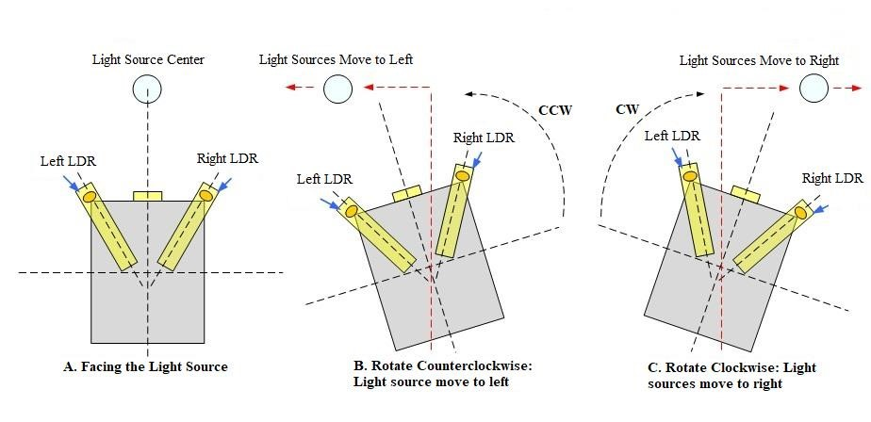

The figure depicts the notion for the instalment of the light dependent resistors (LDR). A secure state is attained when the light intensities of the two LDR become the same. The principal source of light energy, the Sun, moves from east to west. This movement of the Sun causes the variation in the level of light intensities falling on the two LDRs. The designed algorithm compares the variation in the light intensities inside the microcontroller and the motor then is operated to rotate the solar panel, so it moves aligned with the trail of the light source.

### 2.3 RESEARCH DESIGN

Contemplating the idea of building the said project, the idea that has been conceived primarily is to make the best use of solar energy. The next path that unravels is firstly the method to be adopted in storing the solar energy at its maximum level which further ends up with hatching of the project called “AUTOMATIC SOLAR TRACKING SYSTEM’’. Culminating towards making the said project caviar in its utilization several components have been unleashed, some of which are mentioned so-1. Solar Panel,

1. DC Motor,
2. L293D Motor driver module,
3. Microcontroller NodeMcu,
4. LDR sensor module,
5. Current sensor,

All in consolidation of the said components the concerned project is orchestrated, ought to seek for imbibing the sun rays at its maximum level through the LDR sensor module etched on the edges of the solar panel in accordance with the length of it, revolves in aid with the DC motor by maintaining the proportionality of the Sun’s movement. Therefore, the genesis lies upon the fact of making solar energy a profitable source in the production of various other aspects which are in rest with the acute need of the society. In addition to which it would be further worthier to state that when the world is being maligned and sick through the pollution ruckus this project could unveil to be a robust endeavour.

## 

### CHAPTER 3: THEORITICAL BACKGROUND OF SOLAR TRACKER

### 3.1 The Earth: Rotation and Revolution

The position of the sun changes continuously throughout the day. It is due to the motion of earth that we experience sun at different angles in the sky. Earth exhibit two types of motion. One is the motion of earth along its own axis, and the other is the earth revolving around the sun. the motion of the earth along its own axis, known as **rotation**, results in the phenomenon of days and nights. One rotation of the earth takes 23 hours and 56 minutes. On its own axis, the motion of the earth is west to east.

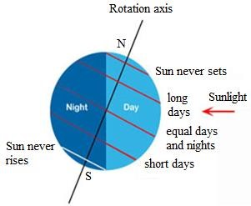

#### Figure 3.1: Earth Rotation

**Revolution**, that is the motion of the earth around the sun is responsible for the different seasons in the year. The earth takes 365 days to revolve around the sun. Earth revolves around the sun in an elliptical orbit and the plane covered by the earth during the revolution is known as an ellipsis. The axis of rotation and ellipsis makes an angle of 66.5 degrees between themselves. This is the explanation behind the summer/winter solaces and spring autumn equinoxes. Due to these motions of the earth, the amount of sunlight received throughout the year varies.

Sunlight is the electromagnetic radiation from the sun expropriated by the earth. The total power given off by the sun into space is much more than that intercepted by the earth.

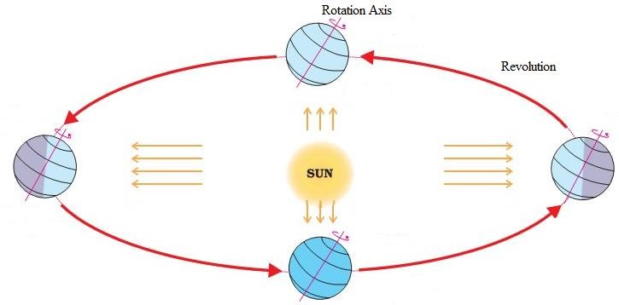

#### Figure 3.2: Earth Rotation and Revolution

Within a given period of time, the emission of solar radiation is somewhat constant and the intensity this radiation hitting a unit area of the earth’s crust is also constant, known as solar constant. The value of this solar constant can be expressed as: -

4πR 2

GSC = σ. T4. ( ) = 1367 W⁄m2

##### 4πD

In the above expression, σ is termed as Stefan Boltzmann Constant with a value of 5.67×10-8 W⁄m2. K4, R is known as the radius of the Sun, 696·106 m and D is 150 ·109 m, the average distance between the Sun and the earth.

The absorption of solar radiation on the surface of the earth also varies with different parameters. Latitude and longitude are one of the prescribed parameters. Latitude the horizontal imaginary line, parallel to the equator, is the angle suspended by the arc linearly join a person’s position and the equator, at the center of the earth. On the contrary longitudes are the vertical imaginary lines, where longitude is the angle suspended by the arc joining the north-pole and south-pole as well as passing through the given location, linearly with the Greenwich meridian, at the center of the earth.

The latitude and longitude express north-south and east-west directions respectively on the earth.

The sunlight is observed at different angles depending on the place on the earth and the angles of the sun. The sun’s angle can be classified into the following: -

* Elevation Angle
* Zenith Angle
* Azimuth Angle

**The elevation angle** is the angle made by the sun with the horizon. The elevation angle is 0 degree at sunrise and 90 degrees around noontime, at the equator. The elevation angle is different at a different time of the day and different for different latitudes. The depicted formula can be used to determine the elevation angle.

##### 𝛼 = 90 + 𝜑 − 𝛿

When the equation above gives a number greater than 90° then subtract the result from 180°. It means the sun at solar noon is coming from the south as is typical the northern hemisphere.

φ is the latitude of the location of interest (+ve for the northern hemisphere and −ve for the southern hemisphere). δ is the declination angle, which depends on the day of the year.

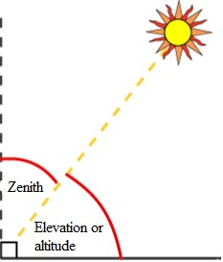

#### Figure 3.3: Angle of elevation and zenith angle

**Zenith angle** is akin with elevation angle. The only difference being it is measured along the vertical. Therefore, it’s the angle between the sun and the vertical i.e. Zenith Angle = 90° – elevation angle.

##### 𝜁 = 90° − 𝛼

**Azimuthal Angle**, this is the compass direction from which the sunlight is coming. At solar noon, the sun is directly south in the northern hemisphere and directly north in the southern hemisphere. The azimuth angle varies throughout the day. At the equinoxes, the sun rises directly east and sets directly west regardless of the latitude. Therefore, the azimuth angles are 90 degrees at sunrise and 270 degrees at sunset.

Sunrise and Sunset time can be formulated by the following formulas-

Sunrise= 12 − 1 cos−1(−tan 𝜑 tan 𝛿) − 𝑇𝐶

15° 60

Sunset= 12 + 1 cos−1(− tan 𝜑 tan 𝛿) − 𝑇𝐶

15° 60

Where φ being the latitude of the place, δ being the declination angle and TC is the Time Correction.[8]

### 3.2 Types of Solar Tracker

|  |  |  |
| --- | --- | --- |
| **Types** |  | **Specification** |
| Active Solar  Tracker | • | It uses motors and gear trains or direct drive actuators, to follow the movement of the sun. |
|  | • | Directed by a controller. |
|  | • | Deactivates during darkness based on the design of the system. |
|  | • | It uses a light sensor to locate the angle at which maximum sunlight can be absorbed. |
|  | • | The MCU directs the solar panel to change the angle. |
| Passive Solar  Tracker | •  •  • | It uses a liquid, easily compressible and boiled.  It is driven by the solar heat.  The fluid moves when heated, like a teeter-totter and hence the solar panel moves. |
| Chronological Solar Tracker | * Works with the rotation of the earth. * Have no sensors. * Depends on the geographical location. * Uses a controller to calculate the moment and position of the earth with respect to the sun at a given time and location. | |
| Single Axis Tracker | * Tracks in a single cardinal direction. * It has a single row tracking configuration. * More reliable. * It has a longer lifespan.   The common categories in which single axis trackers can be classified holds:   * Horizontal single axis trackers (HSAT). * Horizontal single axis tracker with tilted modules (HTSAT). * Vertical single axis tracker (VSAT). * Tilted single axis tracker (TSAT). * Polar aligned single axis tracker (PSAT). | |

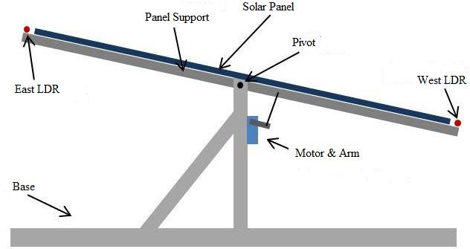

#### Figure 3.4: Single Axis Tracker

|  |  |  |
| --- | --- | --- |
| Dual Axis Tracker | •  • | It moves along two cardinal directions (Horizontal & Vertical).  The axes are traditionally orthogonal. |
|  | • | Its efficiency is much more than any single Axis Tracker. |
|  | • | It conventionally follows the movement of the sun and hence captivates maximum solar radiations. |

#### Table 3.1: Types of Solar Tracker

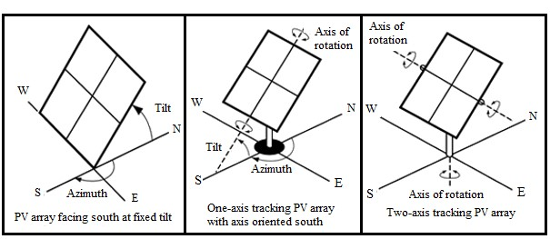

**Figure 3.5: Dual Axis Tracker**

### 3.3 Fixed Collectors

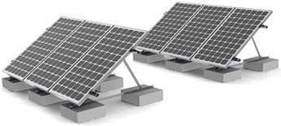

#### Figure 3.6: Fixed Collectors

The fixed collectors are secured at a place where the gross solar energy obtained is comparatively higher than most of the predefined places and is the inclination is kept in accordance with the defined context. The motive is to install collected places which are subjected to receive the maximum amount of sunlight and collect solar energy over a long period of time hence the demand for tracking devices can be overcome. This creates a substantial diminution in the expenses and the preservation of the collectors. The knowledge of the movement of the sun throughout a season and different hours of the year is essential to enable maximum captivation of solar energy. The Sun chart for Calcutta is shown below

**Figure**

**3**

**.7:**

**Sun path diagram for Calcutta**

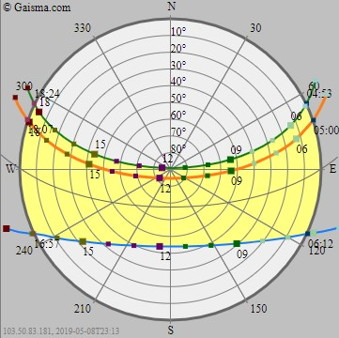

Legends

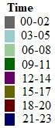

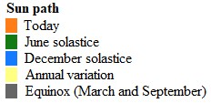

Through the use of the chart, it is possible to ascertain the position of the sun at different times and seasons so that the panel can be fixed for maximum output. Fixed trackers are cheaper in tropical countries like Kenya. For countries beyond +10 degrees North and -10 degrees South of the equator, there is need for serious tracking. This is because the position of the midday sun varies significantly.

The chart shows that the position of the sun is highest between 1200h and 1400h. For the periods outside this range, the collectors are obliquely oriented to the sun and therefore only a fraction reaches the surface of absorption.

### 3.4 Maximum power point tracking

Photovoltaic cell shares a composite bond with the surroundings they work and the maximal power generated. The non-linear electrical tendencies of a solar cell is indicated by a ratio of solar cell’s maximum power to the product of open-circuit voltage and short circuit current, also known as fill factor. Based on the three parameters, which are the fill factor (FF), open-circuit voltage (VOC) and short-circuit Current (ISC) the electrical tendencies of a photovoltaic cell can be determined under situational environments.

Under working environment, as derived by Ohm’s Law, a certain voltage (V) and current (I) values which correlated to that single point at which the power obtained is maximum, corresponds to a certain load, resistance. The I-V curve of photovoltaic cells behaves as a current constant source for most of the region. Once the maximum power point region is reached, there are changes in the curve as the curve now describes a relationship of current and voltage as inversely exponential. So the elementary circuit theory describes that the power obtained from the device where the magnitude of the gradient of the curve is at par and opposite to the current voltage ratio, can be termed as maximum power point.

Therefore, in the exposition of photovoltaic modules, among the given space and time, there lies a point from which the power dragged is maximum. This point in the PV module is known as maximum power point and the methodology of tracking down this point to ensure that our controlling point always stays around this maximum power point tracking.

The proposition of maximum power point tracking is to collect the maximum power, by setting the most effective voltage in PV module. The juxtaposition is done between the output voltages with the battery voltage. They extract the high voltage power from the PV modules and modify them to fulfill the requirement of charging lower voltage batteries. The power is henceforth converted to the best voltage to obtain maximum current in the battery.

#### Favorable conditions for maximum power point tracking

MPPT works under conditions where extra power is required and this

* For maximum power extraction from MPPT, cold and cloudy weather is most preferable. PV module have a higher efficiency during these climate conditions
* When the charge in the battery is at its minimum, the MPPT is at its excellence. Maximum amount of current is obtained by the MPPT in such lower battery conditions.

#### MPPT solar charge controller

There have been such charge controllers created and inscribed with maximum power point tracking algorithm to considerably increase the quantity of current supplied to the batteries from the photovoltaic modules.

The alteration done in the process or the conversions taking place are shown in the figure below:

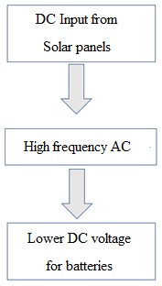

#### Figure 3.8: Conversions taking place inside the Solar charge controller

The work is to optimize the photovoltaic modules with the batteries.

Some more examples of DC-DC converters:

* Boost controllers
* Buck converters

The implementation of the MPPT solar charge controller can be done in off-grid solar power system like

1. Stand-alone **solar power system,** 2. **Solar home system,**

3. **Solar water pump system,** etc.

#### Features of MPPT solar charge controllers

* MPPT solar charge controllers are used to sense the alterations in the characteristics of a solar cell depicted by I-V curve for any applications which has PV module as energy source.
* MPPT solar charge controllers are devised to withdraw maximum power from photovoltaic modules, they push the photovoltaic modules to work on voltage surrounding maximum power point to enable the extraction of maximum power.
* MPPT solar charge controllers provides access to the user to operate PV module of voltage output greater than the driving voltage of battery system.
* The complications of a highly efficient system’s output is negotiated by MPPT solar charge controller. Moreover, since the output of photovoltaic power is utilized to charge DC-DC converter, the MPPT solar charge controller can be made to operate with more energy sources.
* MPPT solar charge controller can not only be utilize with PV modules but can also be subjected to the other various renewable energy sources. For example, smaller water turbines, wind turbines etc.

**Classification of power controllers on their different kinds of approach towards the optimization of power output of the photovoltaic cells.**

There are certain kinds of algorithms which are utilized from time to time based on several conditions. The classification is done on the basis of above criterions: -

Perturb and observe – One of the most popular maximum power point tracking method among the others, also known as hill climbing method, is one of the most often utilized method as the execution of this algorithm is quite elementary. In this method the voltage source is monitored by the controller and the magnitude is increased slowly and the power is observed for every small change of voltage. With the increase in voltage, there is an increase in the power as well and this change is voltage is brought till there is no alteration in the magnitude of power. This method can be a very fruitful method provided other parameters and techniques are taken care of.

Incremental Conductance - Unlike, perturb and observe method, this method senses the alteration in the situations more abruptly. The consequent output voltage is calculated by observing the increasing voltage and current of the photovoltaic array. This method involves a little more calculative algorithm.

The algorithm of this method is designed to compare the changing conductance (I/V) with the conductance of the photo voltaic array. When there two parameters are at par with each other the output voltage becomes responsible for maximum power generation.

Current Sweep- in this method, an upgradation of an I-V characteristic of photovoltaic module at certain time intervals i.e. a sweep waveform, is done and ten the maximum power is calculated from this curve.

Temperature Method – The algorithm for this method works of the equation: -

##### 𝑉𝑚𝑝𝑝(𝑇) = 𝑉𝑚𝑝𝑝(𝑇𝑟𝑒𝑓) + 𝑢𝑣𝑚𝑝𝑝(𝑇 − 𝑇𝑟𝑒𝑓)

In the above equation, 𝑉𝑚𝑝𝑝 stands for the maximum power point voltage and 𝑢𝑣𝑚𝑝𝑝 is the temperature coefficient of 𝑉𝑚𝑝𝑝. 𝑇 and 𝑇𝑟𝑒𝑓 are temperatures, calculated and taken from references respectively. So, in this method the maximum power point is calculated or assumed by observing the temperature of the solar panels. The voltage is expected to alter on the basis of temperature linearly. The temperature observed is referred to reference and hence the output voltage is computed from the above equation. The algorithm used in this method is comparatively simpler and hence power utilization is less. Moreover, the method is flexible enough to be implemented on both analog and digital circuit. What makes it out stand is, since the variation of temperature with respect to time is lethargic, the oscillation in power output is omitted.

**Where the MPP trackers should be placed?**

Initially, there were solar inverters used to perform maximum power point tracking for all the PV modules installed. The system was such that there was a single current supply for all the modules present. The modules were arranged in series with each other. But as the parameters of different modules, differs with each other due to manufacturing forbearance, partial shading, etc., the I-V characteristic and output of each module differs as well. Since, our supply is same throughout the arena, some module gets restrained from generating maximum power. As a result, the efficiency of the system is considerably decreased.

Now a days, companies have started to install maximum power point trackers inside each module to increase the maximum power generation and hence, allow to work on its maximum efficiency.

**3.5 Advantages and Pitfalls of Solar Energy:**

###### 3.5.1 Advantages: -

* The process of attaining solar energy is unsoiled.
* It is a renewable source of energy.
* The investment is done only during the installation of solar panels, the expenses of acquired solar energy after installation is little.
* Solar energy is a perennial source of energy.
* There is no adulteration is the process of acquiring solar energy.
* The yield rate is very high, using solar panels.
* It requires the least maintenance, once the setup is installed.
* Solar energy is very useful and can be easily drawn into applications in rural areas where the extraction of electricity is difficult.
* Solar energy does not create noises compared to the noises created by the machinery in the extraction of other natural resources.

###### 3.5.2 Pitfalls: -

* The installations of the solar panel could be pretty expensive, which would require huge investments and years of saving.
* Production of electricity is directly dependent on the energy captivated which is interlinked with the path sun covers. This factor could bring many countries to disadvantage.
* The power station of solar energy lags in the production of the latter as compared to the traditional power stations. Moreover, the costs of building such solar power stations could be exorbitant.
* The consumption of solar energy during the night requires the energy to be stored in large batteries, which would hence occupy a huge section.

The utilization of solar energy is encouraged as the number of merits exceeds the number of demerits.

## CHAPTER 4: HARDWAR PROTOTYPE

**Hardware Interface** :

##### **Solar Panel:-**

**Solar panel** refers to a panel designed to absorb the sun's rays as a source of energy for

generating electricity or heating. Photovoltaic modules use light energy (photons) from

the Sun to generate electricity through the photovoltaic effect. The majority of modules

use wafer-based crystalline silicon cells or thin-film cells. The structural (load carrying)

member of a module can either be the top layer or the back layer. Cells must also be

protected from mechanical damage and moisture. Most modules are rigid, but semi-

flexible ones are available, based on thin-film cells. The cells must be connected

electrically in series, one to another. Externally, most of photovoltaic modules use MC4

connectors type to facilitate easy weatherproof connections to the rest of the system.

Modules electrical connections are made in series to achieve a desired output voltage

and/or in parallel to provide a desired current capability. The conducting wires that take

the current off the modules may contain silver, copper or other non-magnetic conductive

transition metals. Bypass diodes may be incorporated or used externally, in case of partial

module shading, to maximize the output of module sections still illuminated.

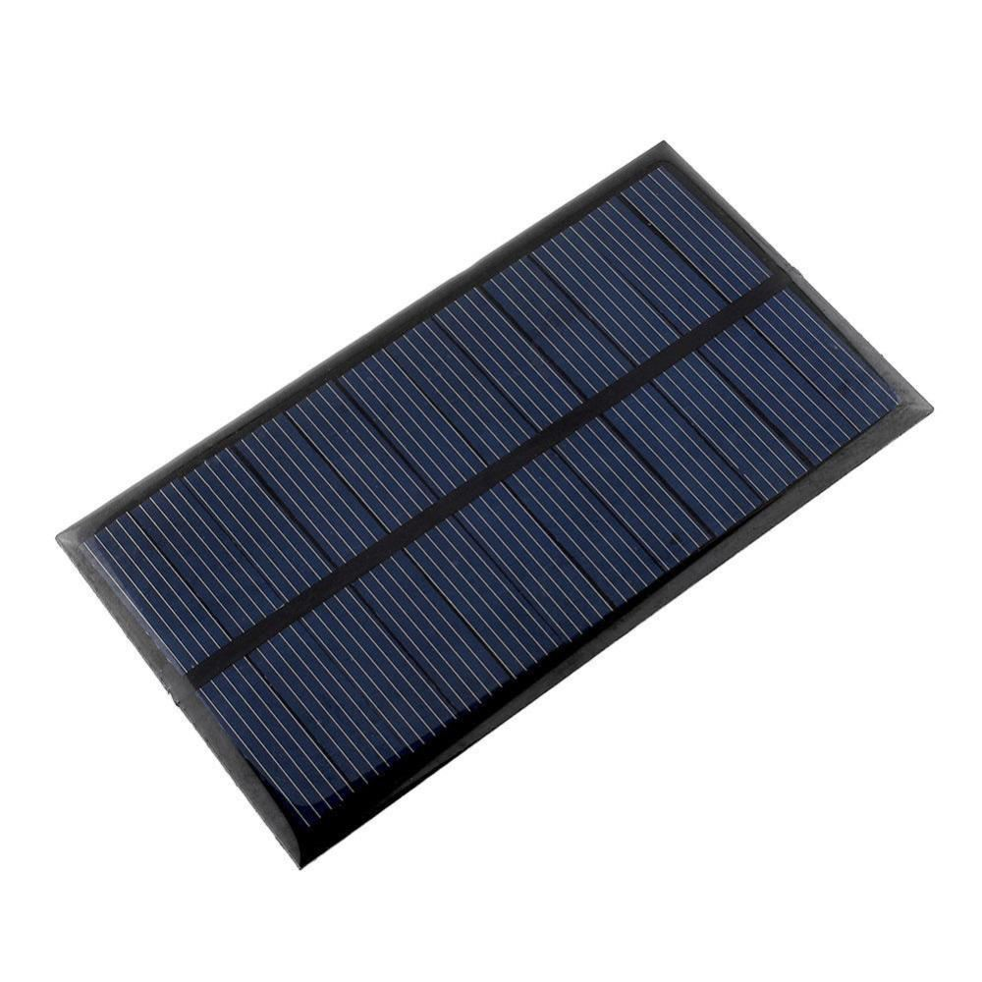

#### Figure 4.1: Solar Panel

##### **Arduino UNO Microcontroller** :-

##### 

**Arduino** is an open source, computer hardware and software company, project, and user community that designs and manufactures microcontroller kits for building digital devices and interactive objects that can sense and control objects in the physical world. The project's products are distributed as open-source hardware and software, which are licensed under the GNU Lesser General Public License (LGPL) or the GNU General Public

License (GPL) permitting the manufacture of Arduino boards and software distribution by anyone. Arduino boards are available commercially in preassembled form, or as do-ityourself kits.

Arduino board designs use a variety of microprocessors and controllers. The boards are equipped with sets of digital and analog input/output (I/O) pins that may be interfaced to various expansion boards (*shields*) and other circuits. The boards feature serial

communications interfaces, including Universal Serial Bus (USB) on some models, which are also used for loading programs from personal computers. The microcontrollers are typically programmed using a dialect of features from the programming languages C and C++. In addition to using traditional compiler toolchains, the Arduino project provides an integrated development environment (IDE) based on the Processing language project.

Arduino/Genuino Uno:- is a microcontroller board based on the ATmega328P. It has 14 digital input/output pins (of which 6 can be used as PWM outputs), 6 analog inputs, a 16 MHz quartz crystal, a USB connection, a power jack, an ICSP header and a reset button. It contains everything needed to support the microcontroller; simply connect it to a computer with a USB cable or power it with a ACto-DC adapter or battery to get started.. You can tinker with your UNO without worring too much about doing something wrong, worst case scenario you can replace the chip for a few dollars and start over again.

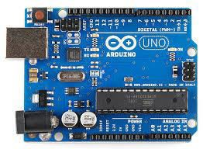

#### Figure 4.2: Aurdino UNO Atmega 328

##### LDRs :-

A **Light Dependent Resistor** (LDR) or a photo resistor is a device whose resistivity is a function of the incident electromagnetic radiation. Hence, they are light sensitive devices. They are also called as photo conductors, photo conductive cells or simply photocells. They are made up of semiconductor materials having high resistance. A photoresistor is made of a high resistance semiconductor. In the dark, a photoresistor can have a resistance as high as several megohms (MΩ), while in the light, a photoresistor can have a resistance as low as a few hundred ohms. If incident light on a photoresistor exceeds a certain frequency, photons absorbed by the semiconductor give bound electrons enough energy to jump into the conduction band. The resulting free electrons (and their hole partners) conduct electricity, thereby lowering resistance. The resistance range and sensitivity of a photoresistor can substantially differ among dissimilar devices. Moreover, unique photoresistors may react substantially differently to photons within certain wavelength bands.

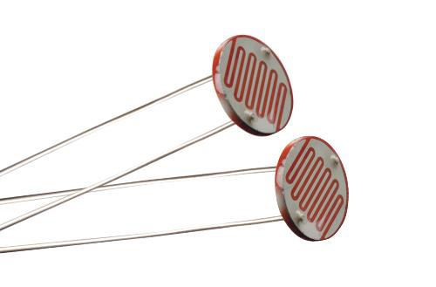

#### Figure 4.3: Photo-sensitive Resistors

##### **Servo Motors:-**

A **servomotor** is a rotary actuator or linear actuator that allows for precise control of angular or linear position, velocity and acceleration. It consists of a suitable motor coupled to a sensor for position feedback. It also requires a relatively sophisticated controller, often a dedicated module designed specifically for use with servomotors.

Servomotors are not a specific class of motor although the term *servomotor* is often used to refer to a motor suitable for use in a closed-loop control system.

A servomotor is a closed-loop servomechanism that uses position feedback to control its motion and final position. The input to its control is a signal (either analogue or digital) representing the position commanded for the output shaft.

The motor is paired with some type of encoder to provide position and speed feedback. In the simplest case, only the position is measured. The measured position of the output is compared to the command position, the external input to the controller. If the output position differs from that required, an error signal is generated which then causes the motor to rotate in either direction, as needed to bring the output shaft to the appropriate position. As the positions approach, the error signal reduces to zero and the motor stops.

The very simplest servomotors use position-only sensing via a potentiometer and bang-bang control of their motor; the motor always rotates at full speed (or is stopped). This type of servomotor is not widely used in industrial motion control, but it forms the basis of the simple and cheap servos used for radio-controlled models.

More sophisticated servomotors use optical rotary encoders to measure the speed of the output shaft and a variable-speed drive to control the motor speed. Both of these enhancements, usually in combination with a PID control algorithm, allow the servomotor to be brought to its commanded position more quickly and more precisely, with less overshooting.

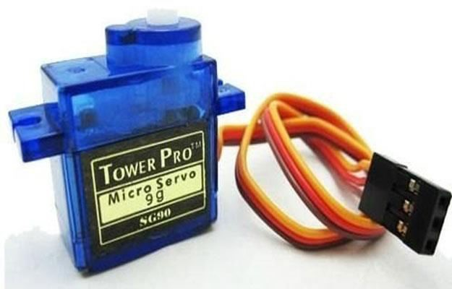

#### Figure 4.4: Servomotor

##### **System Interface**

**ATmega328p Microcontroller**:-The high-performance Microchip picoPower 8-bit AVR RISC-based microcontroller combines 32KB ISP flash memory with read-while-write capabilities, 1024B EEPROM, 2KB SRAM, 23 general purpose I/O lines, 32 general purpose working registers, three flexible timer/counters with compare modes, internal and external interrupts, serial programmable USART, a byte-oriented 2-wire serial interface, SPI serial port, a 6-channel 10-bit A/D converter (8channels in TQFP and QFN/MLF packages), programmable watchdog timer with internal oscillator, and five software selectable power saving modes. The device operates between 1.8-5.5 volts. **b) User Interface**

It should be the connector between the various systems and the system or between other parts or unit of the system.

###### Arduino IDE:-

A program for Arduino may be written in any programming language for a compiler that produces binary machine code for the target processor. Atmel provides a development environment for their microcontrollers, AVR Studio and the newer Atmel Studio

. The Arduino project provides the Arduino integrated development environment (IDE), which is a cross-platform application written in the programming language Java. It originated from the IDE for the languages *Processing* and *Wiring*. It includes a code editor with features such as text cutting and pasting, searching and replacing text, automatic indenting, brace matching, and syntax highlighting, and provides simple *one-click* mechanisms to compile and upload programs to an Arduino board. It also contains a message area, a text console, a toolbar with buttons for common functions and a hierarchy of operation menus.

A program written with the IDE for Arduino is called a *sketch*. Sketches are saved on the development computer as text files with the file extension *.ino*. Arduino Software (IDE) pre1.0 saved sketches with the extension *.pde*.

The Arduino IDE supports the languages C and C++ using special rules of code structuring. The Arduino IDE supplies a software library from the Wiring project, which provides many common input and output procedures. User-written code only requires two basic functions, for starting the sketch and the main program loop, that are compiled and linked with a program stub *main()* into an executable cyclic executive program with the GNU toolchain, also included with the IDE distribution. The Arduino IDE employs the program *avrdude* to convert the executable code into a text file in hexadecimal encoding that is loaded into the Arduino board by a loader program in the board's firmware.

**Operation** :

1. LDRs are used as the main light sensors. Two servo motors are fixed to the structure that holds the solar panel. The program for Arduino is uploaded to the microcontroller. The working of the project is as follows
2. LDRs sense the amount of sunlight falling on them. Four LDRs are divided into top, bottom, left and right.
3. For east – west tracking, the analog values from two top LDRs and two bottom LDRs are compared and if the top set of LDRs receive more light, the vertical servo will move in that direction.
4. If the bottom LDRs receive more light, the servo moves in that direction.
5. For angular deflection of the solar panel, the analog values from two left LDRs and two right LDRs are compared. If the left set of LDRs receive more light than the right set, the horizontal servo will move in that direction.
6. If the right set of LDRs receive more light, the servo moves in that direction.

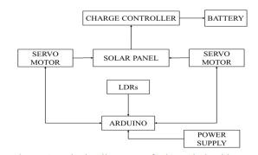

#### Figure 4.5: Block diagram of Aurdino based solar tracking system

##### **Block diagram of arduino based sun solar tracking system:**

#### Figure 4.6 : Single Axis Tracker pin diagram

**pin diagram of arduino based sun solar tracking system :**

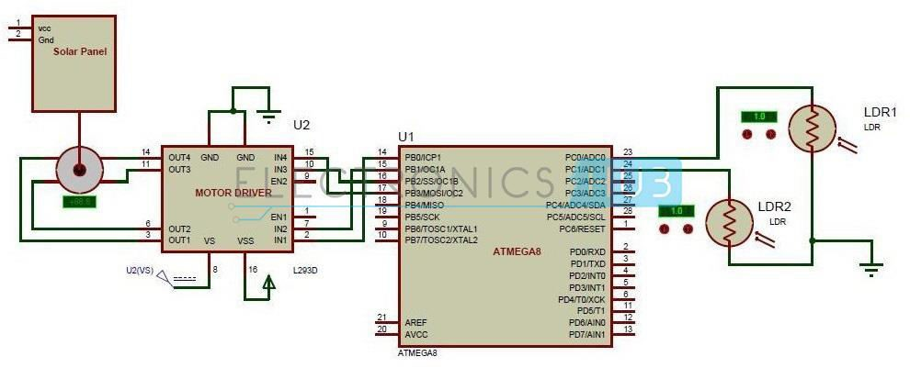

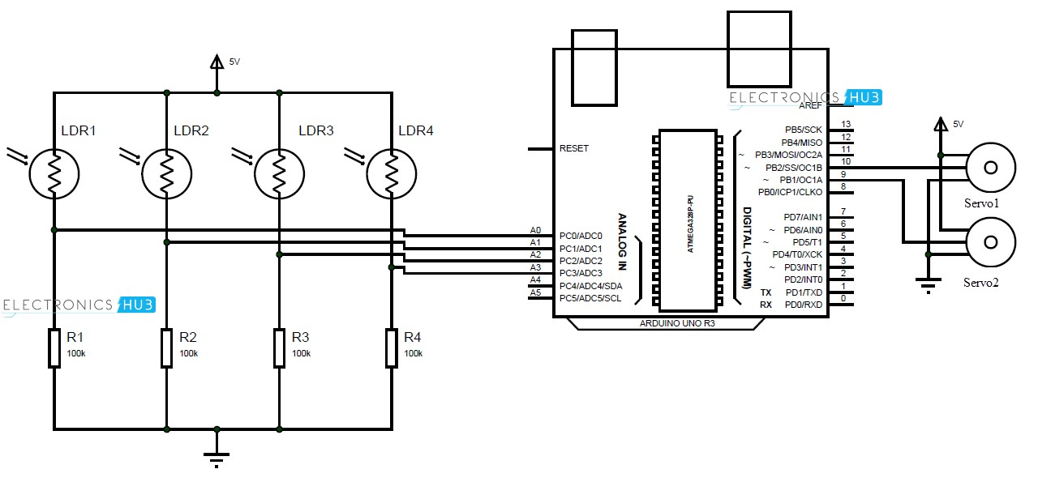

#### Figure 4.7 : Dual Axis Tracker Pin Diagram

**Functionality :**

**Algorithm :**

Step1: Start

Step2: Initialise all necessary inputs and outputs to zero.

Step3: Assign analog LDR outputs and PWM servomotor inputs to Arduino Uno.

Step4: If centre LDR = 0, then delay (longer).

Step5: Check alignment (Simultaneously for northsouth and east-west)

Step6: If up (LDR) greater than centre and down (LDR) lesser than centre, then increase position of servomotor1 by 1 unit. Give delay.

Step7: Else if up (LDR) lesser than centre and down (LDR) greater than centre, then decrease position of servomotor1 by 1 unit. Give delay.

Step8: (Simultaneously along with step6) If right (LDR) greater than centre and left (LDR) lesser than centre then increase the position of servomotor2 by 1 unit. Give delay.

Step9: Else if right (LDR) is lesser than centre and left (LDR) greater than centre then decrease position of servomotor2 by 1 unit. Give delay.

Step10: Goto Step 5.

Step11: End.

Flowchart of tracking algorithm for azimuth control and elevation control

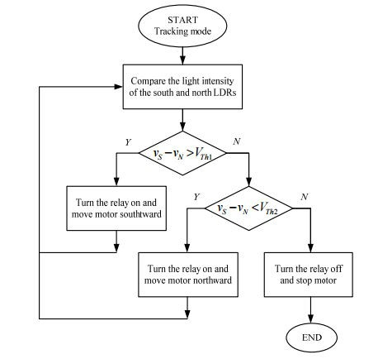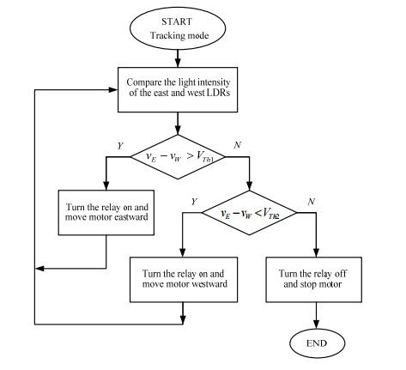

## CHAPTER 5: EXPERIMENT RESULTS, ANALYSIS

### 5.1 Experiment Results

The results for the project were gotten from LDRs for the solar tracking system and the panel that has a fixed position. The results were recorded for four days, recorded and tabulated. The outputs of the LDRs were dependent on the light intensity falling on their surfaces. Arduino has a serial that communicates on digital pins 0 and 1 as well as with the computer through a USB. If these functions are thus used, pins 0 and 1 can be used for digital input or output.

Arduino environment’s built in serial monitor can be used to communicate with the NodeMcu board. To collect the results, a code was written that made it possible to collect data from the LDRs after every one hour.

|  |  |
| --- | --- |
| Time (Hrs) | PV Array Output (V) |
| 0600 | 08.25 |
| 0700 | 08.95 |
| 0800 | 09.52 |
| 0900 | 09.89 |
| 1000 | 10.33 |
| 1100 | 10.76 |
| 1200 | 11.00 |
| 1300 | 10.82 |
| 1400 | 10.56 |
| 1500 | 10.32 |
| 1600 | 10.08 |
| 1700 | 09.26 |
| 1800 | 08.34 |

#### Table 5.1: Photovoltaic array outputs for bright sunny day on 4th December 2021

The values from the two LDRs are to be read and recorded at the given intervals. The LDRs measure the intensity of light and therefore they are a valid indication of the power that gets to the surface of the solar panel. The light intensity is directly proportional to the power output of the solar panel.

|  |  |  |
| --- | --- | --- |
| Time (Hrs) | LDR1(V) | LDR2 (V) |
| 0630 | 0.277 | 0.276 |
| 0730 | 0.504 | 0.509 |
| 0830 | 1.757 | 1.933 |
| 0930 | 1.631 | 1.783 |
| 1030 | 1.900 | 1.798 |
| 1130 | 2.910 | 2.969 |
| 1230 | 1.990 | 1.990 |
| 1330 | 1.985 | 1.990 |
| 1430 | 0.976 | 0.985 |
| 1530 | 0.941 | 0.892 |
| 1630 | 0.824 | 0.594 |
| 1730 | 0.128 | 0.981 |
| 1830 | 0.982 | 0.968 |

#### Table 5.2: LDR Outputs for cloudy day on 7th December 2021

|  |  |  |
| --- | --- | --- |
| Time (Hrs) | LDR1 (V) | LDR2 (V) |
| 0630 | 1.477 | 1.487 |
| 0730 | 2.804 | 2.839 |
| 0830 | 3.203 | 3.990 |
| 0930 | 3.990 | 3.990 |
| 1030 | 4.130 | 4.149 |
| 1130 | 4.500 | 4.590 |
| 1230 | 4.990 | 4.990 |
| 1330 | 4.888 | 4.990 |
| 1430 | 4.976 | 4.985 |
| 1530 | 4.941 | 4.892 |
| 1630 | 4.873 | 4.790 |
| 1730 | 3.964 | 3.940 |
| 1830 | 2.708 | 2.815 |

**Table 5.3: LDR outputs for bright sunny day on 2nd December 2021**

### 5.2 Analysis

From the tables, it can be seen that the maximum sunlight occurs at around midday, with maximum values obtained between 1200 hours and 1400 hours. In the morning and late evening, intensity of sunlight diminishes and the values obtained are less that those obtained during the day. After sunset, the tracking system is switched off to save energy. It is switched back on in the morning.

For the panel fitted with the tracking system, the values of the LDRs are expected to be close. This is because whenever they are in different positions there is an error generated that enables its movement. The motion of the panel is stopped when the values are the same, meaning the LDRs receive the same intensity of sunlight. For the fixed panel, the values vary because the panel is at a fixed position. Therefore, at most times the LDRs are not facing the sun at the same inclination. This is apart from midday when they are both almost perpendicular to the sun.

Days with the least cloud cover are the ones that have the most light intensity and therefore the outputs of the LDRs will be highest. For cloudy days, the values obtained for the tracking system and the fixed system do not differ too much because the intensity of light is more or less constant. Any differences are minimal. The tracking system is most efficient when it is sunny. It will be able to harness most of the solar power which will be converted into energy. In terms of the power output of the solar panels for tracking and fixed systems, it is evident that the tracking system will have increased power output. This is because the power generated by solar panels is dependent on the intensity of light. The more the light intensity the more the power that will be generated by the solar panel.

## CHAPTER 6: CONCLUSION, FUTURE SCOPE

### 6.1 CONCLUSION

Today in the world of rampant productivity, energy is the fundamental source upon which the whole civilization is based upon. As it is said that energy can neither be created nor be destroyed and, in that response, it can be signified that it can somehow be stored. The attempt towards making such goal substantiated, this project has been endeavoured towards unravelling the path of such objectivity. It is quite natural that constant utilisation of energies somehow opens the door of scarcity as per as earthly sources are concerned. Sun, in the stand of which, the tallest source, spiked over for age’s right from the origin of the whole universe, through which life has been conceived, is the basic and the mother source of all the energies. Considering the very fundamental from the viewpoint of storing such energy, the project has been unravelled. Energies other than from the Sun, are the process from which such are been produced through the burning of various materials, involving emission of a large amount of pollution, causing the environment and the atmosphere sick day by day. Fastness and smartness of the world’s current behavioural visibility, where easy access of every sphere of life is in need of the acute comfortability, every day is a new challenge of hatching something new and unique which makes an energy to be the ultimatum source behind all the hard work exists. In that regards it would be worthier to reveal that commercialisation has boomed its wings to such an extent in the need of money and power that we are somehow present in the pool of acute ignorance of the world’s resources scarcity, in consequence of which the whole world is wounded. Healing the world is the basis cultivation with which the hour clock is calling and this project presents the eye, therefore, to open the corridors of reducing the amount of pollution in storing of energy culled out from the Sun and also to make the pace of advancement revved around.

### 6.2 FUTURE SCOPE

The very embodiment through which the futuristic conundrum be set aside, is the project called “Automatic Solar Tracking System”. A trailblazer by its spirit, this system works in its utmost efficiency, whether that be in terms of its pecuniary ability or in terms of its accessibility. In the smoke of the darkness where pollution engulfing every spheres of advancement as an outcome of producibility, this device in its very efficiency work towards only advancement and development by flushing out the pollution at large.

## REFERENCES

1. Ying-Tung Hsiao, China-Hong Chen, “Maximum Power Tracking for Photovoltaic Power System,” [Conference Record of the 2002 IEEE Industry Applications Conference. 37th IAS Annual Meeting,](https://ieeexplore.ieee.org/xpl/mostRecentIssue.jsp?punumber=8075) ISBN-0-7803-7420-7, 13-18 Oct, 2002, pp 1035-1039.
2. Mayank Kumar Lokhande, “Automatic Solar Tracking System,” International Journel of Core Engineering & Management, October, 2014.
3. Scott J Hamilton, “Sun-Tracking Solar Cell Array System,” University of Queensland, Department of Electrical Engineering, 1999
4. Furkan Dincer, Mehmet Emin Meral, “Critical Factors that Affecting Efficiency of Solar

Cell,” University of Yuzuncu Yil, Department of Electrical and Electronics Engineering, Van, Turkey, 2010.

1. R.Z. Wang, T.S. Ge, “Advances in Solar Heating and Cooling,” Woodhead Publishing, 2016, Pages 81-93, ISBN 9780081003015,
2. Levent Bas, “Thin Film vs. Crystalline Silicon PV Modules,” December, 2011.
3. M. A. Panait, T. Tudorache, “A Simple Neural Network Solar Tracker for Optimizing Conversion Efficiency in Off-Grid Solar Generators”, International Conference on Renewable energies and Power quality (ICREPQ), march 12-14, Santander, 2008.
4. Juan Reca-Cardeña, Rafael López-Luque, Chapter 9- Design Principles of Photovoltaic

Irrigation Systems, “Advances in Renewable Energies and Power Technologies”, Elsevier Science, 2018

1. C. Chang, Chapter 5 Tracking solar collection technologies for solar heating and cooling systems, “Advances in Solar Heating and Cooling”, Woodhead Publishing, 2016
2. Kamrul Islam Chowdhury, Md.Iftekhar-ul-Alam, Promit Shams Bakshi, “Performance Comparison Between Fixed Panel, Single-axis and Dual-axis Sun Tracking Solar Panel System,” BRAC University, Department of Electrical and Electronic Engineering, 2017.