Pull the docker image urmsandeep/ai-artistic-style-service

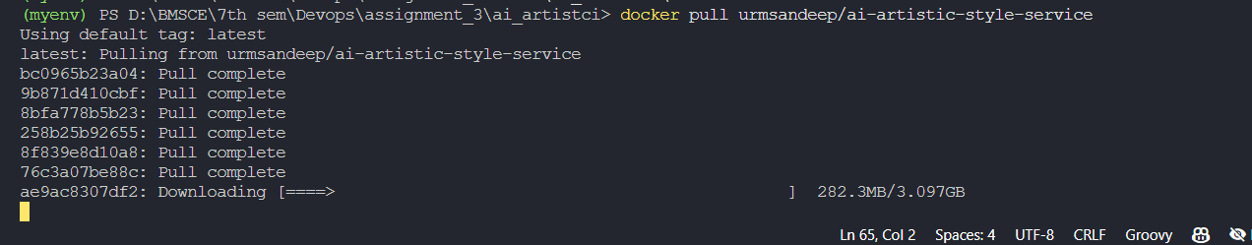

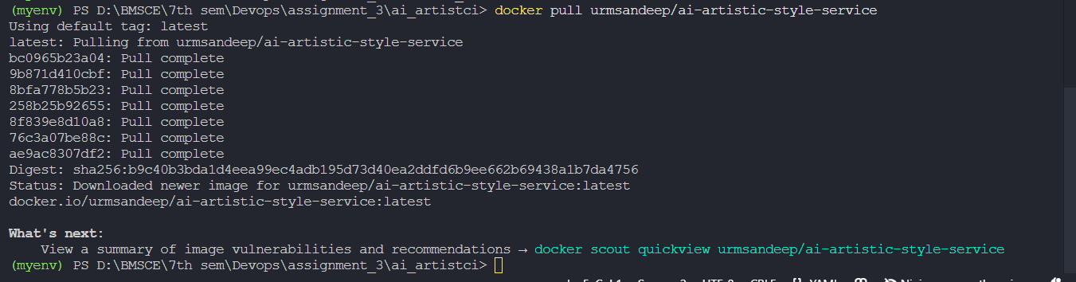

Run docker image urmsandeep/ai-artistic-style-service



Ensure that container is running

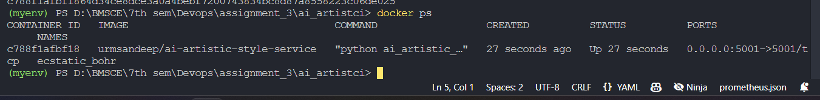

Use curl to invoke the service on port 5001, giving path to input image “input.jpg’

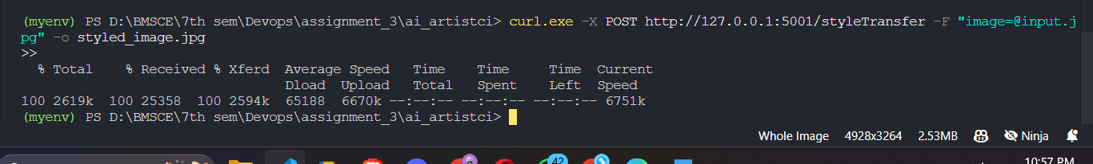

Docker-compose.yml file

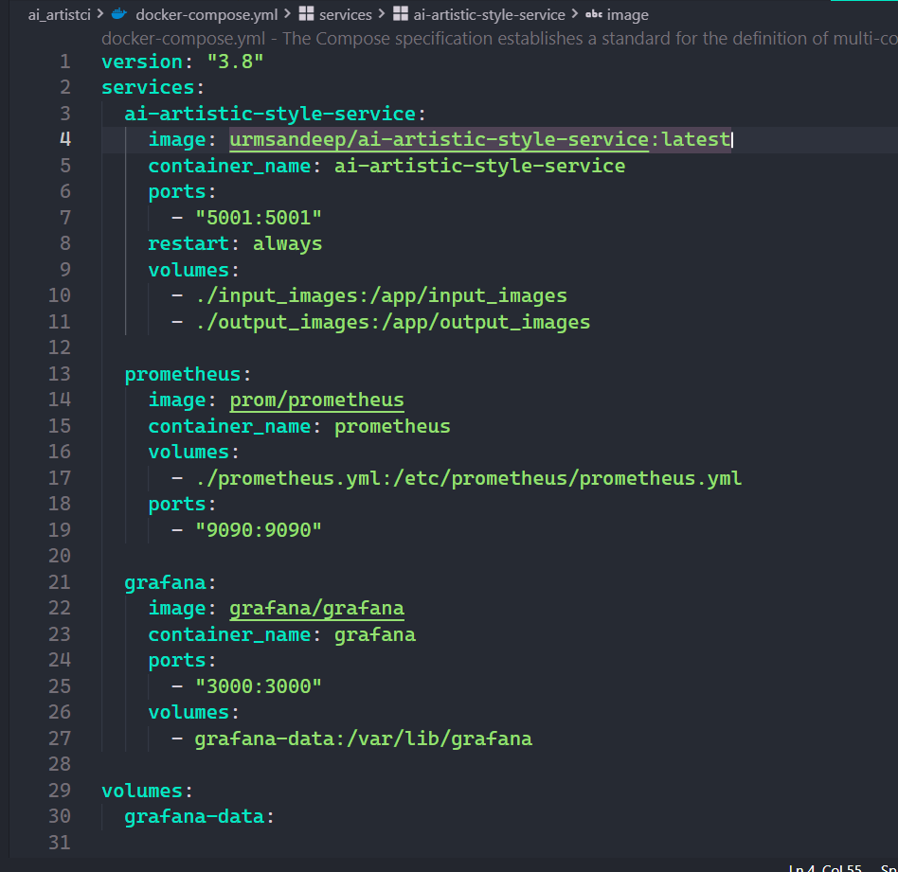

Start the services and verify the containers

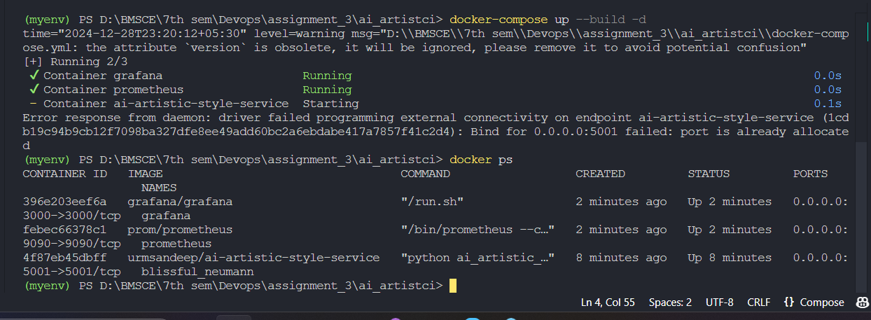

Prometheus.yml

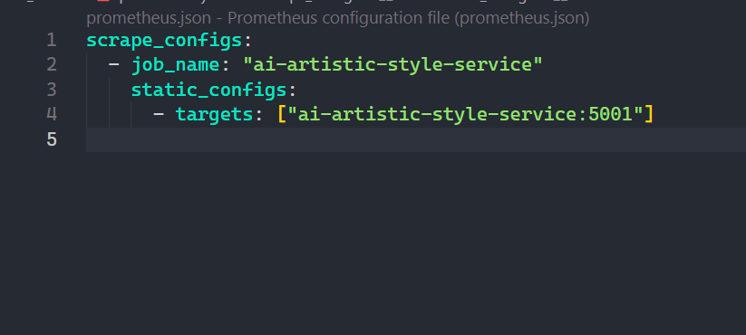

Restart Docker Compose

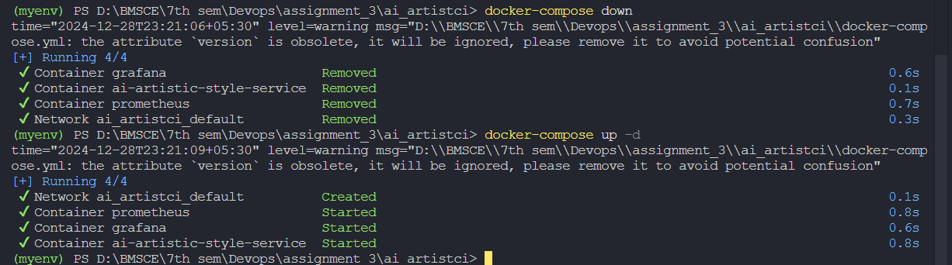

Localhost:9090->Prometheus

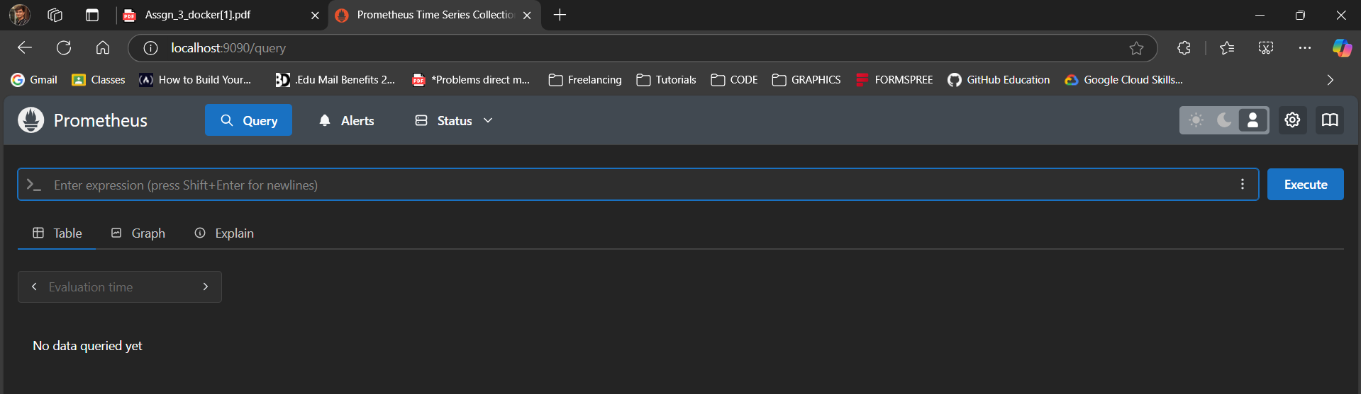

Localhost:3000->Graphana

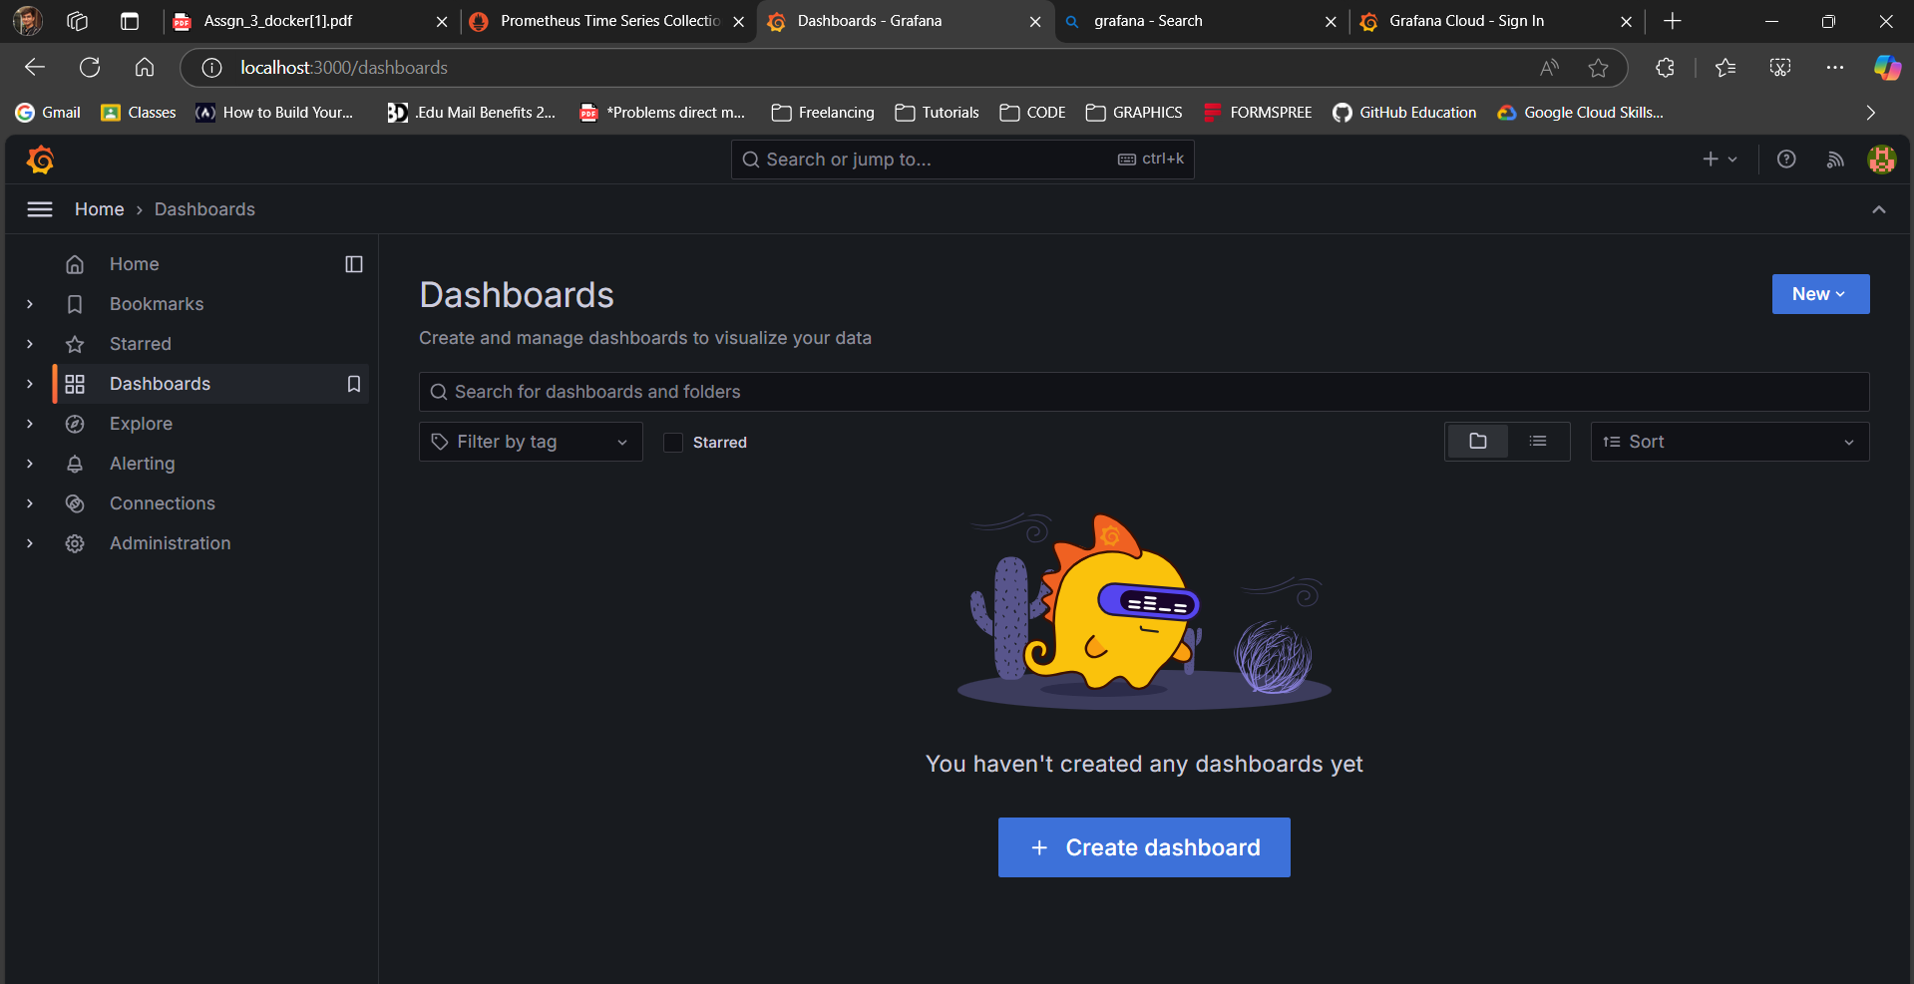

Total API Requests: Query: rate(http_requests_total[1m])

CPUUsage: Query: container_cpu_usage_seconds_total

Memory Usage: Query: container_memory_usage_bytes

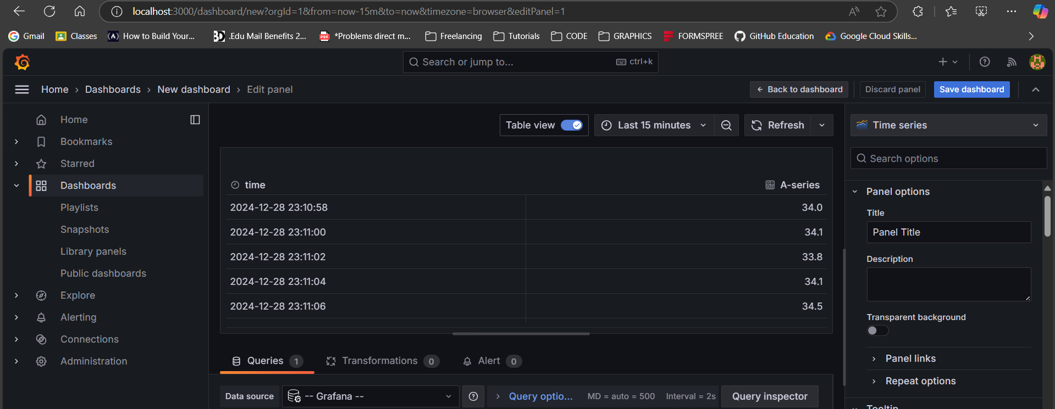

Setting up Jenkins

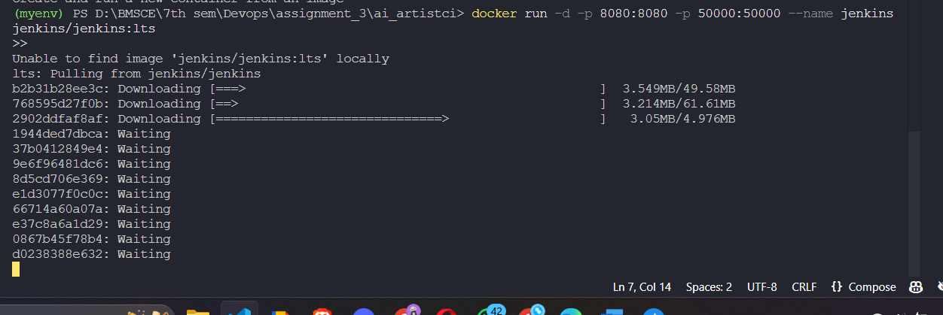

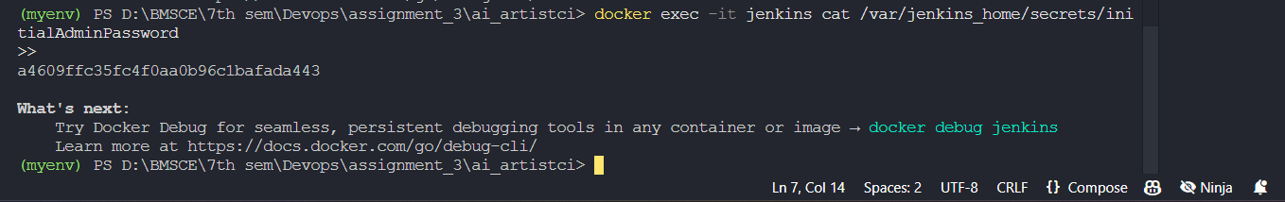

Adding plugins in Jenkins

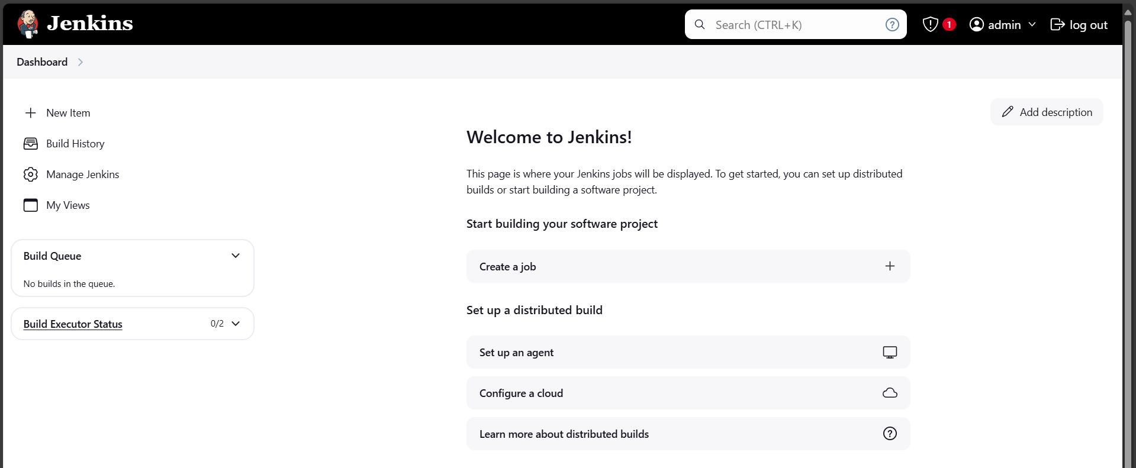

Input image :

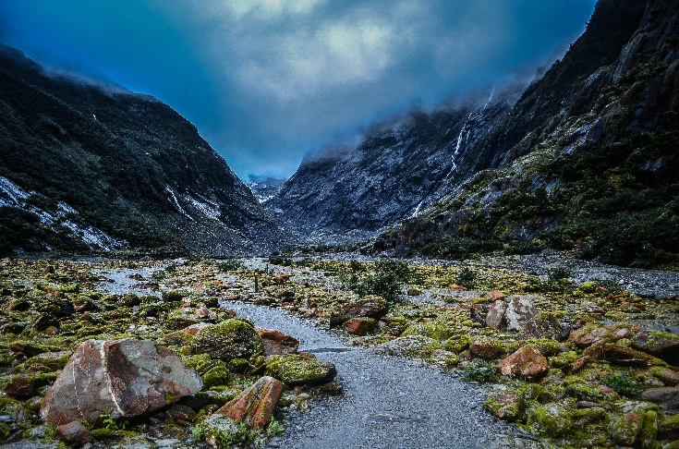

Output Image:

