CC085-Recurring Payments

Version 1.5
Date: Jul 2025

For more information, contact:
Support@omnipayments.com

INDEX

1. Overview 3
2. How does it operate? 3
3. Requirement 6
4. Merchant Compensation Reports Changes 6
5. Brand Specification Reports 6
6. Doubts 8

- Overview

This document provides the details about the new feature Recurring Payment which Compraqui wants to support for merchants and cardholders. This service will automate recurring payments, optimize merchants' financial management and enhance customer loyalty, ensuring compatibility with multiple payment methods and compliance with current regulations.
- How does it operate?

Recurring payments work through an automated and secure process, where a merchant periodically charges a customer using their credit or debit card without them having to authorize each transaction manually. Between Compraquí and Seglan there will be an API that once the cardholder has selected the required product or plan will send Compraquí the information so that it can raise the payment with the user's data. After that, the authorization request will be sent to OP and this in turn will send it to the brands and return the authorized or rejected payment.

How does it operate?

- Web Login: The user logs in to the website where he/she selects the product or plan he/she wishes to purchase.
- Customer registration: The user enters their card details and authorizes recurring payments.
- Tokenization: For security, card details are converted into a secure token rather than stored directly.
- Initial authorization: A first charge or card verification is performed.
- Automatic cashouts: At each payment cycle, the system automatically processes the transaction without the need for user interaction.
- Control: The customer can cancel the subscription at any time.

This system is ideal for subscriptions, memberships, utilities, insurance and scheduled purchases, offering convenience to customers and ensuring consistent revenue for merchants.

Recurring Payments - 1st transaction
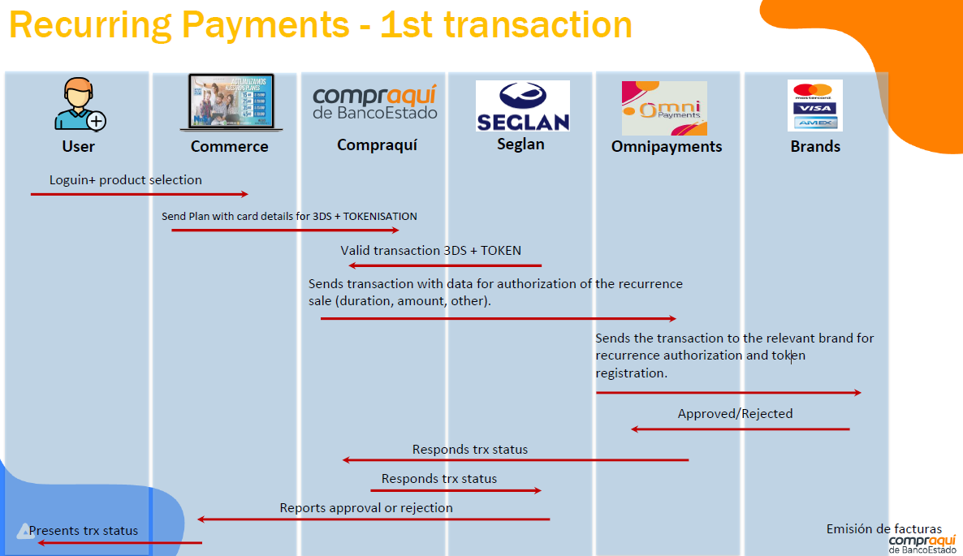

Recurring Payments - Next transaction
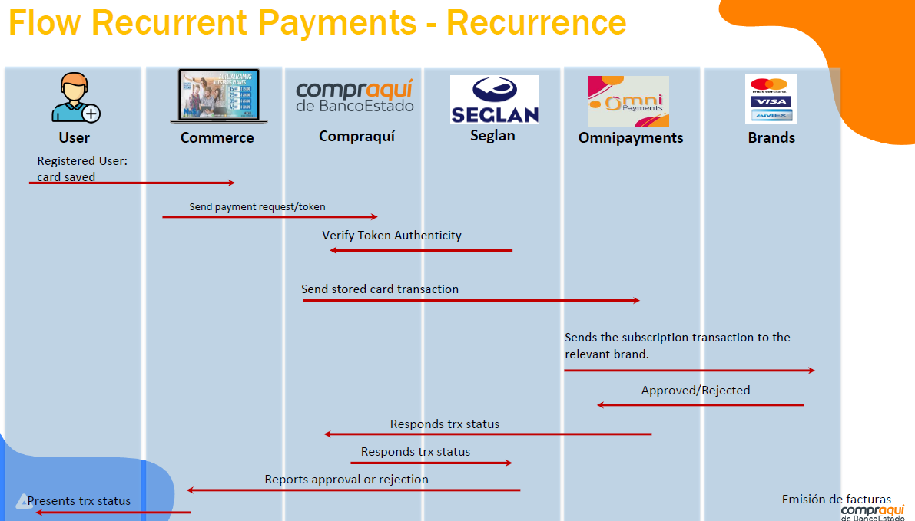

- Requirement

OmniPayments to support the recurring payment transactions receiving from all supported channels (MVP, MPOS, DA, Payment Link, H2H) except EFE for all Card brands supported (VISA, MasterCard, Maestro, AMEX).

OmniPayments will have to map the required fields to support the recurring payment transactions processed online and support any mappings required for Brand presentment.
OmniPayments will verify the required changes and will share the updated channel specifications based on the new mappings required.

- Merchant Compensation Reports Changes

BECH has asked that OP include an additional identifier column named as “PaymentTypeIndicator” at the end of the following compensation reports. This identifier will indicate whether the transaction is related to a Card on File / Recurring Payment. If the transaction is for a Recurring Payment, OP will send the value RecurringPayment in this column. For normal transactions,this column will be empty.
This enhancement will help both OP and BECH in easily identifying such transactions.

Report Names –
1. Retailer reports [CC009, CCX63]
2. Daily report
3. Pagos.csv report [CCX70]
4. Brand.csv report [CCX70]
- Brand Specification Reports

Below are the reports shared by VISA and MasterCard for mapping reference:

- Doubts

- How will be the certification process with brands?
- No Certification with Brands required
- Previous Transaction Identifier is required in recurring payment transactions. It will be received in the request or we need to fetch from old transactions?
- It will be received in the Request
- Specifications for AMEX are not shared? Recurring payment for AMEX also need to be supported right? How will it be certified?

OmniPayments
OmniPayments software is used by processors, Acquirers and Issuers. OmniPayments routes transactions to Visa for Authorization, Tokenization and Fraud prevention. It can be deployed on premise or in the cloud on HPE NonStop servers for 99.99999% availability. For further information, contact us at:
www.OmniPayments.com
OmniPayments LLC
1566 La Pradera Dr
Campbell, CA 95008, USA

