D1-CC109-Payment 365 Phase 1

Version 1.2
Date: Aug 2026

For more information contact:
Support@omnipayments.com

INDEX

1. Requirement Overview 3
2. Split1 3
3. Split 2 4
6. Changes ………………………………………………………………………………………………………………………………5

- Requirement Overview

Define the technical design to implement Change Control CC109 (Payment 365, Phase 1): weekend/holiday API-based payments for BECH (bank 012) merchants, configurable per-merchant cycle behaviors, transaction splitting, MDR prioritization, and the associated reporting change. Provider-side API integration and internally-generated reject files for 365-type weekend payments are Phase 2 out of scope here; this design exposes clean seams for that follow-on.
- High Level Architeacture

The The design layers on top of the existing CCX43/CC109 batch pipeline rather than replacing it — a new Cycle Resolver and Split Engine sit in front of the existing report generator, and a new API Payment Executor runs in parallel to the existing .txt/SFTP payment path, active only for weekend/holiday BECH traffic.
Component | Type | Responsibility
Merchant Config Service | Changed | Store & validate PaymentType/PaymentNotEligible; expose effective-dated reads
New Screen 365 MDR related | New | Uthis file we maintain the product dynamic either 365 MDR enable of disable
Weekend Split Config Service | New | CRUD for EnableSplit/SplitAmount (OmniCompensator screen), effective-dated
Cycle Resolver | New | Pure function: (date, bank_code, PaymentType) → applicable cycle window(s)
Split Engine | New | Generates Child IDPs per cycle for BECH weekend/holiday (and retains existing Banco Chile weekday split, unchanged)
MDR/Commission Resolver | Changed | Priority chain: Zero% Campaign → 365-Days MDR (Payment Group) → Regular MDR
Report Generator Service | Changed | Templated builder for all report variants incl. PaymentType column, PaymentNotEligible stream
API Payment Executor | New | Executes weekend/holiday BECH payments via bank API; retry + alerting
Reject/Reconciliation Service | Changed | Trace-ID based status rollup, Child→Parent aggregation

- Sprint

Below are the sprint wise changes
- New columns (RetailerLoader + API) schema migration, API payload, UI dropdowns, validation
2a. 365 Merchant Enable screen — bulk upload UI, backend endpoint, row-level validation, error reporting
2b. Transaction Split Amount screen WeekendSplitConfig table + OmniCompensator UI + effective-dating validation
- MDR changes Payment Group field + the Zero%→365-Days→Regular priority resolver
- New report columns PaymentType column across the report family, with the population/blank rule
- Handle 365 Merchants the Cycle Resolver logic and its truth table, including the Fri/Sat/Sun freeze rule
- Not Eligible / Specials precedence rules, exclusion filters, the parallel PaymentNotEligible report stream
- Sprint 1
New Columns — Retailer Loader + API
- DB Migration: Add PaymentType and PaymentNotEligible columns to the RetailerId table.
PaymentType: pw.CharField(max_length=40)
PaymentNotEligible: pw.CharField(max_length=8)

File Changes: modle.py

- Retailer Loader: Add both columns to the retailer load process.

Add both PaymentType and PaymentNotEligible columns to the Python retailer loader so that these values are inserted into the respective database tables when the retailer load process runs.
data["PaymentType"] = rows["PaymentType"]
data["PaymentNotEligible"] = rows["PaymentNotEligible"]

File Changes: retailer_loader.py

- Screen: Add both columns to the UI with dropdown values.

PaymentType
Dropdown Values:
- Same Cycle Payment
- Same Cycle Payment 365
- Full Day Payment
- Full Day 365 Days
- Empty
- Specials

PaymentNotEligible
Dropdown Values:
- True
- False
- Empty

File Changes: omnicomp.py,

2a. 365 Merchant Enable Screen
A dedicated screen is required to enable 365 Merchant configuration for higher MDR. The screen should include a Channel selection, which will be used to enable 365 MDR for the selected channel.
The screen should allow users to:
- Enable/disable 365 Merchant configuration.
- Select the applicable Channel.
- Configure the MDR to be applied for the selected channel.
- Maintain the configuration for each channel.
The screen should also include the following audit columns:

- Channels,
- Is_enable
- Updated By
- Updated At
A separate table, commissionconfig365, has been created to store these 365 MDR configuration values.

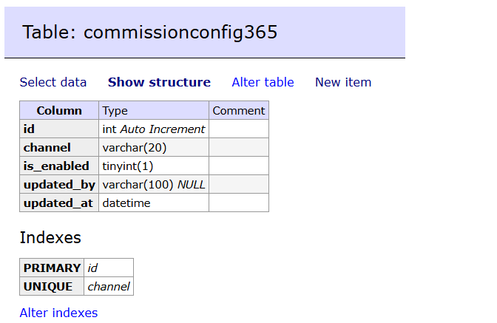

Screen:
The screenshot below shows the config 365 merchant and its current functionality.
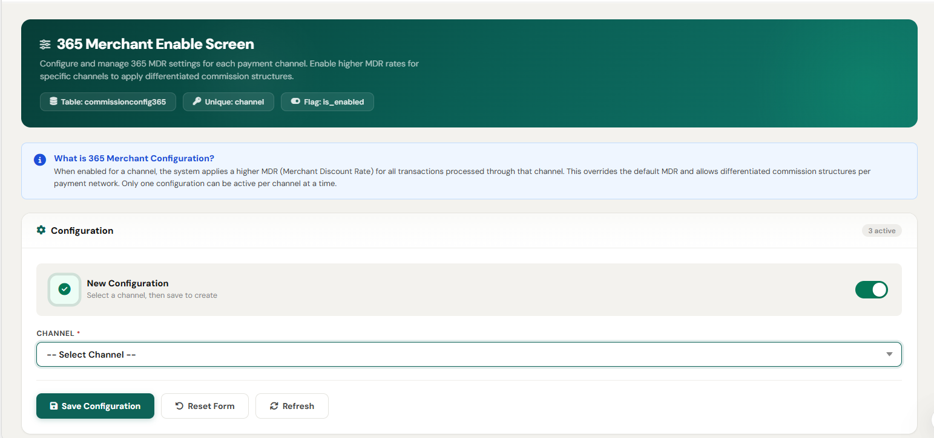

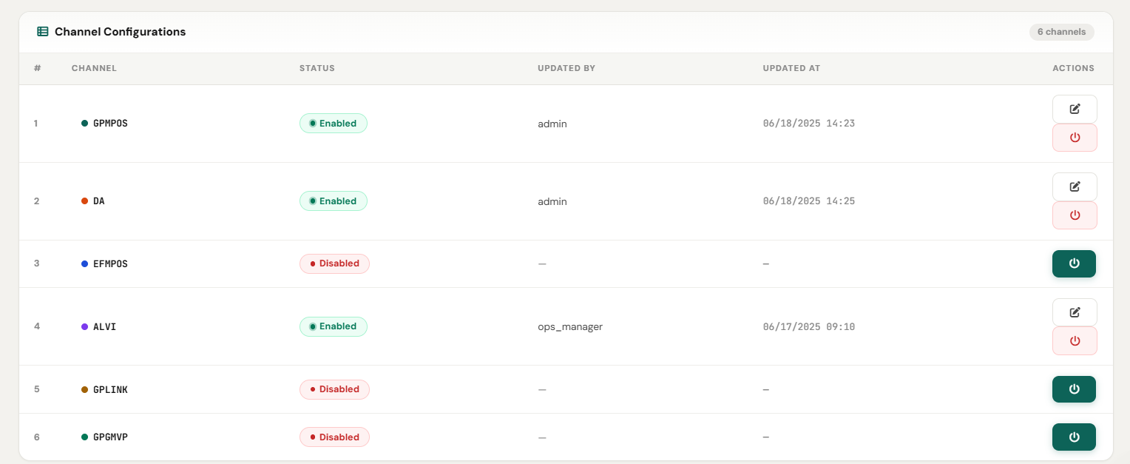

2b. Transaction Split Amount Screen
Table: WeekendSplitConfig
UI: split_logic.html

class WeekendSplitConfig(MySQLModel):
EnableSplit = pw.BooleanField(default=False)
SplitAmount = pw.IntegerField(default=0)

The screen allows configuration of the transaction split logic using the following fields:
- EnableSplit: Enable or disable transaction splitting (True / False).
- SplitAmount: Define the transaction split amount as an integer value.

Changes in Files:
- model.py
- split_logic.html
- onlicomp.py
Screen:
Below is the screenshot of the Transaction Split Amount screen.
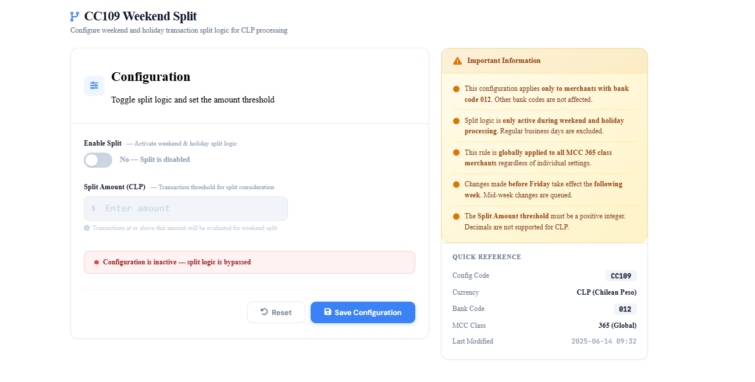

2. MDR Changes — Payment Group and Priority Resolver
Add a Payment Group field to the retailercommissionrules and retailercommissionvalues screens.
During commission calculation:
- Check the Payment Group value.
- Also Create a Table that manage 365 enable or not commissionconfig365
Table name is : commissionconfig365

Column | Type | Comment
id | int Auto Increment
channel | varchar(20)
is_enabled | tinyint(1)
updated_by | varchar(100) NULL
updated_at | datetime

- If Payment Group = "365 Days", apply the configured "365 Days" MDR commission to merchants belonging to:
  - Same Day Payment 365 Days
  - Full Day Payment 365 Days

3.1. Commission Related Changes (Corrected)
Payment Group is added as a new index alongside VATGroup in the commission rule/value tables. The commission selection logic is extended with a 365-Day tier that sits between the existing Zero Commission check and the existing VATGroup-based production logic — it never replaces VATGroup resolution, only adds a higher-priority attempt before it.
3.2 Selection Logic
- Zero Commission Check Check whether the merchant is configured in the zero_commissions table. If configured, return 0 commission immediately — this check always wins and short-circuits everything below it.
- TGR Merchant Check Check whether the retailer is configured in TGR_Merchants. If it is, skip the 365-Day tier entirely and go directly to VATGroup / existing production commission logic (Step 4).

- 365-Day Check (only reached if the retailer is NOT a TGR merchant) a. Check whether the 365-Days MDR override is enabled, and specifically whether it is enabled for this transaction's channel. b. If not enabled for this channel, go directly to VATGroup / existing production logic (Step 4). c. If enabled for this channel, check whether the retailer's configured PaymentType is a 365 type (Same Cycle Payment 365 / Full Day 365 Days). d. If it is, build the caseList with PaymentGroup added alongside VATGroup, and check whether a matching rule exists for that combination.
  - If a match exists, resolve priority among the matching caseList entries (existing 5-tier priority resolution — retailer-specific → DEFAULT-channel → retailer-DEFAULT → DEFAULT-DEFAULT → global DEFAULT) and pass the selected rule to commission calculation.
  - If no match exists, fall through to Step 4.

- VATGroup / Existing Production Logic Single, shared fallback path — reached from TGR merchants, channels not enabled for 365-MDR, non-365 PaymentTypes, and 365-eligible merchants with no matching 365 rule. Resolves commission using VATGroup only, exactly as in current production, with the same 5-tier priority resolution.

- Commission Calculation The resolved rule (either from the 365 tier or the VATGroup tier) is passed to the existing calculation formula — unchanged.

3.3 Flow Diagram

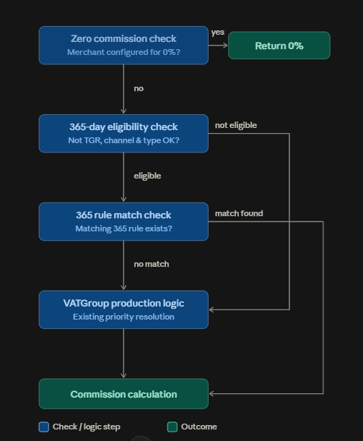

3.4 Files Impacted
File | Change
model.py | Add PaymentGroup field to retailercommissionrules / retailercommissionvalues models; add new CommissionConfig365 model (per-channel 365-MDR enable/disable)
liquidation.py | Extend preload_data() to load TGR_CONFIG_SET and MDR_365_CONFIG; extend check_vat() / get_commission() with the TGR → channel-enabled → PaymentType → PaymentGroup-match chain described above
omnicomp.py | New screen for enabling/disabling 365-Days MDR per channel (backs CommissionConfig365)
retailercommissionrule.html | Add PaymentGroup dropdown field to the rule configuration form
retailercommissionvalues.html | Add PaymentGroup dropdown field to the values configuration form

- New report columns PaymentType column across the report family, with the population/blank rule
During commission calculation we add payment typegroup using that add this column in the reports those are mentation in the R1

- Handle 365 Merchants the Cycle Resolver logic and its truth table, including the Fri/Sat/Sun freeze rule
There are six PaymentType categories:
- Same Cycle Payment
- Same Cycle Payment 365
- Full Day Payment
- Full Day 365 Days
- Empty
- Specials

During commission calculation, the PaymentType column is added and populated with the configured value. Liquidation is performed cycle-wise, and the corresponding PaymentType value is stored with the liquidation data.
For the fresh flow, the PaymentType value is used to determine the applicable processing flow, particularly for weekends and holidays.

  - Same Cycle Payment
Merchants configured with Same Cycle Payment will continue to follow the existing production behavior without any changes.
Transactions are processed in two cycles per day based on Chile time:
- Cycle 1: 00:00:00 – 13:59:59
- Cycle 2: 14:00:00 – 23:59:59

Existing production flow — no changes.

  - Same Cycle Payment 365
Merchants configured with Same Cycle Payment 365 will follow two different processing behaviors.
- Weekdays
  - Two cycles, C1 and C2, will be followed.
  - Existing cutover timings will apply:
  - C1: 00:00:00 – 13:59:59
  - C2: 14:00:00 – 23:59:59
  - The PaymentType will be stored against the respective cycle.
  - Payment execution will be performed through .txt files.

- Weekends and Holidays
  - These merchants are also eligible for weekend and holiday payments.
  - Weekend and holiday transactions will be processed in C2.
  - Payment execution will be performed through the API.
  - Only transactions with Bank Code = 012 will be considered.
  - Transactions with other bank codes will be skipped.
  - The skipped transactions will continue to be processed through the normal weekday flow.
  - Other transactions are skip and reports are generate on weekday

  - Full Day Payment
Merchants configured with Full Day Payment will follow a single-cycle processing model.
All transactions for the day will be grouped using the full-day cutover:
- Full Day: 00:00:00 – 23:59:59 Chile time
Rules:
- No weekend payments will be generated.
- No holiday payments will be generated.
- Reports will be generated only on weekdays.
- Transactions will be identified using the PaymentType value.

  - Full Day 365 Days
Merchants configured with Full Day 365 Days will follow the Full Day Payment behaviour on weekdays and will additionally support weekend and holiday payments.
Weekdays
- Full-day processing will be performed.
- Payment will be generated in Cycle C2.
- Payment execution will be performed through .txt files.
Weekends and Holidays
- Payments will be generated through the API.
- Only transactions with Bank Code = 012 will be considered.
- Transactions with other bank codes will be skipped.
- The skipped transactions will be processed through the normal weekday flow.

  - Empty
If the PaymentType field is Empty, the merchant will follow the same behavior as Full Day Payment.
Therefore:
- Single full-day processing.
- Cutover: 00:00:00 – 23:59:59
- No weekend payments.
- No holiday payments.
- Reports generated only on weekdays.

  - Specials
- Merchants configured with:
- PaymentType = Specials
- must be excluded from this process.
- They must not be included in any reports generated from the CC109 flow.
PaymentType | Weekday | Weekend/Holiday | Payment Method | Bank Code
Same Cycle Payment | C1 + C2 | Existing production behavior | Existing flow | All Bank Code
Same Cycle Payment 365 | C1 + C2 | C2 | .txt / API | 012 only for weekend/holiday
Full Day Payment | Full Day | No payment | Existing flow | All Bank Code
Full Day 365 Days | Full Day / C2 | Supported | .txt / API | 012 only for weekend/holiday
Empty | Same as Full Day | No payment | Existing flow | All Bank Code
Specials | Excluded | Excluded | Not applicable | Not applicable

PaymentType
│
├── Same Cycle Payment
│ └── Existing Production Flow
│
├── Same Cycle Payment 365
│ ├── Weekday → C1 / C2
│ └── Weekend/Holiday → C2 + API + Bank Code 012
│
├── Full Day Payment
│ └── Weekday → Full Day
│
├── Full Day 365 Days
│ ├── Weekday → Full Day / C2
│ └── Weekend/Holiday → API + Bank Code 012
│
├── Empty
│ └── Same as Full Day Payment
│
└── Specials
└── Exclude from CC109 reports

- Not Eligible / Specials precedence rules, exclusion filters, the parallel PaymentNotEligible report stream
A separate table will be created to store transactions identified as Payment Not Eligible during Phase One (P1) or the respective processing flow.
During P1:
- Identify merchants where PaymentNotEligible = True.
- Store the corresponding transactions in the separate PaymentNotEligible table.
- During Phase Two (P2), retrieve the transactions from this table.
- Exclude transactions from other channels.
- Process and store only transactions where:
  - ChannelType = GPMPOS
  - PaymentNotEligible = True
- Generate a separate report stream for these transactions.
PaymentNotEligible Rules
- If PaymentNotEligible is = True or Empty, the transaction will be considered in the regular payment reports.
- If PaymentNotEligible = True, the transaction will not be included in the regular payment reports.
- Instead, the corresponding reports will be generated separately using the standard report naming convention with the suffix:
_PaymentNotEligible
The suffix must be added before the file extension.

Example Report Names
YYYYMMDD_GPSMARTPOS_C2_DepositDetails_PaymentNotEligible.csv
YYYYMMDD_GPSMARTPOS_C2_TransactionsDetails_PaymentNotEligible.csv
YYYYMMDD_GPSMARTPOS_C2_valevista_PaymentNotEligible.txt
YYYYMMDD_GPSMARTPOS_bancodechile_PaymentNotEligible.txt
SMARTPOS_DEPOSIT_REPORT_C2_YYYYMMDD_PaymentNotEligible.txt
YYYYMMDD_GPSMARTPOS_C2_DepositDetailsR1_PaymentNotEligible.csv
YYYYMMDD_GPSMARTPOS_C2_TransactionsDetailsR2_PaymentNotEligible.csv
PurchaseApproved_ReversalDecline_OriginalStatusTxns_SameDayPayment_C2_YYYYMMDD_PaymentNotEligible.csv

Processing Flow
P1 / Processing Flow
↓
Check PaymentNotEligible
↓
PaymentNotEligible = True?
├── No / Empty/False → Regular Payment Reports
│
└── Yes
↓
Store in PaymentNotEligible Table
↓
P2
↓
Retrieve PaymentNotEligible Transactions
↓
Filter ChannelType
↓
Keep GPMPOS Only
↓
Generate Separate Reports
↓
_ReportName_PaymentNotEligible

This keeps the PaymentNotEligible transactions in a parallel reporting stream while maintaining the existing standard reporting flow for eligible transactions.

- Split Transaction Amount:
Table
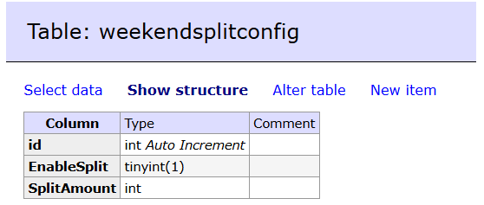

Screen:
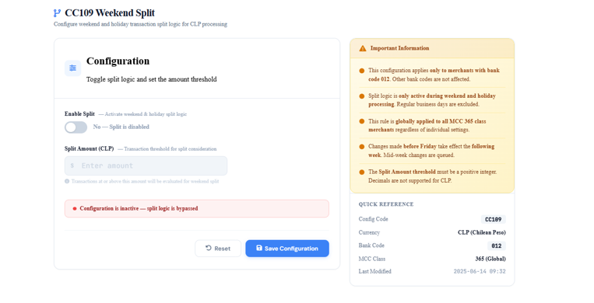

7.1 Configuration
Field | Type | Description
EnableSplit | YES/NO toggle | Controls whether split logic applies during weekend/holiday BECH (bank code 012) processing
SplitAmount | Numeric | Transaction amount threshold above which a merchant's weekend/holiday transaction(s) are split into multiple payment records

Configuration is global applied to all 365-category merchants, not set per merchant in CC109. Validation: SplitAmount must be populated whenever EnableSplit = YES; the UI must block enabling split without a configured amount.
6.2 OmniCompensator Screen
New "CC109 Weekend Split" screen where Compraqui configures EnableSplit and SplitAmount. Config changes must be saved before Friday cutoff to apply to the immediately upcoming weekend — changes made Monday or during an active weekend run apply starting the next weekend instead.
6.3 Split Logic
1. On weekend/holiday processing run:
Check EnableSplit config
NO -> skip split logic entirely, process as single payment line (existing behavior)
YES -> continue to step 2

2. Fetch configured SplitAmount

3. For each Bank Code = 012 (BECH) merchant transaction (or grouped
transactions sharing the same merchant):
IF transaction amount (or combined amount) > SplitAmount:
- Split into multiple payment records, nearest to SplitAmount per group
- Assign a new Child IDP to each split record
(Parent IDP + 2-digit sequence, e.g. IDP018NAN37ae577e42d01)
- Original Parent/Main IDP is retained on every split record
ELSE:
- Process as a single payment record, no Child IDP needed

4. Reporting:
- New "Child IDP" column appended to DepositDetails.csv / DepositDetailsR1.csv
- Existing "ID Deposito" column in TransactionDetails.csv /
TransactionDetailsR2.csv reused to carry the Child IDP value
(falls back to the original Parent IDP when there's no split)

5. Payment file (.txt) constraint:
- Child IDP values must NEVER appear in the .txt payment file
- Only the original Parent/Main IDP is written to the deposit line
body (positions 12–71), even when multiple split lines share it

Note
the primary implementation of this split logic is mentation above, the main split login is done on Phase Two

OmniPayments
OmniPayments software is used by processors, Acquirers and Issuers. OmniPayments routes transactions to Visa for Authorization, Tokenization and Fraud prevention. It can be deployed on premise or in the cloud on HPE NonStop servers for 99.99999% availability. For further information, contact us at:
www.OmniPayments.com
OmniPayments LLC
1566 La Pradera Dr
Campbell, CA 95008, USA

