CC109-Payment 365
Phase 1

Version 1.30
Date: Jun 2026

For more information contact:
Support@omnipayments.com

INDEX

1. Requirement Overview 4
2. Current State 4
3. Merchant API Enhancement 5
4. Payment Processing behavior 7
4.1 Payment Type = Same Cycle Payment (Existing Behavior) 7
4.2 Payment Type = Same Cycle Payment 365 (New Behavior) 7
4.3 Payment Type = Full Day Payment (New Behavior) 8
4.4 Payment Type = Full Day 365 Days (New Behavior) 8
4.5 Payment Type = Empty (New Behavior) 9
4.6 Payment Type = Specials (New Behavior) 9
5. “PaymentNotEligible” Field Logic 10
6. Merchant Transaction Split Logic 11
6.1 OmniCompensator Changes 11
6.2 Changes in the Compensation Reports for BECH merchant transactions splitting on weekends and holidays 14
6.2.1 “ID Deposito” Column Behavior 15
6.2.2 Transaction Grouping Logic for Split Amount Processing 16
6.2.3 Single Transaction Exceeding Split Amount Limit 20
6.2.4 Payment .txt file behaviour 22
6.3 Example Scenario – Payment Status Behaviour for Split Transactions 25
6.3.1 Original transaction received from merchant: 25
6.3.2 First Day Processing 26
6.3.3 Payment Execution Result 27
6.3.4 Next Day Processing 28
6.4 Banco Chile Transaction Split Logic 29
7. Payment Processing Rules and Report Enhancements 30
7.1 MDR (Commission) Handling 30
7.1.1 365 Payment Types 30
7.1.2 Non-365 Payment Types 34
7.1.3 Preference to Zero % Commission Campaign 34
7.2 Report Enhancement – New PaymentType Column 39
7.3 Exclusion of CCX70 Merchants from CC109 Reporting 40
7.4 Merchant Installment Transaction handling on weekends and holidays 41
7.5 Weekend Migration 41
7.6 Future Scope Consideration 42
8. Regular Payment Report Generation Logic 42
8.1. Weekday Report Generation 43
8.1.1 Cycle 1 Reports 43
8.1.2 Cycle 2 Reports 44
8.2 Weekend and Holiday Report Generation 45
8.2.1 Saturday Processing (Chile Morning) 45
8.2.2 Sunday Processing (Chile Morning) 46
8.2.3 Special Handling 46
8.3 Monday Processing (Cycle 2) 47
8.4 Exception Handling 48
8.5 Supporting excel sheet 48
9. PaymentNotEligible Merchants Report Generation Logic 49
10. Reject Flow processing 50
11. Merchant Compensation Reports – SFTP and OmniCompensator Availability 50
12. Assumptions and noted Points 51
13. Implementation effort 52
14. Implementation costs 52
15. Doubts 53

- Requirement Overview

The objective of the Payment 365 Days project is to enable BECH merchant payments on weekends and holidays through API integration. Existing weekday payment processing using .txt files will remain unchanged. Compraqui plans to implement this project in two phases. This document describes the scope of Phase 1.
Phase 1 includes changes only for the Merchant API, Omni Console, OmniCompensator and Compensation Reports. Changes related to the Provider API will be discussed in Phase 2.
- Current State

2.1 CCX43 Same-Day Payment Flow
Currently, BECH merchant payments are processed only on weekdays through a file‑based approach using CCX43 i.e. Same Cycle Payment.

Existing Flow:
- OP generates payment files (e.g. CCX43 .txt reports) from the Compensation module in two cycles:
Cycle 1 (C1) – Cutover as 00:00:00 – 13:59:59
Cycle 2 (C2) – Cutover as 14:00:00 – 23:59:59
- Payment files are shared with Compraqui’s Payment Team.
- Compraqui verifies the files manually.
- Verified files are uploaded to the BECH portal.
- Payments are executed via wire transfer.
- After execution, Compraqui sends a payment status / reject file back to OP.
- OP processes the reject file and updates transaction status (PAGADO / RECHAZADO).

Limitations:
- Manual intervention required.
- Dependency on file uploads and verification.
- Fixed two‑cycle payment structure.

- Merchant API Enhancement

Compraqui requires OP to make the payment cycle behavior merchant‑configurable.

Merchant API Enhancement:
Two new fields will be introduced in the Merchant API for GPMPOS channel merchants:

1.Field Name: PaymentType

Allowed Values:
- Same Cycle Payment
- Same Cycle Payment 365
- Full Day Payment
- Full Day 365 Days
- Empty
- Specials [not included in the reports]

Details:
- This field will determine the payment cycle behavior for the merchant.
- Compraqui will set this value during merchant creation via Omni UI.
- The value can also be updated at any time through Omni UI or API integration.

2. Field Name: PaymentNotEligible

Allowed Values:
- True (merchant must be excluded from payment reports)
- False (merchant must be included in payment reports)
- Empty

Details:
- This field will control whether the merchant is considered in payment report generation.
- Compraqui will set this value during merchant creation via Omni UI.
- The value can be updated at any time through Omni UI or API integration.

API Changes:
- Two new JSON fields will be introduced in the Merchant API:
  - PaymentType
  - PaymentNotEligible
- These fields will be exposed as dropdown/select options with the predefined values listed above.
- This will allow Compraqui to create and update merchant configurations dynamically via API integration.

Effective Behavior:
Any configuration changes made to these fields will take effect starting from the next Cycle 1 onward.

Note: To maintain a consistent API structure across all channels, Compraqui will introduce the new fields (PaymentType and PaymentNotEligible) for all channels.
However, during CC109 report generation, OP will consider only GPMPOS (0012) merchants. Merchants belonging to other channels (such as DA, GPMVP, H2H, EFE, GPLINK) will be ignored regardless of the values configured in these fields.
Compraqui may keep these fields empty for channels DA, GPMVP, H2H, EFE, GPLINK during merchant creation or update. Even if values are provided, OP will ignore these fields for all channels other than GPMPOS.

Loader Support:
For bulk updates to add/update values into above 2 new fields for merchants, OP will provide Compraqui with a loader screen in the Omni UI along with the required file format. Using this loader screen, Compraqui will be able to update the values of merchants on the same day. The loader can support up to 5,000 merchant updates at a time. This Omni UI loader will function independently from the modifyMerchant-Req API and will be available for use at any time. OP will also share a user manual with Compraqui explaining how to use the loader and the required format.

- Payment Processing behavior

The payment processing behavior in OP will vary depending on the configured PaymentType. The system will dynamically determine the processing logic for each transaction based on the merchant’s PaymentType.

4.1 Payment Type = Same Cycle Payment (Existing Behavior)
Merchants configured under “Same Cycle Payment” will follow the existing production behavior without any changes.

In this setup, transactions are processed in two cycles within a day based on defined cutover timings:
Cycle 1: 00:00:00 – 13:59:59 (Chile time)
Cycle 2: 14:00:00 – 23:59:59 (Chile time)

- Each cycle is processed independently, meaning payment calculation, file generation, and reporting are done separately for Cycle 1 and Cycle 2.
- For bank-level handling, Cycle 1 will include only transactions where bank code = 012 (BECH). All transactions with bank code ≠ 012 will be processed in Cycle 2, regardless of transaction time.
- Payments for these merchants will be executed only on weekdays (Monday to Friday) using the standard .txt payment files, and no processing will occur on weekends or holidays.

4.2 Payment Type = Same Cycle Payment 365 (New Behavior)
Merchants configured under “Same Cycle Payment 365” will follow the same behavior as Same Cycle Payment during weekdays, ensuring consistency with existing production logic.

This means:
- Two cycles (Cycle 1 and Cycle 2) will be followed
- Same cutover timings will apply
- Payment execution will be done via .txt files
- In addition to weekday processing, these merchants will also be eligible for weekend and holiday payments.

During weekends and holidays:
- Payment will be processed in single cycle only ie. C2
- Payments will be processed via API instead of .txt files
- Only transactions with bank code = 012 (BECH) will be considered
- Transactions with bank code ≠ 012 will not be processed and will be included in the next weekday cycle

4.3 Payment Type = Full Day Payment (New Behavior)
Merchants configured under “Full Day Payment” will follow a single-cycle processing model.
In this approach, all transactions for the day will be grouped together using a full-day cutover:
- Cutover: 00:00:00 – 23:59:59 (Chile time)

Unlike Same Cycle Payment, these merchants will be processed only in Cycle 2, and Cycle 1 will not be applicable.
Payments will be executed only on weekdays (Monday to Friday) using .txt files, with no processing on weekends or holidays.
As a result, reporting and payment files will contain complete day transactions in a single cycle, simplifying settlement for these merchants.

4.4 Payment Type = Full Day 365 Days (New Behavior)
Merchants configured under “Full Day 365 Days” will follow the Full Day Payment behavior during weekdays and will additionally support weekend and holiday payments.

During weekdays:
- Full-day processing will be followed
- All transactions (00:00:00 – 23:59:59) will be processed in Cycle 2
- Payments will be executed via .txt files

During weekends and holidays:
- Payments will be executed via API
- Only transactions with bank code = 012 (BECH) will be processed
- Transactions with bank code ≠ 012 will be deferred to the next weekday cycle
- This configuration combines the simplicity of full-day processing with the flexibility of 365-day payment execution.

4.5 Payment Type = Empty (New Behavior)
- If the PaymentType field has Empty value, the merchant will follow the same behavior as Payment Type = Full Day Payment (refer to Section 4.3).
- This ensures a default processing logic is applied when no explicit configuration is provided.
- For transactions of this type, in the “PaymentType” column of TransactionDetails and DepositDetails reports (with and without R1 and R2), OP should keep the column empty and should not populate it with “Full Day Payment”.

4.6 Payment Type = Specials (New Behavior)
- Merchants configured with Payment Type = Specials must be excluded from this process ie from all reports generated from CC109 flow.
- The assumption will be these merchants might be handled under the CCX70 Parametric Payment System.

Additional Condition:

- If a merchant is marked as “Specials” but is not configured under the CCX70 Parametric Payment System, then:
  - All transactions for such merchants must not be included in any compensation reports [ie. Not in CCX43, CC109, CCX63, CC009, CCX70 nowhere].

OP will make separate reference report named as “Special_PaymentType_MerchantTransactions_ YYMMDD.csv” if there are any transactions with payment Type = Special which are not configured under “Parametric payment flow”. This report will have same structure and columns as “PurchaseApproved_ReversalDecline_OriginalStatusTxns_SameDayPayment_C1/C2_YYMMDD.csv”.
- “PaymentNotEligible” Field Logic

Regardless of the value received in the PaymentType field, report generation must be driven based on the value of the PaymentNotEligible field.

If the PaymentNotEligible field is set to True:
- The merchant must be excluded from regular payment reports.
- Accordingly, all transactions for such merchants must not be included in the Regular Payment Reports (refer to Section 8: Regular Payment Report Generation Logic).
- Instead, these transactions must follow the report generation logic defined under Section 9: PaymentNotEligible Merchants Report Generation Logic.
- Additionally, such merchants must not be processed for payments via API.

If the PaymentNotEligible field is set to False:
- The merchant must be included in regular payment reports.
- Accordingly, all transactions for such merchants must be included in the Regular Payment Reports (refer to Section 8).

If the PaymentNotEligible field is Empty:
- The system will treat it as False by default.
- Accordingly, the merchant will be included in the Regular Payment Reports (refer to Section 8).

Note: The “PaymentNotEligible” flag takes precedence over “PaymentType” for both report generation and API-based payment processing.

- Merchant Transaction Split Logic

6.1 OmniCompensator Changes
OP will provide a new screen named “CC109 Weekend Split” to Compraqui, where Compraqui can configure the transaction amount threshold for splitting BECH bank account transactions during weekends and holidays.
Using this screen, Compraqui can configure whether split logic should be applied during Weekends and Holidays also also configure corresponding split amount limits.

This configuration will be applicable only for:
- Merchants having Bank Code = 012
- Weekend/Holiday processing transactions

Whatever value is configured in this field will be used by OP for applying split transaction logic during weekend and holiday processing.

The configuration will be applied globally for all 365 category merchants and not at individual merchant level.

The “CC109 Weekend Split” screen will contain the field:
- EnableSplit
- SplitAmount

Configuration Fields:
Field Name | Description | Example Value
EnableSplit | Controls whether split logic should be applied during weekends & Holidays | YES / NO
SplitAmount | Transaction amount threshold to be considered for weekend & Holidays split logic | 7,000,000

Processing Logic-

If: EnableSplit = YES
Then: OP will apply split transaction logic for weekend and holidays processing transactions based on the value configured in SplitAmount.

If: EnableSplit = NO
Then: OP will not apply split logic during weekends and holidays. Merchant transactions will continue as a single payment line even for large transaction amounts.

Example1: Configuration

Configuration | Value
EnableSplit | YES
SplitAmount | 7,000,000

Resulting Behavior

Day Type | Split Logic Applied | Payment Line Behavior
Weekdays | NO (Existing Logic) | Single Payment Line
Weekends | YES (If Amount > 7,000,000) | Multiple Split Payment Lines
Holidays | YES (If Amount > 7,000,000) | Multiple Split Payment Lines

Example 2: Configuration

Configuration | Value
EnableSplit | NO
SplitAmount | Empty

Resulting Behavior

Day Type | Split Logic Applied | Payment Line Behavior
Weekdays | NO (Existing Logic) | Single Payment Line
Weekends | NO | Single Payment Line
Holidays | NO | Single Payment Line

Other Example Scenario cases-
If:
- Payment Type = SAME CYCLE PAYMENT/ FULL DAY PAYMENT
- Transaction received on Saturday

Then:
- As per existing logic, OP will include the transaction in Monday’s processing/report generation cycle.
- Since the transaction is not processed during weekend cycle execution, weekend split logic must not be applied.

Configuration Effective Behavior-
Compraqui must update the configuration values before Friday for changes to be applied during the upcoming weekend processing.
If configuration values are updated on Monday or after weekend processing has started:
- The updated configuration will become effective from the next upcoming weekend onwards.

Below is the sample dummy screen of Omni Compensator for reference –

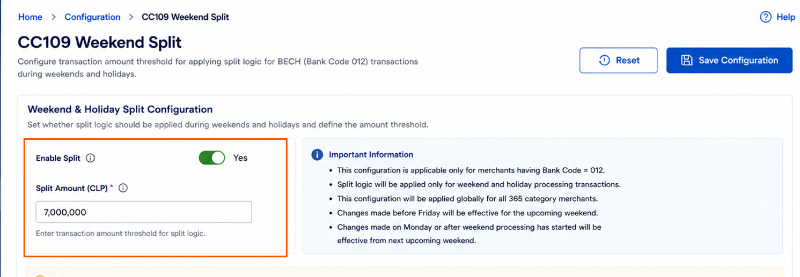

Note –
- If “EnableSplit” is configured as YES, then the corresponding Split Amount field must contain a valid amount value.
- If the Split Amount field is empty, then the corresponding Split Enabled toggle must remain NO.
- OP should display validation message in Omni Compensator if user tries to enable split logic without configuring the split amount.

6.2 Changes in the Compensation Reports for BECH merchant transactions splitting on weekends and holidays
To achieve this, OP will introduce a new column called “Child IDP” at the end of the following reports:
- DepositDetails.csv
- DepositDetails R1.csv

Additionally, OP will reuse the existing column “ID Deposito” and populate it with the Child IDP value in the following reports:
- TransactionDetails.csv
- TransactionDetails R2.csv

6.2.1 “ID Deposito” Column Behavior

OP will reuse the ID Deposito column in the TransactionDetails.csv and TransactionDetailsR2.csv reports for storing the Child IDP value.
To maintain compatibility with the current production behavior:
- If a Child IDP exists for a split transaction scenario, OP will populate the Child IDP value in the ID Deposito column.
- If no Child IDP exists (non-split transaction scenario), OP will continue to populate the original Parent/Main IDP value in the ID Deposito column, similar to the current production implementation.

Example –

Scenario | IDP | Child IDP | Value Populated in "ID Deposito" Column
Split Transaction | IDP018NAN37ae577e42d | IDP018NAN37ae577e42d01 | IDP018NAN37ae577e42d01
Non-Split Transaction | IDP018NAN37ae577e42d | Not Applicable | IDP018NAN37ae577e42d

6.2.2 Transaction Grouping Logic for Split Amount Processing
For weekend or holidays, if “EnableSplit” is Active or YES and the combined amount of multiple transactions of same merchant exceeds the configured “SplitAmount” value, OP will group transactions into separate payment sets based on the nearest possible amount close to the configured threshold value.
Since it may not always be possible to create a transaction group with the exact configured split amount, OP will identify the nearest possible transaction combination and generate separate Child IDPs accordingly.

Example Scenario (In Omnicompensator)-
- EnableSplit = Yes
- SplitAmount = 7,000,000

In this case:
- OP will first assign a common Parent IDP for all merchant transactions.
- OP will then group transactions into separate Child IDPs based on the nearest possible amount close to 7,000,000.

Example:
IDP = IDP018NAN37ae577e42d
- Amount = 6,996,723
  - IDP: IDP018NAN37ae577e42d
  - Child IDP: IDP018NAN37ae577e42d01
- Remaining Amount = 408,088
  - IDP: IDP018NAN37ae577e42d
  - Child IDP: IDP018NAN37ae577e42d02

IDP | Child IDP / ID Deposito | Amount
IDP018NAN37ae577e42d | IDP018NAN37ae577e42d01 | 6,996,723
IDP018NAN37ae577e42d | IDP018NAN37ae577e42d02 | 408,088

Report Behaviour

- In DepositDetails.csv, there will be two payment lines with the same IDP but different Child IDPs.
- In TransactionDetails.csv, all transactions will continue to have the same IDP, but they can be differentiated using the “ID Deposito” column.
- All transaction groups will remain associated with the same Parent IDP.
- Each split transaction group will receive a unique Child IDP.
- Child IDPs will be generated by appending a sequence number to the Parent IDP.
- OP will follow the same grouping logic for both: Weekends and Holidays
- This logic is applicable only for merchants with Bank Code = 012.

DepositDetailsR1.csv report -

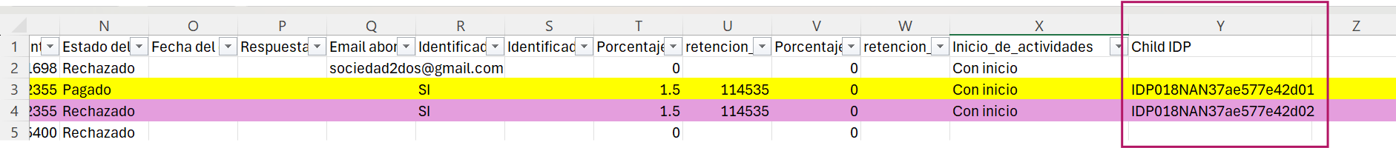

TransactionDetailsR2.csv report-

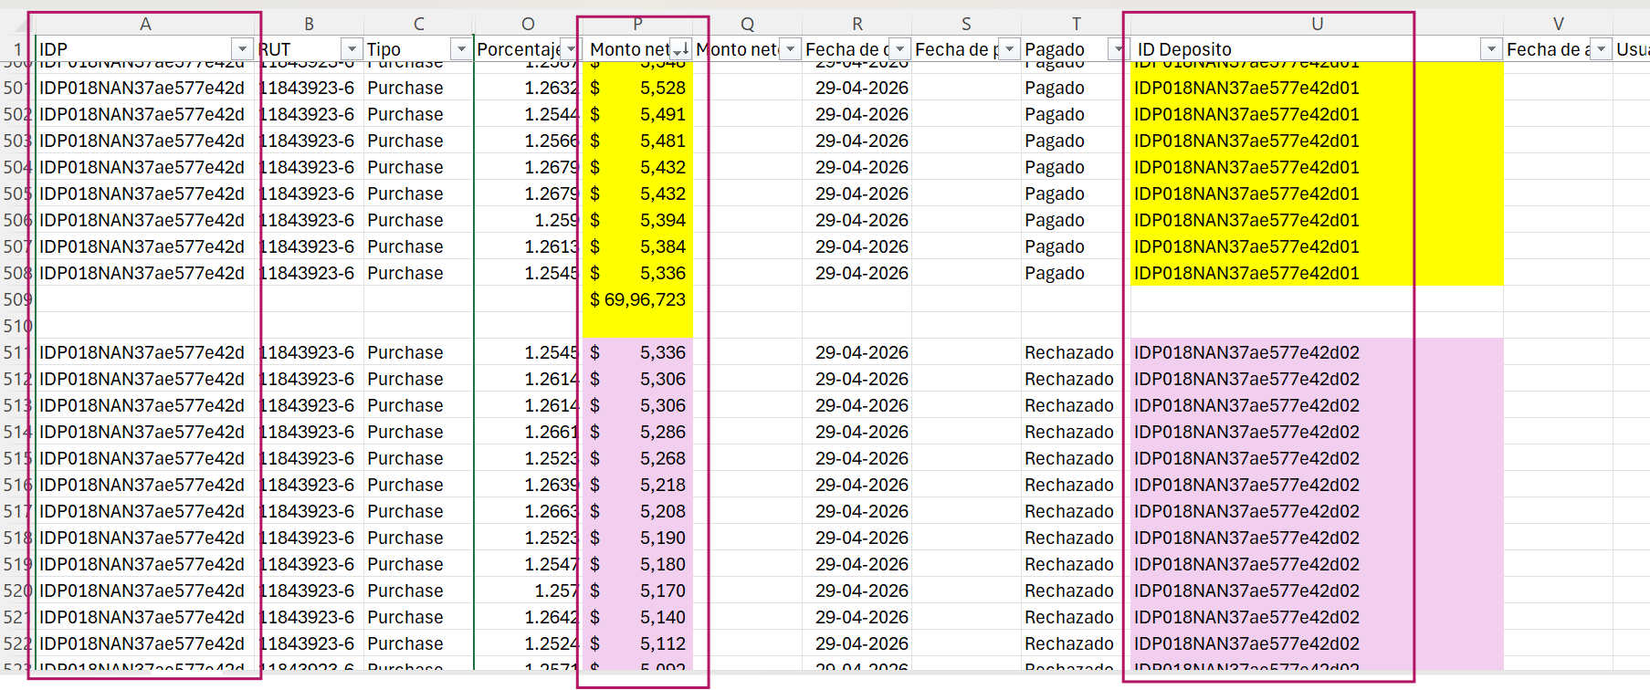

Attached in the sample R1 and R2 reports for reference –

The same flow will continue for reject handling as well.

Example:

- If payment for Child IDP IDP018NAN37ae577e42d01 gets status as PAGADO, then all transactions mapped to that Child IDP will have PAGADO status.
- If payment for Child IDP IDP018NAN37ae577e42d02 gets rejected, then all transactions mapped to that Child IDP will have RECHAZADO status.

Attached in the sample without R1 and R2 reports for reference –

Important Note
Child IDPs will not be maintained across cycles.

Example:
Day 1:
- Total Transactions = 8M
  - 7M → PAGADO
  - 1M → RECHAZADO
Day 2:
- Rejected Transactions = 1M
- Fresh New Transactions = 8M

In this case, OP will consider all 9M transactions together and assign Child IDPs again. OP will not track previous day Child IDPs.

However, OP will continue to maintain the main IDP and retry the payment until IDP110, with no changes to the existing retry flow.

6.2.3 Single Transaction Exceeding Split Amount Limit
For weekend or holidays, if “EnableSplit” is Active or YES and a single BECH merchant transaction amount itself exceeds the configured “SplitAmount” value, OP will split the transaction amount into multiple payment records and assign separate Child IDPs using the same Child IDP generation logic described in the previous section 6.2.2.

Example Scenario (In Omnicompensator)-
- EnableSplit = Yes
- SplitAmount = 7,000,000

If a single transaction amount exceeds 7,000,000, OP will split the payment amount into multiple payment records.

IDP | Child IDP | Amount
IDP018NAN37ae577e42d | IDP018NAN37ae577e42d01 | 7,000,000
IDP018NAN37ae577e42d | IDP018NAN37ae577e42d02 | Remaining Amount

Report Behavior
DepositDetailsR1.csv / DepositDetails.csv
- OP will split the transaction into multiple payment records based on the configured split limit.
- Each split payment record will contain a different Child IDP.
- Multiple payment lines will be generated for the same original transaction.

TransactionDetailsR2.csv / TransactionDetails.csv
- OP will continue to maintain a single transaction record with the complete original transaction amount.
- No transaction-level split will be displayed in these reports for this specific scenario.
- Only payment-level splitting will be reflected in deposit reports and payment files.

However, in cases where a split transaction fails — meaning that for a transaction amount greater than 7M, the second split transaction is rejected — OP should include both transactions in the reject reports generated on the next day (TransactionDetails.csv).
- The first transaction should be shown with status as PAGADO.
- The second transaction should be shown with status as RECHAZADO.

Child IDP | Status
IDP018NAN37ae577e42d01 | PAGADO
IDP018NAN37ae577e42d02 | RECHAZADO

Note:
- OP will follow the same splitting logic for both: weekends and holidays
- This logic is applicable only for merchants with Bank Code = 012 on weekends and holidays.

In R1 report –

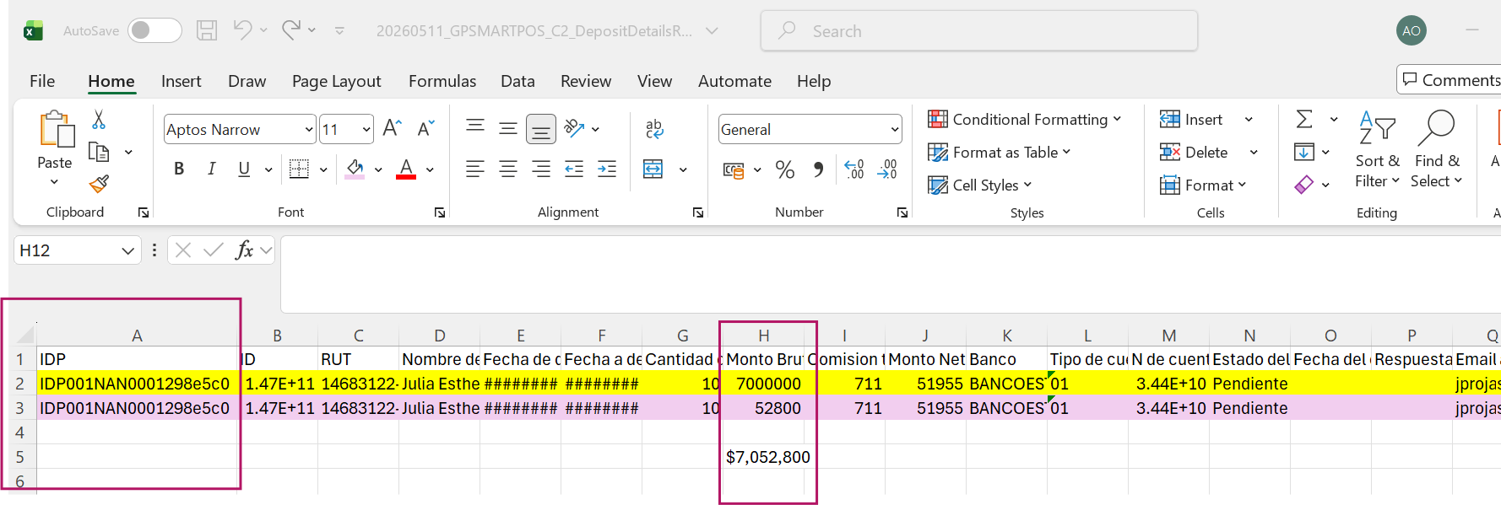

In the R2 report –
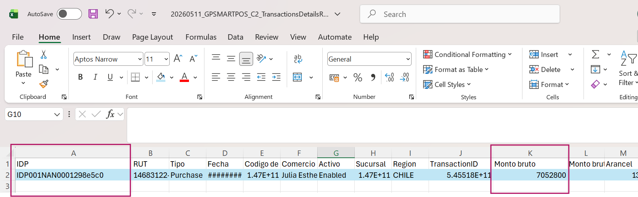

Sample reference reports for example-

6.2.4 Payment .txt file behaviour

For weekend or holidays,If the merchant Bank Code = 012 and “EnableSplit” is Active or YES, then OP may generate multiple payment lines in the SMARTPOS_DEPOSIT_REPORT_C*_YYYYMMDD.txt payment file whenever the configured “SplitAmount” condition is satisfied.

Example Scenario=
- Processing Day = Saturday
- EnableSplit = Yes
- SplitAmount = 7,000,000
- Transaction Amount = 10,000,000

In this case, OP will generate multiple payment lines in the payment file using the same original Parent/Main IDP, similar to the current Banco Chile transaction split behavior.

Example

Payment Line | IDP | Amount
Payment Line 1 | IDP001NAN91bc881f71a | 7,000,000
Payment Line 2 | IDP001NAN91bc881f71a | 3,000,000

Behavior
- Same Parent/Main IDP will be repeated across multiple payment lines.
- Child IDPs must not appear in the .txt payment files.

Banco Chile Payment File Behavior
There will be no change in the existing Banco Chile payment file structure:
- YYYYMMDD_GPSMARTPOS_bancodechile.txt
Current production behavior will remain unchanged.

IDP Population Rules in .txt Files
Even in split transaction scenarios:
- OP must populate only the original Parent/Main IDP in the .txt payment files.
- Child IDP values must not appear anywhere in the .txt files.

As defined in the Deposit Document Format Specification:
- Positions 12 to 71 must contain only the original Parent/Main IDP value.
- Child IDP values must not be populated in these positions.

This behavior will remain consistent with the current production implementation followed for Banco Chile split transactions.

Note:
- OP will follow the same splitting logic for both: weekends and holidays
- This logic is applicable only for merchants with Bank Code = 012 on weekends and holidays.

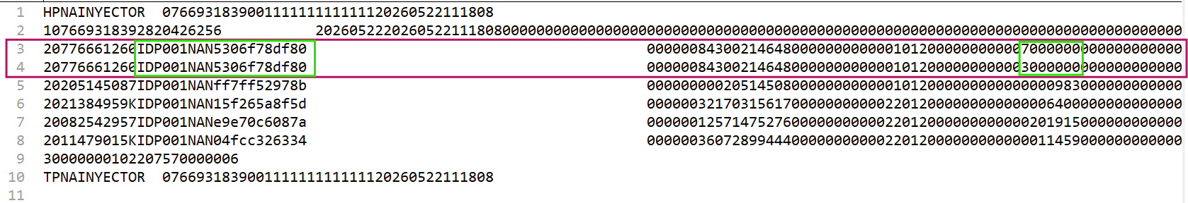

Note: Until the implementation of CC109 Phase 2, if Compraqui selected merchants under Payment Type = Same Cycle Payment 365 or Full Day Payment 365, OP generated the payment reports and uploaded them to both the SFTP location and OmniCompensator during weekends.
For split transactions, the generated .txt payment file contains the same IDP for all related split records. Therefore, similar to the current production Banco Chile payment file processing, when Compraqui performs payments manually using the .txt file, OP considers the payment status received in the reject file for the first transaction associated with a given IDP and applies the same status to all other split transactions sharing that IDP.
As a result, all transactions belonging to the same IDP are updated with a common payment status based on the status of the first processed transaction, even if the individual split transactions may have different payment outcomes.

6.3 Example Scenario – Payment Status Behaviour for Split Transactions

Configuration (In Omnicompensator)-
- EnableSplit = Yes
- SplitAmount = 7,000,000

Note:
- OP will follow the same splitting logic for both: weekends and holidays
- The logic explained in this example is applicable only for merchants with Bank Code = 012 on weekends and holidays.

6.3.1 Original transaction received from merchant:
- IDP001NAN1234 → 10,000,000

Since OP cannot process a single amount above the supported limit of 7M, the system internally splits the original IDP into multiple child IDPs for payment processing.

Internal split child IDPs created by OP:
- IDP001NAN123401 → 7,000,000
- IDP001NAN123402 → 3,000,000

Parent IDP | Child IDP | Amount
IDP001NAN1234 | IDP001NAN123401 | 7,000,000
IDP001NAN1234 | IDP001NAN123402 | 3,000,000

6.3.2 First Day Processing
1. Payment .txt File

Payment Line | IDP | Amount
Payment Line 1 | IDP001NAN1234 | 7,000,000
Payment Line 2 | IDP001NAN1234 | 3,000,000

Meaning:
- Since OP cannot process a single payment amount greater than 7,000,000, OP internally splits the transaction for payment processing.
- In the .txt payment file, OP will generate multiple payment lines using the same original Parent/Main IDP.
- Child IDPs will not appear in the .txt payment files.
- This behavior avoids impact to existing downstream reconciliation or merchant-side systems dependent on the current file structure.
- This behavior will remain the same as the current Banco Chile split transaction implementation.

depositR1.csv
This report shows the internal split child IDPs because OP processes them separately during payment execution.
Example:
- IDP001NAN123401 → 7,000,000
- IDP001NAN123402 → 3,000,000

Meaning:
- OP generates separate payment instructions for each child IDP.
- Each child IDP is processed independently during bank processing.
- Therefore, split child IDPs are reflected in this report.

txnDetailsR2.csv
This report continues showing the original parent IDP.
Example:
- IDP001NAN1234 → 10,000,000
Meaning:
- At this stage, final payment execution status is not yet consolidated.
- Therefore, reporting still reflects the original merchant IDP instead of child IDPs.
- This maintains consistency with the merchant’s original request during interim processing.

6.3.3 Payment Execution Result
While making actual payments:
- IDP001NAN123401 → 7,000,000 → PAGADO
- IDP001NAN123402 → 3,000,000 → RECHAZADO

Child IDP | Amount | Status
IDP001NAN123401 | 7,000,000 | PAGADO
IDP001NAN123402 | 3,000,000 | RECHAZADO

Meaning:
- First child IDP was successfully processed and paid.
- Second child IDP failed during payment processing.
- This creates a partial success scenario where only part of the original 10M IDP was deposited successfully.

Actual successful payment: 7M
Failed payment: 3M
Result Type | Amount
Successfully Paid | 7,000,000
Failed Payment | 3,000,000

6.3.4 Next Day Processing

.txt File (Next Day)
Example:
- IDP002NAN1234 → 3,000,000

DepositDetailsR1.csv (Next Day)
Example:
- IDP002NAN1234 → 3,000,000

Meaning:
- This report contains IDPs currently being processed in the active cycle.
- It does not represent historical child IDP payment results from previous cycles.

TransactionDetailsR2.csv (Next Day)
Example:
- IDP002NAN1234 → 3,000,000

Meaning:
- Only the IDP received for current processing is reflected.
- Previous day child IDP execution statuses are not shown in this interim report.

Reject Reports (Generated on Next Day)
DepositDetails.csv
This report shows the final payment execution status for child IDPs.
Example:
- IDP002NAN123401 → 7,000,000 → PAGADO
- IDP002NAN123402 → 3,000,000 → RECHAZADO

Meaning:
- Each child IDP status is shown independently.
- Merchant can identify which child IDP succeeded and which child IDP failed.

This is required because:
- One child IDP was successfully deposited.
- One child IDP failed.
- Final reconciliation must therefore happen at child IDP level instead of parent IDP level.

TransactionDetails.csv
This report also reflects final child IDP payment statuses.
Example:
- IDP002NAN123401 → 7,000,000 → PAGADO
- IDP002NAN123402 → 3,000,000 → RECHAZADO
Meaning:
- Merchant receives visibility of actual payment execution results.
- Report helps in reconciliation and tracking partial payment scenarios.
- Final statuses are maintained separately for each child IDP.

6.4 Banco Chile Transaction Split Logic
For merchants having bank codes other than 012, there will be no change in the current production transaction splitting logic. OP will continue including Banco Chile transactions only in weekday working business day reports.

For Banco Chile transactions (Bank Code ≠ 012):
- If the transaction amount exceeds 5,000,000, OP will split the transaction into multiple entries in the payment .txt file YYYYMMDD_GPSMARTPOS_bancodechile.txt
- Existing production behavior will remain unchanged.
- Payment Processing Rules and Report Enhancements

7.1 MDR (Commission) Handling
MDR (Merchant Discount Rate) application will depend on the configured Payment Type and will be controlled based on Compraqui’s requirement.

7.1.1 365 Payment Types
Applicable for:
- Same Cycle Payment 365
- Full Day 365 Days

For these merchants:
- “365 Days” MDR values may be applied based on explicit request from Compraqui
- If such a request is provided, the “365 Days” MDR will be applied uniformly across all merchants under the respective Payment Type
- This “365 Days” MDR will be for all the fields like card, bin, international/domestic transaction, region,etc.
- MDR will not be maintained at an individual merchant level, but at Payment Type level
This “365 Days MDR” commission will be applied for GPMPOS channel for CC009 and CC109 flows [should not applied to parametric payment flow (CCX70)] and on all 7 days of the week. Therefore, the same commission values will be reflected consistently in:
- CC109 Reports
- Retailer.csv reports
- Daily.csv reports
To support this requirement, OP will introduce a new “Payment Group” field in the retailercommissionrules and retailercommissionvalues screens for DEFAULT commissions only.
When commission calculation is performed:
  - OP will check the "Payment Group" column value.
  - If Payment Group = "365 Days", the configured “365 Days” MDR commission will be applied to merchants belonging to the Same Day Payment 365 Days and Full Day Payment 365 Days groups.

Please note that - this support will be available for both merchant-specific commission and DEFAULT commission configuration.
Same priority of MDR will be followed like we have on production currently (as we discussed in CC107). For better understanding, below will be the priority always even if merchants are under 365 Days type.
Note: Zero commission will always have the highest priority as mentioned in the point 7.1.3 section of this R1. This pyramid applies if the merchant is not under a zero % commission campaign.
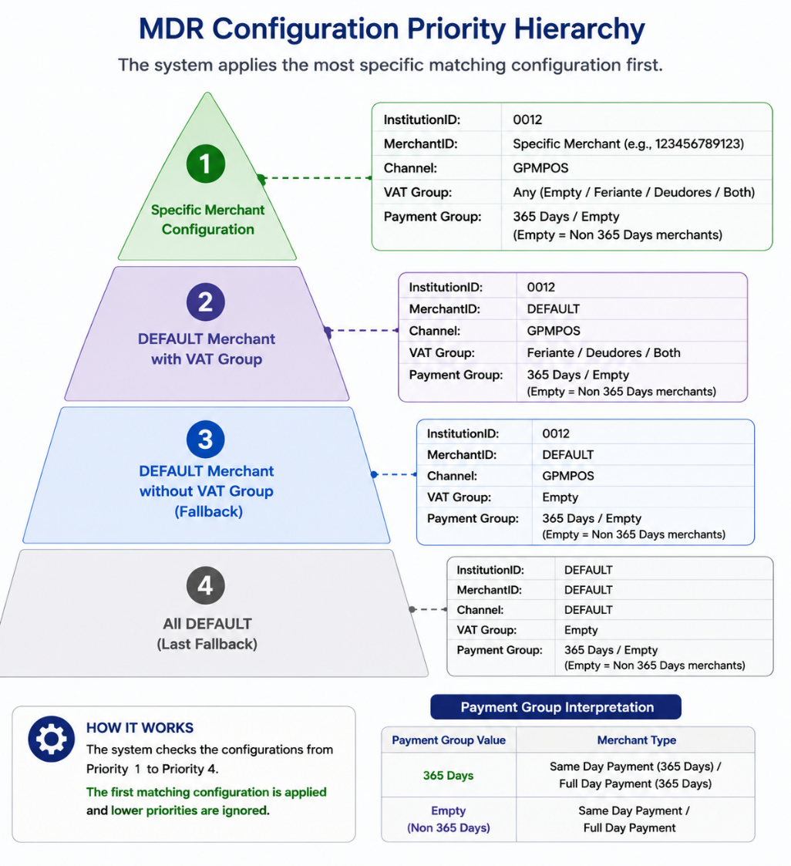
Attached are the sample dummy commission configuration values.

Example Scenarios-
Case 1
- InstitutionID = 0012
- MerchantID = 123456789123
- Channel = GPMPOS
- VAT Group = Feriante
- PaymentType = Same Day Payment 365

For this case, as the merchant's PaymentType is "Same Day Payment 365", OP will identify the corresponding Payment Group value and validate the commission configuration in the retailercommissionrules and retailercommissionvalues tables.

OP will apply the commission configured for:
- InstitutionID = 0012
- MerchantID = 123456789123
- Channel = GPMPOS
- VAT Group = Feriante
- Payment Group = 365 Days

Accordingly, the “365 Days” MDR/commission configured for Payment Group = 365 Days in the attached CC109_HigherMDR.xlsx file will be applied during compensation processing.

Case 2
- InstitutionID = 0012
- MerchantID = 123456789123
- Channel = GPMPOS
- VAT Group = Feriante
- PaymentType = Same Day Payment

For this case, as the merchant's PaymentType is "Same Day Payment", no Payment Group-specific commission lookup will be performed.
OP will continue to apply the existing commission logic currently available in production, and the regular commission configured for the merchant/VAT Group combination will be applied.

In case Compraqui does not request “365 Days” MDR, then for all the Payment Types:
Existing production MDR values will continue to apply for these merchants.

The applicable MDR (whether “365 Days” or standard) will be used consistently for:
- Weekdays
- Weekends
- Holidays

7.1.2 Non-365 Payment Types
Applicable for:
- Same Cycle Payment
- Full Day Payment

For these merchants:
- Existing production MDR values will continue
- No changes will be made to current commission logic

7.1.3 Preference to Zero % Commission Campaign

Merchants configured under the Zero % Commission Campaign will always receive the highest priority during commission calculation.
If a merchant is enrolled in the Zero % Commission Campaign, the system will apply 0% commission, regardless of:
- Whether the merchant is a 365 Days merchant.
- Whether “365 Days” MDR is enabled for 365 Days merchants.
- Any other MDR configuration applicable to the merchant.

The commission application priority will be:
- Zero % Commission Campaign
- “365 Days” MDR for 365 Days merchants
- Regular MDR (existing production logic)

Example
Assume “365 Days” MDR has been enabled for all 365 Days merchants.

Assume the following commission configurations already exist in OmniCompensator:

Merchant Configuration Before Campaign

Merchant | Payment Type | Payment Group 365 Days | Commission Configured in OmniCompensator
ABC | Same Day Payment | No | 2.5%
XYZ | Same Day Payment (365 Days) | Yes | 3.0%
PQR | Full Day Payment | No | 2.0%
DEF | Full Day Payment (365 Days) | Yes | 2.8%

During the 0% Commission Campaign
Assume Compraqui includes ABC and XYZ in the 0% Commission Campaign file.

Merchant | Payment Type | Original MDR | Included in 0% Campaign | Commission Applied
ABC | Same Day Payment | 2.5% | Yes | 0%
XYZ | Same Day Payment (365 Days) | 3.0% | Yes | 0%
PQR | Full Day Payment | 2.0% | No | 2.0%
DEF | Full Day Payment (365 Days) | 2.8% | No | 2.8%

After the Campaign Ends
Assume ABC and XYZ are removed from the campaign file.

Merchant | Payment Type | Original MDR | Included in 0% Campaign | Commission Applied
ABC | Same Day Payment | 2.5% | No | 2.5%
XYZ | Same Day Payment (365 Days) | 3.0% | No | 3.0%
PQR | Full Day Payment | 2.0% | No | 2.0%
DEF | Full Day Payment (365 Days) | 2.8% | No | 2.8%

Key Points
- Whenever a merchant is configured under the Zero % Commission Campaign, the system must apply 0% commission, irrespective of any 365 Days or Regular MDR settings.
- During the campaign period, merchants included in the campaign file will receive 0% commission.
- Once the campaign ends and the merchant is removed from the campaign file, the system automatically resumes applying the merchant's original commission configuration.
- This behavior applies equally to both:
  - 365 Days Payment Types (Same Day Payment (365 Days) / Full Day Payment (365 Days))
  - Non-365 Payment Types (Same Day Payment / Full Day Payment)

Simple Examples

Merchant | Payment Type | Included in 0% Campaign | Commission Applied
Merchant A | Same Day Payment / Full Day Payment | Yes | 0% Commission
Merchant B | Same Day Payment (365 Days) / Full Day Payment (365 Days) | Yes | 0% Commission
Merchant C | Same Day Payment (365 Days) / Full Day Payment (365 Days) | No | MDR configured for Payment Group = 365 Days
Merchant D | Same Day Payment / Full Day Payment | No | Regular MDR

Key Message:
- The 0% Commission Campaign always takes priority over both the 365 Days MDR configuration and the Regular MDR configuration.
- The 0% Commission Campaign is a temporary override. It does not modify the original MDR configuration stored in OmniCompensator. Once the campaign ends, the merchant automatically returns to its original commission configuration.

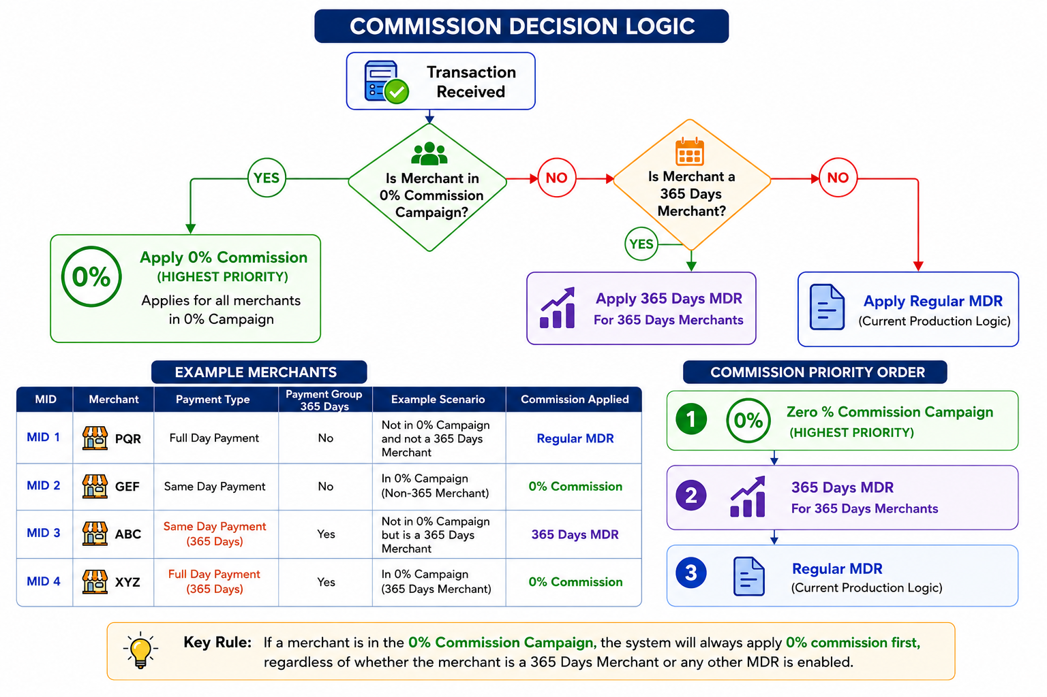

7.2 Report Enhancement – New PaymentType Column
To support identification of transactions based on payment behavior, OP will introduce a new column “PaymentType” in the reports.

Applicable Reports:
The new column will be added at the end of the following reports:
YYYYMMDD_GPSMARTPOS_C2_DepositDetails.csv
YYYYMMDD_GPSMARTPOS_C2_TransactionsDetails.csv
YYYYMMDD_GPSMARTPOS_C2_DepositDetailsR1.csv
YYYYMMDD_GPSMARTPOS_C2_TransactionsDetailsR2.csv

The following example Retailer reports will be enhanced to include a new column, "PaymentType" at the end:
- 0012_GPGMVP_Retailer_YYMMDD.csv
- 0012_GPLINK_Retailer_YYMMDD.csv
- 0012_GPMPOS_Retailer_YYMMDD.csv
- 2003_DA_Retailer_YYMMDD.csv
- 0012_Daily_Report_YYMMDD.csv
- 2003_Daily_Report_YYMMDD.csv
- 0016_Daily_Report_YYMMDD.csv
- 2002_Daily_Report_YYMMDD.csv
- 8052_Daily_Report_YYMMDD.csv
- 2001_Daily_Report_YYMMDD.csv
- 8051_Daily_Report_YYMMDD.csv
- 2003_DA_BRAND_MID_Retailer_YYMMDD.csv
- 0012_GPMPOS_BRAND_MID_Retailer_YYMMDD.csv
- 0016_EFMPOS_BRAND_MID_Retailer_YYMMDD.csv
- DA_RetailerGroup_PAGOS_Retailer_YYMMDD.csv
- EFMPOS_RetailerGroup_PAGOS_Retailer_YYMMDD.csv
- GPMPOS_RetailerGroup_PAGOS_Retailer_YYMMDD.csv

Although the “PaymentType” value will be populated only for the GPMPOS channel, OP will add this column to the InstID_Channel_Retailer_YYMMDD.csv, InstID_Daily_Report_YYMMDD.csv, InstID_Channel_BRAND_MID_Retailer_YYMMDD.csv, Channel_RetailerGroup_PAGOS_Retailer_YYMMDD.csv reports of all channels under the normal report (CC009) and parametric payment (CCX70) generation flow to maintain a consistent report structure across channels.
For channels where PaymentType is not applicable, the column will be generated with an empty value.

Column Behavior:
- The column will contain the PaymentType value configured for the merchant in Omni UI
- This ensures that transactions belonging to different payment behaviors can be easily identified within combined reports

Expected Values:
The column will contain one of the following values:
- Same Cycle Payment
- Same Cycle Payment 365
- Full Day Payment
- Full Day 365 Days
- Empty

7.3 Exclusion of CCX70 Merchants from CC109 Reporting
Merchants configured under CCX70 – Parametric Payment Flow will be excluded from all CC109 reports, irrespective of the configured Payment Type.

This means that even if a merchant is configured with any Payment Type such as:

- Same Cycle Payment
- Same Cycle Payment 365
- Full Day Payment
- Full Day 365 Days
- Empty

their transactions will not be included in CC109 report generation if the merchant is enabled under the CCX70 flow.

For example, if a merchant (e.g., ABC) is configured with Payment Type = Same Cycle Payment 365 but is also part of the CCX70 flow, then all transactions for that merchant will be processed under CCX70 logic and will be excluded from CC109 reports.

This behavior applies consistently across all Payment Types.

7.4 Merchant Installment Transaction handling on weekends and holidays
Merchant installment transactions should be processed only on weekdays or working business days.

However, if any new merchant installment transaction is received on weekends or holidays, i.e. a transaction with CurrentInstallmentNumber = 1, OP should process that transaction on weekends or holidays via API.

For merchant installment transactions where CurrentInstallmentNumber > 1, OP should process those transactions only on working business days, i.e. weekdays.

7.5 Weekend Migration
If Compraqui changes a merchant's payment type on Friday, Saturday, or Sunday, the change is not applied immediately. Instead, OP picks up the new payment type starting from Monday Cycle 1 (C1).

Example
- Merchant ABC is configured as Same Day Payment.
- On Friday at 18:00:00, Compraqui changes the merchant to Same Day Payment 365.

Then –
- The new configuration is not used during the current weekend.
- Transactions received during:
- Friday (14:00:00 – 23:59:59)
- Saturday (00:00:00 – 23:59:59)
- Sunday (00:00:00 – 23:59:59)
will be processed using the weekend migration logic and will be included in the Monday-generated C2 payment reports.
- Starting from the following next weekend, the merchant will be treated as a 365 merchant, meaning its transactions will also be processed and paid during weekends according to the 365-payment setup.

7.6 Future Scope Consideration
Currently, weekend and holiday payment processing via API is applicable only for BECH bank accounts (bank code = 012).

However, the system should be designed in a way that:
- This functionality can be extended to other bank accounts (e.g., Banco Chile or others)
- Changes can be implemented with minimal code modifications

Any such extension will be handled through a separate Change Request (CC).
- Regular Payment Report Generation Logic

To optimize report generation and avoid creating multiple reports for each Payment Type, OP will combine transactions of all Payment Types into common reports.

Even though different Payment Types follow different cutover timings and processing rules, all transactions will be consolidated into the same report structure. Compraqui will be able to differentiate transactions using the “PaymentType” column available in DepositDetails.csv and TransactionsDetails.csv reports, specifically:
- YYYYMMDD_GPSMARTPOS_C*_DepositDetails*.csv
- YYYYMMDD_GPSMARTPOS_C*_TransactionsDetails*.csv

8.1. Weekday Report Generation
During weekdays, OP will generate both Cycle 1 (C1) and Cycle 2 (C2) reports.

8.1.1 Cycle 1 Reports

Cycle 1 reports will include:
- Transactions received from reject files of previously processed cycles
- Transactions within cutover window 00:00:00 – 13:59:59 (Chile time)
- Applicable only for:
- Same Cycle Payment
- Same Cycle Payment 365

Reports Generated:
- YYYYMMDD_GPSMARTPOS_C1_DepositDetails.csv
Includes transactions from reject files of previously paid cycles

- YYYYMMDD_GPSMARTPOS_C1_TransactionsDetails.csv
Includes transactions from reject files of previously paid cycles

- YYYYMMDD_GPSMARTPOS_C1_BancoChileTxns.csv
Includes transactions from cutover 00:00:00 – 13:59:59 for Same Cycle Payment and Same Cycle Payment 365 with bank code ≠ 012

- YYYYMMDD_GPSMARTPOS_C1_valevista.txt
Includes transactions falling under Vale Vista logic (IDP111)

- SMARTPOS_DEPOSIT_REPORT_C1_YYYYMMDD.txt
Includes BECH transactions from cutover 00:00:00 – 13:59:59 for Same Cycle Payment and Same Cycle Payment 365 i.e. transactions with bank code = 012

- YYYYMMDD_GPSMARTPOS_C1_DepositDetailsR1.csv
Includes transactions from cutover 00:00:00 – 13:59:59 for Same Cycle Payment and Same Cycle Payment 365

- YYYYMMDD_GPSMARTPOS_C1_TransactionsDetailsR2.csv
Includes transactions from cutover 00:00:00 – 13:59:59 for Same Cycle Payment and Same Cycle Payment 365

8.1.2 Cycle 2 Reports

Cycle 2 reports will include:
- Transactions from reject files
- Transactions based on PaymentType-specific cutover logic

Reports Generated:
- YYYYMMDD_GPSMARTPOS_C2_DepositDetails.csv
Includes transactions from reject files

- YYYYMMDD_GPSMARTPOS_C2_TransactionsDetails.csv
Includes transactions from reject files

- YYYYMMDD_GPSMARTPOS_C2_valevista.txt
Includes Vale Vista transactions (IDP111)

- YYYYMMDD_GPSMARTPOS_bancodechile.txt
Includes transactions from 00:00:00 – 23:59:59 for all Payment Types with bank code ≠ 012:
- Same Cycle Payment
- Same Cycle Payment 365
- Full Day Payment
- Full Day 365 Days

- SMARTPOS_DEPOSIT_REPORT_C2_YYYYMMDD.txt
Includes transactions with bank code = 012 for following cutover:
- 14:00:00 – 23:59:59 → Same Cycle Payment & Same Cycle Payment 365
- 00:00:00 – 23:59:59 → Full Day Payment & Full Day 365 Days

- YYYYMMDD_GPSMARTPOS_C2_DepositDetailsR1.csv
Includes:
- 14:00:00 – 23:59:59 → Same Cycle Payment & Same Cycle Payment 365
- 00:00:00 – 23:59:59 → Full Day Payment & Full Day 365 Days

- YYYYMMDD_GPSMARTPOS_C2_TransactionsDetailsR2.csv
Includes:
- 14:00:00 – 23:59:59 → Same Cycle Payment & Same Cycle Payment 365
- 00:00:00 – 23:59:59 → Full Day Payment & Full Day 365 Days

8.2 Weekend and Holiday Report Generation
During weekends and holidays:
- Only Cycle 2 reports will be generated
- Applicable only for:
- Same Cycle Payment 365
- Full Day 365 Days
- Only BECH transactions (bank code = 012) will be included
- Payments will be executed via API

8.2.1 Saturday Processing (Chile Morning)
Reports Generated
- YYYYMMDD_GPSMARTPOS_C2_DepositDetails.csv
- YYYYMMDD_GPSMARTPOS_C2_TransactionsDetails.csv
- YYYYMMDD_GPSMARTPOS_C2_valevista.txt
- SMARTPOS_DEPOSIT_REPORT_C2_YYYYMMDD.txt
- YYYYMMDD_GPSMARTPOS_C2_DepositDetailsR1.csv
- YYYYMMDD_GPSMARTPOS_C2_TransactionsDetailsR2.csv
- YYYYMMDD_GPSMARTPOS_C2_BancoChileTxns.csv

Cutover Logic
- Same Cycle Payment 365 → Friday 14:00:00 – 23:59:59
- Full Day 365 Days → Friday 00:00:00 – 23:59:59

8.2.2 Sunday Processing (Chile Morning)
Reports Generated
- YYYYMMDD_GPSMARTPOS_C2_DepositDetails.csv
- YYYYMMDD_GPSMARTPOS_C2_TransactionsDetails.csv
- YYYYMMDD_GPSMARTPOS_C2_valevista.txt
- SMARTPOS_DEPOSIT_REPORT_C2_YYYYMMDD.txt
- YYYYMMDD_GPSMARTPOS_C2_DepositDetailsR1.csv
- YYYYMMDD_GPSMARTPOS_C2_TransactionsDetailsR2.csv
- YYYYMMDD_GPSMARTPOS_C2_BancoChileTxns.csv

Cutover Logic
- Same Cycle Payment 365 → Saturday 00:00:00 – 23:59:59
- Full Day 365 Days → Saturday 00:00:00 – 23:59:59

8.2.3 Special Handling
- YYYYMMDD_GPSMARTPOS_bancodechile.txt will NOT be generated on weekends and holidays
- Instead, a reference report will be generated:
- YYYYMMDD_GPSMARTPOS_C2_BancoChileTxns.csv
- This will include Banco Chile transactions received during weekends

8.3 Monday Processing (Cycle 2)
On Monday, OP will resume standard weekday processing via .txt files, but Cycle 2 reports will include transactions from Friday, Saturday, and Sunday.

Reports Generated
- YYYYMMDD_GPSMARTPOS_C2_DepositDetails.csv
- YYYYMMDD_GPSMARTPOS_C2_TransactionsDetails.csv
- YYYYMMDD_GPSMARTPOS_C2_valevista.txt
- YYYYMMDD_GPSMARTPOS_bancodechile.txt
- SMARTPOS_DEPOSIT_REPORT_C2_YYYYMMDD.txt
- YYYYMMDD_GPSMARTPOS_C2_DepositDetailsR1.csv
- YYYYMMDD_GPSMARTPOS_C2_TransactionsDetailsR2.csv

Cutover Coverage
BancoChile File
Includes full data for:
- Friday
- Saturday
- Sunday

R2 Report Cutover Logic
- Same Cycle Payment:
- Friday (14:00:00 – 23:59:59)
- Saturday (full day)
- Sunday (full day)

- Same Cycle Payment 365:
- Sunday (full day only)
- Full Day Payment:
- Friday + Saturday + Sunday (full day)

- Full Day 365 Days:
- Sunday (full day only)

8.4 Exception Handling
If a merchant is configured under:
- Same Cycle Payment 365, or
- Full Day 365 Days

but has:
- Bank code ≠ 012

Then:
- Transactions will not be included in weekend/holiday reports
- These transactions will be carried forward to the next weekday cycle
- Payment will be executed via .txt files

8.5 Supporting excel sheet
Attached is the supporting Excel sheet for reference to explain the report consolidation logic.
This sheet was shared by Javier Pentz via email titled “CC109 - Payment 365 Analysis” on 16th April 2026.
It can be referred to for understanding the reduction in number of reports and transaction grouping.

Attached is the example of daywise report names and cutover –
- PaymentNotEligible Merchants Report Generation Logic

If the PaymentNotEligible field is set to True, all reports must be generated with the standard naming convention, appending the suffix “_PaymentNotEligible” at the end of the file name.

Example Report Names:
- YYYYMMDD_GPSMARTPOS_C2_DepositDetails_PaymentNotEligible.csv
- YYYYMMDD_GPSMARTPOS_C2_TransactionsDetails_PaymentNotEligible.csv
- YYYYMMDD_GPSMARTPOS_C2_valevista_PaymentNotEligible.txt
- YYYYMMDD_GPSMARTPOS_bancodechile_PaymentNotEligible.txt
- SMARTPOS_DEPOSIT_REPORT_C2_YYYYMMDD_PaymentNotEligible.txt
- YYYYMMDD_GPSMARTPOS_C2_DepositDetailsR1_PaymentNotEligible.csv
- YYYYMMDD_GPSMARTPOS_C2_TransactionsDetailsR2_PaymentNotEligible.csv
- PurchaseApproved_ReversalDecline_OriginalStatusTxns_SameDayPayment_C2_YYYYMMDD_PaymentNotEligible.csv

Generation Conditions:
- These reports should be generated on all days including both weekdays and weekends/holidays if the PaymentNotEligible condition sets TRUE.
- These PaymentNotEligible reports must be generated only if at least one merchant has PaymentNotEligible = True.
- If no merchants are flagged as PaymentNotEligible = True, then these reports must not be generated.

Processing Logic:
- OP must follow the same report generation logic, structure, and format as defined for Regular Payment Reports (refer to Section 8).

Payment & Delivery Rules:
- These reports must not be used for payment processing via API.
- On weekends and holidays, these reports must only be generated and transferred (FTPed) to the designated FTP location, without triggering any payment processing via API.
- Reject Flow processing

- Payment Type = Same Cycle Payment
No change in reject flow. Compraqui will share the reject file with OP in email for both cycles, as currently done in production.

- Payment Type = Full Day Payment
Compraqui will share the reject file once payments are completed (approximately 6:00 PM Chile time, similar to CCX43 C2 timing).

- Weekends & Holidays [Payment Type = Same Cycle Payment 365 and Full Day 365 Days]
OP will receive payment status via API response and will generate the reject file internally based on the received payment status to process the reject flow. This will be handled in Phase 2 of this project.

- Fallback Scenario [Current weekdays Production]
If Compraqui is unable to share the reject file via email, OP must be able to execute the job and process the reject flow without the reject file.
- Merchant Compensation Reports – SFTP and OmniCompensator Availability

Omni will FTP all Merchant Compensation reports to the decided SFTP location on all days, including:
- Weekdays
- Weekends
- Holidays

This behavior will remain applicable even when merchant payments are processed through API integration instead of regular traditional .txt payment files.

In addition to SFTP transfer, Omni will also upload all generated reports to OmniCompensator so that Compraqui users can:
- View reports
- Download reports
from OmniCompensator on:
- Weekdays
- Weekends
- Holidays
- Assumptions and noted Points

1. Retailer report InstID_Channel_Retailer_YYMMDD.csv ie. example - 0012_GPMPOS_Retailer_YYMMDD.csv will include transactions of all 4 Payment Type.
Therefore -
- Same Cycle Payment
- Same Cycle Payment 365
- Full Day Payment
- Full Day 365 Days

2. Retailer report InstID_Channel_Retailer_YYMMDD.csv ie. example - 0012_GPMPOS_Retailer_YYMMDD.csv will be generated only on working weekdays ie. Not on holidays and weekends.

3. These CC changes will not impact on any other CCs such as CC009, CCX70, or CCX63; they are specific to CCX43 only.

4. Parent and Child merchants should be treated separately based on bank code while report generation.
For example –

MID Parent – 1222222 Bank code = BECH
Child – 13333333 Bank code = SANTANDER
Child – 14444 Bank code = BECH
Child – 1555555 Bank code = BANCO CHILE
If parent merchant chooses Payment Type = Same Cycle Payment 365, then only MID with bank code BECH should be paid on weekends and holidays. Other than BECH bank code should not be included in weekend payments.

5.There should be functionality on Omni Compensator to download all these reports. At the same time,
Omnipayments will also SFTP the generated reports at FTP location even on weekends and holidays.

6. Credit Voucher (CV) is not supported in the CCX43 flow. Therefore, the same behavior will continue for the CC109 reports as well, and CV transactions will not be supported in CC109.

7. Following CC109 Phase 1 implementation, C1 reports may be delayed by up to 15 minutes due to increased commission processing for the 365-day MDR enhancement. No impact is expected on C2 reports.
- Implementation effort

Once the requirement is discussed and outstanding questions are clarified, then accounts team will provide the effort estimates.
- Implementation costs

This is a Change Control and cost estimation will be provided once the effort estimates are calculated.
- Doubts
OP: Whether this CC applies only to the GPMPOS channel, considering CCX43 is currently in production?
Only GPMPOS ccx43, i wanted to have DA but you told me that it will affect DA completely
OP: For weekend and holiday payments via API, should OP consider only BECH [bank code = 012] bank account transactions?
Weekend will be only bech

17-Apr-2026
Javier Q1:
If a merchant updates its Payment Type from Same Cycle Payment to Same Cycle 365 on Friday at 3 PM (15:00:00 Chile time), from which cycle will the changes start reflecting?
Answer:
You will start seeing the changes from the Sunday morning Chile reports, i.e., transactions from Saturday.
Javier Q2:
If the transaction amount is 15 million Chilean pesos, and as per R1 we decided to split the amount if it exceeds 7M, then this transaction will have 3 payment lines: 7M, 7M, and 1M.
What if one of the 7M transactions fails during payment via API? Then how will OP identify this transaction in the reject flow with the same IDP and amount while marking it as Pagado or Rechazado?
Answer:
When OP makes payments via API, a separate Trace ID is generated for each transaction. While generating the reject file, OP will use the Trace ID to identify the transaction and handle the payment status accordingly.
Javier Q3:
When making payments via API, what if the server is down? Then how many times will OP retry?
Will OP Support send an email to Compraqui immediately after the defined number of retries is completed?
Answer:
The retry mechanism will be managed via configuration. Ideally, OP will attempt retries 3–5 times. Once the maximum retries are exceeded, OP will immediately send an email alert to Compraqui.

OP: In rare cases, the Payment Type might be empty. In that case, should OP include those transactions in the weekday reports? Also, should the Payment Type be kept empty in the R1 and R2 reports for those merchant transactions?
Javier- Consider Merchant with Payment Type = Empty as Full Day Payment Merchants with empty value ie. Space in the column Payment Type of R1 and R2 reports.
Op: On weekdays, will Compraqui share a combined reject file for both Same Day Payment and Full Day Payment processed transactions, or will separate files be shared?
Javier - Combined

12-May-2026
OP: If any new merchant installment transaction comes on weekends or holidays, i.e. a transaction with CurrentInstallmentNumber = 1, should OP also hold that transaction and process it on the next working business day?
Or for new merchant installment transactions, can OP still process and make payment for the first installment on the same day even if it is Saturday or Sunday?
Maria Cande-It is OK that the first installment for businesses be paid on the weekend or a holiday.
For future trade fees that are paid only on business days

OmniPayments
OmniPayments software is used by processors, Acquirers and Issuers. OmniPayments routes transactions to Visa for Authorization, Tokenization and Fraud prevention. It can be deployed on premise or in the cloud on HPE NonStop servers for 99.99999% availability. For further information, contact us at:
www.OmniPayments.com
OmniPayments LLC
1566 La Pradera Dr
Campbell, CA 95008, USA

