CUSTOMER SHOPPING ANALYTICS
PRDA-04 | Insights Report
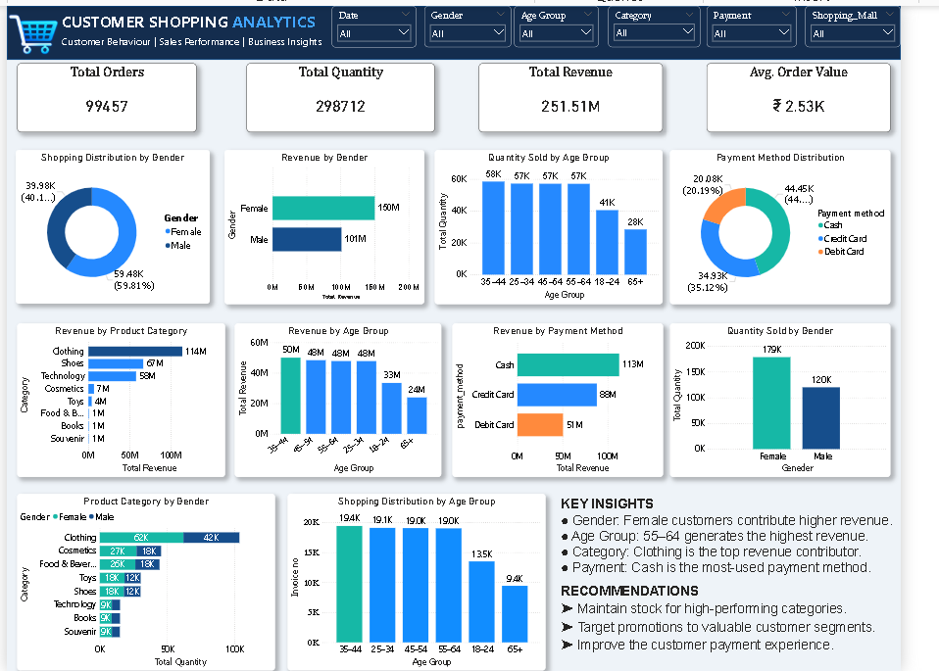

1. Executive Summary
The dashboard presents an overview of customer shopping behaviour by gender, age group, product category, payment method and shopping mall. Its headline figures show 99,457 orders, 298,712 units and ₹251.51M revenue, with an average order value of about ₹2.53K. The dashboard suggests female customers contribute more revenue, Clothing is the largest category, the 55–64 age group is the strongest revenue segment, and Cash is the most-used payment method.

2. Dashboard KPIs (as displayed)
KPI | Dashboard value
Total Orders | 99,457
Total Quantity | 298,712
Total Revenue | ₹251.51M
Average Order Value | ₹2.53K

3. Key Insights from the Dashboard
- Gender: Female customers account for approximately 59.81% of shopping distribution (59.48K vs 39.98K) and generate more revenue (about ₹150M vs ₹101M).
- Age group: The dashboard’s quantity chart shows the 35–44, 45–54 and 55–64 groups at roughly 57–58K units each. Revenue by age is highest for 55–64 at about ₹50M.
- Product category: Clothing is the leading revenue category at approximately ₹114M, followed by Shoes (₹67M) and Technology (₹50M).
- Payment method: Cash is the most-used method and generates about ₹113M, ahead of Credit Card (₹88M) and Debit Card (₹51M).
- Gender × category: The stacked bar chart indicates Clothing has the largest quantity in both gender groups; male quantity appears higher for Clothing in the dashboard chart, while the overall revenue chart favours female customers.
- Age distribution: The shopping distribution chart shows the 35–44 group as the largest invoice-count segment (~19.4K), while the 65+ group is the smallest (~9.4K).

4. Recommendations
- Prioritise inventory and replenishment for Clothing, Shoes and Technology because they contribute the largest share of dashboard revenue.
- Build targeted campaigns for female customers and test segment-specific offers for customers aged 55–64.
- Keep Cash payment convenient while promoting card options through secure, simple checkout incentives.
- Use age and gender slicers to compare category preferences and campaign response before allocating marketing budgets.
- Track order count, revenue, quantity and average order value together; a high quantity does not always mean the highest revenue.

