JOB MARKET ANALYSIS
PRDA-04 | Insights Report

1. Executive Summary
The dataset contains 742 job-posting records, 343 distinct company names, 60 industries and 10 grouped job-title categories. The average estimated salary is $101.5K, with an average lower salary estimate of $74.8K and average upper estimate of $128.2K. California (CA) has the largest number of postings (152), followed by Massachusetts (MA) (103) and New York (NY) (72). Python, Excel and SQL are the most frequently flagged skills in the dataset.

2. Dataset Overview
Measure | Result
Rows / job postings | 742
Columns / features | 42
Distinct companies (company_txt) | 343
Distinct industries | 60
Grouped job-title categories | 10
Average estimated salary | $101.5K
Average minimum salary estimate | $74.8K
Average maximum salary estimate | $128.2K
Average available company rating (excluding -1) | 3.69/5

3. Key Findings and Insights

3.1 Job postings by state
CA leads with 152 postings, followed by MA (103) and NY (72). Together, these three states account for 44.1% of all records. This suggests that the dataset's opportunities are concentrated in a few locations. Job seekers may prioritize these states, while employers in other states may need more targeted outreach to attract candidates.

3.2 Industries with the most postings
The five largest industries are Biotech & Pharmaceuticals, Insurance Carriers, Computer Hardware & Software, IT Services, and Health Care Services & Hospitals. Together, they represent 44.9% of records. Biotech & Pharmaceuticals is the largest single industry group in this dataset.

3.3 Companies with the most openings
The highest posting counts are tied among MassMutual, Reynolds American and Takeda Pharmaceuticals at 14 records each. Software Engineering Institute has 11, and Liberty Mutual Insurance has 10. Counts represent records in this dataset, not necessarily all current vacancies at these employers.

3.4 Job titles with the most postings
Data Scientist is the dominant grouped title with 313 postings, followed by Other Scientist (143), Data Engineer (119) and Analyst (101). These four categories account for 94.1% of postings. The dashboard should retain a Top-N filter to keep less frequent categories from crowding the visual.

3.5 Salary patterns
Across all records, the mean estimated salary is $101.5K; the mean lower and upper salary estimates are $74.8K and $128.2K. In CA, the average salary is $123.5K, with average lower/upper estimates of $92.4K / $154.6K. Salary comparisons by state or title should use average measures, not sums, because sums increase with the number of records.
By grouped title, Machine Learning Engineer has an average estimated salary of $126.4K across 22 postings. Data Scientist averages $118.3K across 313 postings. Small categories, such as Director, have very few records, so their averages should be interpreted cautiously.

3.6 Skills most often required
Python appears in 392 postings (52.8%), Excel in 388 (52.3%), and SQL in 380 (51.2%). AWS appears in 176 postings and Spark in 167. This supports prioritizing Python, SQL and Excel as core skills, then building cloud and big-data skills such as AWS and Spark. Skill flags indicate whether the dataset marks a skill as required.
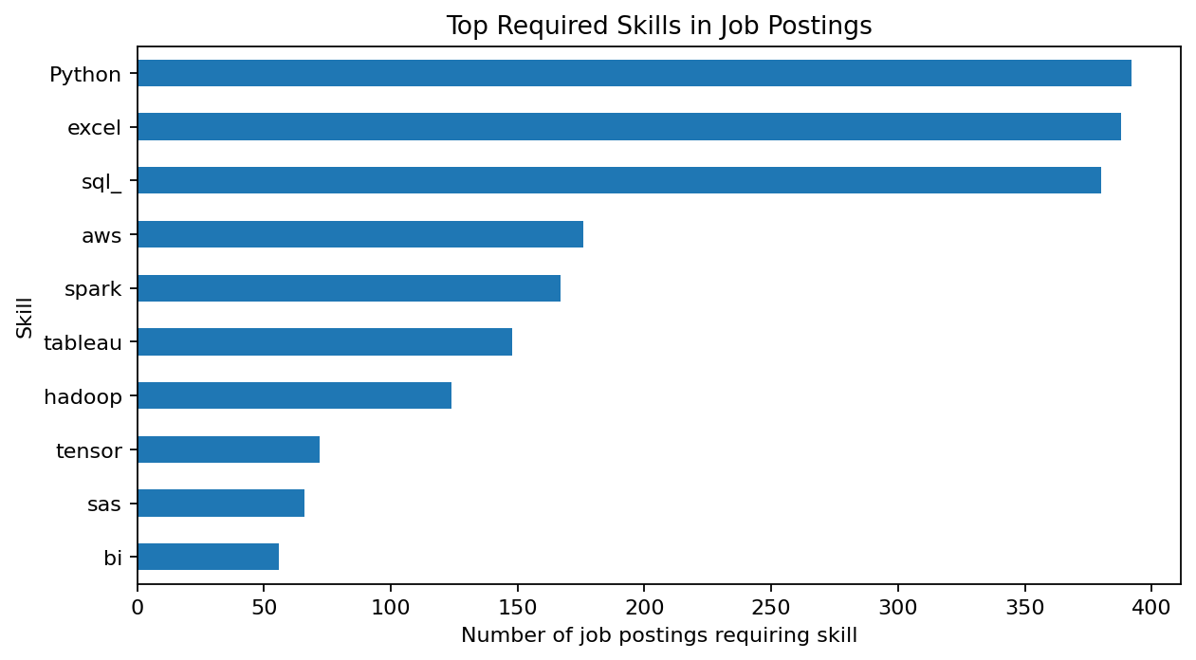

3.7 Education indicator and salary
P (PhD indicator): 107 postings; mean estimated salary $116.0K.
M (Master's indicator): 252 postings; mean estimated salary $105.6K.
Unknown / not specified: 383 postings; mean estimated salary $94.7K.
The P category has the highest average salary in this dataset, followed by M and then Unknown/not specified. However, Degree is an indicator extracted from job descriptions, not a verified education level of an employee. This is an association in the postings and should not be interpreted as proof that a degree causes higher pay.

3.8 Seniority and company ratings
Seniority is not identified ('na') for 519 records; 220 are marked senior and 3 junior. The high unknown share limits conclusions about seniority. There are 11 records with Rating = -1, which should be treated as missing rather than as a real rating. The rating-versus-salary scatter plot is useful for exploring patterns, but it does not establish causation.

6. Dashboard Review
Page 1 — Job Market Overview
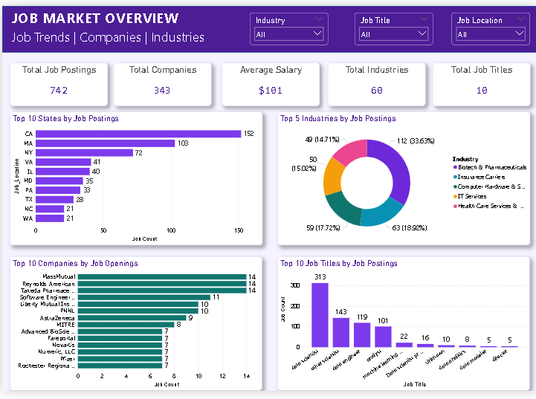

Page 2 — Salary, Skills & Education Analysis
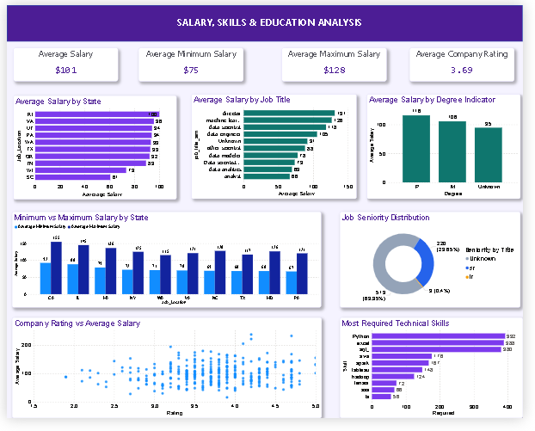

7. Conclusion
The supplied job-market data shows a strong concentration of postings in CA, MA and NY; Data Scientist is the most common grouped job title; and Python, Excel and SQL are the most frequently flagged skills. The estimated salary measures provide a useful benchmark, while the missing/unknown values in Degree and seniority should be kept visible when interpreting results. These findings can guide candidate skill development, recruitment targeting and salary benchmarking, subject to the dataset's scope and freshness.

