**Exploratory Data Analysis (EDA) on USA Dataset**

* **Introduction**

**Project Overview**

This project involves performing an Exploratory Data Analysis (EDA) on a dataset pertaining to the United States. The goal is to uncover patterns, trends, and insights that can inform future decisions or further analysis. This report will detail the steps taken in data cleaning, preparation, and analysis, alongside key findings and visualizations.

**Dataset Description**

The dataset used in this analysis contains information related to various socio-economic and demographic variables across different states in the USA. Key variables include state-wise sales figures, order quantities, and other relevant metrics. The data spans a significant time period, allowing for robust analysis of trends and patterns.

* **Problem Statement**

1. finding sales trends months wise​
2. what is preferred day most people placed orders​
3. finding top 5 most selling products​
4. which state ordering more products​
5. how price is distributed understanding by violin plot​
6. understanding price distribution sales trends by histogram​
7. understanding price distribution sales trends by kde​
8. finding correlation between the quantity ordered and product price​
9. which state contributing more on sales and orders quantity​

* **Finding Sales Trends Months Wise**

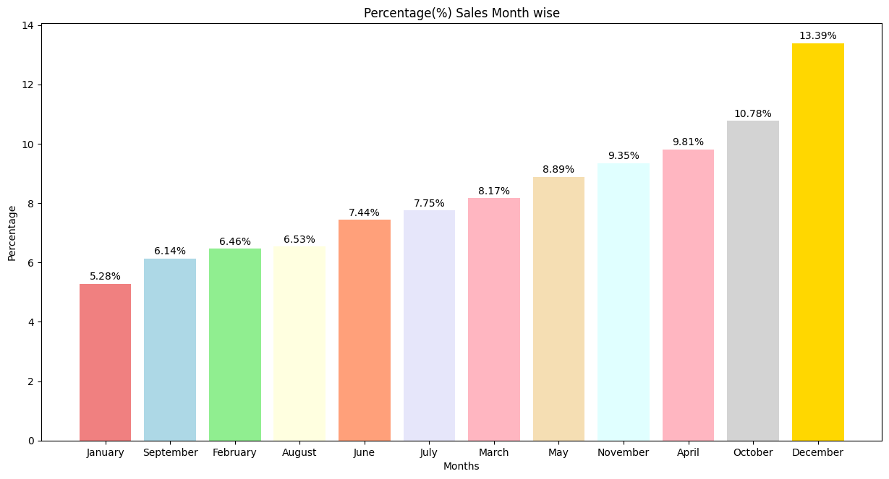

**Conclusion :-** This is a bar graph depicting the percentage of sales made each month. It shows that December is the month with the highest percentage of sales, followed by October. January has the lowest percentage of sales.

* **What is preferred Day most people placed orders​**

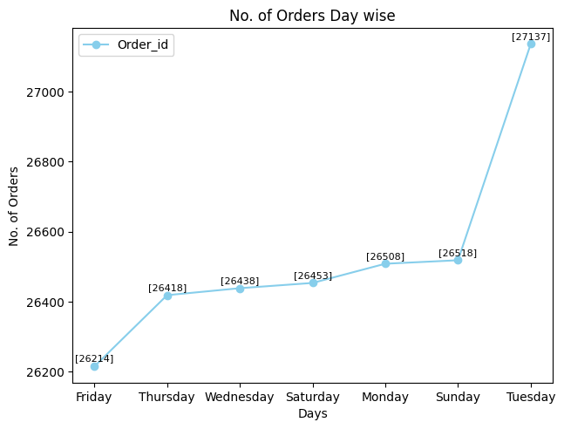

**Conclusion :-** The line chart shows the number of orders across different days of the week. The orders generally remain steady from Friday to Monday, with a slight increase each day. However, there's a significant spike on Tuesday, indicating that it's the busiest day for orders, with the highest number of orders at 27,137.So **Tuesday** is the most popular day for placing orders

* **Finding top 5 most selling products**

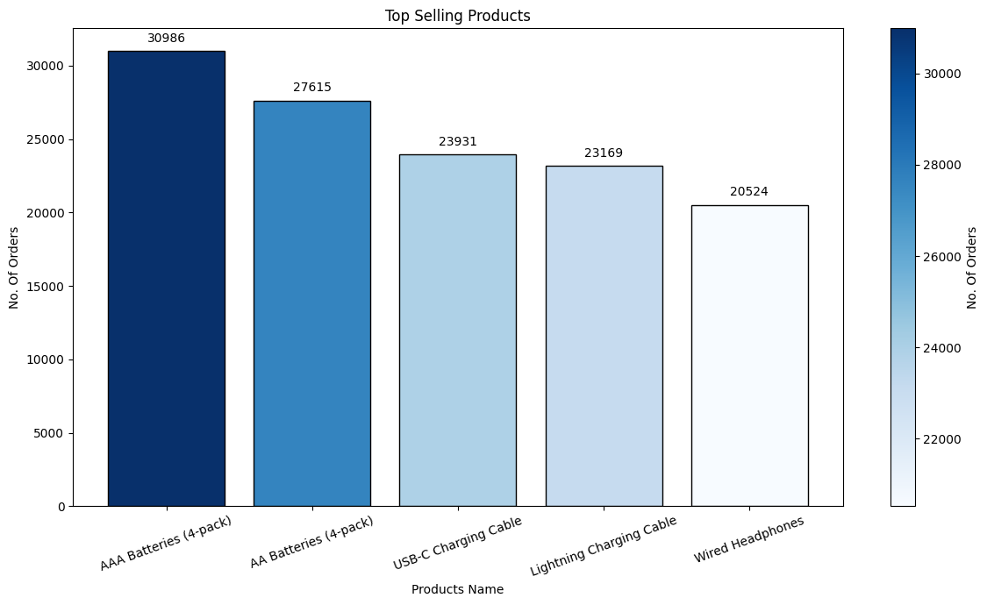

**Conclusion:** Batteries (both AA and AAA) are in high demand, possibly due to their frequent use in various household devices. Charging cables also have a good market, likely due to the widespread use of electronic gadgets. Headphones are also popular, though slightly less so than batteries and charging cables.

* **Which state ordering more products.**

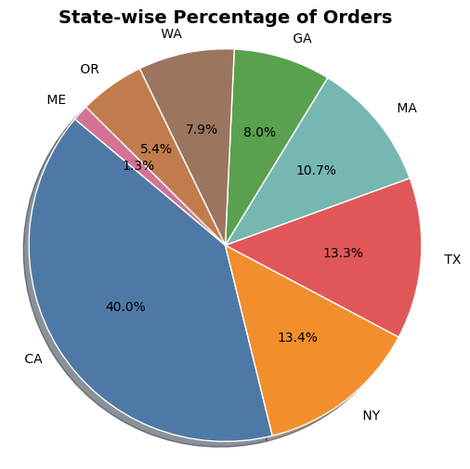

**Conclusion :** california is the dominant market for the products sold, followed by New York and Texas. Companies might consider focusing their marketing strategies and logistics operations in these states to maximize efficiency and customer reach.

* **How price is distributed understanding by violin plot​**

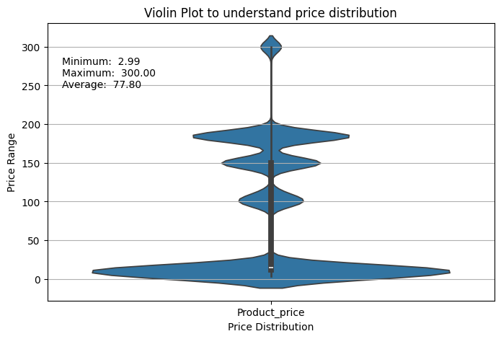

**Conclusion:** The market appears to cater to a wide range of customers, with most products being affordable. This price diversity allows capturing a broad customer base, including both budget-conscious consumers and those willing to spend more on premium items.

* **Understanding price distribution sales trends by histogram​.**

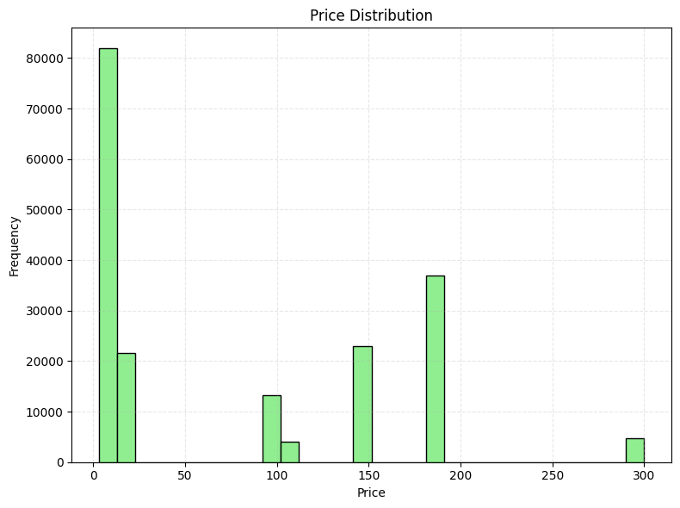

**Conclusion:** The majority of prices are clustered around 0-20, with a smaller peak around 150. There are a few prices between 100 and 120, and a small peak around 300. This suggests that there are a few distinct price points in the data, and that the majority of items are priced relatively low.

**6. Conclusion and Recommendations**

**6.1 Summary of Findings**

The EDA provided valuable insights into the sales performance across different states in the USA. The analysis highlighted key trends, patterns, and relationships within the data.

**6.2 Actionable Recommendations**

Based on the findings, the following recommendations are made:

* **Target High-Performing States:** Focus marketing and sales efforts on states with historically high sales.
* **Seasonal Promotions:** Leverage the identified seasonal trends to optimize promotional campaigns and inventory management.