**Gaussian Discriminant Analysis (GDA)**

**MIT2019090, Vishal Kumar**

GDA, is a method for data classification commonly used when data can be approximated with a Normal distribution.

**Dataset Used:** Microchip dataset (70% train and 30% test data)

We have scaled up the data between 0 and 1, so that we can use it in the formula

Before and After transforming the data: (upper one is before the transformation and lower one is after the transformation)

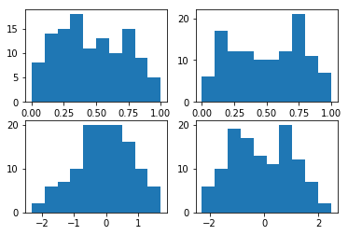

**Scatter plot of raw data:**

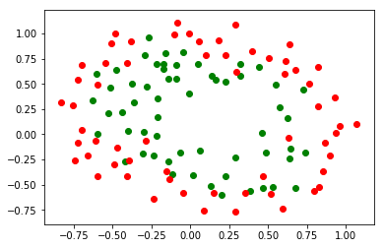

**Scatter plot of transformed data:**

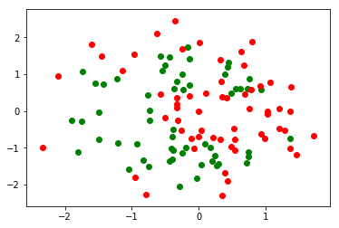

**Observation:**

**Box-Muller**:

Max Accuracy: 88.23%

Confusion Matrix: [[7 1]

[1 8]]

**Without Box-Muller:**

Max Accuracy: 72.72%

Confusion Matrix: [[11 7]

[ 2 13]]