**Self-Organizing Neural Network (Kohonen Network)**

**Vishal Kumar, MIT2019090**

A self-organizing map (SOM) is a type of artificial neural network (ANN) that is trained using unsupervised learning to produce a low-dimensional (typically two-dimensional), discretized representation of the input space of the training samples, called a map.

Kohonen Network, introduced a concept, where the topology of the input-data space can be learnt using SOM. In this scheme, a neural lattice can be one or multi-dimensional as usual and a neighborhood concept among individual neurons in a lattice is a priory embedded. As neurons update their weights upon competition, a meaningful coordinate system for diﬀerent input features over the lattice is developed.

**Dataset:**

Given Kohonen network with 100 neurons arranged in the form of a two-dimensional lattice with 10 rows and 10 columns.

**Training:**

Train the network with 1500 two-dimensional input vectors generated randomly in a square region in the interval between -1 and +1. Select initial synaptic weights randomly in the same interval (-1 and +1) and take learning rate parameter α is equal to 0.1.

data = np.random.uniform(-1, 1, (1500, 2))

alpha = 0.1

**Testing:**

data_test = np.array([[0.1,0.8], [0.5, -0.2], [-0.8, -0.9], [-0.6, 0.9]])

**Observation:**

Converges after 14 epochs while training. Alpha =0.1

For epoch: 0 = 0

For epoch: 1 = 195

For epoch: 2 = 110

For epoch: 3 = 79

For epoch: 4 = 57

For epoch: 5 = 43

For epoch: 6 = 27

For epoch: 7 = 21

For epoch: 8 = 14

For epoch: 9 = 21

For epoch: 10 = 6

For epoch: 11 = 10

For epoch: 12 = 4

For epoch: 13 = 1

For epoch: 14 = 0

Total epochs : 14

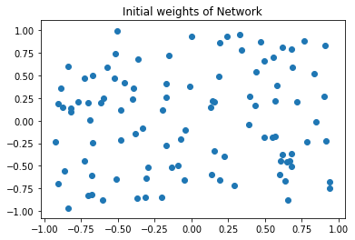

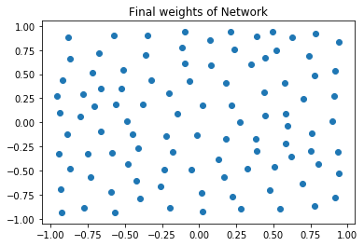

**Testing Results:**

Input 0 = [0.1 0.8] Result: 818

Input 1 = [ 0.5 -0.2] Result: 34

Input 2 = [-0.8 -0.9] Result: 313

Input 3 = [-0.6 0.9] Result: 132