Environment Setup
The following tools and technologies were used to implement the CI/CD pipeline:
- Git
- GitHub
- Java
- Maven
- Jenkins
- Docker
- Docker Hub
- Ansible
- Kubernetes
- Prometheus
- Grafana
Project Workflow
- Source code was maintained in GitHub.
- Jenkins was integrated with GitHub to perform Continuous Integration.
- Maven was used to compile, test and package the application.
- Docker was used to build application images.
- Docker Hub was used as the image repository.
- Ansible was used to automate deployments.
- Kubernetes was used for container orchestration and application deployment.
- Prometheus was used for metrics collection.
- Grafana was used for visualization and monitoring.
Architecture
GitHub → Jenkins → Maven Build → Docker Build → Docker Hub → Ansible → Kubernetes → Prometheus → Grafana
GIT HUB URL : -

1.Successfully added the source code into Git using Git Bash and pushed to GitHub
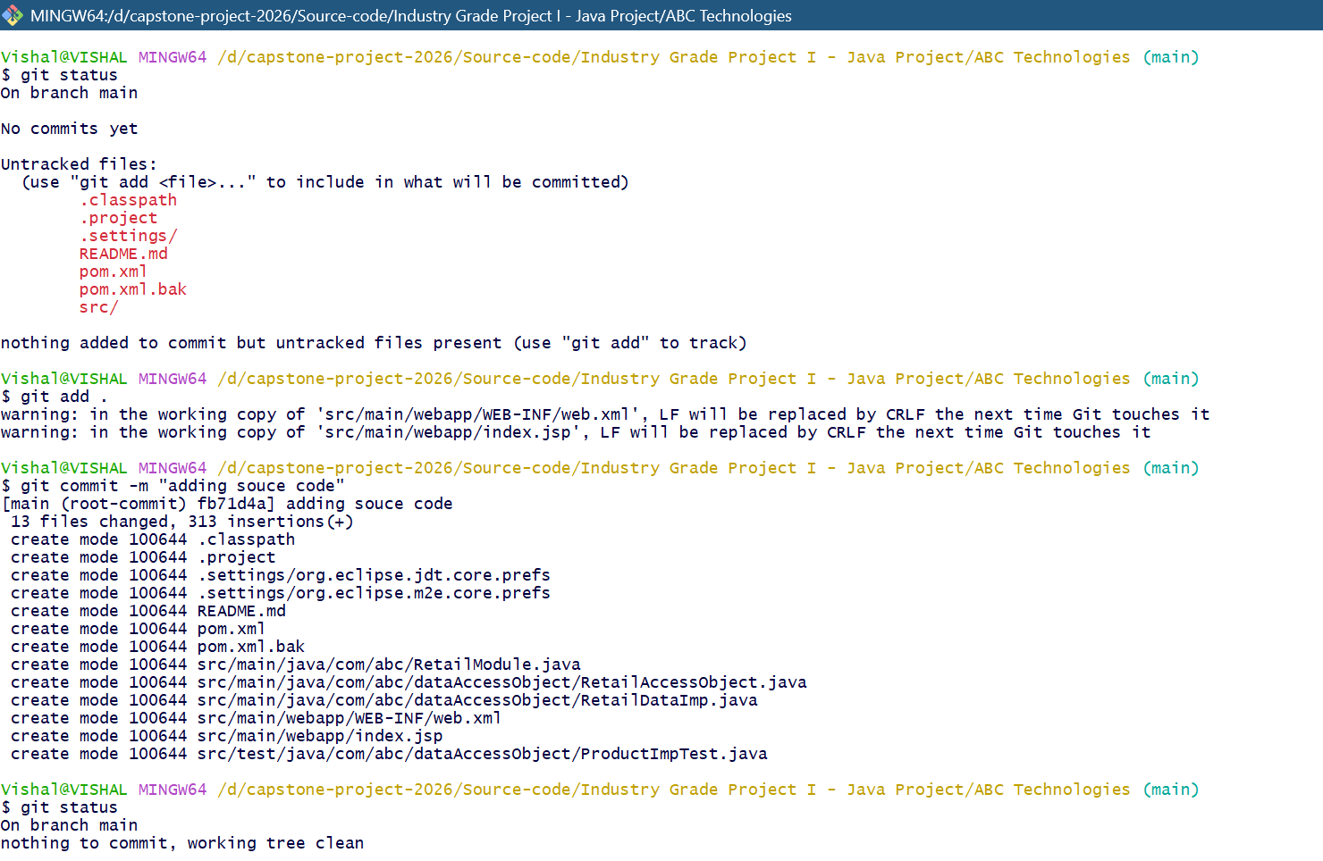
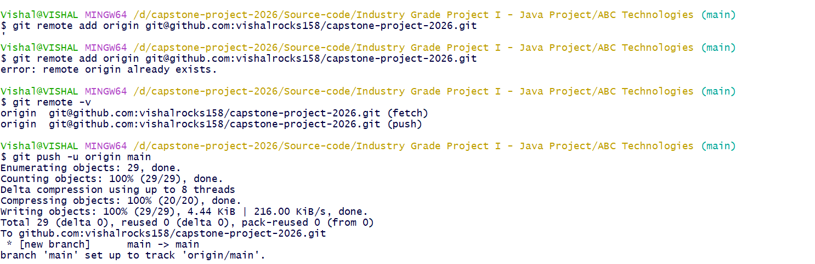
2. Successfully installed Jenkins, Maven, docker, git on a Linux instance.
Install Java
sudo apt update
sudo apt install openjdk-21-jdk -y
Verify:
java -version

Install Git
sudo apt install git -y
Verify:
git --version

Install Maven
sudo apt install maven -y
Verify:
mvn --version

Install Docker
sudo apt update
sudo apt install docker.io -y
sudo systemctl enable docker
sudo systemctl start docker
Verify:
docker --version
sudo systemctl status docker

Install Jenkins
Import Jenkins repository key:
curl -fsSL https://pkg.jenkins.io/debian-stable/jenkins.io-2023.key | sudo tee \
/usr/share/keyrings/jenkins-keyring.asc > /dev/null

Add Jenkins repository:
echo deb [signed-by=/usr/share/keyrings/jenkins-keyring.asc] \
https://pkg.jenkins.io/debian-stable binary/ | sudo tee \
/etc/apt/sources.list.d/jenkins.list > /dev/null

Install Jenkins:
sudo apt update
sudo apt install jenkins -y

Start Jenkins:
sudo systemctl enable jenkins
sudo systemctl start jenkins
Verify:
sudo systemctl status jenkins

Give Jenkins Access to Docker
sudo usermod -aG docker jenkins
sudo systemctl restart jenkins
Verify:
groups jenkins

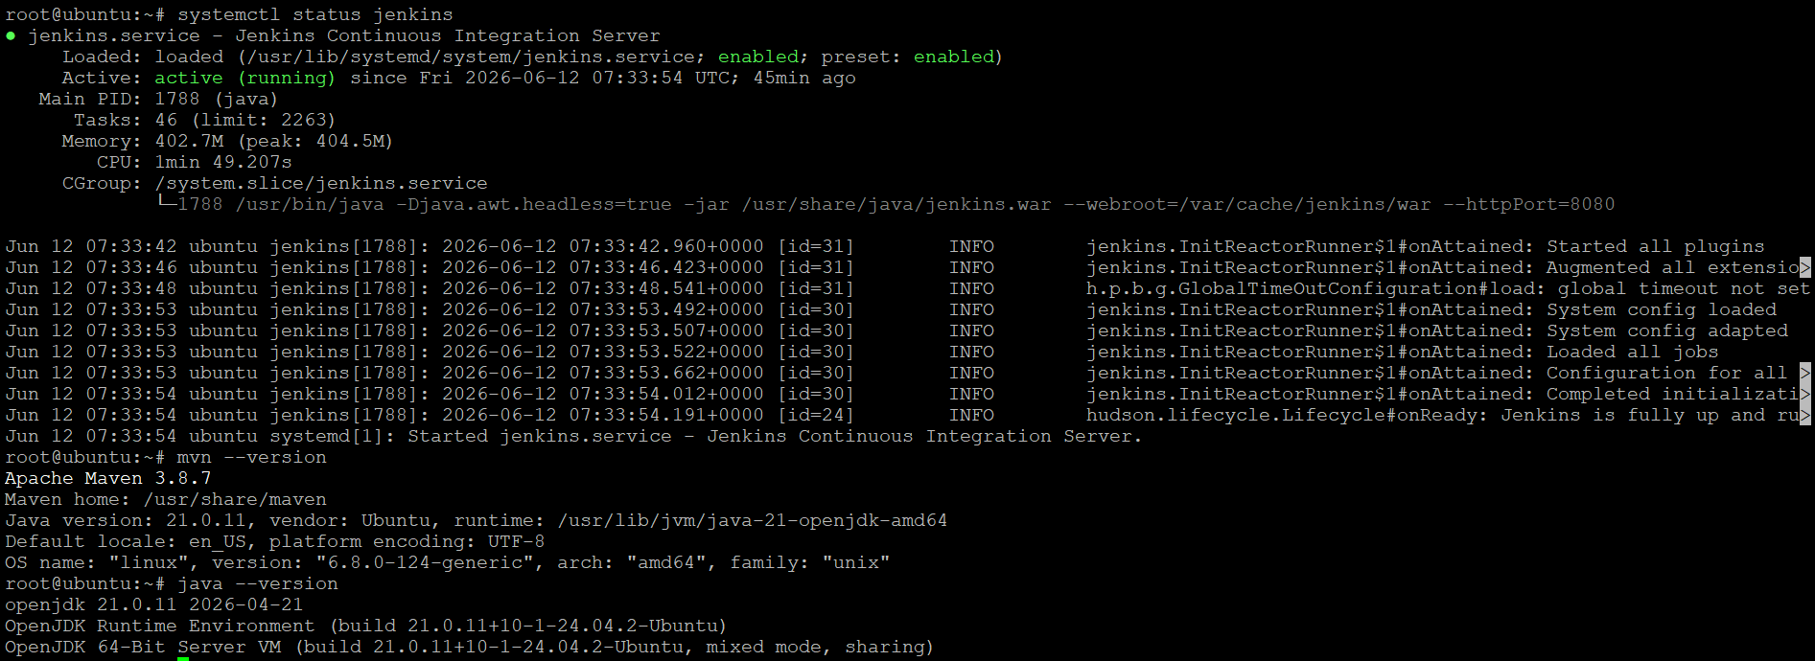
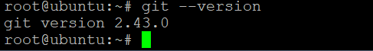
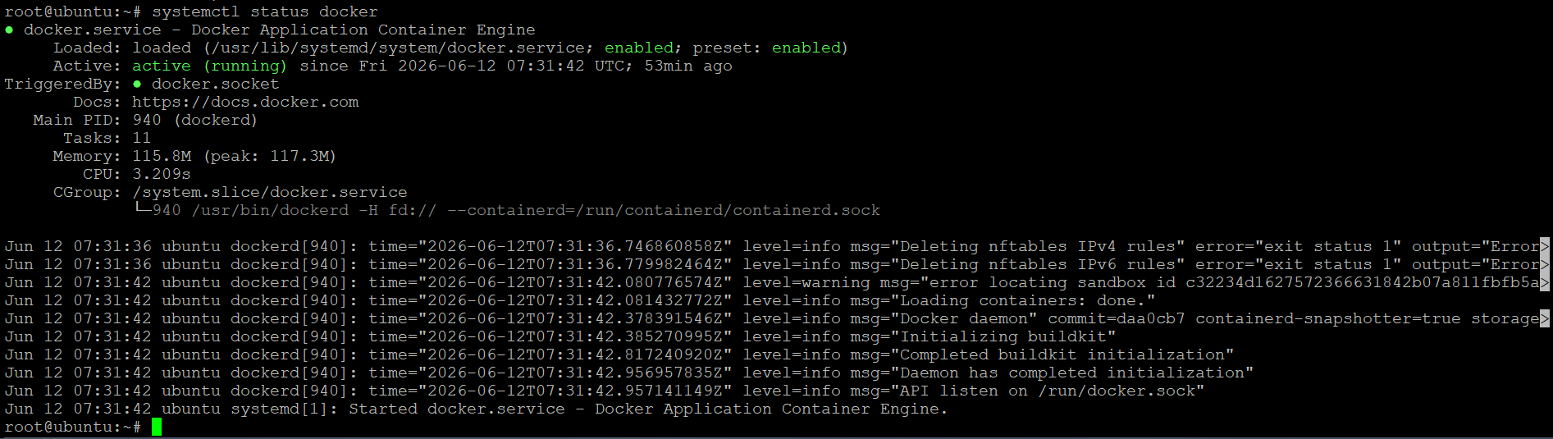
3. Successfully built the pipeline using Maven groovy syntax. Below is the source code for the same.
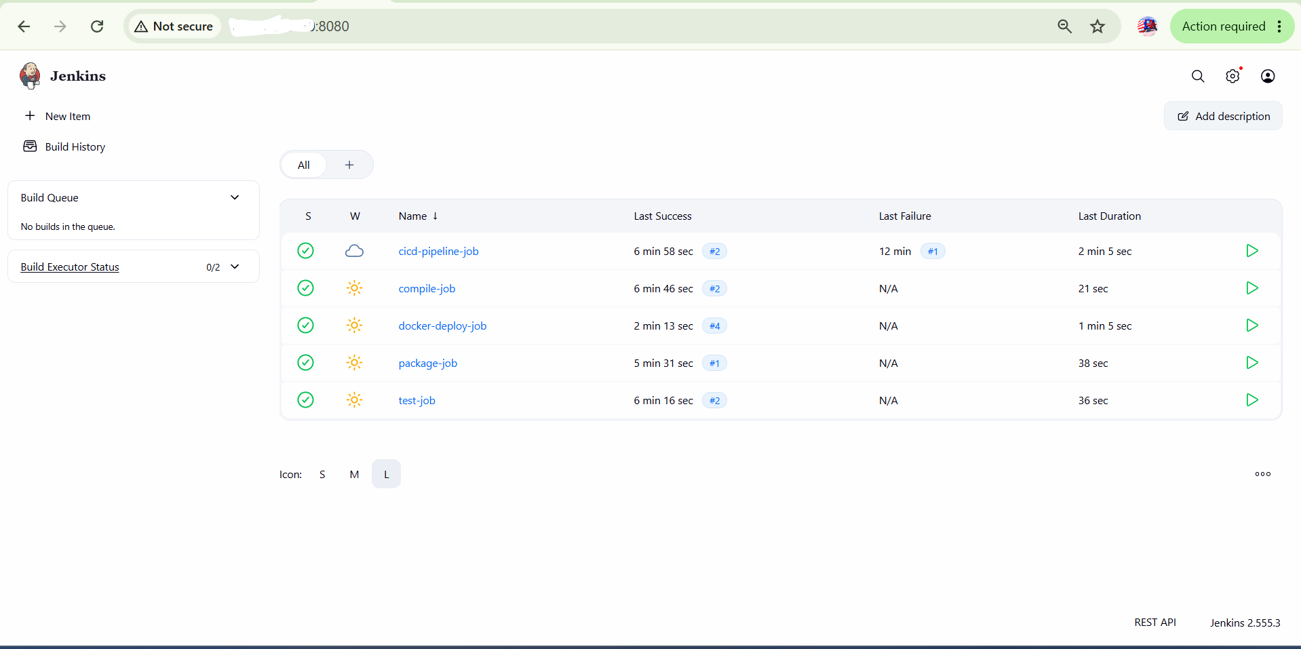
Below are the CI CD JOBS Steps
Step 1: Compile JOB
pipeline {
agent any

stages {
stage('Checkout') {
steps {
git branch: 'main', url: 'https://github.com/vishalrocks158/capstone-project-2026.git'
}
}

stage('Compile') {
steps {
sh 'mvn compile'
}
}
}
}
Step 2 : Test JOB
pipeline {
agent any

stages {
stage('Checkout') {
steps {
git 'https://github.com/vishalrocks158/capstone-project-2026.git'
}
}

stage('Test') {
steps {
sh 'mvn test'
}
}
Step 3: Package JOB
pipeline {
agent any

stages {
stage('Checkout') {
steps {
git 'https://github.com/vishalrocks158/capstone-project-2026.git'
}
}

stage('Package') {
steps {
sh 'mvn package'
}
}

stage('Verify WAR') {
steps {
sh 'ls -l target/'
}
}
}
}
Step 4 : CI CD Jobs
This job executes the first 3 jobs.
pipeline {
agent any

stages {
stage('Compile Job') {
steps {
build job: 'compile-job'
}
}

stage('Test Job') {
steps {
build job: 'test-job'
}
}

stage('Package Job') {
steps {
build job: 'package-job'
}
}
}
}
Step 5 : Docker Deploy JOB
pipeline {
agent any

stages {
stage('Checkout') {
steps {
git 'https://github.com/vishalrocks158/capstone-project-2026.git'
}
}

stage('Package') {
steps {
sh 'mvn package'
}
}

stage('Build Docker Image') {
steps {
sh '''
cp target/ABCtechnologies-1.0.war abc_tech.war
docker build -t capstone-proj-2026:$BUILD_NUMBER .
docker tag capstone-proj-2026:$BUILD_NUMBER vishalrocks158/capstone-proj-2026:$BUILD_NUMBER
'''
}
}

stage('Push Docker Image') {
steps {
withDockerRegistry([credentialsId: 'dockerhub', url: '']) {
sh 'docker push vishalrocks158/capstone-proj-2026:$BUILD_NUMBER'
}
}
}

stage('Run Container') {
steps {
sh '''
docker rm -f capstone-app || true
docker run -d --name capstone-app -p 8090:8080 vishalrocks158/capstone-proj-2026:$BUILD_NUMBER
'''
}
}
}
}

4. Successfully built the docker image, created a running container and pushed the image to docker hub using CI CD pipeline
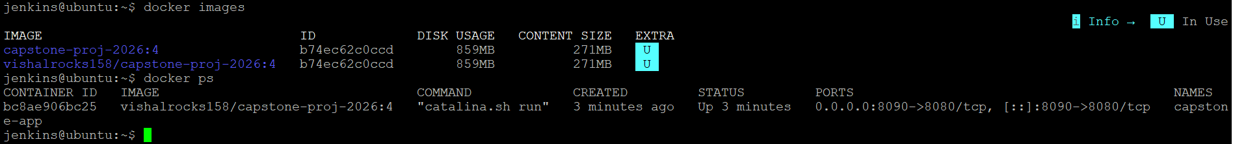
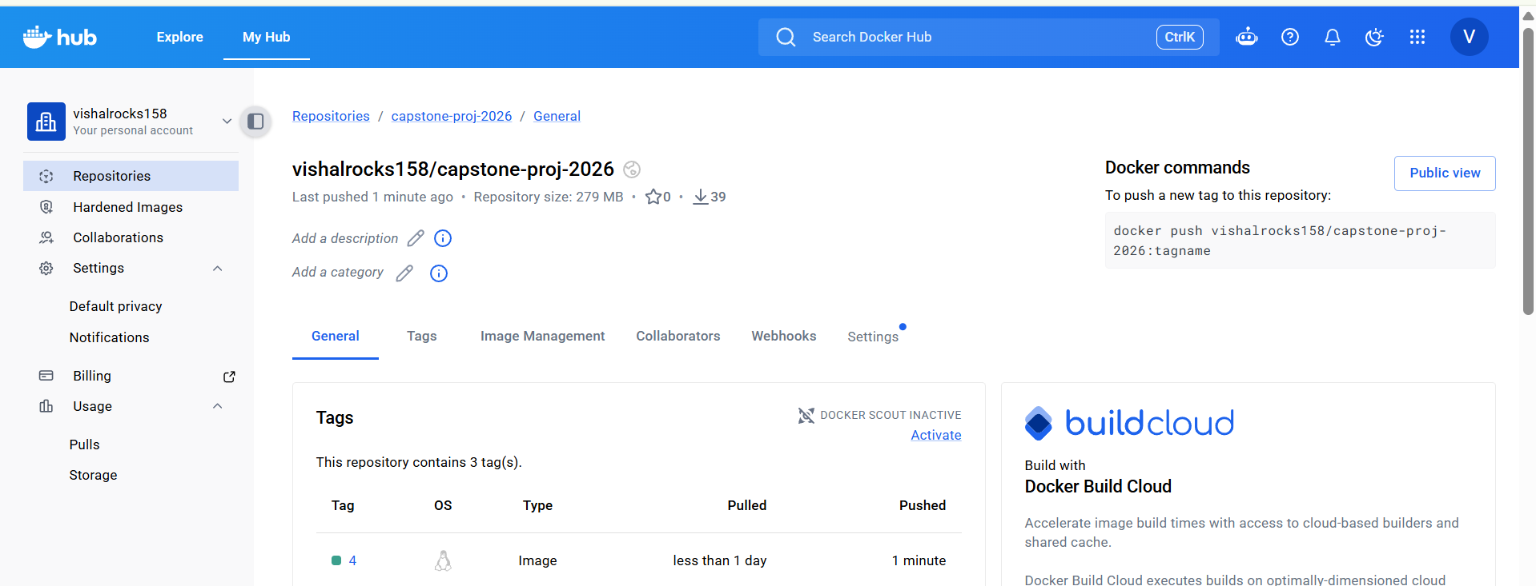
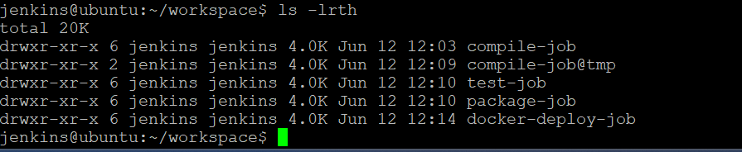
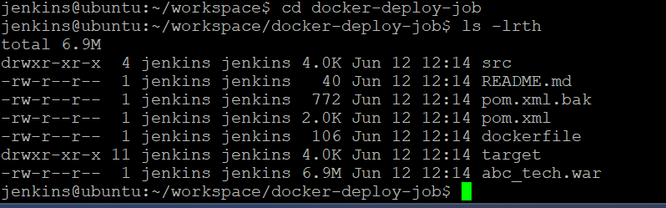
5. Successfully accessed the application using port 8090 as 8080 is already being used by Jenkins.
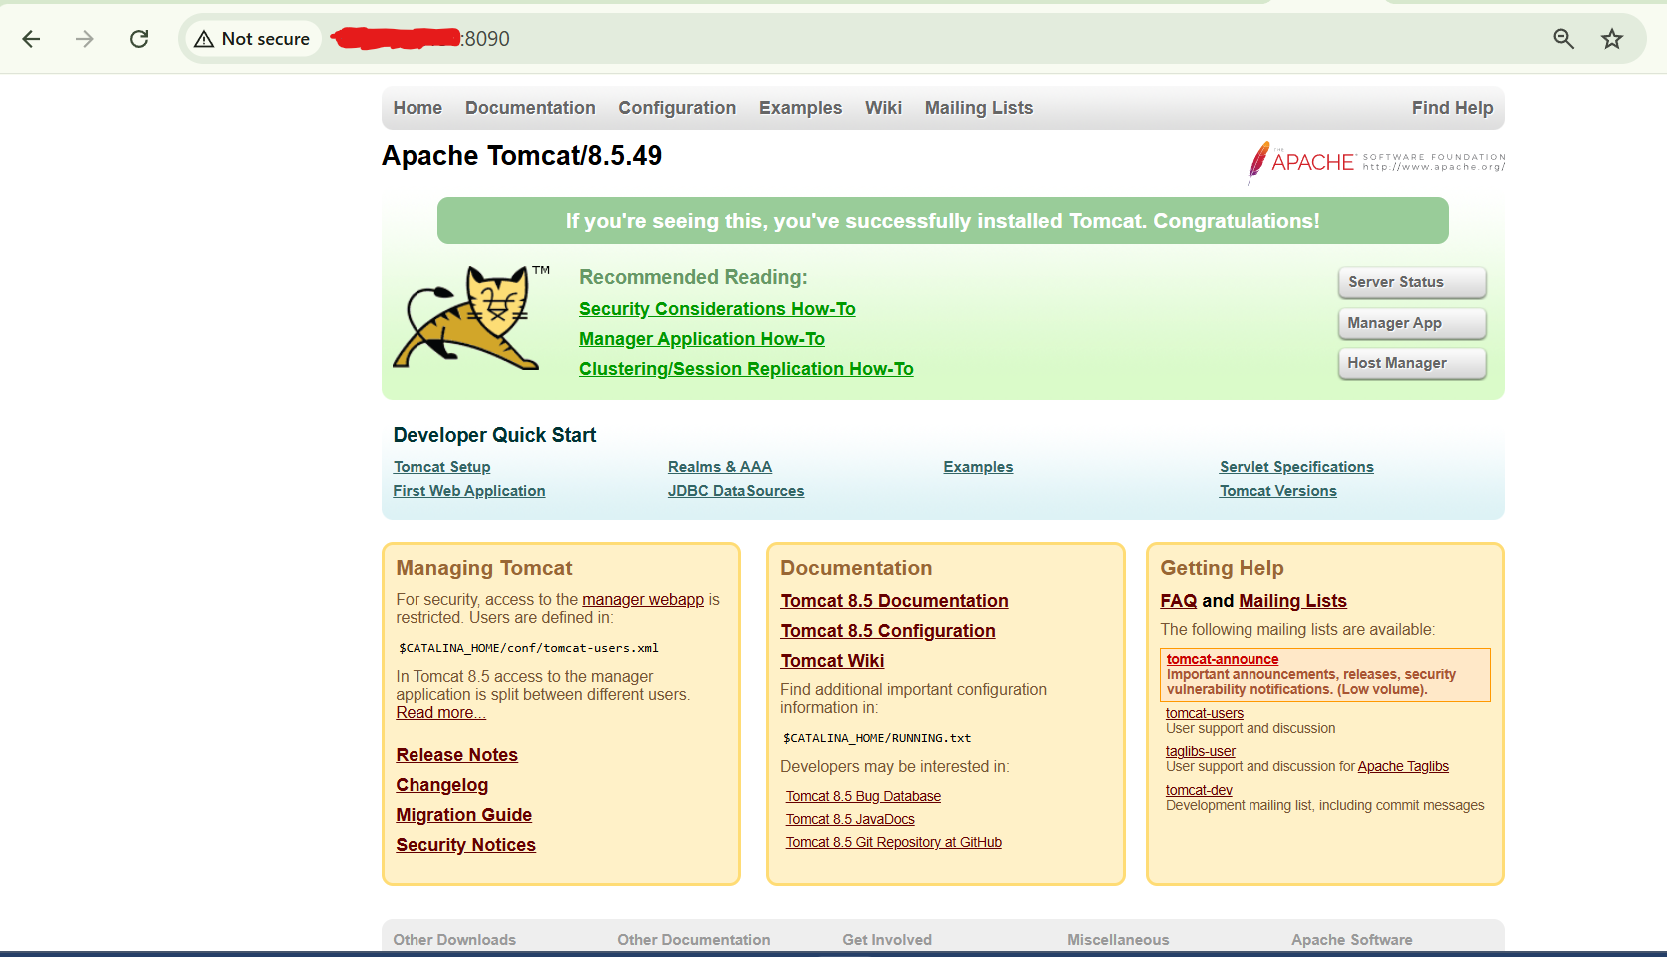
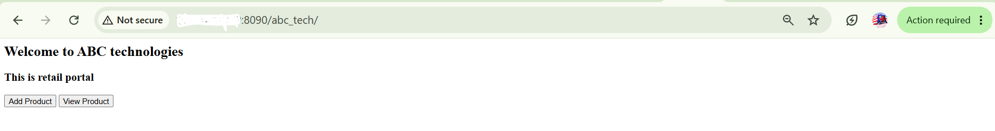

-----------------------------------------------------
6. Successfully installed containerd and completed the K8S installation
Install Kubernetes on BOTH VMs
Disable Swap
sudo swapoff -a
sudo sed -i '/ swap / s/^/#/' /etc/fstab
Install Containerd
sudo apt update
sudo apt install -y containerd
sudo systemctl enable containerd
sudo systemctl start containerd
Kernel Modules
cat <<EOF | sudo tee /etc/modules-load.d/k8s.conf
overlay
br_netfilter
EOF
sudo modprobe overlay
sudo modprobe br_netfilter
Sysctl
cat <<EOF | sudo tee /etc/sysctl.d/k8s.conf
net.bridge.bridge-nf-call-iptables=1
net.bridge.bridge-nf-call-ip6tables=1
net.ipv4.ip_forward=1
EOF
sudo sysctl --system

Install Kubernetes Packages
Run on BOTH nodes:
sudo mkdir -p /etc/apt/keyrings
curl -fsSL https://pkgs.k8s.io/core:/stable:/v1.34/deb/Release.key | sudo gpg --dearmor -o /etc/apt/keyrings/kubernetes-apt-keyring.gpg
echo 'deb [signed-by=/etc/apt/keyrings/kubernetes-apt-keyring.gpg] https://pkgs.k8s.io/core:/stable:/v1.34/deb/ /' | sudo tee /etc/apt/sources.list.d/kubernetes.list
sudo apt update
sudo apt install -y kubelet kubeadm kubectl
sudo apt-mark hold kubelet kubeadm kubectl

Initialize Master
On Master only:
sudo kubeadm init --pod-network-cidr=192.168.0.0/16
Save the join command.

Configure kubectl
Master:
mkdir -p $HOME/.kube
sudo cp /etc/kubernetes/admin.conf $HOME/.kube/config
sudo chown $(id -u):$(id -g) $HOME/.kube/config

Install Calico
Master:
kubectl apply -f https://raw.githubusercontent.com/projectcalico/calico/v3.29.0/manifests/calico.yaml

Join Worker
Run the join command from master on worker:
sudo kubeadm join ...
Verify:
kubectl get nodes
Expected:
k8s-master Ready
k8s-worker Ready

Install Ansible on Jenkins Server
sudo apt update
sudo apt install ansible -y

Install kubectl on Jenkins Server
curl -LO "https://dl.k8s.io/release/$(curl -L -s https://dl.k8s.io/release/stable.txt)/bin/linux/amd64/kubectl"
chmod +x kubectl
sudo mv kubectl /usr/local/bin/

Copy kubeconfig to Jenkins
From master:
scp ~/.kube/config jenkins-server:/tmp/config
On Jenkins:
sudo mkdir -p /var/lib/jenkins/.kube
sudo cp /tmp/config /var/lib/jenkins/.kube/config
sudo chown -R jenkins:jenkins /var/lib/jenkins/.kube
Test:
sudo su - jenkins
kubectl get nodes

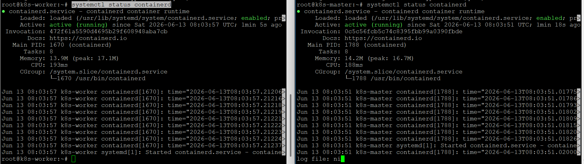
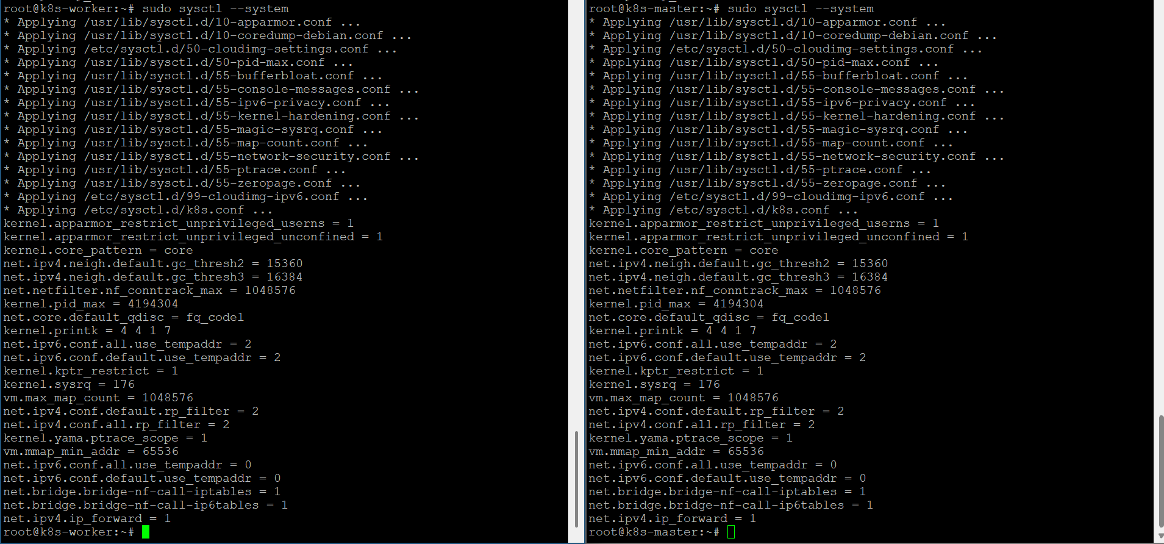
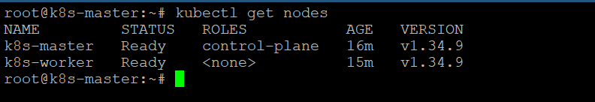
7. Successfully installed Ansible & Kubectl on the Jenkins server
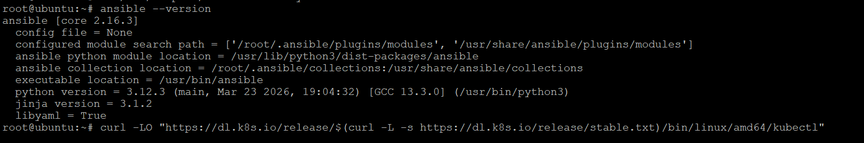
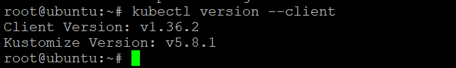
8. Now, Jenkins server can access the K8s nodes ...
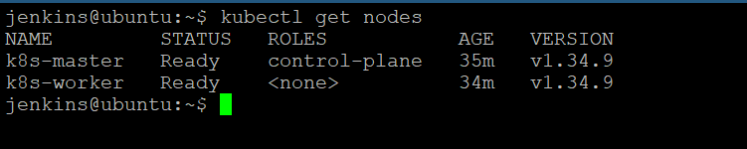
This means:
✔ kubectl installed on Jenkins server
✔ kubeconfig copied correctly
✔ Jenkins can reach Kubernetes API Server
✔ Jenkins can manage the cluster
✔ Jenkins → Kubernetes connectivity is working

9. Integration of Docker, Ansible and Kubernetes
After successfully building and pushing the Docker image to Docker Hub, Ansible was integrated with Jenkins to automate Kubernetes deployments.
- A Kubernetes Deployment manifest (deployment.yaml) was created to deploy the application using the Docker image stored in Docker Hub.
- A Kubernetes Service manifest (service.yaml) was created using the NodePort service type to expose the application externally.
- An Ansible playbook (deploy-k8s.yml) was developed to automate the deployment process. The playbook performs the following tasks:
  - Generates the final deployment file using environment variable substitution.
  - Deploys the Kubernetes Deployment.
  - Creates the Kubernetes Service.
  - Verifies the status of Pods and Services.
- Kubernetes cluster connectivity was established from the Jenkins server using the Kubernetes configuration file (kubeconfig) and kubectl.
- A Jenkins Pipeline job named ansible-k8s-job was created to execute the Ansible playbook automatically.
- Upon execution of the Jenkins job, Ansible deployed the application to the Kubernetes cluster and verified successful deployment.
Results:
- Application deployed successfully on Kubernetes.
- Two application Pods were created and reached the Running state.
- Kubernetes Service was created and exposed through a NodePort.
- Jenkins, Ansible, and Kubernetes were successfully integrated to achieve automated deployment.

pipeline {
agent any

stages {
stage('Checkout') {
steps {
git branch: 'main', url: 'https://github.com/vishalrocks158/capstone-project-2026.git'
}
}

stage('Deploy to Kubernetes using Ansible') {
steps {
sh '''
export BUILD_NUMBER=${BUILD_NUMBER}
ansible-playbook deploy-k8s.yml
'''
}
}

stage('Verify Kubernetes') {
steps {
sh 'kubectl get pods'
sh 'kubectl get svc'
}
}
}
}

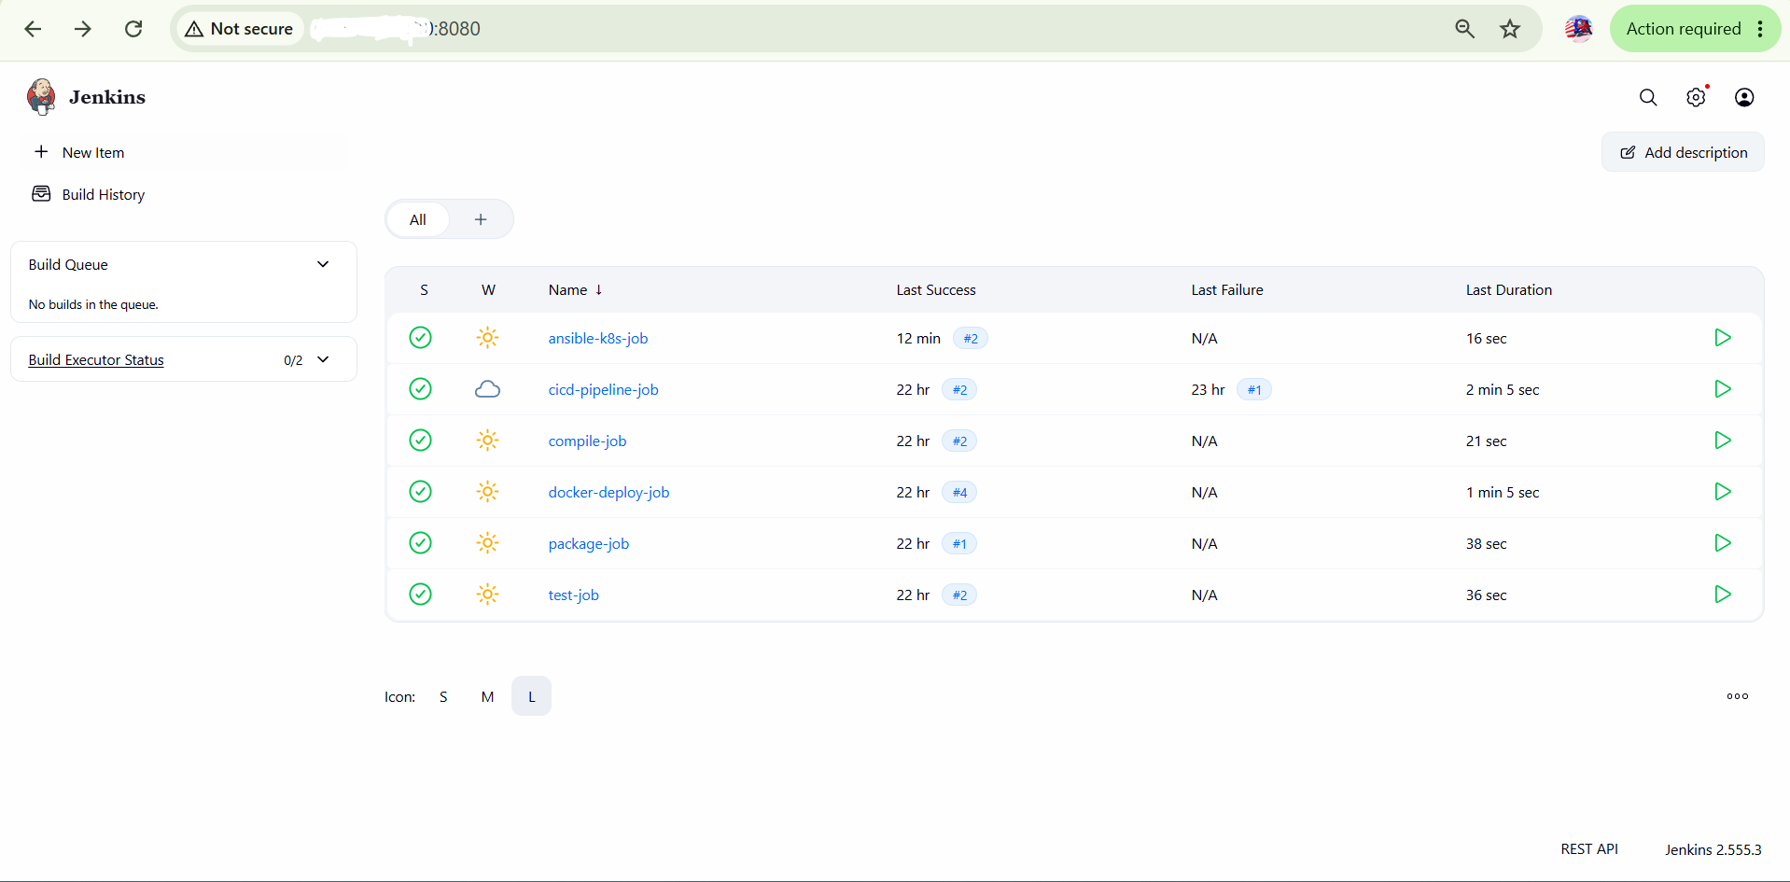

$ cat deployment.yaml
apiVersion: apps/v1
kind: Deployment
metadata:
name: capstone-app
spec:
replicas: 2
selector:
matchLabels:
app: capstone-app
template:
metadata:
labels:
app: capstone-app
spec:
containers:
- name: capstone-app
image: vishalrocks158/capstone-proj-2026:4
ports:
- containerPort: 8080
$ cat service.yaml
apiVersion: v1
kind: Service
metadata:
name: capstone-service
spec:
type: NodePort
selector:
app: capstone-app
ports:
- port: 8080
targetPort: 8080

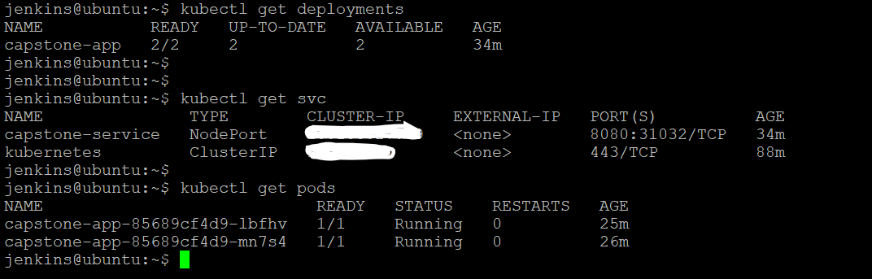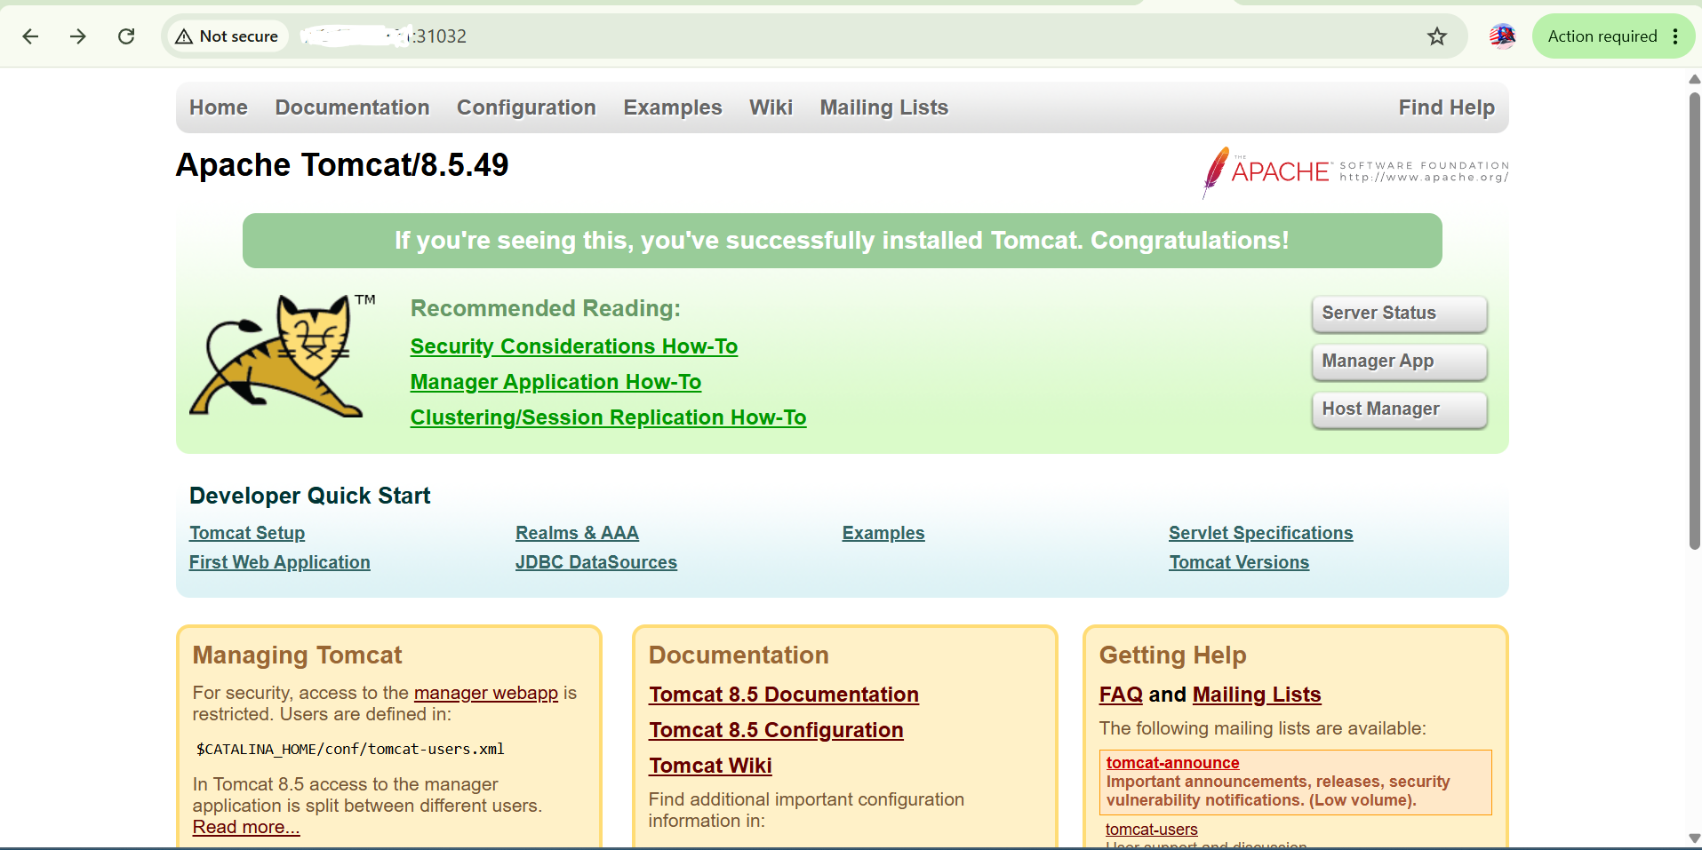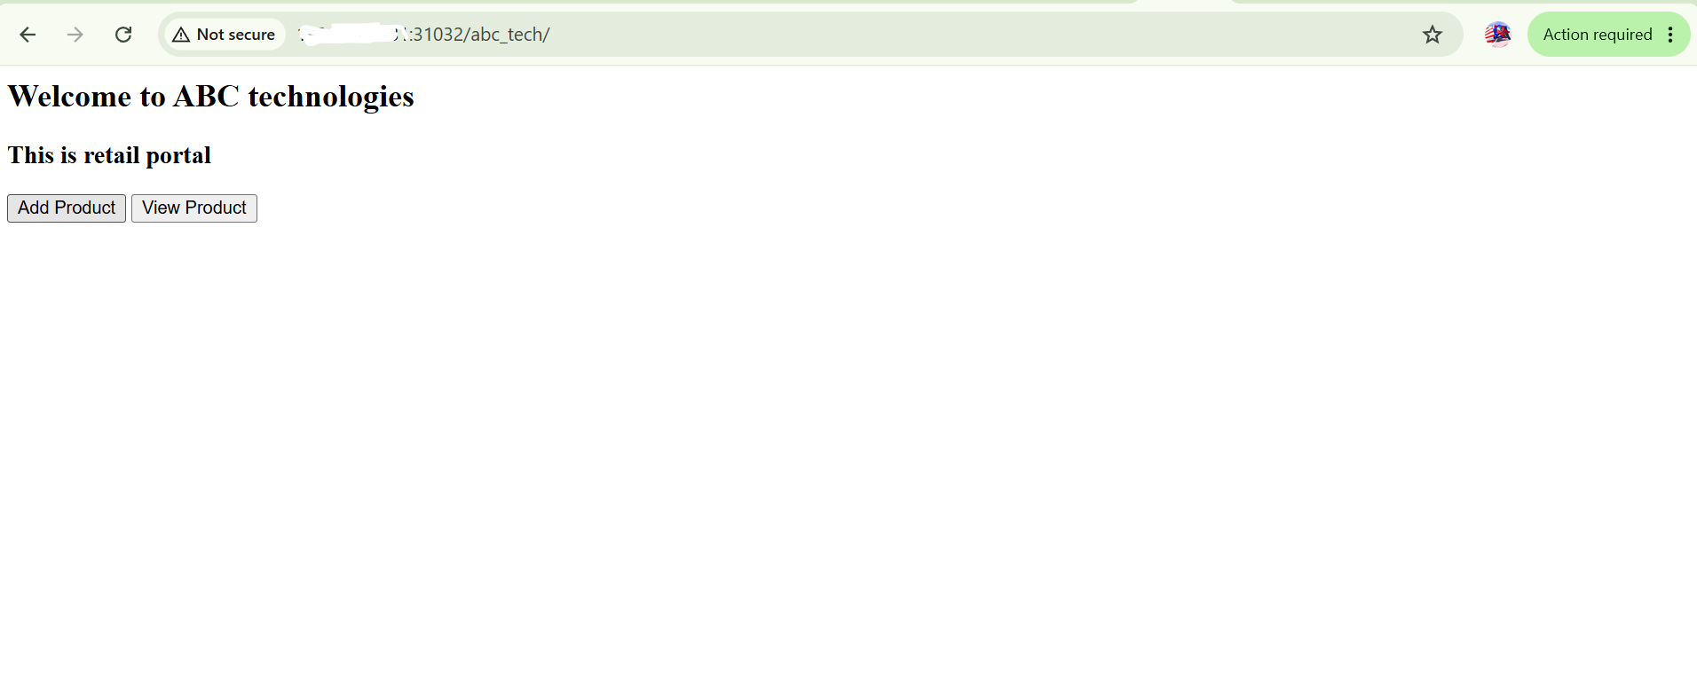
10. Prometheus & Grafana
Step 1 - Install Node Exporter
On k8s-master:
cd /opt
sudo wget https://github.com/prometheus/node_exporter/releases/download/v1.9.1/node_exporter-1.9.1.linux-amd64.tar.gz
sudo tar -xvzf node_exporter-1.9.1.linux-amd64.tar.gz
sudo mv node_exporter-1.9.1.linux-amd64 node_exporter
Run:
cd /opt/node_exporter
./node_exporter &
Verify:
curl http://localhost:9100/metrics

Step 2 - Install Prometheus
cd /opt
sudo wget https://github.com/prometheus/prometheus/releases/download/v3.6.0/prometheus-3.6.0.linux-amd64.tar.gz
sudo tar -xvzf prometheus-3.6.0.linux-amd64.tar.gz
sudo mv prometheus-3.6.0.linux-amd64 prometheus
Edit config:
vi /opt/prometheus/prometheus.yml
Add:
scrape_configs:
- job_name: 'node_exporter'
static_configs:
- targets: ['localhost:9100']
Start Prometheus:
cd /opt/prometheus
./prometheus --config.file=prometheus.yml &
Verify:
http://<master-ip>:9090
Status → Targets should show:
node_exporter UP

Step 3 - Install Grafana
sudo apt update
sudo apt install -y apt-transport-https software-properties-common wget
sudo mkdir -p /etc/apt/keyrings
wget -q -O - https://apt.grafana.com/gpg.key | gpg --dearmor | sudo tee /etc/apt/keyrings/grafana.gpg > /dev/null
echo "deb [signed-by=/etc/apt/keyrings/grafana.gpg] https://apt.grafana.com stable main" | sudo tee /etc/apt/sources.list.d/grafana.list
sudo apt update
sudo apt install grafana -y
Start:
sudo systemctl enable grafana-server
sudo systemctl start grafana-server
Verify:
sudo systemctl status grafana-server

Step 4 - Connect Grafana to Prometheus
Open:
http://<master-ip>:3000
Default login:
admin
admin
Add datasource:
Type: Prometheus
URL: http://localhost:9090
Click:
Save & Test

Step 5 - Import Dashboard
Dashboard ID:
1860
(Node Exporter Full Dashboard)
This will automatically give:
CPU Usage
Memory Usage
Disk Usage
Network Usage
Load Average
Filesystem Usage

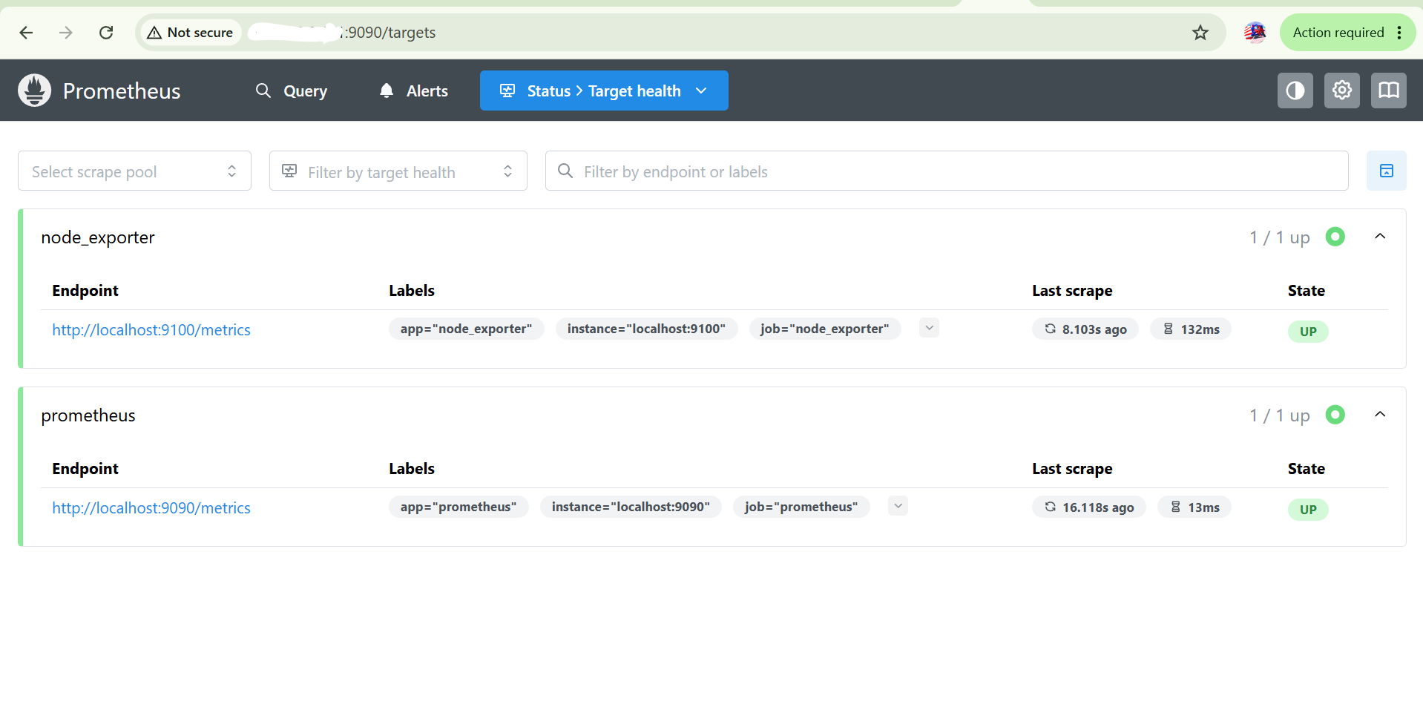

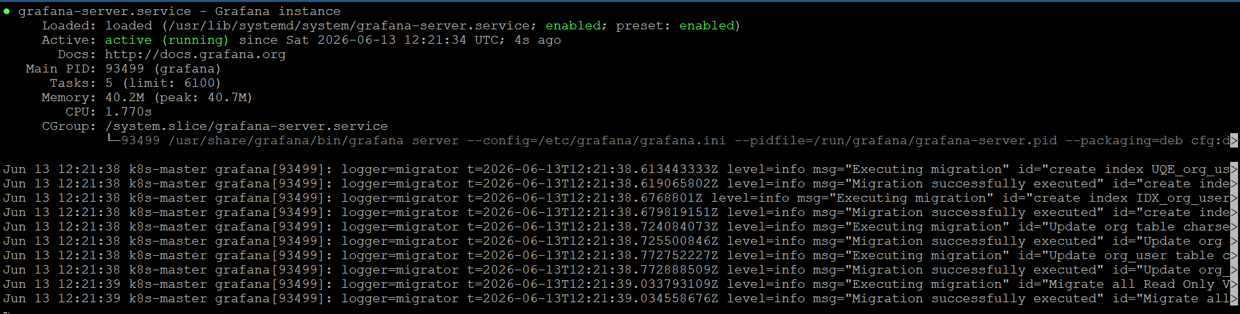

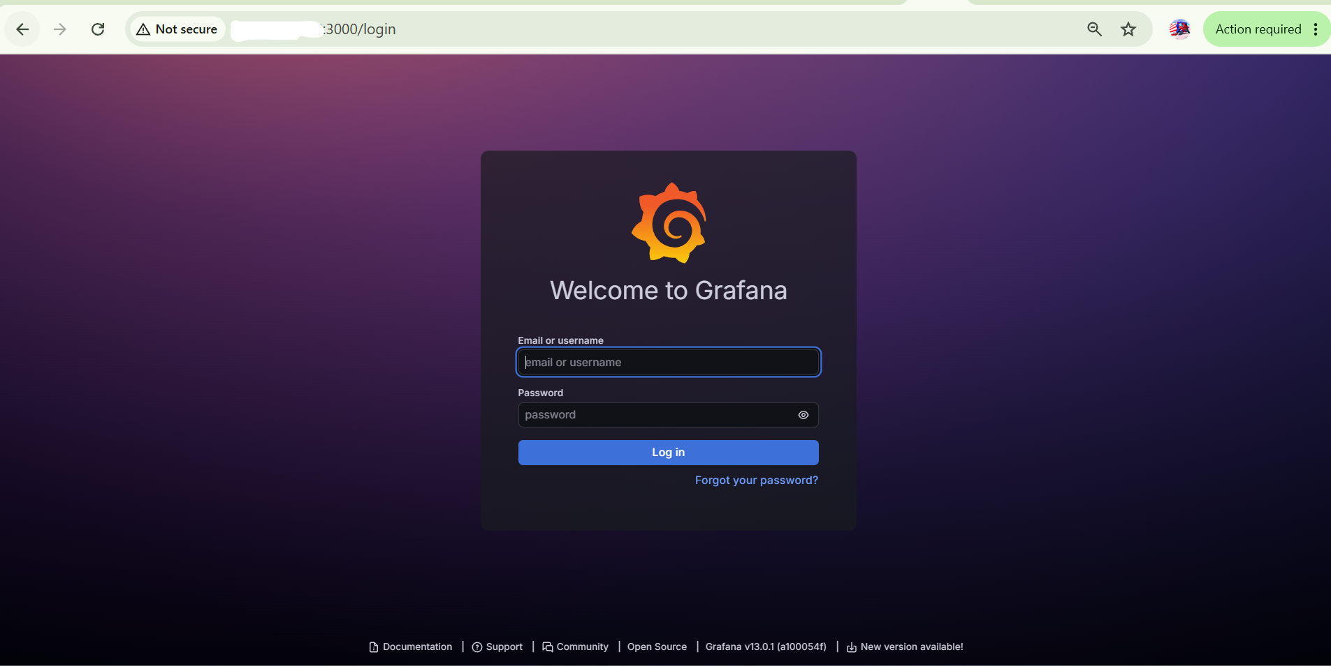

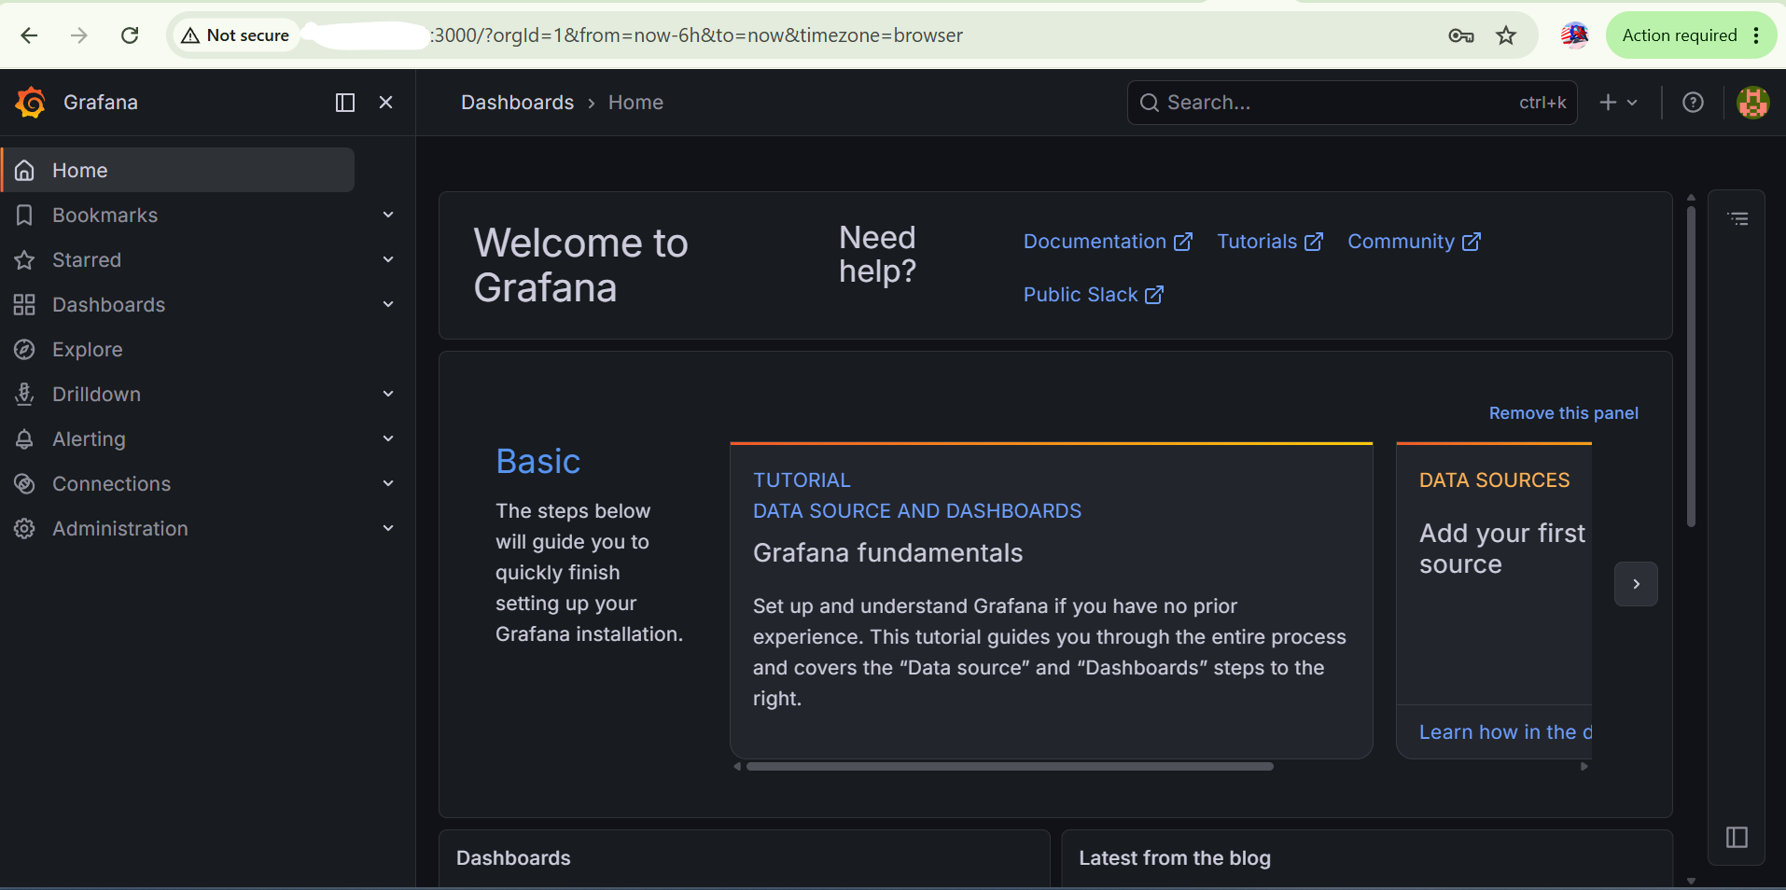

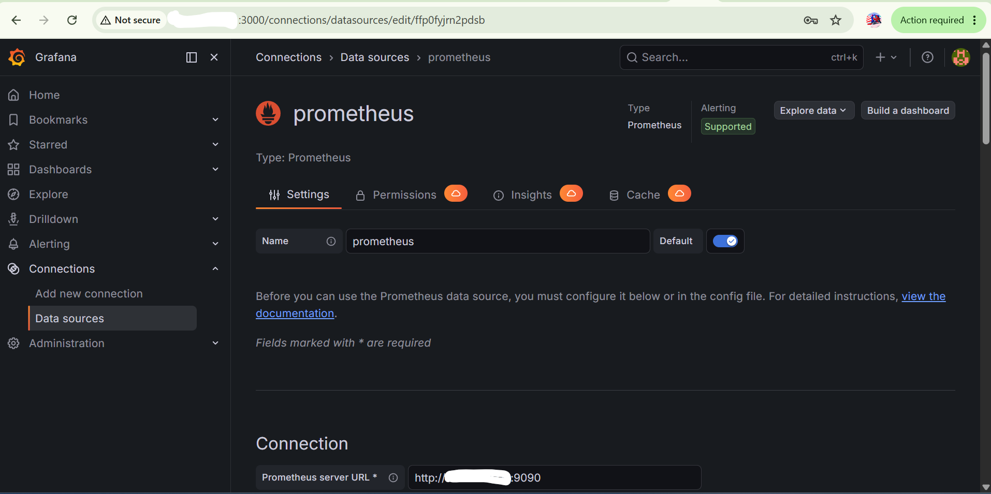

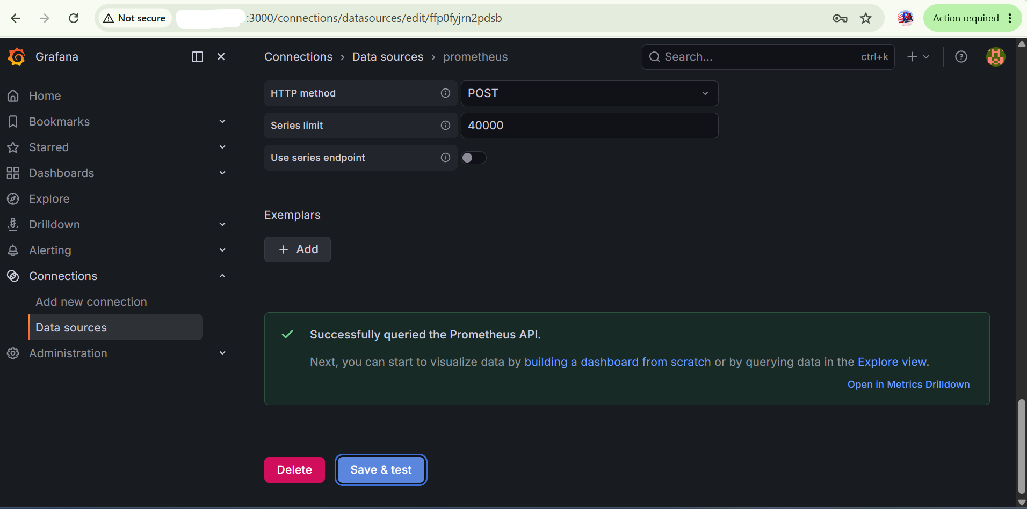

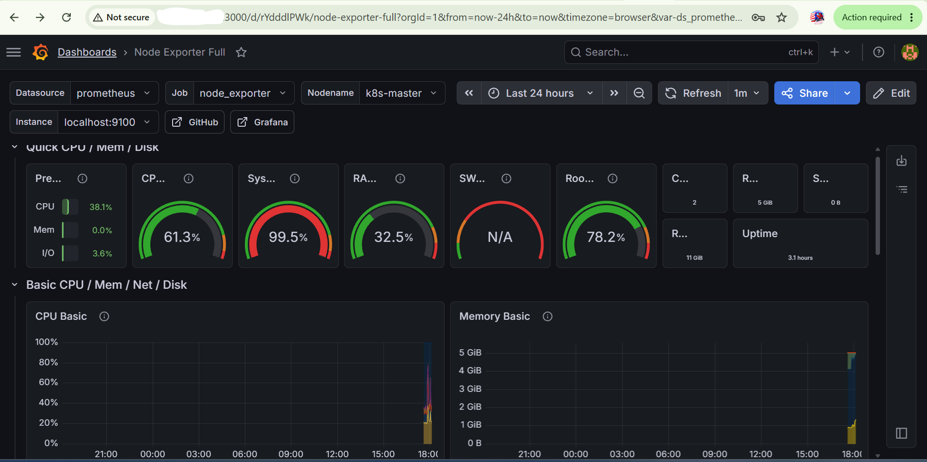

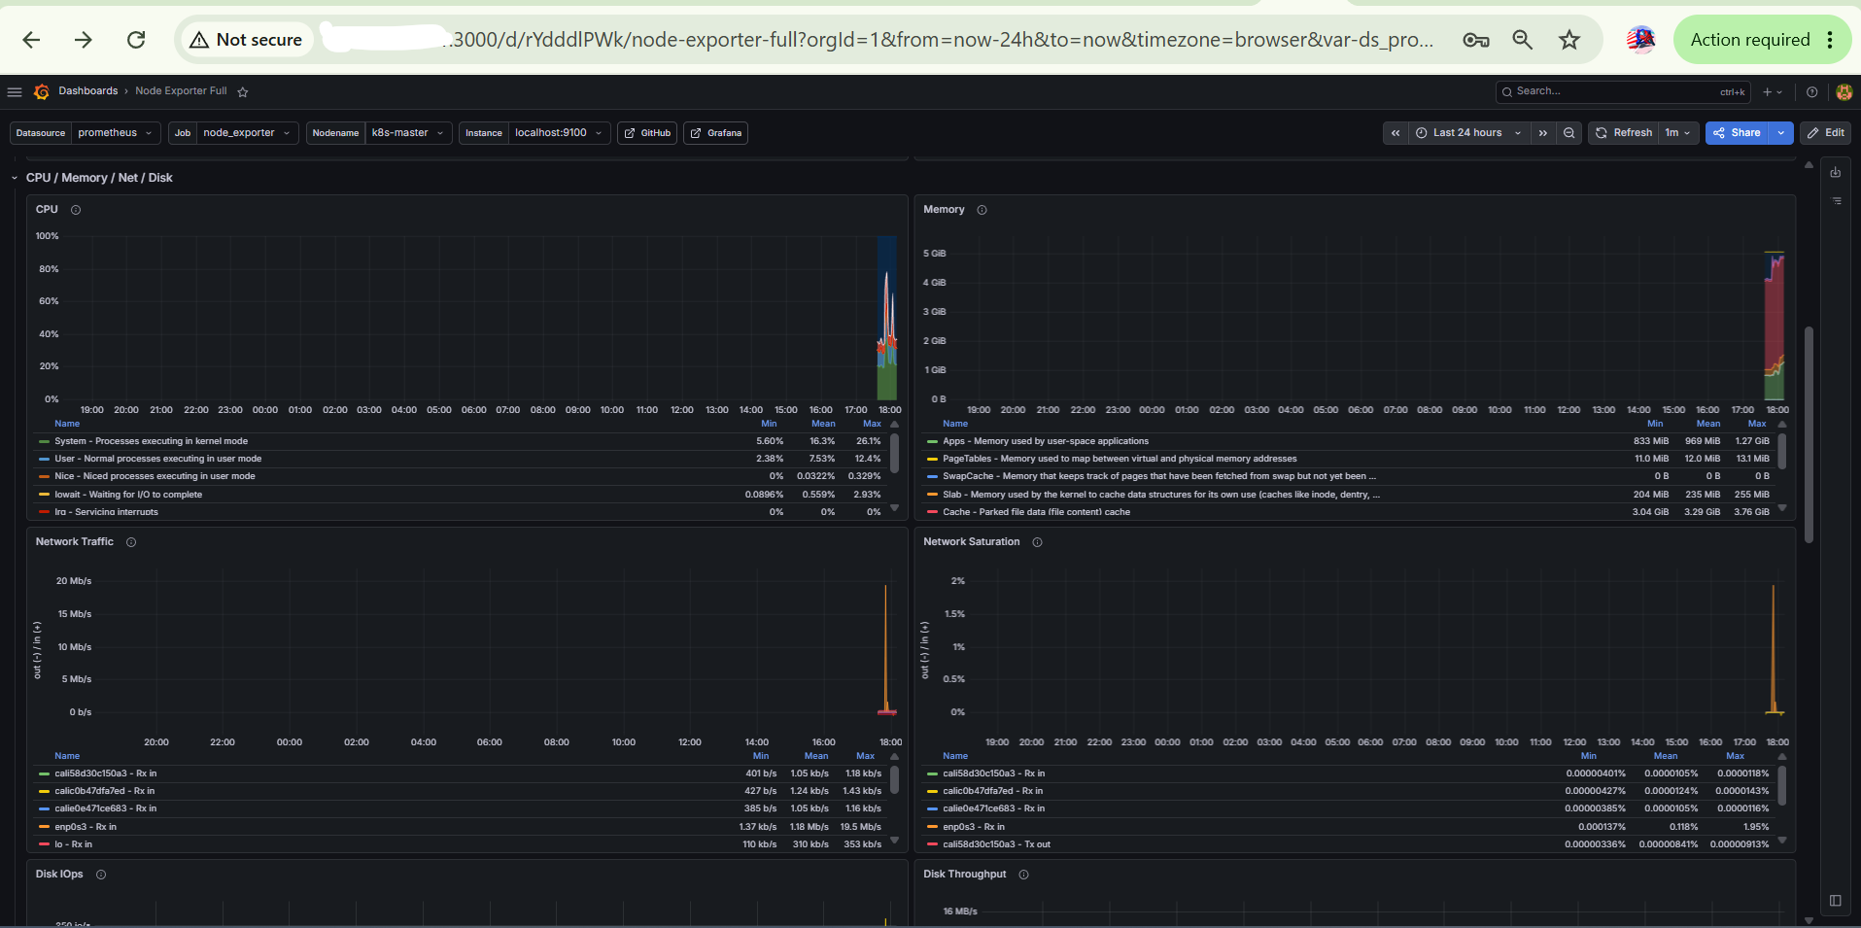

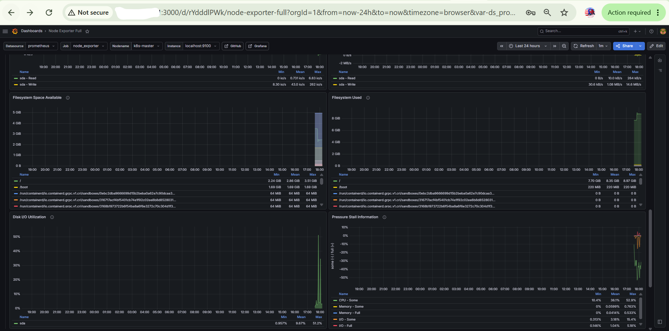

Project Declaration
I hereby declare that this project titled "Building a CI/CD Pipeline for a Retail Company" has been designed, implemented, and documented by me as part of the Post Graduate Certification Program in DevOps.
The complete solution, including source code management, Continuous Integration, Continuous Delivery, Docker image creation, containerization, Kubernetes deployment, Ansible automation, monitoring, and reporting, was implemented and validated by me using the tools and technologies specified in the project requirements.
The project workflow includes:
- Source Code Management using Git and GitHub
- Continuous Integration using Jenkins
- Build and Packaging using Maven
- Containerization using Docker
- Image Repository Management using Docker Hub
- Deployment Automation using Ansible
- Container Orchestration using Kubernetes
- Monitoring using Prometheus
- Visualization and Dashboarding using Grafana
All configurations, scripts, manifests, pipeline definitions, deployment files, and documentation submitted as part of this project were created, executed, tested, and verified by me.
I confirm that this work is my own implementation completed for academic and learning purposes.
Submitted By:
Vishal Thakur
Project:
Building a CI/CD Pipeline for a Retail Company
Program:
Post Graduate Certification Program in DevOps
Date: ____13-06-2026________________
Conclusion
The objective of the project was to design and implement an end-to-end CI/CD pipeline for a retail application. The solution successfully automated source code management, build, testing, packaging, containerization, deployment, and monitoring activities.
The application source code was managed using GitHub, integrated with Jenkins for Continuous Integration, packaged using Maven, containerized using Docker, and stored in Docker Hub. Deployment automation was achieved using Ansible and Kubernetes. Prometheus and Grafana were used to monitor and visualize system and application metrics.
The implemented solution reduced manual intervention, improved deployment efficiency, and demonstrated a complete DevOps workflow from code commit to application deployment and monitoring.

