OPERATONAL CALCULATOR

PURPOSE: To calculate basic and complex mathematical operations.

OVERVIEW: In this system the calculator is used for basic mathematical operations like add, subtract, division and multiplication. It is also used to perform calculations like sine, cos, tan, floor and ceil functions.

FEASIBILITY STUDY:

4W’S & H

WHAT:

The purpose of this project is to calculate is various mathematical operations.

WHEN:

We can use this on daily basis for various calculations like addition, subtraction, division, sine, cos, floor, ceil etc for finance, billing and educational purposes.

WHERE:

It can be used by the user anywhere whenever needed for various operational use.

WHY:

To perform and use mathematical operations for various purposes.

HOW:

It is used to perform calculation from basic arithmetic to complex mathematical operations.

SWOT ANALYSIS:

HIGH LEVEL REQUIREMENT:

1. Basic operations (ADDITION, SUBTRACTION, DIVISION, MULTIPLICATION)
2. Trigonometric operations (SINE, COS, TAN, SEC, COT, COSEC).
3. Floor.
4. Ceil.

LOW LEVEL REQUIREMENT:

1. Should contain minimum capacity to perform operations.
2. windows is required.
3. c compiler is required.

DESIGN:

HIGH LEVEL DESIGN:

LOW LEVEL DESIGN:

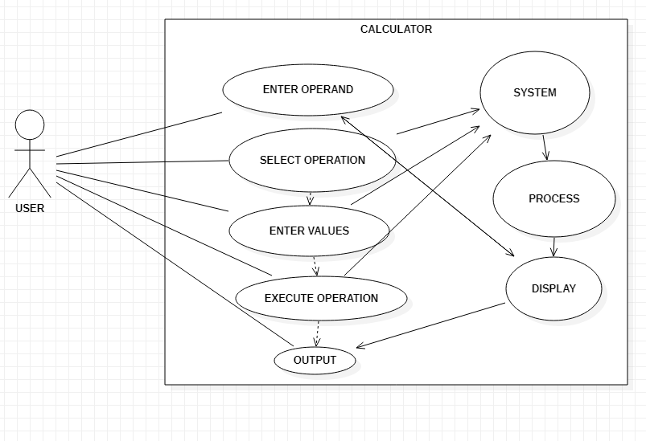

IMPLEMENTATION: