**Iterative Model**

An iterative life cycle model does not attempt to start with a full specification of requirements. Instead, development begins by specifying and implementing just part of the software, which can then be reviewed in order to identify further requirements. This process is then repeated, producing a new version of the software for each cycle of the mode. Typically iterative development is used in conjunction with incremental development in which a longer software development cycle is split into smaller segments that build upon each other.

**Diagram of Iterative model**:

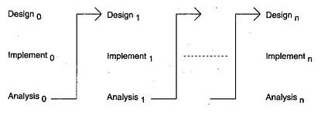

In the diagram above when we work iteratively we create rough product or product piece in one iteration, then review it and improve it in next iteration and so on until it’s finished. As shown in the image above, in the first iteration the whole painting is sketched roughly, then in the second iteration colors are filled and in the third iteration finishing is done. Hence, in iterative model the whole product is developed step by step.

**Advantages of Iterative model:**

* In iterative model we can only create a high-level design of the application before we actually begin to build the product and define the design solution for the entire product. Later on we can design and built a skeleton version of that, and then evolved the design based on what had been built.
* In iterative model we are building and improving the product step by step. Hence we can track the defects at early stages. This avoids the downward flow of the defects.
* In iterative model we can get the reliable user feedback. When presenting sketches and blueprints of the product to users for their feedback, we are effectively asking them to imagine how the product will work.
* In iterative model less time is spent on documenting and more time is given for designing.

**Disadvantages of Iterative model:**

* Each phase of an iteration is rigid with no overlaps.
* Costly system architecture or design issues may arise because not all requirements are gathered up front for the entire lifecycle.