Q1. Program for Printing Star as following method.

\* \* \* \* \*

\* \* \* \*

\* \* \*

\* \*

\*

Solution:

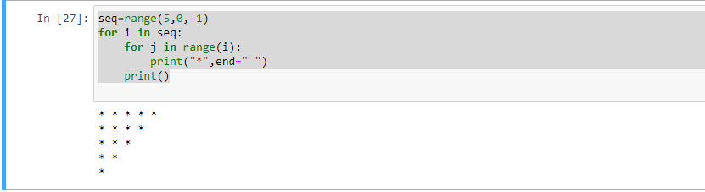

Q2. Write a Python program to remove duplicates from a list

Solution-

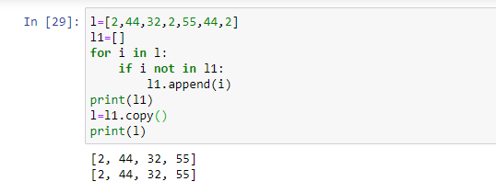

Q3. Write a Python program to get the difference between the two lists

Solution-

