CS628 Assignment 1 – Principles of Least Privilage
Vishal Kumar
Roll Number: 231110058

functionA()

functionA() is attempting to open the "/etc/logrotate.conf" file for appending. If this file can not be opened or doesn’t exist then it will print an error message, otherwise, it will append the text "Rotate = 90" to the file and close it.

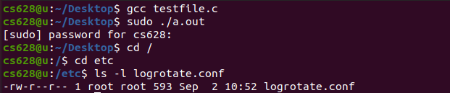
Here, we can easily see that to run this code, we needed to execute this with superuser (root) privileges.

Here, fopen() function is used to open the file in append mode, and logrotate.conf file can only be accessed by the root for appending. So yes the functionA() requires root privilege.
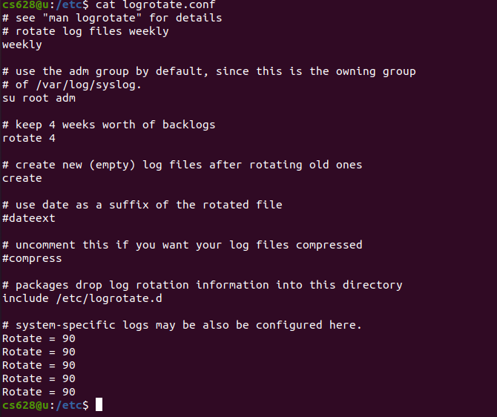
Here, using cat command we can see that “Rotate = 90” text gets appended to the file.

functionB()

The functionB() is designed to read and list the contents of the "/proc" directory. "/proc" is a special directory directory in linux/unix systems that contains information about running processes and some other information.
Here, it is first opening the "/proc" directory and if directory can not be opened then it will print error message. Afterwards it will loop through the directory entries and it will skip entries that do not begin with a digit. It will print the name of the entries starting with digits.
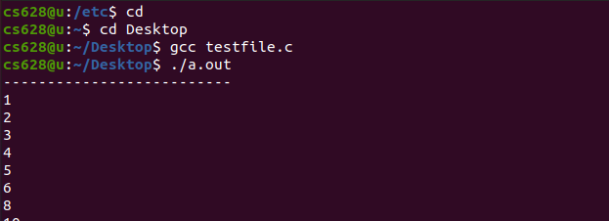
Here we can see that our code is running without even using sudo command.

Here we can see that using opendir(), we are trying to open the directory, and since it can be read by everyone, there is no such requrirement of root privileges.
So the functionB() doesn’t require root privilege.

functionC()

functionC() is attempting to configure a firewall using the iptables command to block outgoing traffic to google.com from a specific network segment.
First of all it is calling getifaddrs to retrieve a list of network interfaces and their addesses. Then it iterates through the list of network interfaces and checks if it’s an IPV4 inteface, not a loopback, is up, not point to point, and no ARP. And then it allocates memory for subnet string, and constructs an iptable command to block outgoing traffic to google.com, and then exectues the iptables command, and then finally check the exit status of the system.
Here we can easily see that this code is using iptables to perform firewall operations, and manipulating firewall rules requires root privileges. So yes functionC() requires root privileges.

functionD()

functionD() is attempting to create a systemd network configuration file for the “eth0” interface in the "/etc/systemd/network” directory.
First of all it is taking a network interface name as an argument and then it constructs a filename for the systemd network configuration file using snprintf, and then it tries to open the file using fopen command. If the file doesn’t open either due to permission issues or non existen directory, it prints an error message, whereas if the file is opened then using fprintf, it writes network configuration settings to the file.

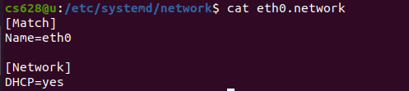
Here using cat command we can see that what changes has been made to this file.
Actually fprintf sets network interface name and specifies DHCP as network configuration.

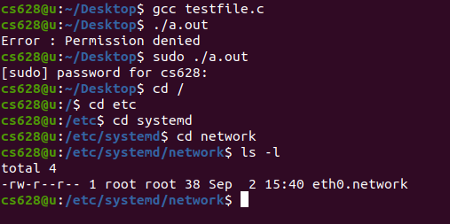
As we know that modifying system configuration files in the "/etc/systemd/network” directory requires root privileges and in the snap we can also see that writing permission is only granted for owner which is root, so again we can easily say that functionD() requries root privileges.

functionE()

functionE() is attempting to read the last 20 characters(if we are assuming 0-based indexing) from each line of the "/var/log/syslog" log file and it generates a string containing those characters. If successful then prints a generated string otherwise prints an error message.

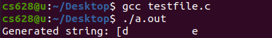

To explain the functionality of the code, there is a custom function named my_strdup that duplicates a given string using malloc, if allocation fails, then it returns null.

In this section of the code, we are trying to open the log file for reading using fopen().

As we can see that here, read permission is granted for the user, so we can say that functionE() doesn’t require root privilege.

functionF()

functionF() is attempting to set up a new cron job by taking a cron job schedule(which is basically a string) as input and then writing it to a temp file and then set the crontab from the contents of the temp file using the crontab command.

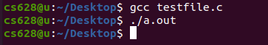

As we can see here, during execution it doesn’t require superuser privilege.

As this code creates a temporary file in the “/tmp” directory and writes the cron job information to it and we can see down below everyone is having permission on the “/tmp” directory, so definitely it doesn’t require any root privileges.

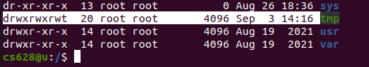

functionG()

functionG() is attemting to add a cron job to the system’s crontab file located at "/etc/crontab".

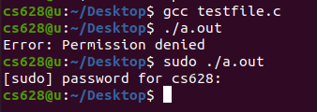

As we can see above when we try to run this program it requires superuser privilege.

When it tries to open the system’s crontab file in append mode, we can see below that it can only be done with root privilege bcz only root has that permission.

So, we can say that functionG() requires root privilege.

functionH()

functionH() is attempting to resovle the domain names(hostnames) to their corresponding IP addresses using the getaddrinfo() and print them to console.

This operation doesn’t require root privileges because it’s a common operation performed by user level applications to map domain names to IP addresses.
Here our code is simply performing a standard DNS resolution operation, which doesn’t require root privileges.

I()

The purpose of this function I() is to list and display informations about user accounts on a unix-like system. It uses the function setpwent() to initialise the password file for reading and then using while loop it iterates through user account entries in the password file and then it uses the function getpwent() to get the next user account entry and stroes it in the pointer p. Afterwards, it prints various pieces of information about the user account which are the Username, the Userid, and the user’s home directory.

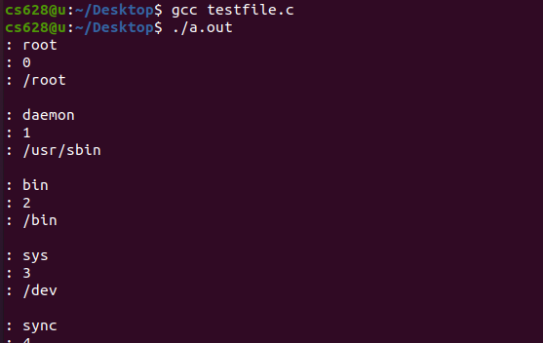

As I have already discussed the purpose of this code, it is used for informational purposes which basically reads publicy accessible user account data, so this function I() doesn’t require any root privileges as such.

J()

The primary purpose of this function J() is retrieve and print information about the filesystem mounted at the path “/” which is root directory.

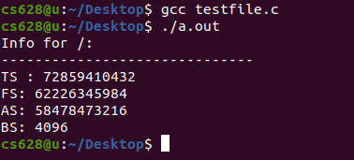

As we can see above in the snap that it calculates and prints the the TS(total size), FS(free space), AS(available space), BS(block size) of the filesystem.

Now, coming to the privilege part, it doesn’t require any root privileges as it is reading publicly accessible filesystem information.

Thank you!

