**Day 9 Task: Deep Dive in Git & GitHub for DevOps Engineers.**

#owner = vishal saxena

**Q. Set your user name and email address, which will be associated with your commits.**

To set your user name and email address for Git commits, you will need to run the following commands:

1. To set your user name, run the command "git config --global user.name "Your Name"" (replace "Your Name" with your actual name)
2. To set your email address, run the command "git config --global user.email "[your.email@example.com](mailto:your.email@example.com)"" (replace "[your.email@example.com](mailto:your.email@example.com)" with your actual email address)

You can check the settings by running "git config --global --list" command, it will show all the git global config

Once you have set your user name and email address, they will be associated with all of your future Git commits.

Note: If you want to set the user name and email address for a specific repository, instead of using "--global" option use the command inside that specific repository directory.

**Q. Connect your local repository to the repository on GitHub.**

To connect your local repository to a repository on GitHub, you will need to perform the following steps:

1. Create a new repository on GitHub. To do this, log in to your GitHub account, navigate to the "Repositories" tab, and click the "New" button. Give your repository a name and a description, and select whether you want it to be public or private.
2. Initialize a Git repository in your local project directory by running the command "git init"
3. Add your files to the local repository by running the command "git add ."
4. Commit your changes to the local repository by running the command "git commit -m "Initial commit""
5. Add the remote GitHub repository as an "origin" to your local repository by running the command "git remote add origin <https://github.com/><username>/<repositoryname>.git" (replace <username> and <repositoryname> with your GitHub username and repository name respectively).
6. Push your local repository to the remote GitHub repository by running the command "git push -u origin master"

Once these steps are completed, your local repository will be connected to the repository on GitHub and you can continue to push and pull changes to and from the remote repository.

**Q. Create a new file in Devops/Git/Day-02.txt & add some content to it**

Created a new file in Devops and add text into the Day-02.txt file and side by side we can see the remote repository.

Please refer to the below image for better understanding

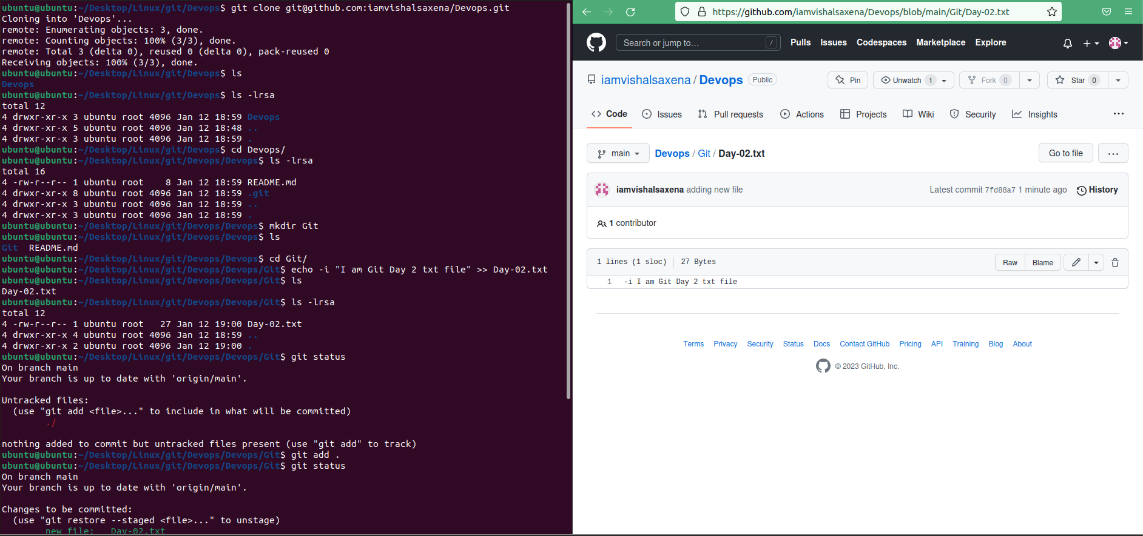

**Q. Push your local commits to the repository on GitHub**

Before adding new file to the Devops remote repository

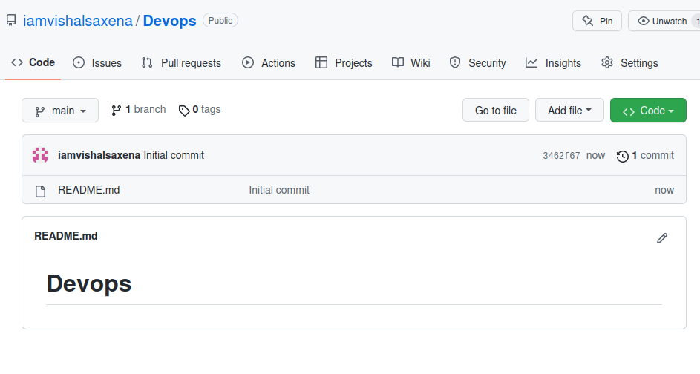

After adding new file to the Devops remote repository

