**Day-13 Task for 90DaysofDevops**

**#Owner - vishal saxena**

**Task1:**

1. **Install Python in your respective OS, and check the version.**
2. **Read about different Data Types in Python.**

**Solutions : -**

**But we can install python by the following command**

**apt-get install python3.6**

**As I am using ubuntu so the python is preinstalled on my system , Kindly check the installed python details .**

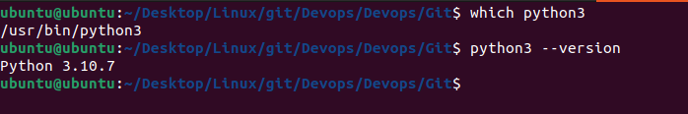

**Python Datatypes**

In Python, there are several built-in data types that are used to store different types of data. Some of the most commonly used data types in Python are:

1. Numbers: used to store numeric values. Python has three built-in numeric data types: int (integers), float (floating-point numbers), and complex (complex numbers).
2. Strings: used to store and manipulate text. Strings can be enclosed in single or double quotes.
3. Lists: used to store a collection of items that can be of any data type. Lists are enclosed in square brackets and items are separated by commas.
4. Tuples: similar to lists, but tuples are immutable, meaning that the items cannot be changed after they are created. Tuples are enclosed in parentheses and items are separated by commas.
5. Dictionaries: used to store key-value pairs, where each key is mapped to a specific value. Dictionaries are enclosed in curly braces and keys are separated from values by a colon.
6. Booleans: used to store a value of True or False.
7. Sets: used to store a collection of unique items, similar to lists and tuples, but the items are not ordered and duplicates are not allowed. Sets are enclosed in curly braces and items are separated by commas.
8. None: special data type that represents the absence of a value.