Open the HelloWorld.sln using Visual Studio and compile the solution.

Make sure HelloWorld.Service is set as a startup project

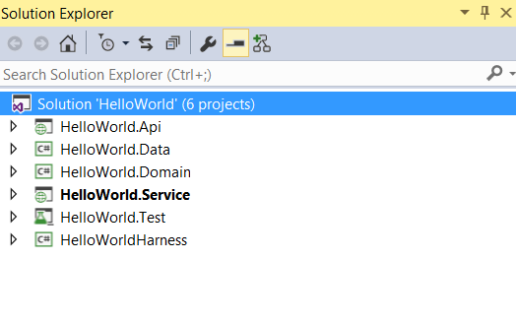

Press F5 to start the service.

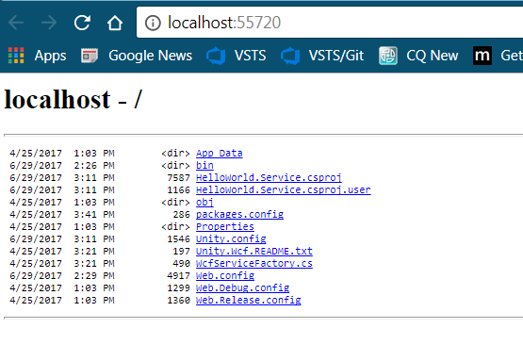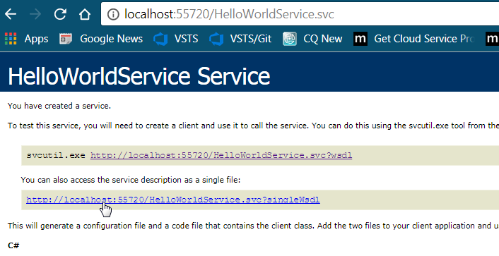

Right click on HelloWorldHarness and start new instance by clicking on Debug 🡪 Start New Instance

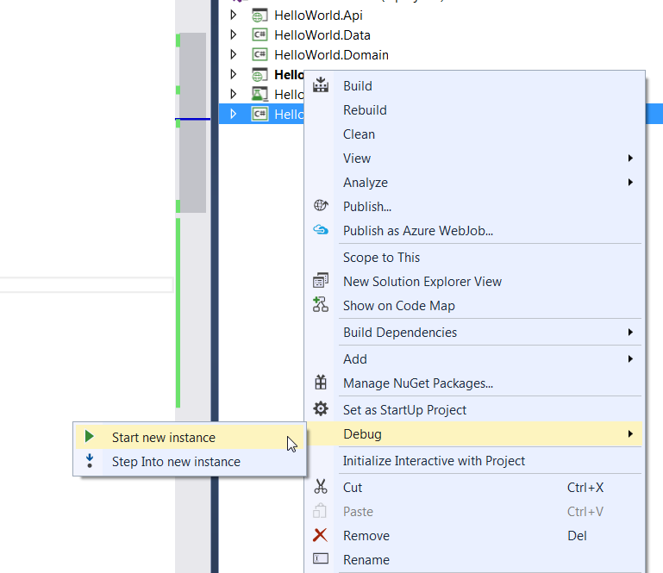

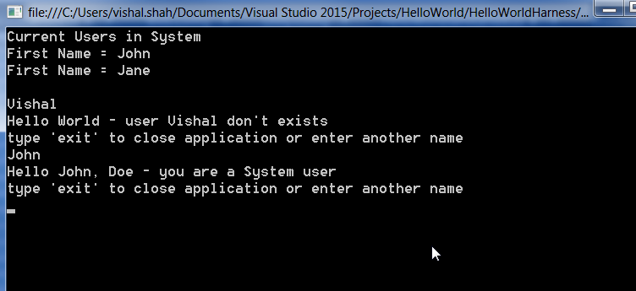

Stop Debugging and right click on HelloWorld.Api to run the Web API

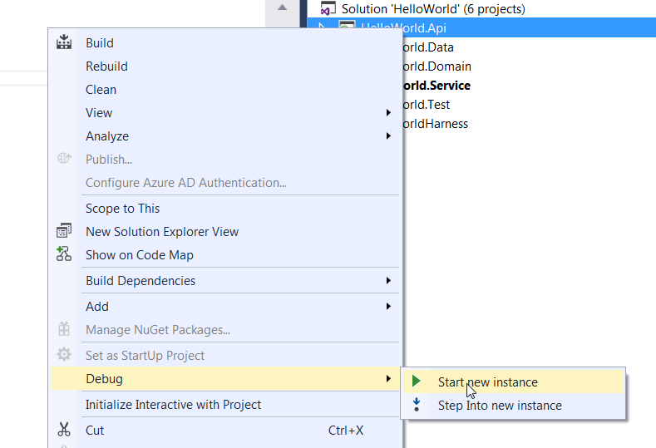

Using tool like Postman or Fiddler – submit a request as shown below

Invalid User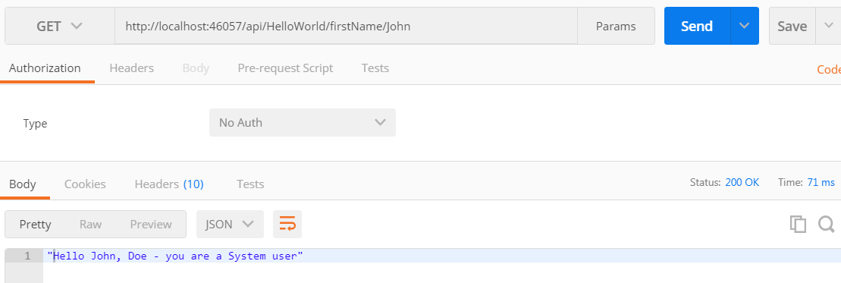

Valid User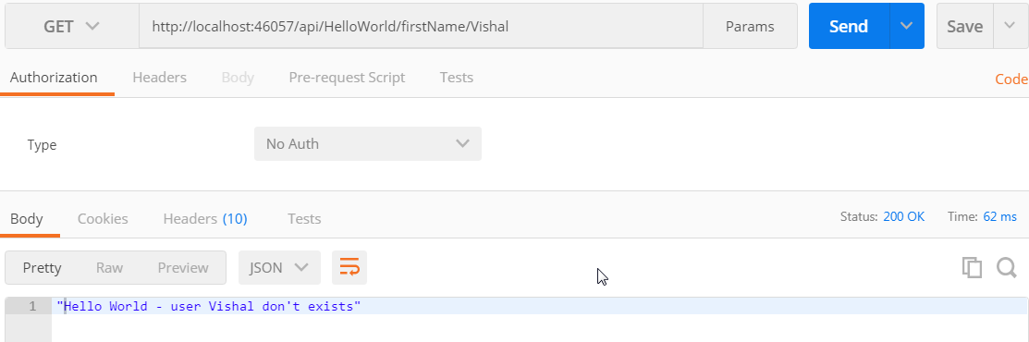

Stop the Debugging – and open Test Explorer and run available unit tests

