ToyBox
Deployment & User Guide
A full-stack children's toy store — React + Vite frontend, FastAPI + SQLite backend, with admin-approved registration and a built-in shopping assistant
October 2026

1. Overview
ToyBox is a complete, runnable e-commerce application for a children's toy store. It has a React 18 + TypeScript storefront, a FastAPI + SQLAlchemy backend backed by SQLite (Postgres on Render), Stripe Checkout in test mode (or a built-in dev payment), registration that an admin approves before the shopper can sign in, a floating shopping assistant for signed-in shoppers, and an admin dashboard. The store ships seeded with 24 toys across five categories, an admin account, a demo customer, and synthetic 2026 order history.

1.1 Architecture at a glance
- Frontend: React 18, Vite, TypeScript, Tailwind CSS, Zustand, React Router — http://localhost:5173 in development. The layout is fluid and edge-to-edge: pages fill the browser window, and reading-heavy pages (product, cart, checkout, orders) are capped at a comfortable width so they never stretch on very wide screens.
- Backend: FastAPI on Uvicorn, SQLAlchemy 2.x, Alembic migrations — http://localhost:8000, interactive API docs at /docs.
- Auth: JWT access tokens (30 min) plus refresh tokens (7 days); the frontend refreshes on a 401 and retries once. Logout revokes the refresh token. Every account has an approval status (pending, approved or rejected) and only approved accounts can sign in or keep a session. Usernames are not case-sensitive.
- Registration approval: registering creates a pending account and does not sign the person in. The site admin is emailed, then approves or rejects the registration in the Approvals tab. The applicant is emailed the result, and a rejection needs a written reason.
- Payments: one path, signed-in checkout. It uses Stripe Checkout (test mode, or a built-in dev-payment path when no Stripe key is set). The browser is never trusted with money, and stock is decremented exactly once, when the payment is confirmed.
- Shopping assistant: a floating chat widget on every storefront page, available only to registered, signed-in shoppers (the server answers 401 to anyone else). It is backed by a Lyzr agent through the backend; the API key never reaches the browser.
- Email: a notice to the admin about each new registration, and an approval or rejection email to the applicant, sent over SMTP. Email is best-effort: a failed email never blocks a registration or an admin decision, and the admin screen warns instead.
- Roles: customer or admin. Admin routes are enforced on the server, not just hidden.

1.2 What this guide covers
- Section 2 — deploying the app locally (Windows or macOS), with Docker as an alternative.
- Section 3 — deploying to Render, the environment variables, and the pre-launch checklist.
- Section 4 — every customer-facing screen, including registration and approval, and the shopping assistant.
- Section 5 — the admin dashboard, including approving registrations.
- Section 6 — maintenance: the Reset Data script and keeping the chatbot knowledge pack in sync.

1.3 What's new in this version
- Admin-approved registration: a pending popup for the applicant, and emails to the admin and to the applicant.
- A new Approvals tab in the admin dashboard, a pending-count tile on the Overview and a count badge on the tab.
- The shopping assistant is for signed-in shoppers only; visitors who are not signed in see a "Please log in to chat" popup.
- The no-account purchase option has been removed; checkout is for signed-in shoppers only.
- Usernames are no longer case-sensitive.
- The demo logins are no longer shown on the Login page or printed in this guide.
- A Reset Data cleanup script for development databases (section 6).
- The test suite never sends real email or calls Lyzr.
- An admin sign-in always opens the dashboard Overview.

2. Local Deployment Guide

2.1 Prerequisites
- Python 3.11 or later (python on Windows, python3 on macOS).
- Node.js 18+ and npm (the chat logic tests need Node 24).
- (Optional) Docker Desktop, for the Docker Compose alternative.

2.2 Project layout
ECommerce_Website/
backend/ FastAPI app, requirements.txt, alembic migrations
backend/scripts/ seed, reset_data and helper scripts
frontend/ React app, package.json
scripts/ start/stop scripts for Windows and macOS
docs/ this document and the chatbot knowledge pack
render.yaml Render deployment blueprint
docker-compose.yml optional container-based deployment

2.3 One-time setup

Backend
- Open a terminal in backend/ and install dependencies: pip install -r requirements.txt
- Create backend/.env from the root .env.example. Set JWT_SECRET_KEY to a long random string. Defaults otherwise work locally (SQLite, dev payment mode, CORS open to localhost:5173). To receive registration emails, also fill in the SMTP_* settings, ADMIN_NOTIFY_EMAIL and FRONTEND_BASE_URL (see the table below). The file is read only at startup, so restart the backend after every .env change.
- Create the schema: python -m alembic upgrade head. Run this again after pulling new model changes. Always use the python -m form on Windows. There are three migrations: 0001 the initial schema, 0002 columns for the removed no-account checkout (now unused), and 0003 the user approval status. Accounts that already exist become approved.
- Load demo data: python -m scripts.seed (add --reset to drop and recreate every table first). It creates an admin account, a demo customer account and the synthetic order history. Change the admin password from the Account page right after your first sign-in; the seed password is in backend/scripts/seed.py and must never be kept on a public site.

Frontend
- Open a terminal in frontend/ and run npm install.
- (Optional) Create frontend/.env with VITE_API_BASE_URL=http://localhost:8000 if the backend is elsewhere, and VITE_N8N_FEEDBACK_FORM_URL for the Feedback page form.

Optional services
Feature | Variables (backend/.env) | Without them
Shopping assistant | LYZR_API_KEY, LYZR_AGENT_ID | Chat replies 'chat not configured' (503)
Registration emails | SMTP_HOST, SMTP_PORT, SMTP_USER, SMTP_APP_PASSWORD, EMAIL_FROM, ADMIN_NOTIFY_EMAIL, FRONTEND_BASE_URL | Registration and admin decisions still work, but no emails are sent and the Approvals page says the email could not be sent. If ADMIN_NOTIFY_EMAIL is empty, the notice goes to the admin account's own address.
Real Stripe payments | STRIPE_SECRET_KEY, STRIPE_WEBHOOK_SECRET | Dev-payment mode completes the order
Feedback form | VITE_N8N_FEEDBACK_FORM_URL (frontend) | Feedback page shows 'not configured'

Accounts created by the seed
- Admin — username admin. It opens the admin dashboard. Set its password yourself from the Account page after the first sign-in.
- Customer — username customer. An ordinary demo shopper account with some order history.
No passwords are printed in this guide or shown on the Login page. New shoppers create their own account and wait for an admin to approve it (section 4.6).

2.4 Day-to-day: starting and stopping
The scripts in scripts/ start the backend (port 8000) and frontend (port 5173) as background processes, track PIDs in scripts/.pids/, write logs to scripts/logs/, and wait for /health before returning.

Windows (PowerShell)
cd C:\path\to\ECommerce_Website
.\scripts\start.ps1

# later, to stop everything
.\scripts\stop.ps1

If PowerShell blocks the script, run once per session: Set-ExecutionPolicy -Scope Process -ExecutionPolicy Bypass
Before starting, clear leftover environment variables in the PowerShell window (DATABASE_URL, SMTP_HOST, ADMIN_NOTIFY_EMAIL and the LYZR_* variables). If they are set, the app uses them instead of backend/.env. On a slow cold start start.ps1 may print "Backend did not report healthy within 45s"; check http://localhost:8000/health, because the backend usually comes up a moment later.

macOS
cd /path/to/ECommerce_Website
chmod +x scripts/start.sh scripts/stop.sh # first time only
./scripts/start.sh

# later
./scripts/stop.sh

2.5 Verifying it's running
- Storefront: http://localhost:5173
- API docs: http://localhost:8000/docs
- Health check: http://localhost:8000/health should return {"status": "ok", ...}

2.6 Alternative: Docker Compose
docker compose up --build
docker compose exec backend python -m scripts.seed # first run only
docker compose down

Migrations run automatically on backend start; the SQLite file and uploads persist on named volumes.

2.7 Running the tests
cd backend && python -m pytest -v
cd frontend && node --test # chat logic; give it no directory argument
cd frontend && npm run typecheck

The backend test suite never sends real email or calls Lyzr; it blanks those settings.

2.8 Troubleshooting
- "alembic is not recognized" — use python -m alembic ... instead.
- "Network Error" when signing in — backend not running; check /health or re-run start.
- Chat says it is unavailable — LYZR_API_KEY / LYZR_AGENT_ID unset (503 chat_not_configured) or Lyzr failed or timed out (503 chat_unavailable). Rate limit is 20 messages a minute.
- Plain coloured product images — the seed fallback, not a bug. Real photos come from backend/scripts/fetch_pexels_images.py with a PEXELS_API_KEY.
- Login says my registration is awaiting approval — an admin must approve it in Admin > Approvals first.
- Login says my registration was not approved — the message shows the admin's reason. The person can register again with the same username and email.
- Emails do not arrive — check the SMTP_* settings and ADMIN_NOTIFY_EMAIL in backend/.env, restart the backend, and look for "Could not send" in scripts/logs/backend.err.log.
- The admin notice went to admin@example.com — ADMIN_NOTIFY_EMAIL is empty, or the backend has not been restarted since it was set.
- Approvals or orders look like another data set — leftover environment variables point DATABASE_URL somewhere else. Clear them and restart.

3. Deploying to Render
render.yaml at the repo root is a Render Blueprint. The backend deploys from backend/Dockerfile on the free web-service plan (sleeps after 15 minutes idle and wakes on the next request; the URL is permanent). Postgres is a separate paid database (toybox-db, starter plan) wired into DATABASE_URL, because free Postgres is deleted after 30 days.

3.1 Environment variables to set in the Render dashboard
These are marked sync: false in the Blueprint. Set them in the dashboard, never in the file. Environment changes take effect only after a redeploy. The Blueprint lists only SMTP_HOST of the email settings, so add the others by hand in the dashboard.
Variable | Purpose
STRIPE_SECRET_KEY, STRIPE_WEBHOOK_SECRET | Stripe test-mode payments and webhook verification
SMTP_* and EMAIL_FROM | Registration emails (admin notice, approval and rejection)
ADMIN_NOTIFY_EMAIL | Who is told about new registrations; falls back to the admin account's email if empty
FRONTEND_BASE_URL | The deployed site's address, used for the login and Approvals links in emails
LYZR_API_KEY, LYZR_AGENT_ID | Shopping assistant
CORS_ORIGINS | The deployed frontend's origin

3.2 Pre-launch checklist
- Change the seeded admin password and never publish demo passwords. The Login page no longer shows them; keep them out of the chatbot knowledge base too.
- Do not set FORWARDED_ALLOW_IPS=*. With the pinned uvicorn, a caller can forge X-Forwarded-For and dodge the chat rate limit. Key the limiter on the right-most X-Forwarded-For entry, or set the platform's real proxy range, then test with a forged header. Because chat now requires a login, keying the limiter on the user id is the better option (recommended, not yet done).
- Add a global per-minute and per-day ceiling, or a Lyzr-side spend cap, on the chat endpoint.
- Make sure the Feedback page work is merged, because the chatbot sends shoppers there.
- Re-export the chatbot product data with --base-url set to the public site URL.
- Re-upload the updated chatbot knowledge pack to Lyzr.
- Set ADMIN_NOTIFY_EMAIL and FRONTEND_BASE_URL, redeploy, then register a test account and approve it to confirm that both emails arrive.

4. User Guide — Shopping as a Customer
All screenshots are taken in a wide browser window. The storefront uses the full width of your browser; very wide screens add more product columns rather than stretching the content.

4.1 Home page
A full-height hero introduces the store with a large heading, an image mosaic and quick links into the catalog. Below it are the category tiles and the favourites.
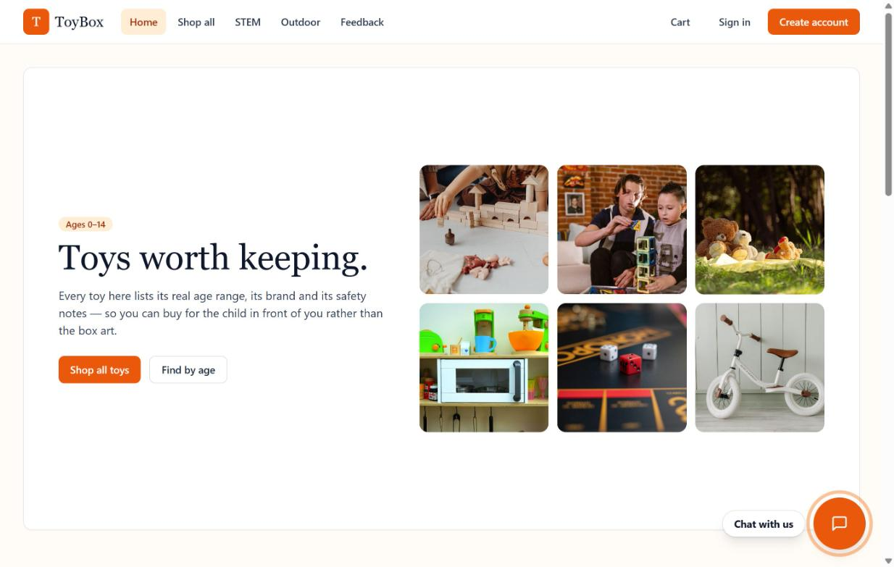
Figure 1 — Home page
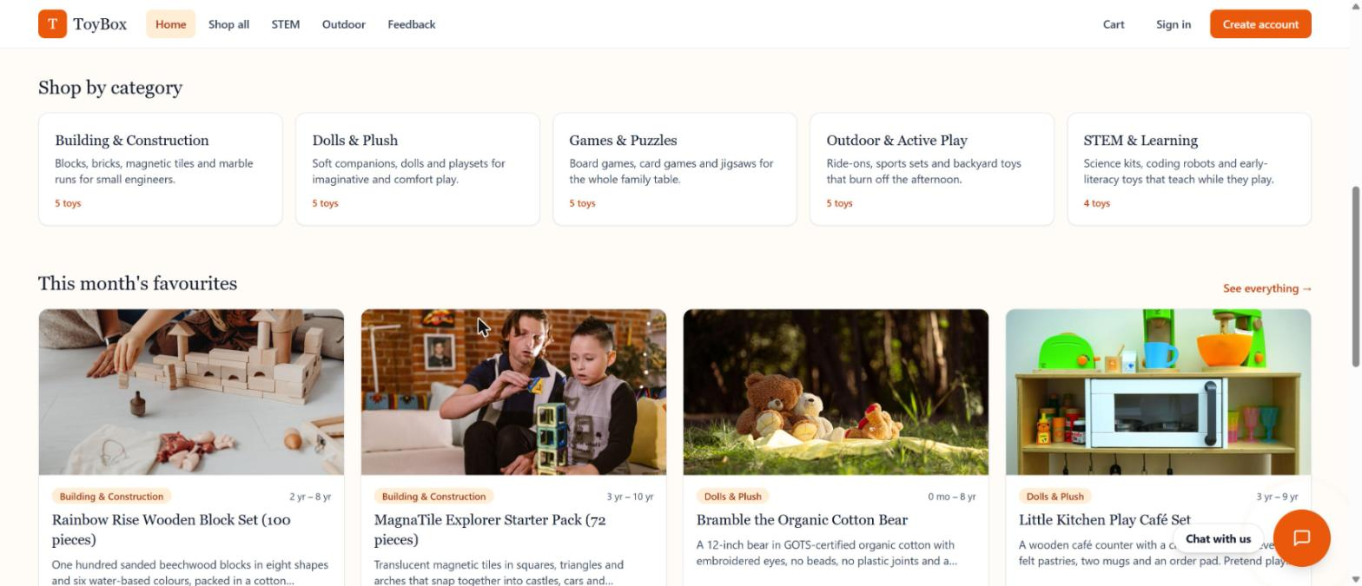
Figure 2 — Home page: categories and favourites

4.2 The shopping assistant
A round chat button with a "Chat with us" label floats at the bottom-right of every storefront page (it is hidden in the admin area). It stays in view while you scroll.
Only registered, signed-in shoppers can chat. If you are not signed in, clicking the button shows a popup that says: "I am sorry I cannot respond to you till you register and log in. This is necessary to ensure that only validated people are allowed to use the Application & Chat." The popup has Register and Log in links.
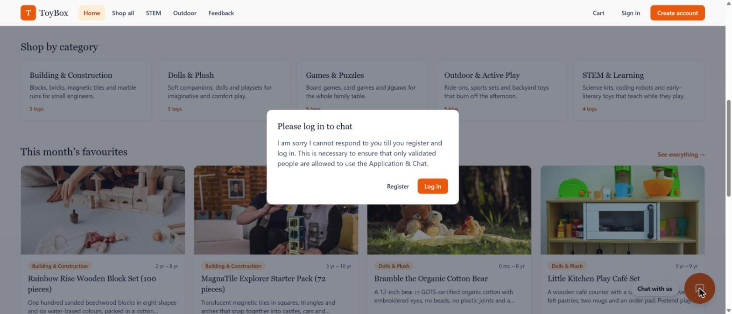
Figure 3 — The "Please log in to chat" popup shown to a visitor who is not signed in
Once you are signed in:
- Click the button to open the chat panel. Press Escape to close it.
- Type a question (up to 500 characters) or tap a suggestion chip.
- Answers can include lists, bold text and links. When an answer mentions a toy, a product card appears with its photo, live price and stock status.
- Each answer has a copy button and thumbs up/down. Thumbs are stored in your browser only.
- New chat starts a fresh conversation.
- Signing out closes the panel and clears the conversation.
- If the assistant cannot help, it points you to the Feedback page.
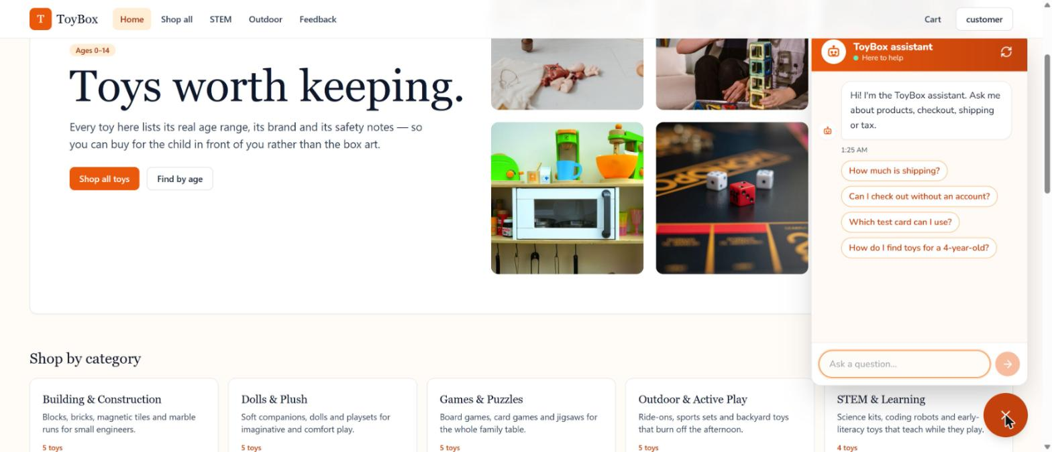
Figure 4 — Chat panel with the greeting and suggestion chips
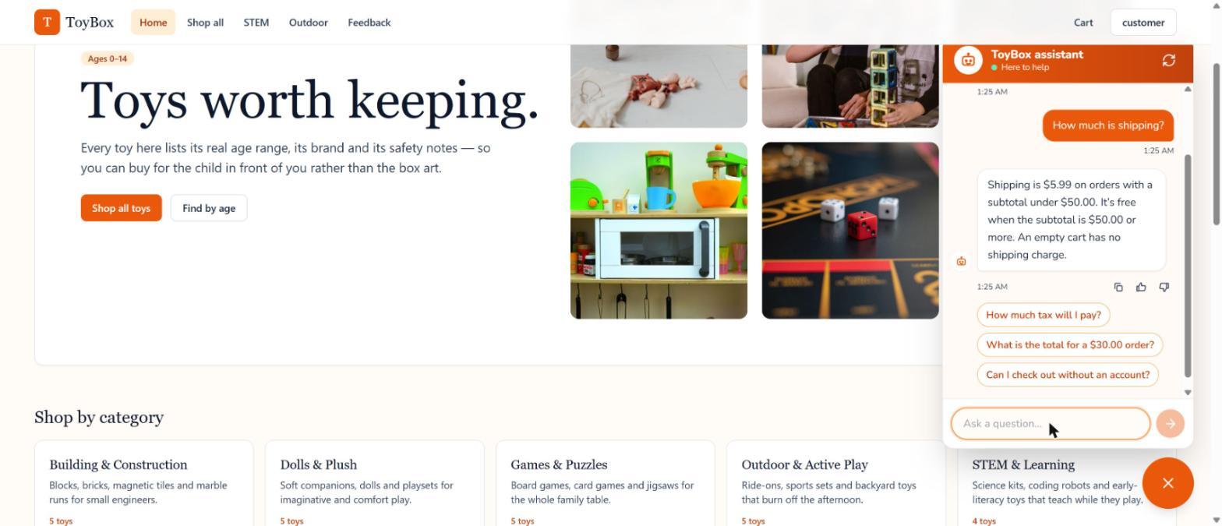
Figure 5 — An answer from the assistant (a question about shipping)
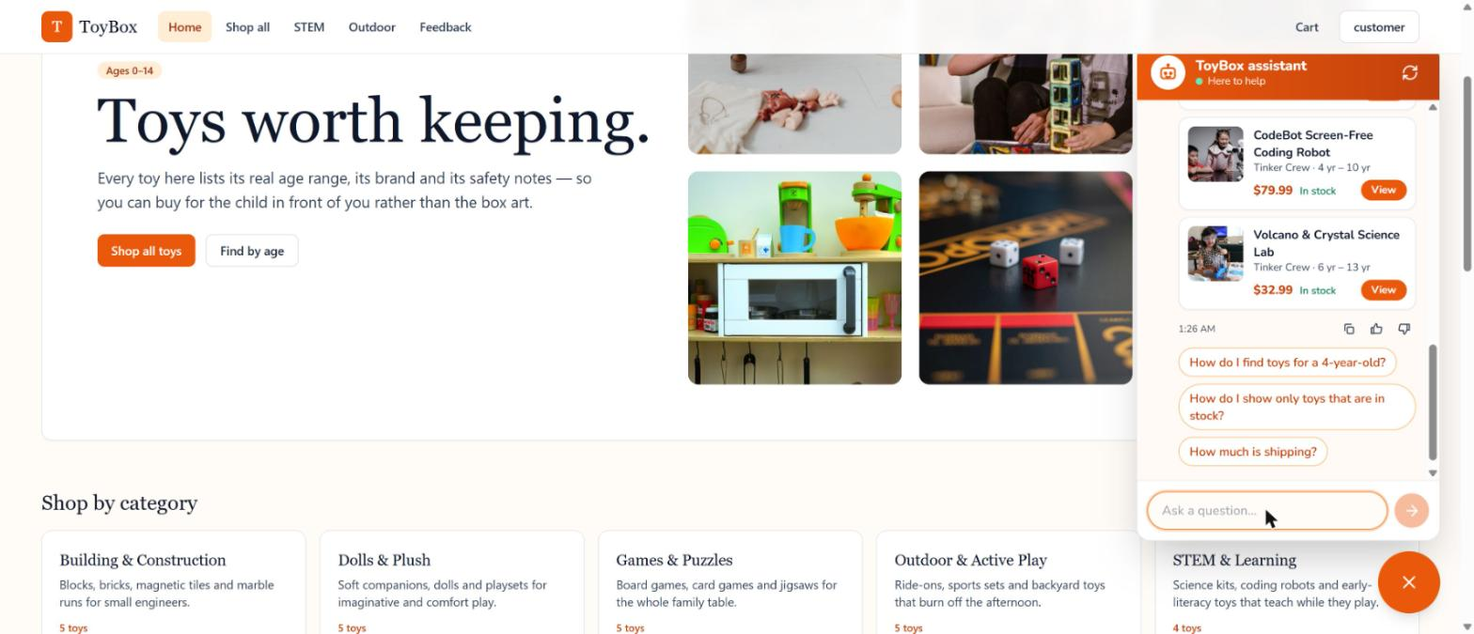
Figure 6 — Product cards inside a chat answer

4.3 Browsing the catalog
Shop all lists every toy with filters for search, category, recommended age, price range, brand and in-stock only. Sort by newest, price or name. Results show 12 toys a page, with up to five columns on wide screens. Filters and sort live in the page URL, so a filtered view can be bookmarked or shared.
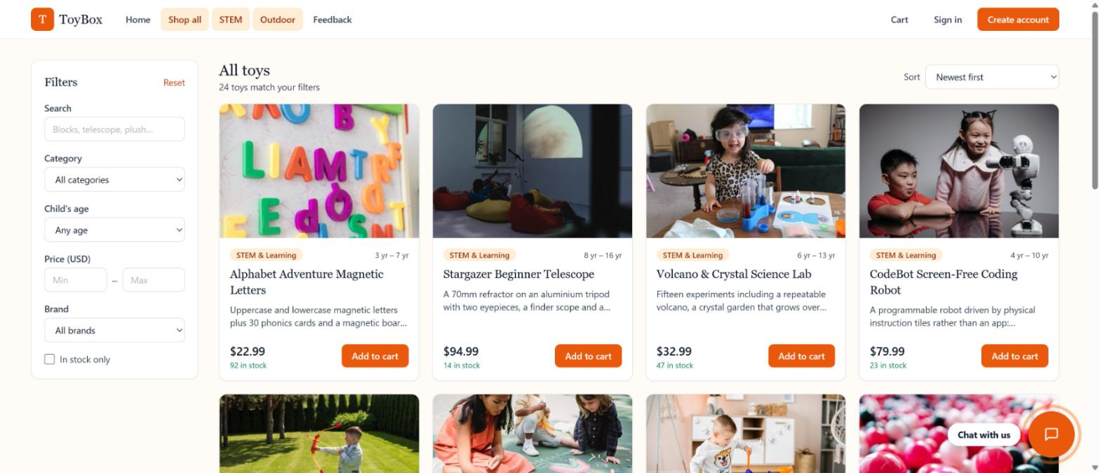
Figure 7 — Catalog with filters and sorting

4.4 Product detail
The product page shows a large photo beside the name, brand, price, recommended age, live stock count, description and the manufacturer's safety notes. A quantity selector and Add to cart button sit beside the details.
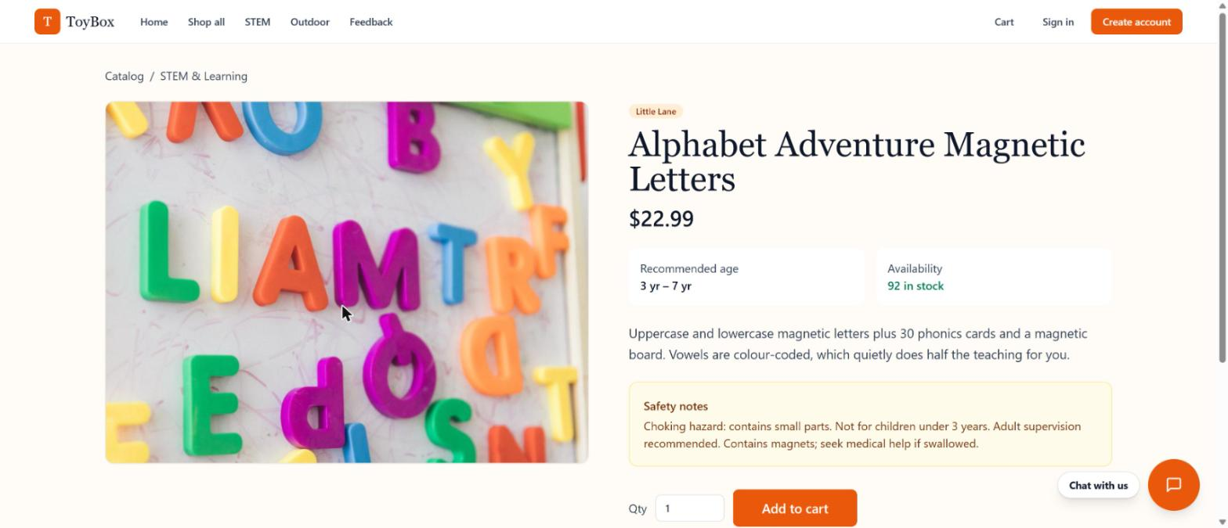
Figure 8 — Product detail page
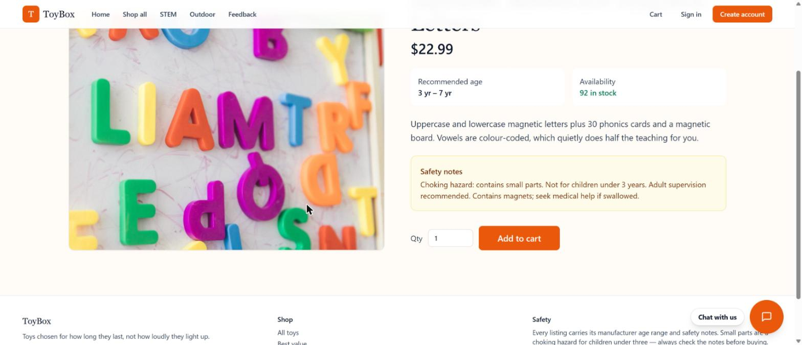
Figure 9 — Product detail: safety notes and add to cart
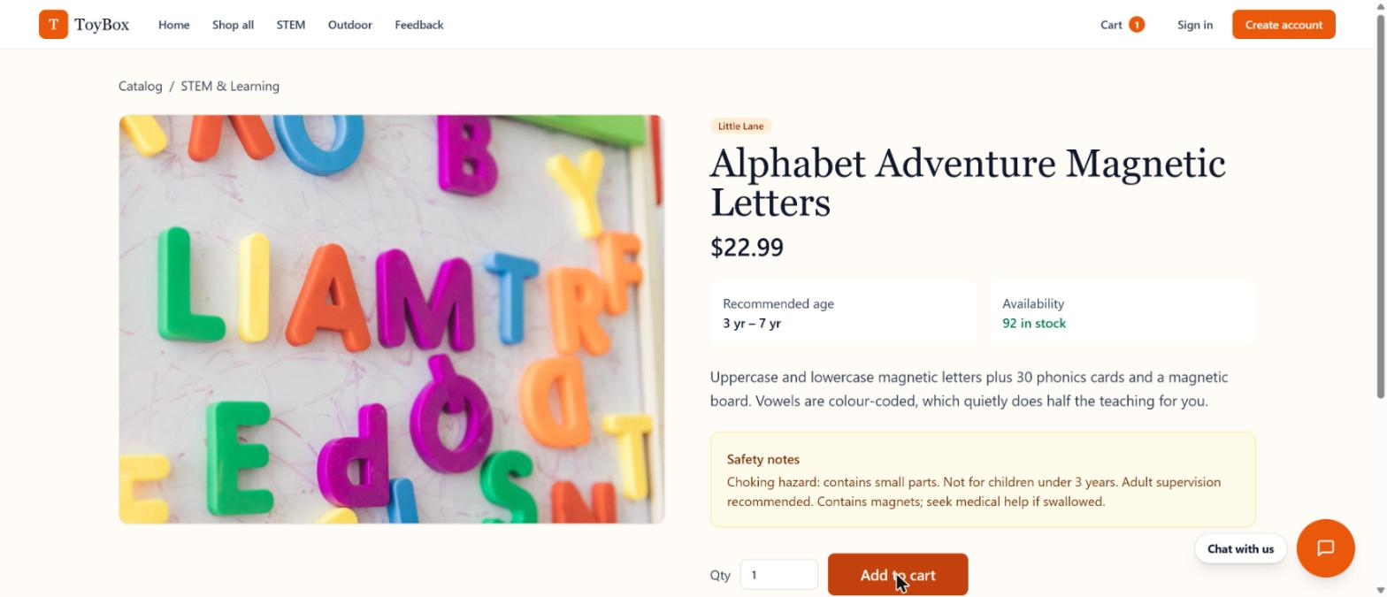
Figure 10 — After adding to cart (the Cart badge in the header shows 1)

4.5 Cart
The cart lists every line with its image, an adjustable quantity, remove, and a running total. Visitors can fill a cart without an account; it is kept in the browser. To check out they must sign in: the checkout button asks them to log in or register, and the browser cart merges into the account the first time they sign in. Signed-in carts are stored on the server. An empty cart shows a full-height welcome with a "Popular right now" row so you can keep shopping.
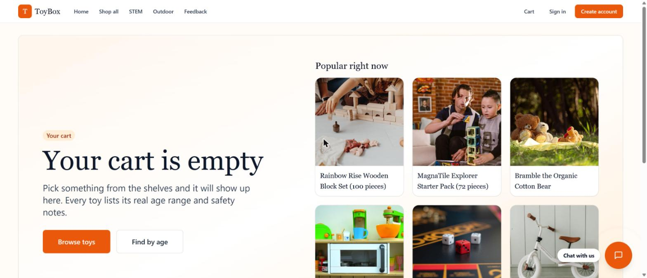
Figure 11 — Empty cart with popular toys
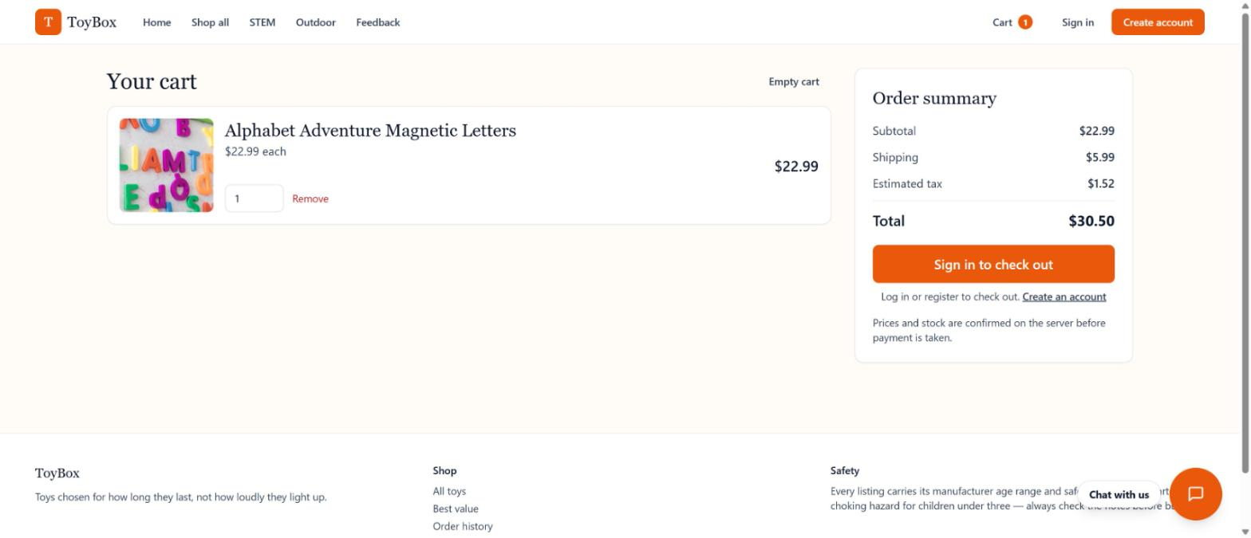
Figure 12 — Cart for a visitor who is not signed in: "Sign in to check out"
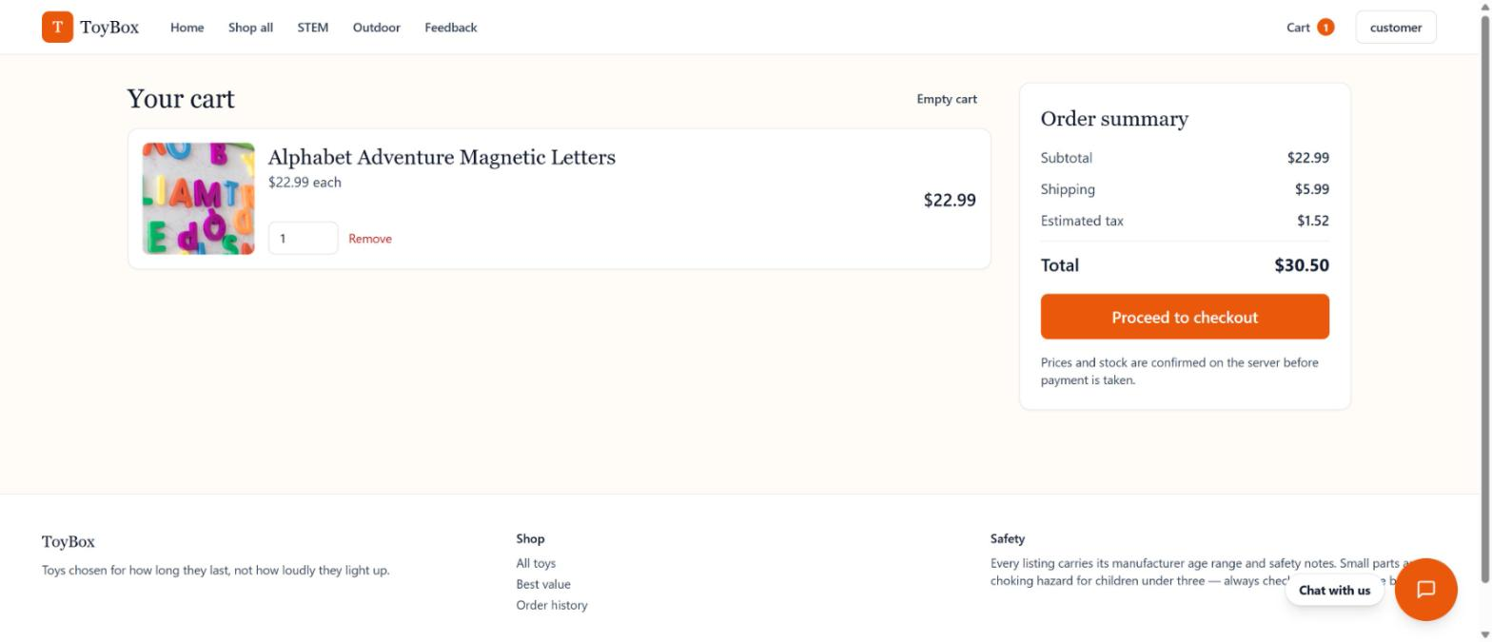
Figure 13 — Cart for a signed-in shopper: "Proceed to checkout"

4.6 Registering and getting approved
Login and Register share a split-panel layout: a colourful panel with toy photos on the left (hidden on small screens) and the form on the right. A new account cannot be used until a site admin approves it.
- Create your account. Choose Create account in the header and enter a username, email and a password of at least 8 characters with a letter and a digit. Full name is optional.
- See the popup. A "Registration submitted" popup says the registration approval is in progress. You are not signed in and the account cannot be used yet.
- The admin reviews it. The site admin is emailed and reviews the registration.
- Approved: an email with a link to the login page arrives. Sign in with the username and password you chose (the username is not case-sensitive).
- Rejected: an email gives the reason and the account cannot sign in. You may register again with the same username and email.
Until the registration is approved, signing in shows "Your registration is awaiting admin approval". After a rejection it shows "Your registration was not approved" followed by the admin's reason.
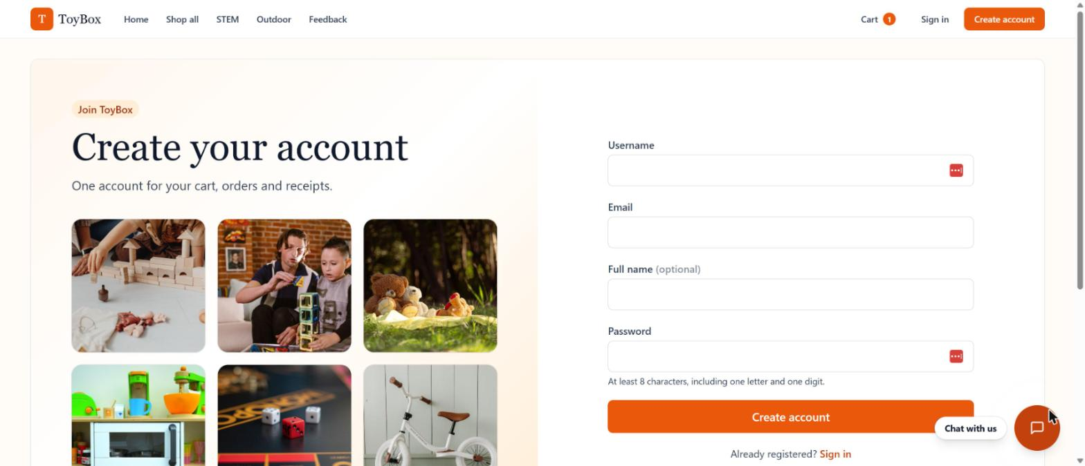
Figure 14 — Create account page
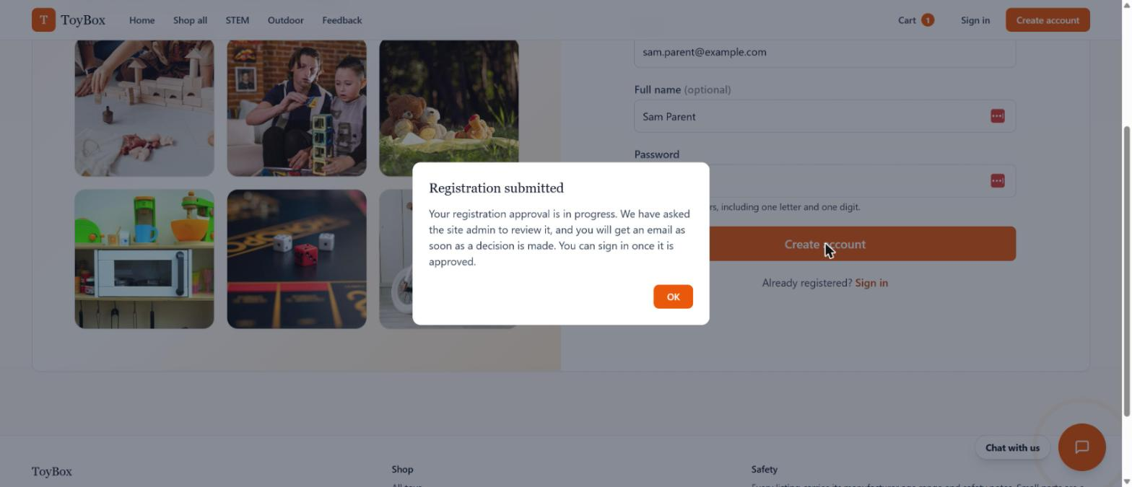
Figure 15 — "Registration submitted" popup after creating an account
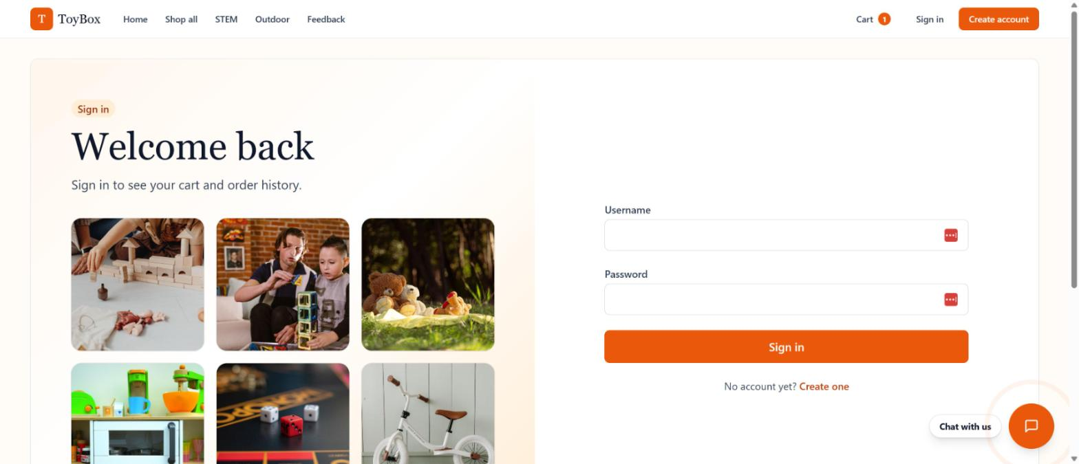
Figure 16 — Sign in page
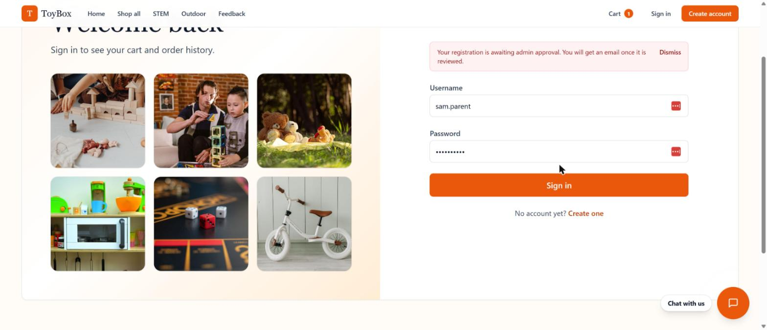
Figure 17 — Sign in while the registration is awaiting approval
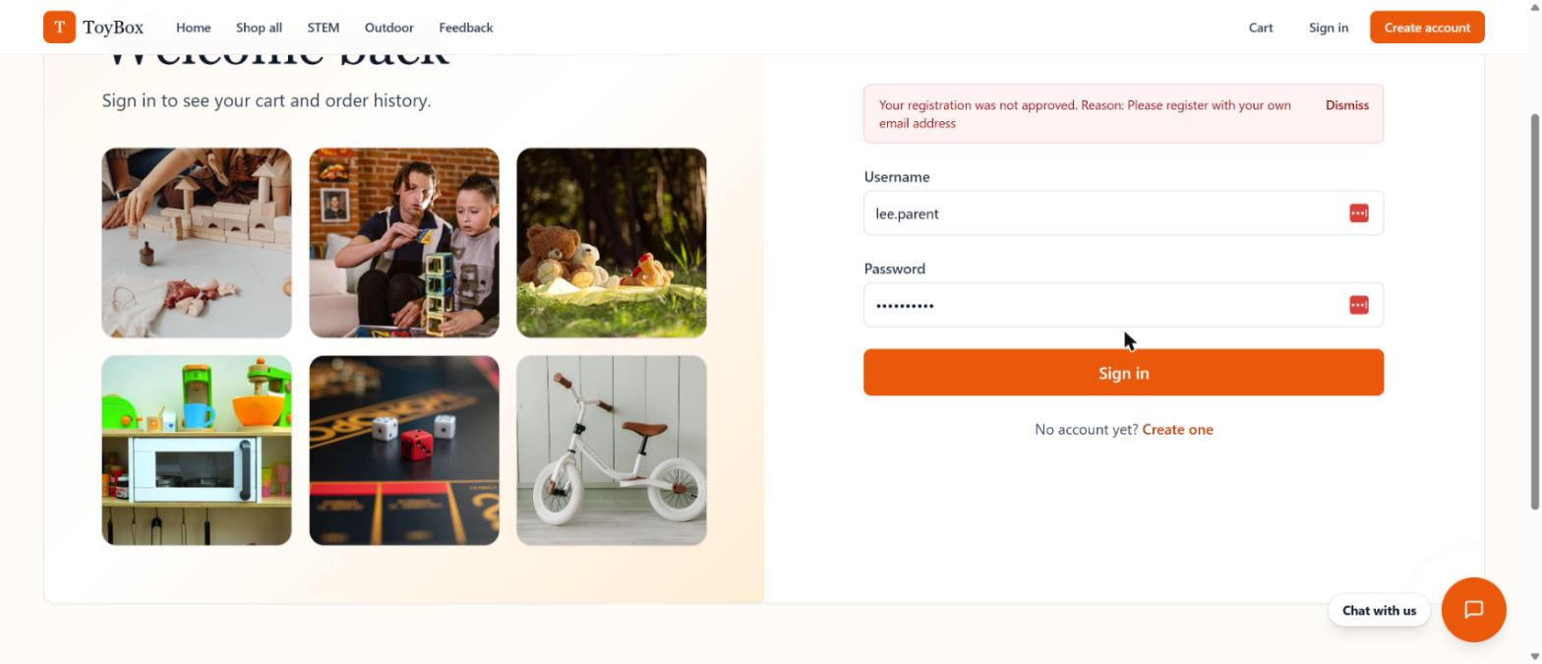
Figure 18 — Sign in after a rejection, showing the admin's reason
Once approved, sign in from the header. Admins always open the dashboard Overview; shoppers return to where they were.

4.7 Checkout (signed-in shoppers only)
Checkout has three steps: Contact, Shipping, then Review & pay. The summary panel keeps a running subtotal, shipping and tax (free shipping above a threshold, $50 in the demo). The order is created as pending and only becomes paid when Stripe confirms the payment (or, in dev mode, when the built-in confirmation runs). Stock is reduced exactly once. There is no receipt email: the confirmation page and the Orders page hold the order details.
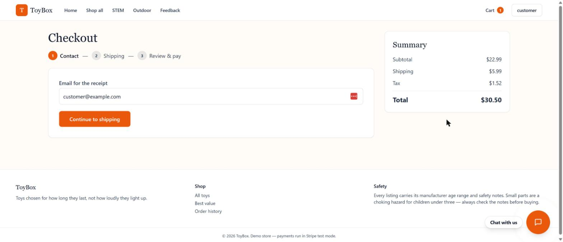
Figure 19 — Checkout, step 1: contact
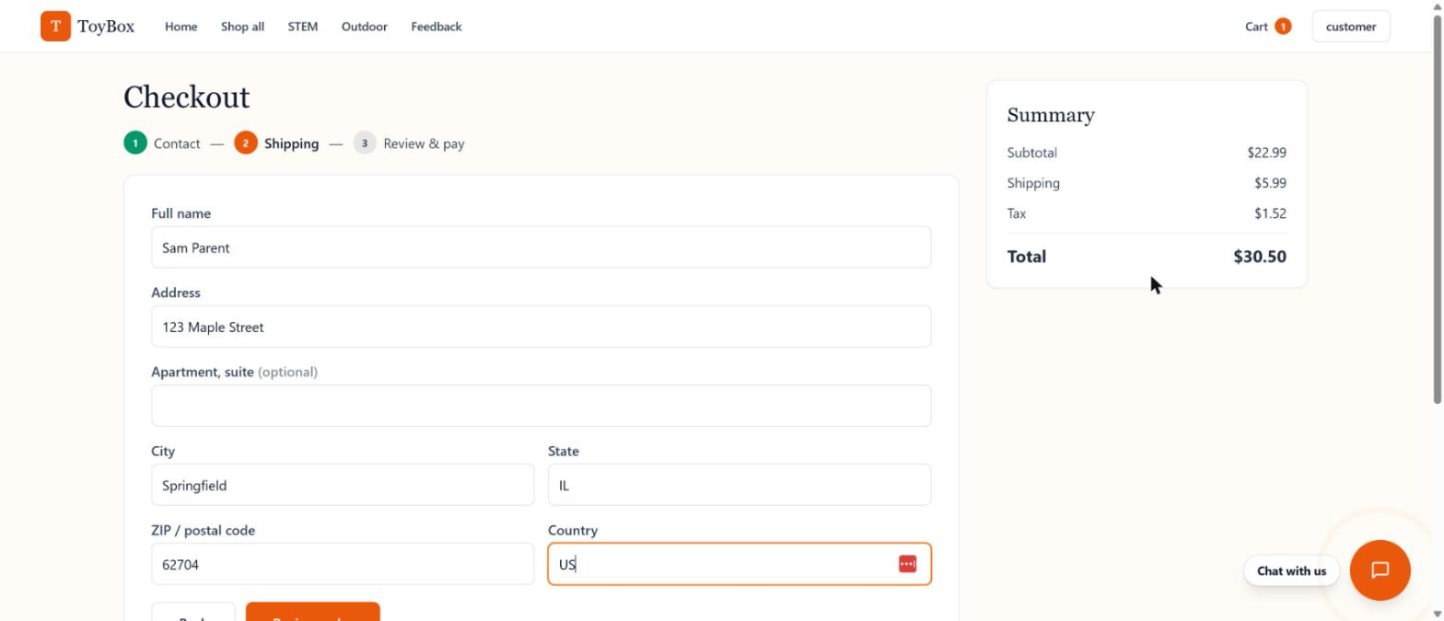
Figure 20 — Checkout, step 2: shipping address
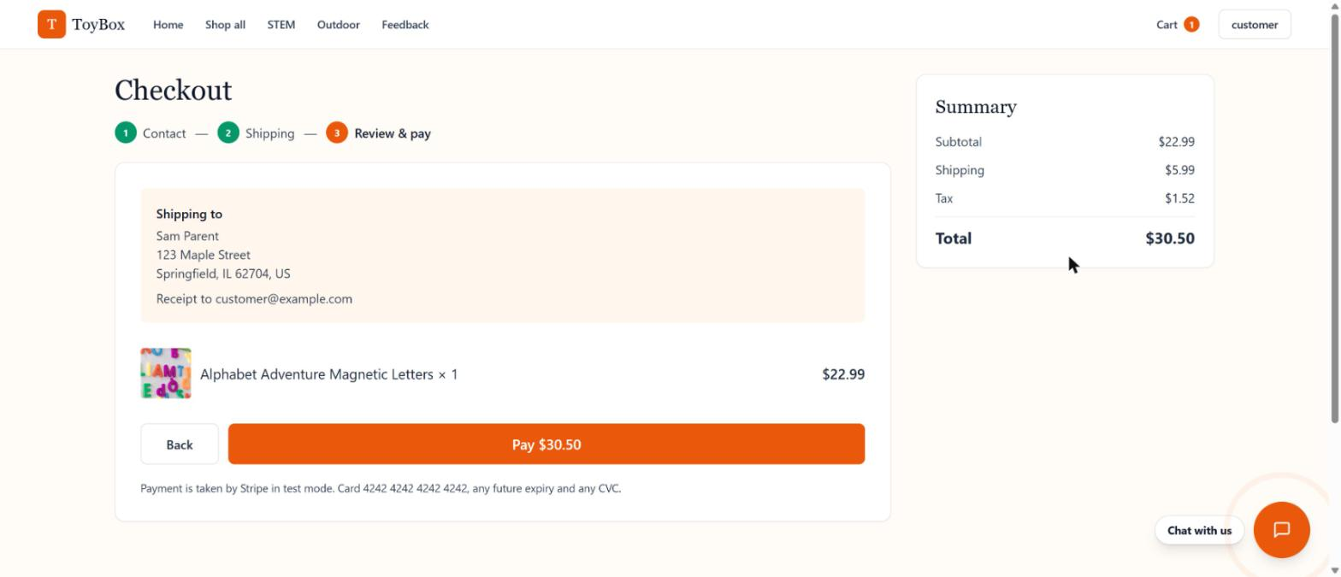
Figure 21 — Checkout, step 3: review and pay
Use test card 4242 4242 4242 4242, any future expiry and any CVC when Stripe is configured. Without a Stripe key the dev-payment mode completes the order when you click Pay.

4.8 Order confirmation
After payment, the confirmation page shows the order number, the total and the items, with buttons to view the order or keep shopping.
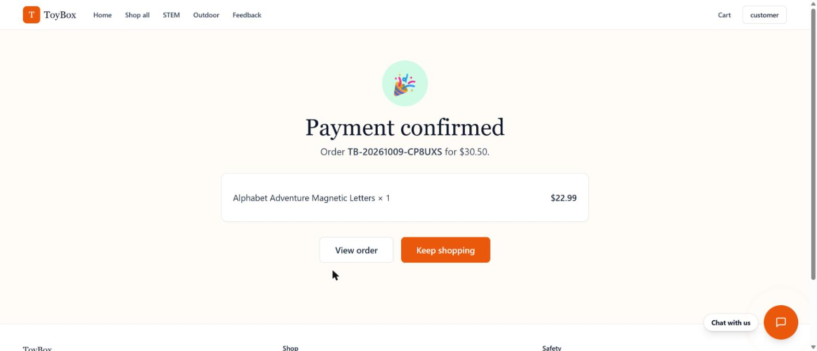
Figure 22 — Payment confirmed

4.9 Order history and order detail
Order history lists every order for the signed-in shopper. Select Details to see status timeline, items, prices, shipping address and totals.
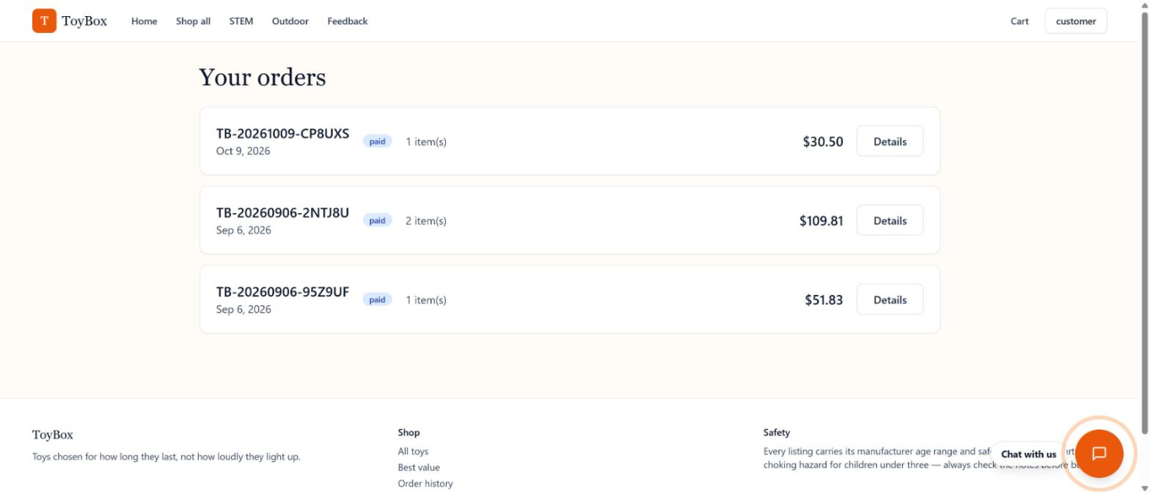
Figure 23 — Order history
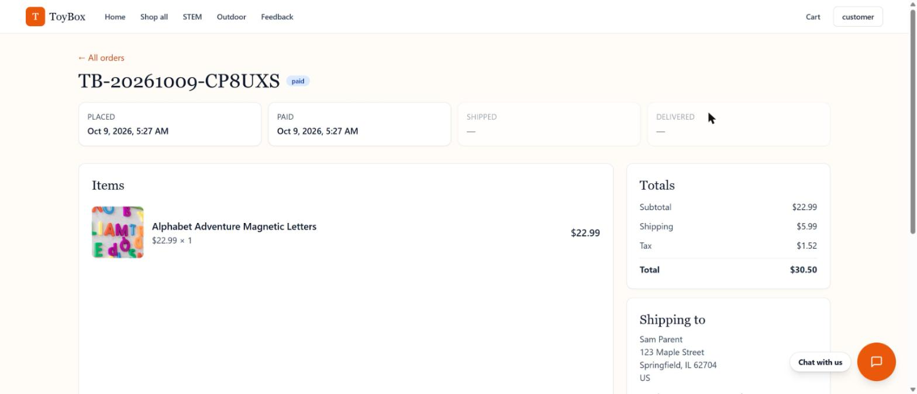
Figure 24 — Order detail

4.10 Account page
Shows the signed-in shopper's profile (username, email, name, role and member since) and lets them change their password. The page does not edit the email address.
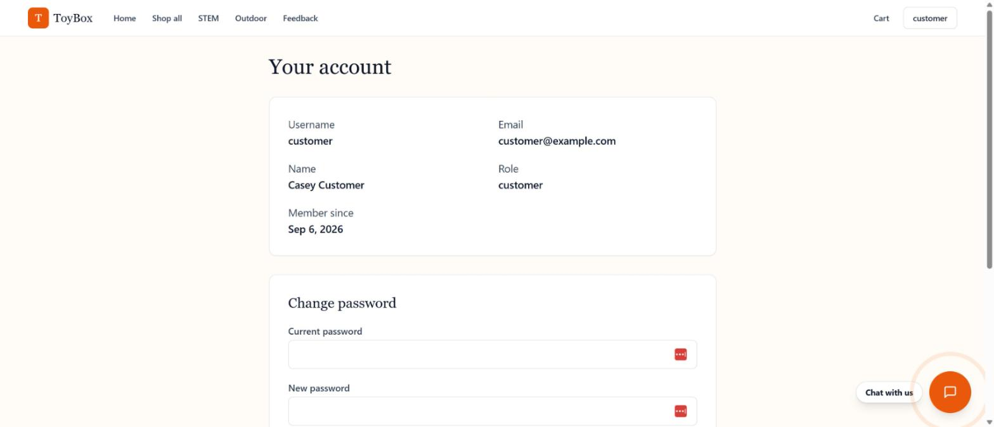
Figure 25 — Account page

4.11 Feedback
The Feedback page embeds the store's feedback form and is linked from the header. The shopping assistant points shoppers here when it cannot help.
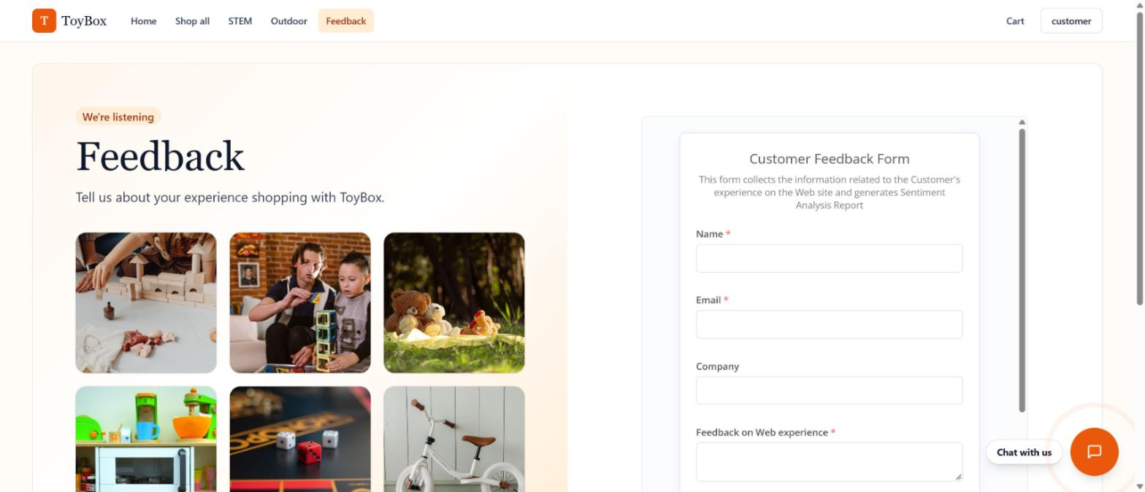
Figure 26 — Feedback page

5. User Guide — Managing the Store as an Admin
Sign in with the admin account (the username is not case-sensitive). You always land on the dashboard Overview. Every admin action is re-checked on the server; a non-admin cannot reach these routes even by URL.

5.1 Dashboard overview
A "Pending approvals" tile at the top always shows how many registrations are waiting (including 0) and links to the Approvals tab. The Approvals tab also carries a red badge with the count. Below it are revenue, order count, pending orders, customers, active products and low-stock count, plus a list of recent orders.
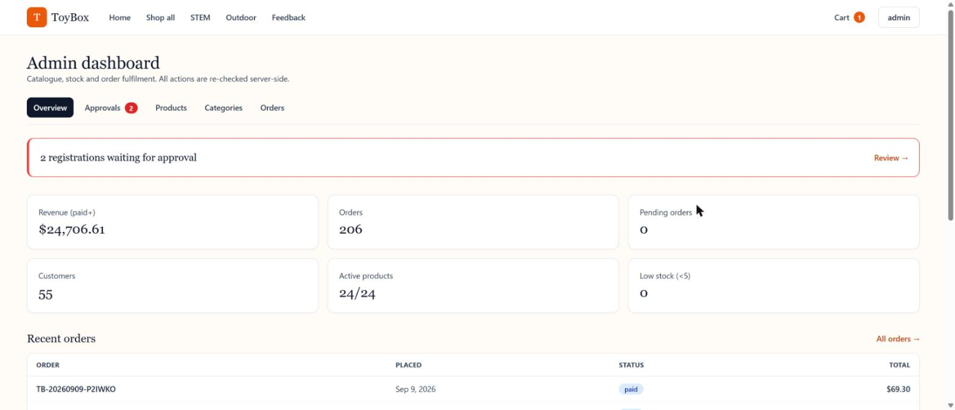
Figure 27 — Admin dashboard overview

5.2 Approving registrations
When someone registers, the address in ADMIN_NOTIFY_EMAIL gets an email with their name, username and email and a link to Admin > Approvals. The tab lists pending registrations with name, username, email and requested date.
- Approve — the person can sign in, and is emailed a login link.
- Reject — a dialog asks for a reason (5 to 500 characters, required). The reason is emailed to the person, and they cannot sign in.
If the email cannot be sent (SMTP not set up, or down), the decision still stands and a notice tells you to contact the person directly. Each registration can be decided once; a second click (for example from another admin) shows an "already reviewed" message and the list refreshes. A rejected person may register again with the same username and email, which puts them back in the queue.
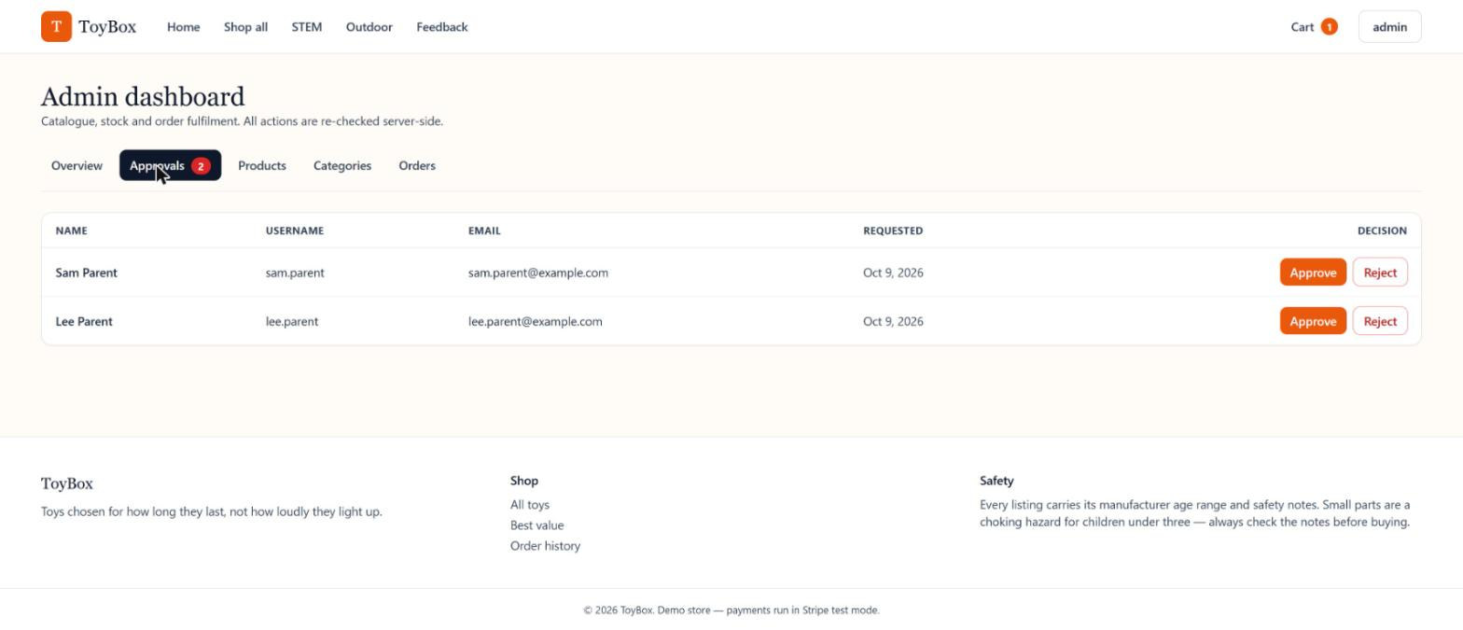
Figure 28 — Admin: pending registrations
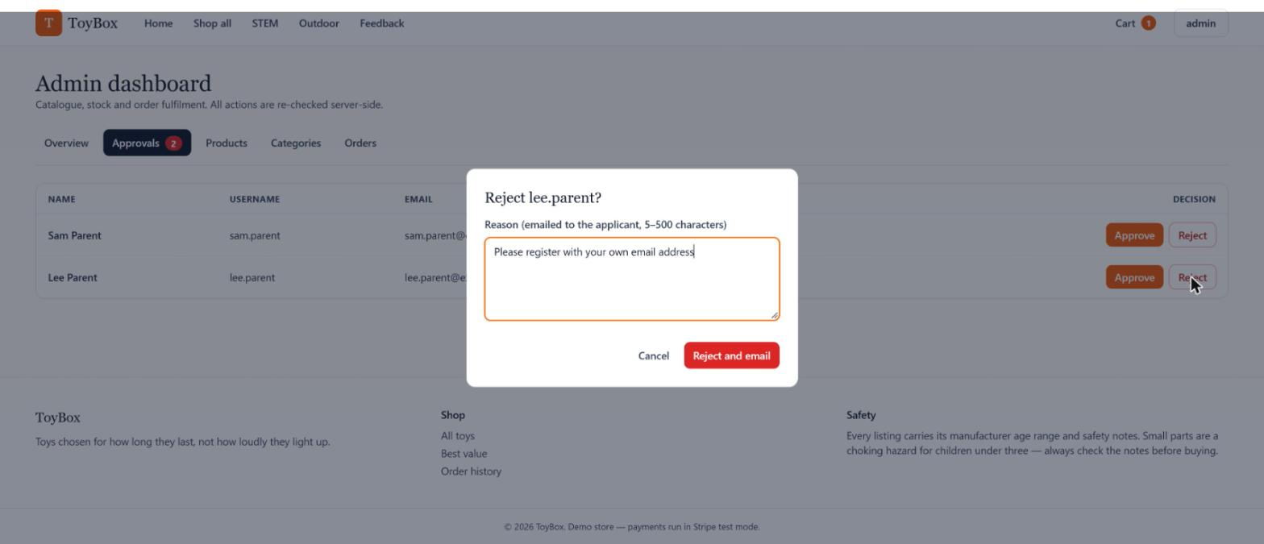
Figure 29 — Admin: rejecting a registration with a reason

5.3 Managing products
The Products tab is a searchable table with category, price, live stock (with quick + / − buttons) and flags such as featured. New product opens a blank form, Edit opens it pre-filled (name, description, price, stock, age range, brand, safety notes, category, images). Delete removes a toy from the catalogue.
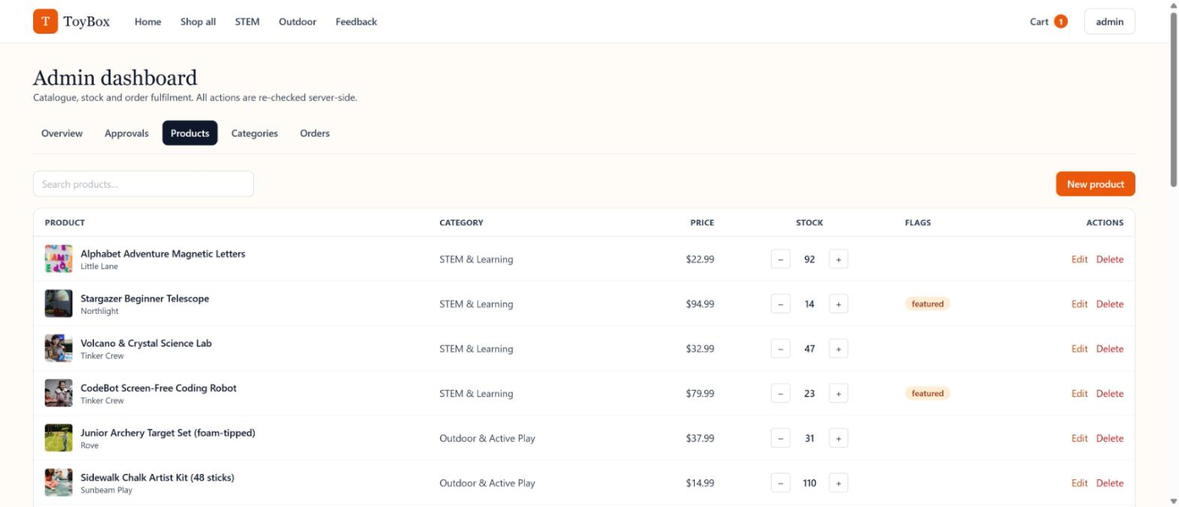
Figure 30 — Admin: product list

5.4 Managing categories
The Categories tab lists the five categories with their product counts. Use the form on the right to add one. Delete is available only for empty categories.
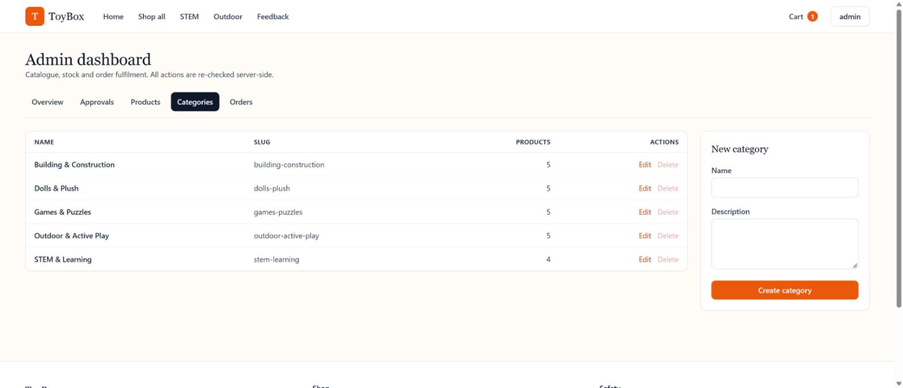
Figure 31 — Admin: category list

5.5 Managing orders
The Orders tab lists every order from every customer with filters for Pending, Paid, Shipped, Delivered and Cancelled. Use the action button on a row (for example Mark shipped) to move an order along. Select an order number to open it.
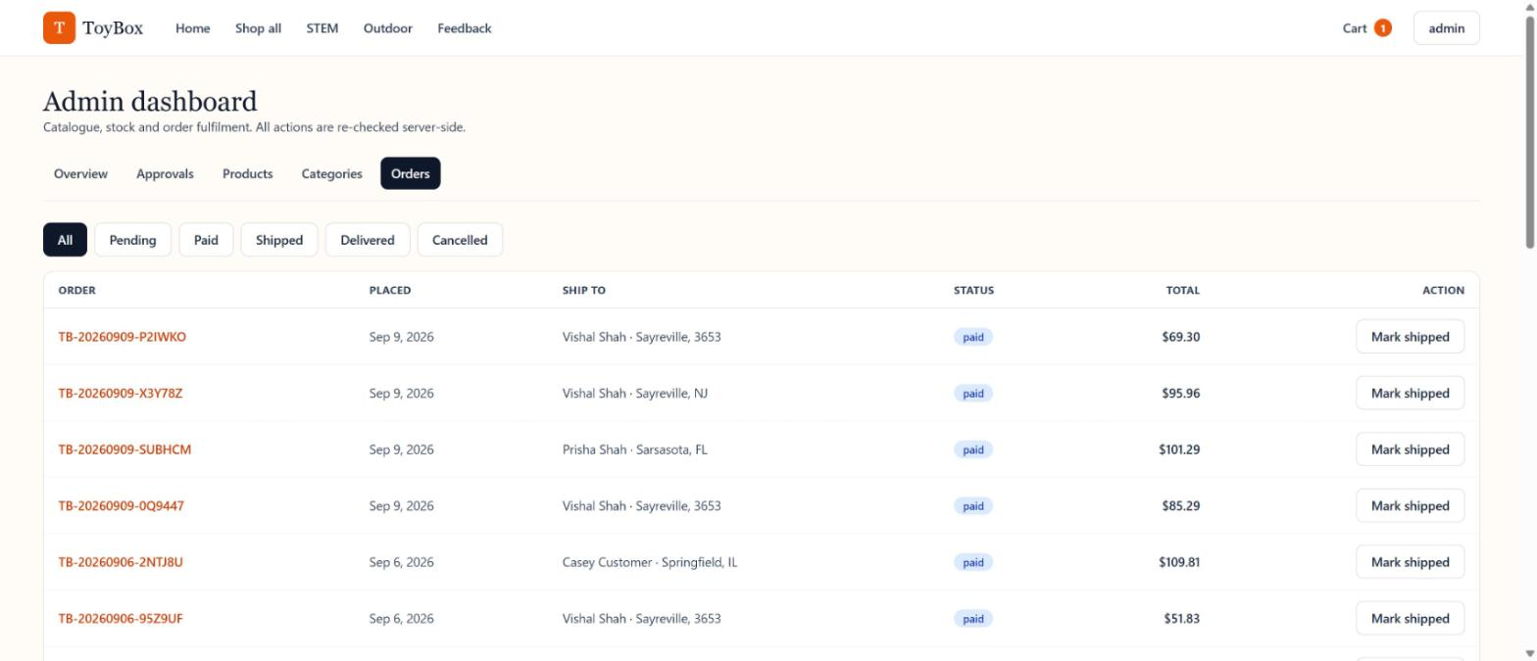
Figure 32 — Admin: order list

6. Maintenance

6.1 Reset Data (cleanup script)
Reset Data returns a development database to a clean slate while keeping the admin account and the whole catalogue. Run it from backend/:
python -m scripts.reset_data # dry run: lists what it would delete
python -m scripts.reset_data --yes # backs up the database, then deletes

- It removes: every customer account (including pending and rejected registrations), all orders, order items, payments, cart items and the revoked-token entries of those users. Stock from the removed paid, shipped or delivered orders is restored.
- It keeps: the admin account and the whole catalogue.
- Backup: before anything is deleted, the database file is copied to a ToyBox-backups folder in your home folder, named app-YYYYMMDD-HHMMSS.db.
- Safety checks: it refuses to run unless the database is SQLite and ENVIRONMENT is development, or if no admin account exists.
- Database is locked: if SQLite reports "database is locked", stop the app and run the script again.
- To undo: stop the app and copy the backup over backend/app.db.
Note: the seeded history orders may not have reduced stock when they were created, so after a reset some products can end above their seeded stock level.

6.2 Keeping the chatbot knowledge pack in sync
The shopping assistant answers from the knowledge pack in docs/chatbot-kb. After you change how the store behaves, update the matching files there, copy the changed files to docs/chatbot-kb/upload and re-upload them to Lyzr (chunk by heading). The product list in products.md is regenerated, not edited by hand:
cd backend
python -m scripts.export_kb_products --base-url https://your-public-site-url

Pass the public site URL as --base-url when exporting for a deployed site; the committed file has localhost links.

