ToyBox
Deployment & User Guide
A full-stack children's toy store — React + Vite frontend, FastAPI + SQLite backend
September 2026

1. Overview
ToyBox is a complete, runnable e-commerce application for a children's toy store. It has a React 18 + TypeScript storefront, a FastAPI + SQLAlchemy backend backed by SQLite, and Stripe Checkout running in test mode for payments. The store ships seeded with 24 toys across five categories, two demo logins, and a year of synthetic order history.

1.1 Architecture at a glance
- Frontend: React 18, Vite, TypeScript, Tailwind CSS, Zustand for state, React Router — served on http://localhost:5173 in development.
- Backend: FastAPI on Uvicorn, SQLAlchemy 2.x ORM, Alembic migrations, SQLite database file — served on http://localhost:8000, with interactive API docs at /docs.
- Auth: JWT access tokens (30 min) plus refresh tokens (7 days); the frontend auto-refreshes on a 401 and retries once.
- Payments: Stripe Checkout Sessions in test mode. When no Stripe key is configured, a built-in dev-payment path completes orders instead so the whole flow works out of the box.
- Roles: every account is a customer or an admin. Admin-only routes are enforced on the server, not just hidden in the UI.

1.2 What this guide covers
- Section 2 — how to deploy the app on your own machine (Windows or macOS), including the start/stop scripts that bring every component up or down in one command.
- Section 3 — a walkthrough of every customer-facing screen: browsing, cart, checkout, accounts and order history.
- Section 4 — a walkthrough of the admin dashboard: product, category and order management.

2. Deployment Guide

2.1 Prerequisites
- Python 3.11 or later, available on your PATH as python (Windows) or python3 (macOS).
- Node.js 18+ and npm, for the frontend build tooling (Vite).
- (Optional) Docker Desktop, only if you choose the Docker Compose alternative in section 2.6.

2.2 Project layout
The parts of the project you'll touch during setup and day-to-day use:
ECommerce_Website/
├── backend/ FastAPI app, requirements.txt, alembic migrations
├── frontend/ React app, package.json
├── scripts/ start/stop scripts for Windows and macOS (this guide)
├── docs/ this document
└── docker-compose.yml optional container-based deployment

2.3 One-time setup
Do this once per machine, or whenever dependencies change.

Backend
- Open a terminal in the backend/ folder.
- Install Python dependencies: pip install -r requirements.txt
- Copy the root .env.example values you need into a new backend/.env file. At minimum set JWT_SECRET_KEY to a long random string; the defaults work for local development otherwise (SQLite database, dev payment mode enabled, CORS open to localhost:5173).
- Create the database schema: python -m alembic upgrade head (on Windows, if 'alembic' isn't recognized as a command, use python -m alembic upgrade head — the module form always works without any extra PATH configuration).
- Load the demo catalogue and accounts: python -m scripts.seed. This creates 5 categories, 24 products with images, the two demo logins below, and a year of synthetic 2026 order history.

Frontend
- Open a terminal in the frontend/ folder.
- Install dependencies: npm install
- (Optional) Create a frontend/.env file with VITE_API_BASE_URL=http://localhost:8000 if the backend runs anywhere other than the default.

Demo accounts (seeded by the script above)
- Customer — username admin, password Admin123! — full admin dashboard access.
- Customer — username customer, password Customer123! — ordinary shopper account.

2.4 Day-to-day: starting and stopping the site
Once the one-time setup above is done, use the start/stop scripts in the scripts/ folder to bring the whole site up or down. They start the backend (Uvicorn on port 8000) and the frontend (Vite on port 5173) as background processes, write their process IDs to scripts/.pids/ and their console output to scripts/logs/, so you never need to keep a terminal window open.

Windows (PowerShell)
cd C:\path\to\ECommerce_Website
.\scripts\start.ps1
# ...later, to stop everything...
.\scripts\stop.ps1
If PowerShell blocks the script with an execution-policy error, run this once per session first: Set-ExecutionPolicy -Scope Process -ExecutionPolicy Bypass

macOS
cd /path/to/ECommerce_Website
chmod +x scripts/start.sh scripts/stop.sh # first time only
./scripts/start.sh
# ...later, to stop everything...
./scripts/stop.sh
What each script does:
- start — checks that frontend/node_modules and the backend Python packages are installed (and tells you what to run if not), starts the backend and frontend, waits for the backend's /health endpoint to respond, then prints both URLs.
- stop — stops the backend and frontend by their tracked process IDs, with a fallback that kills whatever is listening on ports 8000 or 5173 in case a PID file is missing or stale.
- Both scripts are safe to re-run: starting an already-running component is skipped with a message instead of starting a duplicate.

2.5 Verifying it's running
- Storefront: http://localhost:5173
- API docs (interactive, Swagger UI): http://localhost:8000/docs
- API health check: http://localhost:8000/health should return {"status": "ok", ...}

2.6 Alternative: Docker Compose
The project also ships a docker-compose.yml that builds and runs the backend and a production build of the frontend in containers, if you'd rather not install Python or Node locally. This is documented here as an alternative — the start/stop scripts above are the primary, recommended path for local development.
docker compose up --build
docker compose exec backend python -m scripts.seed # first run only
# Storefront: http://localhost:5173
# API: http://localhost:8000
docker compose down # stop and remove the containers

2.7 Troubleshooting
- "alembic is not recognized" — alembic.exe isn't on your PATH even though the package is installed. Use python -m alembic ... instead of alembic ... everywhere.
- "Network Error" when signing in — the backend isn't running. Confirm with http://localhost:8000/health, or just re-run start.ps1 / start.sh.
- Product images look like plain colored placeholders with text — this is the seed data's built-in fallback so the storefront is never blank; it's not a bug. Real photos can be fetched from Pexels with backend/scripts/fetch_pexels_images.py if a PEXELS_API_KEY is set in backend/.env.

3. User Guide — Shopping as a Customer

3.1 Home page
The landing page introduces the store and highlights featured toys pulled from across every category, alongside quick links into the catalog.
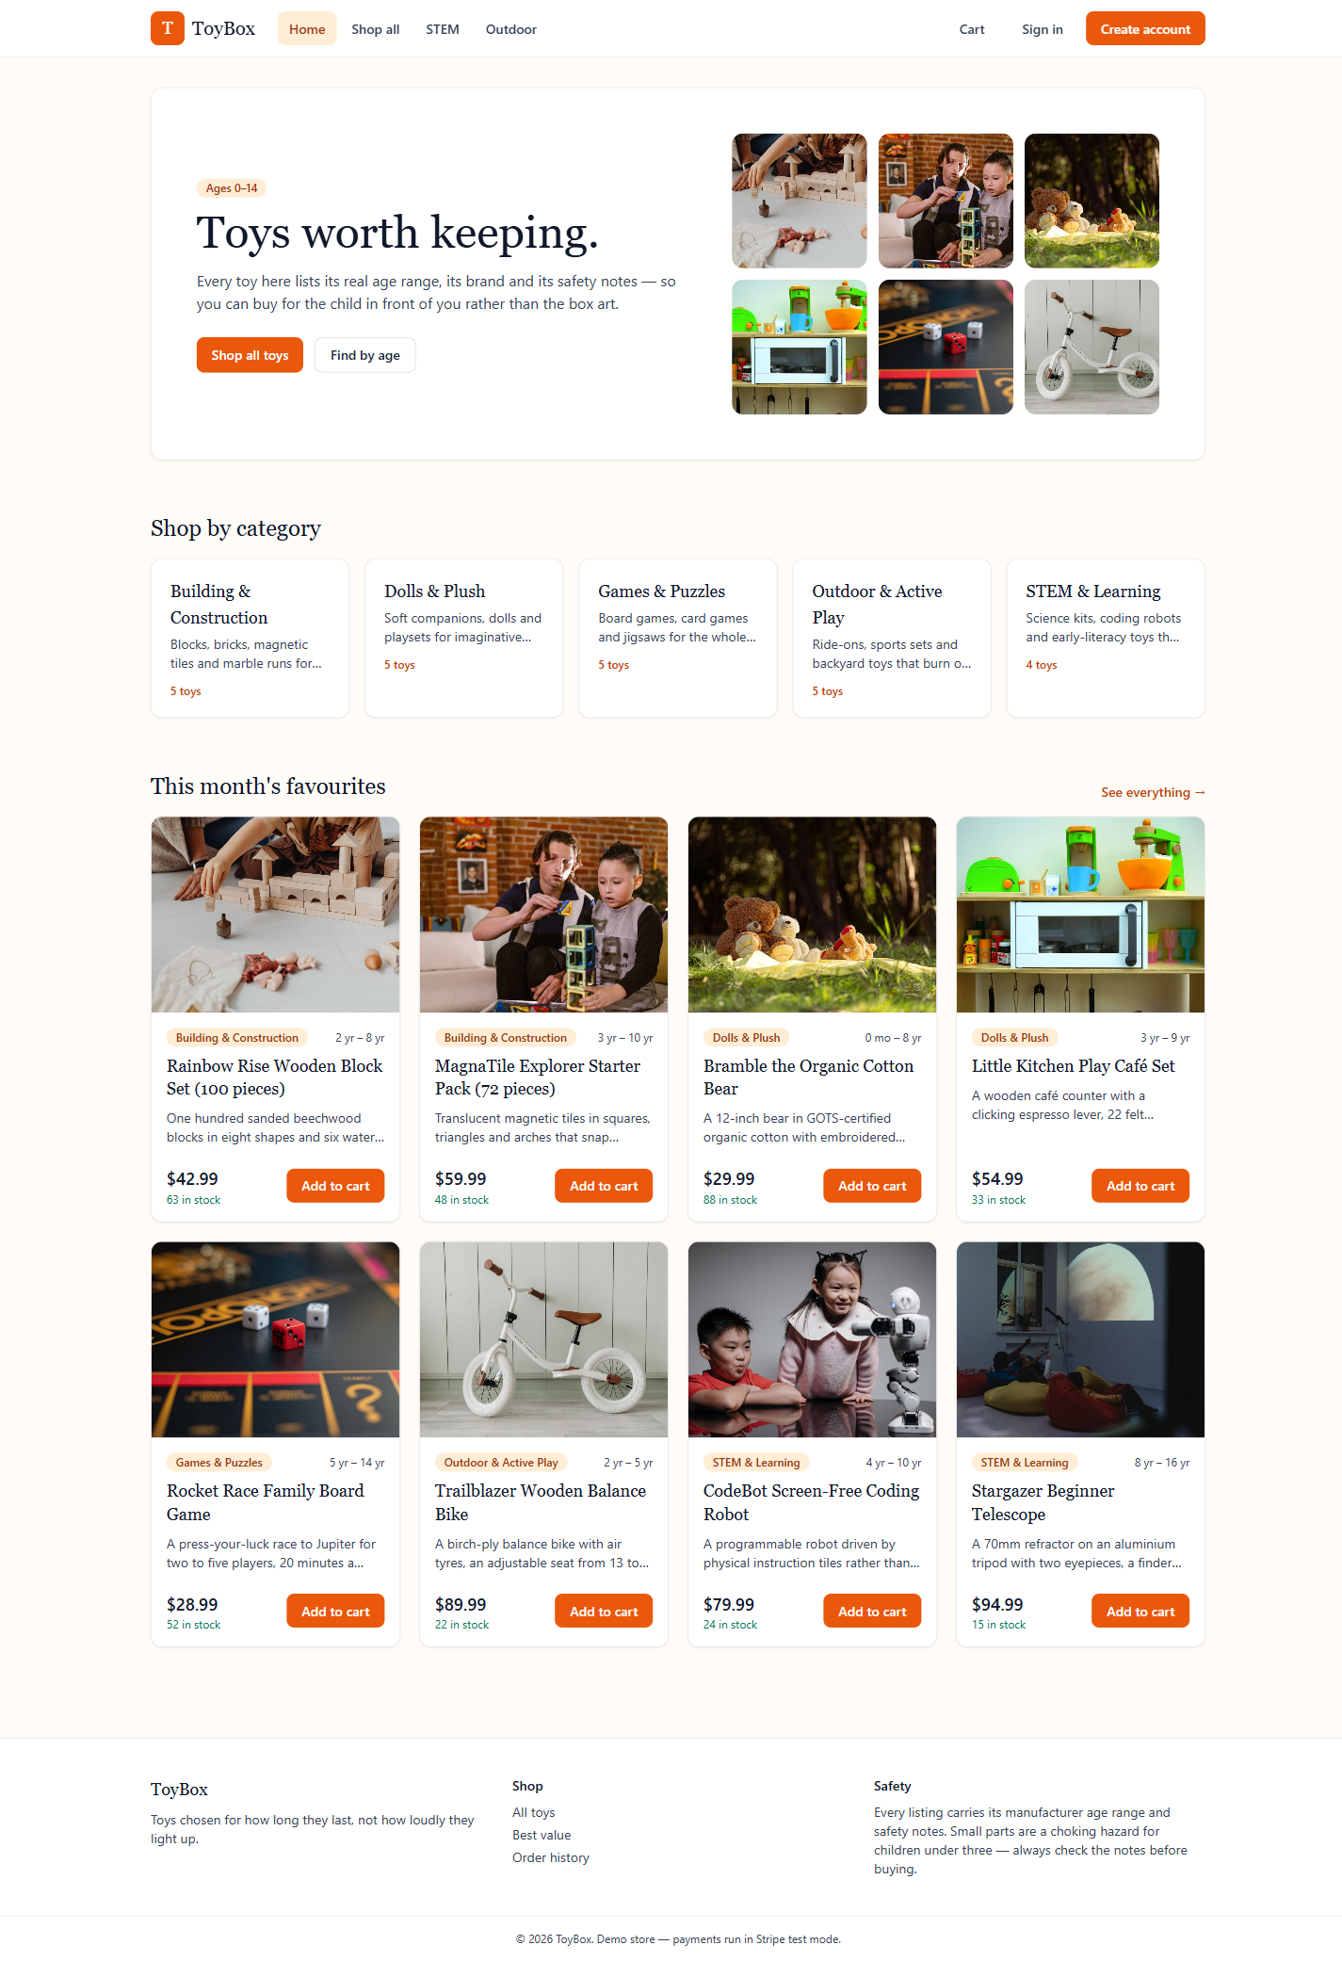
Figure 1 — Home page

3.2 Browsing the catalog
The Catalog page (Shop all in the top navigation) lists every toy with a filter panel on the left: free-text search, category, recommended age in months, a min/max price range, brand, and an in-stock-only toggle. Results can be sorted by newest, price (either direction) or name, and are paginated at 12 toys per page. Filters and sort are reflected in the page URL, so a filtered view can be bookmarked or shared.
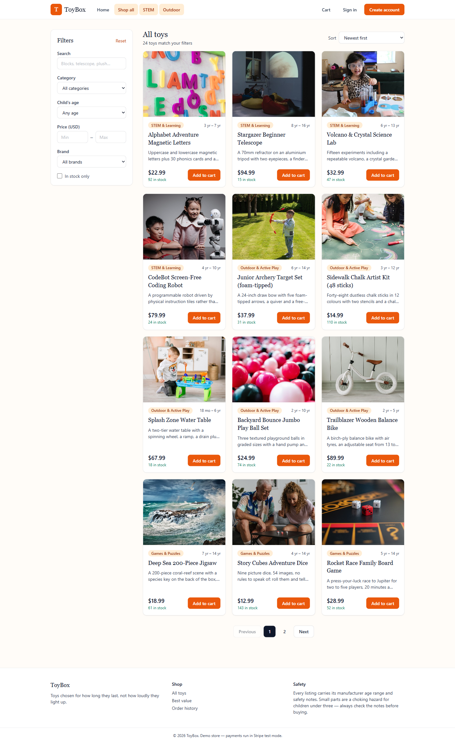
Figure 2 — Catalog with filters and sorting

3.3 Product detail
Selecting a toy opens its detail page: full description, recommended age range, live stock count, brand, price, and the manufacturer's safety notes (choking hazards, magnet warnings, age restrictions, etc.) shown prominently rather than buried in fine print. A quantity selector and Add to cart button sit below.
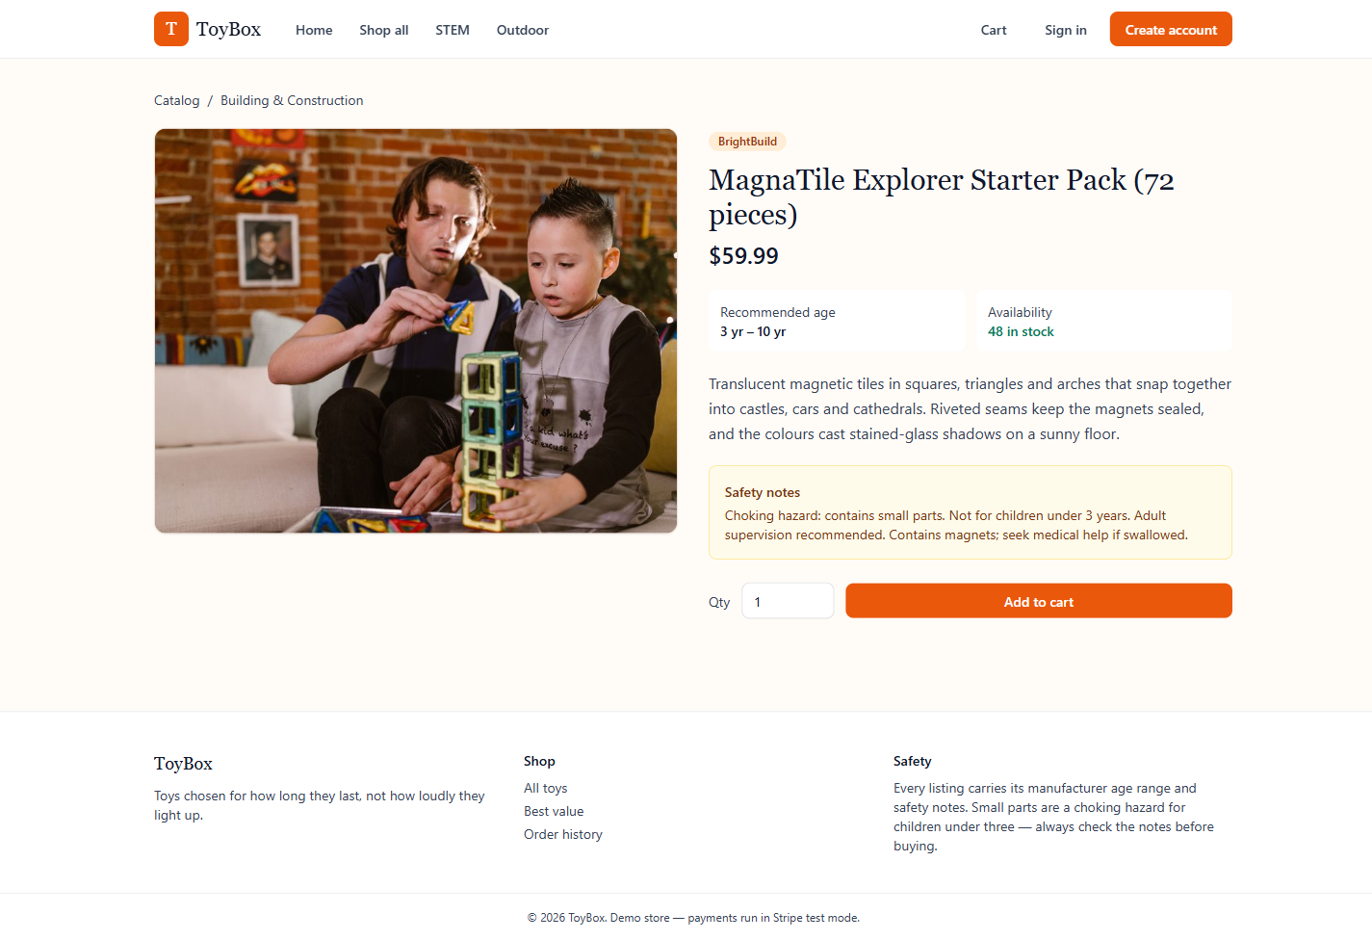
Figure 3 — Product detail page

3.4 Cart
The cart lists every line item with its image, quantity (adjustable in place), a remove option, and a running subtotal. The cart is stored server-side against the signed-in session, so it survives a page refresh or a return visit.
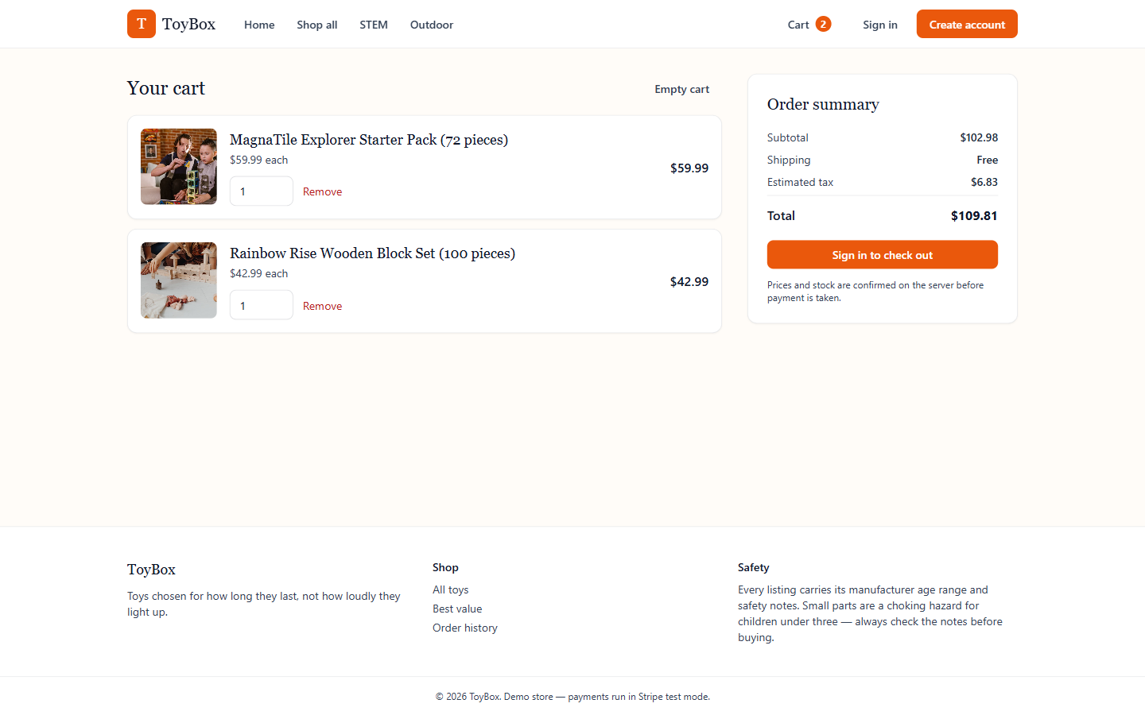
Figure 4 — Shopping cart

3.5 Creating an account and signing in
New shoppers create an account from Create account in the header. Returning shoppers sign in from Sign in — the login page also lists the two seeded demo logins for quick testing.
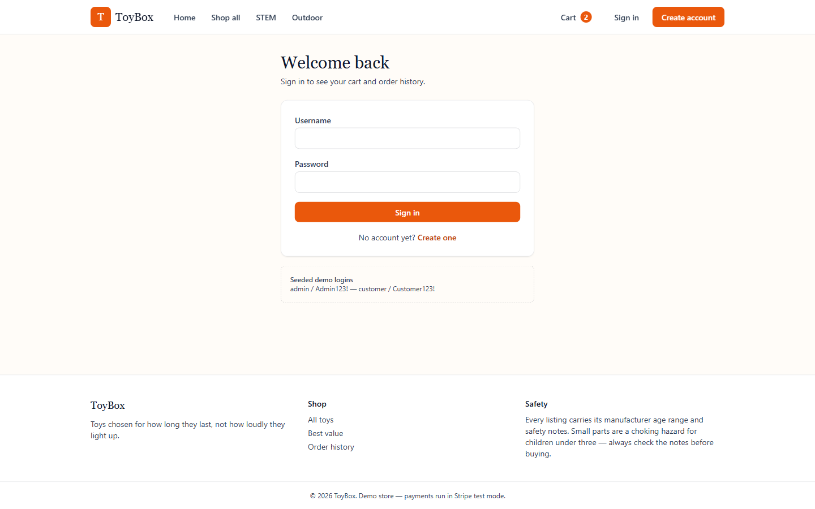
Figure 5 — Sign in page
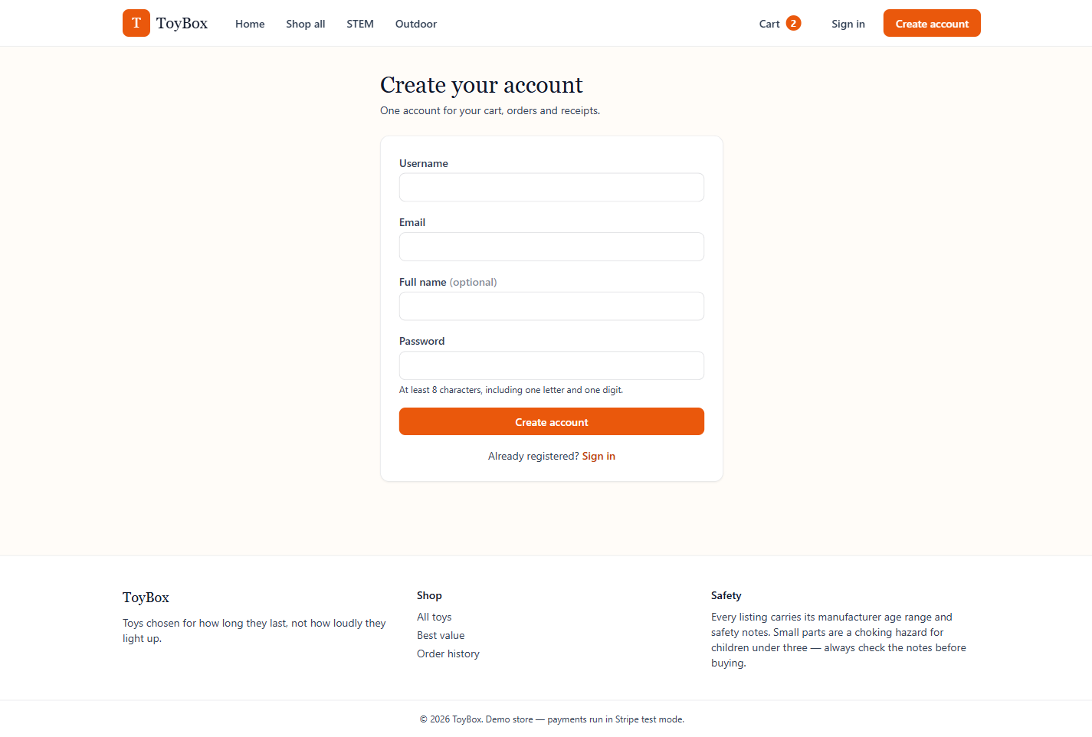
Figure 6 — Create account page

3.6 Checkout
Checkout is a signed-in-only, three-step flow: Contact, Shipping, then Review & pay. Each step's summary panel on the right keeps a running subtotal, shipping and tax total (shipping is free above a threshold; tax is calculated as a percentage of the subtotal).
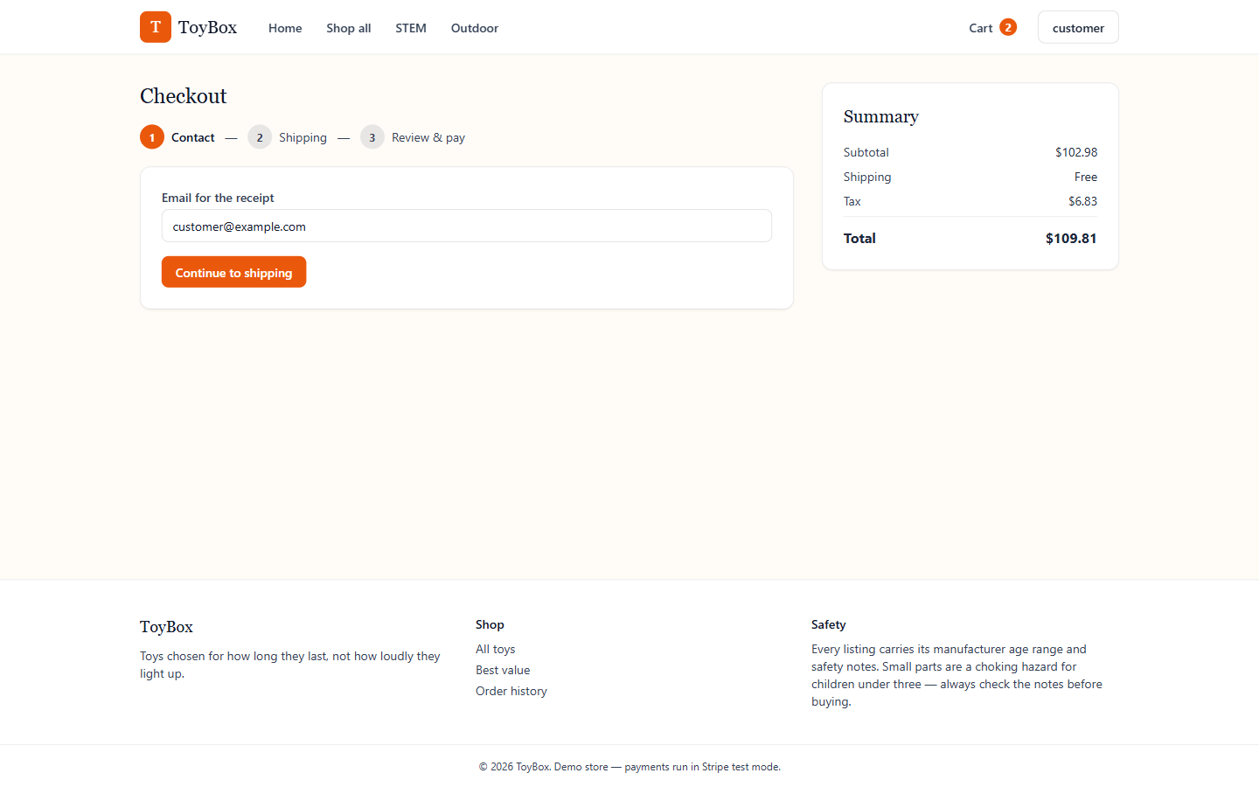
Figure 7 — Checkout, step 1: contact email
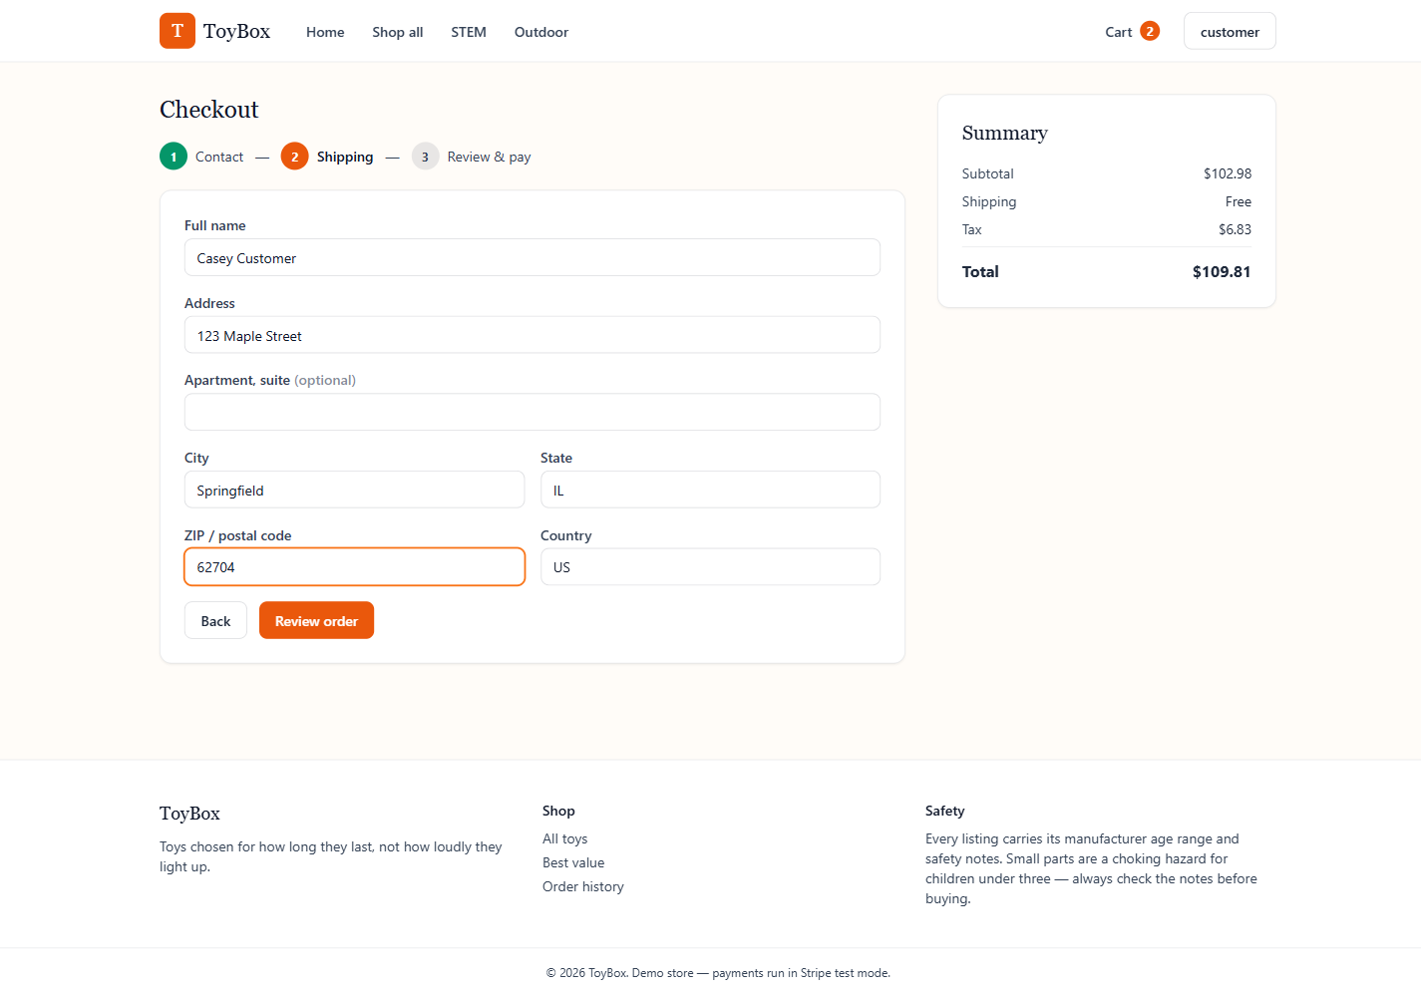
Figure 8 — Checkout, step 2: shipping address
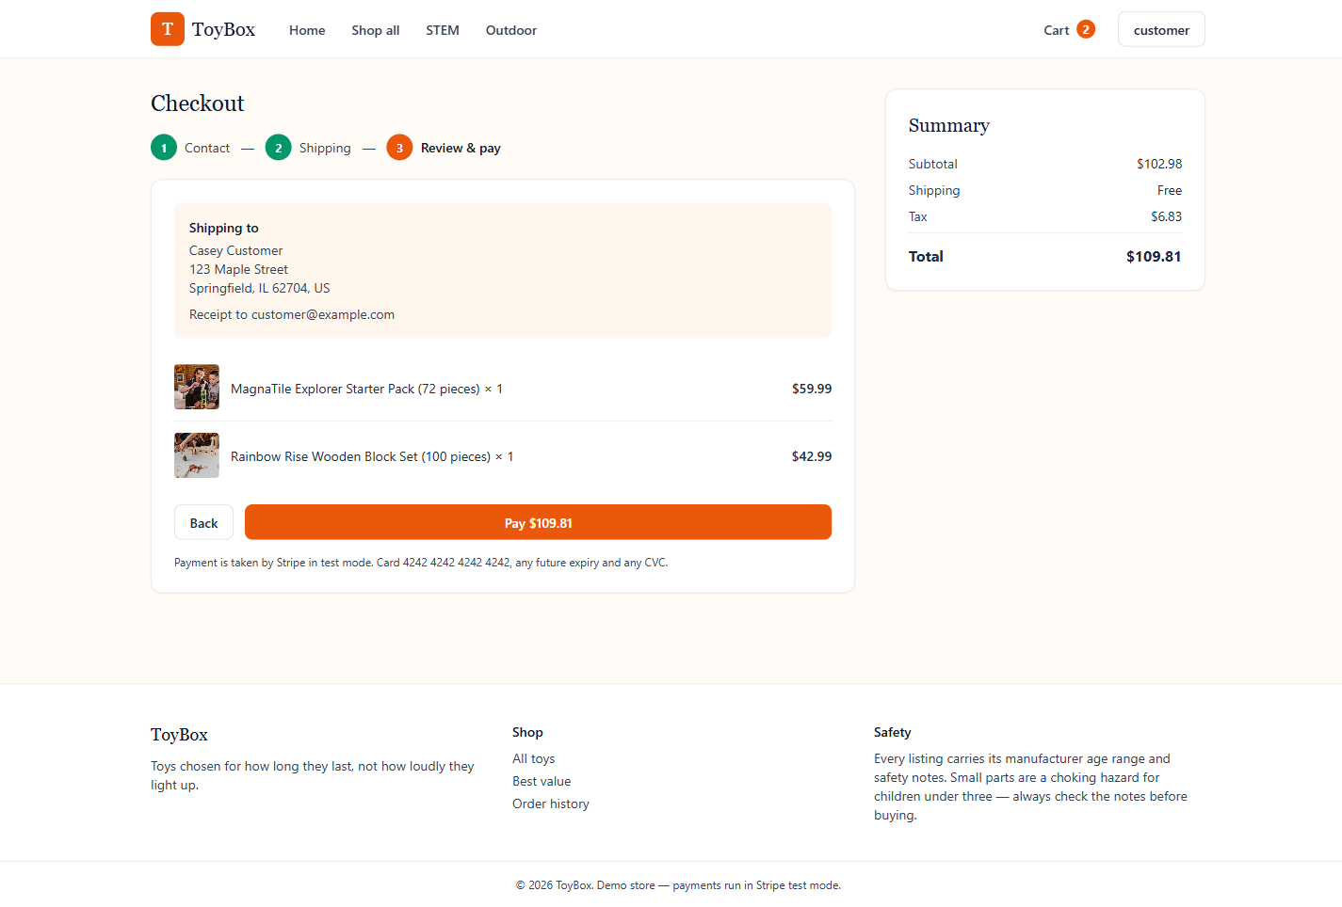
Figure 9 — Checkout, step 3: review order and pay
Payment runs through Stripe in test mode. With a Stripe key configured, this hands off to a real Stripe Checkout Session; the seed defaults use ToyBox's built-in dev-payment mode instead, so clicking Pay completes the order immediately without needing a Stripe account — useful for local development and demos.

3.7 Order confirmation
A successful payment lands on a confirmation page showing the new order number.
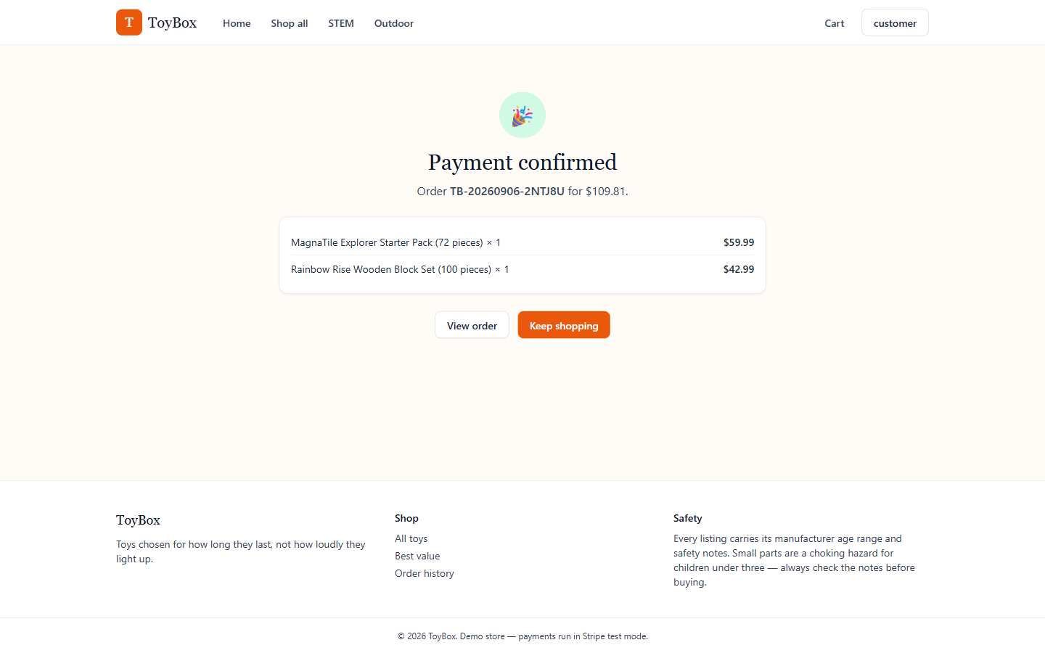
Figure 10 — Order confirmation

3.8 Order history
Order history (linked from the footer and account menu) lists every past order for the signed-in shopper. Selecting one opens its detail page: items purchased, quantities, prices, shipping address and current fulfillment status.
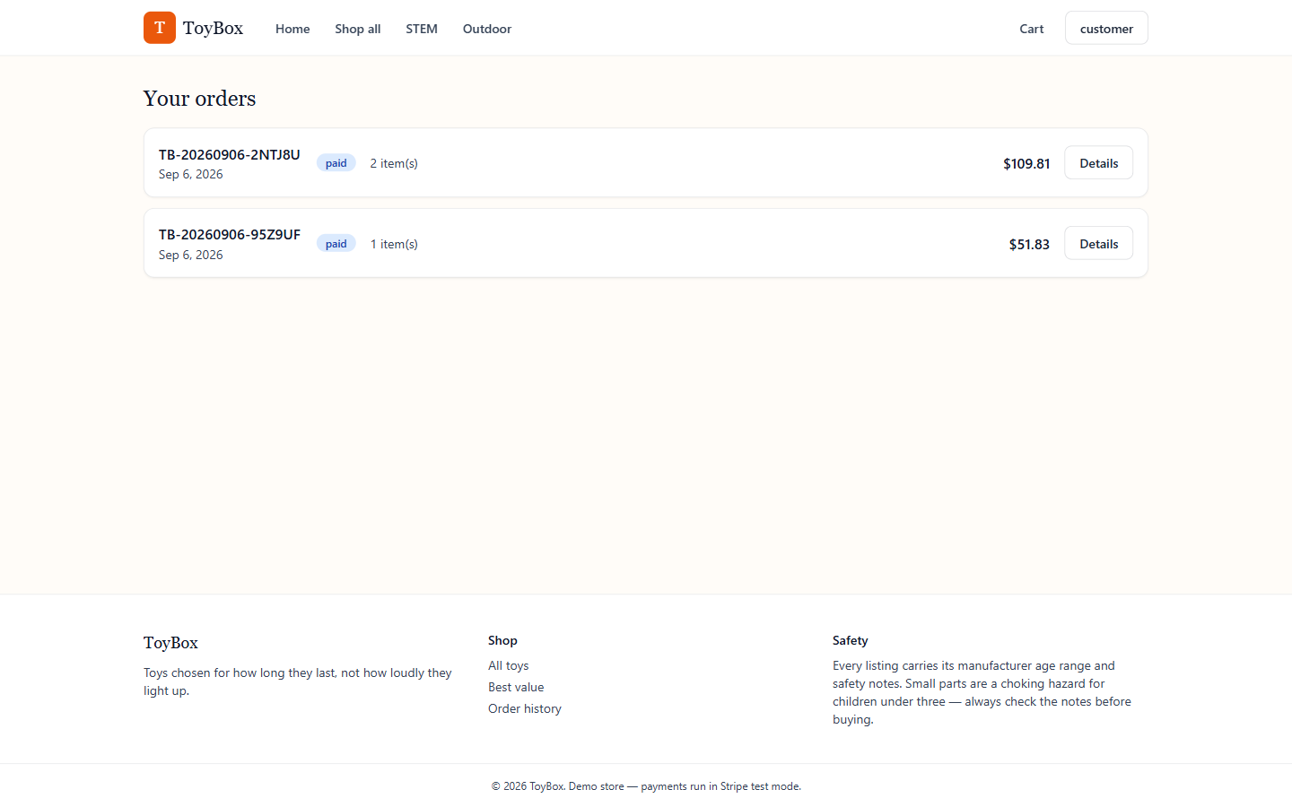
Figure 11 — Order history
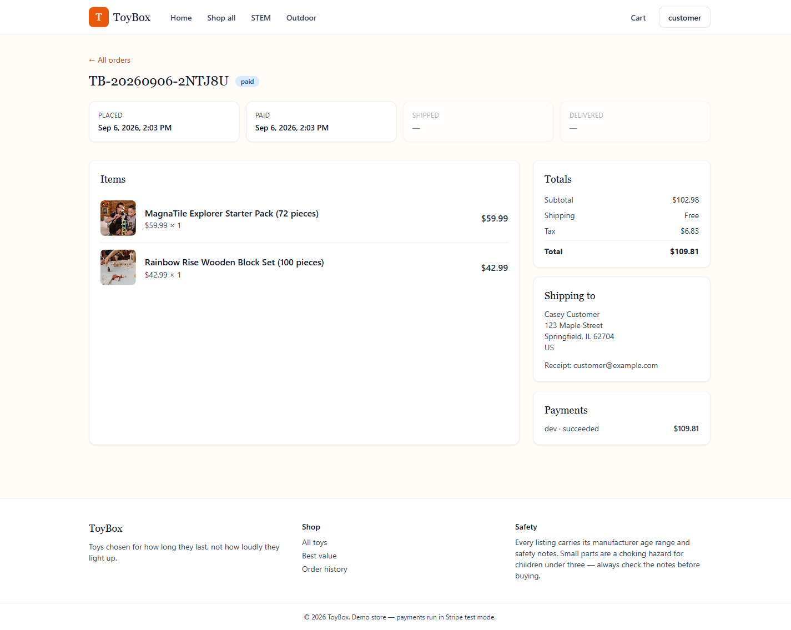
Figure 12 — Order detail

3.9 Account page
A simple account page shows the signed-in shopper's profile details.
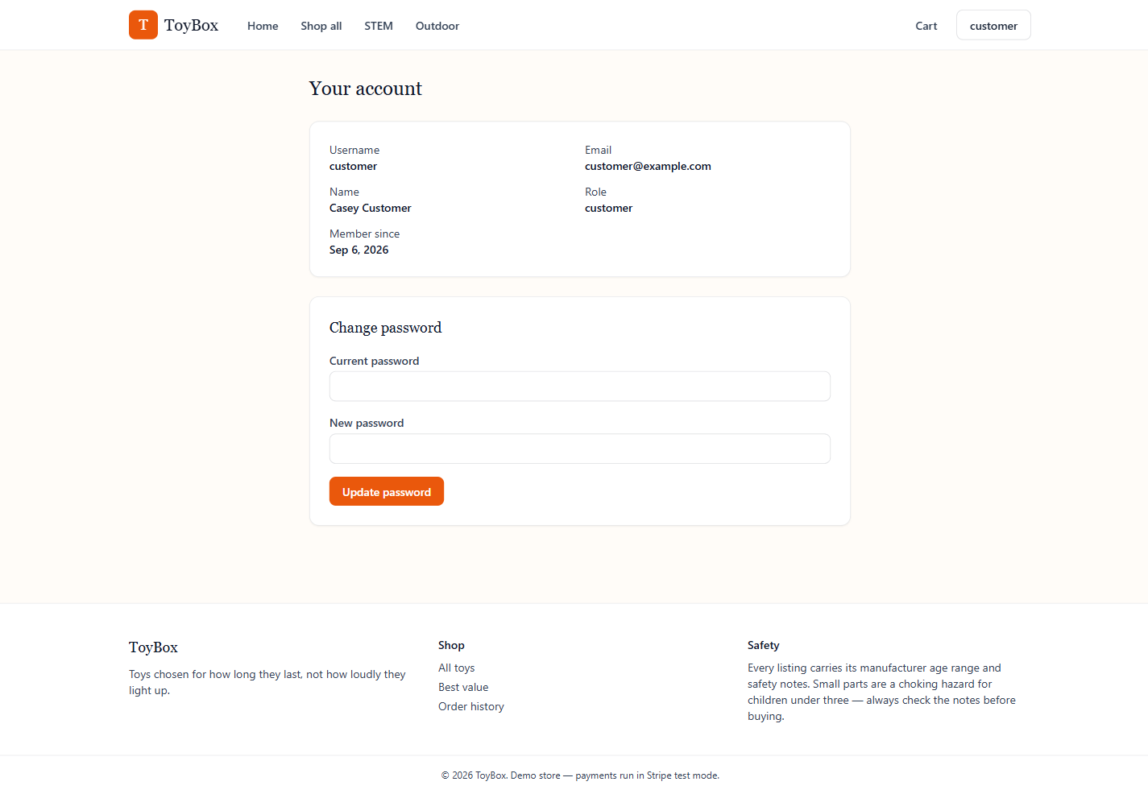
Figure 13 — Account page

4. User Guide — Managing the Store as an Admin
Signing in with an admin account (for example, the seeded admin / Admin123! login) goes straight to the admin dashboard instead of the storefront home page. Every admin action is re-checked on the server, not just hidden in the UI — a non-admin account cannot reach these routes even by URL.

4.1 Dashboard overview
The overview page is the admin landing page: a summary of the catalogue and recent activity.
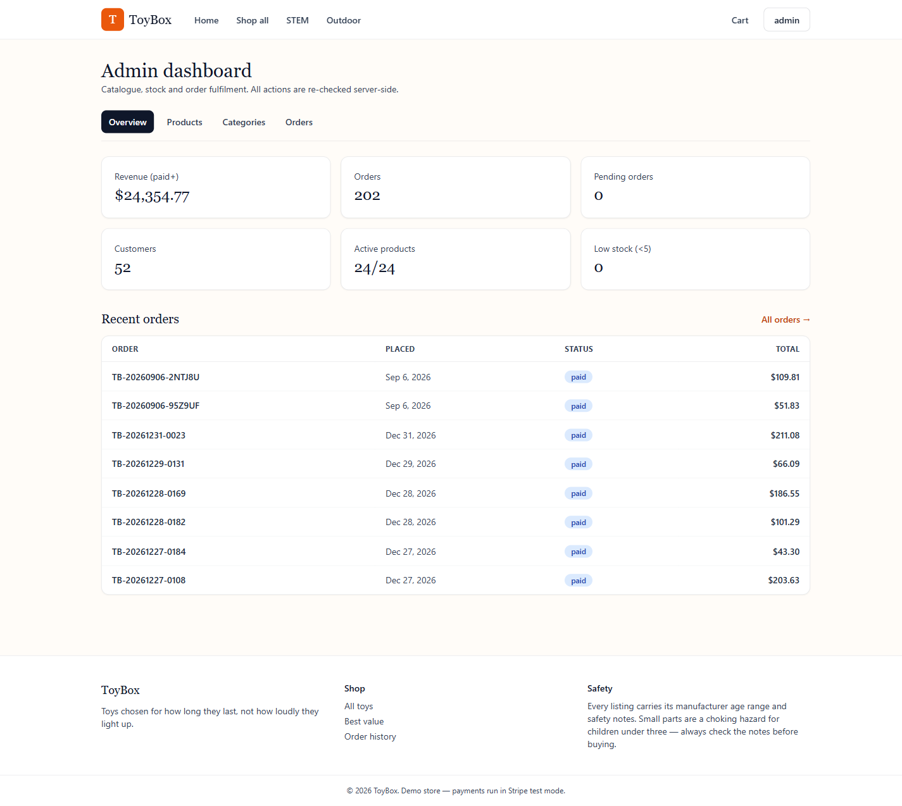
Figure 14 — Admin dashboard overview

4.2 Managing products
The Products tab lists every toy in a searchable, paginated table showing category, price, live stock (with quick +/- adjusters right in the table), and status flags such as featured. New product opens a blank form; Edit opens the same form pre-filled for an existing toy — both cover name, description, price, stock, age range, brand, safety notes, category and images. Delete removes a toy from the catalogue.
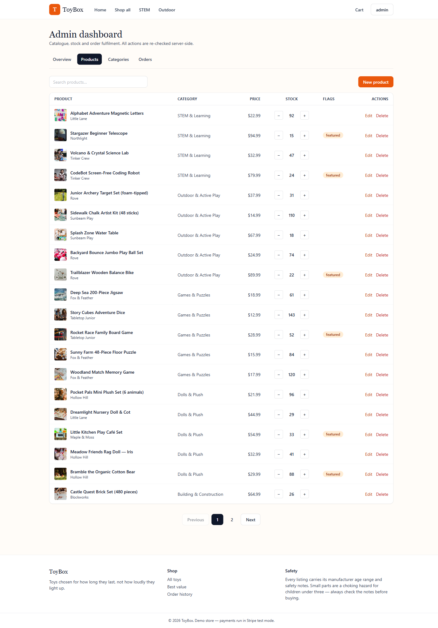
Figure 15 — Admin: product list
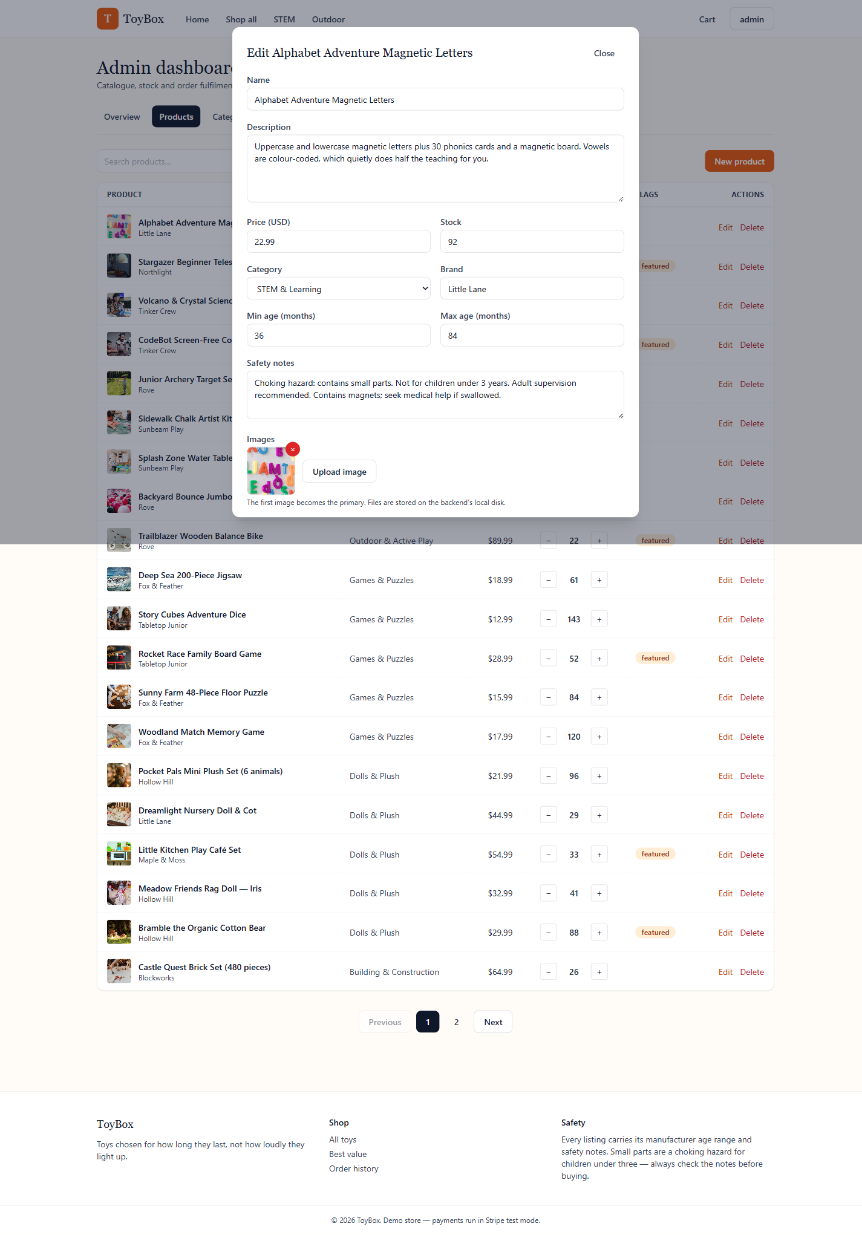
Figure 16 — Admin: editing a product

4.3 Managing categories
The Categories tab manages the five top-level categories toys are organized under.
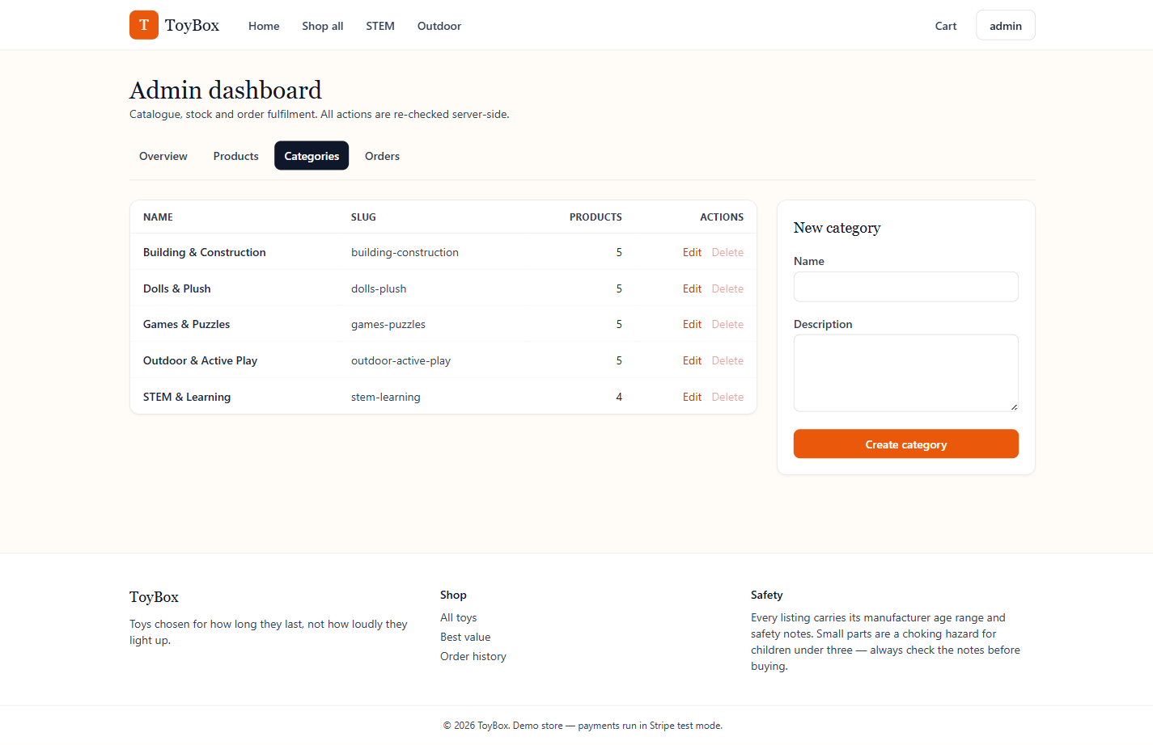
Figure 17 — Admin: category list

4.4 Managing orders
The Orders tab lists every order placed on the store, across every customer, with its status and total. This is where fulfillment status is tracked and updated as orders are shipped and delivered.
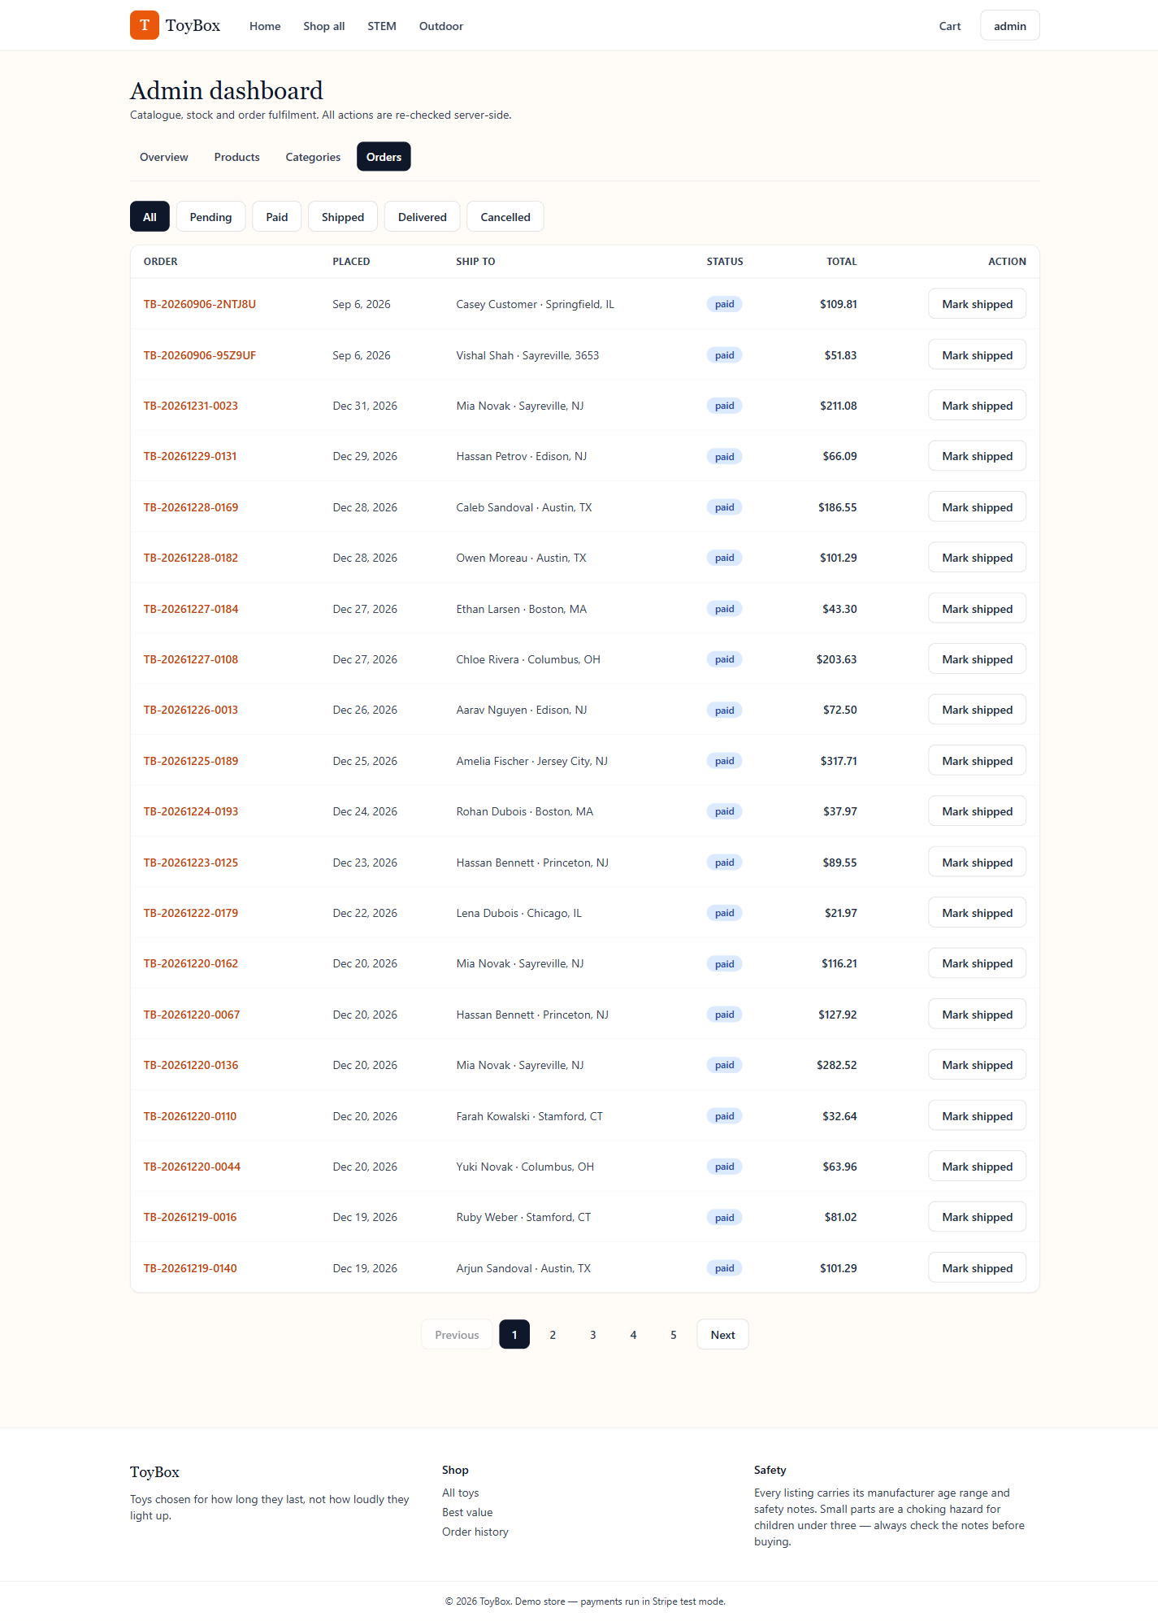
Figure 18 — Admin: order list

