FRESH & QUICK
MOBILE APP USER MANUAL
Covers the Customer App and Delivery Partner App
(React Native + Expo — Vendor and Admin remain web-only)
Version 4.4 — Customer-completed delivery, real phone figures
2 October 2026

Table of Contents
Chapter 1 — Introduction 3
Chapter 2 — Getting Started 6
Chapter 3 — Customer App 9
Chapter 4 — Delivery Partner App 22
Chapter 5 — FAQ & Troubleshooting 27
Chapter 6 — Ask Zippy 29
Appendix A — Order Status Reference 31

Chapter 1 — Introduction
The Fresh & Quick mobile app is a React Native + Expo application that brings two of the platform's four portals — the Customer App and the Delivery Partner App — to a phone. It is a companion to the existing Fresh & Quick web app, not a separate product: it talks to the same self-hosted Supabase backend and the same Next.js API routes as the web app, so an account created on the web works identically when signed into on mobile, and an order placed on one surface is immediately visible on the other.
The mobile app covers the two portals a real end user or gig worker would use day to day on a phone:
- Customer App — browse stores, order food or goods, track delivery, and manage your account.
- Delivery Partner App — go online, accept ready orders and mark them picked up (the customer's app then completes the delivery), with a History screen for finished jobs.
The Vendor Portal (store/restaurant management) and the Admin Portal (platform operations) are desk-oriented back-office tools and remain web-only in this release. Store owners and platform staff should continue to use a browser for those.

1.1 What's New in This Version
This manual has been rewritten to match a 4-phase UberEats-style visual and structural redesign of the Customer App, done after the app's first build. The biggest change: the Customer App now opens into a bottom tab bar (Home / Orders / Account) instead of a plain stack of screens, and several screens moved from full pages to overlay-style bottom sheets. Nothing about what the app can do has changed — every feature from the first release still works the same way underneath — but where you find things, and how screens are presented, has changed throughout. Chapters 2 and 3 below describe the app as it exists today; if you used an earlier build, don't rely on old habits for where things live.
Since version 2.0 the whole app was re-skinned with a new orange / navy / green look (pill-shaped buttons, rounded cards, colored section backgrounds) and the colors used behind white text were darkened so buttons and badges are easy to read. Signing in and Account changed too: the app now always starts signed out (each cold launch asks you to log in), and your name plus a Reset password option now appear in the Account tab (Customer) and the dashboard header (Delivery Partner). The Customer App and Delivery Partner screenshots in Chapters 3 and 4 (sign-up, Home, Store Detail, Cart, Checkout, Orders, order detail, Account, the Delivery dashboard cards and History) are real captures from screen recordings of the app on a phone, with personal details blurred. The one exception is the Available order card in section 4.3, which is a wireframe drawn from the app's source code with demo data (an order is normally auto-assigned before it can be photographed in that list).
What's new for version 4.0 (order visibility): (1) Checkout now asks for a required Phone number. (2) The Orders tab shows richer rows — store, a colored status pill, date and time, up to three item thumbnails with an item count, and the total. (3) The order screen is now a full order detail: a six-step tracker (Placed, Accepted, Preparing, Ready, On the way, Delivered) with a single "Step N of 6" caption, a Deliver-to card, an Items card with photos, totals and payment, and a timeline of times. (4) Status wording changed: the old single "Out for delivery" is now two statuses, Partner assigned (a delivery partner accepted the order) and On the way (the order was picked up); status colors now match the web portals. (5) The Delivery Partner dashboard now shows only active work — Your active deliveries with the full drop-off details, then Available orders with an Accept button — and a new History screen lists finished deliveries. The old View address button and the "Claim" wording are gone. (6) Customers also receive an email when the restaurant accepts an order and when it is delivered. (7) You can now create a Customer account inside the app: the customer sign-in screen has a Log in / Sign up toggle (full name, email, password of at least 6 characters), and after sign-up you are signed in automatically.
What's new for version 4.1 (customer-completed delivery): delivery partners no longer mark an order delivered; they only tap Mark picked up, and their card then says "Customer is receiving the order…". After pickup, the customer's order detail screen plays a 15-second courier animation ("Your order is on the way!", counting down "Arriving in 15s") and the order is then marked Delivered automatically, which also sends the delivered email. If the customer never opens the order, the system completes the delivery 20 seconds after pickup. See §3.6.1 and §4.4.
What's new for version 4.2: the courier animation now always plays, even when the phone's Reduce Motion accessibility setting is on, and the animation and the automatically delivered order are shown with real screenshots from an iPhone (see §3.6.1).
What's new for version 4.3: the Delivery Partner chapter now shows real phone screenshots of an assigned delivery with the Mark picked up button and of the same delivery after pickup ("Customer is receiving the order…"); the old screenshot with a Mark delivered button has been removed.
What's new for version 4.4: if the customer never opens the order, the system now marks it Delivered 20 seconds after pickup (it was 5 minutes), and the order screen does not need to be open for that to happen; the "Delivered! Enjoy your meal." modal no longer has a Done button and closes itself 3 seconds after it shows (a Close button appears only if delivery could not be confirmed). An older duplicate screenshot of the partner dashboard was removed from section 4.5.

1.2 What's the Same as the Web App, and What's Different
Everything that matters to an end user — your account, your cart, your order history, your store's menu, live order status (the same six steps and the same status colors) — is shared with the web app because both talk to the same backend. What differs is purely presentational: the mobile app is a native phone interface (tab/stack navigation, native inputs, pull-to-refresh, bottom sheets) instead of a browser page, and a small number of features that depend on hardware not available in this build (see the notes on maps and location below) are simplified the same way they are on the web.

1.3 Honest Limits of This Build
This is a functional demo/development build, and a few things are deliberately simplified or left as UI-only rather than fully built out:
- No real maps. There is no Google Maps API key configured, so the address picker and delivery tracking use plain text fields and a coordinate readout instead of an interactive map with real tiles or turn-by-turn routing.
- No real payments. Every payment method at checkout is a mock (Mock Card, Mock UPI, Cash on Delivery); no card or bank details are transmitted or stored, and no real money moves.
- No push notifications. Order and delivery status updates are shown by the app periodically re-checking with the server (polling) while a screen is open, not by a push notification arriving in the background.
- No background location tracking. The Delivery Partner App only shares a live location ping while the app is open and the partner is toggled online — it does not track location while the app is closed or backgrounded.
- Address selection is a “coming soon” stub. Tapping the address pill on Home shows an alert rather than opening a real address picker or saving a delivery address for reuse.
- Favoriting a restaurant is local and UI-only. The heart icon on a store card or the Store Detail screen toggles in the app but is not saved to your account — it resets the next time you open the app, and no backend column stores it.
- The cart's tip selector is UI-only. There is no tip column in the backend; a selected tip percentage is never added to your subtotal, delivery fee, or total, and is never sent to checkout — it is purely cosmetic, with a disclaimer shown directly under it in the app.
- Order-tracking's Call and Message buttons are demo stubs. Tapping either on the courier card shows an alert saying it isn't wired up to a real backend yet — there is no telephony or chat integration.
- Screenshots are captures from screen recordings of the real app running on a phone, with personal details blurred (the round blue gear button in them is the Expo developer menu of the test build, not part of the app). The Available order figure in section 4.3 is a wireframe drawn from the source code with demo data. Everything new in this version was also checked by type-check, automated tests and code review.
None of these are bugs to report — they reflect the current scope of this build, matching the equivalent stubs already documented in the web app's own user manual.

Chapter 2 — Getting Started

2.1 Opening the App
When you open the app, you land on a role picker screen with two options: Customer and Delivery Partner. Tap the one that matches how you intend to use the app — each leads to its own sign-in screen.

2.2 Signing In
Enter the email and password for your Fresh & Quick account and tap Log In. If you do not have an account yet, tap "Need an account? Sign up" under the form: the screen changes to Customer Sign Up, where you enter your full name, your email and a password of at least 6 characters, then tap Sign Up. When the account is created you are signed in automatically and land on Home. Accounts made in the app and accounts made on the web app are the same — the same email and password work on both. (Only the Customer App has sign-up; delivery partner accounts are created by an administrator.) On the sign-up screen, "Have an account? Log in" switches back.
If your email or password is incorrect, the sign-in screen shows the error message returned by the server directly below the form.
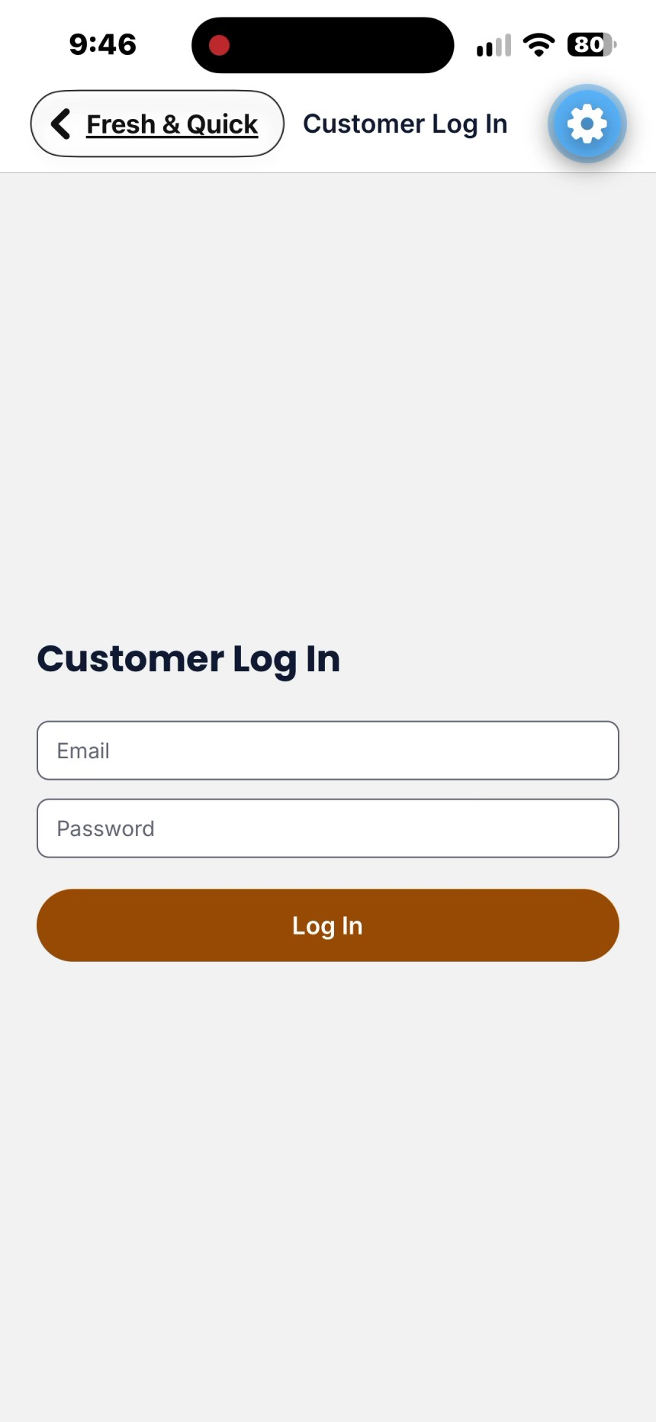
Screenshot — Customer sign-in screen (email, password, Log In).
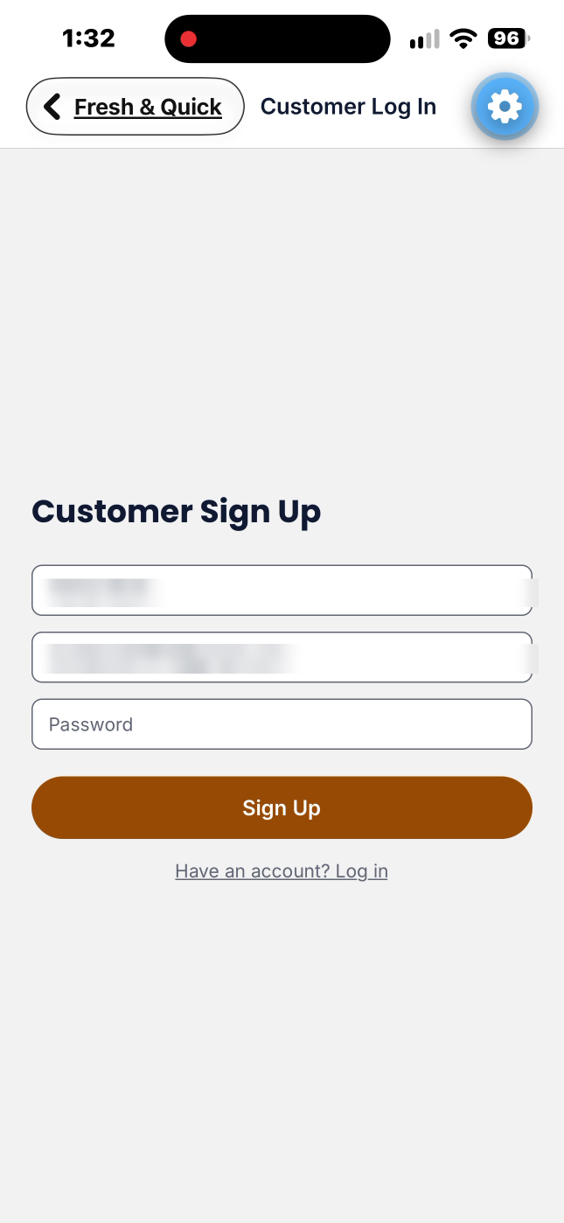
Screenshot — Customer sign-up screen (full name, email, password, Sign Up). Personal details blurred.
Always signed out at launch: the app does not remember your last session. Every time you open it from scratch you land on the role picker and sign in again. Switching between apps and coming back does not sign you out.

2.3 Tab-Based Navigation (New)
Once signed in as a Customer, the app opens into a bottom tab bar with three tabs: Home, Orders, and Account. This replaces the earlier build's single stack of screens with no persistent navigation. The tab bar stays visible across Home, the Orders list, and the Account screen; it is intentionally hidden on screens you're meant to focus on one task at a time — Store Detail, Cart, Checkout, and an individual order's tracking screen — which are reached by tapping into them and dismissed with a back gesture or an explicit close/back control on that screen.
Note: The Delivery Partner App has no tab bar — it opens on a single dashboard once signed in, with a History link in its header that opens a second screen (see Chapter 4).

2.4 Switching Roles or Accounts
Each app is signed in as one role at a time. To use the app as a different role (for example, to also act as a delivery partner), sign out from within that portal — for the Customer App, this is the Sign out row on the Account tab (§3.8); for the Delivery Partner App, it's the Sign out link in the dashboard header — and pick the other role from the role picker screen shown at launch.

2.5 Connecting to the Backend (Web vs. Mobile)
The mobile app always talks to one backend address at a time, configured at build time via the EXPO_PUBLIC_API_BASE_URL environment variable — typically your development machine's LAN IP address (for example http://192.168.1.42:3000) so a phone on the same Wi-Fi network can reach it, since "localhost" on a phone means the phone itself, not your computer.
This is different from the web app's optional multi-port testing mode (four ports, one per role, so a customer, vendor, delivery partner, and admin can all be signed in at once in the same browser — see the web User Manual, section 2.5). That multi-port scheme is a browser-only convenience for testing multiple roles side by side; the mobile app doesn't need it and isn't affected by it — it simply signs in as one role at a time (Customer or Delivery Partner, see section 2.4) against the single server address it was built with.

Chapter 3 — Customer App
The Customer App is organized around three bottom tabs — Home, Orders, Account — plus four full-focus screens reached by tapping into them: Store Detail, Cart (a bottom sheet), Checkout, and an order's individual Tracking screen. This chapter covers each in the order you'd naturally move through them.

3.1 Home
Home is the Home tab's screen and opens on a pull-to-refresh scroll view with, from top to bottom:
- An address pill (“Deliver now · Current location”) — tapping it currently shows a “Coming soon” alert; address selection isn't wired up in this build.
- A search pill (“Search restaurants or dishes”) — typing filters the store list further down by store name, cuisine tag, or the name of any dish/product sold at that store, so searching for a specific dish surfaces every store that sells it, not just stores whose own name matches.
- A horizontally scrolling row of category chips (circular icons, one per cuisine/category) — tapping one filters the store list to that category; tapping the same chip again clears the filter.
- A promo carousel — swipeable banner cards for stores currently running a promotion, each showing the store's promo text over its banner photo. Only stores with an active promo appear here, and the row is hidden entirely when none do.
- An “Order again” row — up to 10 stores you've ordered from before, most recent first, each with a Reorder button that jumps straight to that store's Store Detail screen. Hidden for a new account with no order history.
- A “Restaurants near you” list — every open, non-suspended store as a photo-forward card: 16:9 banner image (or a plate emoji placeholder if none is set), a favorite heart in the photo's corner (local-only, see §1.3), a promo badge overlaid on the photo when applicable, the store's name, and a single metadata line (star rating · average prep time · delivery fee, e.g. “★4.5 · 25 min · ₹30 delivery”).
Tapping a store card, a promo card, or a reorder card all open that store's Store Detail screen. Pulling down from the top of the list refreshes every section (stores, categories, promos, reorder row) in one action.
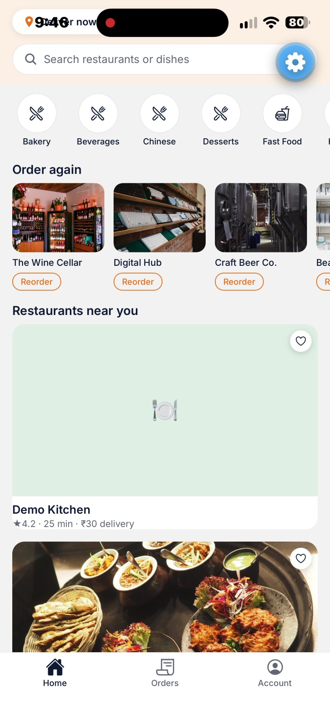
Screenshot — Home tab: search, category chips, Order again row, and store cards.

3.2 Store Detail
The Store Detail screen opens with a full-width hero banner (the store's banner photo, or a plate emoji on a tinted background if none is set), with a back chip and a favorite-heart chip overlaid on its corners. Below the hero is the store's name, cuisine tags, rating, and average prep time, followed by a closed/suspended banner if the store currently can't take orders.
Below that, a row of category pills (e.g. Starters, Mains, Desserts) sticks to the top of the screen as you scroll past it, so you can always see which section you're in and tap a pill to jump straight to it — tapping a pill both scrolls to that section and highlights the pill; the highlight does not yet auto-update purely from scroll position, so it only changes when you tap a pill directly (see the Known Limitations note below).
The menu itself is grouped into sections matching the store's own category labels (uncategorized items fall into a trailing “Other” group). Each item row shows:
- A veg/non-veg indicator dot, the item name, and its description (up to 2 lines).
- Its price.
- A thumbnail image with a circular “+” Quick Add button overlaid on its corner.
Tapping an item with no configurable options adds it straight to your cart. Tapping an item that has size/add-on options (configured by the store owner) instead opens a bottom-sheet customization view, where you choose required and optional groups before adding it to your cart; a required group left with no valid options keeps Add-to-cart disabled rather than letting you submit an incomplete selection. Every item can also carry its own special-instructions note (e.g. “no onions”), entered in that same customization step.
Adding an item from a different store than what's already in your cart prompts a native confirmation dialog to clear the current cart first — a cart can only ever hold items from one store at a time.
Note: The pill-nav's active highlight only updates on tap, not on scroll — a minor known gap carried over from the web app's own scroll-spy nuance, not a functional bug (the pill row still scrolls correctly to every section).
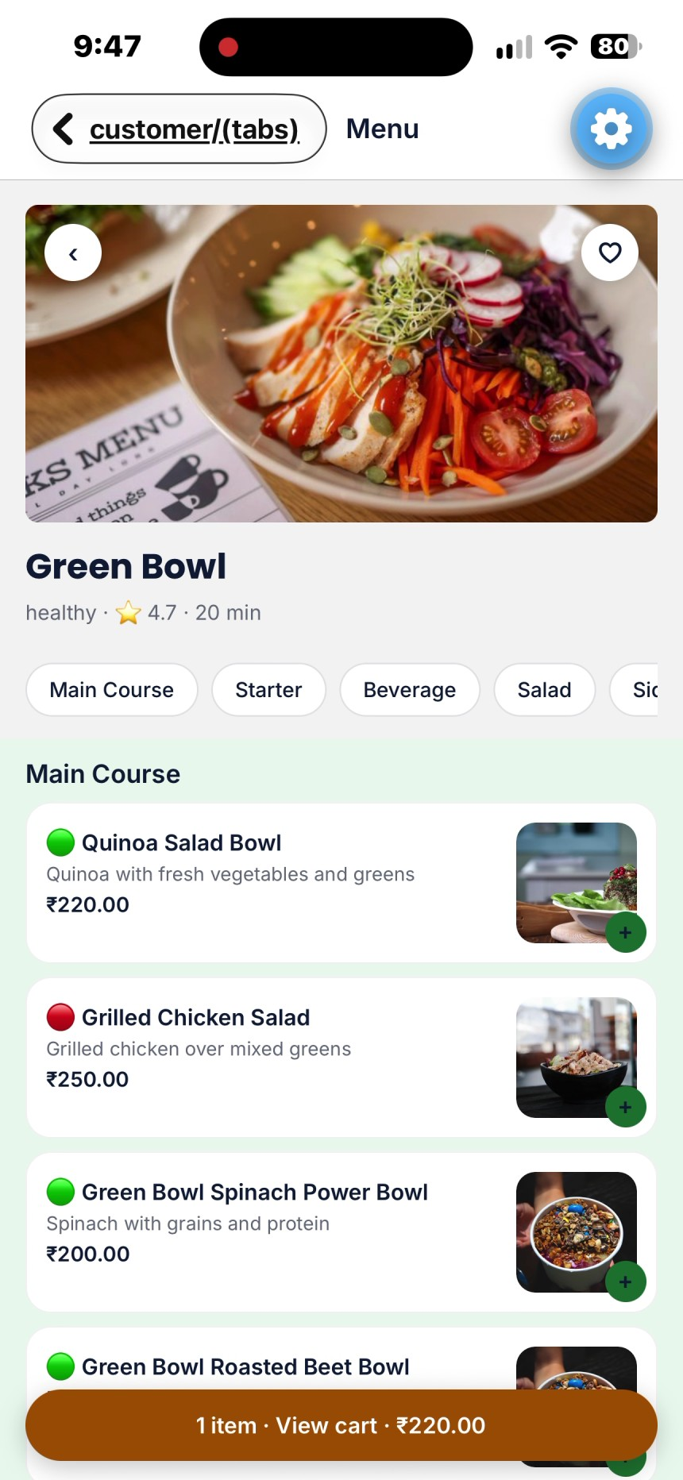
Screenshot — Store Detail: hero photo, category pills, menu rows, and the floating cart pill.

3.3 Cart
The cart opens as a bottom sheet over whichever screen you were on, not a separate full page — a dimmed backdrop covers the screen behind it, the sheet has a drag-handle bar at its top, and an ✕ close button returns you to where you were. Each line shows the item's thumbnail, name, any selected customization options, a quantity stepper (− / +), a Remove link, and a per-line note field. Below the line items:
- An order note field for the whole order (e.g. gate code, “leave at door”) — separate from each line's own special-instructions note.
- A Clear cart link.
- A tip selector (15% / 18% / 20% / Other) with an explicit disclaimer underneath it — see the stub note below.
- An order summary (Subtotal, Delivery fee, Total) and a Checkout button, pinned at the bottom of the sheet.
Not fully wired up yet: the tip selector is UI-only. Choosing a tip percentage highlights that button but never changes your subtotal, delivery fee, or total, and no tip value is sent at checkout — there is no tip column in the backend yet. The app tells you this directly under the selector.
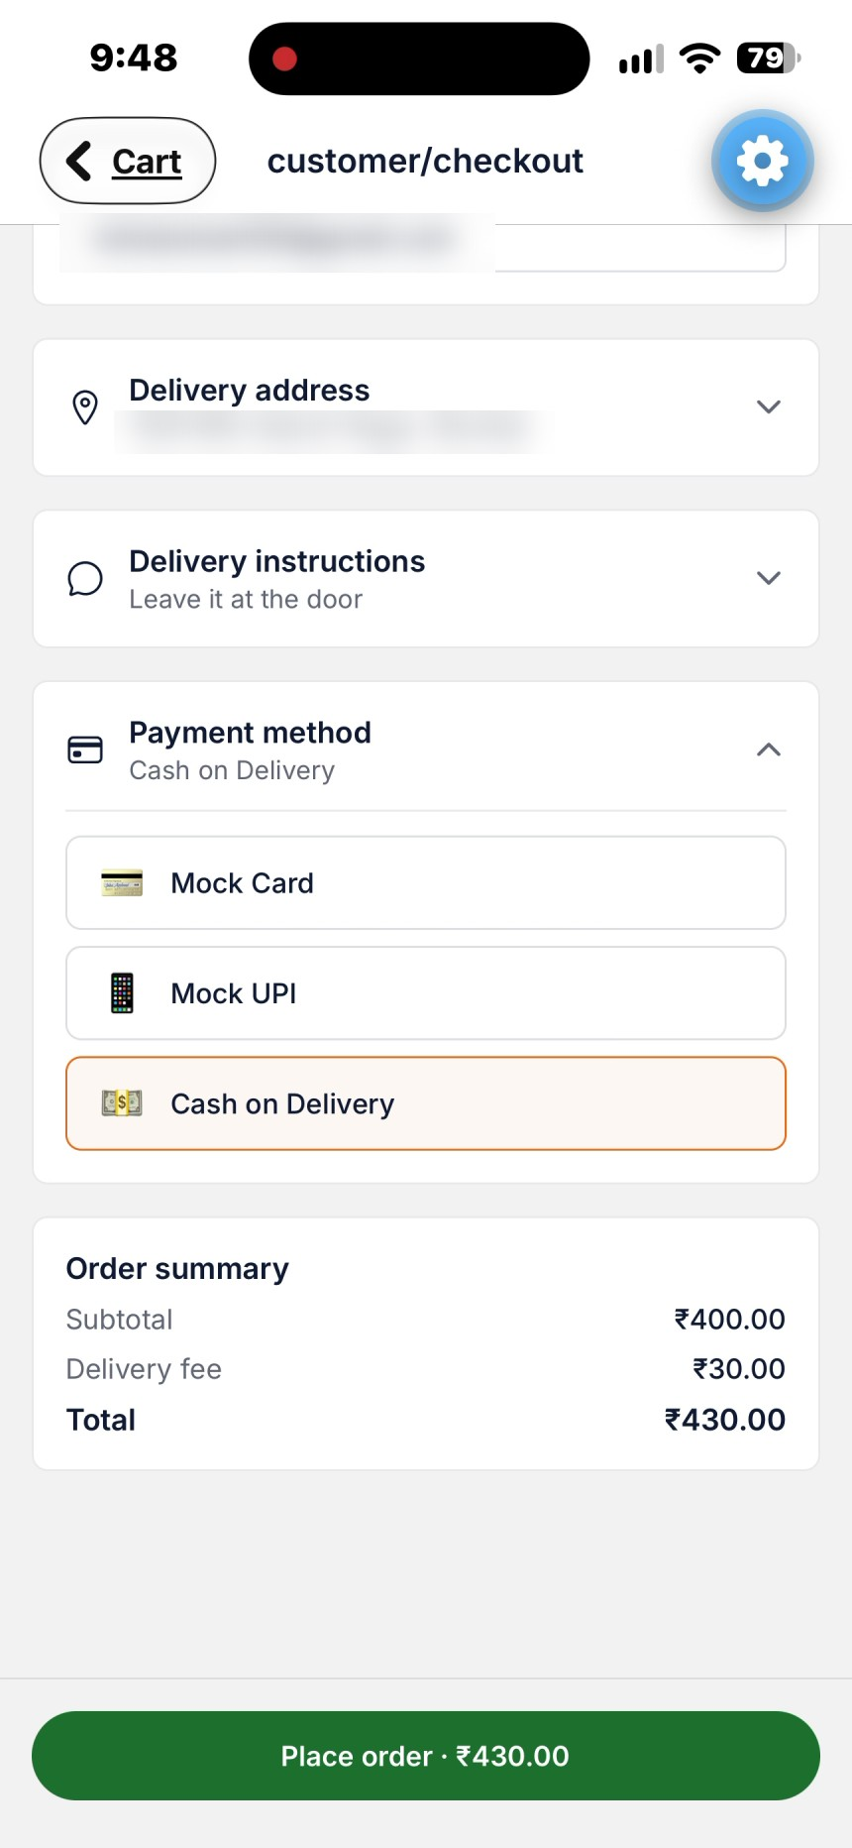
Screenshot — Cart: item rows with quantity steppers, order note, tip selector, and pinned Checkout.

3.4 Checkout
Checkout is a single scrollable screen. A Contact details block (Name, Email and Phone; name and email are pre-filled from your account profile where available) sits at the top, followed by three collapsible rows — each shows a one-line summary when collapsed and expands in place to reveal its fields when tapped, with only one row open at a time:
Phone is required. Enter an Indian 10-digit mobile number that starts with 6, 7, 8 or 9; you may type it with an optional +91, 91 or 0 in front. It is saved as +91 followed by the 10 digits, so the delivery partner can call you and so it appears on your order. If the number is not valid, an error message appears under the field and Place order stays disabled; the server checks the number again when the order is placed.
- Delivery address — Address line 1 (required), Address line 2 (optional), City, State, and Pincode. There is no map picker in this build; you type the address directly.
- Delivery instructions — the same order-note text you may have already entered in the cart; editing it here updates the same value.
- Payment method — Mock Card (16-digit card number, MM/YY expiry, cardholder name), Mock UPI (a UPI ID such as name@bank), or Cash on Delivery. All three are simulated — no real payment processor is contacted.
Below the three rows, an Order summary block shows subtotal, the store's real delivery fee, and the total. A Place order button is pinned to the bottom of the screen (not part of the scrolling content) and stays disabled until every required field above is valid; while submitting, it shows a spinner in place of its label. After a successful submission, you're taken directly to that order's Tracking screen.
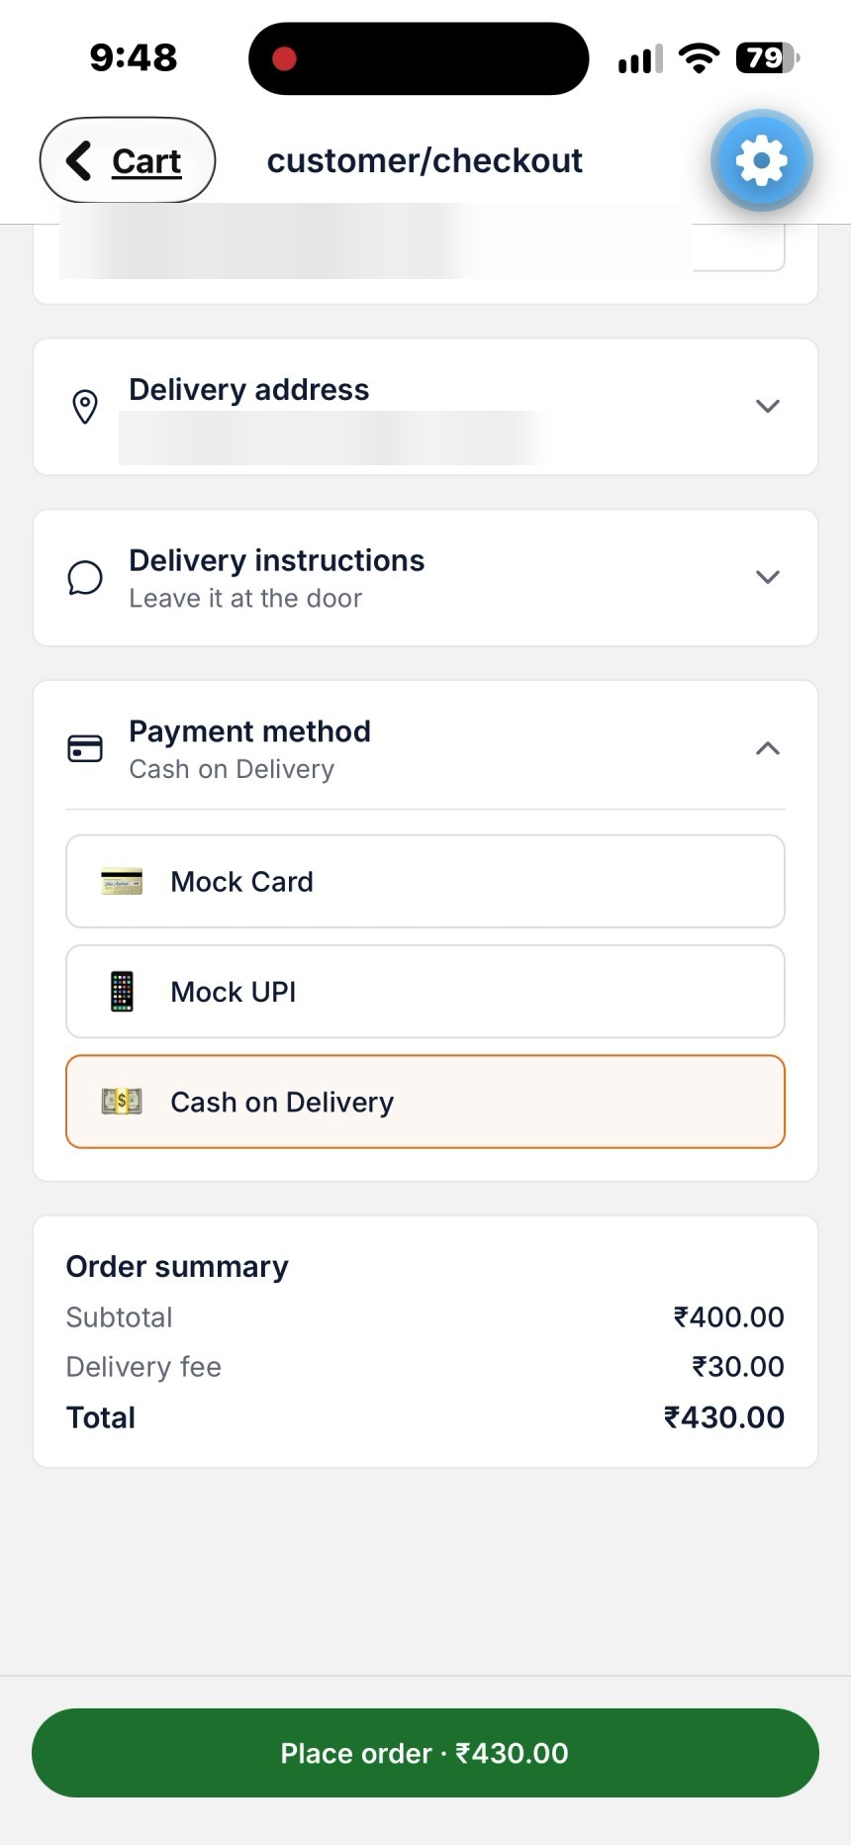
Screenshot — Checkout: collapsible rows with the payment options open and Place order ready.

3.5 Orders (tab)
The Orders tab (heading "Your orders") lists every order you've placed, most recent first. Each row shows the store name, a colored status pill (for example Placed, Preparing, On the way, Delivered), the date and time the order was placed, up to three small item photos with an item count such as "2 items", and the order total. Tapping a row opens that order's detail screen (§3.6). If you have no orders the tab says "No orders yet." The list reloads each time you return to the tab, so a new order appears without restarting the app. The tab bar stays visible on this list.
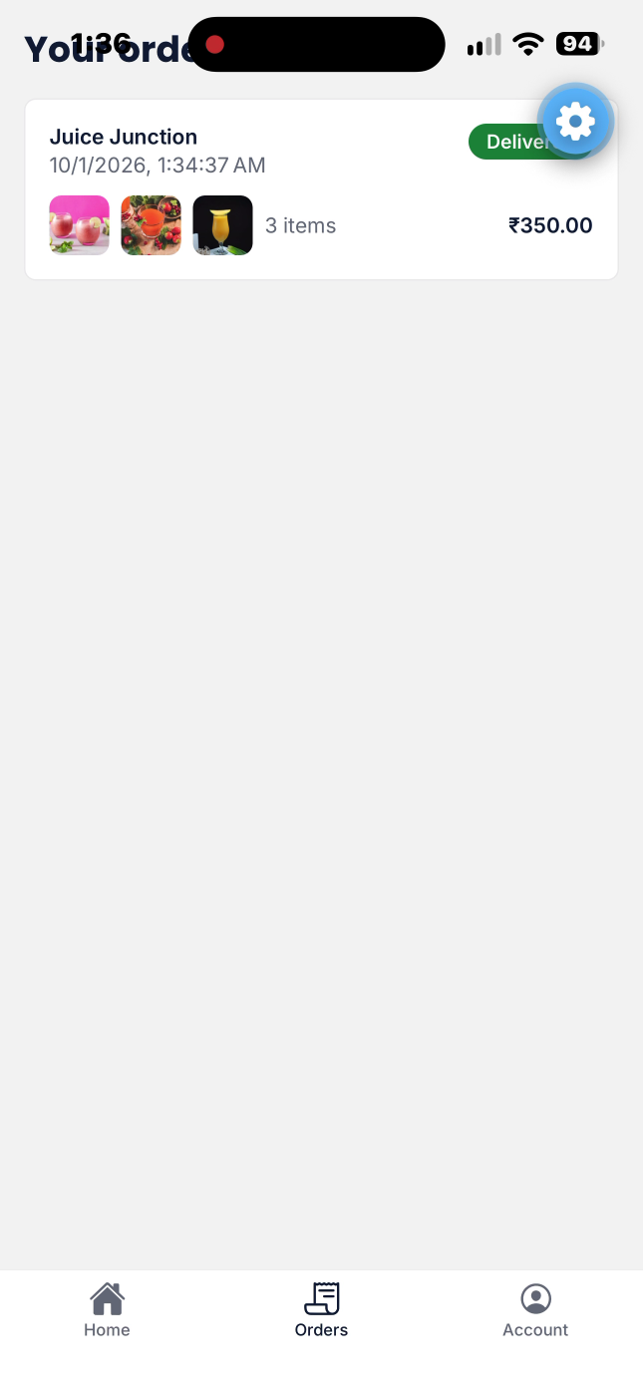
Screenshot — Orders tab: each order row shows the store, date and time, a colored status pill, up to three item thumbnails with an item count, and the total.

3.6 Order Detail and Tracking
Tapping an order opens its detail screen. At the top is the heading "Order #" followed by the first eight characters of the order id, with the status pill beside it, then the store name and the time the order was placed, and a one-line status message (for example "Restaurant is preparing your order"). Below that is the order tracker: six numbered circles joined by lines — Placed, Accepted, Preparing, Ready, On the way, Delivered — with finished steps checked and the line filled up to the current step. Because six labels do not fit a phone's width, the tracker shows a single caption under the circles instead, such as "Step 3 of 6 · Preparing". The two delivery statuses share step 5: Partner assigned and On the way both show "Step 5 of 6 · On the way" (the status pill and message tell them apart). If the restaurant rejects the order, or the order is cancelled, a red banner ("Restaurant rejected your order — payment refunded" or "Order cancelled") replaces the tracker. If payment failed, the screen shows "Payment failed. Your order was not placed — please try checking out again." instead of the tracker.
Below the tracker the screen shows: a Deliver to card (your name, email and phone — the phone is a tap-to-call link when it is a normal +91 number, otherwise plain text — then your delivery address and, if you entered one, the delivery note, or "No delivery address on file"); an Items card with each item's photo, quantity, chosen options, any special instructions and line total; a totals block (Subtotal, Delivery fee, Total, and Payment, for example "Paid · Cash on delivery"); and a timeline of times for the stages the order has reached (Placed, Accepted, Picked up, Delivered).
Once a delivery partner is assigned (status Partner assigned or On the way), a courier card appears below the tracker with a "Delivery partner" label (the partner's name is not shown), an initials circle and Call / Message icon buttons.
Not fully wired up yet: the courier card's Call and Message buttons. Both show an alert (“isn't wired up to a real backend yet”) rather than placing a call or opening a chat — there is no telephony or messaging integration in this build.
While a partner is assigned or on the way, a bordered box below the courier card shows their last-known coordinates as plain text (e.g. “12.9716, 77.5946”) with a timestamp, and an explicit “Live map coming soon” line — there is no Google Maps key configured, so this is a coordinate readout, not an interactive map. The whole detail screen refreshes automatically every 3 seconds while it's open, and stops refreshing once the order reaches a final status (Delivered, Cancelled or Rejected).
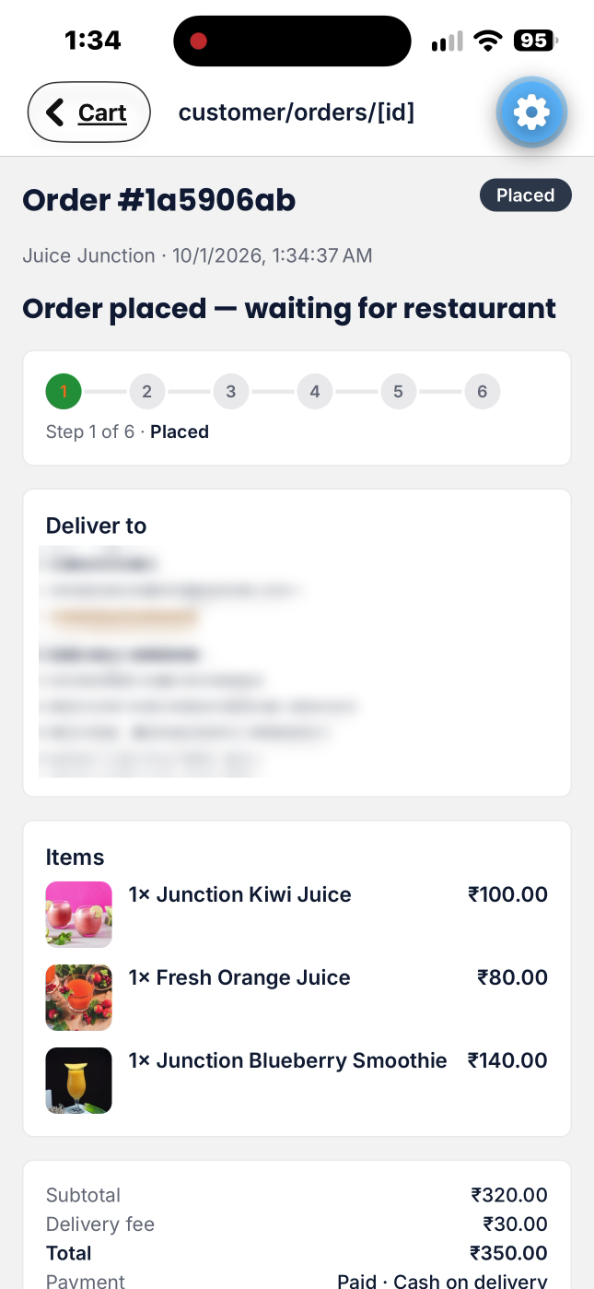
Screenshot — Order detail just after placing: "Step 1 of 6 · Placed", the Deliver to card (blurred here), the Items card with photos, and totals.
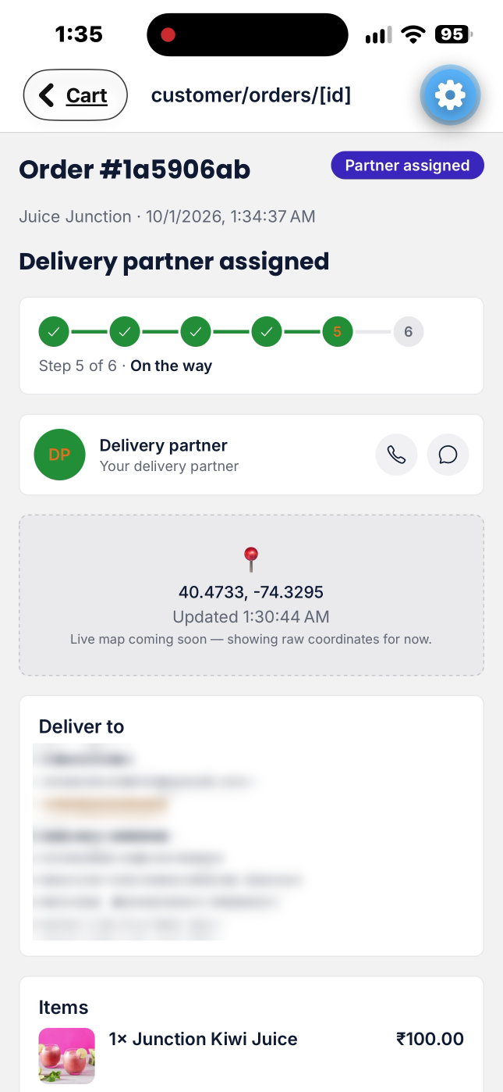
Screenshot — Order detail with a delivery partner assigned: six-step tracker at "Step 5 of 6 · On the way", courier card, and coordinate readout. Personal details blurred.
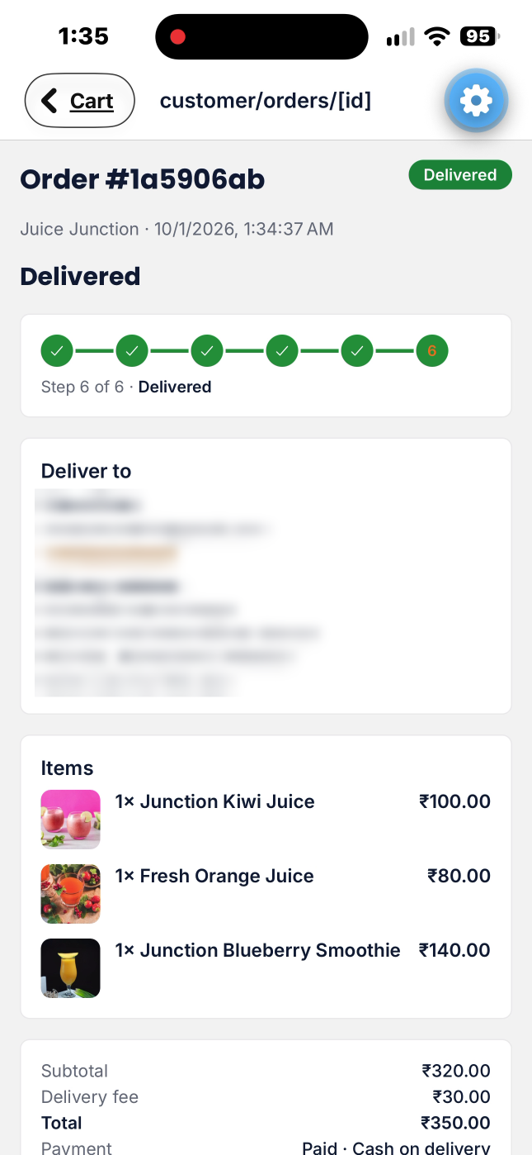
Screenshot — Order detail once delivered: all six steps checked ("Step 6 of 6 · Delivered"). Personal details blurred.
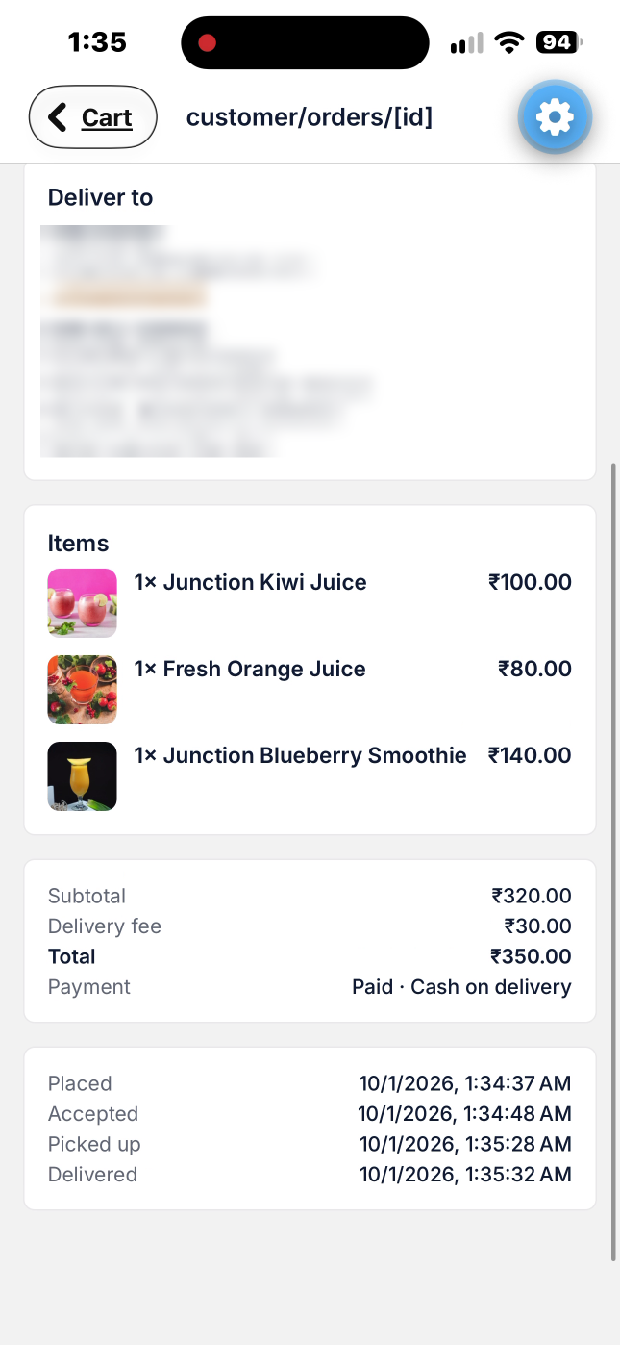
Screenshot — Order detail scrolled down: items, totals and payment, and the timeline of times (Placed, Accepted, Picked up, Delivered). Personal details blurred.

3.6.1 Courier Animation and Automatic Delivery
Delivery partners only mark an order picked up; they cannot mark it delivered. Once your order is On the way, its detail screen opens a "Your order is on the way!" modal with an animated courier scene and a countdown that reads "Arriving in 15s". The animation always plays for a full 15 seconds from the moment the modal first appears, however long ago the partner picked the order up. The animation always plays, even if the phone's Reduce Motion accessibility setting is on.
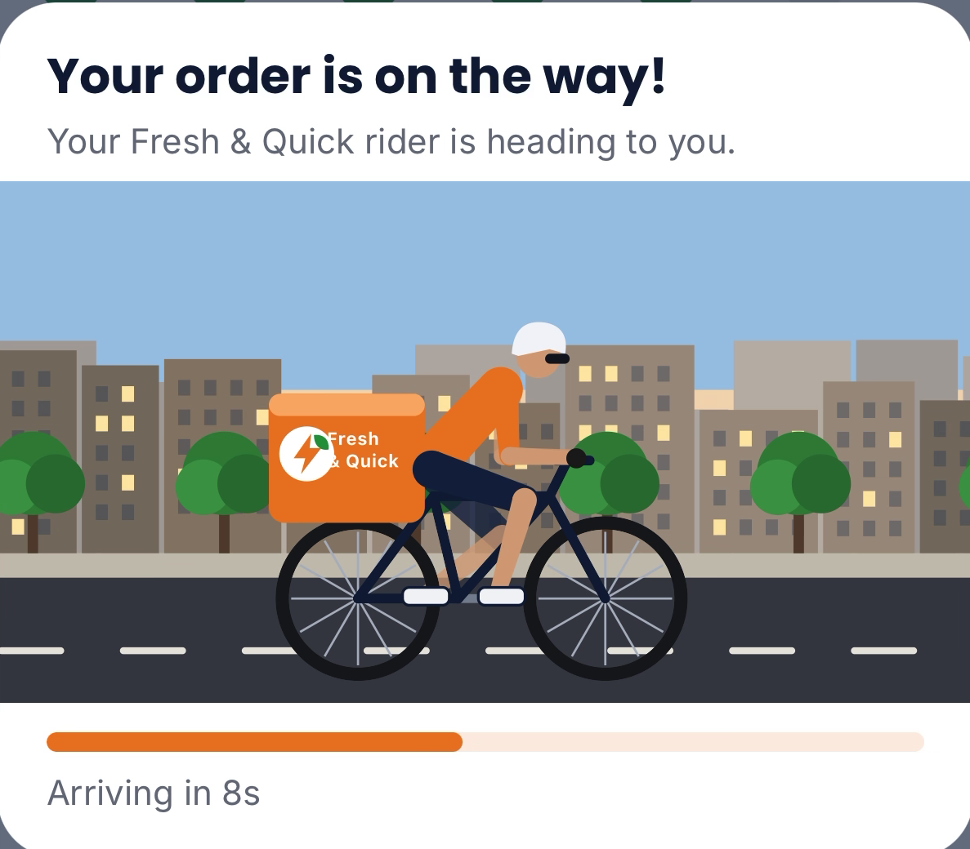
Screenshot — The courier animation modal on a phone: "Your order is on the way!", the rider scene and the 15-second countdown (here "Arriving in 8s").
When the countdown ends the modal briefly shows "Confirming delivery…", then "Delivered! Enjoy your meal.", and the order becomes Delivered (step 6 of 6); there is no Done button: the modal closes itself 3 seconds after it shows. The delivered email is sent at that moment, once per order. If you leave the screen part-way through and come back while the app stays open, the animation resumes where it left off. If delivery could not be confirmed straight away, the modal says "We couldn't confirm delivery just yet — your order will be marked delivered shortly." and shows a Close button. This flow has been checked on a real iPhone.
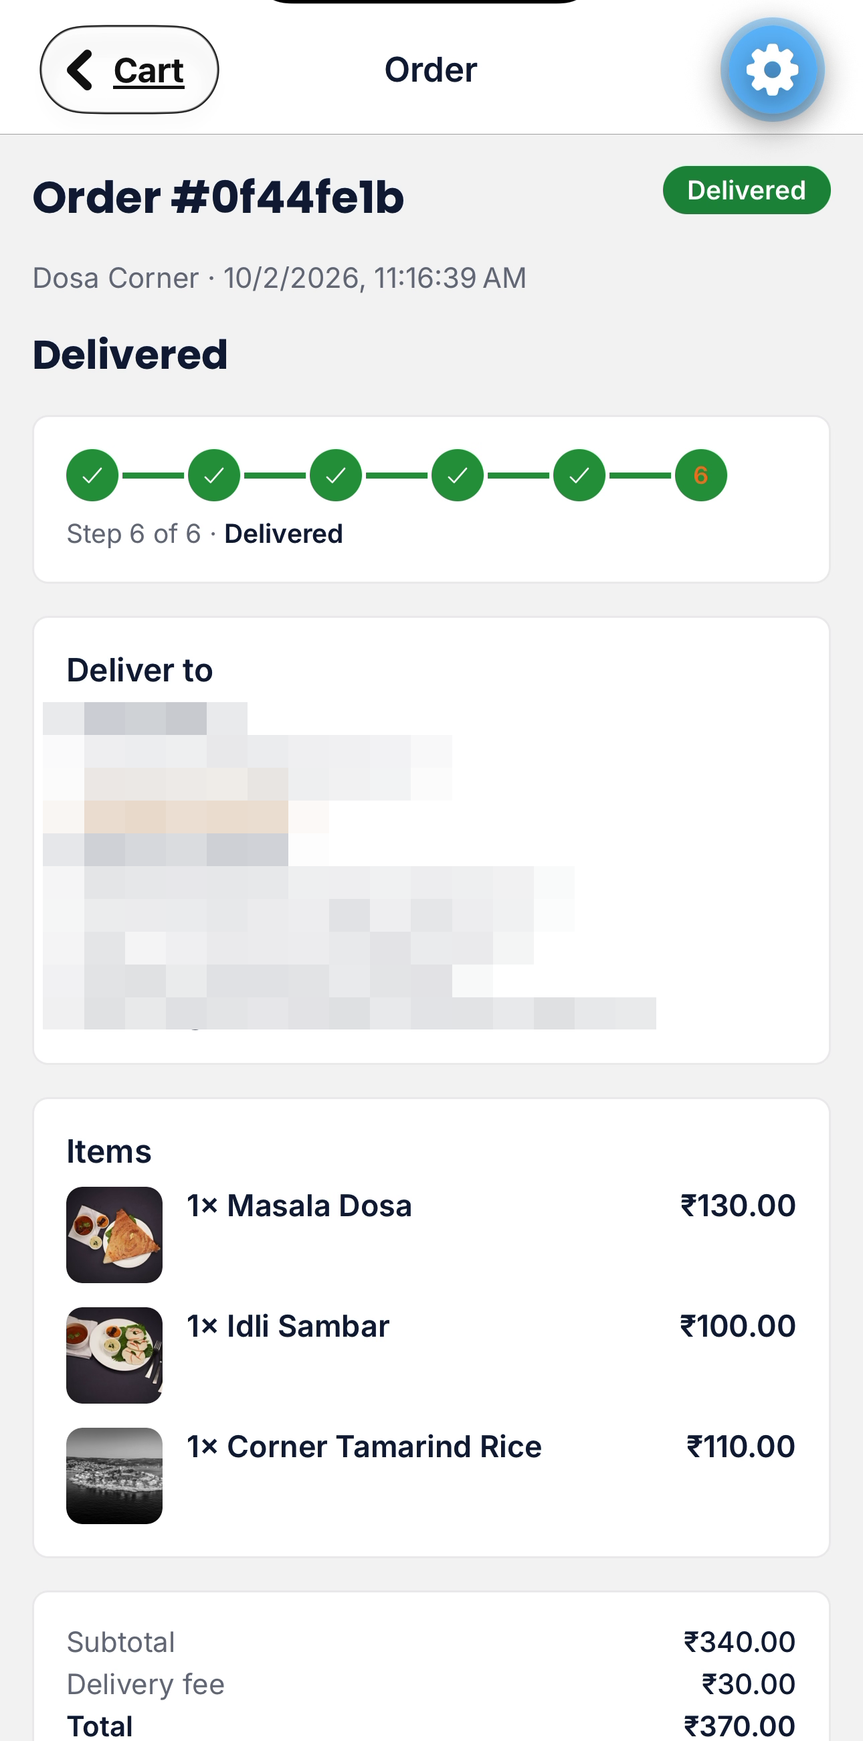
Screenshot — The order marked Delivered automatically when the animation ends: status pill "Delivered" and "Step 6 of 6 · Delivered". Personal details blurred.
If you never open the order after pickup, nothing is lost: the platform completes the delivery by itself 20 seconds after pickup and sends the same single delivered email, so the order screen does not need to be open for delivery to complete. Either way an order is delivered exactly once.

3.7 Account (tab, new)
The Account tab replaces the earlier build's separate top-level navigation to account-related screens with a single screen. At the top is a profile card showing your name and email, with a Reset password link underneath: tapping it sends a password-reset email to your account address, and the link changes to “Reset email sent” once the server accepts it. Below the card are three rows:
- Wallet — opens a read-only reference screen listing the payment methods available at checkout (Mock Card, Mock UPI, Cash on Delivery). No real card or bank details are ever stored or shown here, since this app uses mock payments only.
- Help — opens a static FAQ screen covering finding stores, placing and tracking orders, cancellation, and payment methods — the same content as Chapter 5 of this manual.
- Sign out — confirms with a native dialog, then signs you out and returns you to the role picker.
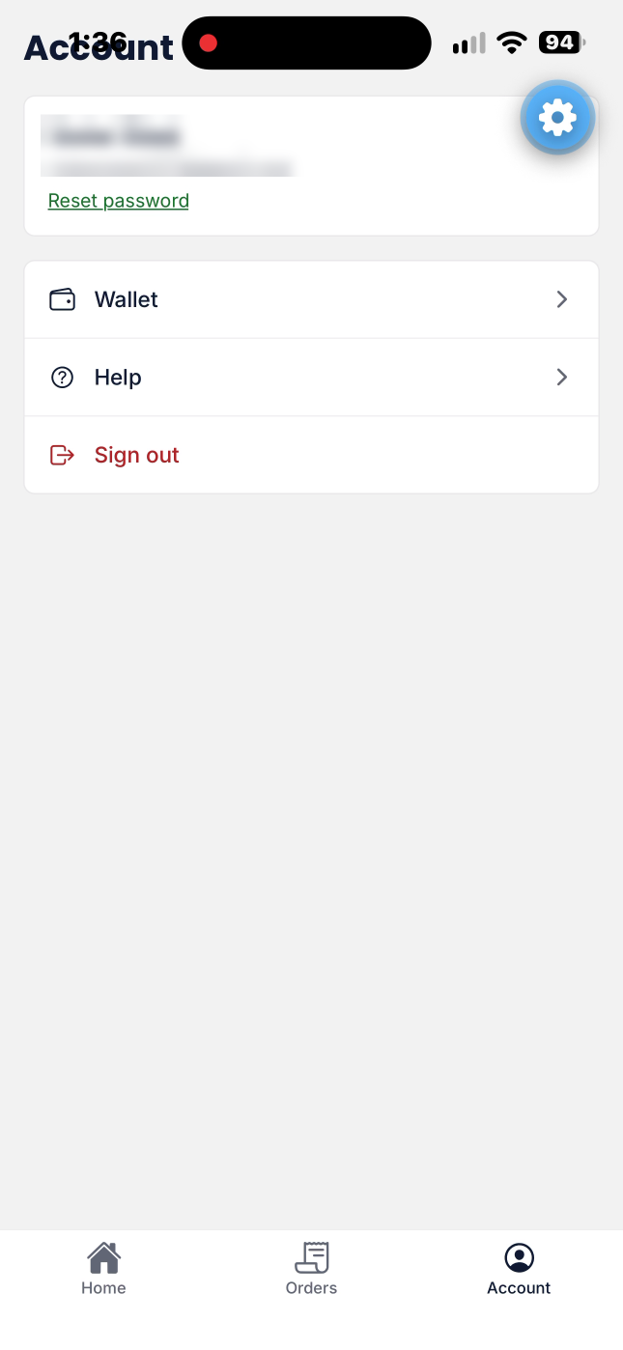
Screenshot — Account tab: your name and email (blurred here), Reset password, Wallet, Help and Sign out.

3.8 Where Things Moved From the Previous Build
If you used the app before this redesign, here's a quick map from old to new:
- Home, Cart, Checkout as separate always-visible nav links → Home is now a tab; Cart is a bottom sheet reached via the floating cart pill (see below) or the Checkout screen's back button; Checkout is reached from the cart.
- A single long checkout form → the same fields, now grouped into three tap-to-expand rows plus a separate contact-details block, with the submit button pinned to the bottom of the screen instead of scrolling with the form.
- Wallet and Help as their own reachable screens → both now live one tap deeper, under the Account tab.
- A plain order-status text line → the six-step order tracker described in §3.6, inside a full order detail screen.
One more piece of new chrome: whenever your cart has at least one item, a floating pill (“N items · View cart · ₹total”) appears above the tab bar on the Home and Store Detail screens — tapping it opens the cart bottom sheet directly. It's hidden on the Cart, Checkout, Account, and Orders screens themselves.

Chapter 4 — Delivery Partner App
The Delivery Partner App opens on a dashboard once you're signed in, mirroring the web delivery portal's dashboard, with a second History screen reached from a History link in the header. The header also shows your name with a Reset password link (same behavior as the Customer Account tab, see §3.7). The dashboard shows only active work: your active deliveries first, then orders available to accept.

4.1 Signing In
From the role picker, choose Delivery Partner and sign in with your delivery partner account's email and password.

4.2 Going Online and Offline
At the top of the dashboard is a large Online/Offline toggle. Tap it to switch status; while toggling, a loading indicator shows in place of the label. While you are Offline the Available orders section only says "Go online to see available orders."; you only see available orders, and only send location pings, while toggled Online.

4.3 Available Orders
The Available orders section lists orders that have reached Ready status and that no partner has accepted yet. Each card shows the store name and pickup address, the items in the order (with photos), the order amount, and an Accept button. To protect the customer's privacy, the customer's name, phone number and address are not shown here — the card says "Customer details appear after you accept." Tap Accept to take the order: it moves into Your active deliveries and is no longer visible to other partners. With nothing available the section says "None right now." The list refreshes automatically every 10 seconds while you're online. Note: when the n8n automation is running, a ready order is assigned automatically within about 10 seconds to the nearest online partner (by last-known location), so it usually appears straight under Your active deliveries instead of waiting here; the Available list only holds an order when no online partner has a location.
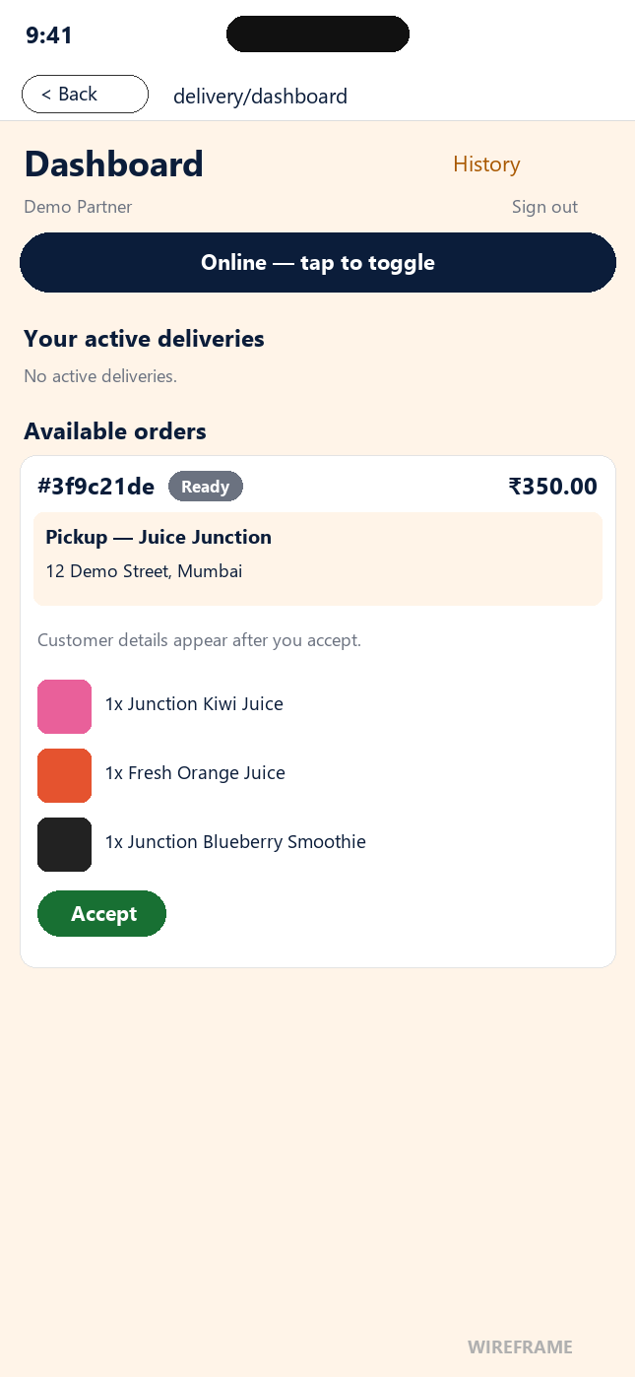
Wireframe — Delivery dashboard with an Available order card (pickup store and address, items, Accept). Drawn from the app's source with demo data: this card could not be captured on the phone because, in this build, a ready order is auto-assigned to a partner within seconds (see below).

4.4 Your Deliveries and Advancing Status
The Your active deliveries section lists the orders you have accepted that are not finished yet (status Partner assigned or On the way); with none it says "No active deliveries." Each card shows the order number, a status pill, the amount, the Pickup store and its address, the Drop-off details (see §4.5), and the items with photos. A single action button advances the order: Mark picked up while the order is Partner assigned. After you mark it picked up the order is On the way and the card shows "Customer is receiving the order…" in place of a button — there is no Mark delivered button. The customer's app plays a 15-second courier animation and then marks the order Delivered automatically (or the system does it 20 seconds after pickup if the customer never opens the order). There is no way to skip a step or move an order backward. A delivered order leaves this list and moves to History. (The first figure below shows an assigned delivery with the Mark picked up button; the second shows the same delivery after pickup.)
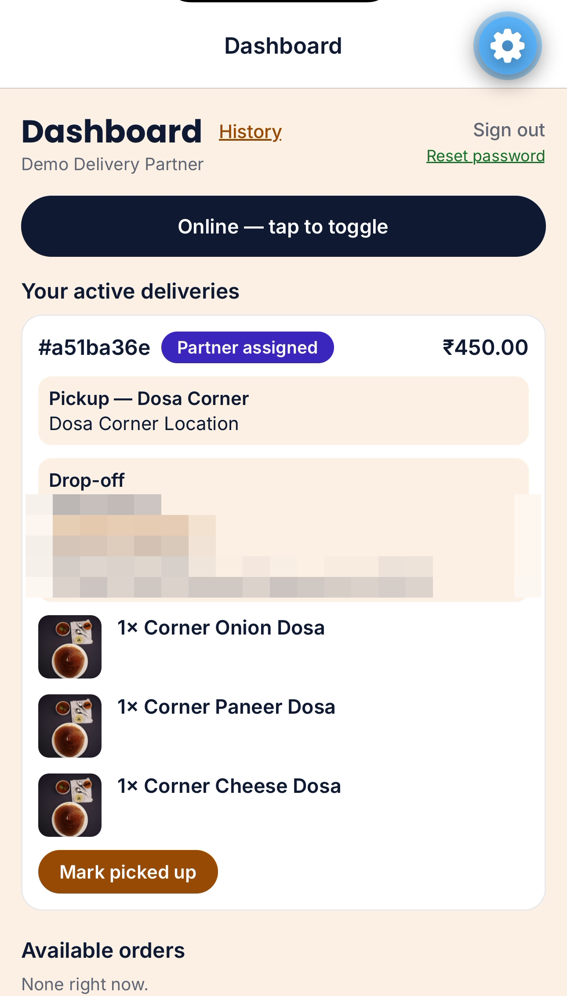
Screenshot — An assigned delivery on the partner dashboard, with the Mark picked up button. Drop-off details masked.

4.5 Drop-off Details and History
Once you have accepted an order, its active card shows the drop-off details: the recipient's name, their phone number (tap it to call when it is a normal +91 number), the full delivery address and the delivery note, if there is one. You can see a customer's phone and address only while the order is Partner assigned or On the way for you; the old View address button no longer exists because the details are shown directly on the card. This build has no Google Maps key configured, matching the Customer App's own coordinate-only tracking view.
The History link in the dashboard header opens the History screen: your finished orders, newest first, up to your 50 most recent. Each card shows the pickup store, who the order was delivered to, when it happened and a short summary of the items — no phone number or address is shown for finished orders. A Refresh button reloads the list and a Back to dashboard link returns you to the dashboard; with nothing finished yet it says "No completed deliveries yet."
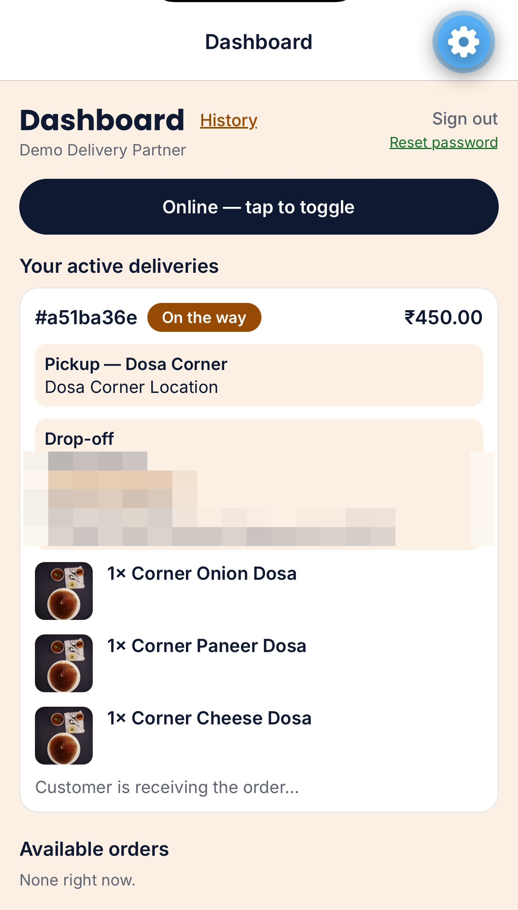
Screenshot — The active delivery after Mark picked up: status "On the way" and the note "Customer is receiving the order…". The partner has no further button; the customer's phone completes the delivery. Drop-off details masked.
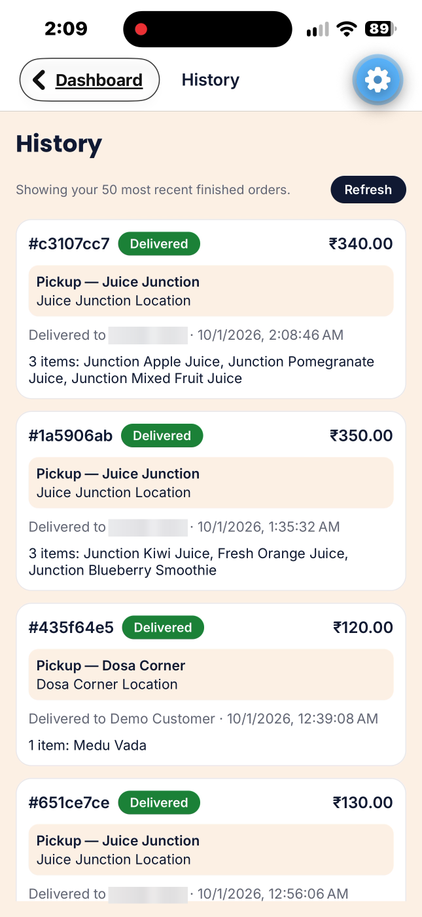
Screenshot — Delivery History screen: finished deliveries with pickup store, delivered-to name (blurred here), time and items summary.

4.6 Location Sharing
While you're toggled Online, the app asks for permission to use your device's foreground location and, once granted, sends a location ping to the server roughly every 15 seconds so the platform has a rough sense of where online partners are. This only happens while the app is open in the foreground and you're online — the app does not track or share your location in the background or while offline, and a missed ping (for example, if location is briefly unavailable) is not shown as an error; it's simply skipped until the next successful reading.

Chapter 5 — FAQ & Troubleshooting
These are the same questions shown on the Customer App's own Help screen (Account tab → Help), plus a couple of mobile-specific notes.
Question | Answer
How do I find restaurants or stores? | Use the search pill on Home, or tap a category chip. Home also shows a scrollable list of nearby open stores, plus an “Order again” row if you have order history.
How do I place an order? | Add items to your cart from a store's menu screen (configuring options first if the item has any), review the cart bottom sheet, then go to Checkout to enter contact details, delivery address, and a payment method.
Can I order from more than one restaurant at once? | No — a cart can only hold items from one store at a time. Adding an item from a different store prompts you to clear your current cart first.
How do I track my order? | After placing an order you land on its detail screen, which shows a six-step tracker (Placed, Accepted, Preparing, Ready, On the way, Delivered) with a "Step N of 6" caption, plus your items, delivery details and totals. It refreshes automatically every 3 seconds. You can also find current and past orders under the Orders tab.
How do I cancel an order? | Orders can only be cancelled by the store before they accept it, or automatically if payment fails. Once a store accepts an order, it can no longer be cancelled from the app.
What payment methods are supported? | This is a demo app — all payments are mocked. Choose Mock Card, Mock UPI, or Cash on Delivery at checkout; no real payment is ever processed and no real card or bank details are stored.
Why doesn't tapping the tip buttons in my cart change my total? | The tip selector is UI-only in this build — there's no backend column for it yet, so a selected tip is never added to your order. The cart screen says this directly under the selector.
Why does tapping Call or Message on my delivery partner just show a pop-up? | Those buttons on the courier card are demo stubs — there's no telephony or chat integration in this build. The pop-up is expected, not an error. (Your own phone number on the order, if it is a normal +91 number, is a real tap-to-call link.)
The app can't reach the server / nothing loads | This is a demo/development build that points at one specific server address (your development machine's LAN IP, set via EXPO_PUBLIC_API_BASE_URL — see section 2.5). If Home, Store Detail, or any other screen fails to load data, the development server is most likely not running, or the phone is not on the same Wi-Fi network as it — this is expected for a local/dev deployment, not a bug to work around in the field. Contact whoever set up your build to confirm the server address.
Does the app show my delivery partner's real-time location on a map? | No. This build has no Google Maps key configured, so both the Customer App and the Delivery Partner App use simple text/coordinate readouts instead of live map tiles or turn-by-turn tracking — matching the web app's current stub-level maps support.
Will I get an email about my order? | Yes. An email is sent to the email address you entered at checkout when the restaurant accepts your order and again when the order is delivered.
Why does checkout ask for my phone number? | A valid Indian 10-digit mobile number is required so the delivery partner can reach you. It is shown on your order and, to the delivery partner, only while your order is assigned to them or on the way.
What can a delivery partner see about me? | Partners who have not accepted your order see only the store, items and amount. After a partner accepts, they see your name, phone, address and delivery note until the order is delivered; finished orders in their History show only who it was delivered to.
How do I create an account? | On the Customer sign-in screen tap "Need an account? Sign up", enter your full name, email and a password of at least 6 characters, and tap Sign Up. You are signed in automatically. The same account also works on the web app. Delivery partner accounts cannot be created in the app — an administrator adds them.
Why did my order turn Delivered by itself? | Delivery partners only mark an order picked up. After pickup, your order screen plays a 15-second courier animation ("Arriving in 15s") and the order is then marked Delivered automatically, and the delivered email is sent. If you never open the order, the system marks it Delivered 20 seconds after pickup. See §3.6.1.

Chapter 6 — Ask Zippy

6.1 What Ask Zippy Is
Ask Zippy is the platform's built-in help assistant. You type a question in plain words and Zippy answers it in a chat sheet, so you do not have to leave your order or search the manual. It is available in both the Customer App and the Delivery Partner App.

6.2 Opening Zippy and Asking a Question
An orange Ask Zippy button (marked with a lightning bolt) floats near the bottom-right of the Customer App and Delivery Partner App screens. Tap it to open the chat sheet, which slides up over the screen, and tap the close button to dismiss it. A new chat opens with a short welcome message and three suggested questions; tap one or type your own and send it. The whole answer appears at once after a moment, and it ends with a short note naming the guide it came from.
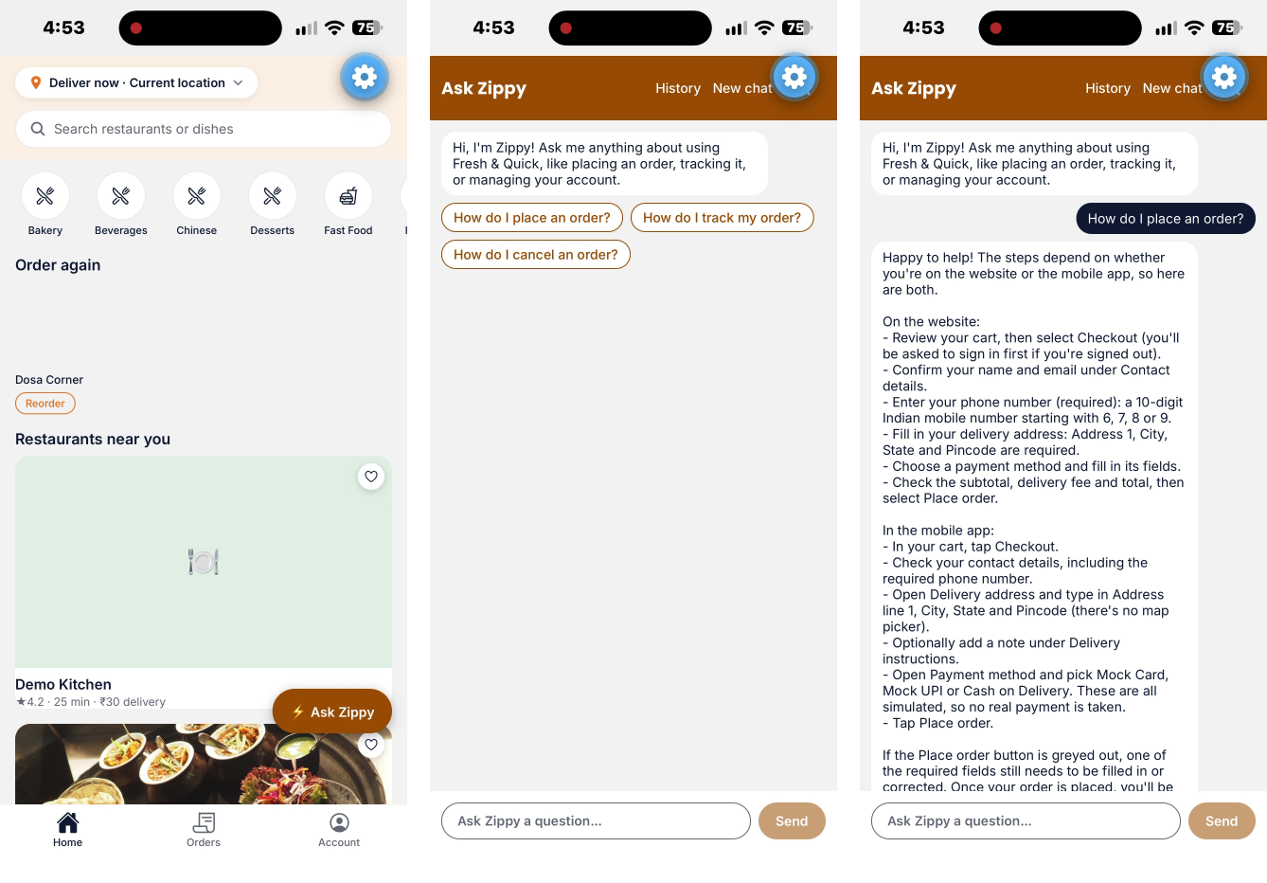
Screenshot — Ask Zippy in the Customer App: the button on the Home tab (left), a new chat with suggested questions (middle) and Zippy's answer to "How do I place an order?" (right).

6.3 Asking about stores and menus
Zippy can answer questions about stores and dishes using their current details. Examples: "Is Dosa Corner open right now?", "What does the Cheese Dosa cost?", "Which stores have free delivery?", "Which dishes have extra options?"
- Prices, delivery fees and open or closed status are looked up when you ask and can change at any time, so check them again in the cart and at checkout before you pay.
- The answer appears in one piece after Zippy has looked things up, not word by word, so a store question can take several seconds.
- The mobile app does not have a delivery location yet, so Zippy cannot sort stores by distance there. You can still ask about ratings, delivery fees and which stores are open.
- Zippy still cannot see or place orders, and it cannot pay for or change anything. For your orders, use the Orders tab or page.

6.4 Chats, History and New Chat
Tap New chat to start a fresh conversation. When you are signed in, your chats are saved and a history button lets you see earlier chats and continue one. History is shared with the website, so a chat started there can be continued on your phone and the other way round.

6.5 What it can and cannot do
Zippy answers how-to questions about using Fresh & Quick, such as placing an order, tracking it, what each order status means, payments, and managing your account. It answers from the platform's own guides and says which guide the answer came from. Zippy is role-aware: a customer is shown customer guides, and a vendor, delivery partner or admin is shown the guides for their own portal.
Zippy can look up stores, dishes, prices, options and whether a store is open, using their current details (see the section on asking about stores and menus). It still cannot see your orders. It cannot place, change, cancel or pay for an order, and it never acts on your behalf. If the guides do not cover a question, Zippy says so instead of guessing.

6.6 Limits, privacy and support
- Each question can be up to 1,000 characters.
- Signed-in users can send up to 20 questions per minute and 100 per day. Visitors are limited to 10 per minute and 40 per day. If you go over, Zippy asks you to wait a moment.
- Your questions are sent to Anthropic (Claude) and OpenAI to produce the answer. Do not type passwords or card numbers into the chat.
- Under the platform's policy, orders and saved Zippy chats may be deleted after 30 days. Deletion is not automatic, so to have your data deleted, or for a problem Zippy cannot solve, contact support at vishalshah1973@gmail.com or +919820020000.

Appendix A — Order Status Reference
Every order moves through a fixed status chain. The table below lists every possible status, the label shown in the app, and the step of the six-step tracker it maps to (Placed 1, Accepted 2, Preparing 3, Ready 4, On the way 5, Delivered 6). This applies identically to orders viewed in the Customer App and the Delivery Partner App, since both read the same underlying order record, and the status colors match the web portals.
Status | Meaning
placed (label: Placed) | Tracker step 1 of 6. The customer has submitted the order and payment is being resolved; waiting for the restaurant.
accepted (label: Accepted) | Tracker step 2 of 6. The store has accepted the order and will begin preparing it.
preparing (label: Preparing) | Tracker step 3 of 6. The store is actively preparing the order.
ready (label: Ready) | Tracker step 4 of 6. The order is ready for pickup; it now appears in online delivery partners' Available orders list (or is assigned automatically within seconds when the automation is running).
assigned (label: Partner assigned) | Tracker step 5 of 6. A delivery partner has accepted the order and is on the way to the store.
picked_up (label: On the way) | Tracker step 5 of 6. The delivery partner has collected the order and is on the way to the customer. The customer's order screen then plays a 15-second courier animation, after which the order becomes Delivered automatically.
delivered (label: Delivered) | Tracker step 6 of 6. The order has been handed to the customer. Final state. It is set by the customer's app after the animation (or by the system 20 seconds after pickup); delivery partners cannot set it.
cancelled (label: Cancelled) | No tracker step; a red banner is shown instead. The order was cancelled, for example because payment failed. Final state.
rejected (label: Rejected) | No tracker step; a red banner is shown instead. The restaurant rejected the order and payment is refunded. Final state.

