Fresh & Quick
Usage Guide
Food Delivery Web Platform — Customer, Vendor, Delivery Partner & Admin

1. What This Application Is
Fresh & Quick is a food delivery web platform, similar in spirit to apps like DoorDash or Uber Eats. It lets a customer browse nearby restaurants and other local stores, order items, and track delivery — while separate areas of the same site let a vendor manage its store's menu and orders, a delivery partner manage deliveries, and an admin oversee the whole platform.
The site has four separate portals, each with its own login:
- Customer app — browse, order, pay, and track deliveries across restaurants and every other marketplace category.
- Vendor portal — store owners manage menu/catalog, orders, and availability from a sidebar-navigated dashboard.
- Delivery portal — delivery partners accept and fulfil deliveries from a two-column dashboard.
- Admin portal — platform staff oversee restaurants, delivery partners, and orders from a tabbed dashboard.

2. Customer App

2.1 Home Page
The home page is the starting point for every customer. It shows:
- A left-hand sidebar for jumping straight to a category: Restaurants, Grocery, Convenience, Alcohol, Health, Retail, Pet, Flowers, Baby, Personal Care, and Electronics.
- A search bar to find restaurants or cuisines by name.
- Quick filters: Rating, Delivery fee, and "Under 30 min".
- A sort dropdown (Distance, Rating, Delivery fee, Prep time).
- Cuisine category chips (Bakery, Chinese, Indian, Italian, etc.) for one-tap filtering.
- Store sections such as "Popular near you" and "Quick delivery", mixing restaurants with grocery, pet, beauty, and other category stores.
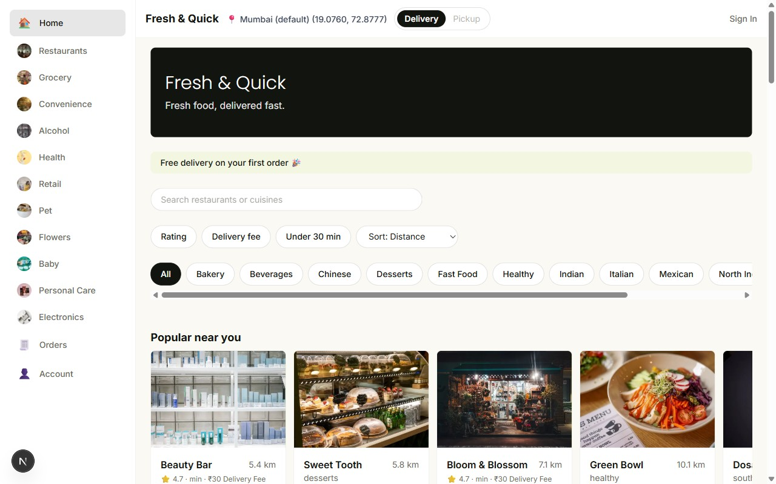
Home page — sidebar categories, search, filters, and a mixed feed of restaurants and other stores

2.2 Restaurant / Store Page
Tapping any store card opens its menu page, showing the store name, tags, rating, estimated prep time, a menu search box, category filter buttons, and the list of items with price and a + button to add each one to the cart.
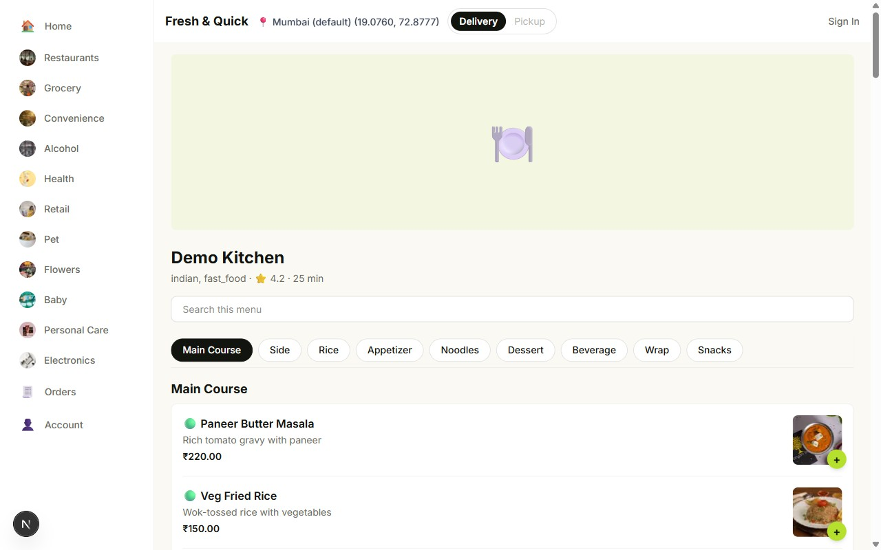
Restaurant page — menu items grouped by category, with an Add (+) button for each dish

2.3 Non-Restaurant Categories
The same browse-and-add flow now covers ten non-restaurant categories as well — grocery, convenience, alcohol, health, retail, pet, flowers, baby, personal care, and electronics. Each category store has its own catalog page laid out the same way as a restaurant's menu.
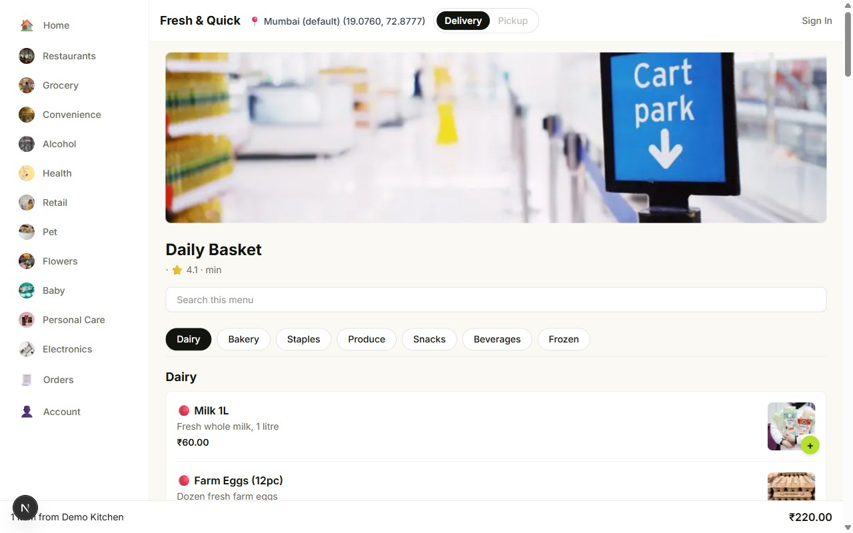
Daily Basket (Grocery) — a non-restaurant category store's browse page

2.4 Cart
Adding an item shows a floating cart bar at the bottom of the screen with the item count, store name, and running total. Tapping it opens the cart panel, which lists every item with quantity controls, a note field, and the subtotal, before proceeding to checkout.
- The cart can only hold items from one store at a time — adding an item from a different store prompts to clear the current cart first.
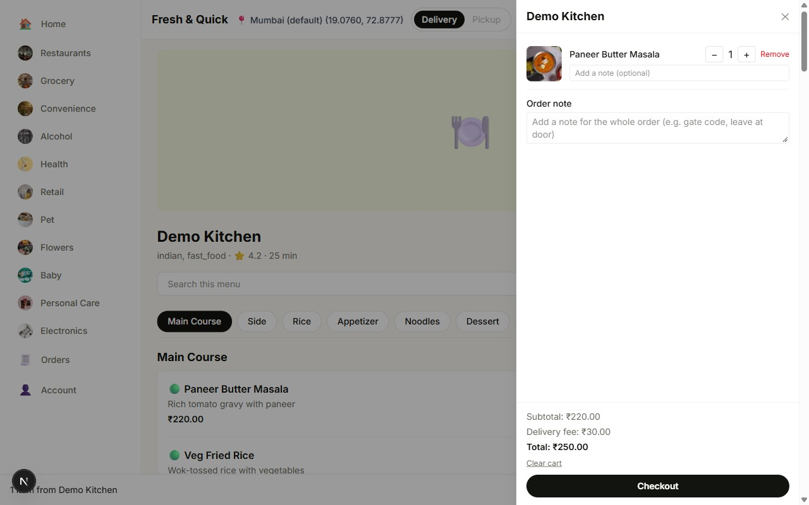
Cart panel — items, quantities, order note, and subtotal

2.5 Checkout
The checkout page collects the delivery address, shows an order summary with line items, delivery fee, and total (all amounts calculated precisely, down to the paisa), and lets the customer place the order. Checkout requires signing in first — an unauthenticated customer is redirected to the login page and returned to checkout after signing in.
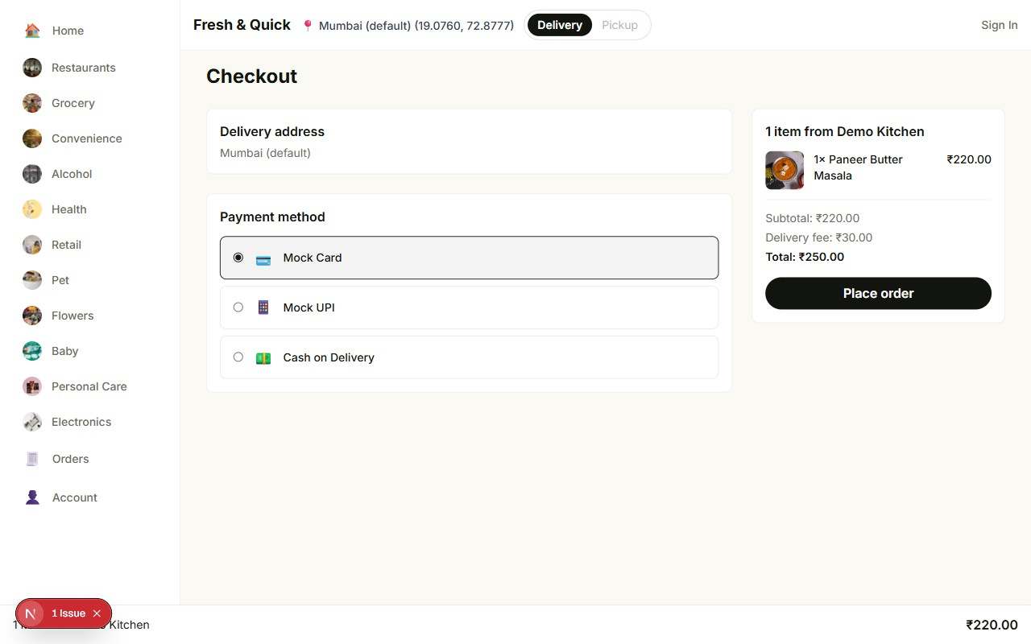
Checkout page — order summary and delivery details

2.6 Sign In / Account
Orders, Account, and Checkout all require signing in. The login page accepts a registered email and password; new customers can register from the same screen.
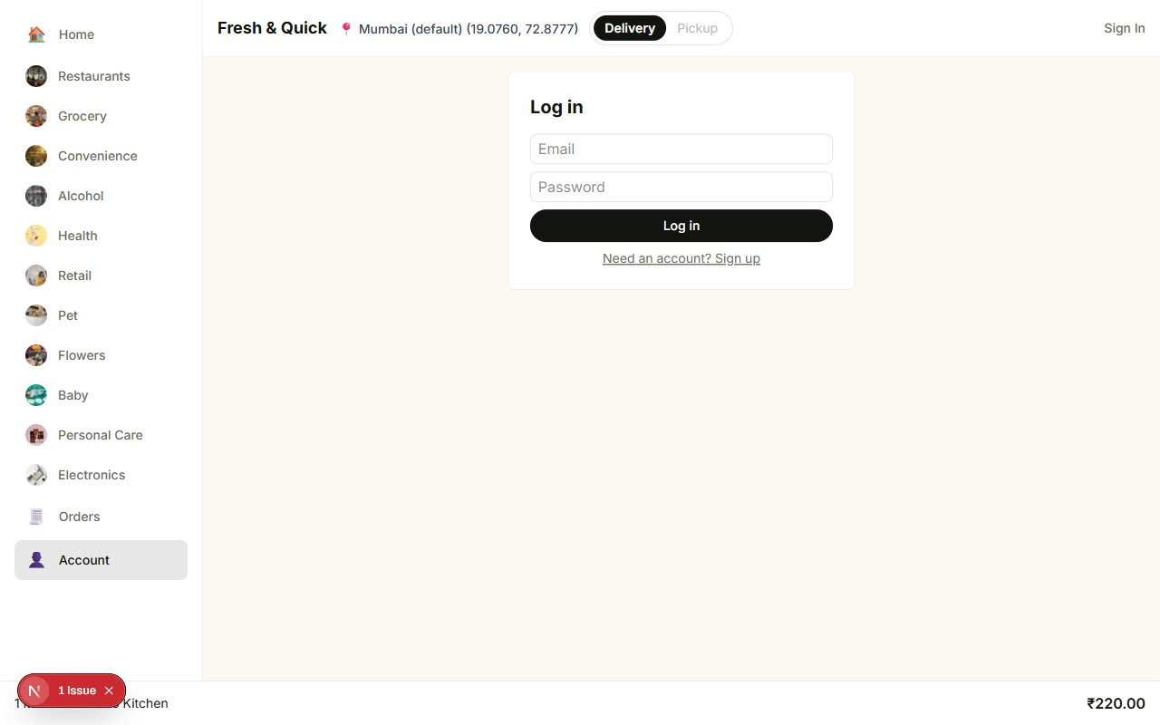
Customer sign-in page
Once signed in, customers can view past and active orders (with live status: placed, accepted, preparing, out for delivery, delivered) and manage saved delivery addresses under Account.

3. Vendor Portal (Store Owners)
Store owners — whether a restaurant or any other marketplace category — sign in separately at the vendor portal to manage their own store. The login page itself has no sidebar; it is a plain centered form.
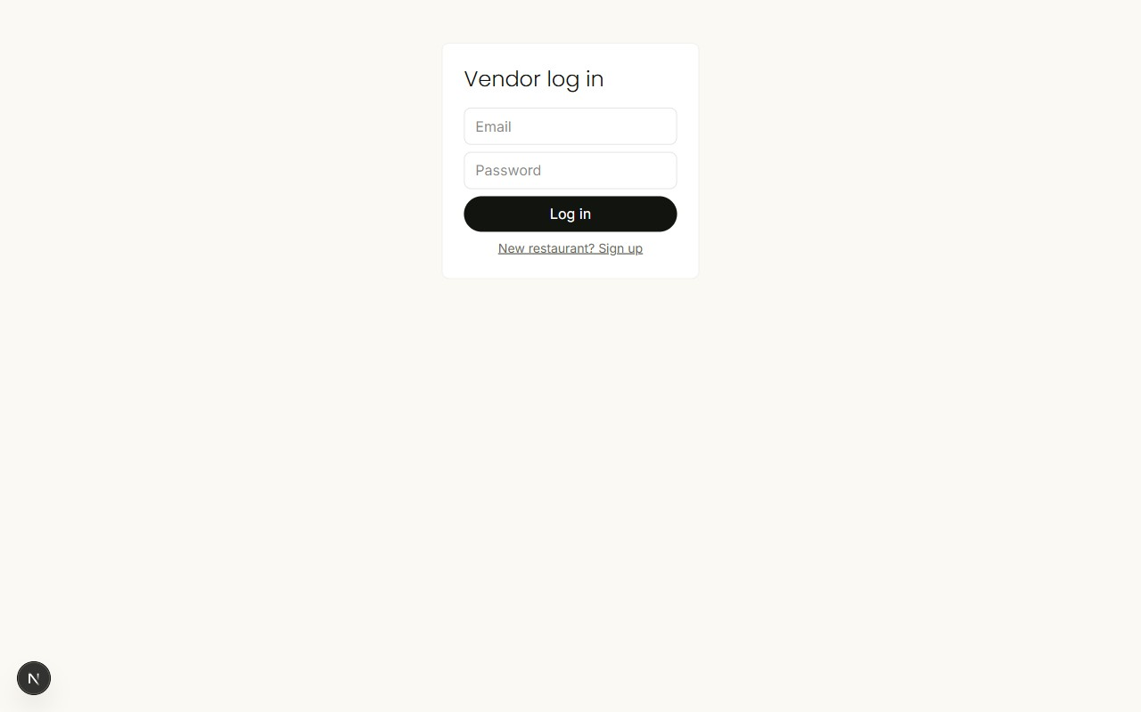
Vendor sign-in page (no sidebar)
After signing in, the vendor portal switches to a persistent left sidebar (Dashboard, Menu, Orders, plus an open/closed status pill and Sign out) with the working area on the right:
- Dashboard — restaurant status (Open/Closed, with a Close/Open restaurant toggle) and a delivery settings card for editing the delivery fee and promo text.
- Menu — a form to add a new item (name, price, image URL) above a table of every existing item, each row showing its image, name, price, veg/non-veg tag, availability, and Edit / Mark unavailable / Delete / Options actions.
- Orders — incoming orders, shown as a table the vendor works through as each one moves through its status chain (accepted → preparing → ready → out for delivery → delivered); when there are no orders yet it simply reads "No orders yet."
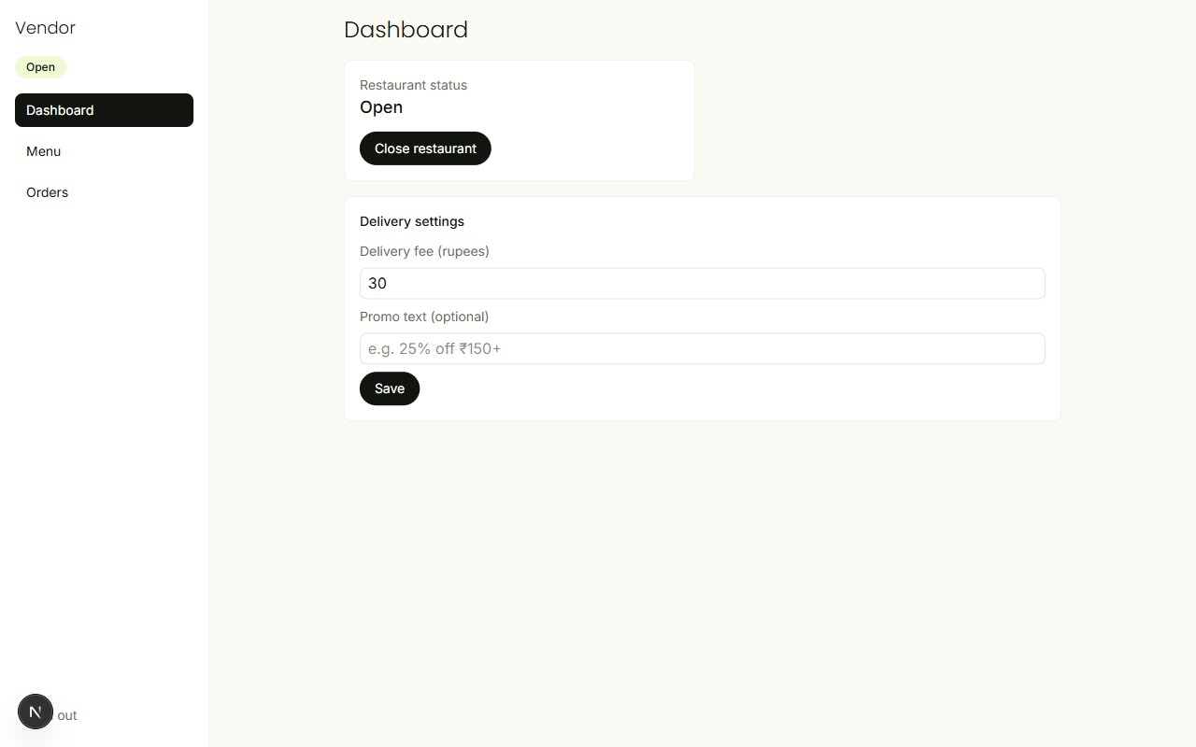
Vendor dashboard — restaurant status and delivery settings
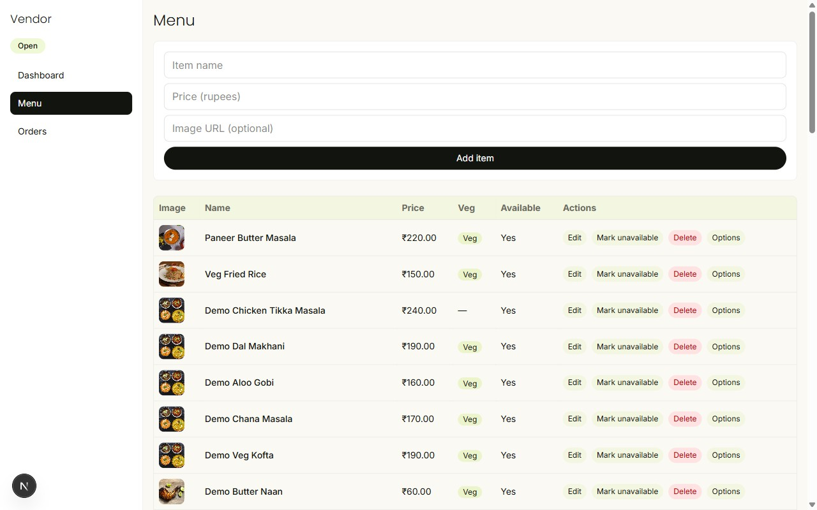
Vendor menu page — add-item form above the full menu table
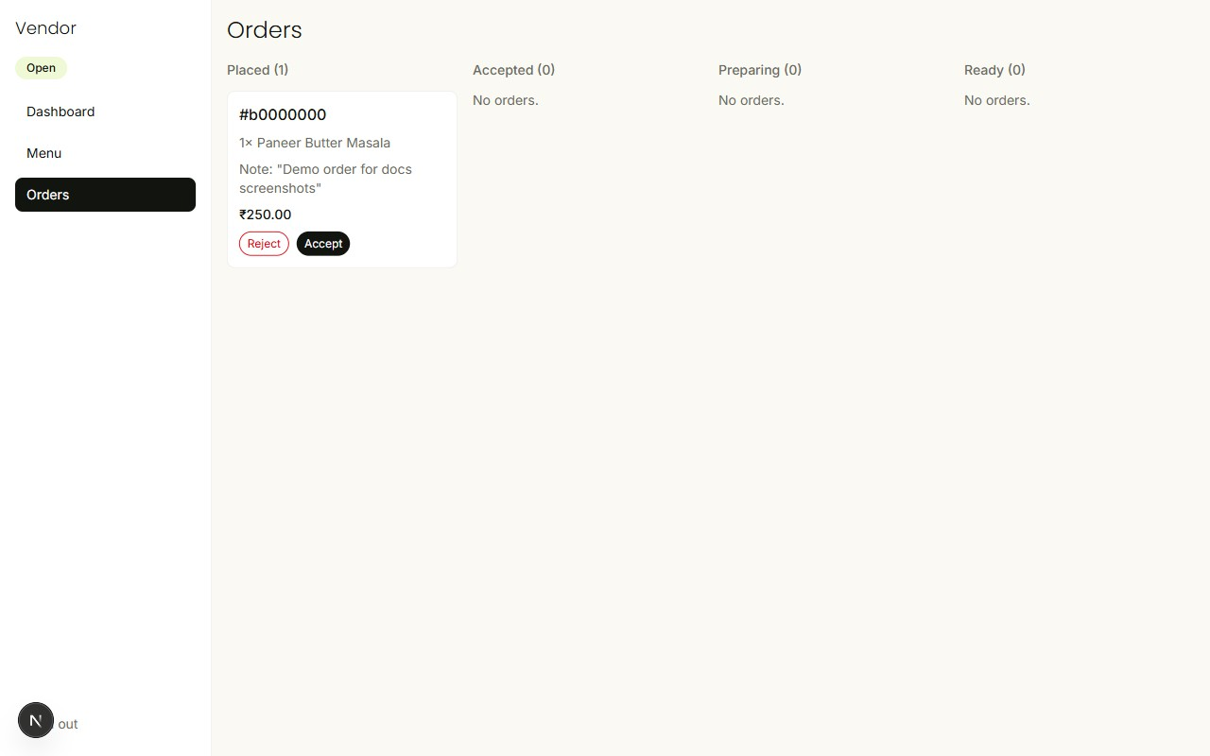
Vendor orders page — kanban board showing an incoming order in the Placed column

4. Delivery Partner Portal
Delivery partners sign in at the delivery portal to see and fulfil deliveries assigned to them.
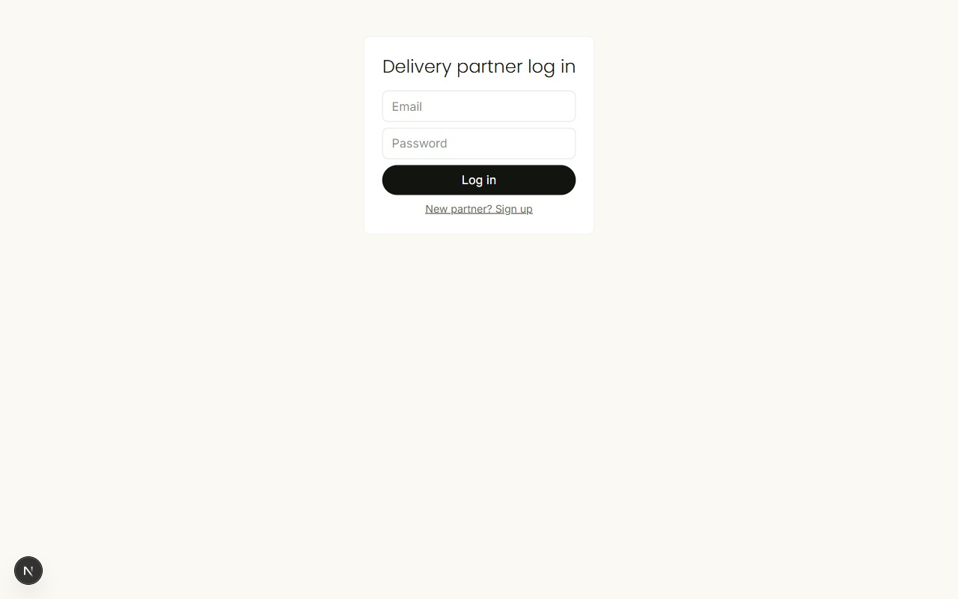
Delivery partner sign-in page
After signing in, a top bar shows the partner's online/offline status and a Sign out link, and the dashboard below it is split into two columns:
- An Online/Offline toggle button plus two manual latitude/longitude fields used as a stand-in for live GPS in this local environment.
- Available orders (left column) — orders waiting for a delivery partner to accept, visible once the partner is online.
- Your deliveries (right column) — the partner's own accepted, in-progress, and completed deliveries.
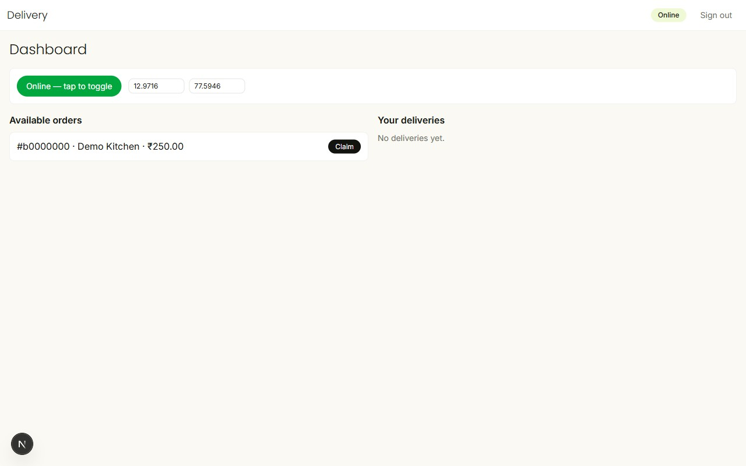
Delivery dashboard — online toggle and location fields, with a ready-to-claim order shown in the Available orders column

5. Admin Portal
Platform administrators sign in at the admin portal for oversight of the whole platform.
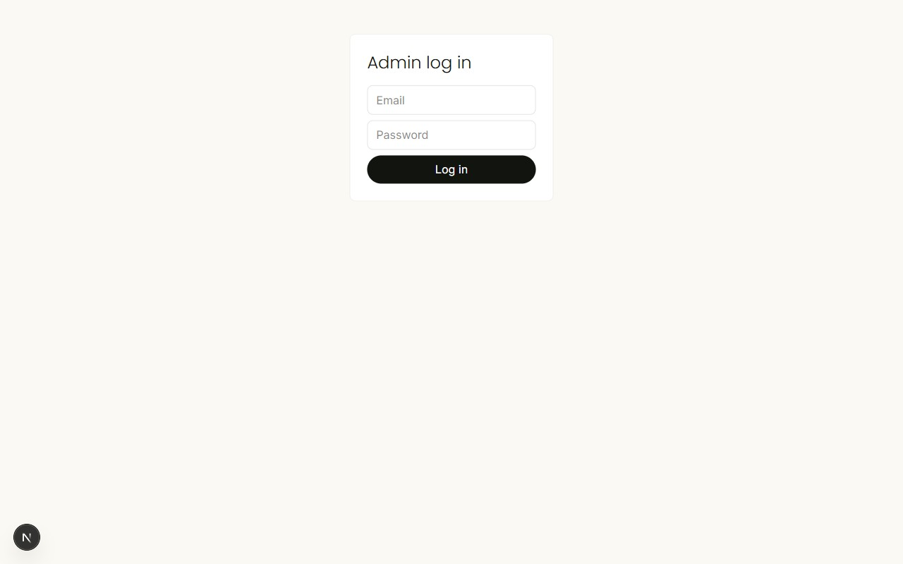
Admin sign-in page
After signing in, a top bar reads "Admin" with a Sign out link, and the dashboard below is a single tabbed table:
- Orders tab — every order on the platform with its restaurant, status, total, and a reassign action.
- Restaurants tab — every store (57 in the current seed data, spanning all marketplace categories) with its open/suspended status and a Suspend action.
- Delivery partners tab — every delivery partner account and its status.
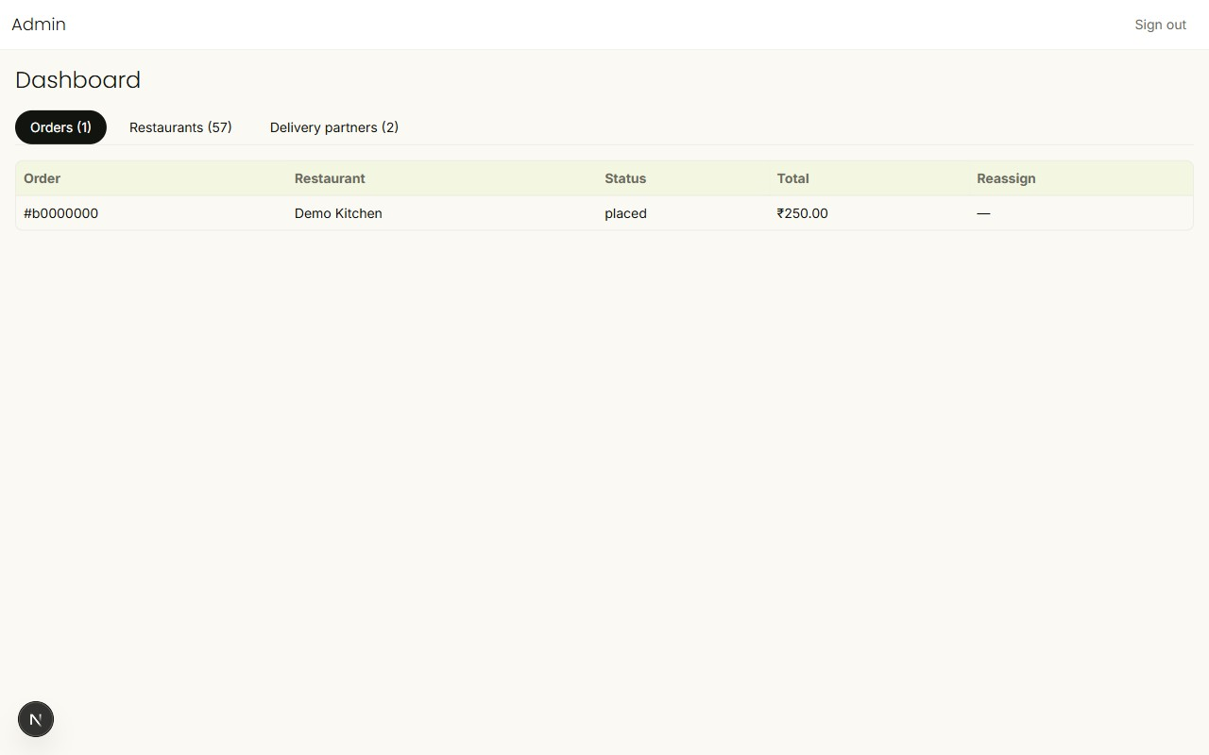
Admin dashboard — Orders tab listing a real order with its restaurant, status, and total
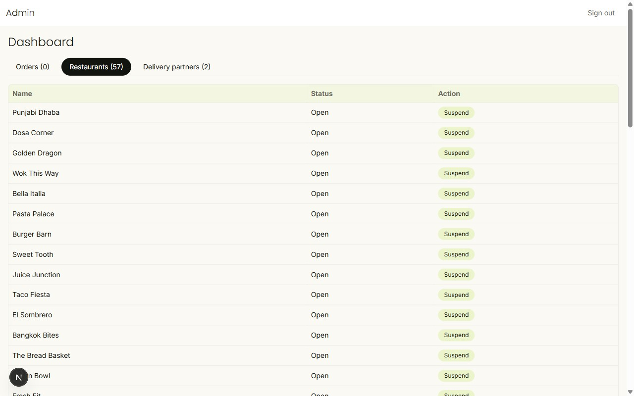
Admin dashboard — Restaurants tab, listing every seeded store with a Suspend action

6. Typical Customer Journey (Step by Step)
1. Open the site — it lands on the Home page, showing nearby restaurants and stores, with a category sidebar on the left.
2. Search or filter by cuisine, category, rating, delivery fee, or prep time — or tap a cuisine chip or sidebar category.
3. Tap a restaurant or store card to open its menu/catalog.
4. Tap + on an item to add it to the cart. The floating cart bar appears at the bottom.
5. Tap the cart bar to review items, adjust quantities, or add a note.
6. Proceed to Checkout, sign in if prompted, confirm the delivery address, and review the order summary and total.
7. Place the order.
8. Track the order's status from the Orders tab as it moves from placed to delivered.

7. Notes for Readers of This Guide
- All prices are shown in Indian Rupees (₹) and are calculated to the exact paisa — no rounding errors.
- The four portals (Customer, Vendor, Delivery, Admin) are fully separate — a login on one does not grant access to another.
- The marketplace now spans 11 categories (restaurants plus grocery, convenience, alcohol, health, retail, pet, flowers, baby, personal care, and electronics) across 57 seeded stores — see UserList.docx for the full account list.
- The vendor, delivery, and admin portals shown in this guide reflect the current sidebar / top-bar / tabbed-table redesign, not the earlier bare-list layout.
- Screenshots of the vendor, admin, and delivery Orders views in this guide show a single demo order seeded specifically to illustrate those screens with real data — the seed data otherwise starts with zero orders, and the same kanban/table layouts populate the same way as further real orders come in.
- Screenshots in this guide were captured from a local development instance of the site and may differ slightly in restaurant/store names or numbers from the live site.

