FRESH & QUICK
USER MANUAL

Technical Reference & User Guide for Customer, Vendor, Delivery Partner & Admin Portals
Version 3.5 – Ask Zippy can take you to checkout
4 October 2026

Table of Contents
Chapter 1 — Introduction & System Overview 3
Chapter 2 — Getting Started 6
Chapter 3 — Customer Module 7
Chapter 4 — Vendor Module 20
Chapter 5 — Delivery Partner Module 26
Chapter 6 — Admin Module 30
Chapter 7 — Cross-Cutting Features 35
Chapter 8 — Ask Zippy 38
Appendix A — Technical Architecture & Stack 41
Appendix B — Database Schema Reference 43
Appendix C — Seeded Test Accounts 45
Appendix D — Glossary of Terms 49

Chapter 1 — Introduction & System Overview
Fresh & Quick is a full-stack, multi-portal food and local-goods delivery platform, built as a functional, from-scratch clone of the delivery-app experience popularised by apps like DoorDash and Uber Eats. It is not a single application but four cooperating web portals that share one Next.js codebase and one Postgres database, each portal gated to its own role so that a login on one portal never grants access to another.
The platform's marketplace has grown beyond restaurants: as of this manual, 77 seeded stores span 11 categories — Restaurants plus Grocery, Convenience, Alcohol, Health, Retail, Pet, Flowers, Baby, Personal Care and Electronics — all browsable, orderable and trackable through the same customer experience.

1.1 The Four Portals
- Customer App ("/customer") — anonymous browsing of every store and category, cart management, checkout with contact details (including a required phone number) and a choice of payment method, and an Orders list with a full order detail page and six-step tracker.
- Vendor Portal ("/vendor") — store owners (restaurants and every other marketplace category) manage their menu/catalog, open or close their store, set delivery fee and promo text, and work incoming orders through a colour-coded kanban board that shows who each order is for, with a Full details view.
- Delivery Partner Portal ("/delivery") — delivery partners go online, accept ready orders and mark them picked up, using the full pickup and drop-off details on each card, with a History of finished deliveries and a live location ping. The customer's own order page then completes the delivery (see section 3.5.1).
- Admin Portal ("/admin") — platform staff see every order and open its full detail, add vendors and delivery partners, suspend a misbehaving store, and reassign a stuck delivery to a different partner.
Each portal is reachable at its own top-level path and has its own dedicated sign-in page; the platform enforces this separation both in the UI (separate login forms, separate navigation shells) and at the data layer (Postgres row-level security policies scoped to each role, plus service-role-only write paths for anything security-sensitive).

1.2 How the System Fits Together
All four portals are pages within one Next.js application. Every data-changing action goes through a Next.js API route running on the server, which uses a privileged "service role" Supabase key to talk to Postgres — this key never reaches the browser. Reads that are safe for a signed-in user's own browser to perform directly (e.g. browsing restaurants, viewing your own orders) go through Supabase's auto-generated REST layer (PostgREST) protected by row-level security policies, so that even a technically savvy customer cannot read or write another customer's data by crafting their own request.
A separate automation layer, n8n, listens for events such as an order being placed and drives cross-portal side effects — resolving a mock payment, notifying the vendor, emailing the customer when an order is accepted and when it is delivered, and so on — by calling a small set of internal API routes ("/api/internal/*") protected by a shared secret header. If n8n is not running, the same checkout still works: the checkout route falls back to resolving payment itself after a short wait, so the demo experience never depends on n8n being present.
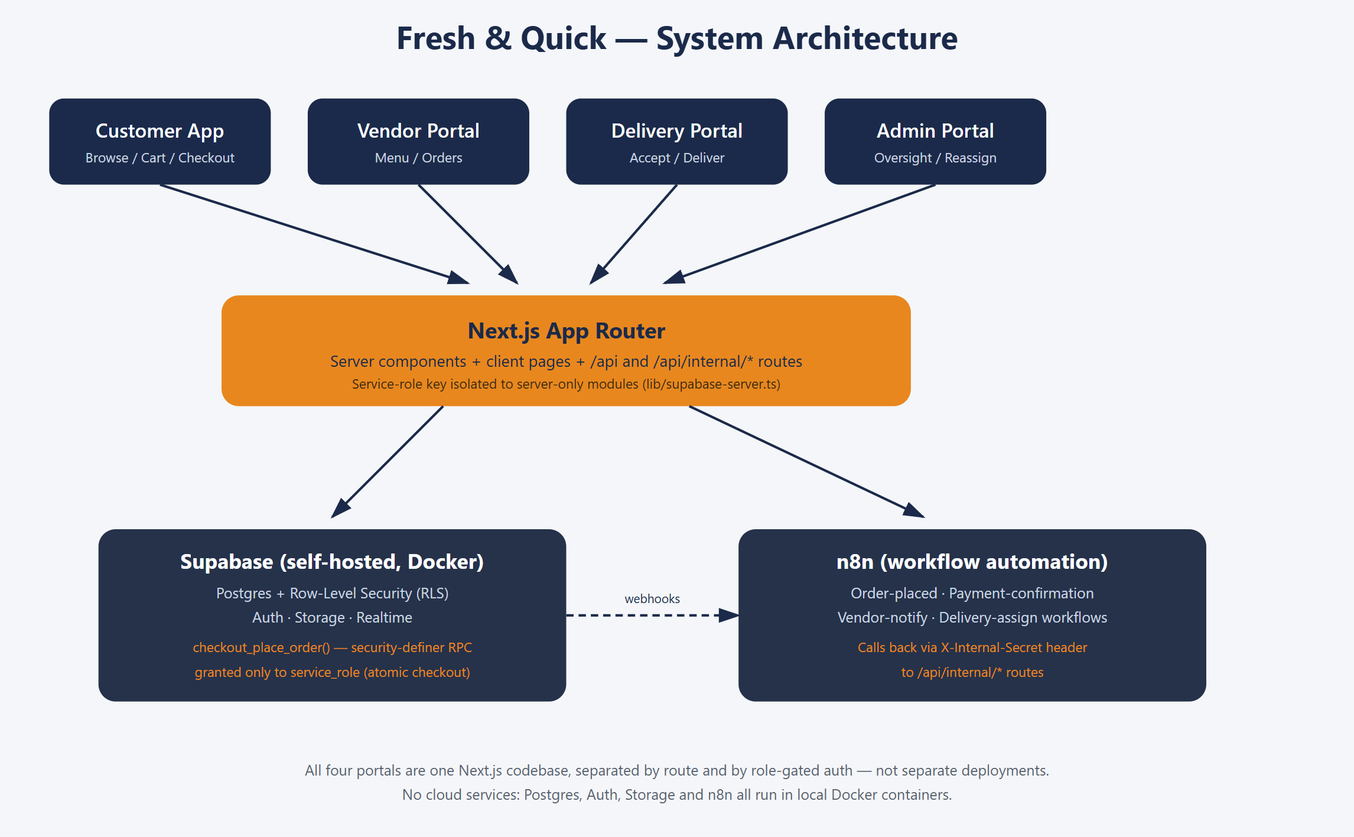
Figure 1.1 — System architecture: four portals, one Next.js codebase, Supabase Postgres with row-level security, and an n8n automation layer reachable via internal webhooks.

1.3 Who This Manual Is For
This manual is written for two audiences at once: (1) anyone actually using the platform — a customer placing orders, a restaurant or store owner managing their menu, a delivery partner fulfilling orders, or platform staff running the admin console — and (2) a technical reader who wants to understand how the system is built, summarised in the Technical Appendix at the end of this manual.

1.4 What's New in Version 3.5
Version 3.5 adds a Go to checkout card to Ask Zippy: when you ask Zippy to check out, it shows a card that opens the Checkout page for your current cart (section 8.4); you still enter your details and pay yourself, and Zippy never places or pays for an order. Version 3.4 added cart changes to Ask Zippy: a signed-in customer can ask Zippy to add a dish, repeat a past order, change a quantity, remove a line or empty the cart, and confirm each change with a card (section 8.4). Version 3.3 shortens the automatic fallback: if the customer never opens the order, the system now completes the delivery 20 seconds after pickup (it was 5 minutes), and the customer does not need the order page open for delivery to complete; the "Delivered! Enjoy your meal." card no longer has a Done button and closes itself after 3 seconds (section 3.5.1). Version 3.2 added one clarification: the courier animation always plays, whatever the browser's reduced-motion setting (section 3.5.1). Version 3.1 changed how a delivery is completed (first item below). The other items were added in version 3.0, whose screenshots this edition keeps:
- Customer-completed delivery (new in 3.1): delivery partners no longer press Mark delivered; they only press Mark picked up. The customer's order page then plays a 15-second courier animation ("Your order is on the way!", counting down "Arriving in 15s") and the order becomes Delivered automatically, which also sends the delivered email. If the customer never opens the order, the system completes the delivery 20 seconds after pickup. After pickup the partner's card shows "Customer is receiving the order…" in place of a button. See sections 3.5.1 and 5.1.
- Phone number at checkout: Checkout now has a required Phone field under Contact details (an Indian 10-digit mobile number starting with 6 to 9; an optional +91, 91 or 0 prefix is accepted). It is stored as +91XXXXXXXXXX and shown to the vendor and, once an order is assigned, to the delivery partner.
- Orders list and order detail: the sidebar Orders link opens your list of orders (store, date, status, item thumbnails and total). Opening an order shows a six-step tracker (Placed, Accepted, Preparing, Ready, On the way, Delivered), the deliver-to details, the items with photos, totals, payment and a timeline. The status wording is now Partner assigned and On the way instead of a single Out for delivery.
- Delivered email: when an order is delivered, a confirmation email goes to the email address entered at checkout (subject "Your order from <store> has been delivered") listing the items, totals and where it was delivered. The order-accepted email goes to the same address.
- Vendor Orders board: larger type and colour-coded New, Accepted, Preparing and Ready columns; every card shows who the order is for, phone, payment, address, items with photos and any delivery note, and Full details opens the complete order. The board refreshes every 10 seconds.
- Delivery partner Dashboard and History: the Dashboard now shows active work only, with the pickup store and address, the recipient name, tap-to-call phone and address, and the items on each card; available orders show the customer only after you press Accept (the old View address button and the Claim wording are gone). A new History page lists finished deliveries.
- Admin portal: the old tabbed page is replaced by a sidebar with Overview (summary tiles), Orders (table with a status filter), an order detail page with a Reassign control, Vendors (with Add vendor) and Delivery Partners (with Add delivery partner). The admin types a temporary password (minimum 6 characters) and shares it with the new account holder.
- Carried over from version 2.0: the orange / navy / green look with pill-shaped buttons; every browser starts signed out after the server restarts; My Profile with a Reset password link in every portal; your delivery location is remembered between visits; and the delivery and admin portals use the same left-sidebar layout as the vendor portal.

Chapter 2 — Getting Started

2.1 Local Environment Prerequisites
Fresh & Quick runs entirely on infrastructure you control — there is no cloud/hosted Supabase project and no external database. To run it locally you need:
- Node.js 20 or newer
- Docker Desktop, running, before you start the stack (Supabase's local stack and the optional n8n container both run as Docker containers)

2.2 Starting the Application
1. npm install — installs the Next.js application's dependencies.
2. npx supabase start — starts local Postgres, Auth, Storage and Realtime in Docker containers.
3. Copy the API URL and anon key that step 2 prints into .env.local (see .env.example for the exact variable names).
4. npm run app:seed — applies every database migration and loads the seed data (77 stores, 80 test accounts, menu items, and cuisine taxonomy).
5. npm run dev — starts the Next.js application at http://localhost:3000, which redirects to the customer app by default.
For a production-style build and start (matching how the app is actually deployed) rather than the hot-reloading dev server, use npm run app:build followed by npm run app:start; both are also available as npm run app:stop to shut everything down together.
Signing in after a restart: because the app treats every server start as a fresh session, you will be signed out of every portal the first time you open it after running npm run app:start (or restarting npm run dev). Simply sign in again.

2.3 URLs at a Glance
Portal | URL | Notes
Customer app | http://localhost:3000/customer | No login needed to browse
Vendor portal | http://localhost:3000/vendor/login | Store owners
Delivery portal | http://localhost:3000/delivery/login | Delivery partners
Admin portal | http://localhost:3000/admin/login | Platform staff, no self-signup
Supabase Studio | http://localhost:54323 | Database admin UI

2.4 Test Accounts
The seed data includes one demo account per role, ready to sign in with immediately — see Appendix C for the complete account list, including every seeded restaurant and non-restaurant store's own vendor login. New customer, vendor and delivery-partner accounts can also be created at any time from each portal's own "Sign up" toggle; admin accounts are seeded only, since the platform has no admin self-registration flow by design.

2.5 Testing Multiple Roles at Once (Multi-Port Mode)
By default the app runs entirely on http://localhost:3000, with each portal distinguished only by its login path (/customer, /vendor/login, /delivery/login, /admin/login). Because all four portals share that one origin, and a browser's sign-in session is stored per-origin, logging into a second portal in another tab on the same port silently replaces the session of whichever role was signed in first — fine for testing one role at a time, but not for having a customer, vendor, delivery partner, and admin all signed in simultaneously to watch an order move through the whole system.
For that, start the app in multi-port mode instead: npm run app:start:all-roles (or .\scripts\start.ps1 -Dev -AllRoles) runs the same application four times, one per port, so each portal is its own browser origin with its own independent session:
Role | URL (multi-port mode)
Customer | http://localhost:3000/customer
Vendor | http://localhost:3001/vendor/login
Delivery Partner | http://localhost:3002/delivery/login
Admin | http://localhost:3003/admin/login
All four can be open in tabs of the same ordinary browser window at once, with no Incognito windows or separate browser profiles needed. Use npm run app:start:dev when you only need one role at a time; use app:start:all-roles when you want to watch an order cross from customer to vendor to delivery to admin live. npm run app:stop (or app:stop:all-roles) shuts down whichever mode is running.

Chapter 3 — Customer Module
The customer app is the storefront: browsing, cart, checkout, and order tracking. Browsing every store and category requires no account at all; an account is required only once you try to check out, so that guest browsing is always frictionless.

3.1 Home Page
The home page is a DoorDash-style layout with a persistent left sidebar, a header with an address picker and a Delivery/Pickup toggle (Pickup is a disabled placeholder — no pickup flow exists in this version), and a body that mixes restaurants with every other store category into cuisine- and category-grouped horizontal carousels.
- Left sidebar — one-tap jumps to Home, Restaurants, and each of the ten non-restaurant categories (Grocery, Convenience, Alcohol, Health, Retail, Pet, Flowers, Baby, Personal Care, Electronics), plus Orders and Account.
- Header search box — finds restaurants or stores by name or cuisine/category label.
- Quick filters — Rating, Delivery fee, and "Under 30 min", plus a sort dropdown (Distance, Rating, Delivery fee, Prep time).
- Cuisine category chips — one-tap filtering by cuisine (Bakery, Chinese, Indian, Italian, and more).
- Store carousels — sections such as "Popular near you" and "Quick delivery" mix restaurants with grocery, pet, beauty and every other category by default; each carousel shows left/right scroll arrows once there is more content than fits on screen.
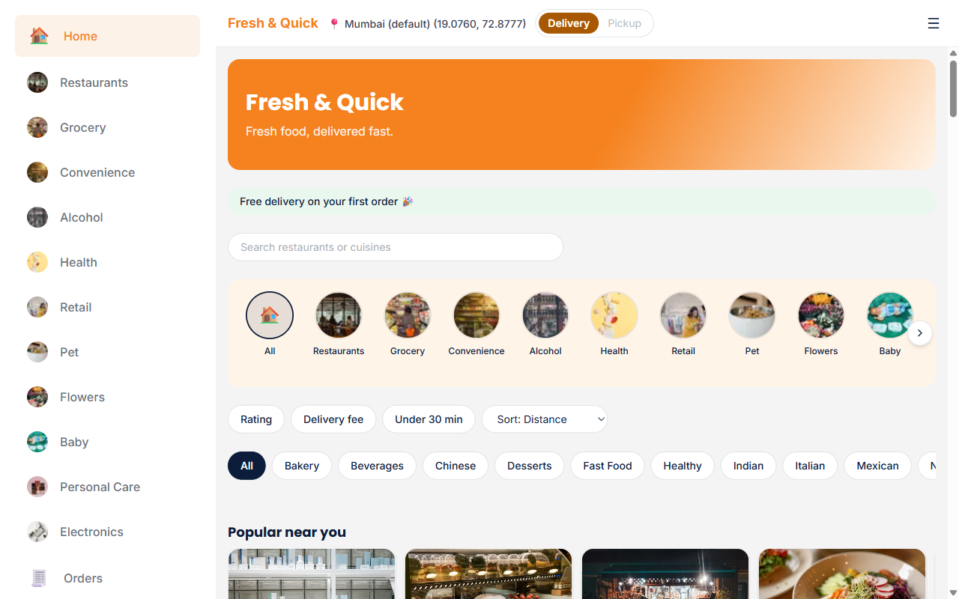
Figure 3.1 — Customer home page: sidebar categories, header search and delivery toggle, and a mixed feed of restaurants and other stores.

Step by step: finding something to order
1. Open http://localhost:3000/customer — it lands on the home page.
2. Either tap a category in the left sidebar, tap a cuisine chip, type into the search box, or simply scroll the curated carousels.
3. Tap any store card to open that store's full menu or catalog page.

3.2 Restaurant & Store Pages
Every store — whether a restaurant or a grocery, pet, electronics, or any other category store — uses the same browse-and-add layout: a banner, the store's name, cuisine/category tags, rating and estimated prep time, a menu search box, a real-rating summary block, a horizontal “Featured items” carousel (the first available items with a photo), category filter pills, and the full item catalog laid out as a 4-column grid of cards (2 columns on narrow screens), grouped by category. Each item card shows its photo, name, description, price, a veg/non-veg indicator dot for food items, and a circular “+” button that adds one unit to the cart.
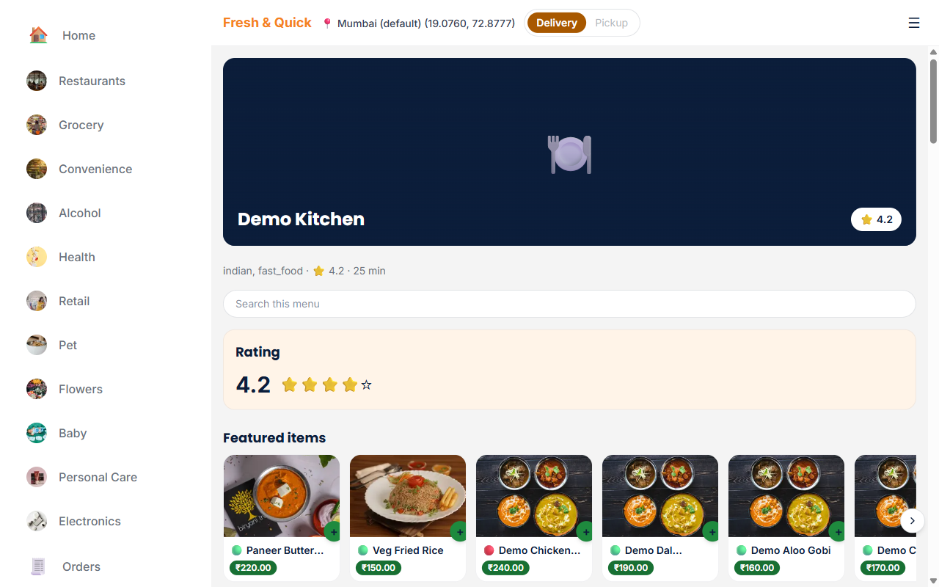
Figure 3.2 — Demo Kitchen's store page: the store rating, a Featured items carousel, category pills, and the item catalog as a card grid, with the persistent cart panel on the right once an item has been added.
Ten non-restaurant categories use the identical catalog layout, so everything explained above for a restaurant menu applies equally to a grocery, pet-supply, or electronics store's catalog page.
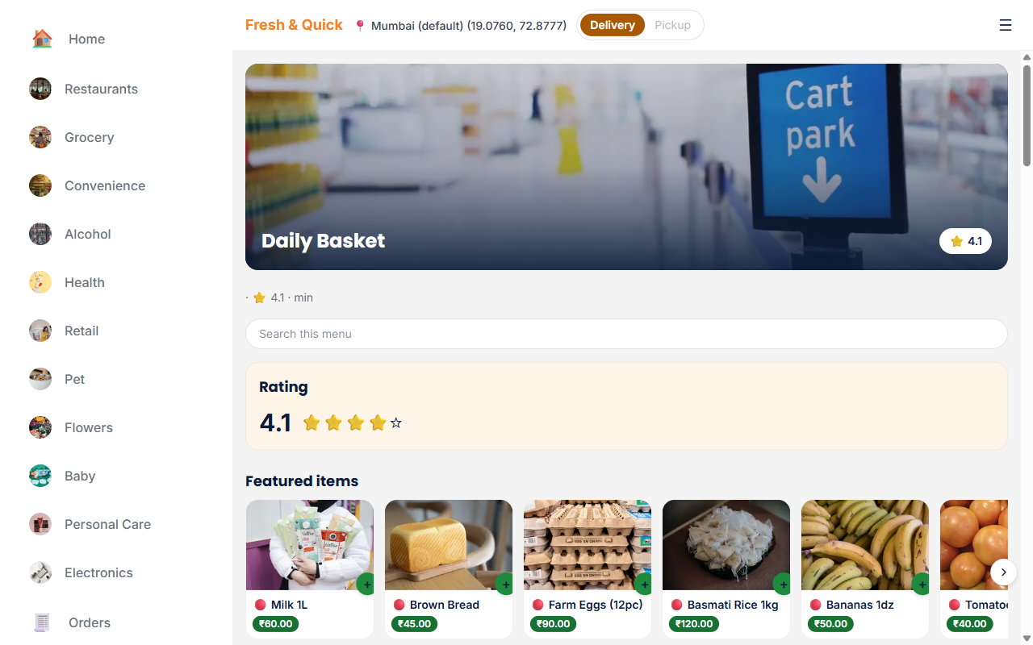
Figure 3.3 — Daily Basket, a Grocery-category store, browsed with the exact same rating/featured-items/grid layout as a restaurant menu.
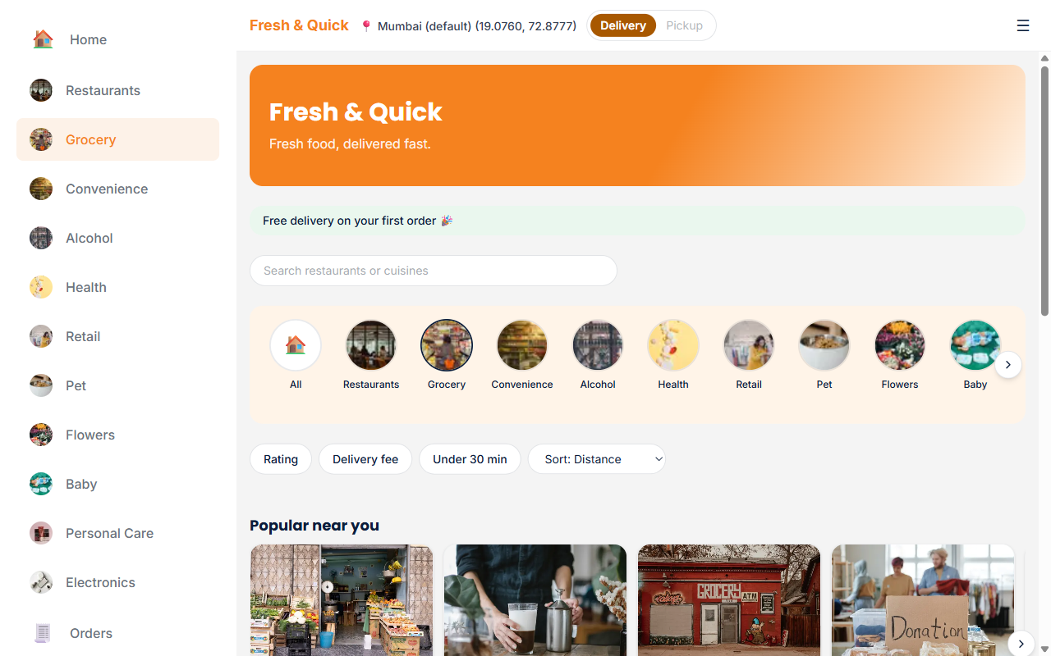
Figure 3.4 — The home page filtered to the Grocery category via the sidebar, showing every seeded grocery store.

3.3 Cart
The cart is single-store only by design: adding an item from a different store than the one already in your cart prompts you to clear the cart first, rather than silently mixing items from two different stores into one order. On a store's own page, the cart appears as a persistent panel docked to the right of the menu, listing every item with quantity +/- controls, a per-item note field, a Remove link, the running subtotal and delivery fee, and a whole-order note field separate from any per-item notes.
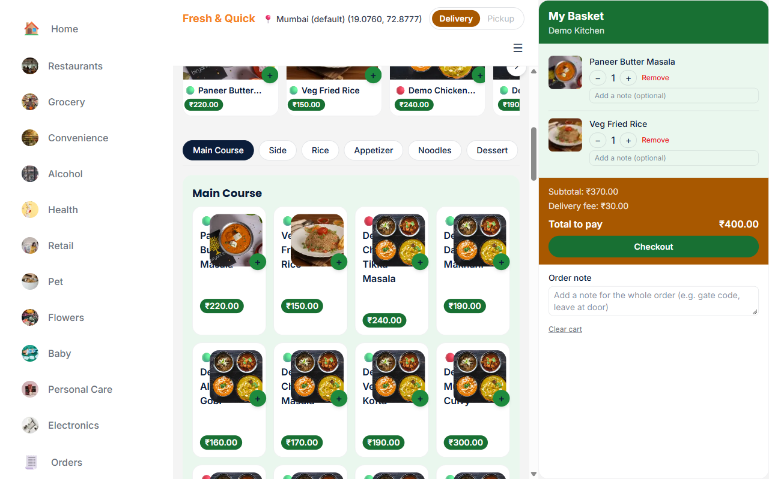
Figure 3.5 — The cart panel with an item added: quantity control, per-item note, subtotal/delivery-fee/total breakdown, and the whole-order note field.
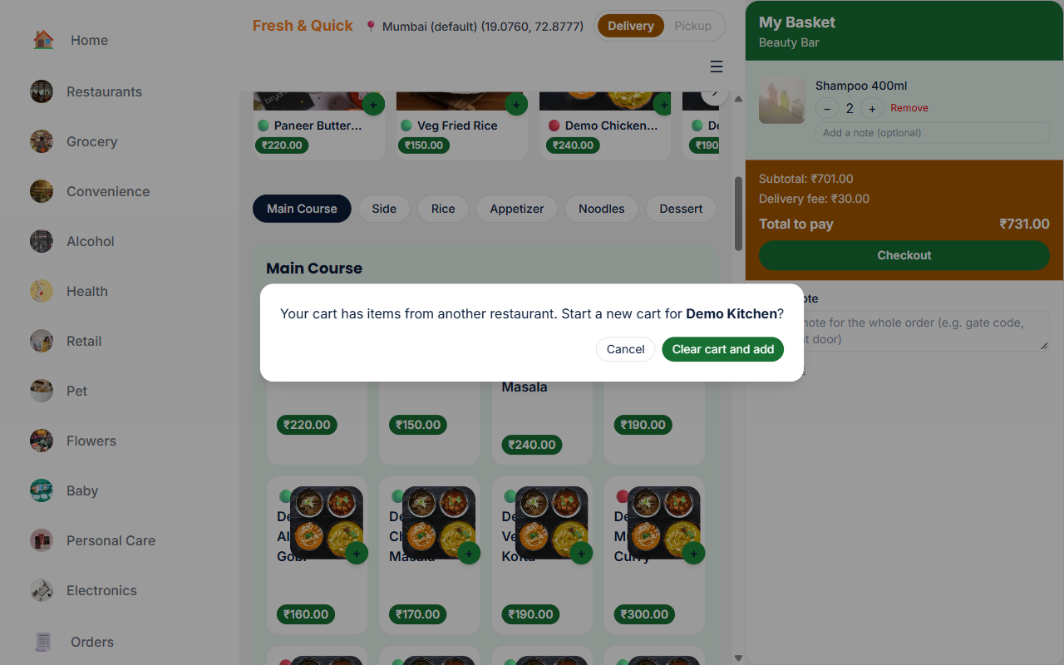
Figure 3.5a — Adding an item from a different restaurant asks whether to start a new cart: a cart can only hold items from one store at a time.

Step by step: building an order
1. On a store's page, tap the + button next to each item you want.
2. Use the − / + controls in the cart panel to adjust quantity, or Remove to drop an item.
3. Optionally add a per-item note (e.g. "no onions") or a whole-order note (e.g. a gate code or "leave at door").
4. Review the subtotal, delivery fee and total, then select Checkout.

3.4 Checkout
Checkout is a single page: contact details, delivery address, and payment method stacked in one column on the left. The persistent cart panel on the right — the same panel visible on every store page — shows the order summary and the single Place Order button for the whole app; checkout no longer shows a second, separate order-summary card. Reaching checkout while signed out redirects you to the login page and returns you to checkout automatically once you sign in.
The checkout page collects three things before it will let you place an order:
- Contact details — a recipient name, email and a required Phone (an Indian 10-digit mobile number starting with 6 to 9; a +91, 91 or 0 prefix is optional and is stored as +91XXXXXXXXXX). The email receives the order-accepted and order-delivered emails; the phone is shown to the vendor and, once a delivery partner is assigned, to that partner.
- Delivery address — a real form: Address 1, Address 2 (optional), City, State, and Pincode, all required except Address 2. Saved locally so it's pre-filled on your next order.
- Payment method — Mock Card, Mock UPI, or Cash on Delivery, each with its own required fields.
The Place Order button stays disabled (greyed out) until every required field (including a valid Phone) and every field for the selected payment method validates — this prevents an incomplete or malformed order from ever reaching the server.
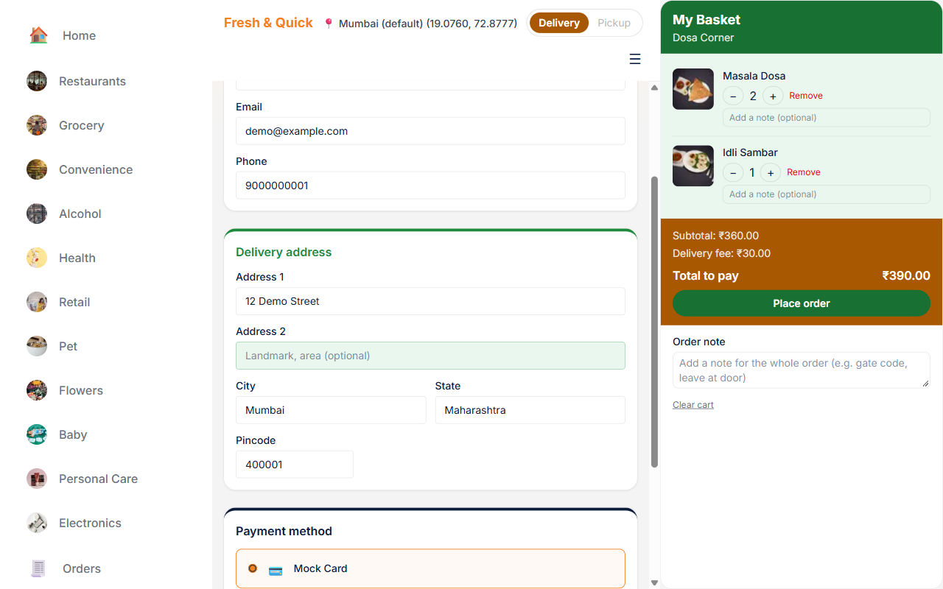
Figure 3.6 — Checkout with Mock Card selected: Contact details (name, email and Phone), the Address 1/2/City/State/Pincode delivery address form, card number/expiry/cardholder-name fields, and the persistent cart panel's order summary and Place Order button on the right.
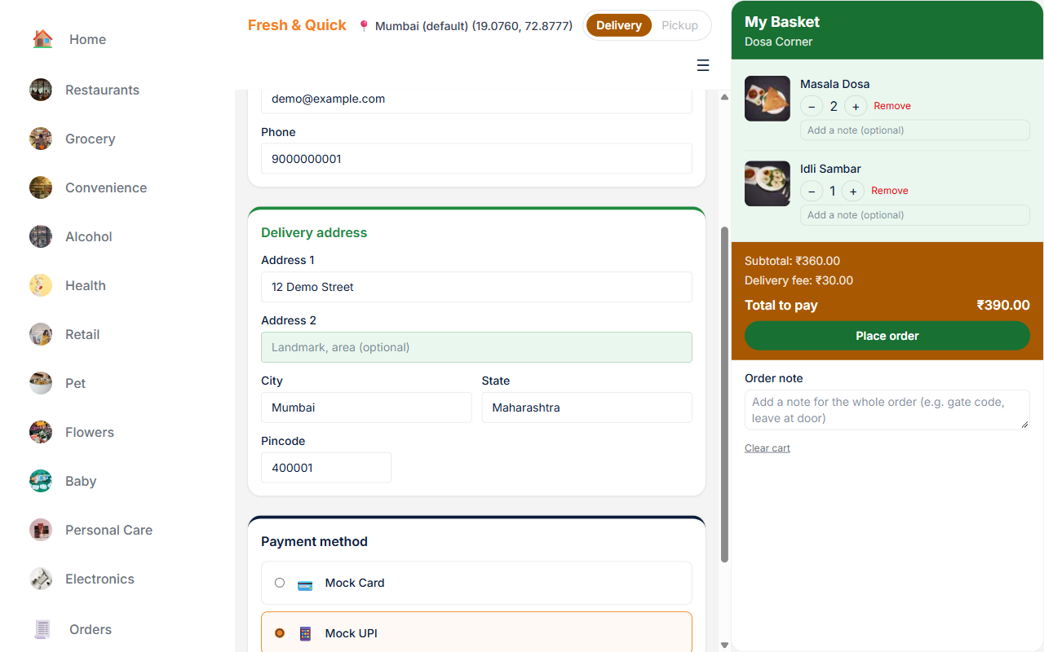
Figure 3.7 — Checkout with Mock UPI selected, showing the UPI ID field that replaces the card fields; the delivery address form stays the same regardless of payment method.
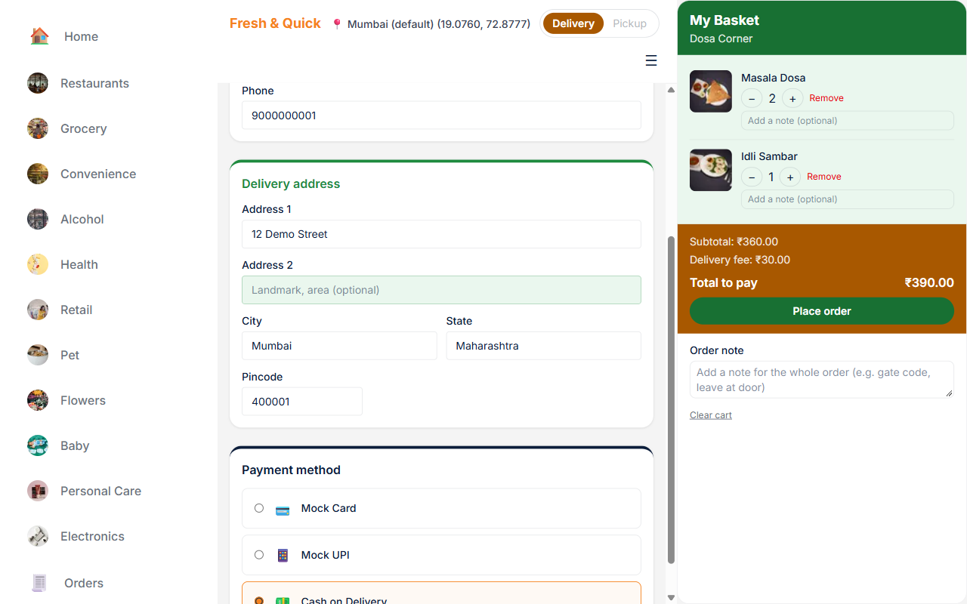
Figure 3.7a — Checkout with Cash on Delivery selected: the required Phone field under Contact details, the delivery address form, and the order summary on the right. No extra fields are needed for Cash on Delivery.

Payment methods explained
- Mock Card — requires a 16-digit card number, an MM/YY expiry, and a cardholder name. Resolves to success or failure at random, roughly an 80% success rate, to simulate a real payment gateway.
- Mock UPI — requires a UPI ID (e.g. name@bank). Same ~80% success/failure simulation as Mock Card.
- Cash on Delivery — no extra fields required, and always succeeds immediately, since payment happens in person at delivery.
All prices throughout the platform are calculated and stored to the exact paisa (1/100 of a rupee) using integer arithmetic, never floating-point multiplication — this avoids the rounding errors that plain JavaScript float math would otherwise introduce into money calculations.
Placing an order is processed atomically on the server: the order row, its line items, and the payment record are all created together through a single database transaction (a Postgres function reserved for the server's own privileged connection), so a partial failure midway through checkout cannot leave a half-created order behind. If a local n8n automation instance is running, it resolves the mock payment within a few seconds; if not, the checkout route itself waits out a ~10-second timeout and then resolves the payment in-process, so every order completes correctly either way — just faster with n8n connected.

Step by step: completing checkout
1. Fill in or confirm your recipient name and email under Contact details.
2. Enter your Phone number (required): a 10-digit Indian mobile number, with or without +91, 91 or 0 in front.
3. Choose a payment method and fill in its required fields.
4. Review the order summary — line items, subtotal, delivery fee, and total — on the right.
5. Select Place Order once the button is enabled.
6. Wait for payment to resolve; you are then taken to the order's detail page.

3.5 Orders, Order Detail & Tracking
After a successful checkout, the customer lands on that order's detail page. At the top is a six-step tracker — Placed, Accepted, Preparing, Ready, On the way, Delivered — with a one-line description of the current step. Once a delivery partner accepts the order its status reads Partner assigned, and once the partner has picked it up it reads On the way (these two labels replace the single "Out for delivery" status of earlier versions). A rejected or cancelled order shows a red banner in place of the tracker. Once a partner is assigned, a bordered coordinate box shows their last reported location in place of a live map (no Google Maps key is configured in this environment, so this is a readable stand-in rather than an interactive map).
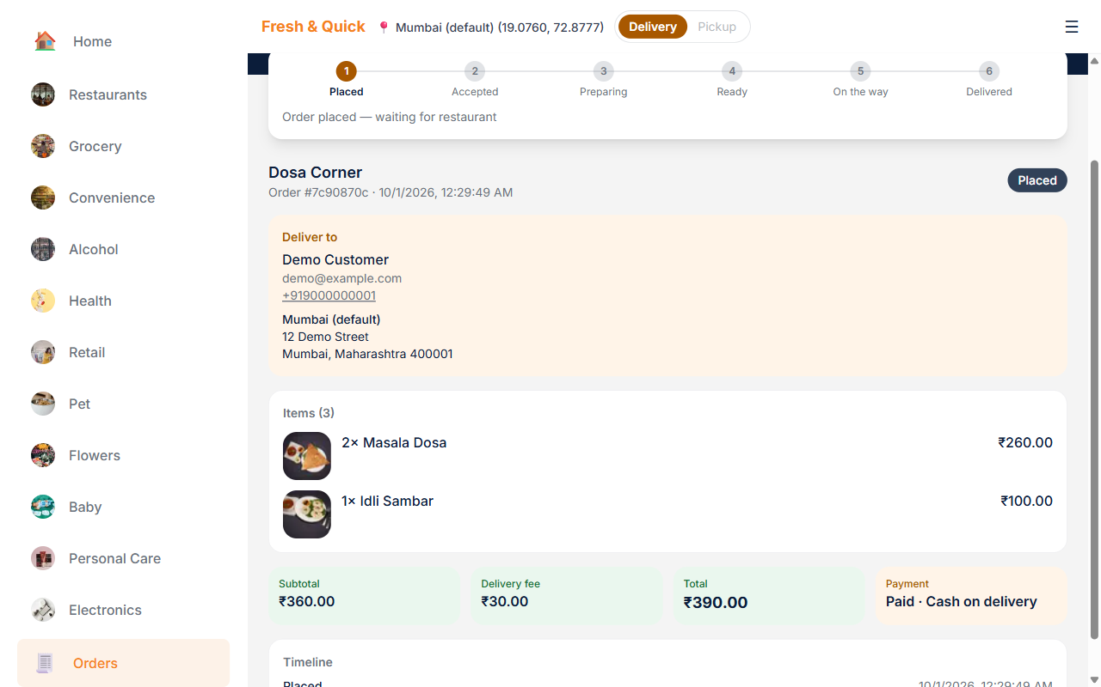
Figure 3.8 — Order detail page for a freshly placed Cash on Delivery order: the six-step tracker at Placed, the deliver-to card, the order's items with photos, and the subtotal, delivery fee, total and payment.
Below the tracker the page shows a Deliver to card (name, email, phone and address), the Items with photos and line prices, Subtotal, Delivery fee and Total tiles beside a Payment tile (for example "Paid · Cash on delivery"), and a Timeline listing the time each stage was reached.
The order detail page polls the server periodically for status updates and stops polling once the order reaches a terminal state (Delivered, Rejected or Cancelled), so it does not poll forever after the order journey has ended.
To find an order later, choose Orders in the left sidebar. The Orders list shows every order you have placed, newest first: the store name, order number and date, a status pill, thumbnails of the items with an item count, and the total. Select any order to open its detail page.
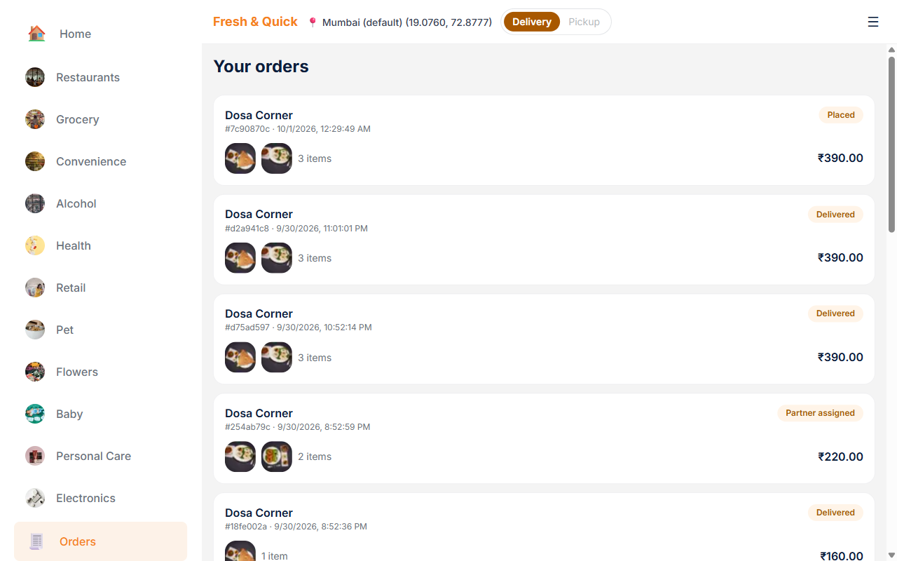
Figure 3.8a — The Orders list: one card per order with the store, order number and date, a status pill (Placed, Partner assigned, Delivered, and so on), item thumbnails with a count, and the total.
As the order progresses the tracker ticks off each step. While the order is On the way the first four steps are ticked, step 5 is highlighted, and the partner's last reported location appears above the order summary.
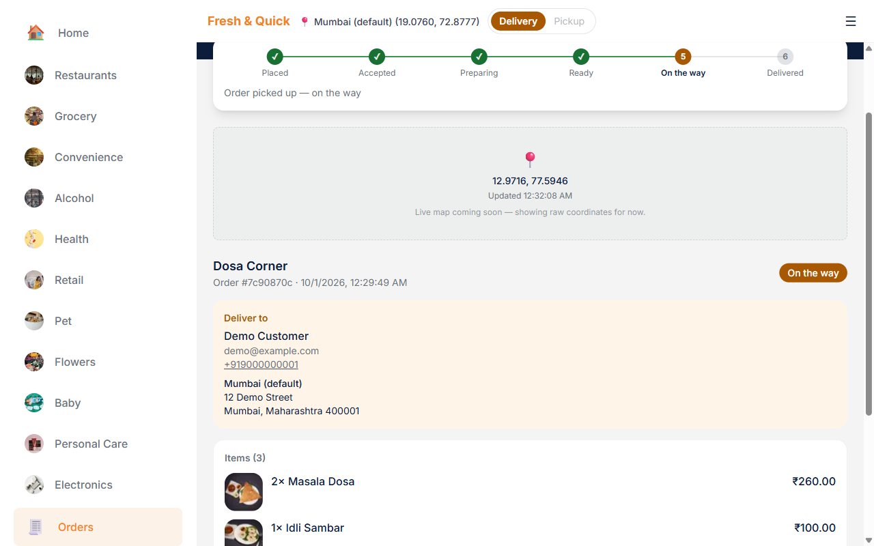
Figure 3.8b — Order detail while the order is On the way: steps 1 to 4 are ticked, step 5 is highlighted, and the order summary follows the partner location box.
Once the order is delivered the status pill turns green and the Timeline records the time of each stage reached (Placed, Accepted, Picked up and Delivered). The Subtotal, Delivery fee and Total tiles and the Payment tile stay on the page for reference.
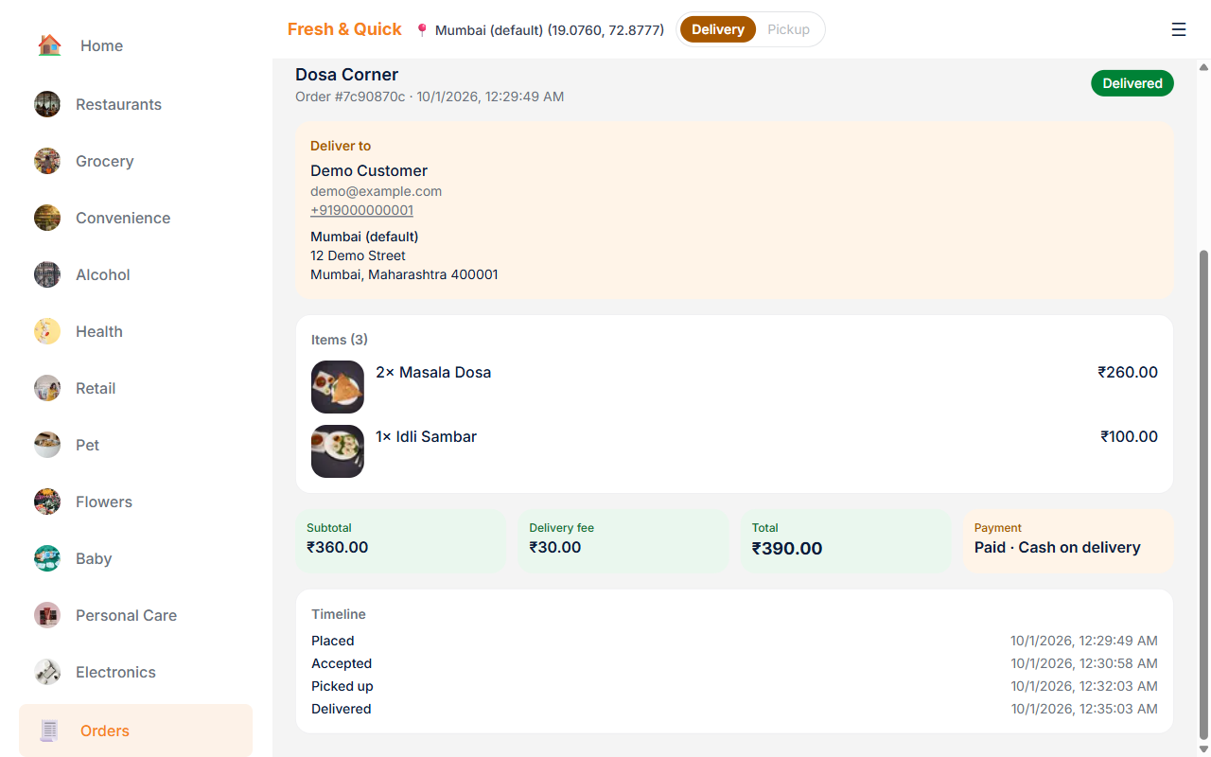
Figure 3.8c — Order detail for a delivered order (scrolled down past the tracker): the deliver-to card, items, totals, payment and the Timeline of times for each stage reached.
Delivered email: when an order is delivered, n8n also emails the address entered at checkout. The subject is "Your order from <store> has been delivered", and the message reads "Thank you for your order. Your order has been successfully delivered. Please let us know your experience." It lists each item with its photo, quantity and options, the subtotal, delivery fee and total, and the name, phone and address it was delivered to. The order-accepted email is sent to the same checkout address.

3.5.1 The Courier Animation and Automatic Delivery
Delivery partners only mark an order Picked up; they cannot mark it Delivered. Once the order is On the way, the customer's order detail page completes the journey. If the order page is open, a "Your order is on the way!" dialog appears with an animated courier scene and a countdown that reads "Arriving in 15s". The animation always plays for a full 15 seconds from the moment the dialog first appears, however long ago the partner picked the order up. The animation always plays, regardless of the browser's reduced-motion preference.
When the countdown ends the dialog briefly shows "Confirming delivery…", then "Delivered! Enjoy your meal." and the order becomes Delivered (tracker step 6 and a green status pill); there is no Done button: the dialog closes itself 3 seconds after it shows. The delivered email is sent at that moment, once per order. If you leave the page part-way through and come back in the same browser session, the animation resumes where it left off. If delivery could not be confirmed straight away, the dialog says "We couldn't confirm delivery just yet — your order will be marked delivered shortly." and shows a Close button; the order page then completes the delivery on its own.
If you never open the order after pickup, nothing is lost: the platform completes the delivery by itself 20 seconds after pickup and sends the same single delivered email, so the order page does not need to be open for delivery to complete. Either way an order is delivered exactly once.

3.6 Signing In & Creating an Account
The customer sign-in page accepts a registered email and password; a toggle on the same screen switches to account creation for a brand-new customer. Both flows use Supabase's own authentication service under the hood, so passwords are never stored or handled directly by the application code.
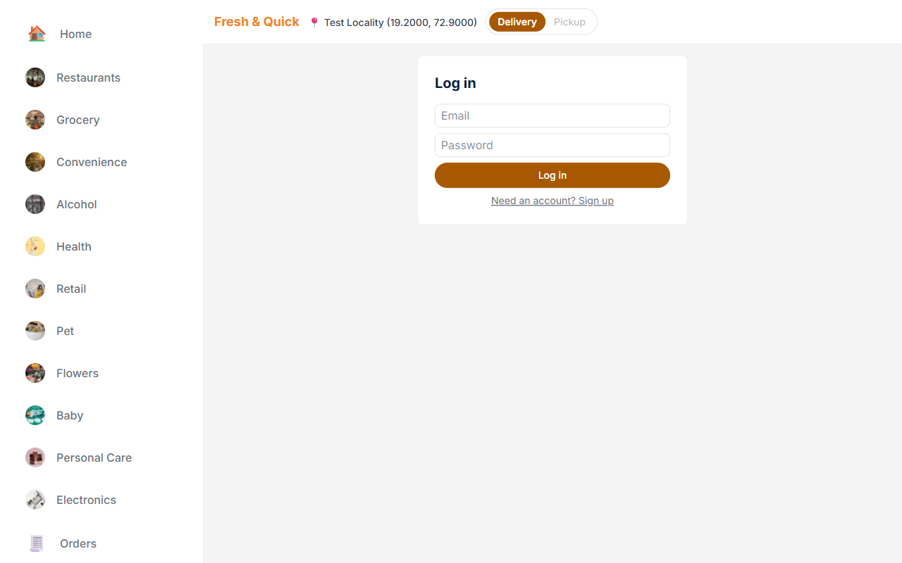
Figure 3.9 — Customer sign-in page. The same screen toggles to "Sign up" for new customers.
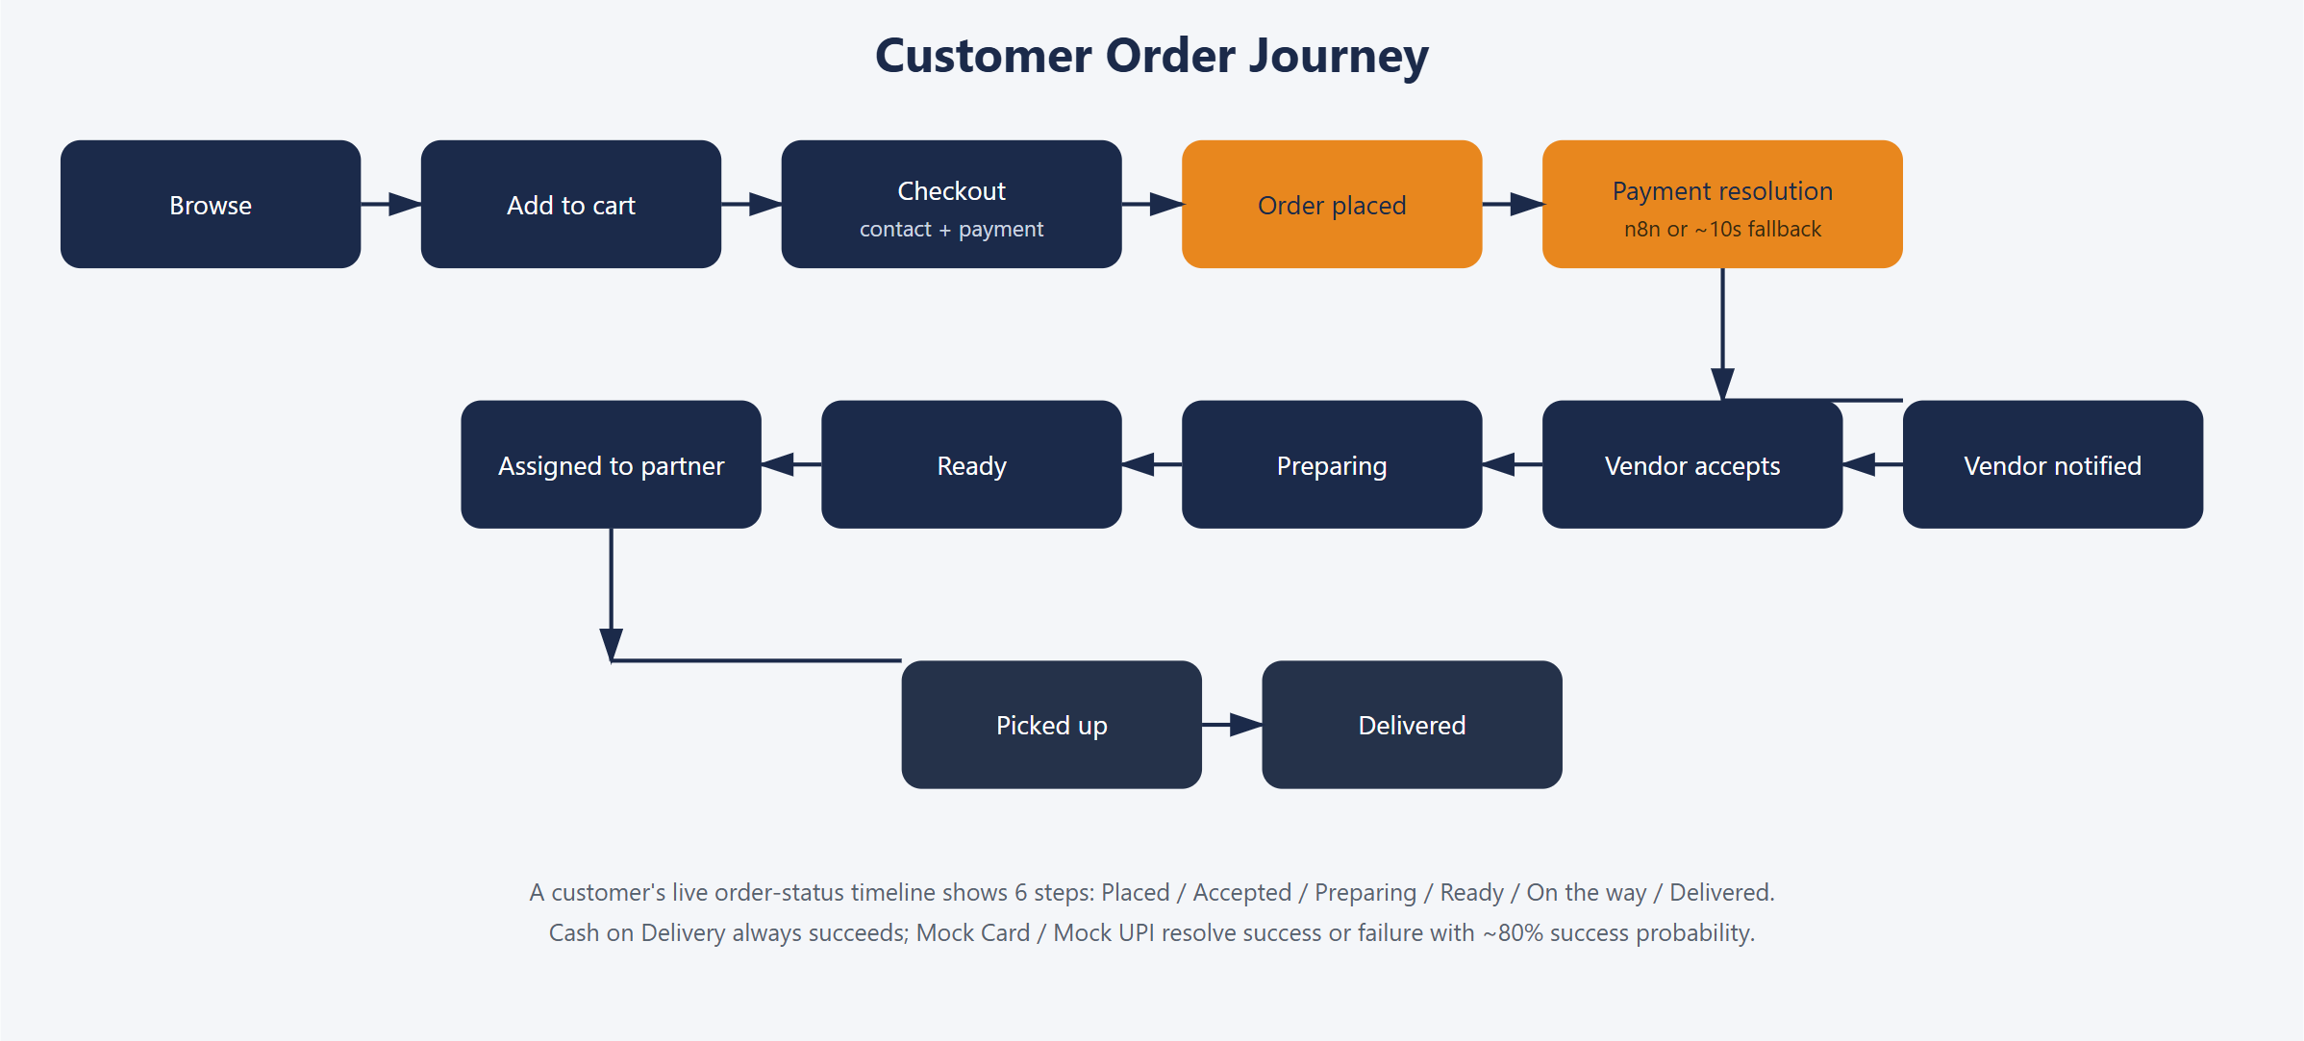
Figure 3.10 — The full customer order journey from browsing to delivery.

3.7 Account Menu
Once signed in, the Sign In / Sign Up buttons in the left sidebar disappear, and the hamburger icon in the top-right of the header opens the account menu: your name, Orders (the Orders list of your past and current orders — tap one to open its order detail page and tracker), Wallet (the payment methods available at checkout), Help (a short FAQ on how to use the site), and Sign out. Under your name is a Reset password link: click it and a password-reset email is sent to your account address, and the link changes to “Reset email sent”.
Figure 3.11 — The account menu open from the header hamburger icon, showing the signed-in customer's name with a Reset password link, and the Orders / Wallet / Help / Sign out links.

3.8 Troubleshooting: Unexpected Errors on an Order Page
If an order-tracking page shows an unexpected error instead of your order's status, the most common cause is being signed into a different role's account in another browser tab on the same localhost:3000 origin — for example, signing into the vendor portal in one tab silently replaces the customer session an already-open order-tracking tab was relying on, so that page's next refresh tries to load your order as the vendor instead of as yourself. The fix is simply to sign in again as the customer on the order page: it now detects this automatically and sends you back to the login screen instead of showing a raw error. To avoid this altogether when you want more than one role signed in at once (for example, to watch an order move from customer to vendor to delivery to admin), use the multi-port mode described in section 2.5, which gives each role its own browser origin and its own independent session.

Chapter 4 — Vendor Module
Every seller on the platform — whether a restaurant or any of the ten non-restaurant categories — is a "vendor" account with access to the same vendor portal. A vendor signs in separately from customers, at its own login page, and manages exactly one store: its menu/catalog, its open/closed status, its delivery settings, and its incoming orders.

4.1 Vendor Sign-In & Sign-Up
The vendor login page is a plain, centered form with no sidebar (the sidebar only appears once signed in). A "New restaurant? Sign up" toggle on the same screen lets a brand-new store register directly: email, password, store name, one or more cuisine/category tags, and a latitude/longitude stub standing in for a real address (no mapping API key is configured in this environment).
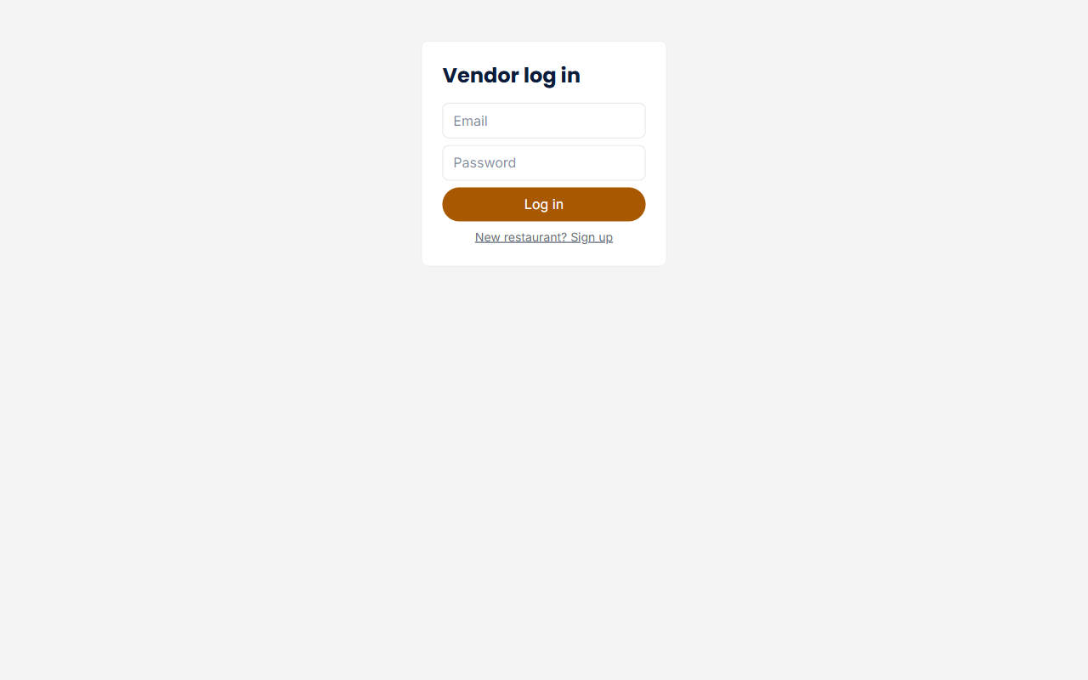
Figure 4.1 — Vendor sign-in page (no sidebar); the same screen toggles to new-restaurant sign-up.
A brand-new store starts closed (is_open = false) and cannot be opened until it has at least one available menu item — the platform refuses to let an empty store go live, so customers never land on a store with nothing to order.

4.2 Vendor Dashboard
After signing in, the vendor portal shows a persistent left sidebar (Dashboard, Menu, Orders, an open/closed status pill, a My Profile section with your name, email and a Reset password link, and Sign out) with the working area on the right. The Dashboard page itself has two parts:
- Store status — an Open/Closed indicator and a toggle to close or reopen the store.
- Delivery settings — a card for editing the store's own delivery fee and an optional promo text line shown to customers.
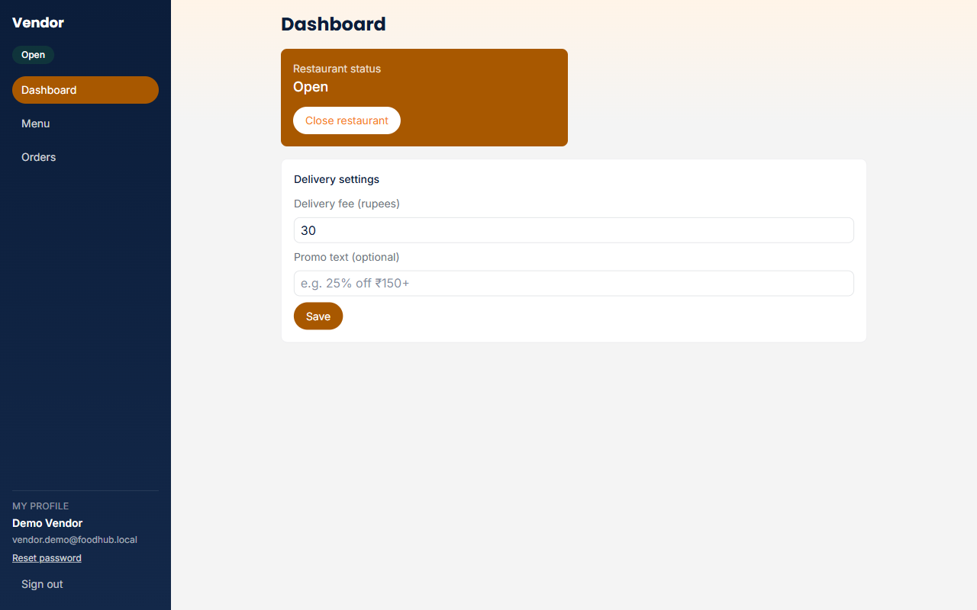
Figure 4.2 — Vendor dashboard: store status with the Open/Closed toggle, and the delivery settings card.

Step by step: opening a brand-new store
1. Sign up at /vendor/login (toggle to "New restaurant? Sign up").
2. Go to Menu and add at least one item, making sure it is marked Available.
3. Return to Dashboard and use the Open restaurant toggle — this is refused if there are zero available items.
4. Optionally set a delivery fee and promo text under Delivery settings.

4.3 Menu Management
The Menu page shows an add-item form (name, price, image URL, and the other item fields) above a table listing every existing item — its image, name, price, veg/non-veg tag, availability, and a row of actions: Edit, Mark unavailable, Delete, and Options (for item customization option groups, e.g. size or spice level, introduced in a later redesign pass).
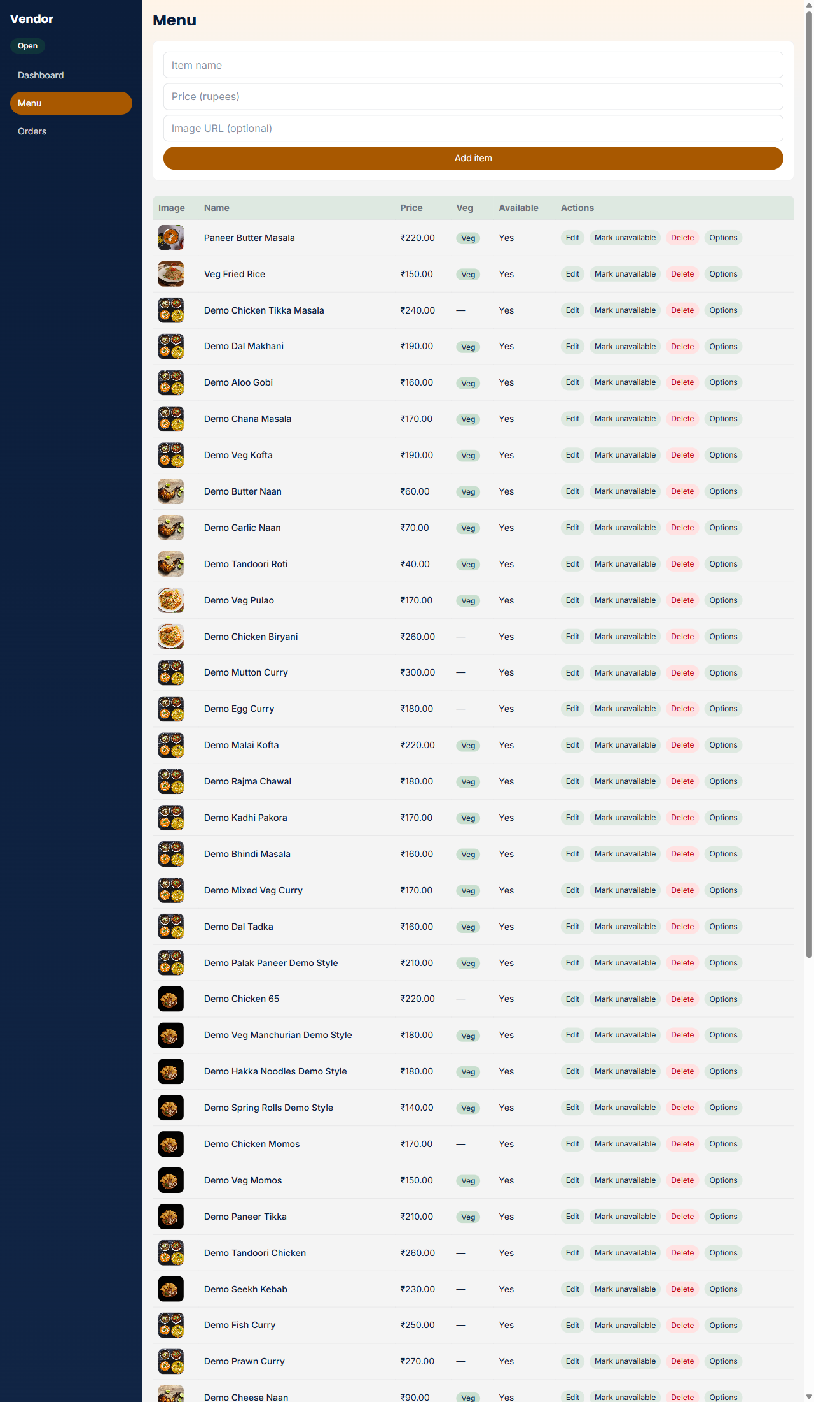
Figure 4.3 — Vendor menu management page: the add-item form above the full menu table with per-row actions.

Step by step: adding a menu item
1. On the Menu page, fill in the add-item form: name, description, price, category, veg/non-veg, and an image URL.
2. Submit the form — the new item appears immediately at the top of the table below, marked Available by default.
3. Use Edit on any row to change its details later, or Mark unavailable to temporarily hide it from customers without deleting it.
Any code path that touches an item's price is written using integer-paisa arithmetic; Postgres's own numeric constraints on the products and orders tables reject invalid values, giving the platform a second line of defence even if a client-side validation were ever bypassed.

4.4 Orders (Kanban Board)
The Orders page shows every incoming order for this store as a kanban board with one large, colour-coded column per stage: New, Accepted, Preparing, and Ready (each header shows how many orders it holds, and an empty column reads "Nothing here yet"). The board refreshes itself every 10 seconds. Each card shows the order number and total; who the order is for, their phone number, the payment (for example "Paid · Cash on delivery") and the delivery address; the items with photos and quantities; and any delivery note. A new order appears in the New column with Reject and Accept order buttons; accepting it moves it to Accepted, from which the vendor advances it forward one stage at a time (Start preparing, then Mark ready) using a single button on the order's card. A Full details link on every card opens a dialog with the full order. Once Ready, the order becomes visible to online delivery partners and leaves the vendor's own workflow.
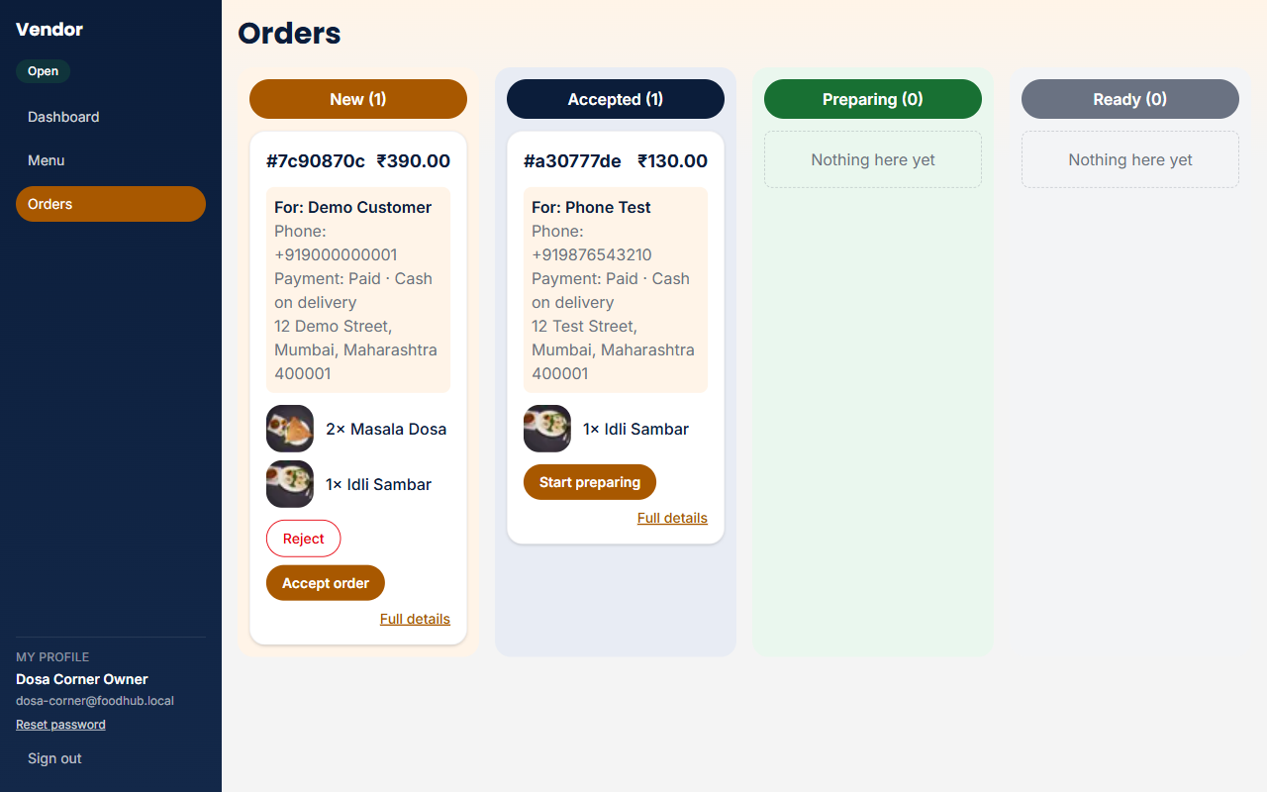
Figure 4.4 — Vendor Orders board: colour-coded New, Accepted, Preparing and Ready columns. Each card shows who the order is for, phone, payment, address and items with photos, with Reject / Accept order on a new order and a Full details link.
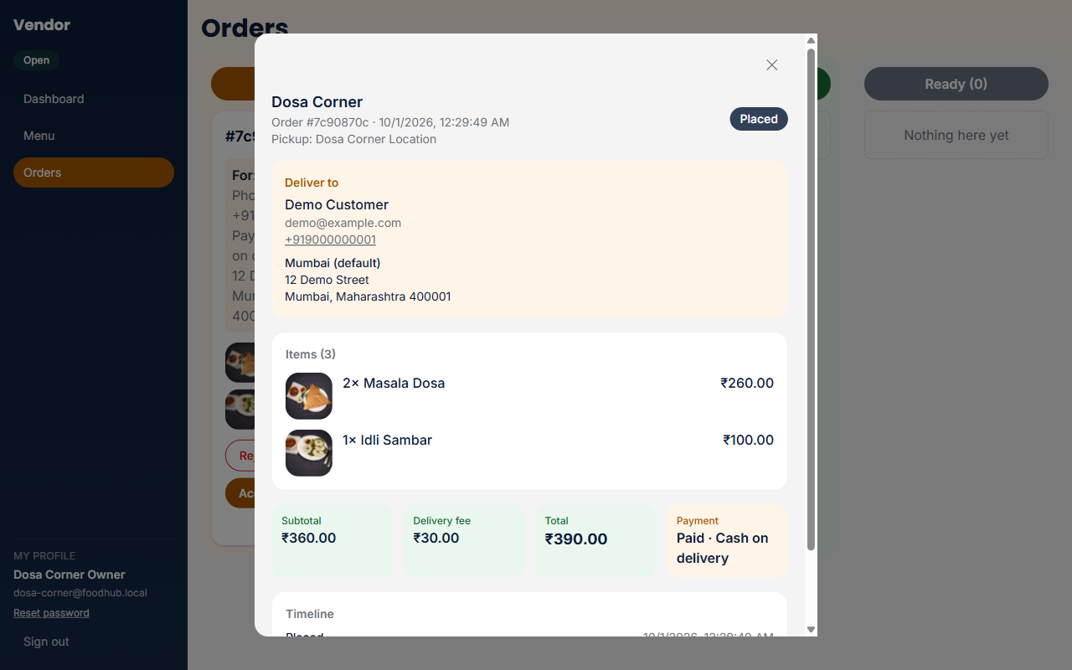
Figure 4.4a — The Full details dialog: the deliver-to card, items with photos, subtotal, delivery fee, total, payment and the order timeline.

Step by step: fulfilling an order
1. A new order appears in the New column — review who it is for, its items and total (select Full details for the complete order).
2. Select Accept order to take the order, or Reject to decline it (a rejected order is not fulfilled and the customer sees it marked Rejected).
3. Once accepted, select Start preparing when you begin cooking/packing.
4. Select Mark ready once the order is ready for pickup — it now appears to delivery partners as an available order.
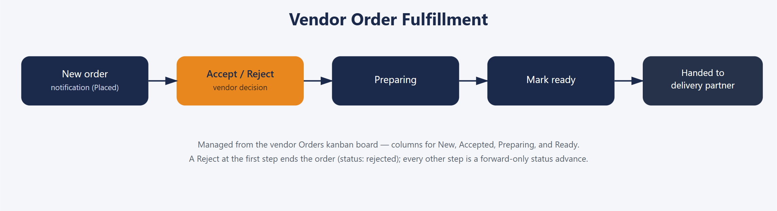
Figure 4.5 — The vendor order fulfillment flow, from a new order notification through to hand-off to a delivery partner.

Chapter 5 — Delivery Partner Module
Delivery partners sign in at their own portal to see and fulfil deliveries. Like the vendor portal, delivery partners can self-register from the login page's "New partner? Sign up" toggle, collecting email, password, full name, and vehicle type.
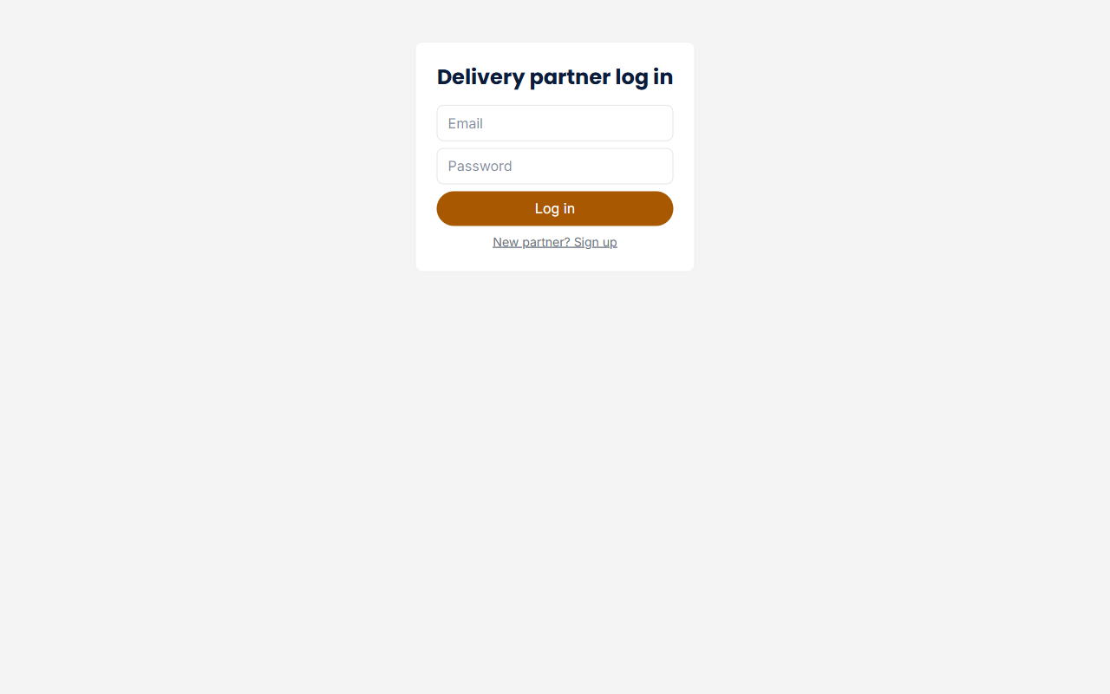
Figure 5.1 — Delivery partner sign-in page; the same screen toggles to new-partner sign-up.

5.1 Delivery Dashboard & History
After signing in, a persistent left sidebar shows the partner's online/offline status pill, the Dashboard and History links, a My Profile section (name, email and a Reset password link) and Sign out. The Dashboard shows active work only, in two sections:
- Your active deliveries — one card for every order you have accepted that is not yet delivered: the order number and amount, the Pickup store and its address, the Drop-off recipient's name, a tap-to-call phone number and the full address, the items with photos, and a Mark picked up button. After pickup the card shows "Customer is receiving the order…" in place of a button — partners do not mark orders delivered.
- Available orders — orders that have reached Ready status and have no delivery partner assigned yet, visible to any online partner on a first-come basis: the store, its pickup address, the items, the amount and an Accept button. The customer's name, phone and address appear only after you accept the order.
An Online/Offline toggle plus two manual latitude/longitude fields stand in for live GPS tracking in this local environment; where the browser grants location permission, these fields prefill automatically from the device's own geolocation, falling back to manual entry otherwise.
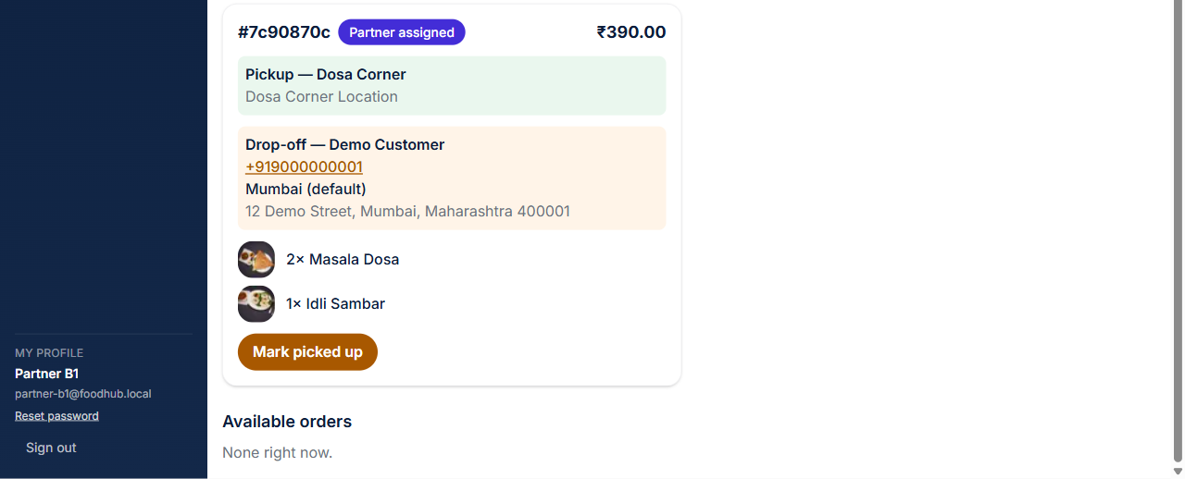
Figure 5.2 — Delivery Dashboard, Your active deliveries: each card shows the pickup store, the drop-off name, tap-to-call phone and address, the items, and the next action (Mark picked up); the sidebar shows Dashboard, History and the My Profile section.
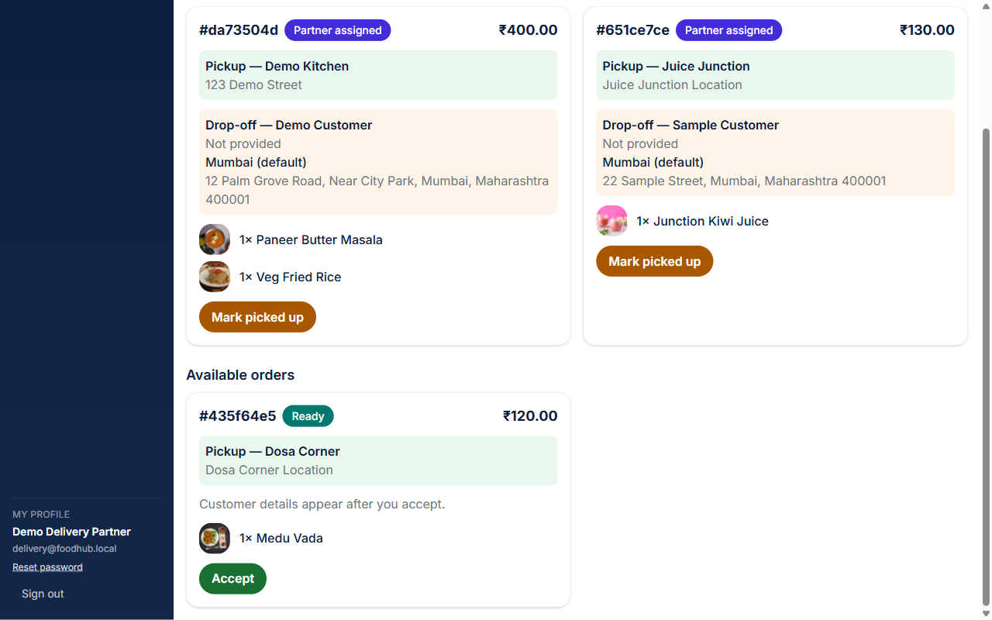
Figure 5.2a — Available orders: the store, pickup address, items, amount and Accept button. "Customer details appear after you accept."
History (in the sidebar) lists your finished orders — delivered, cancelled or rejected — newest first, up to 50. Each card shows the order number, status and amount, the pickup store, who it was delivered to and when, and the items. History does not show a customer's phone number or address: a partner sees those only while an order is assigned to them or picked up. Refresh reloads the list.
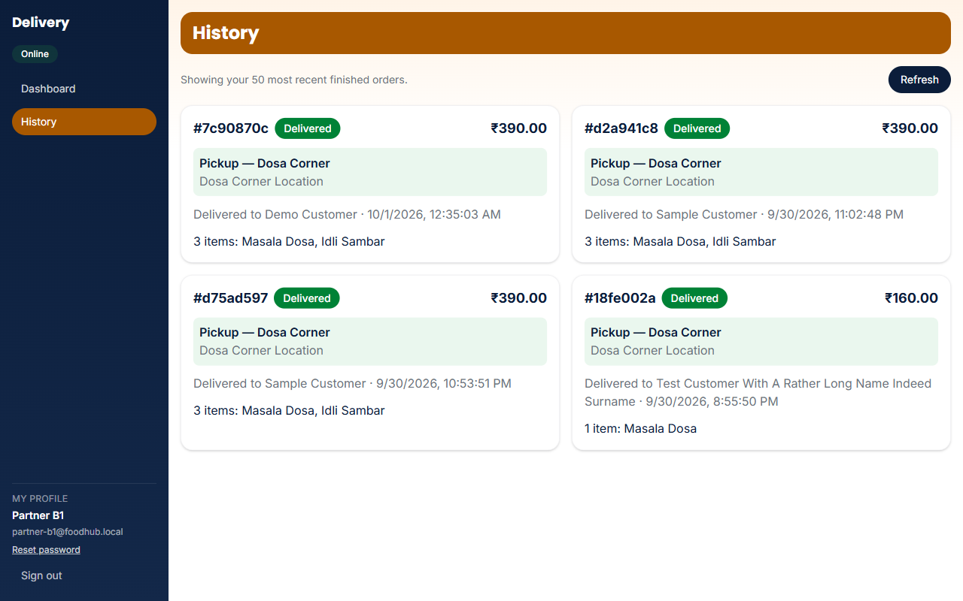
Figure 5.2b — History: finished deliveries with the pickup store, who each order was delivered to, the time and the items.

Step by step: fulfilling a delivery
1. Toggle Online at the top of the dashboard.
2. Select Accept on any order listed under Available orders — it moves to Your active deliveries and the customer's details appear on its card.
3. Use the tap-to-call phone number and the full address on the card to reach the customer.
4. Select Mark picked up when you collect the order. The card then reads "Customer is receiving the order…" and has no further button: the customer's order page plays a 15-second courier animation and the order is marked Delivered automatically (or by the system 20 seconds after pickup if the customer never opens it). A delivered order moves to History.
While online, the dashboard automatically sends a location ping every 15 seconds and polls for newly available orders every 10 seconds, so a partner does not need to manually refresh the page to see new work appear. The customer's own order detail page reflects that shared location once a partner has accepted the order (Partner assigned), and that access expires automatically once the order is Delivered.
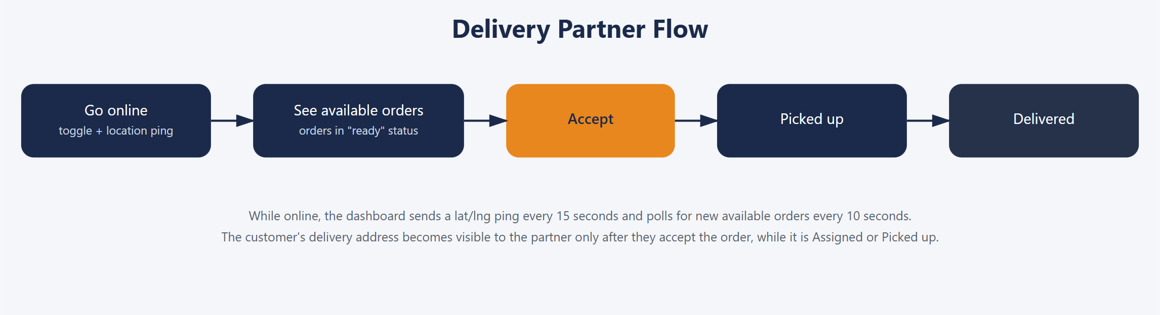
Figure 5.3 — The delivery partner flow, from going online through to picking up an order. The final Delivered step is completed from the customer's side (section 3.5.1), not by the partner.

Chapter 6 — Admin Module
The admin portal gives platform staff full oversight of the marketplace: every order, every vendor/store, and every delivery partner, across all four portals, and lets them add new vendors and delivery partners. There is no admin self-signup — admin accounts exist only as seeded, pre-provisioned accounts, reflecting that granting admin access is an operational decision, not a public sign-up flow.
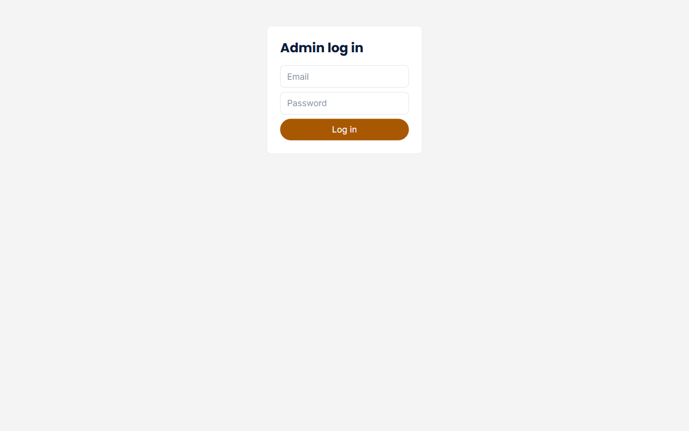
Figure 6.1 — Admin sign-in page.

6.1 Overview & Sidebar
After signing in, a left sidebar lists Overview, Orders, Vendors and Delivery Partners, followed by a My Profile section (name, email and a Reset password link) and Sign out. Each item opens its own page. The Overview page shows three summary tiles only — Active orders, Vendors and Revenue (rejected and cancelled orders are not counted in revenue).
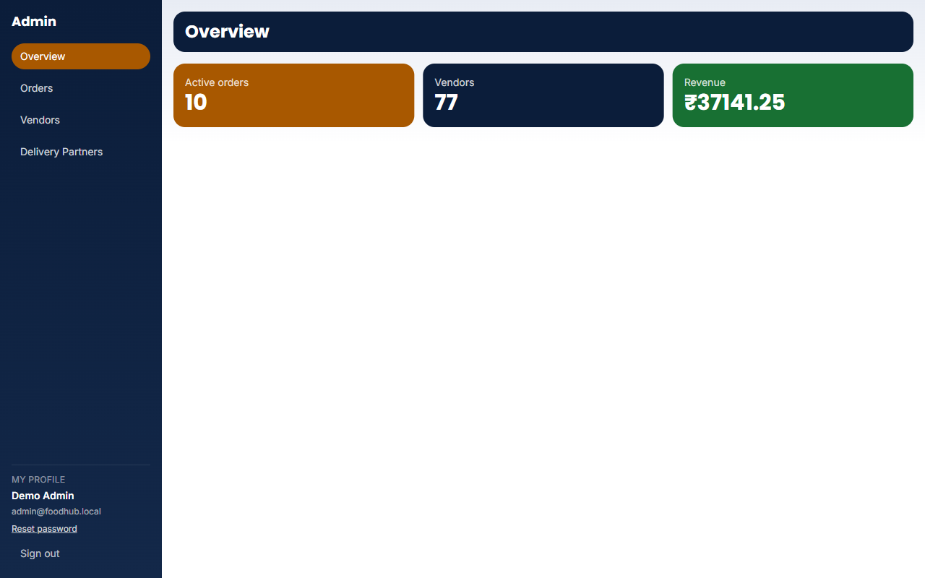
Figure 6.1a — Admin Overview: the sidebar (Overview, Orders, Vendors, Delivery Partners) and the Active orders, Vendors and Revenue tiles.

6.2 Orders and Order Detail
The Orders page is a table of every order on the platform: the order number (a link), customer, store, a status pill, the amount, the delivery partner (a dash when none is assigned) and the time placed. A status filter at the top right narrows the table to one status. Selecting an order number opens the Order detail page, which shows the same full view the customer sees (deliver-to details, items with photos, totals, payment and timeline) plus the delivery partner. For an order that is Partner assigned or On the way, a Reassign control with a dropdown of currently-online delivery partners lets an admin move the order to a different partner — useful if the originally assigned partner goes offline or is unresponsive.
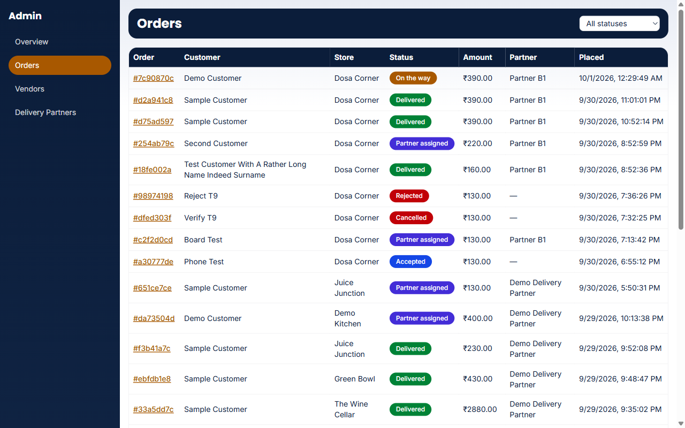
Figure 6.2 — Admin Orders: every order with its number, customer, store, status, amount, delivery partner and placed time, plus a status filter.
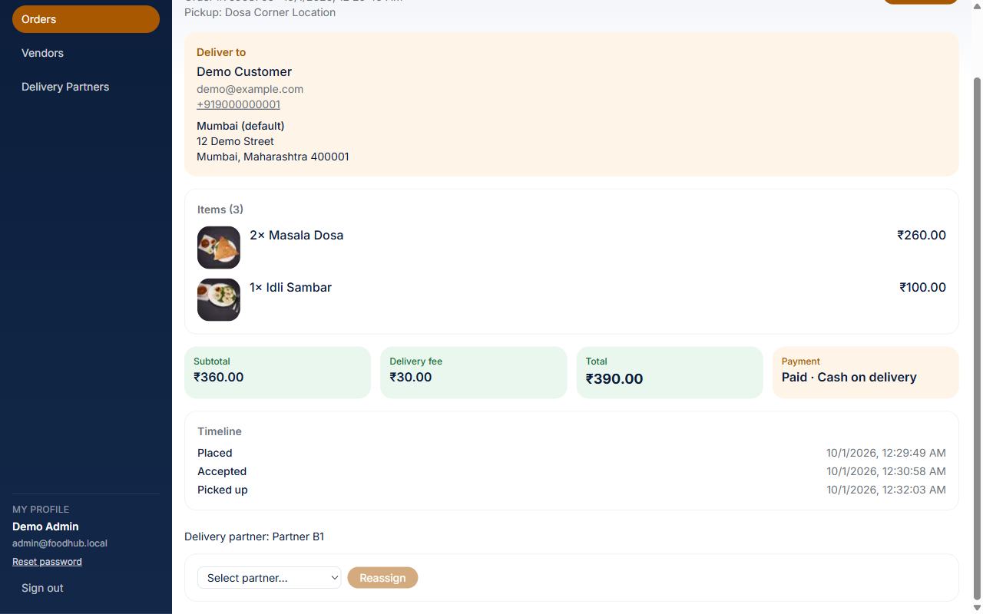
Figure 6.2a — Admin Order detail (scrolled to the lower part of the page): the deliver-to card, items, totals and payment, the Timeline, the delivery partner and the Reassign control.

Step by step: reassigning a stuck delivery
1. Open Orders and select the order number (the order must be Partner assigned or On the way).
2. On the order detail page, open the Select partner dropdown, which lists every currently-online delivery partner.
3. Choose a different partner and select Reassign — the order updates immediately and the new partner sees it under their own Your active deliveries.

6.3 Vendors
The Vendors page lists every store on the platform — 77 in the current seed data, spanning all 11 marketplace categories — with its Active or Suspended status and a Suspend (or Unsuspend) action. Suspending a store immediately removes it from customer browsing without deleting any of its data; unsuspending brings it back. The Add vendor form takes a store name, owner name, email, a temporary password (minimum 6 characters; the admin shares it with the vendor, who can change it from their profile) and latitude/longitude; the new vendor is active immediately and can sign in at /vendor/login.
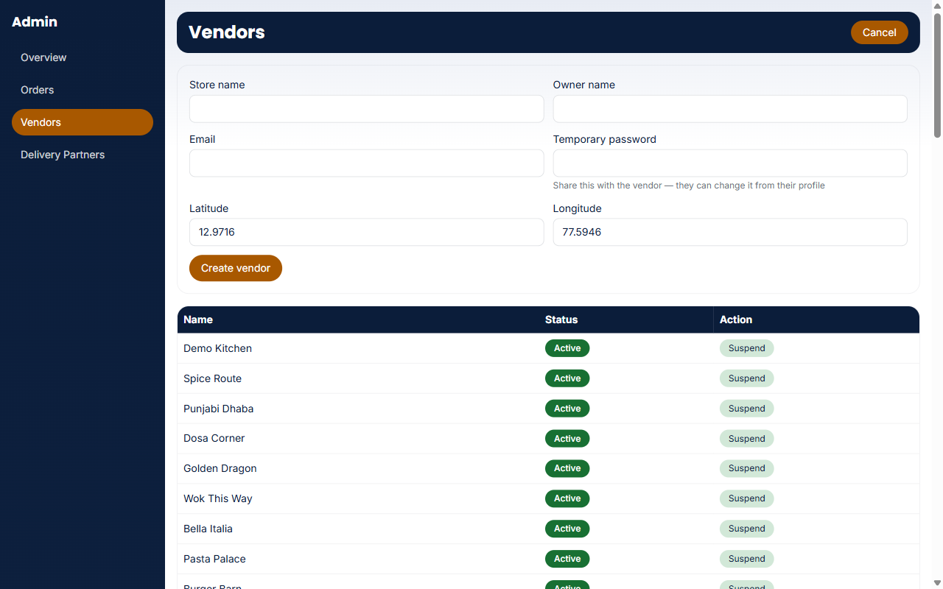
Figure 6.3 — Admin Vendors: the Add vendor form above the list of every store with its status and a Suspend action.

6.4 Delivery Partners
The Delivery Partners page lists every delivery partner account with its current status (Online or Offline) and vehicle, giving admin staff visibility into how many partners are actively available at any given moment. The Add delivery partner form takes a full name, email, temporary password (minimum 6 characters, shared by the admin with the partner) and vehicle; the new partner can sign in at /delivery/login.
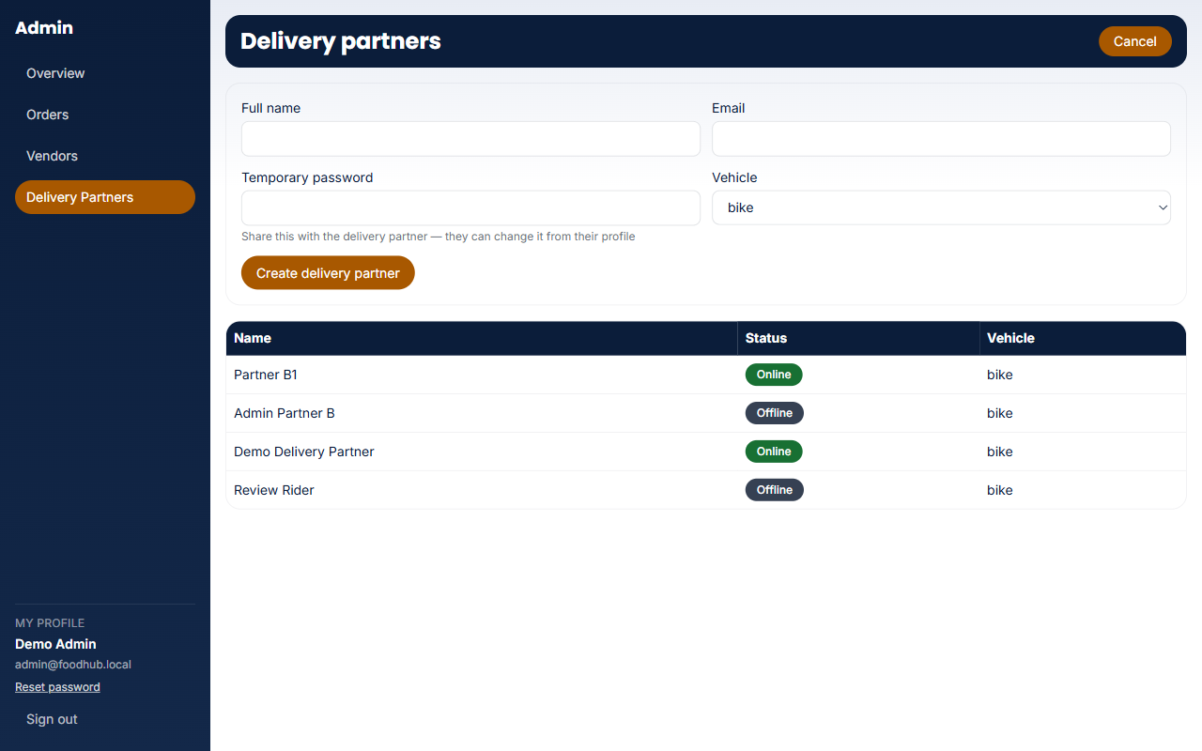
Figure 6.4 — Admin Delivery Partners: the Add delivery partner form above the list of partners with their status and vehicle.

Chapter 7 — Cross-Cutting Features

7.1 Money & Pricing Precision
Every part of the platform that touches a price — menu item prices, cart subtotals, delivery fees, order totals — is computed using integer arithmetic in the smallest currency unit (paise, 1/100 of a rupee), never plain floating-point multiplication in JavaScript. This matters because floating-point money math can silently introduce rounding errors (for example, 0.1 + 0.2 not equalling exactly 0.3 in IEEE-754 arithmetic); Postgres's own numeric CHECK constraints on the orders table (including a constraint that a stored total must exactly equal its subtotal plus delivery fee) would reject such an error outright once real, non-round decimal prices are used, rather than the kind of whole-number seed prices that could otherwise mask the bug.

7.2 Notifications & the n8n Automation Layer
A set of n8n workflows automate cross-portal side effects that would otherwise require polling: resolving a mock payment shortly after an order is placed, notifying a vendor of a new order, emailing the customer when an order is accepted and when it is delivered, and similar events. n8n calls back into the Next.js application through a small family of "/api/internal/*" routes, authenticated with a shared secret header (X-Internal-Secret) rather than a normal user session, since these calls originate from an automation server rather than a logged-in browser. If no n8n instance is reachable, every one of these flows still completes correctly through an in-process fallback inside the relevant API route — n8n makes the demo faster, not functionally required.

7.2.1 The 5 Workflows and What Triggers Each
All 5 workflows are triggered by a Postgres Database Webhook (via the n8n_notify() trigger function on the orders/payments tables) firing an HTTP POST to n8n on a row INSERT or UPDATE OF status — none of the 5 is interval- or cron-based. Supabase fires the webhook on every row event for the table it is attached to; each workflow's own IF/Filter node is what narrows execution down to the specific status value(s) it cares about.
01 — Order Placed
Trigger: payments UPDATE OF status = 'success'
Calls POST /api/internal/orders/[id]/notify-vendor, which writes a row to public.notifications for the vendor. This now fires only once a payment actually succeeds, not at the moment the order is placed — earlier versions notified the vendor immediately on order placement, which could notify a vendor of an order whose payment then failed and was cancelled a moment later.
02 — Payment Mock Confirmation
Trigger: payments INSERT (status='pending')
Calls back into the app to resolve the mock payment to success/failed via applyPaymentResult(). The checkout route itself polls for up to ~10s and falls back to resolving the payment in-process if n8n does not answer in time, so checkout behaves identically either way.
03 — Restaurant Accepts / Status Change
Trigger: orders UPDATE OF status (accepted/preparing/ready)
Writes a placeholder notification row on every filtered transition; on accepted specifically, a second branch also emails the customer via a Gmail node. The email goes to the address entered at checkout (requires a connected Gmail OAuth2 credential — without one this branch fails at the Gmail node only, which does not block the order).
04 — Delivery Partner Assignment
Trigger: orders UPDATE OF status = ready
Looks up the store's lat/lng, requests nearest-first candidate delivery partners, and assigns the closest online partner automatically if any are online.
05 — Delivery Status Propagation
Trigger: orders UPDATE OF status (picked_up/delivered)
Propagates delivery-side status changes to any downstream notification/logging the workflow defines. On delivered it also sends the delivered email via a Gmail node to the address entered at checkout: the subject is "Your order from <store> has been delivered", and the body thanks the customer, lists the items (with photos, quantities and options), the subtotal, delivery fee and total, and the name, phone and address it was delivered to. On picked up it also starts a 20-second fallback: if the customer's own order page has not completed the delivery by then, the workflow completes it, so the delivered email is sent exactly once either way.

7.2.2 Live Verification — 2026-09-28 and 2026-09-30
The local stack (self-hosted Supabase via Docker, the n8n container with N8N_INTERNAL_SECRET/APP_BASE_URL/SUPABASE_URL all set to host.docker.internal per docs/n8n-webhook-setup.md, and the Next.js dev server) was started fresh and a real order was placed end-to-end through the running customer app (test account customer@foodhub.local) to observe actual behaviour, not just configuration. Findings, checked directly against Postgres rather than assumed from n8n's execution log:
- Workflow 01 (Order Placed): confirmed firing. The order was placed at 00:13:42 UTC and a matching row appeared in public.notifications at 00:13:44.98 — about 2.6 seconds later, consistent with a live webhook round trip rather than the app's own code creating that row synchronously.
- Workflow 02 (Payment Mock Confirmation): confirmed firing. The order's payment moved from pending to success at 00:13:46.78 — about 4.4 seconds after checkout, well inside the ~10-second in-process fallback window documented in section 7.2 and Appendix A, so this resolution was n8n's, not the fallback's.
- Workflow 03 (Restaurant Accepts): the seeded vendor account (daily-basket@foodhub.local) advanced the same order through accepted → preparing → ready via /vendor/orders in this session, which is the real trigger for workflow 03's filtered UPDATE OF status. The Gmail-send branch was not separately confirmed (no Gmail credential is configured in this local n8n instance, matching the known gap in section 4 of docs/n8n-webhook-setup.md), so this document did not claim that branch fired at the time (confirmed later, see 2026-09-30 below) — only that the accepted/preparing/ready transitions themselves, which are what the workflow listens for, occurred live.
- Workflow 04 (Delivery Partner Assignment): NOT observed to auto-assign in this test. With the order at status=ready and a delivery partner already online (delivery@foodhub.local), the order appeared under that partner's “Available orders” list for manual self-accept rather than being auto-assigned by the workflow — orders.delivery_partner_id remained null until the partner accepted it by hand through /delivery/dashboard. This manual is deliberately not claiming workflow 04 fired successfully; it may not be active in this local n8n instance, or its assignment call may not have succeeded silently. Either way, the manual accept path (section 5.1) worked correctly as the primary, always-available assignment mechanism, exactly as designed — workflow 04 is additive automation on top of it, not a replacement for it.
- Workflow 05 (Delivery Status Propagation): not separately exercised in this pass (the test order was left at the accepted/assigned stage); see docs/n8n-webhook-setup.md section 5 for its documented test procedure; the delivered email it sends was verified live on 2026-09-30, see below.
Net conclusion: this local instance's checkout-critical automation (workflows 01 and 02) is live, active, and measurably faster than its own documented fallback — not merely configured on paper. Workflow 04's auto-assignment did not visibly act in this run, so treat the delivery partner's manual Accept as the mechanism to rely on and workflow 04 as an unconfirmed bonus in this environment rather than a guaranteed path.
2026-09-30 follow-up: the order-accepted email (workflow 03) and the delivered email (workflow 05) were verified live against the same local stack. An order was placed with a checkout email address, accepted by the vendor, then moved through picked up to delivered by a delivery partner. Both emails arrived at the checkout email address (not the account address), and the delivered email carried the subject "Your order from <store> has been delivered", the thank-you sentence, the item rows with photos, quantities and options, the subtotal, delivery fee and total, and the delivered-to name, phone and address. The Gmail branch noted as unconfirmed above is therefore now confirmed for both emails. (That test predates version 3.1, when partners still marked orders delivered; delivery is now completed from the customer's order page or by the 20-second fallback.)

7.3 Payment Methods
Three payment methods are available at checkout, described in full in section 3.4: Mock Card and Mock UPI (each with method-specific required fields, and each resolving to success or failure with roughly an 80% success rate to simulate a real gateway), and Cash on Delivery (no extra fields, always succeeds). All three are simulated — no real payment processor is integrated, appropriate for a local development and demonstration environment.

7.4 Categories & the Marketplace Taxonomy
The platform's category system (11 categories: Restaurants plus the 10 non-restaurant categories listed throughout this manual) and cuisine taxonomy (Indian, Chinese, Italian, Mexican, and more) are both enforced as fixed, predefined lists at the database level, not just in the UI — a database trigger rejects any cuisine tag or category value outside the recognised set. This keeps every filter, chip, and carousel on the customer home page working against a known, closed set of values rather than free-text tags that could drift or typo over time.

Chapter 8 — Ask Zippy

8.1 What Ask Zippy Is
Ask Zippy is the platform's built-in help assistant. You type a question in plain words and Zippy answers it in a chat panel, without you having to leave the page or search the manual. It is available to everyone, including visitors who are not signed in.

8.2 Finding and Opening Zippy
On the website, an Ask Zippy button floats at the bottom-right corner of every page of every portal, including the login pages. On pages that show the basket, the button sits beside the basket so it never covers it. Select the button to open the chat panel and select the × in its header to close it.
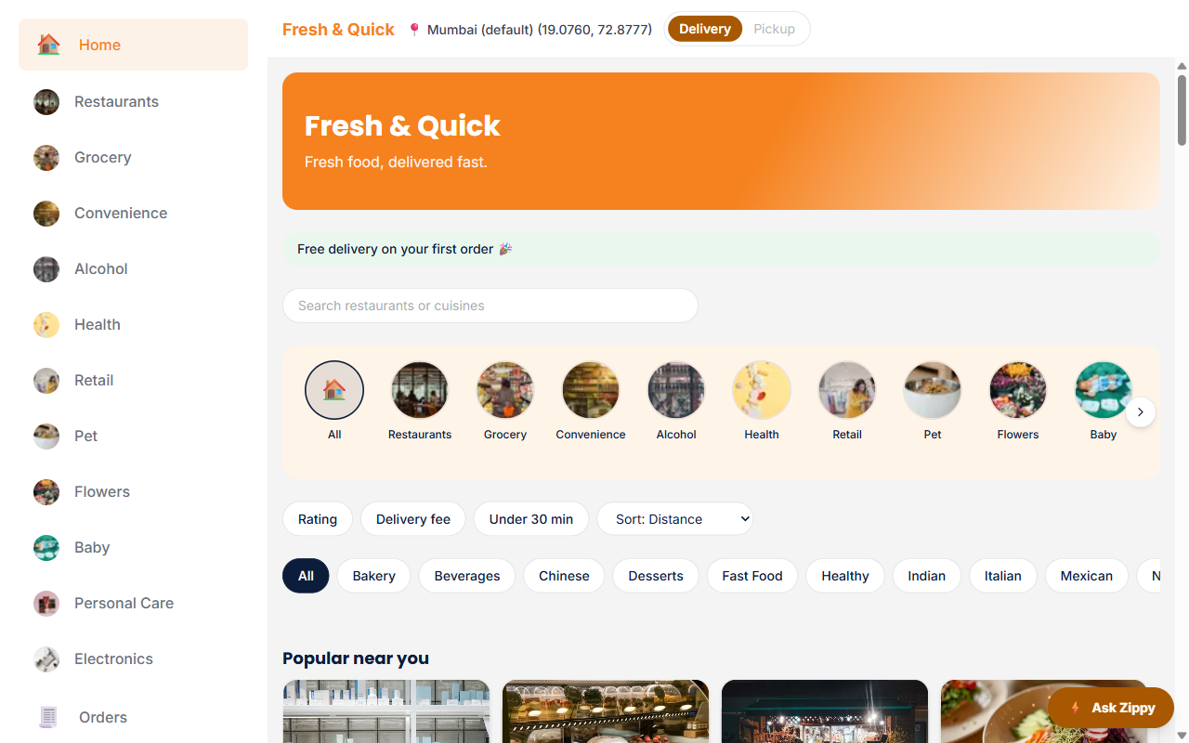
Figure 8.1 — The Ask Zippy button at the bottom-right of the Customer home page.

8.3 Asking a Question
A new chat opens with a short welcome message and three suggested questions: how to place an order, how to track an order and how to cancel an order. Select one, or type your own question in the box at the bottom and press Enter or Send. The whole answer appears at once and ends with a short note naming the guide it came from.
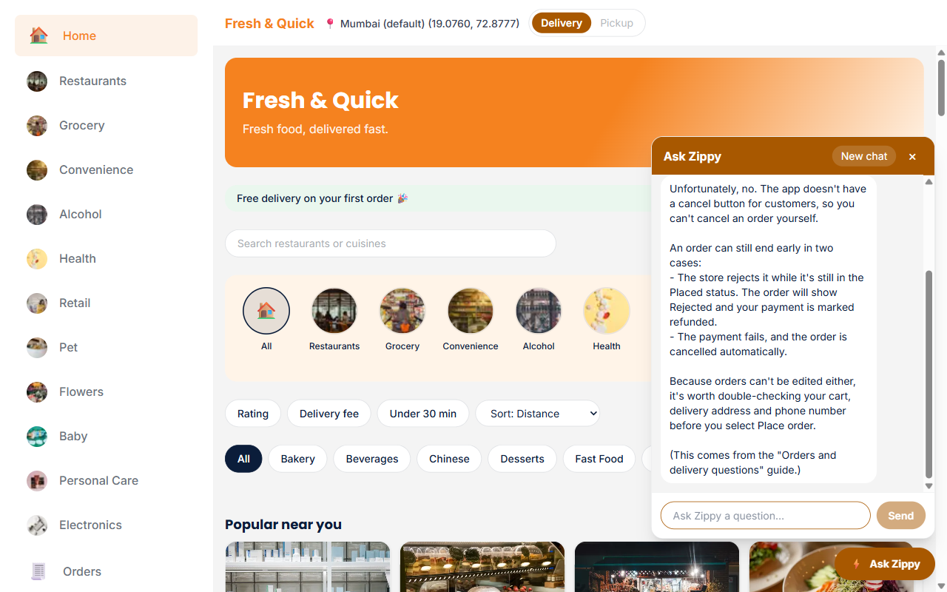
Figure 8.2 — Zippy answering "Can I cancel an order?" from the platform's ordering guide.

8.4 Asking about stores and menus
Zippy can answer questions about stores and dishes using their current details. Examples: "Is Dosa Corner open right now?", "What does the Cheese Dosa cost?", "Which stores have free delivery?", "What options does the Cheese Dosa have?"
- Prices, delivery fees and open or closed status are looked up when you ask and can change at any time, so check them again in the cart and at checkout before you pay.
- The answer appears in one piece after Zippy has looked things up, not word by word, so a store question can take several seconds.
- "Nearest" questions, such as "Which three stores are closest to me?", use the delivery location you have chosen on the website, or the default location if you have not chosen one. The location is used only to answer that question and is not saved with your chat.
- Zippy can also look up your own orders when you are signed in as a customer and ask about them: the status, what was in the order, the totals, the payment, and the delivery details on it. Example: "Where is my order?" It cannot see anyone else's orders, and it cannot place, change, cancel or pay for an order. Order details are used only to answer the question you asked.
- When you are signed in as a customer, Zippy can also change your cart for you. Ask, for example, "Add two Cheese Dosas to my cart", "Order what I had last time", "Make the Cheese Dosa three", "Remove the lassi" or "Empty my cart". Zippy does not change the cart by itself: it shows a card describing the change, and nothing happens until you tap Confirm. Tap Dismiss to ignore the card. Each card can be confirmed once.
- Adding from a different store than the one already in your cart replaces the cart when you confirm, and the card says so beforehand, for example "Confirming replaces the 3 items from Dosa Corner in your cart." Closed or suspended stores and unavailable dishes are refused; when you ask to repeat a past order, unavailable dishes are skipped and listed. Quantities are 1 to 20, a reply shows at most 3 cards, and for a dish with a required choice (such as a size) Zippy asks which option you want before showing the card.
- Zippy does not place, pay for or cancel orders and does not edit the order note. After confirming a change you still review the cart and check out yourself (or ask Zippy for the Go to checkout card, below). Cart changes are available only to signed-in customers; visitors, stores, delivery partners and admins get none. On the website, the Confirm button works on the customer pages; elsewhere the card shows a link to the customer area, where you can ask again.
- Checkout from chat: when you are signed in as a customer, ask Zippy to check out, for example "Check out for me" or "Take me to checkout", and it shows a Go to checkout card. Tap it once and the chat closes and the Checkout page opens for your current cart. Zippy refuses, with no card, if your cart is empty, the store is closed or suspended, or a dish is unavailable. You enter your own name, contact details and delivery address and pay on the Checkout page; Zippy never places or pays for an order and never asks for those details or card numbers. If your cart changed to a different store after the card was shown, the card says "Your cart changed, ask me again." The Go to checkout card works on any page of the website for a signed-in customer.

8.5 Chats, History and New Chat
Select New chat in the panel header to start a fresh conversation. When you are signed in, your chats are saved and a History button appears beside New chat: select it to see your earlier chats and pick one to continue, then select Chat to go back. Because history belongs to your account, a chat you started on the website can be continued in the mobile app. A visitor's chat is temporary and is lost when the page is closed or New chat is selected.

8.6 What it can and cannot do
Zippy answers how-to questions about using Fresh & Quick, such as placing an order, tracking it, what each order status means, payments, and managing your account. It answers from the platform's own guides and says which guide the answer came from. Zippy is role-aware: a customer is shown customer guides, and a vendor, delivery partner or admin is shown the guides for their own portal.
Zippy can look up stores, dishes, prices, options and whether a store is open, using their current details (see the section on asking about stores and menus). When you are signed in as a customer it can also look up your own orders, and it cannot see anyone else's. It cannot place, change, cancel or pay for an order. The only thing it can change is your cart, and only after you tap Confirm on a card, and it can open the Checkout page for you with a Go to checkout card (see section 8.4). If the guides do not cover a question, Zippy says so instead of guessing.

8.7 Limits, privacy and support
- Each question can be up to 1,000 characters.
- Signed-in users can send up to 20 questions per minute and 100 per day. Visitors are limited to 10 per minute and 40 per day. If you go over, Zippy asks you to wait a moment.
- Your questions are sent to Anthropic (Claude) and OpenAI to produce the answer. Do not type passwords or card numbers into the chat. When a question needs your order details, those details are sent too.
- Under the platform's policy, orders and saved Zippy chats may be deleted after 30 days. Deletion is not automatic, so to have your data deleted, or for a problem Zippy cannot solve, contact support at vishalshah1973@gmail.com or +919820020000.

Appendix A — Technical Architecture & Stack

A.1 Technology Stack
Layer | Technology
Frontend framework | Next.js (App Router, TypeScript) + Tailwind CSS
Backend | Next.js API routes (server-side), running in the same codebase as the frontend
Database | Postgres, via self-hosted Supabase (Docker) — no cloud/hosted Supabase project
Auth | Supabase Auth (email/password), one role column driving portal redirect
Storage | Supabase Storage (self-hosted)
Realtime / polling | Supabase Realtime plus client-side polling for order status and available-order lists
Automation | n8n (self-hosted, Docker), calling back via internal API routes
Row security | Postgres Row-Level Security (RLS) policies, scoped per role and per table

A.2 Why Self-Hosted, Local-Only
A deliberate project decision (documented from the platform's earliest design phase) keeps every backing service — Postgres, Auth, Storage, and the n8n automation layer — running in local Docker containers rather than any hosted cloud service. This keeps the running cost at zero and keeps the entire stack reproducible on a single developer machine, at the cost of features that would need a real cloud deployment (e.g. a public webhook endpoint reachable from outside the local machine).

A.3 Security Model
- The Supabase "service role" key — which bypasses all row-level security — is only ever imported in server-side files explicitly guarded by the server-only package, so it can never end up in a browser-shipped JavaScript bundle.
- Any API route that creates data on a customer's behalf derives that customer's identity from a verified session token (checked server-side against Supabase Auth), never from a client-supplied ID in the request body.
- Checkout runs through a single Postgres function (a "security definer" RPC) so that an order's four related inserts — the order row, its line items, and its payment record — happen atomically; that function is granted only to the service role, so a customer's own browser session cannot call it directly and bypass the checkout route's own validation.
- Row-level security write policies exist only on tables a browser client is genuinely meant to write to directly; every other table is written exclusively through service-role-backed API routes, closing off a class of bug where a leftover "just in case" RLS write policy becomes a live bypass of an API route's own validation.

A.4 Architecture Diagram
Figure A.1 — System architecture (repeated from Chapter 1 for reference).

Appendix B — Database Schema Reference
The tables below summarise the platform's core Postgres schema. Every table has Row-Level Security enabled; most read access is public or authenticated-only, while all sensitive writes route through service-role-backed API routes rather than direct client writes.

B.1 users
Extends Supabase's own auth.users table with an application profile: a role (customer, vendor, delivery, or admin — this single column drives which portal a signed-in user is redirected to), full name, phone, and avatar URL.

B.2 addresses
A saved delivery address for a user: a label, a structured street address (line1, an optional line2, city, state, and pincode), and a latitude/longitude pair captured from the manual location-entry stub.

B.3 stores
Represents any store on the platform, not only food restaurants — the same table backs every one of the 11 marketplace categories. Key columns: owner (the vendor's user id), name, an array of cuisine/category tags, a location (address reference plus lat/lng), an open/closed flag, average prep time in minutes, a rating, and a banner image URL.

B.4 products
An item in a store's catalog: name, description, price (checked non-negative at the database level), category, a veg/non-veg flag, an availability flag, and an image URL. Belongs to exactly one restaurant/store row.

B.5 orders
The central transactional record: customer, restaurant/store, an optional assigned delivery partner, a delivery address, a recipient phone number, and a status that moves forward through a fixed chain — placed, accepted, preparing, ready, assigned, picked_up, delivered, or rejected/cancelled at any point. Subtotal, delivery fee, and total are each checked non-negative, and a database constraint requires total to exactly equal subtotal plus delivery fee, closing off an entire class of pricing bug at the data layer. Version 3.0 added recipient_phone (text, required; older orders hold the literal "Not provided") and three nullable timestamps, accepted_at, picked_up_at and delivered_at, that a database trigger stamps when the status changes. From version 3.1 only the customer's order page (or the n8n 20-second fallback) moves an order from picked_up to delivered; a delivery partner can no longer set delivered.

B.6 order_items
One row per line item within an order: which menu item, what quantity (must be positive), and the unit price actually charged at the time of the order (stored independently of the menu item's current price, so a later price change never rewrites the price on a historical order).

B.7 delivery_partners
One row per delivery-partner user: online/offline flag, current latitude/longitude and the timestamp of the last location ping, and vehicle type. This is the table the delivery dashboard's Online toggle and location-ping feature read from and write to.

B.8 payments
One row per order's payment attempt: method (mock_card, mock_upi, or mock_cod), status (pending, success, or failed), amount, a mock reference string standing in for a real payment gateway's transaction id, and a paid-at timestamp.

B.9 reviews
An optional post-delivery review: which order, which customer, which restaurant/store, a 1–5 star rating, and an optional comment. This table exists in the schema from the platform's first migration onward but does not yet have a customer-facing UI for leaving a review.

B.10 Schema Summary Table
Table | Purpose | Key columns
users | App profile layered on Supabase Auth | role, full_name, phone
addresses | Saved delivery addresses | line1, line2, city, state, pincode, lat, lng, is_default
stores | Any store (all 11 categories) | name, cuisine_tags[], is_open, rating
products | Catalog items for a store | name, price, category, is_available
orders | Central order record | status, subtotal, delivery_fee, total, recipient_phone, accepted_at, picked_up_at, delivered_at
order_items | Order line items | menu_item_id, quantity, unit_price
delivery_partners | Partner online status & location | is_online, current_lat, current_lng
payments | Payment attempts per order | method, status, amount
reviews | Post-delivery reviews | rating, comment

Appendix C — Seeded Test Accounts
Re-running npx supabase db reset restores exactly these 80 accounts with exactly these passwords every time, making the environment fully reproducible for testing or demonstration. All passwords below are dummy, development-only credentials, seeded locally, and are never used outside a local Supabase instance.

C.1 Core Accounts (one per role)
Role | Login page | Email | Password
Admin | /admin/login | admin@foodhub.local | admin-demo-password
Customer | /customer/login | customer@foodhub.local | demo1234
Delivery Partner | /delivery/login | delivery@foodhub.local | demo1234
Vendor (Demo Kitchen) | /vendor/login | vendor.demo@foodhub.local | demo1234
A second delivery partner is not part of the seed data: create one at /delivery/login ("New partner? Sign up") or have an admin add one from Admin → Delivery Partners. With more than one partner Online, workflow 04 auto-assigns a ready order to one of them; with none Online it appears under Available orders for any Online partner to accept. Vendor, delivery-partner and admin accounts that an admin creates from the Admin portal are likewise not part of the seed data.

C.2 Restaurant Vendor Accounts
All 16 restaurants share the password demo1234; sign in at /vendor/login with any of these to manage that restaurant's menu and orders.
Restaurant | Email | Cuisine
Spice Route | spice-route@foodhub.local | indian
Punjabi Dhaba | punjabi-dhaba@foodhub.local | north_indian
Dosa Corner | dosa-corner@foodhub.local | south_indian
Golden Dragon | golden-dragon@foodhub.local | chinese
Wok This Way | wok-this-way@foodhub.local | chinese
Bella Italia | bella-italia@foodhub.local | italian
Pasta Palace | pasta-palace@foodhub.local | italian
Burger Barn | burger-barn@foodhub.local | fast_food
Sweet Tooth | sweet-tooth@foodhub.local | desserts
Juice Junction | juice-junction@foodhub.local | beverages
Taco Fiesta | taco-fiesta@foodhub.local | mexican
El Sombrero | el-sombrero@foodhub.local | mexican
Bangkok Bites | bangkok-bites@foodhub.local | thai
The Bread Basket | the-bread-basket@foodhub.local | bakery
Green Bowl | green-bowl@foodhub.local | healthy
Fresh Fit | fresh-fit@foodhub.local | healthy

C.3 Non-Restaurant Marketplace Vendor Accounts
Six stores per category (all sharing the password demo1234), grouped below by category. Sign in at /vendor/login.

C.3.1 Grocery
Store | Email | Category
Daily Basket | daily-basket@foodhub.local | Grocery
Fresh Mart | fresh-mart@foodhub.local | Grocery
Green Grocer | green-grocer@foodhub.local | Grocery
Harvest Greens | harvest-greens@foodhub.local | Grocery
Metro Grocery | metro-grocery@foodhub.local | Grocery
Pantry Post | pantry-post@foodhub.local | Grocery

C.3.2 Convenience
Store | Email | Category
24/7 Shop | 247-shop@foodhub.local | Convenience
24Seven Store | 24seven-store@foodhub.local | Convenience
Corner Store | corner-store@foodhub.local | Convenience
QuickBite Mart | quickbite-mart@foodhub.local | Convenience
Metro Mart Express | metro-mart-express@foodhub.local | Convenience
QuickStop | quickstop@foodhub.local | Convenience

C.3.3 Alcohol
Store | Email | Category
Barrel & Bottle | barrel-and-bottle@foodhub.local | Alcohol
Craft Beer Co. | craft-beer-co@foodhub.local | Alcohol
Spirits & More | spirits-and-more@foodhub.local | Alcohol
The Bottle Shop | the-bottle-shop@foodhub.local | Alcohol
The Liquor Loft | the-liquor-loft@foodhub.local | Alcohol
The Wine Cellar | wine-cellar@foodhub.local | Alcohol

C.3.4 Health
Store | Email | Category
Care & Cure | care-and-cure@foodhub.local | Health
HealthFirst Pharmacy | healthfirst-pharmacy@foodhub.local | Health
MedPlus Pharmacy | medplus-pharmacy@foodhub.local | Health
Nature Cure Clinic | nature-cure-clinic@foodhub.local | Health
Vitamin Shop | vitamin-shop@foodhub.local | Health
WellnessRx | wellness-rx@foodhub.local | Health

C.3.5 Retail
Store | Email | Category
Fashion Hub | fashion-hub@foodhub.local | Retail
Home Essentials | home-essentials@foodhub.local | Retail
Style Bazaar | style-bazaar@foodhub.local | Retail
Trend Corner | trend-corner@foodhub.local | Retail
Urban Living | urban-living@foodhub.local | Retail
Urban Nest | urban-nest@foodhub.local | Retail

C.3.6 Pet
Store | Email | Category
Furry Friends Mart | furry-friends-mart@foodhub.local | Pet
Happy Paws Supply | happy-paws-supply@foodhub.local | Pet
Paws & Claws | paws-claws@foodhub.local | Pet
The Pet Corner | pet-corner@foodhub.local | Pet
Wagging Tails | wagging-tails@foodhub.local | Pet
Whiskers & Wags | whiskers-wags@foodhub.local | Pet

C.3.7 Flowers
Store | Email | Category
Bloom & Blossom | bloom-blossom@foodhub.local | Flowers
Bloom Street | bloom-street@foodhub.local | Flowers
Fresh Petals Co. | fresh-petals-co@foodhub.local | Flowers
Petal Bloom | petal-bloom@foodhub.local | Flowers
Petal & Vine | petal-and-vine@foodhub.local | Flowers
The Flower Basket | flower-basket@foodhub.local | Flowers

C.3.8 Baby
Store | Email | Category
BabyCare Hub | babycare-hub@foodhub.local | Baby
Cuddle & Co. | cuddle-co@foodhub.local | Baby
Little Nest Baby | little-nest-baby@foodhub.local | Baby
Little Steps | little-steps@foodhub.local | Baby
Tiny Tots Store | tiny-tots-store@foodhub.local | Baby
Tiny Treasures | tiny-treasures@foodhub.local | Baby

C.3.9 Personal Care
Store | Email | Category
Beauty Bar | beauty-bar@foodhub.local | Personal Care
Glow Beauty | glow-beauty@foodhub.local | Personal Care
Grooming Co. | grooming-co@foodhub.local | Personal Care
Pure Skin | pure-skin@foodhub.local | Personal Care
Radiant Skin Lab | radiant-skin-lab@foodhub.local | Personal Care
Shine & Glow | shine-and-glow@foodhub.local | Personal Care

C.3.10 Electronics
Store | Email | Category
ByteWorks | byteworks@foodhub.local | Electronics
CircuitPoint | circuitpoint@foodhub.local | Electronics
Digital Hub | digital-hub@foodhub.local | Electronics
Gadget World | gadget-world@foodhub.local | Electronics
Circuit City Store | circuit-city-store@foodhub.local | Electronics
TechZone | techzone@foodhub.local | Electronics

Appendix D — Glossary of Terms
Term | Meaning
Portal | One of the four role-specific areas of the site: Customer, Vendor, Delivery, Admin.
Vendor | A seller account managing exactly one store — a restaurant or any other marketplace category store.
Store / Restaurant row | The database and UI term for any seller's catalog, whether food or non-food.
RLS (Row-Level Security) | A Postgres feature restricting which rows a given database role may read or write, enforced at the database itself rather than only in application code.
Service role | A privileged Supabase key that bypasses RLS, used only in server-side API routes, never exposed to the browser.
RPC (Remote Procedure Call) | A named Postgres function called directly (here, the checkout function that atomically creates an order).
n8n | A self-hosted workflow-automation tool used here to resolve payments and send cross-portal notifications after key events.
Mock payment | A simulated (non-real) payment method — Mock Card, Mock UPI, or Cash on Delivery — used since no real payment gateway is integrated.
Available order | An order that has reached Ready status and has no delivery partner assigned yet, visible to online delivery partners to accept.
Seed data | The fixed set of demo accounts, stores, and menu items loaded by npx supabase db reset, used for local development and testing.
Paisa | 1/100 of an Indian Rupee; all money in the platform is computed and stored in whole paise to avoid floating-point rounding errors.

