Fresh & Quick — n8n Workflow Setup Guide
Step-by-step setup for the 5 reference n8n workflows in n8n/workflows/*.json, with live screenshots of every node captured from a real local n8n instance.
Status: workflow JSON reviewed against n8n's node documentation, not previously executed. This guide's screenshots confirm the JSON imports cleanly into a real n8n instance (vlocal dev) and each node's configuration renders as intended — end-to-end triggering against the live Supabase stack still needs to be tested per workflow (see section 6).

1. Prerequisites
- A running n8n instance (self-hosted — docker run -it --rm --name n8n -p 5678:5678 -v n8n_data:/home/node/.n8n n8nio/n8n).
- This app reachable from n8n over the network. If n8n runs in Docker and the Next.js app runs on your host machine, use http://host.docker.internal:3000 as APP_BASE_URL — localhost inside the n8n container refers to the container itself.
- N8N_INTERNAL_SECRET set to the same value in both this app's .env.local and n8n's own environment variables.
- APP_BASE_URL set in n8n's environment to wherever this Next.js app is reachable from n8n.
- SUPABASE_URL / SUPABASE_SERVICE_ROLE_KEY set in n8n's environment for workflow 4's direct Supabase REST read of a restaurant's lat/lng.

2. Supabase Database Webhook configuration
Configure these in Supabase Dashboard → Database → Webhooks (or supabase/config.toml for the local stack), pointing at your n8n instance's webhook URLs:
Table | Events | n8n webhook path | Workflow
orders | INSERT | foodhub/order-placed | 01
payments | INSERT | foodhub/payment-created | 02
orders | UPDATE(status) | foodhub/order-status-changed | 03
orders | UPDATE(status) | foodhub/order-ready | 04 (filter to status=ready)
orders | UPDATE(status) | foodhub/order-delivery-status-changed | 05 (filter to picked_up/delivered)
Workflows 3, 4, and 5 all listen on orders UPDATE — Supabase sends every column update, so each workflow's own IF/Filter node narrows execution to the status values it cares about.

3. Importing each workflow
In n8n: click the + (Create workflow) button, then the ⋯ (More actions) menu at the top of the new blank canvas → Import → From file → pick one of n8n/workflows/*.json. Repeat once per file — one n8n workflow per JSON file, five total.
Check on import that n8n accepted the node type versions without silently downgrading or erroring. n8n will likely still flag missing credentials on the HTTP Request nodes — that's expected, they use header-based auth (X-Internal-Secret), not n8n Credential objects, by design.

4. Workflow 01 — Order Placed
Trigger: Supabase Database Webhook on orders INSERT. Filters to status = placed, then hits a placeholder “Notify Restaurant” no-op node (real notification channel not built yet).
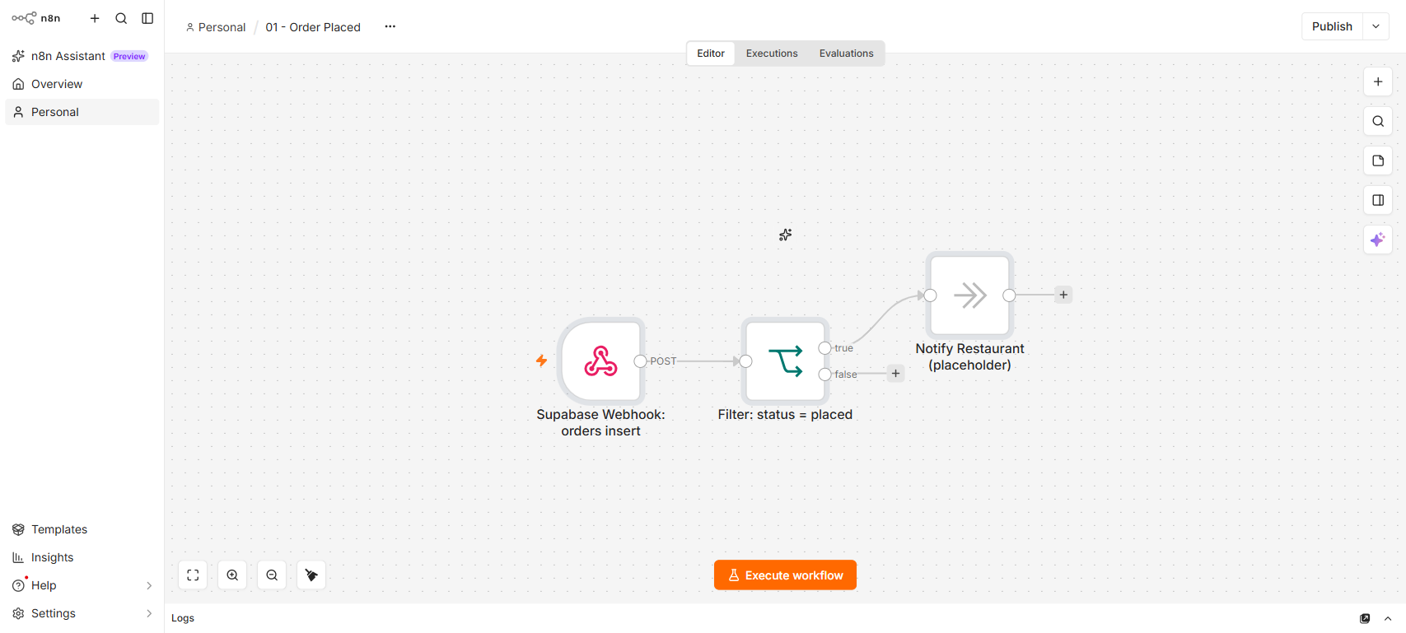
Full canvas: Supabase Webhook → Filter: status = placed → Notify Restaurant (placeholder).

Node 1 — Supabase Webhook: orders insert
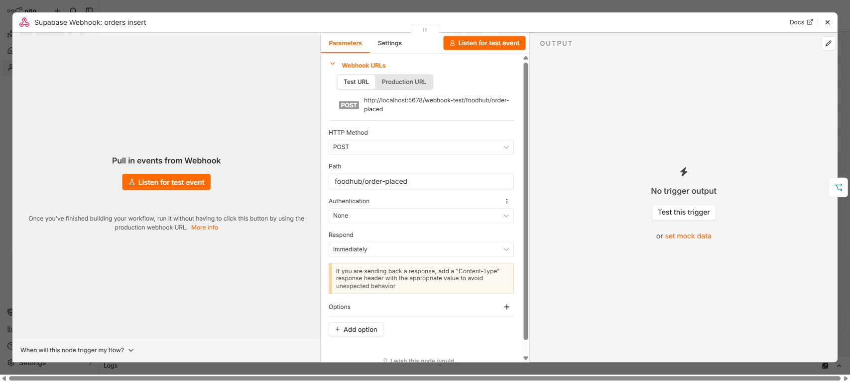
Webhook node. Path: foodhub/order-placed. HTTP Method: POST. Authentication: None (secured at the app-route layer for the two workflows that call back into the app; this trigger node itself just receives Supabase's payload).

Node 2 — Filter: status = placed
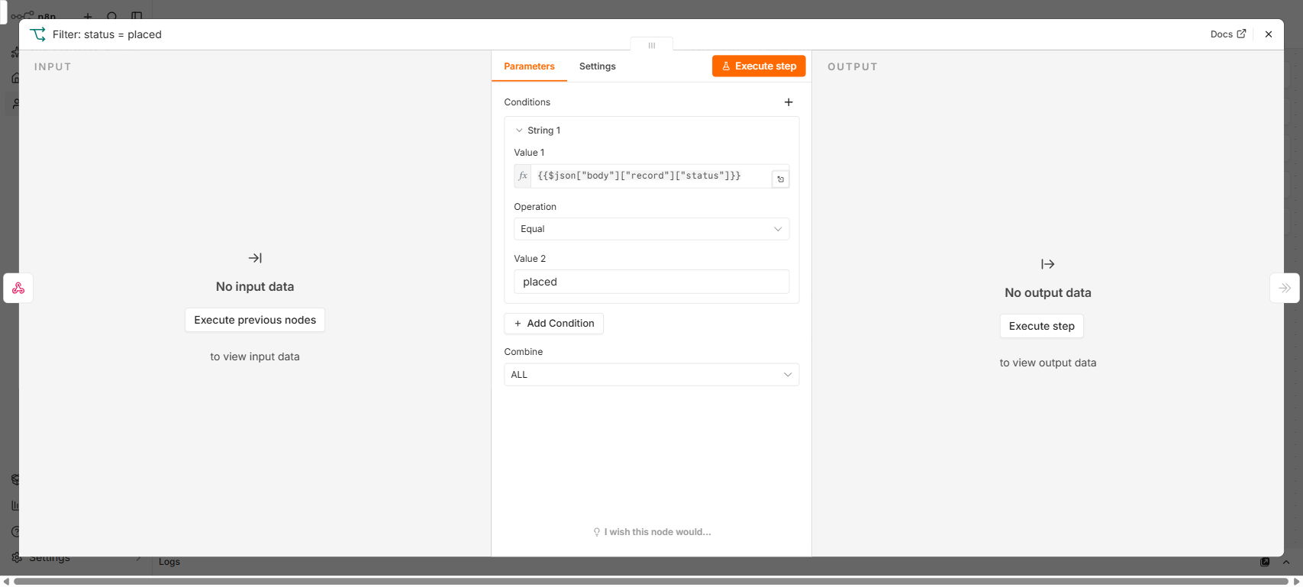
IF node. Narrows the INSERT payload to rows where record.status equals "placed".

Node 3 — Notify Restaurant (placeholder)
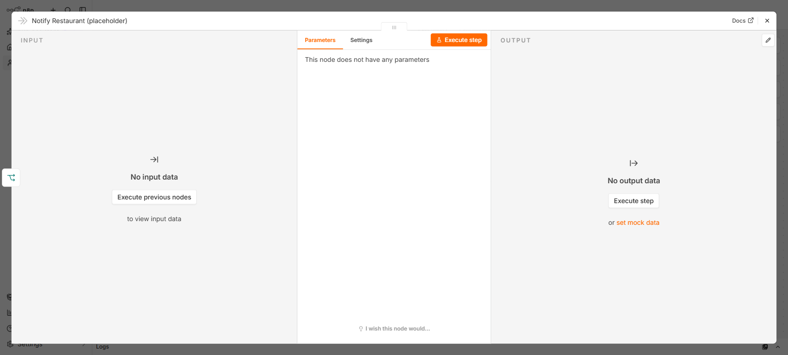
No-op placeholder — replace with a real notification node (email/SMS/push) when that channel exists.

Test
Place a real order through /customer/checkout. Expect: webhook fires on the orders INSERT, filter passes (status is placed on insert), placeholder node executes — check n8n's execution log, there's no visible in-app effect yet.

5. Workflow 02 — Payment Mock Confirmation
Trigger: Supabase Database Webhook on payments INSERT. Simulates a gateway delay, decides success/failure by a weighted random roll, then POSTs the result back to this app's internal API.
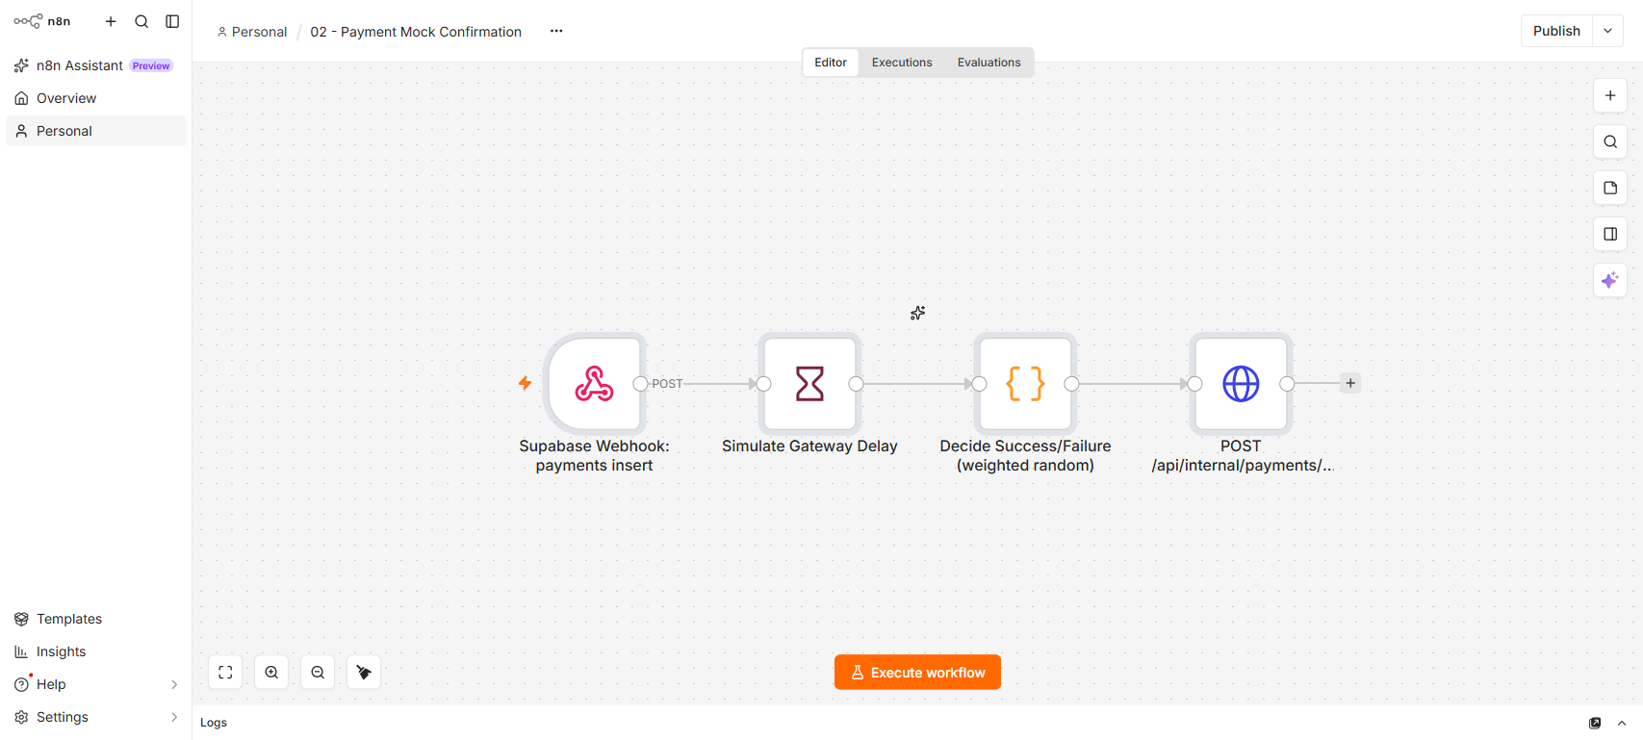
Full canvas: Supabase Webhook → Simulate Gateway Delay → Decide Success/Failure (weighted random) → POST /api/internal/payments/:id/result.

Node 1 — Supabase Webhook: payments insert
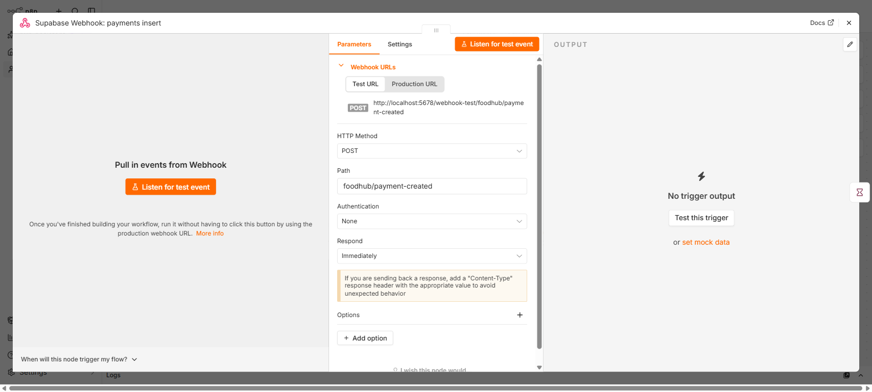

Node 2 — Simulate Gateway Delay
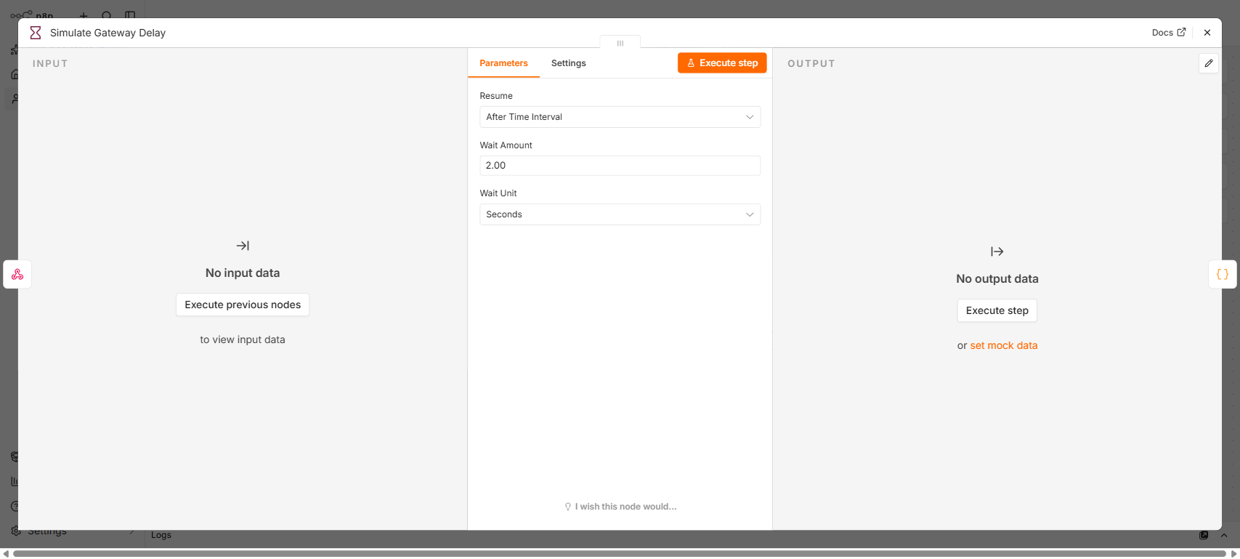
Wait node — mimics a real payment gateway's response latency before resolving.

Node 3 — Decide Success/Failure (weighted random)
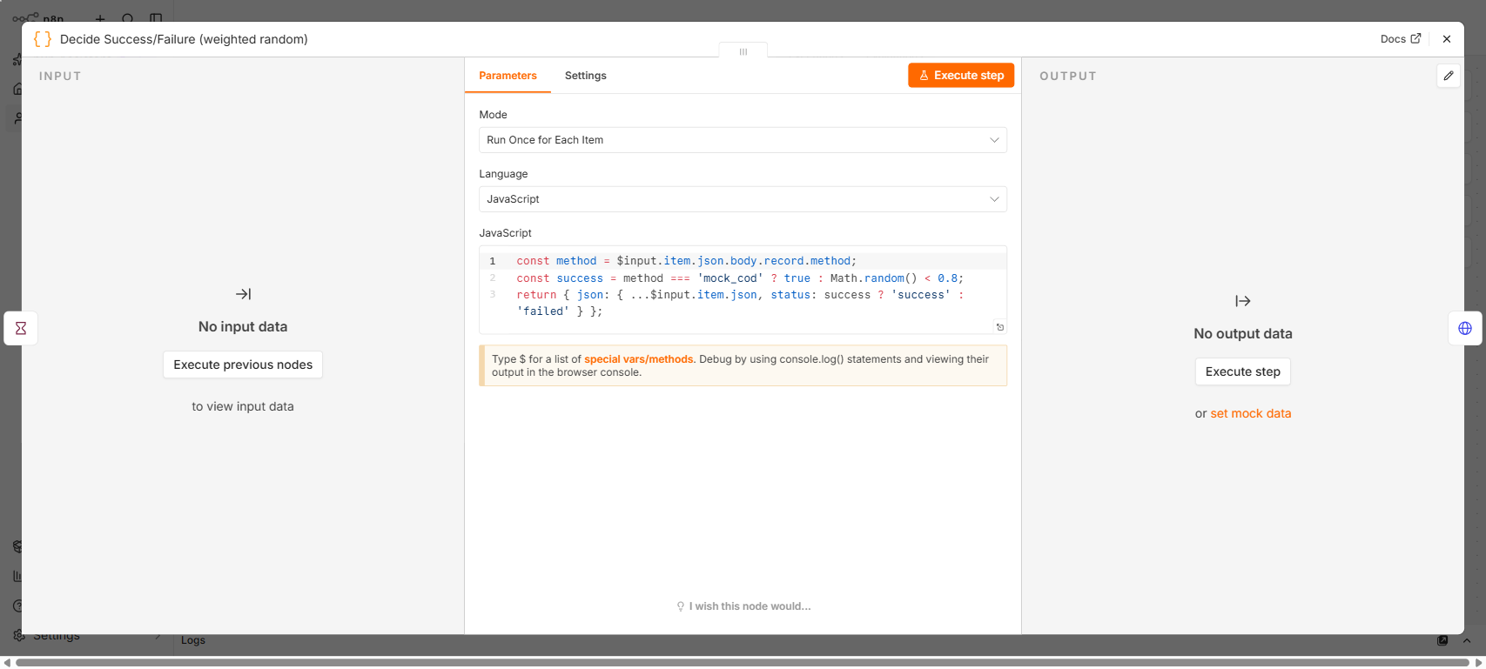
Code node, Run Once for Each Item mode. Cash-on-delivery always succeeds; card/UPI resolve success ~80% of the time via Math.random().

Node 4 — POST /api/internal/payments/:id/result
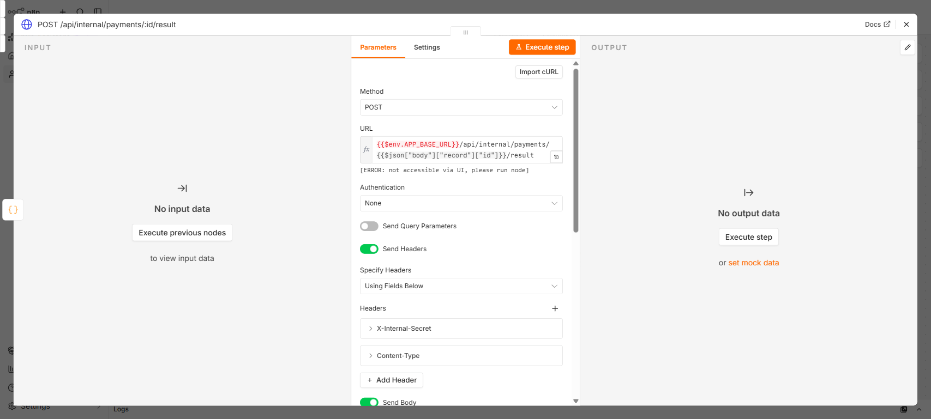
HTTP Request node. Calls this app's internal API with the X-Internal-Secret header to record the resolved payment status.

Important — do not activate yet
This workflow is inert against the current checkout flow: Phase 3's checkout already inserts payments with a final status (success/failed), never pending, so this workflow's INSERT-triggered logic has nothing to act on (the payment-result route's own .eq("status","pending") guard rejects it). Only activate after changing checkout to insert payments as pending instead of resolving synchronously.

Test (once checkout is changed to insert pending payments)
Place an order and confirm the payment's status updates from pending to success/failed a couple of seconds later.

6. Workflow 03 — Restaurant Accepts / Status Change
Trigger: Supabase Database Webhook on orders UPDATE. Filters to status in (accepted, preparing, ready), then hits a placeholder notification node.
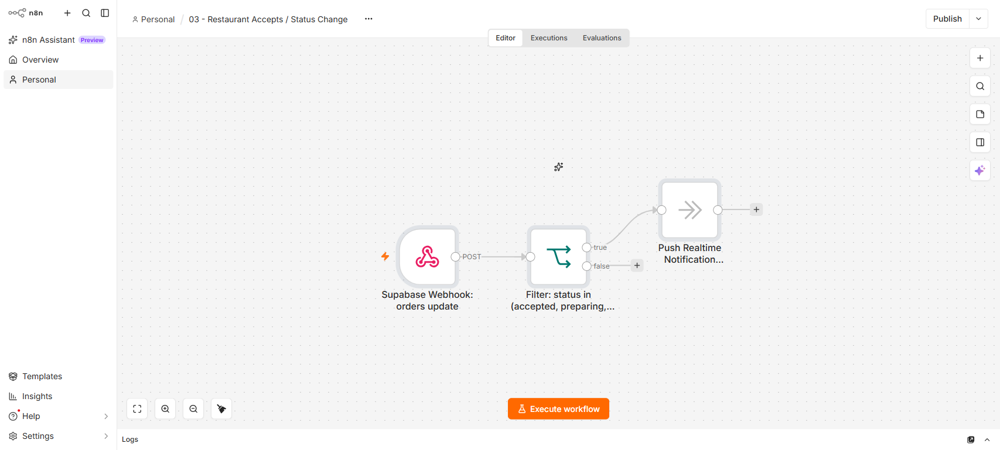
Full canvas: Supabase Webhook → Filter: status in (accepted, preparing, ready) → Push Realtime Notification (placeholder).

Node 1 — Supabase Webhook: orders update
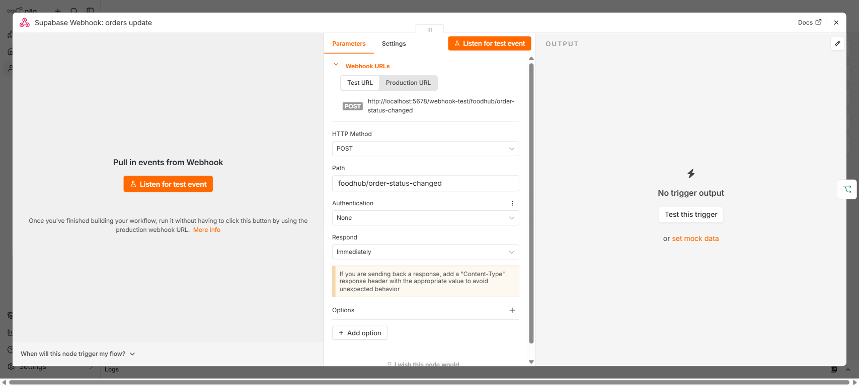

Node 2 — Filter: status in (accepted, preparing, ready)
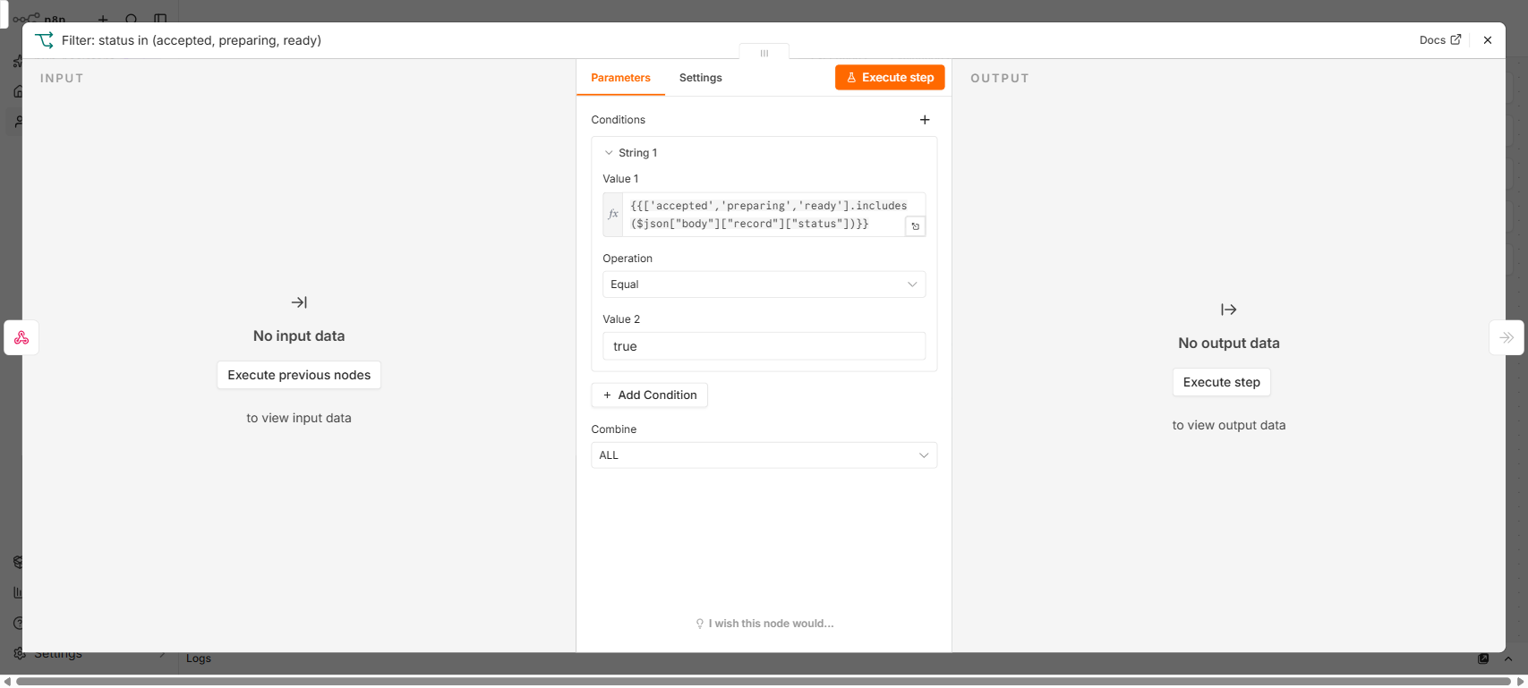

Node 3 — Push Realtime Notification (placeholder)
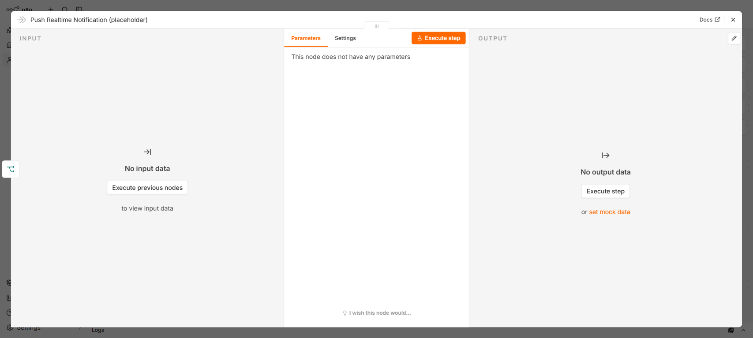

Test
As the seeded vendor, advance an order through /vendor/orders (accept → preparing → ready). Expect: webhook fires on each orders UPDATE, filter passes for each of the three statuses, placeholder node executes. The customer's own order page already reflects the status change via its independent 3-second poll — this workflow doesn't need to work for that to be true.

7. Workflow 04 — Delivery Partner Assignment
Trigger: Supabase Database Webhook on orders UPDATE. Filters to status = ready, fetches the restaurant's lat/lng, requests nearest-first candidate delivery partners, guards against an empty candidate list, then assigns the nearest online partner.
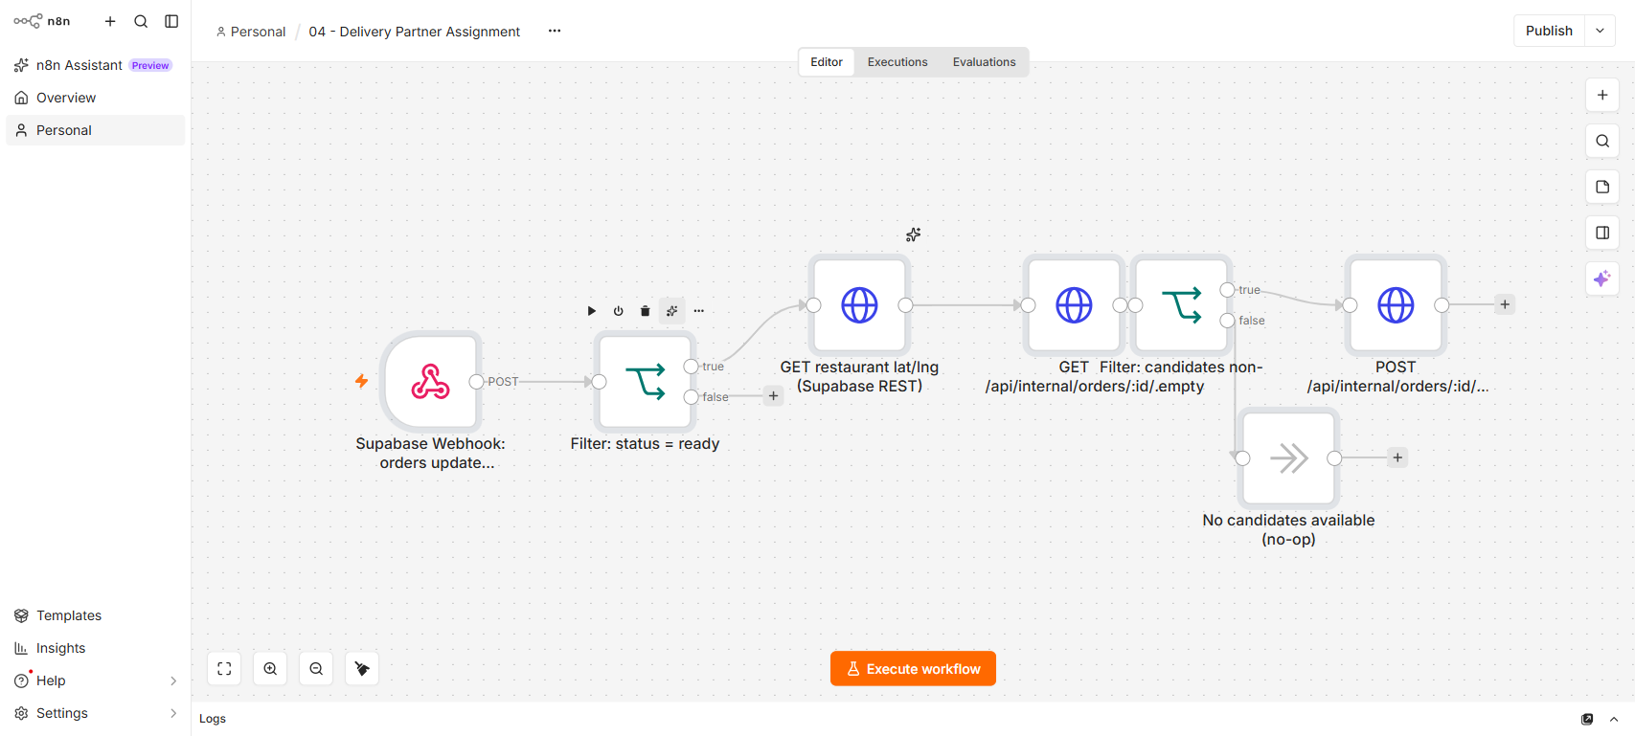
Full canvas — the longest of the five workflows, 7 nodes with a branch for the no-candidates case.

Node 1 — Supabase Webhook: orders update
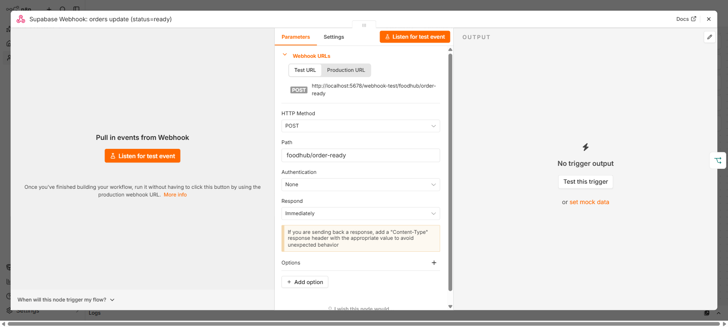

Node 2 — Filter: status = ready
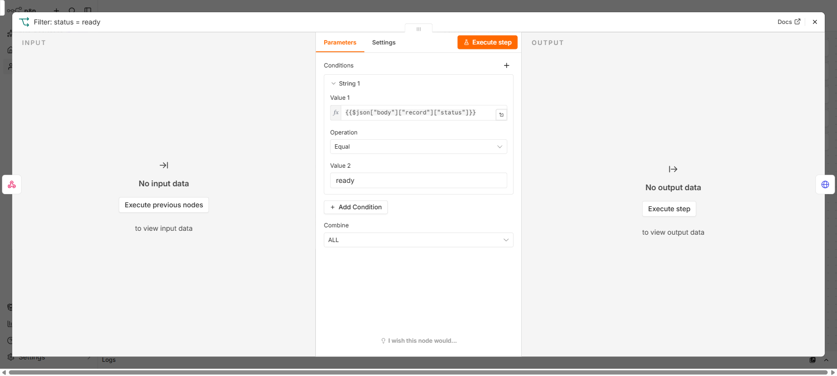

Node 3 — GET restaurant lat/lng (Supabase REST)
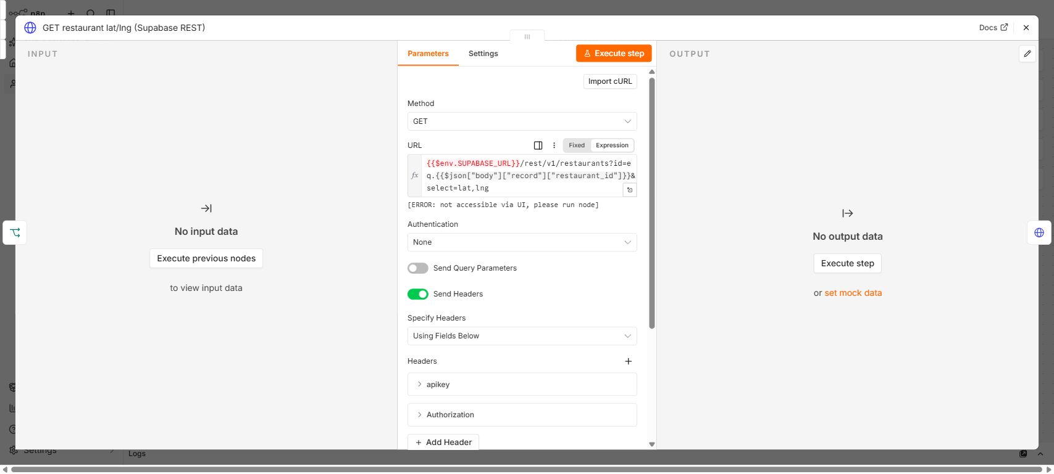
Direct Supabase REST call using SUPABASE_URL/SUPABASE_SERVICE_ROLE_KEY from n8n's environment — not routed through this app.

Node 4 — GET /api/internal/orders/:id/assign
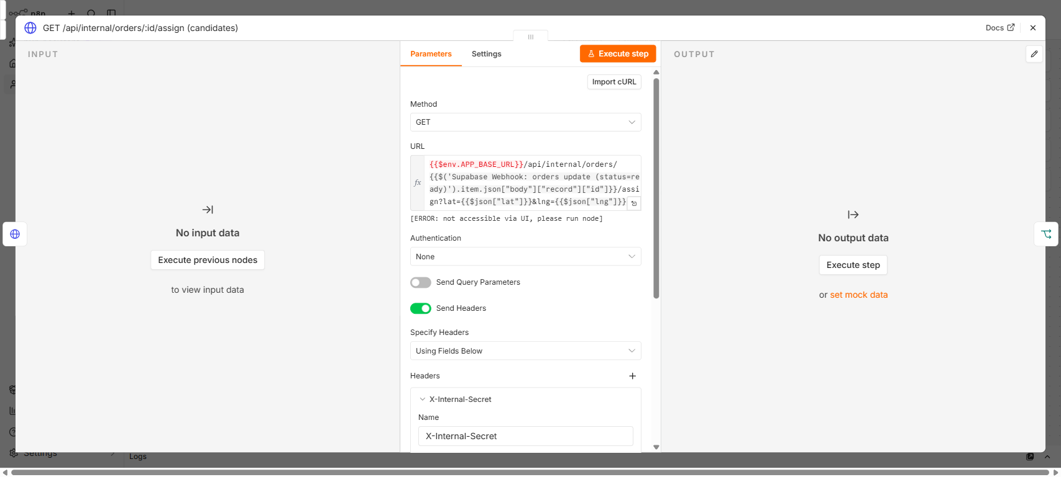
Calls this app's candidates-by-distance endpoint (uses the existing haversineDistanceKm helper), nearest online partner first.

Node 5 — Filter: candidates non-empty
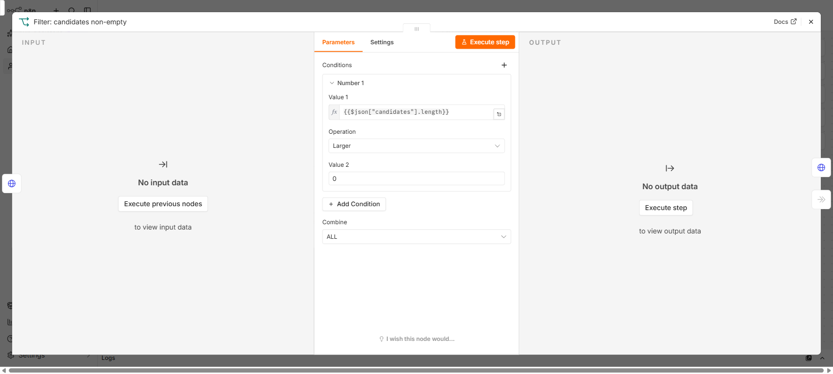
Empty-candidates guard — added after a review caught the original version would have POSTed with an undefined deliveryPartnerId when nobody was online.

Node 6 — POST /api/internal/orders/:id/assign (nearest)
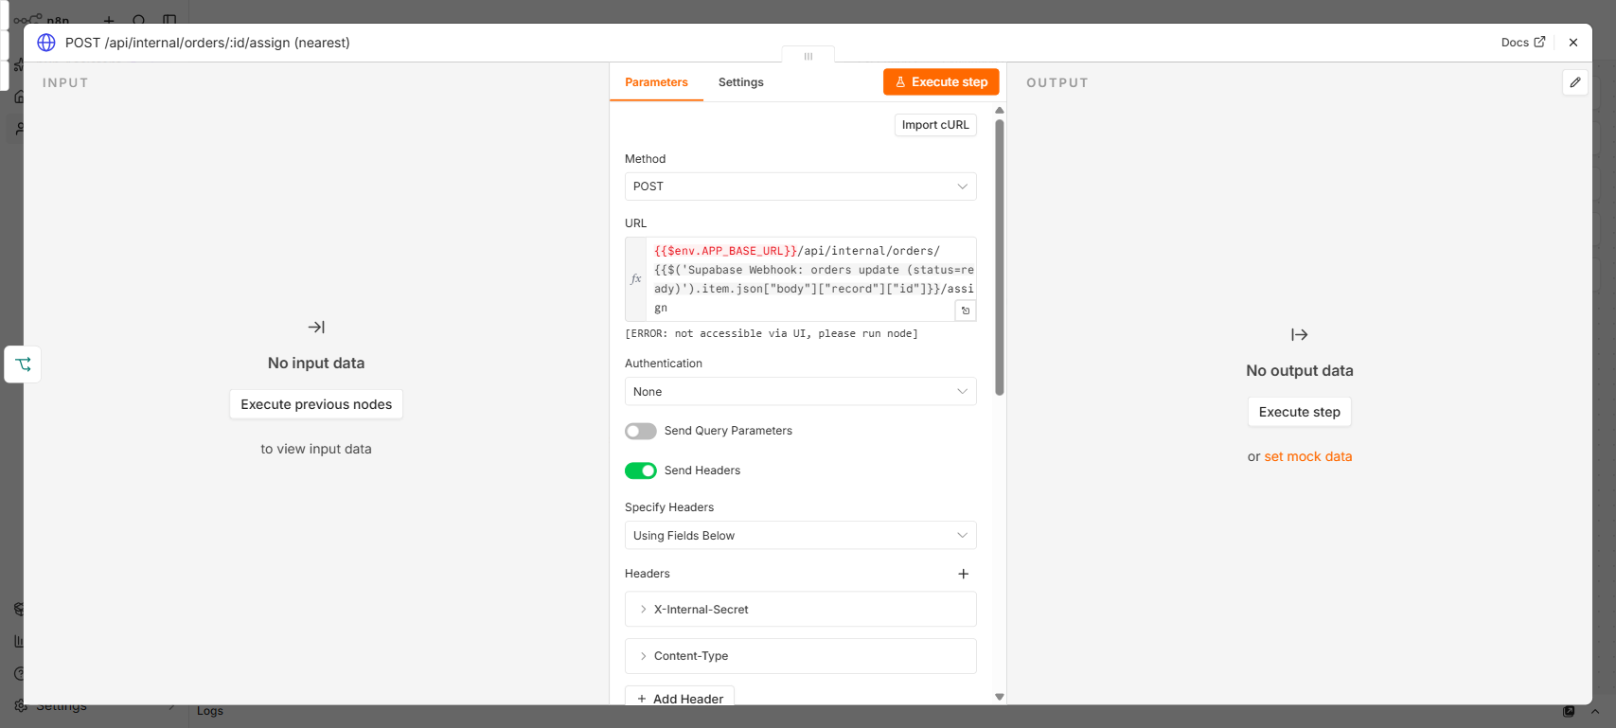
Assigns the order to the nearest online candidate returned by node 4.

Node 7 — No candidates available (no-op)
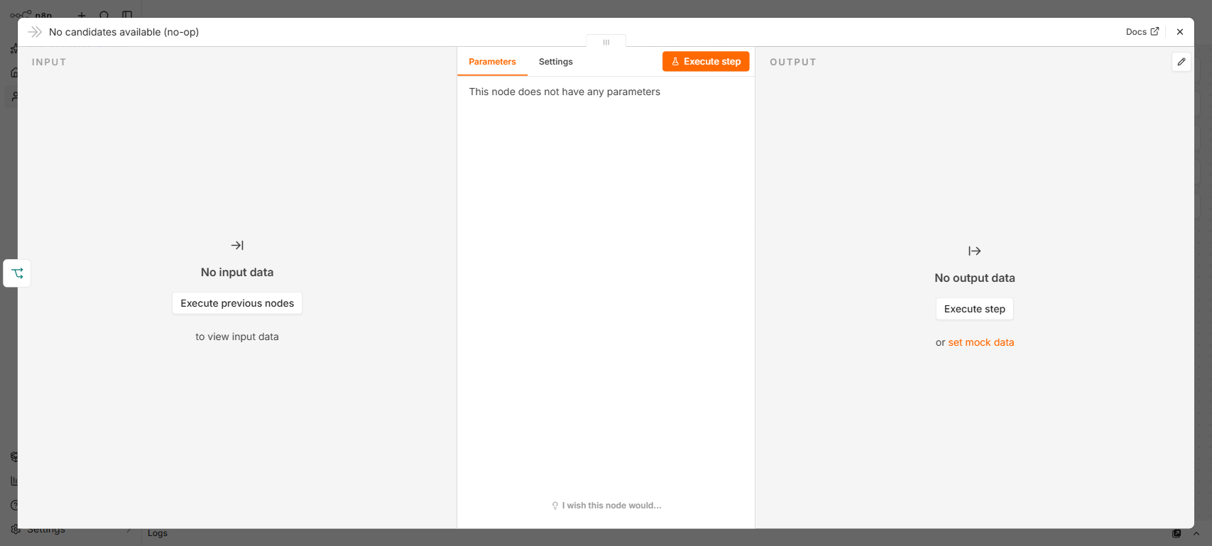
Branch taken when node 5's filter finds zero online candidates — intentionally does nothing further.

Test
Advance an order to ready as the vendor, with at least one delivery partner online (/delivery/dashboard, toggle online). Expect: webhook fires, filter passes, restaurant lat/lng fetched, GET /assign returns nearest-first candidates, empty-candidates guard passes, POST /assign assigns the order — check orders.delivery_partner_id and orders.status (assigned) in Supabase Studio, or that the order disappears from other partners' “Available orders” list.
Also test the empty-candidates path: advance an order to ready with zero partners online, and confirm the execution log shows the “No candidates available (no-op)” branch instead of a POST with an undefined deliveryPartnerId.

8. Workflow 05 — Delivery Status Propagation
Trigger: Supabase Database Webhook on orders UPDATE. Filters to status in (picked_up, delivered) for a realtime push, and separately to status = delivered for a second placeholder step.
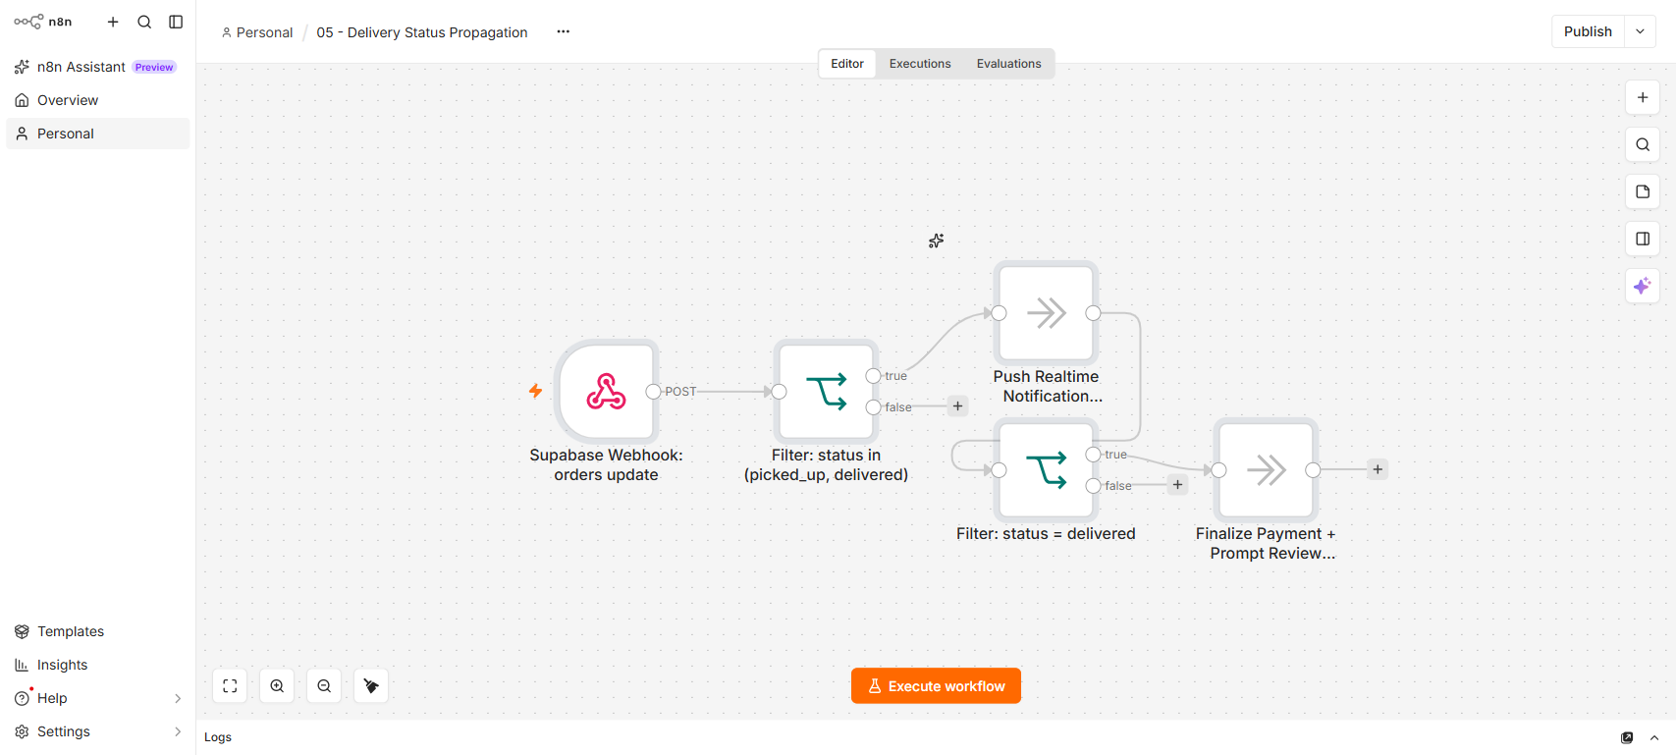
Full canvas: Supabase Webhook → Filter: status in (picked_up, delivered) → Push Realtime Notification, with a second Filter: status = delivered → Finalize Payment + Prompt Review branch.

Node 1 — Supabase Webhook: orders update
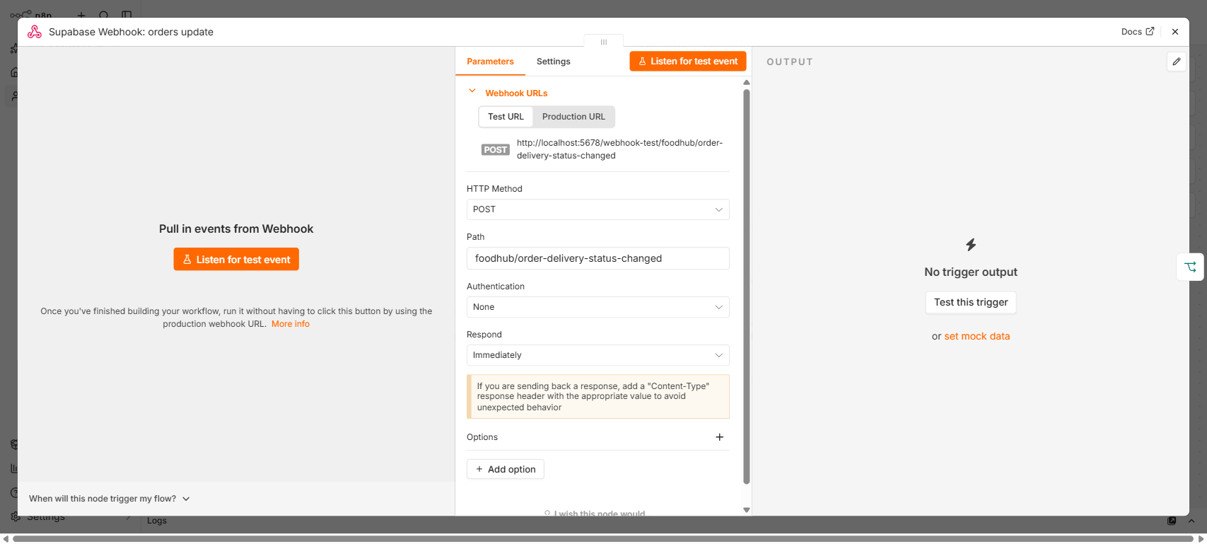

Node 2 — Filter: status in (picked_up, delivered)
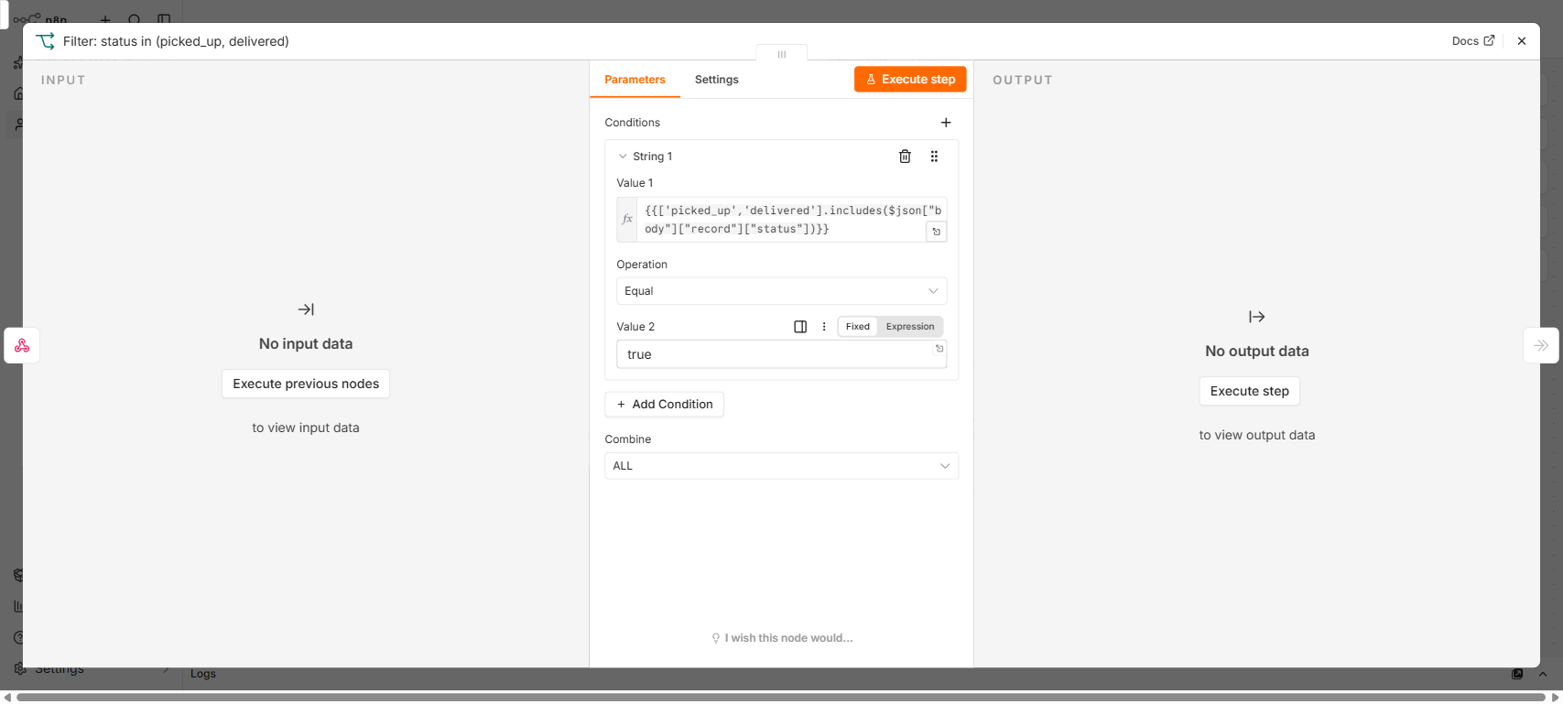

Node 3 — Push Realtime Notification (placeholder)
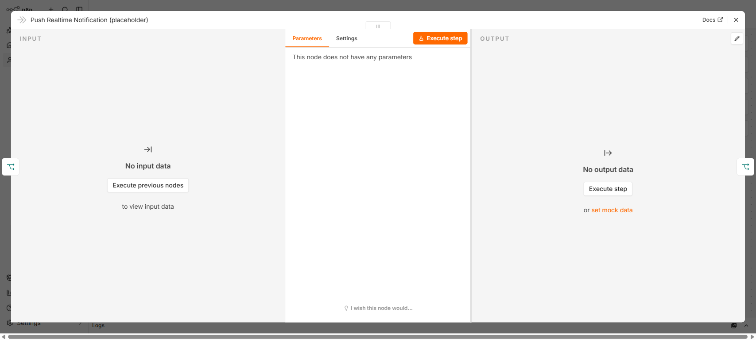

Node 4 — Filter: status = delivered
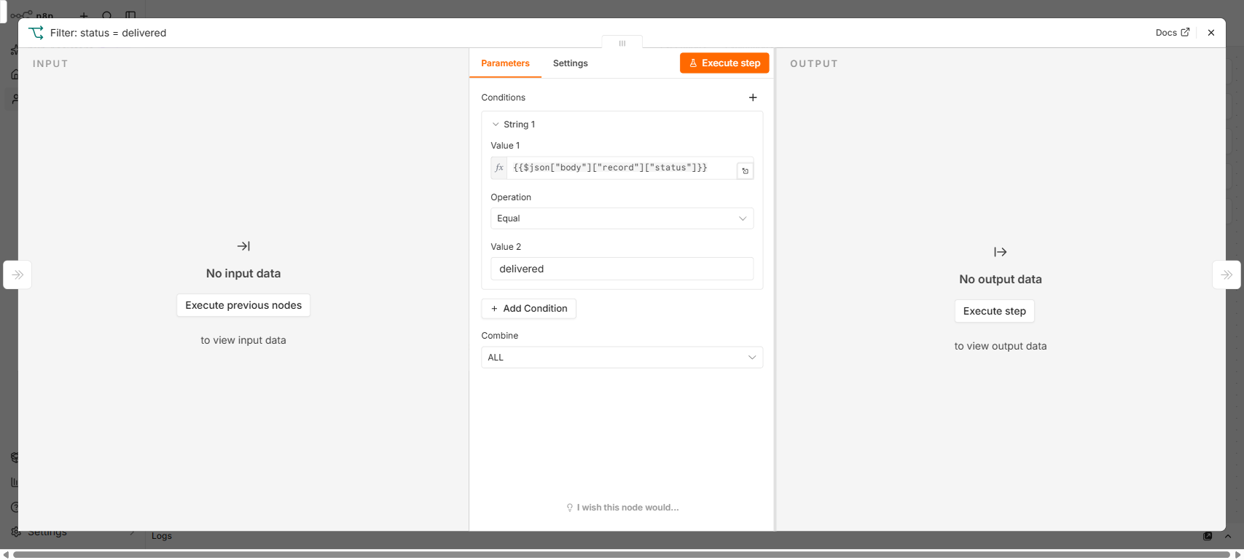
Second, narrower filter — only delivered continues to node 5.

Node 5 — Finalize Payment + Prompt Review (placeholder)
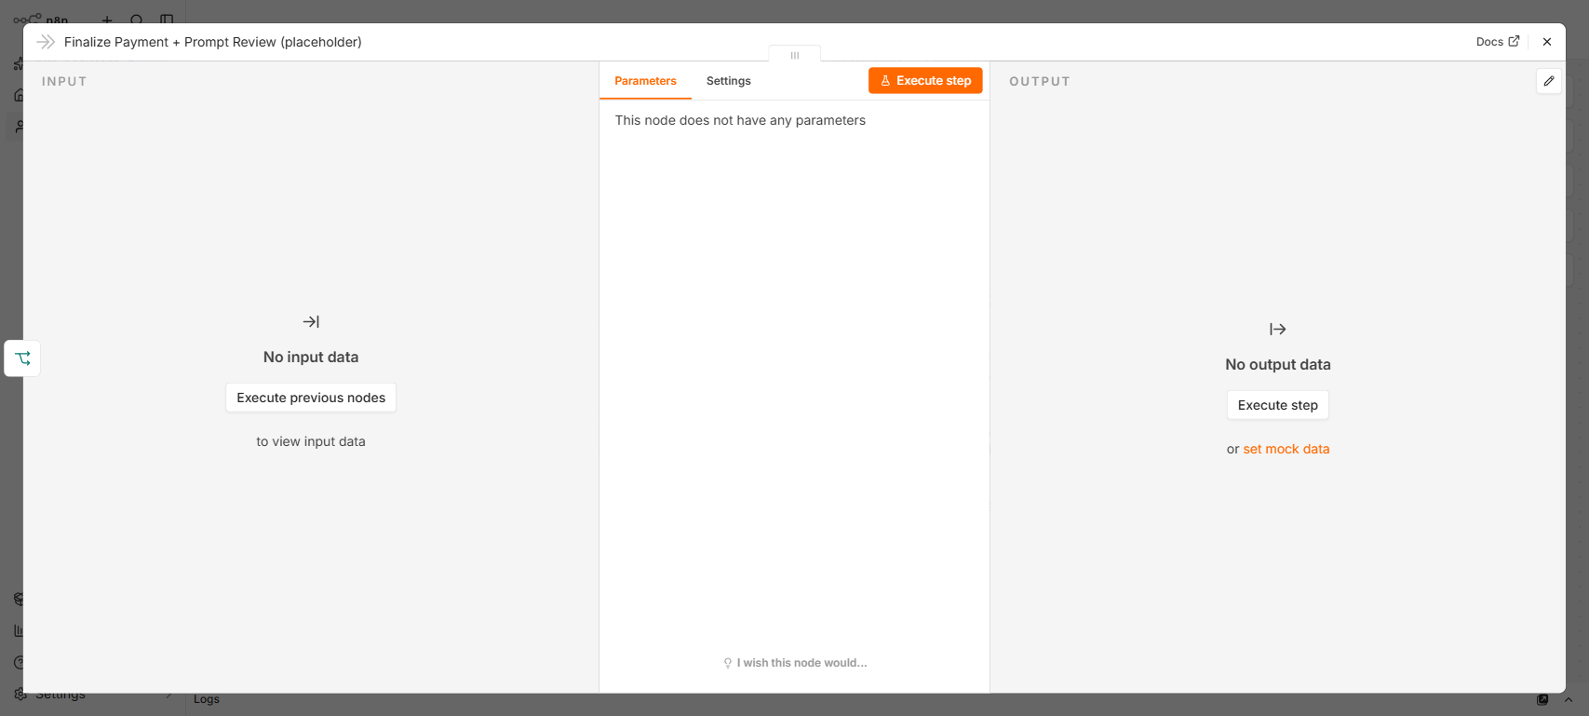
Still a no-op — see this node's own notes field in the JSON for the unresolved design question around what “finalize” should do, since checkout already resolves payment at order time, not delivery time.

Test
As the delivery partner, advance an order through /delivery/dashboard (picked up → delivered). Expect: webhook fires on each orders UPDATE, filter passes for picked_up/delivered, placeholder notification executes, and on delivered specifically the second filter also passes to the Finalize Payment + Prompt Review placeholder.

9. Activation order
None of the 5 workflows depend on another workflow having run first — each is an independent webhook listener. Activate them in any order, including one at a time to test incrementally.
Only workflows 2 and 4 have HTTP Request nodes that call this app, so only those two need APP_BASE_URL and N8N_INTERNAL_SECRET correctly set (workflow 4 also needs SUPABASE_URL/SUPABASE_SERVICE_ROLE_KEY). Workflows 1, 3, and 5 only have webhook/filter/no-op nodes and have no environment-variable dependency.

10. Testing before activation
Before a workflow is active, n8n only serves its webhook on the /webhook-test/... path (click the webhook node's “Listen for test event” button first) — the production /webhook/... path only responds once the workflow's active flag is true.
To test end-to-end against the real Supabase webhook before activating: either temporarily point the Supabase Database Webhook at /webhook-test/... and switch to /webhook/... once you activate, or activate first and test against production from the start. Testing against /webhook-test/... is the safer choice if you don't want a possibly-broken workflow firing on real production events while debugging.

11. Once verified, activate
Only flip a workflow's active flag to true after its test in the relevant workflow section above passes. Activating before environment variables are correctly set (most commonly APP_BASE_URL pointing at an unreachable host) means it will fire on every matching Supabase event and silently fail — check n8n's execution log for red (failed) runs after activating, not just that the webhook received a request.

