Homework #1
CS 5665, Fall 2016

1. Describe data transformation, issues faced and how you resolved ?
Below mentioned is common over all task.
+ Transformation:
- For loading used Pandas lib from python.
- For performing numerical operations numpy lib in python.
- For plotting figures (boxplot, scatter plot) used matplotlib.
- For performing scientific calculation (distance metrics, Cosine similarity) used SciPy
+ Issues:
- Blank values/NaN data/Empty strings: Calculated the mean of data and replaced with mean.
- Zero for electricity or water usage for buildings: Calculated mean of data and replaced Zero's with mean.
- Mean value seems more logical to replace NaN/Zero values.

2. Water Usage Analysis:

Box plot for Water Usage for all buildings:

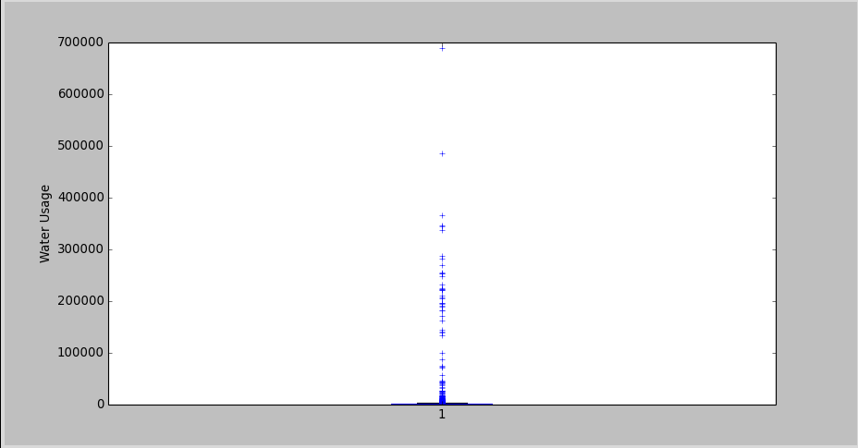

Mean = 6989.44077816
Median = 227.95
Mode = 165.0

# Top 5 departments
# California Department of Transportation : 443
# California Department of Forestry and Fire Protection: 313
# Department of Parks and Recreation: 208
# California Highway Patrol: 107
# California Military Department: 103

California Department of Transportation
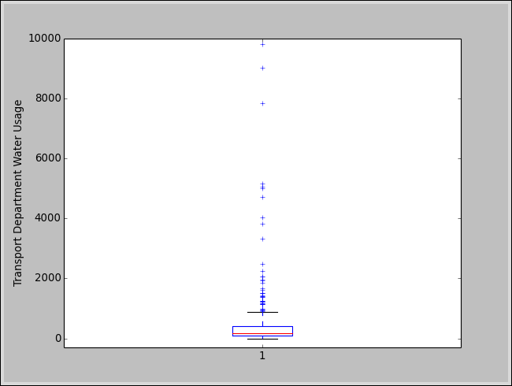

Mean = 508.076543651
Median =165.0
Mode = 165.0

California Department of Forestry and Fire Protection

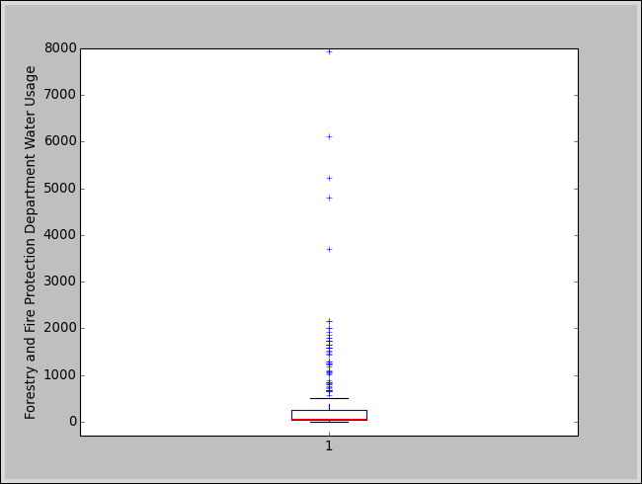

Mean = 508.295613919
Median = 63.3
Mode = 51.5

Department of Parks and Recreation

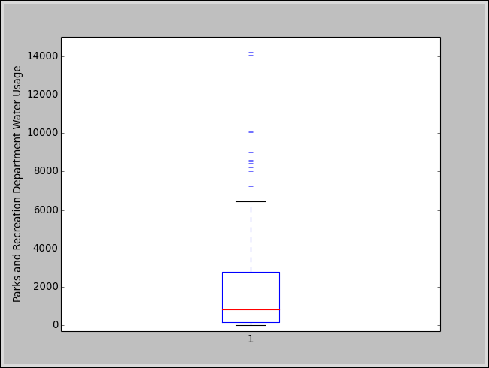

Mean = 2737.91080504
Median = 845.3
Mode = 165.0

California Highway Patrol

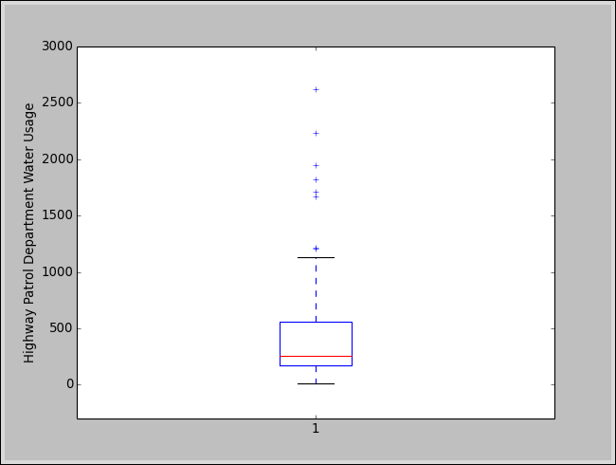

Mean = 1127.77669903
Median = 256.7
Mode = 165.0

California Military Department

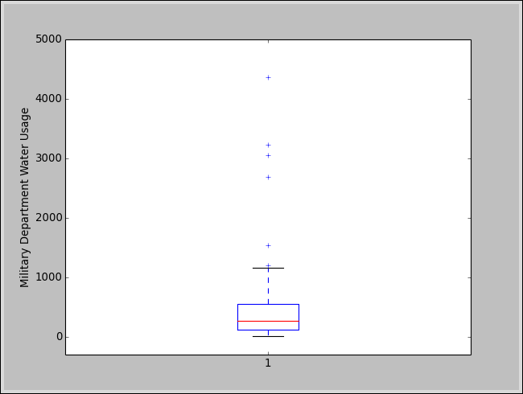

Mean = 481.769447196
Median = 271.9
Mode = 459.465306122

Water Usage Box plot without outliers.

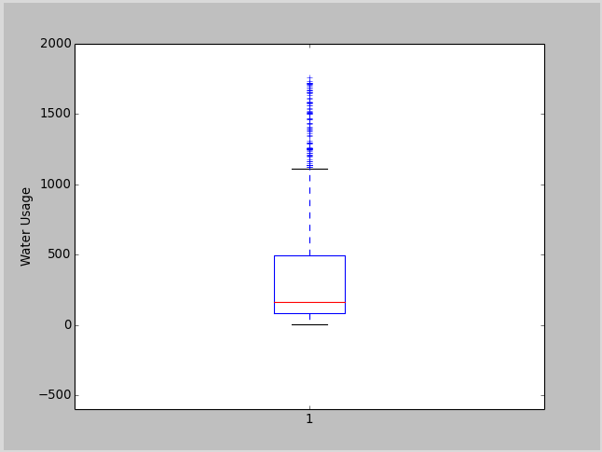
In this case, outliers are anything beyond ±1.5*IQR (InterQuartile Range)

Mean, Median, Mode for data without outliers.
Mean = 350.485376662
Median = 165.0
Mode = 165.0

With outliers
Mean = 6989.44077816
Median = 227.95
Mode = 165.0

Measures of central tendency with removal of outliers are more stable and box plot also reveals it.

2. Resource Usage Correlation:

Relation between Water use and Electricity use of buildings
Pearson Correlation
(0.66577579621732319)

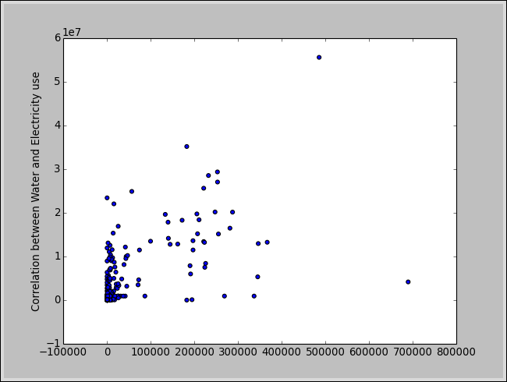

# Top 5 departments
# California Department of Transportation : 443
# California Department of Forestry and Fire Protection: 313
# Department of Parks and Recreation: 208
# California Highway Patrol: 107
# California Military Department: 103

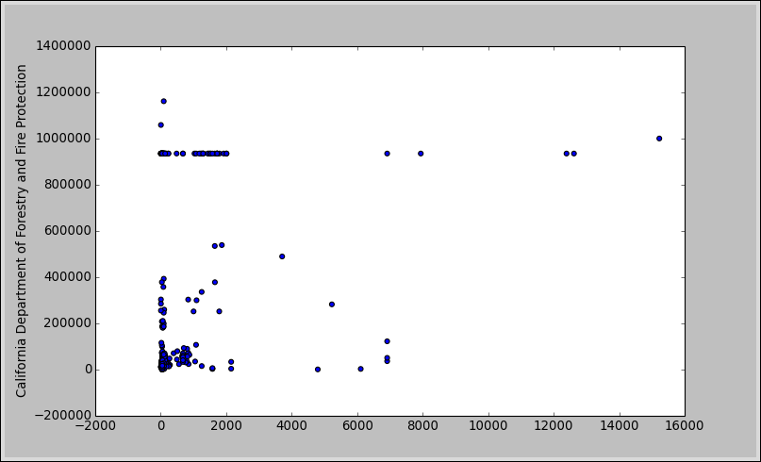
California Department of Forestry and Fire Protection

Pearson Correlation
(0.22651218901438014)

California Department of Transportation

Pearson Correlation
(0.55080708827781)

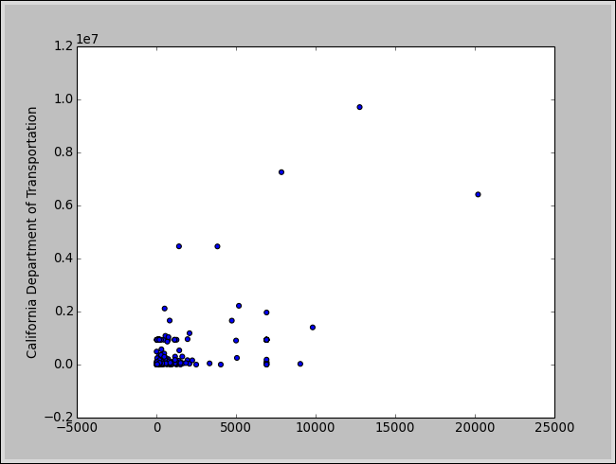

California Highway Patrol
Pearson Correlation
(0.81679260770973405)
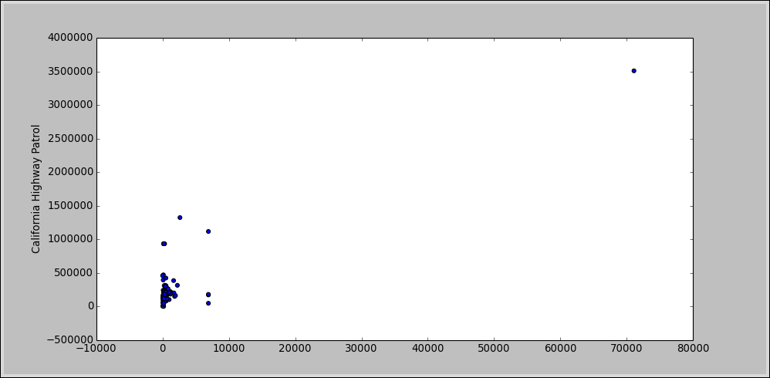

Department of Parks and Recreation:
Pearson Correlation
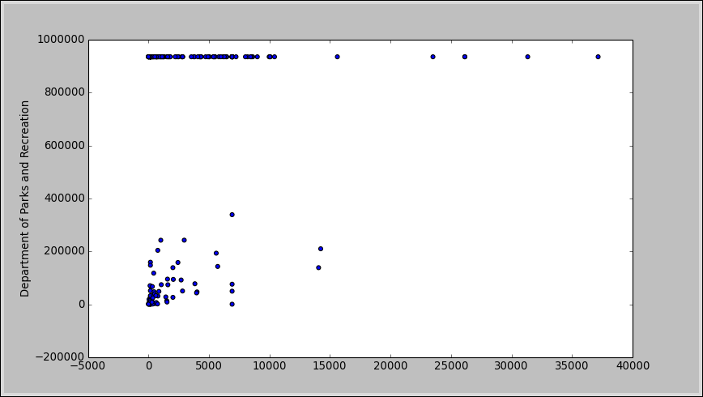
(0.15526842027669963)

California Military Department
Pearson Correlation
(0.18718108469273598)
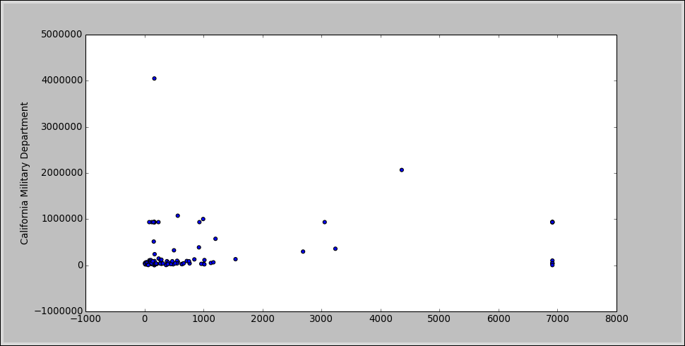

Conclusion:
Buildings of California Department of Transportation have most correlated Water and Electricity usage and buildings of Department of Parks and Recreation have least correlated Water and Electricity usage.

3. Building Similarities.
+ Transformation for nominal data:
- Unique value to each nominal data.

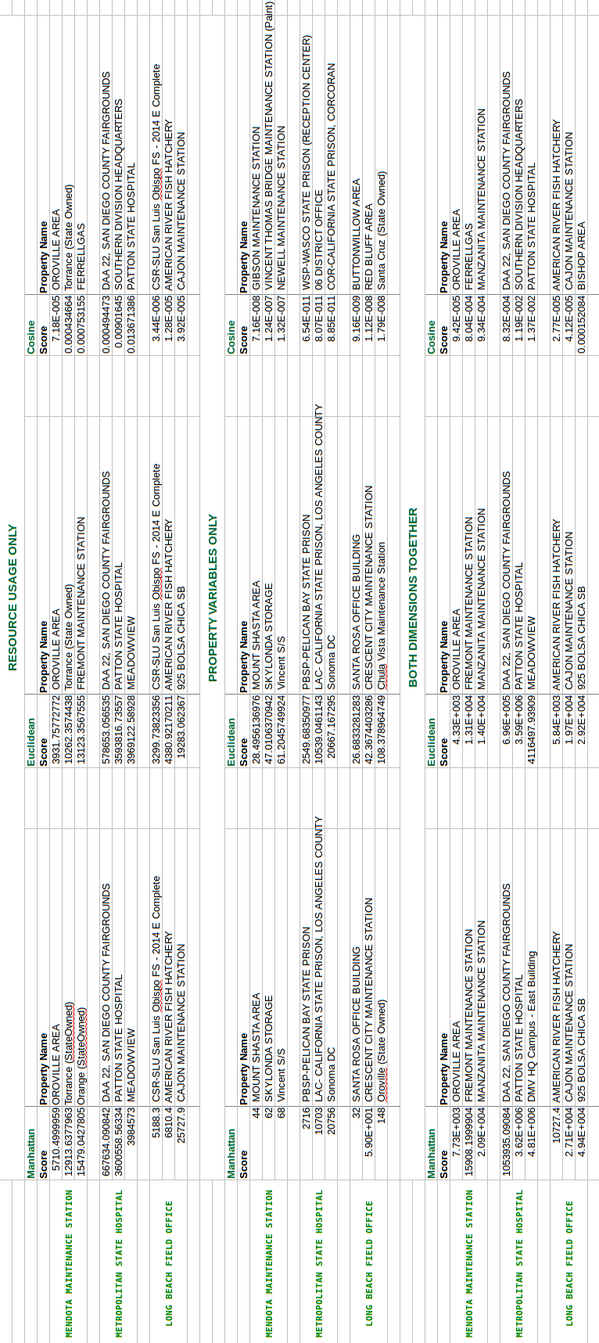

#dept_names ##37
#city_names ##847
#prop_type_names ##1722
#prop_area_names ##1557

There is no ground truth to measure performance. In this case where data is quantitative, either of the distance measure will perform better. As in the results is shows they have same result for ALMOST all the cases.

In terms of dimension, more is better but again there is no ground truth. In this case, I would assume merging both dimension together will perform best.

