1. Created a ASP.net web API with api (included controllers)

2. Integrating Swagger by installing 4 components from

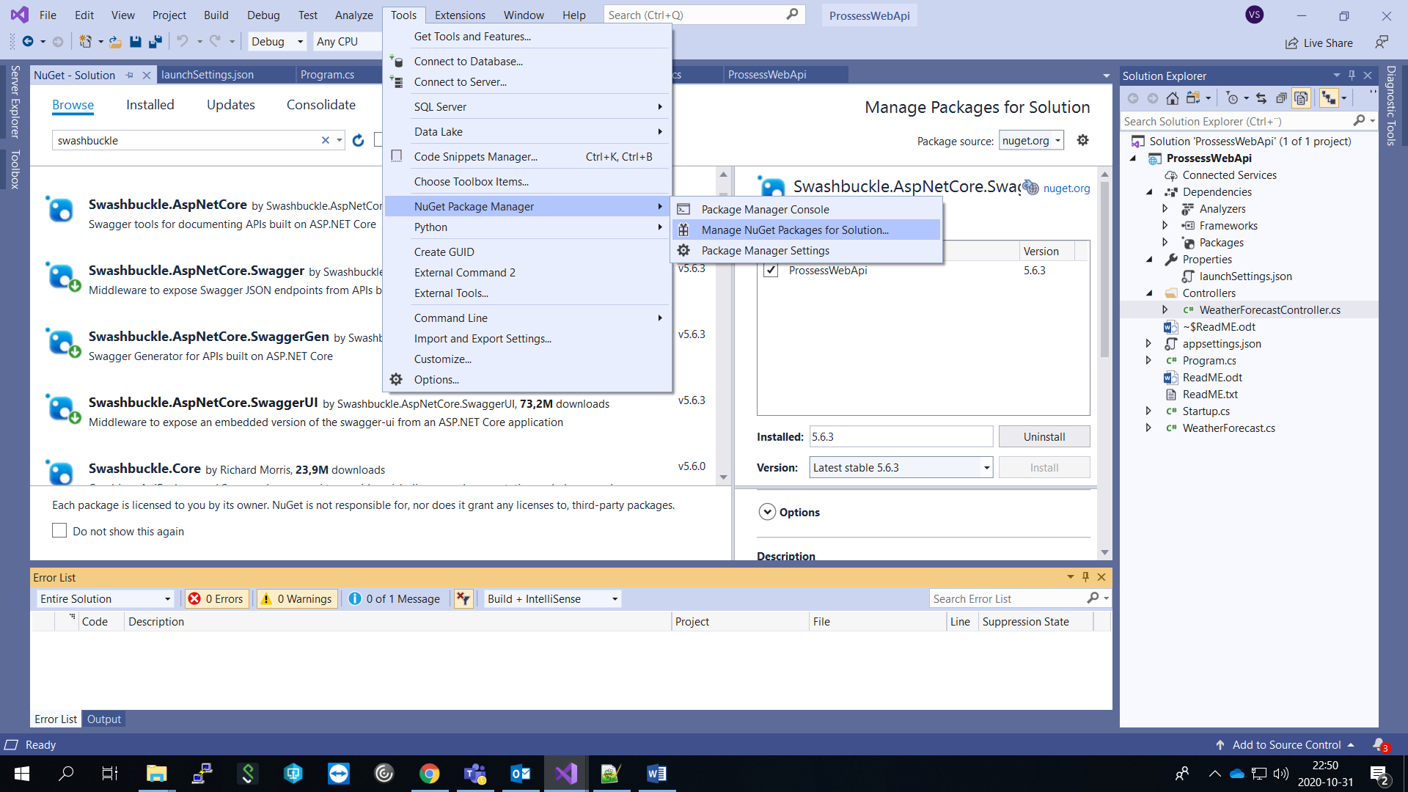

1. [Swashbuckle.AspNetCore.Swagger](https://www.nuget.org/packages/Swashbuckle.AspNetCore.Swagger/)

2. [Swashbuckle.AspNetCore.SwaggerGen](https://www.nuget.org/packages/Swashbuckle.AspNetCore.SwaggerGen/)

3. [Swashbuckle.AspNetCore.SwaggerUI](https://www.nuget.org/packages/Swashbuckle.AspNetCore.SwaggerUI/)

4. Install-Package Swashbuckle.AspNetCore

3. Add following namespaces

using Microsoft.Extensions.Logging;

using System.Reflection;

using System.IO;

using Microsoft.OpenApi.Models;

4. Add and configure Swagger in Startup.cs  
  
