Technical Expertise Document (TED)


This document of Cybage Software Pvt. Ltd. is for restricted circulation. No part of this publication may be reproduced, stored in a retrieval system or transmitted in any form or by any means – recording, photocopying, electronic and mechanical, without prior written permission of Cybage Software Pvt. Ltd.
Document name | Technical Expertise Document  OSGi_Benelog_Tokioo
Version no. | 1.0
Release date | 15-Jul-13
Document ID | S/DEP/TED
Classification | Departmental

Document history

Ver. No | Release Date | Created By / Modified By and Date | Reviewed By and Date | Approved By and Date | Remarks and Changes Made
1 | 19-Jul-13 | Vishal Shukla / 19-Jul-13 |  |  | Initial draft.

Distribution List

Sr. No. | Name | Role | Organization Name
1.
2.
3.
4.
5.

Table of Contents
1. Introduction 4
1.1 Objectives of the Document 4
1.2 Acronyms and Definitions 4
2. Features Used 4
3. Problem Statement 5
4. Technology Evaluation 5
5. Solution Approach 5
6. Challenges/Limitations 5
7. Benchmarking Metrics 6

Introduction
This document will be used to demonstrate technical expertise to stakeholders like potential/existing client that Cybage possesses for the OSGi.

Objectives of the Document
The purpose of this document is to
- Provide list of features used for the given technology
- Identify the kind of problem the given technology was used to address
- Highlight competing technologies, which were considered for the evaluation purpose
- Demonstrate how the given technology can be used to solve the problem
- Identify challenges/limitations of using the given technology
- Provide benchmarking metrics for the given technology, if applicable

Acronyms and Definitions
Sr. No. | Acronyms | Definitions
1 | OSGi | Open Service Gateway Initiative
2 | Spring DM | Spring DynamicModules
3 | CM | Configuration Management
4 | EJB | Enterprise JavaBeans

Features Used
This section covers the list of features used for the given technology in Cybage.

Core OSGi Features:
- Code visibility
- Integration with Maven & Eclipse using Tycho
- Embedding bundles
- Importing/exporting packages
- Developing API bundles
- Developing Service provider bundles
- Developing Service consumer bundles
- Using life-cycle callback features & API
- Managed Service
- Bundling external jars as OSGi third-party bundles

Spring DM Features:
- Declaratively expose spring bean as OSGi services
- Inject OSGi services as spring bean and consume in other beans
- Use Compendium services for Configuration Management

Equinox Container

Problem Statement
This section describes the problem statement, which the technology aims to address.

The project is in a social networking domain, which demands for high availability, high scalability. As the application interacts with user’s personalized storage and social accounts for synchronization of Big Data, it will be required to have module-wise scalability, for example, only scaling facebook, twitter social connector modules and running 4shared, MyDrive connectors in the same server. Recommendation engine module may be deployed as separate clusters depending on usage of particular connectors.

To make it easy to keep the application evolving with changing end user needs and business requirements, it is common to assemble a product from a set of well-defined re-usable components. the driver for modularity and subsequent assembly is to; increase and maintain quality, reduce cost and increase output. Specifically, when the application goes large (such as more than 150), it gets difficult for large team to retain original design goals of different modules and ends up in spaghetti code. Runtime modularity can make sure ensure high code quality in this type of situations.

Moreover, the application needs ability to upgrade module or functionality without any downtime. It gets a lot easier to maintain such systems when having independent versioning of each module and also have multiple versions running at the same time for different dependent modules.

Technology Evaluation
This section highlights competing technologies, which were considered for the evaluation purpose.

Out of above mentioned problems, modularity enforcement, dynamic deployments and horizontal scalability are major evaluation criteria. There are no major competitors of OSGi in java space to resolve all of these problems. However, there are few technologies which can help to mimic some behaviors as separately.

Horizontal scalability and n-tier architecture can be achieved using SOA architecture style. Dynamic deployment can be mimicked with deployment strategy of HotSwap of load balancer.

Solution Approach
This section demonstrates how the given technology can be used to solve the problem statement.

Modularity:
OSGi adds new capability to java jar files, OSGi bundles, which carries additional metadata for OSGi container. This allows OSGi bundles to hide packages from out-side world and gain granular level of visibility control. This makes it easy to design application in terms of API bundle, service provider bundles and consumer bundles.

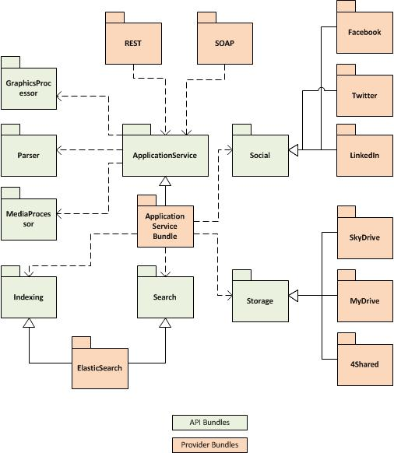
Bundle dependencies

Above diagram shows some of the API and provider bundles developed to modularize the application and gives idea about the dependencies. All the dependencies are on the API bundles (abstractions). This way, components can be de-coupled from the implementations of other modules, OSGi aids to this by making implementation classes private to the bundle.

OSGi was used to create API bundles to define contract for developing Storage Connector, Social Connector and other connectors. Service provider bundles were developed for Facebook, Twitter, 4Shared, SkyDrive which provides implementation for API bundle and expose the implementation as remote OSGi service. This OSGi service can be deployed in multiple machines to form a cluster and consumed by ApplicationServiceBundle(consumer). Consumer bundles don’t need to know about any of the service provider bundles and can only import the API bundle and access the exposed services.

Similarly, the modularity was enforced by creating separate API and implementation service for different concerns like indexing, searching, document parsing, security, graphics processing, database access and so on. This also allowed restarting specific service or plugging different implementation for individual API without getting the whole application down.

Spring DM is used in the project to make it easy to develop and expose and consume services using OSGi.

Scalability & N-tier architecture:
OSGi provides capability of exposing bundle as remote services using R-OSGi. Each logical layer can be deployed as a separate physical cluster to meet required scalability requirements.

Challenges/Limitations
This section describes the challenges/limitations for working with the given technology experienced at the time of project execution.

- Limited support of development tools make it difficult to achieve high productivity using OSGi
- Limited support for build process, specifically when integrating with third-party libraries
- Online documentation and support is very limited
- It takes time to “getting started” for the team if they are new to OSGi
- In-depth understanding is required to troubleshoot issues related to resolving container startup and bundle dependency resolution related issues

Benchmarking Metrics
N/A

