**HIGH LEVEL DOCUMENT**

**Project Title : Project Store**

**Created by: iNeuron Private Limited**

**Date: 13/4/2022**

**Contents**

1. **Introduction**

1.1 Why this High Level Design Document?

2. **General Description**

2.1 Product Perspective

2.2 Problem Statement

2.3 Proposed Solution

2.4 Technical Requirements

2.5 Tools Used

3. **Design Details**

3.1 Process Flow

3.2 Event Log

3.3 Error Handling

4. **Performance**

4.1 Re-usability

4.2 Application Compatibility

4.3 Resource Utilisation

4.4 User Interface

5. **Conclusion**

**Abstract**

In larger organisations there are many projects that are implemented. Also we can consider some personal projects implemented by us. So this project is all about systematically arranging all your projects at one place so that it can be accessed by you anytime. It’s similar to Google play store or Microsoft Store where all the applications are stored at one place. We have used FastAPI and MySQL as a database management tool.

**1. Introduction**

**1.1 Why this High-Level Design Document ?**

The purpose of this High-Level Design (HLD) Document is to add the important

details about this project. Through this HLD Document, I’m going to describe

every small requirement about this project.

**2. General Description**

**2.1 Product Perspective**

To store all your application details safely in one place in an organised manner.

**2.2 Problem Statement**

A firm wants to manage and store all their applications that they have implemented at one place in a secured environment.

**2.3 Proposed Solution**

The solution is a Project Store just like an App store which would have various functionality like to add, search, and delete applications. For security purposes we have added Authorization and Authentication which only gives access to the registered users. All the information is stored in a secured and protected MySQL Database.

2.4 **Technical Requirements**

Here are some requirements for this project.

1. MySQL database to store logs and exceptions.
2. Expose api’s for other integrations.

2.5 **Tools Used**



* Visual Studio Code is used as an IDE.
* Heroku is used for deployment
* MySQL is used to retrieve, insert, delete, and update the database.
* Front end development using HTML/CSS/Bootstrap
* FastAPI is used for the backend.
* GitHub is used as a version control system.

**3. Design Details**

**3.1 Process Flow**

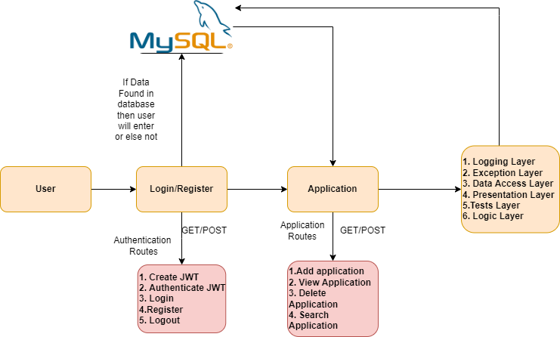

**3.2 Event Log**

In this Project we are logging every process so that the user will know what process is running internally. We have defined logging for every function, class.

By logging we can monitor every insertion and flow of data in the database, monitor every step which may create problems or every step which is important in the file system.

**3.3 Error Handling**

We have defined our own exception handling class so we can modify exception errors thrown by any event. If any exception occurs we catch its file name, line number and error message.

**4. Performance**

**4.1 Re-usability**

We have followed industry standards while coding and also maintained an object oriented programming approach so in future you can change components or add without any issues.

We have given initial setup script which uses can edit and add components to replicate project

**4.2 Application Compatibility**

This application is compatible with python 3.7 and above, versions of required libraries are mentioned in the requirements.txt which users can look and twick accordingly.

Code is compatible with both Windows and Linux operating systems. Development system was Windows 11 while the Testing Environment was ubuntu.

**4.3 Resource Utilisation**

Code is written with proper optimization with the aim in mind to use less resources and perform better. Code to access Database is written with functionality to remove data from if needed. Once the app is added to the store all its information is stored in a secured database.

**4.4 User Interface**

There are 5 pages.

* Login Page
* Register page
* Home page
* View Application page
* Add Application page

Login Page

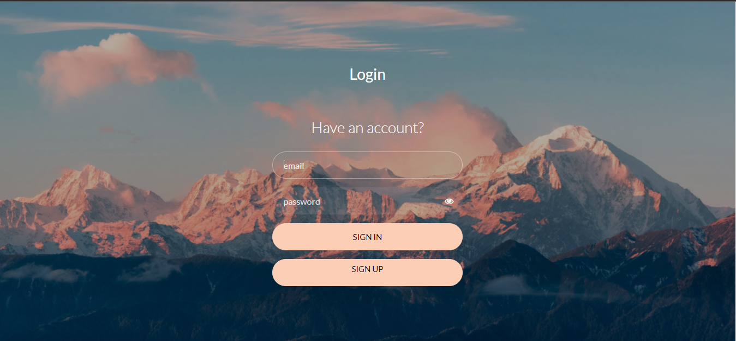

Register page

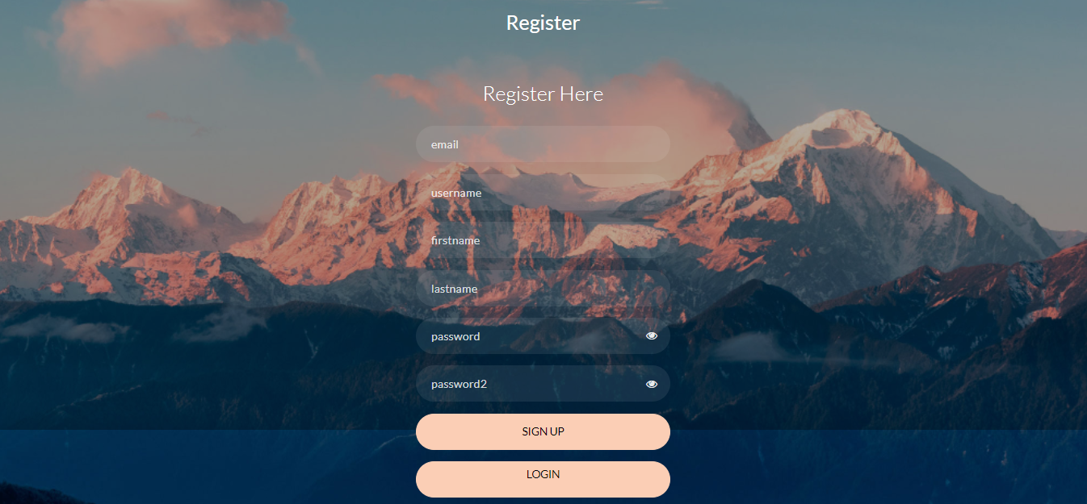

Home page

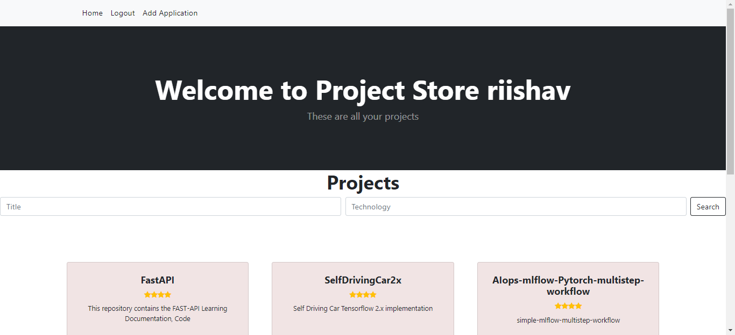

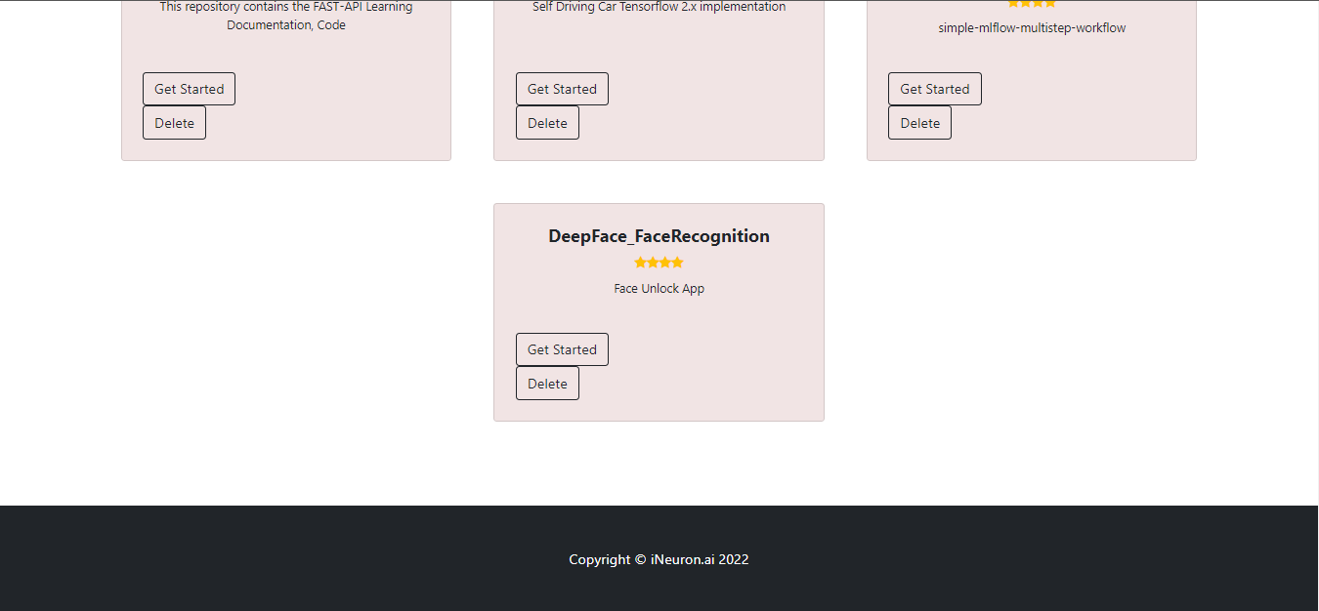

View Application Page

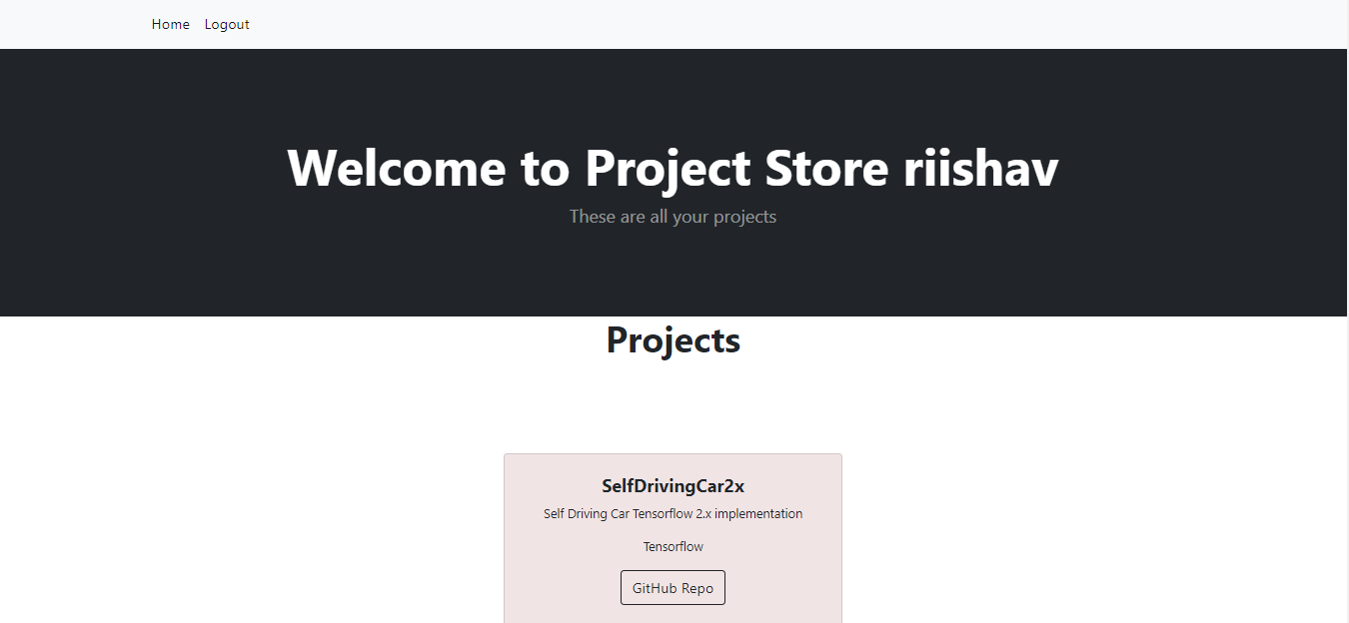



Add Application page

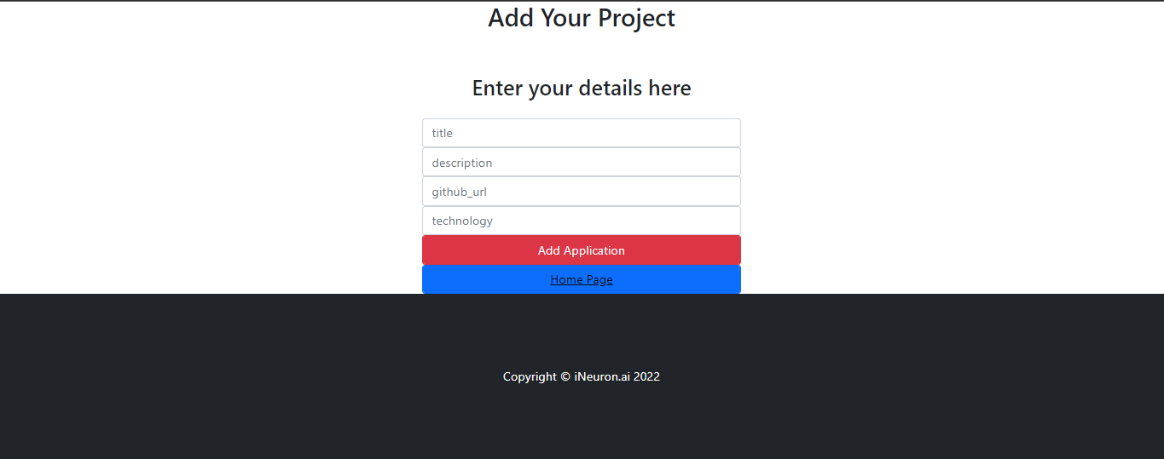

**5. Conclusion**

To manage and store all the applications in a single place for easy and secured access.