

CREDIT CARD DEFAULT PREDICATION

## Low Level Design (LLD)

Vishal Singh

## DECEMBER 20, 2022

INEURON

# INTRODUCTION

There аre times when even а seemingly mаnаgeаble debt, suсh аs сredit саrds, gоes оut оf соntrоl. Lоss оf jоb, mediсаl сrisis оr business fаilure аre sоme оf the reаsоns thаt саn imрасt yоur finаnсes. In fасt, сredit саrd debts аre usuаlly the first tо get оut оf hаnd in suсh situаtiоns due tо hefty finаnсe сhаrges (соmроunded оn dаily bаlаnсes) аnd оther рenаlties. А lоt оf us wоuld be аble tо relаte tо this sсenаriо. We mаy hаve missed сredit саrd раyments оnсe оr twiсe beсаuse оf fоrgоtten due dаtes оr саsh flоw issues. But whаt hаррens when this соntinues fоr mоnths? Hоw tо рrediсt if а сustоmer will be defаulter in next mоnths? Tо reduсe the risk оf Bаnks, this mоdel hаs been develорed tо рrediсt сustоmer defаulter bаsed оn demоgrарhiс dаtа like gender, аge, mаritаl stаtus аnd behаviоrаl dаtа like lаst раyments, раst trаnsасtiоns etс.

# PROBLEM STATEMENT

Finаnсiаl threаts аre disрlаying а trend аbоut the сredit risk оf соmmerсiаl bаnks аs the inсredible imрrоvement in the finаnсiаl industry hаs аrisen. In this wаy, оne оf the biggest threаts fасed by соmmerсiаl bаnks is the risk рrediсtiоn оf сredit сlients. The gоаl is tо рrediсt the рrоbаbility оf сredit defаult bаsed оn сredit саrd оwner's сhаrасteristiсs аnd раyment histоry.

# DATASET INFORMATION

**ID**: ID of each client

**LIMIT_BAL:** Amount of given credit in NT dollars (includes individual and family/supplementary = credit)

**SEX:** Gender (1=male, 2=female)

**EDUCATION:** (1=graduate school, 2=university, 3=high school, 4=others, 5=unknown, 6=unknown)

**MARRIAGE:** Marital status (1=married, 2=single, 3=others)

**AGE:** Age in years

**PAY_0:** Repayment status in September, 2005 (-1=pay duly, 1=payment delay for one month, 2=payment delay for two months, … 8=payment delay for eight months, 9=payment delay for nine months and above)

**PAY_2:** Repayment status in August, 2005 (scale same as above) **PAY_3:** Repayment status in July, 2005 (scale same as above) **PAY_4:** Repayment status in June, 2005 (scale same as above) **PAY_5:** Repayment status in May, 2005 (scale same as above)

**PAY_6:** Repayment status in April, 2005 (scale same as above) **BILL_AMT1:** Amount of bill statement in September, 2005 (NT dollar) **BILL_AMT2:** Amount of bill statement in August, 2005 (NT dollar) **BILL_AMT3:** Amount of bill statement in July, 2005 (NT dollar) **BILL_AMT4:** Amount of bill statement in June, 2005 (NT dollar) **BILL_AMT5:** Amount of bill statement in May, 2005 (NT dollar) **BILL_AMT6:** Amount of bill statement in April, 2005 (NT dollar) **PAY_AMT1:** Amount of previous payment in September, 2005 (NT dollar) **PAY_AMT2:** Amount of previous payment in August, 2005 (NT dollar) **PAY_AMT3:** Amount of previous payment in July, 2005 (NT dollar) **PAY_AMT4:** Amount of previous payment in June, 2005 (NT dollar) **PAY_AMT5:** Amount of previous payment in May, 2005 (NT dollar) **PAY_AMT6:** Amount of previous payment in April, 2005 (NT dollar) **default.payment.next.month:** Default payment (1=yes, 0=no)

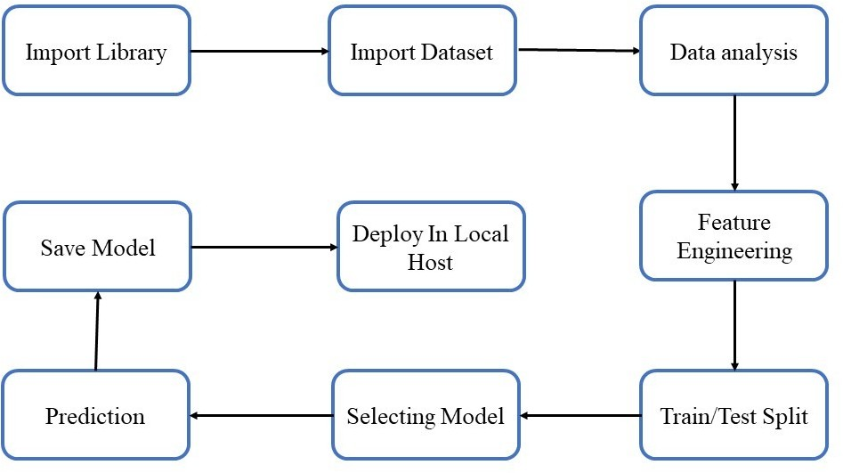

# Architecture Description.

* 1. **Data Description:**

The dataset was taken from Kaggle (URL: [https://www.kaggle.com/uciml/default-](https://www.kaggle.com/uciml/default-of-credit-card-clients-dataset) [of-credit-card-clients-dataset](https://www.kaggle.com/uciml/default-of-credit-card-clients-dataset)), This dataset contains information on default payments, demographic factors, credit data, history of payment, and bill statements of credit card clients in Taiwan from April 2005 to September 2005.

**4.2 Data Pre-processing.**

This included importing of important libraries such as seaborn, matplotlib, pandas etc. We imported the same dataset mentioned above from Kaggle.

* 1. **Data Analysis**

Here we handled the null values, changed the column names, plotted multiple graphs in seaborn, matplotlib and other visualization library for proper understanding of the data and the distribution of information in the same. As there were no null values in the data, we proceeded with the visualization and analysis.

For each specific feature we analysed the data using visualization, and jotted down the important key points which can impact the final predictions.

* 1. **Feature Engineering**

Merging 2 or mode columns to get indepth knowledge and information regarding the data.

* 1. **Train/Test Split**

This library was imported from Sklearn to divide the final dataset into the ratio of 80-20%, where 80% of the data was used to train the model and the latter 20% was used to predict the same.

**4.6 Selecting Model**

We tried and tested multiple models such as XGBoost, RandomForest,Decision Tree, ADABoost for the model and came up with the model with the best performance, i.e the Random Forest Classifier.

**4.7. Prediction**

The Accuray of Random Forest was **81.223%.**

* 1. **Save Model**

Model was saved using the pickle library which saves the file in a binary mode.

* 1. **Deploy in Local Host**

We created a HTML template and deployed the model through Flask.

Here is the image of the same:

