Supply Chain Orchestration: using Data Driven Decision Modelling

Vishal Makode  
200875978Dr. Flynn Castles  
Msc IOT (Data)

*Abstract*—Participating companies should strive for a state of total participation in supply chains. Nonetheless, several obstacles impede genuine progress inside this approach. In the lack of complete information concerning the request of other stakeholders, respondents must meet customer demands. This research explores implementing advanced machine learning approaches, such as neural networks, recurrent neural networks, and random forests to forecast skewed consumption at the endpoint of a distribution network (bullwhip effect).

Keywords—Supply chain management; Forecasting; Neural networks; Machine learning; RNN, Random Forest, Bullwhip effect

# Introduction (*Heading 1*)

Supply chains contribute significantly to user satisfaction, budget control, and a corporation's responses to market advantages and risks. While examining their cost considerations, timeframes, and stock control, firms pursue efficiency, dependability, and reproducibility (Zhang *et al.*, 2016) Evaluate and avoid occurrences and circumstances affecting logistics management, from the most frequent (production delays, manufacturing faults) to the most significant (social turmoil, environmental disasters, manufacturers' financial distress). Several characteristics could complicate the nature of production processes in contexts where uncertainty is already present. As a result of the swift advancement of technology, the lifespan of products is decreasing at an unprecedented rate. Organizations throughout the globe are utilizing reverse supply chain (RSC) tactics to circumvent laws and create profit-generating options. Managing RSC processes worldwide becomes crucial because of increasing international competitiveness, stricter environmental requirements, and various chances for earning and enhanced business reputation (Collin, Eloranta and Holmström, 2009). Generally, the production planning procedure can identify the ideal implementation plan for a supply chain's production and logistical activities. According to its practical use, the area is now relevant to academics and professionals. Data mining is a methodology for extracting information from large databases (Song and Song, 2021). A computer program that facilitates the detection of concealed data within collections. While combining data mining and optimization, after the confidential information is recovered from the collection, the feature selection of an optimization problem could be decreased (Aria and Cuccurullo, 2017). Thus, a practical or high-quality response can be identified in a small amount of time and computational performance. To exemplify the efficacy of this strategy, a machine learning technique for optimal has been applied to a limited optimal control problem, and the outcomes are clarified.

As the economy has been growing, the quality of human existence has continually improved. In addition, as the market for various items rises, individuals are placing an increased significance on product durability and safety (Han and Zhang, 2021). Currently, most of the items moving in the state are distributed via the conventional horizontal cluster product supply chain (Kim and Fortado, 2021). Numerous issues, including the complexity of continuous improvement, significant merchandise damage, lengthy delivery schedules (Robinson *et al.*, 2018), outdated distribution systems, high logistics operations, and relatively low productivity, make it challenging to conform to the key generation (Bals and Turkulainen, 2017). Supply chain management is the most profitable and efficient strategy to respond to the existing intense competition. The fundamental of supply chain management is a technique combined conceptual framework (Turkulainen and Swink, 2017), and several scholars have long predicted that integration will be an essential factor of supply chain research (Luo and Yu, 2019). Consequently, the beginning of organizational learning in the product supply chain and the implementation of digital technologies to enforce an effective system is now the foundation for breaking through modernization deadlock and expanding markets (Han and Zhang, 2021), as well as the eventual target for the capacity building of merchandise distribution network control and administration in today's society (Mogale, Kumar and Tiwari, 2020). The commercial supply chain has shifted from a single regional vertical clustering to an internally strategic alliance and will evolve into a stage characterized by several supply chain functional relationships (Gholamian and Taghanzadeh, 2017).

As per (Mentzer *et al.*, 2001)), the supply chain is the network of businesses in the many actions and procedures that produce wealth in the shape of goods and services given to the end user. These links, operations, and activity affect ecosystems, modeling, planning, and management to function effectively within the challenging environments where proper utilization performs and to produce more flexible and sustainable supply chains. Artificial intelligence (AI) capabilities have evolved in numerous industries in recent decades, especially in supply chains (Borges *et al.*, 2021). AI enables computers to make intelligent decisions and complete operations without personal interaction. Industries use AI and machine learning to understand various fields, including logistical, supply chain management, and storage. Automation definitions change depending on the standpoint from which they are formulated (Zhang, Pee and Cui, 2021).

A limited definition of artificial intelligence can include all machines and devices that use computing capabilities to simulate human intelligence (Kitsios and Kamariotou, 2021). Dependent on what AI accomplishes, various explanations of AI are commonly divided into three areas based on the human component and take precedence: devices that consider and behave like humans and (ii) algorithms that operate and think logically. AI can generally be characterized as a machine's capacity to replicate human intellect, with the idealized potential to evaluate and execute commands that have a high probability of reaching a certain goal (Čerka, Grigien\.e and Sirbikyt\.e, 2015). AI enables it to apply predictive methodologies that enable rapid evaluation and more comprehensive mitigation of hazards or utilized to portray that may develop across the supply chain. It also provides the capability to determine supply chain abnormalities (Akbari and Do, 2021). AI can efficiently and precisely locate key supply chain statistics to construct models that help executives comprehend how each system works and make recommendations for improvement (Ni, Xiao and Lim, 2020). In this new method of utilizing machine learning to enhance the supply chain and look for optimizations, AI helps businesses to continuously learn about activities needing development, discover determinants of output, and anticipate efficiency (Riahi *et al.*, 2021). AI in the supply chain framework continues an innovation whose maximum capabilities humans have yet to comprehend (Nayal *et al.*, 2021).  We proposed a robust approach to finding the effectiveness of machine learning and artificial intelligence over supply chain management.

# Related work

The data-driven supply chain is an integral part of today’s business to move products from one site to another. This type of supply chain optimizes the exposure of the product from unprocessed materials to its usage. Such visibility enables sophisticated supply chains to achieve improved service performance and real-time supply chain knowledge. On the other hand, complete integration has not yet been attained; It is a challenging problem due to the significance of integration for operations in this context. (Castro et al., 2009) introduced a model design that integrates semantically supported simulation with the orchestration of fusion operations. Additionally, the results have shown improved selections based on the newest and optimized information. Furthermore, a significant data-driven decision model has been used to validate this model. Initially, the model integrates a semantic business process framework with assistance from the SCOR taxonomy that will enable the development of multimodal integration workflows in the supply chain in compliance with the known benchmark. Therefore, a conversional language will be employed to create the web service for translation tasks. Additionally, integrating these translators into the business executable process system is also effective process-level interoperability. (Tountopoulos et al., 2018) [2] highlighted the progress in defining a controlling context for data-driven orchestration of utility services in potential intelligent production applications. In addition, the study analyzed the relevance and significance of multi-aspect data in the control of production processes and presented a reference model for orchestrating the different data services. This demonstrates the capability of data-driven service orchestration to facilitate intelligent business scenarios in state-of-the-art manufacturing disruption management. Additionally, the significance of data-driven service orchestration in enhancing decision-making systems within intelligent manufacturing-based ecosystems has been emphasized.

(Hauser et al., 2017) intended to develop a cloud platform that enables the creation of services for the administration of collaborative planning systems among supply chain individuals. Additionally, this study proposed a concept structured via the platform’s five principal services: simulation, detection, evaluation, transformation, and workflow orchestration. First, it introduced the first 4 essential services via the establishment of rules for data analysis, automatic simulation of a supply chain scenario, evaluation of deviations, and modeling of an adaption method. Finally, it discussed the principle of orchestration techniques. (Dalmolen et al, 2015) provided a unique method for supply chain choreography to assist supply chain businesses in generating chain integration that is smooth in practice. Initially, the author developed a body of knowledge by merging supply chain collaboration and constraints literature with scientific observation acquired from applied research and commercial projects. Next, they presented a semantic model that enables fair transition and the creation of an ecosystem in which customizable logistics are the future.

# Background research

Despite having a substantial number of scientific articles in the domain of machine learning and supply chain management individually, not enough attention has been made to the uses of ML algorithms in SCM (Bertolini, 2021). This section analyzes the utilization of the most well-known machine learning classifiers to the SCM related challenges, such as supplier evaluation and segmentation, supply risk detection, market and sale projection, manufacturing, stock control, and transportation.

## ML Algorithms in Supplier

Supplier selection is the most important aspect of the purchasing function (Pang, 2017). Due to the significance of suppliers in terms of cost, time, reliability, supply chain executives have invested significant effort in the supplier selection process. The selection procedure can be driven by MCDM strategies that incorporate competing considerations. Consequently, achieving a balance between these aspects is a crucial challenge for buying managers. MCDM approaches aid decision makers in assessing a group of choices (Guo, 2009). MCDM approaches assist decision-makers in analyzing and selecting among a collection of possibilities. In some instances, the number of prospective suppliers and criteria is much greater than what MCDM approaches can handle effectively. On the other hand, MCDM methods are classified as descriptive and static methods, similar to the majority of other conventional methods. However, in today's competitive marketplace, data analysis approaches are unquestionably more valuable than qualitative research methods. In this era, ML algorithms outperform the aforementioned methods significantly.

Recently, scholars have used the Decision Trees and Support Vector Machine (SVM) as supervised learning classifiers and the Q-learning techniques as a reinforcement learning (RL) technique to tackle the supplier evaluation problem. Table 1 lists few of the most state-of-the-art learning algorithms along with brief descriptions.

1. State-of-the-art Ml algorithms

|  |  |  |
| --- | --- | --- |
| **Types of Machine Learning** | **Classifiers** | **Detail** |
| **Supervised learning** | Decision Trees  Random Forest  SVM  K-nearest neighbor | Decision trees used to classify features into distinct nodes for classification objectives. Additionally, to analyze uncertain decisions (Song, 2015).  It implements decision trees on various examples and utilizes the maximum vote for classification (Biau, 2016).  Support vector machine is most effective for classification purposes (Shmilovici, 2009) when it is used to calculate margins.  Generally, the classifier uses the training data. When the classifier is presented with the test data, both are compared. Here, the K most correlated training data are extracted (Kramer, 2013). |
| **Unsupervised learning** | PCA  K-means clustering | Principal component analysis (PCA) can make calculations faster and simpler by reducing the dimension of the data (Abdi, 2010).  K-means clustering is used to discover data object groupings within a dataset (Likas, 2003) |
| **Ensemble learning** | Boosting  Bagging | Boosting utilizes two types of variables including weak and strong learners. By combining weak learners and transforming them into strong classifiers, the method attempts to reduce bias and variations (Zhou, 2009).  Bagging is another technique that can be used to reduce variations and improve the precision and consistency of ML (Lemmens, 2006). |

## Supply Chain Management Methods

Our analysis employs the following forecasting methodologies.

* Naïve Forecasting
* Neural Networks
* Recurrent Neural Networks
* Support Vector Machines

### Naïve Forecasting

The primary technique is characterized as naïve due to a lack of computations or functions, only a description of the actual sales figures (see figure 1). The naïve forecast is the relatively simplest forecasting technique, and its performance is frequently used as a benchmark against which other systems are evaluated. Additionally, it utilizes the most current value associated with the variable in order to estimate its future value. In some instances, naïve forecasting can effectively predict conditions; however, in others, it could become complex because it only analyzes the current period when attempting to predict the next (Kochak, 2015).

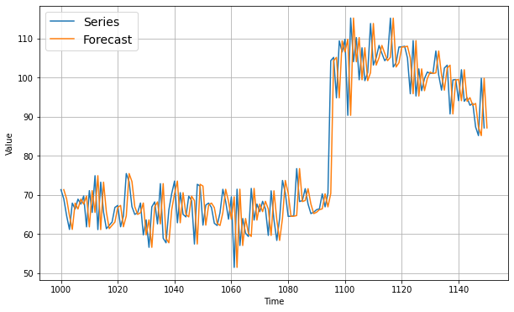

1. An example of time series plot of Naïve forecasting

### Neural Networks

### Despite numerous classes of ANN, we relate to the feed-forward error backpropagation sort neural network. These networks involve individual nodes called nodes, which are structured into different layers such that output signals from neurons in one layer are transmitted to all neurons in the other layer (Da silve, 2017). Consequently, neural activation functions can only move in one direction, i.e., layer by layer. Two layers, the input and output layers constitute the least number of layers. On the other hand, additional layers, referred to as hidden layers, could be added between the input and output layers. The primary function of the hidden layers in neural networks is to maximize their processing capacity.

(Rumelhart, 1985) presented an extension of the perception learning approach for training the accurate sets of connections for arbitrary networks. The input-output pairings are referred to as training pairs and the composed set of presented pairs is called the training set. Therefore, neural networks can be trained and adapt different patterns in the subject area of interest from the given set of statistical dataset.

### Recurrent Neural Networks (RNN)

RNN enables a type of ANN in which each node links from a graph and time sequence. This enables its temporally dynamic behaviour. In addition, RNNs are essential for solving numerous challenging problems, specifically when temporal data is involved. Furthermore, the back-propagation may be employed on a given training set to train an RNN (Werbos, 1990). The architecture of RNN for supply chain demand forecasting problems is depicted schematically in Figure 2.

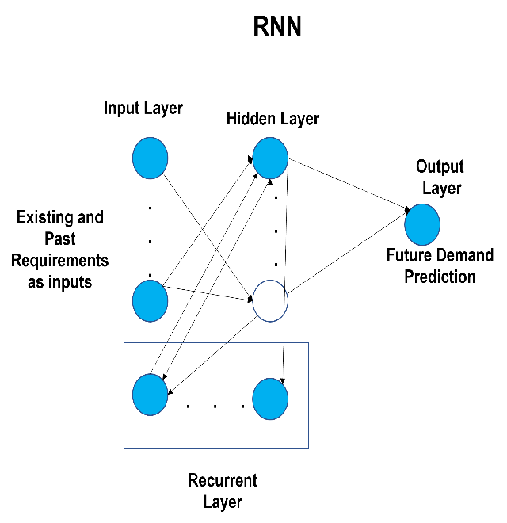

1. RNN for demand prediction (Mathworks, 2000)

### Support Vector Machines

The SVM is a relatively present tool from the domain of AI that employs the structural risk minimization (SRM) convention from statistical learning theory (Vapnik, 1995). Additionally, it has been applied to various domains, and research scholars have recently shown a grown interest in it. Unlike neural networks and MLR, SRM aims to minimize the true error on unseen and randomly chosen test samples (see figure 3)

SVM initiate the data into a larger dimensional space and maximizes the margins between all classes or reduces the margin of error for regression tasks. Furthermore, different kernel techniques, including RBF, can be incorporated to enable non-linear mapping into the larger dimensional space.

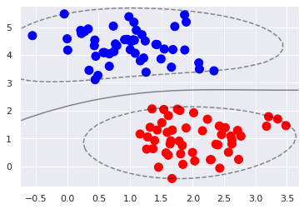

1. An example of SVM decision boundaries.

# Methodology

This study investigates whether ML-based predicting algorithms generate more reliable predictions of misdirected client demand in a distribution network, as observed by the producer. In short, researchers want to determine whether ML generally outperforms conventional forecasting methodologies(Grossman *et al.*, 2022). To assess the performance of machine learning and classical predictive modelling in a dynamic supply chain setting, researchers conducted a series of experiments (Papacharalampous *et al.*, 2022). Our investigation used exponential moving, trend, single exponential, and numerous linear regression to symbolize classic predictive methodologies. Furthermore, predicated on the M3 competition ((Makridakis and Hibon, 2000), researchers incorporated the Theta approach (Makridakis, Spiliotis and Assimakopoulos, 2020), demonstrating excellent outcomes. For completeness, we would include the often employed, traditional ARMA, also known as the Simulation box (Lara-Ben\’\itez, Carranza-Garc\’\ia and Riquelme, 2021) ANN, RNN, and SVM were ML-based prediction algorithms.

The fundamental objective of this effort is to facilitate sales forecasting downstream of the supply chain. Another mechanism of desire displacement in the extended enterprise simulator is the assessment of revenue required according to all supply chain members (Forrester, 1961). According to(Wolstenholme and McKelvie, 2019), requirement communication systems entail that each participant in the supply chain processes and modifies the requirement indication preceding transferring it to the following participant (Romera, Neal and Bos, 2019). As the desired information from the final customers travels throughout the supply chain, it becomes significantly corrupted, increasing economic spectrum sensing (Eastwood and Rue, 2020). This occurs regardless of whether or not the desired signal processing functionality is equal across the extended supply chain (Bandte, 2007). Such effect could be described by complexity theory, wherein a minor change in the source potentially consequences enormous, seemingly arbitrary behaviour in the unstable system's response (Kempener and others, 2008).



1. Requirement signal distortion in a stretched supply chain.

The upper section of Figure. 1 displays a prototype of the wider supply chain with either a participation bottleneck and an increased supply imbalance. The latter might be described as the component of the supply chain upon which stakeholders do not provide specific forecast information (Würtz *et al.*, 1996). Therefore, we aim to anticipate future consumption (adequately in preparation to account for the contractor's advance notice) using only historical orders from the producer. Designers shall study the relevance of sophisticated machine learning algorithms for this purpose (Plus, 2002). As a result, researchers hypothesize that if forecasting accuracy can be improved, expenses will be decreased due to a reduction in supply, and customer loyalty will enhance due to an increase in on-time shipments. In Figure. 1's relatively low, and researchers demonstrate the impact of inaccurate planning and forecasting. This study employs the introductory study of time series (Box, Jenkins and Reinsel, 1970) as a conventional "standard" methodology using which the effectiveness of all other sophisticated methods will be measured. Neural Networks, Recurrent Neural Networks, and Machine Learning are examples of such machines.

Support Vector Machines (SVM), another more contemporary learning algorithm built from computational learning theory (Vapnik, Golowich and Smola, 1996), has an exceptionally rigorous theoretical underpinning and has been implemented in analyses of time series in the past (Mukherjee, Osuna and Girosi, 1997). NN and RNN are applied to predict the statistical model (Burges, 1998). RNN is incorporated into the investigation since the operator's requirement is considered a tumultuous time series (Müller *et al.*, 2018). RNNs provide back-propagation of inaccuracy during a time, which enables the identification of structures at any depth within a response variable (Scholkopf *et al.*, 1997). This indicates that, even though designers offer a period of material as the RNNs show the complexity, they can recognize patterns that continue beyond the present time frame since that includes sequence variants.

In this investigation, the following predicting approaches were employed:

• Naive Forecasts

• Median

• Shifting Average

• Recurring theme

• Linear Regressions Regression

• Probabilistic Neural

• Multilayer Perceptron

• Support Vector Machine.

The nave estimate is one of the shortest methods and is frequently used as a benchmark to measure the effectiveness of those other techniques. It analyzes the most recent value associated with the variable of interest to estimate its valuation. Exponential smoothing forecasts use the averages of a predetermined amount of previous periods to predict future consumption. Using a basic estimation technique with time as the explanatory variable, trend-based modelling attempts to use this information as a time-dependent variable. The multiple linear regression approach attempts to forecast the created change by using a variety of measurements of prior market change as explanatory variables. It is, therefore, an exponential smoothing paradigm. Researchers considered the first five approaches "traditional," while the others are "advanced." We anticipate that the sophisticated techniques could very well outmatch the more ordinary methods due to the following:

•The enhanced methods employ non-linear configurations and, simply put, may provide better simplifications than those that utilize linear modelling techniques;

• We anticipate a great extent of non-linearity in shows that power because of the complicated nature.

In the remaining parts of this section, we will provide a concise summary of various prediction approaches.

## Neural Network

The artificial neural Network is a densely connected collection of neurons, which serve as basic processing units. Multi-layered perceptron (Bishop, 1994) (MLP) ANN is the most well-known technique, as depicted in Figure 2. In MLP format, ANN Neuroses are typically structured into sections with comprehensive or unpredictable interconnections between levels, including a surface for production and one or many hidden nodes. Each layer has several neurons linked with adjacent cells whose densities vary. Within those structures, the different aspects ("neurons") are grouped into levels such that measurement results from a neuron on one surface are sent to all neurons in the following layer (Doebling *et al.*, 1996). Although there are other artificial neural networks, designers reference the feed-forward error back-propagation type neural networks (Zupan and Gasteiger, 1999).

Consequently, brain installations only go in one channel, each layer by layer. Two components, the input, and the output structures, constitute the minimum number of layers. Various layers, referred to as hidden layers, may be inserted between the layer's input and output (Chu *et al.*, 2018). The objective of the hidden neurons in machine learning is to improve their processing capacity (Quaranta, Lacarbonara and Masri, 2020). A neural network potentially serves as a "system will help" if given multiple hidden units. Through training techniques, artificial neural networks are customized to meet a needed projection of inputs to a set. The traditional training methodology for input neural networks is erroneous back-propagation (Falah *et al.*, 2019). This is a sort of supervised learning in which the intended objectives are presented to the Network alongside the ability (Ibragimova *et al.*, 2021). The information interconnections are classified as training combinations, and the subset of possible instruction combinations presented is defined as training examples (Khan and Green, 2021).

Consequently, neural networks can generalize connections in the issue subject area of interest from the presented historical collection of facts (Mugnini *et al.*, 2020). One or more hidden layers may be present in the neural network. The more layers a connection has, the further complicated its organization and the greater its capacity to manage emotional issues (Rathod, Kulkarni and Saha, 2022). The multiple neural Network can translate unlimited dimensions to n dimensions through extensive testing (Koo, Shin and Kim, 2021). Consequently, a multiple neural network framework is intended in this report.

The expected to augment should be a commonly used evaluation measurement roughly equivalent to the measurement evaluation system, which includes supply chain addition operation (Kern *et al.*, 2020), delivery performance, manufacturer prices, current trading, preferences of consumers, the development of new ingredients, logistics operations, crises in the supply chain, availability of the product, communications technology innovation performance, feasible advanced technology, product release phases, statistics shredding (Palagi *et al.*, 2019). It consists of 28 markers in aggregate. From this, the number of hidden entry layers is 28. The learning algorithm is positioned between the input and the output layers and illustrates the translating correlation between the two and output layers (Shahiri Tabarestani and Afzalimehr, 2021). The density of nodes found in the hidden layer significantly affects the artificial Network's functioning (Liehr *et al.*, 2019). Eq 1-4 describes the ANN model.

(1)

(2)

(3)

M = ( (4)

The characters in the calculation represent : the proportion of neurons in each layer, : the population of input neurons, : the population of nodes in each layer, and a: a parameter around 0.5 and 10. Through testing the subsequent modeling, the amount of nodes is established to be five in this study (Randiligama *et al.*, 2021).

The more convolutional nodes, the higher the Network's effectiveness; however, the longer the time complexity. The insufficient number of invisible layers enables network convergence to be problematic (Garner *et al.*, 2021). The frequency of nodes present in the hidden layer cannot be calculated theoretically, despite the widespread application of machine learning. This is an additional flaw of machine learning (Zerroug, Belaidi and Chtita, 2021). In General, there are two approaches to determining the number of hidden neuron modules: The "trial-and-error" technique is established by assessing the education results from various sizes of neurons, while the empirical formula provides an approximated value (de Oliveira Neto *et al.*, 2022). The predicted evaluation outcome is the conclusion correlating to the activation function, i.e., the absolute risk of the responsible supply chain risk management approach. Accordingly, the proportion of neuron connections in the output layer was determined to be one according to the outcome of the vulnerability analysis value (Akb\iy\ik and Yavuz, 2021). Each component in the neural Network collects the data input and transfers it to the previous layers, with the project passing the input data point straight to the subsequent layer (hidden layer or output layer) (Kerwin, De Soto and Adey, 2019). There is a good connection between the input and results of the convolution layer and nonlinear activation nodes in neural network models (Shainline *et al.*, 2018). This is known as the learning algorithm (Masciotta *et al.*, 2019). The control signal is another name for the learning algorithm.

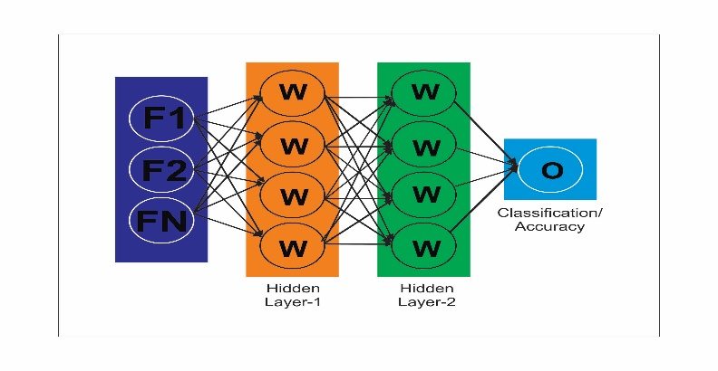

1. System model of ANN

## Recurrent Neural Network

A recurrent neural network (RNN) is any system in which neurons transmit each other input signal (Ackerson, Dave and Seliya, 2021). This notion contains a vast number of potential outcomes. Several reviews of specific RNN subtypes are currently available (Hughes *et al.*, 2019).

RNNs that are artificial neural networks (aRNN) are frequently deemed helpful for advanced applications in these assessments (Lin *et al.*, 2021). To supplement previous contributions, this summary focuses on biologically recurrent neural networks (bRNN) observed in the nervous system. Since feedback is prevalent in the brain, this job could encompass the majority of cognitive control (Li *et al.*, 2018). The current review segregates bRNNS into those wherein control schemes eventuate in neural connections within several processing components that either appear in networks for distinct functional professions such (Pang, Niu and O’Neill, 2020) as needed to store geographic distribution in limited attention span, winner-take-all strategic planning, edge enhancement and normalization (Moghar and Hamiche, 2020), hill climbing, vibrations of various types (relatively constant, traveling vibrations, haphazard), depositing sequential chronological events in learning and memory, and consecutive acquiring knowledge of directories (Wang *et al.*, 2022). A recurrent neural network (RNN) is a machine learning algorithm that employs periodic or time data during the period (Shang *et al.*, 2021). These deep learning algorithms are routinely used for qualitative or chronological applications, including different languages, computational linguistics, voice recognition, and sensitively and appropriately; people are implemented in exciting software such as Homepod, language processing, and Predictive Text. Smartphones are characterized (Almiani *et al.*, 2020) by their "remembered," as information gathered from previous connections is used to alter the present input and result (Apaydin *et al.*, 2020). Whereas conventional (Tan and Wang, 2018) deep neural networks believe that the inputs and outputs are separate, the output of recurrent neural networks depends on the preceding parts in the succession (Guo *et al.*, 2020).

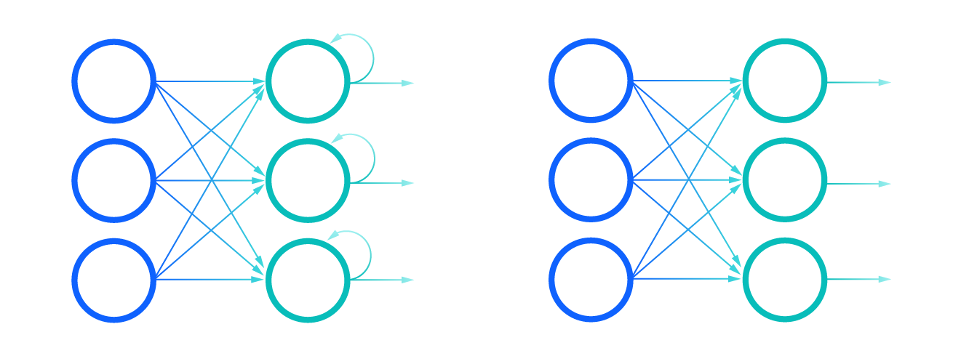

1. Comparison of Recurrent Neural Networks (on the left) and Feedforward Neural Networks (on the right)

Although future occurrences might also be beneficial in defining the output of a particular sequence, continuous recurrent neural networks are incapable of incorporating them into their calculations (Jha *et al.*, 2020).

Let's use the expression "feeling underneath the temperature," widely used to describe someone who is ill, to explain RNNs (Chen *et al.*, 2019). For the expression to understand its meaning, (Sharfuddin, Tihami and Islam, 2018) it must be articulated in that direction (Tang *et al.*, 2018). Therefore, recurrent networks must accommodate the arrangement of (Shen, Bao and Huang, 2018) each word in the vocabulary to anticipate the following word in the sequencing (Fan *et al.*, 2019).

The "rolled" picture of the RNN displays the complete neural (Banerjee *et al.*, 2019) network or the actual paragraph predicted, such as "thinking under the temperature." The "unzipped" image displays the neural network's constituent stages or parameters (Wu, Ding and Huang, 2020). Each layer corresponds to a singular phrase, such as "environment." Previously inputs, such as "emotion" and "beneath," would be recorded (Chu, Fei and Hou, 2019) as a weight matrix in the subsequent timestep to anticipate the output of the sequential manner "the." rolled as (Yang *et al.*, 2019) opposed to unzipped the recurrent neural networks (Dhruv and Naskar, 2020)

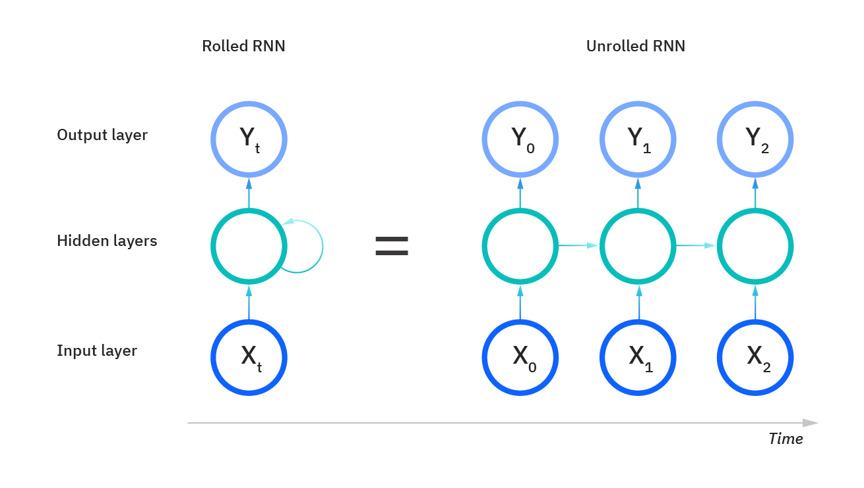

1. System model of RNN

Recurrent networks are also distinguished by their transmission characteristics across all network layers. In contrast to machine learning techniques, which have separate weights for each junction, recurrent neural networks exchange the same weighted parameter throughout each stratum. However, these components are still modified by stochastic gradient descent and optimization algorithm to support evolutionary computation.

Recurrent neural networks compute elevations using the backpropagation through time (BPTT) procedure, which differs slightly from regular stochastic gradient descent because it is particular to episode sequence. BPTT is based on the same concepts as conventional backpropagation, in which the model self-trains by evaluating errors from its activation function to its neural network. These computations allow us to alter and fit the designer's characteristics accurately. BPTT varies from the conservative technique in that it totals mistakes at each time step, although convolutional networks are not obliged to total errors because they cannot share properties across layers.

In this mechanism, RNNs frequently encounter two issues known as inflating grades and disappearing gradients. The amplitude of the contour, which is the inclination of the output layer along the erroneous curve, defines these concerns. When the curve is too narrow, it decreases by updating the input variables until they are inconsequential, or 0. When this happens, the algorithm ceases to learn. Blowing gradients emerge when the gradient is considerable, rendering the model unstable. In this scenario, the model parameters will eventually get excessively huge and be represented as NaN. One approach to these problems is to lower the hidden layer count within the neural network, reducing the RNN model's complexity.

Backpropagation artificial neural networks map one input to one destination, whereas recurrent neural networks do not have this requirement, although being depicted as such in the representations above. Furthermore, the length of their inputs and outputs can vary, and various RNNs are utilized for various use cases, including music production, subjectivity analysis, and computational linguistics.

An activation function, as mentioned in the Learning section on Artificial Neural networks, indicates whether one neuron should be stimulated. Commonly, the nonlinear algorithms translate the activity of a neuronal to a number between 0 and 1 or -1 and 1. The following are descriptions of some of the most common operations:

Matrix multiplication: This is denoted by the equation

(5)

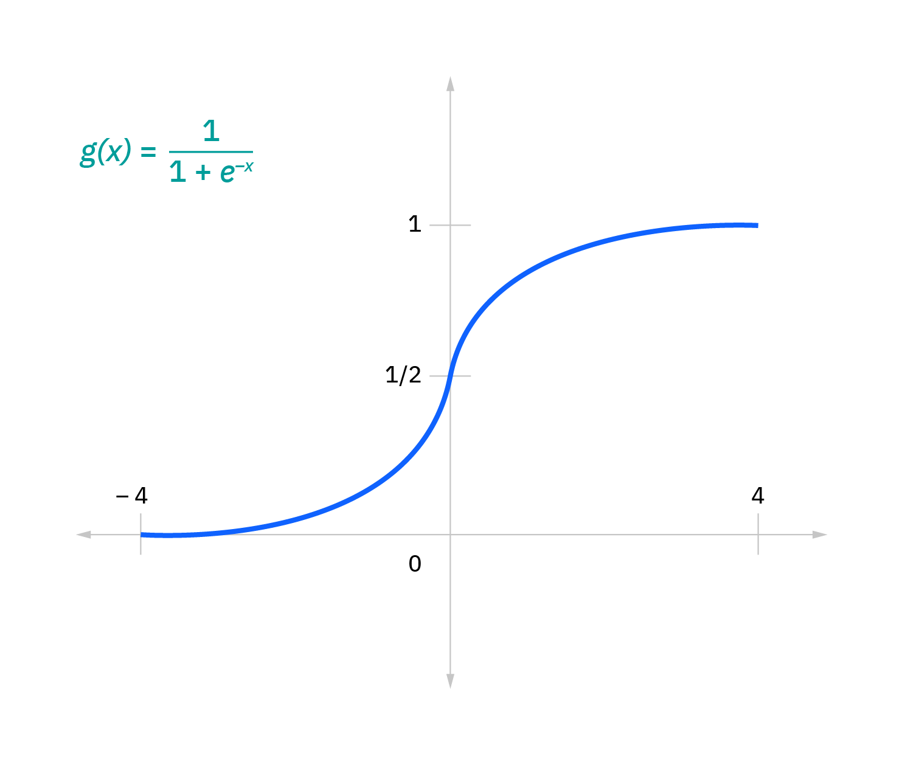

1. This is characterized with the method

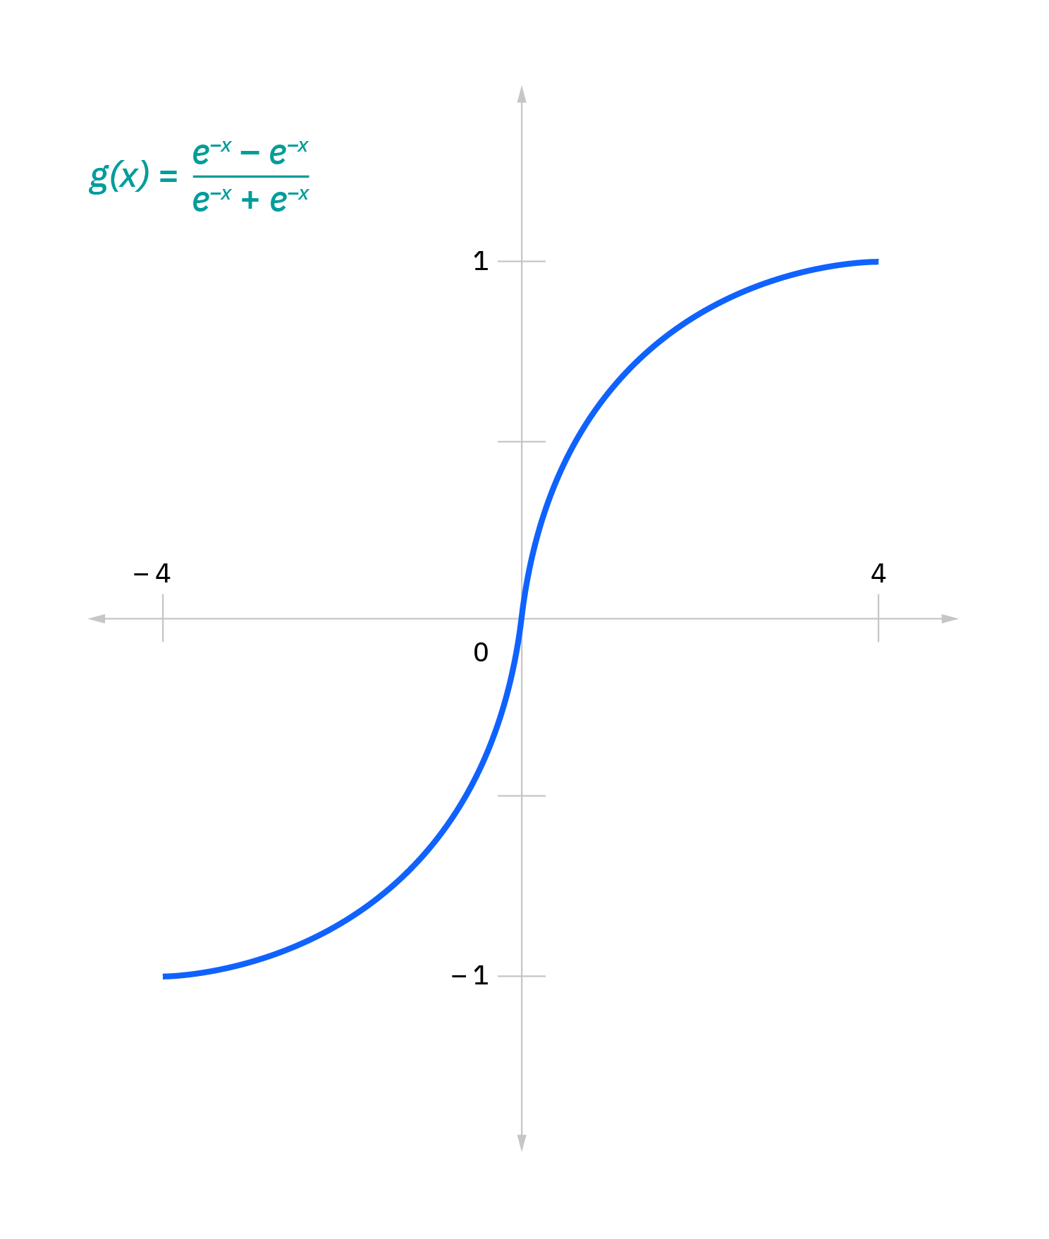

1. This is characterized with the formula

## Random Forest

Leo Breiman and Adele Cutler patented the Random Forest algorithm for machine learning, mixing the output of several decision trees to generate one conclusion. Its development has been spurred by its usability and adaptability, as it solves both classification and regression problems.

Decision diagrams: Given that the randomized forest model comprises numerous decision trees, it seems helpful to begin by concisely outlining the proposed method. Decision trees begin with a fundamental inquiry, such as "Would I surf?" Anyone can then ask various queries to ascertain the conclusion, such as "Is it a longer duration swell?" and "Is the airflow offshore?" These concerns constitute the branch's decision nodes, which split up the information. Each inquiry aids an individual in concluding, represented by the tree structure. Observations that meet the requirements will take the "Yes" course, while those that do not will take the alternative route. Traditionally, the Classification and Regression Tree (CART) technique is used to learn decision trees to determine the optimal data subgroup split. Measurements such as Gini impurity, discriminant analysis, and the median square error (MSE) can be employed to assess the split's accuracy.

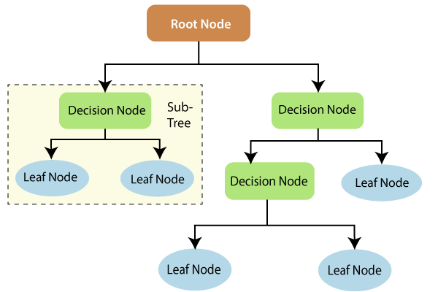

1. This decision tree is an example of a classification problem

Although decision trees are prevalent supervised learning techniques, they are susceptible to bias and prediction accuracy. Furthermore, when numerous decision trees form an aggregation in the stochastic forest technique, the outcomes are more precise, especially when the fruiting trees are statistically independent.

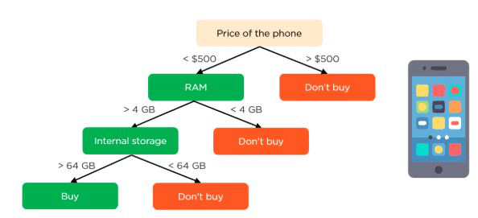

1. Another example of decision tree of a classification problem

Ensemble techniques: Ensemble instructional methods consist of a collection of detectors, such as decision trees, and their projections are combined to get the most popular outcome. Bagging, maximum likelihood estimation, and boosts are well-known aggregation approaches. In 1996, Leo Breiman invented the store a collection; in this method, a randomized selection of information from a training set is collected with replenishment, i.e., the same data point might be sampled many times. After generating several training datasets, these algorithms are autonomously trained, and depending upon the type of task—regression or characterization averaged or percentage of those recommendations result in a more accurate representation. This method is frequently employed to reduce deviation in cluttered information.

Random forest approach: The algorithm modifies the bagging method since it combines bagging and attributes unpredictability to generate a forest of statistically independent decision trees. Feature randomization also called bagging or "the region growing approach,"  provides a random subset of attributes, ensuring a negative association between decision trees. This is the most significant distinction between decision trees and random forests. While the decision tree algorithm analyse every possible feature breakdown, random forests choose only a selection of these features.

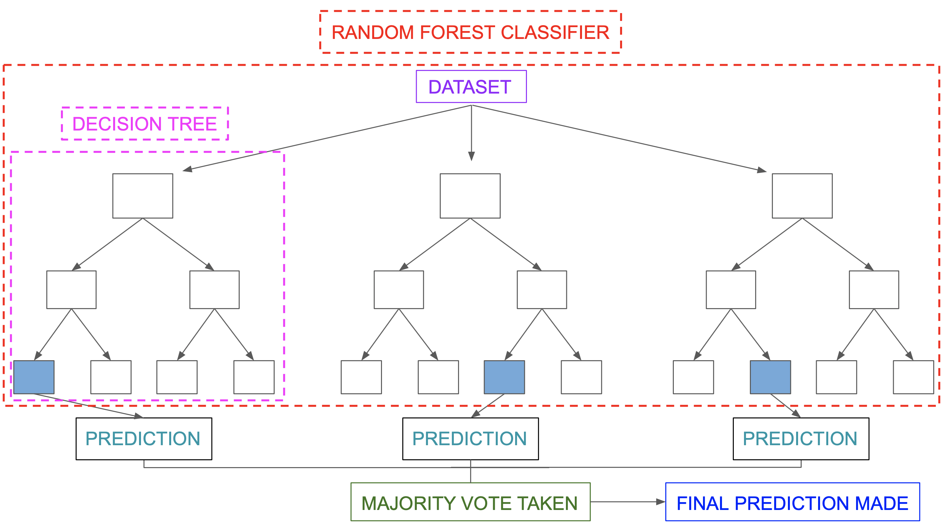

1. Another overview model of Random forest

If we return to the "should I surf?" situation, the question We may ask to verify the predictions may not be as exhaustive as the questions posed by another individual. By considering all possible security unpredictability, researchers can lower the risk of computational complexity, bias, and total variance, culminating in more accurate predictions.

Throughout the training, three principal parameters of the model must be established for random forest approaches. These include the size of branches, the frequency of trees, and the amount of sampled properties. The random forest classification can then be applied to regression or categorization issues.

The random forest technique comprises a series of decision trees, but every forest in the composition is constructed of a training corpus, an information sample obtained from a classification algorithm with substitution. One-third of the base classifier is allotted as test data, referred to as the out-of-bag (OOB) sampling, which we will return to later. Showcase bagging then introduces additional instances of randomization, increasing the diversification of the collection and decreasing the relationship between decision trees. The evaluation of the predictions will vary based on the nature of the situation. For a modeling job, the independent decision trees will be averaging, whereas, for a classification algorithm, the predicted group will be determined by the democratic majority or the most common categorical category. Last, the OOB sampling is employed in the merge to finalize the projection.

Advantages and difficulties of the random forest: When applied to either regression or classification issues, the random forest method offers several significant capabilities and obstacles. These are only a few:

Significant Benefits: Reduced danger of overfitting Decision trees have the possibility of overfitting since they tend to match all training datasets closely. When there are a large number of decision trees in a random forest, the classifier will not generalize the model because the average of stochastic trees reduces the overall dispersion and coefficient of determination.

Offers versatility: Since a confusion matrix can accurately do regression and classification tasks, it is a widespread technique among data scientists. Feature bagging also provides the random forest classifier an efficient estimation method for loss of information, as it retains accuracy even when a percentage of the data is missing.

Simple to determine feature value: Random forest facilitates the evaluation of component contribution or relevance to the model. There are several approaches to evaluating the significance of a characteristic. Typically, Gini centrality and mean drop in impurity (MDI) are employed to determine the degree to which the model's accuracy declines when a particular variable is omitted. Permutation importance, commonly known as mean reduction accuracy (MDA), is an additional measure of importance. MDA determines the average loss in accuracy by permuting the feature values in OOB samples at random.

Key Challenges: Although random forest algorithms can accommodate enormous data sets, they can deliver more precise recommendations; nevertheless, they can be slow to analyze data because they compute data for each informed decision tree.  Since random forests analyze larger data sets, organizations demand additional storage capacity.

More complex: The predictions of a single-choice tree are more straightforward to understand than a rainforest's. The random forest algorithm has been employed in many sectors to help them improve their decisions. Examples of use cases include:

Finance: This method is favored over others since it minimizes the time required for data management and is well before chores. It can assess customers with high corporate debt, detect and prevent fraud, and identify pricing issues with options.

Healthcare: The random forest approach has implications in molecular modeling  , allowing physicians to address issues such as transcriptional identification, antigen research, and sequence identification. Consequently, physicians can estimate pharmacological reactions to individual drugs.

E-commerce: It can be utilized for cross-selling recommendation systems.

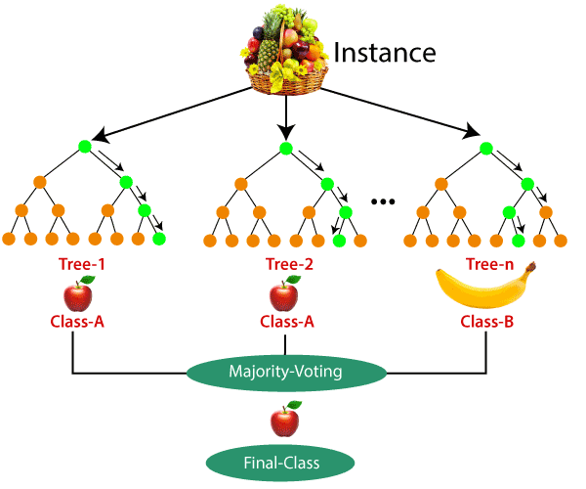

1. Another Detailed model of Random forest for classification example

# Design

Four parties comprising the supply chain that distributes a commodity to an ultimate customer were included in the research experiments. In agreement with the prior explanation, this expanded supply chains model introduces simulation requirement data analysis as the source of request deformation. In summary, demand measurement data is described by a basic regression model that estimates the tendency over the previous ten weekdays and is then utilized to predict demand in two days. This causes intense disturbance at the end of the extended supply chain due to the desired communication systems. In principle, the behavior of the want signaling grows more unpredictable the more "modules" it must traverse. Employing various machine learning approaches, researchers may attempt to anticipate the damaged demand information, which we know was created according to a well-defined sequence. Matlab Software is used to create extended enterprise simulations (MathWorks, 2000).

The macro configuration of the supply chain specifies the one-day postponement for the purchase to be transferred to the subsequent defendant and the three different delays for the products are delivered, as well as all the touchscreen points required for checking the modeling and the information gathering points that collect information to be used by the estimation techniques. The one-day delay for transactions represents the connection lag between the participants, given that the customers must first assess the shopping needs, draught the proforma invoice, and have it authorized before placing the order with the manufacturer, who would then submit it for further handling. The three individuals waiting for the client to accept the products into possession is a distribution delay due to the CPU utilization of the commodities issue, the timely delivery, and the time consumption for goods reception. In the last phase of the distribution network, these delays are nearly comparable, but they pertain to the corporate manufacturing phase, such as completing the proforma invoice and producing the goods.

The middle demand is produced using a single frequency waveform that ranges from 800 to 1200 quantities of the completed image to indicate periodicity. Sometimes once every month, the process is repeated. This sequence is layered with white noise to represent the unpredictability of client demand. The noise consists of regularly disseminated pseudo-random with a power dissipation of 1000, corresponding to a fluctuation of plus or subtraction 100 for every 1000 periods. It is assumed that each collaborator in the extended enterprise has the same structural features. This may be a reasonably straightforward process, but it still results in a misinterpretation of demand.

The activities of a collaborator include capacity planning, consumer buying computation, and transaction processing, which includes product receipt and delivery. Capacity planning is the business activity responsible for modifying the demand signal. The method for demand signal processing is graphical form illustrated. As can be seen, the requisition calculation function receives the request signal after it has been digested by the target costing function. The Delivery, Stocking, and Workload signals are incorporated into the simulated holders to allow simulation supervision and data analysis. In the simulated schemas, the numeric ovals represent the module interconnections. The inputs and outputs are designated beginning with one and are also labeled. In our simulations, the requirements document is based on simple regression models of the previous ten days. The prognosis is used to estimate demand over the next three days. This enables ordering the quantity predicted to be needed in three days. The impact of minor random market fluctuations from the end consumer and demand communication systems modifies the original want, which generally has a straightforward pattern but becomes unpredictable once it reaches the factory.

# Implementation

For accurate assessments, the precise same training and validation data sets were utilised for all forecasting models. Initially, the everyday supplier orders collected from our supply chain simulator are utilised as a data provider for estimation methods. The initial 300 days of research. The input data for the simulations are the demand changes from each of the previous four weeks plus the present month, and the expected output is the total change for the subsequent three periods. Alternatives include the Nave, Average, and Trend forecasts. As a result of this image preprocessing producing null values at the start and conclusion of the generated data set, these values are disregarded. The simulation requirement is divided into two groups the supervised learning and the training sets. Both the training set and the testing set have 600 days. The initial 15 measurements as well as the completed information that may lead.

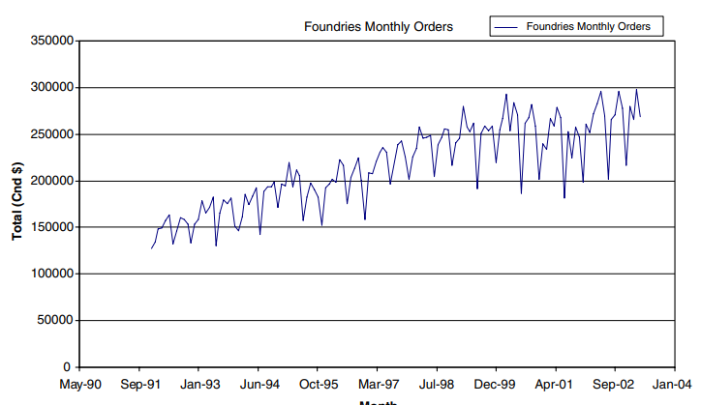

1. Foundries monthly orders.

# Manufacturing facilities have projected sales data for 136 periods. The observations are conducted between January 1992 and April 2003. Due to the data manipulation, which results in numeric attributes, five occurrences from the beginning of the information set and one from the end were eliminated. This totals up to 130 months of information.

# Input data for all models are the % fluctuation in demand over the last four years plus the current month, whereas the output variable is the percentage change over the following month. Due to the growing trend in total demand and the increased frequency of demand instability, percentage growth is preferred to change alone. The manufacturing facilities provided data set has 100 months (77 per cent), whereas the testing set contains 30 months (23 per cent).

# Testing and/or evaluation

A predicting model was developed using three layers of a nutrient backpropagation computational model. For both vast datasets, a neural network with an activation functions transfer function, a development rate of 0.1 and a weight of 0.7 was constructed to encapsulate the relationship between five parameters and one conclusion. To mitigate overtraining, we utilise a 20% bridge set (a subsection of the test dataset) to cease training whenever the inaccuracy on this set begins to increase. For the numerical simulations, ten neurons in the hidden layer were utilised. This selection of 10 neurons in the hidden layer produces a ratio of eight training instances to one neural network poundage:

and describe the number of input, output, and five hidden. The frequency of neurons inside the hidden layer was set at three, and the ratio of observations to parameters was 5.7 for the foundry's sales forecasting. The lesser amount of the provided test set results in a slightly lower ratio. The predicted improvement in consumption for both types of data (designed to simulate and foundries) is the purpose of testing data sources and machine learning. The recurrent neural network architecture was identical to the neural network model defined in the previous, with the addition of feedback connections with every neuron in the concealed layer that flowed back into all the synapses within that stratum in the subsequent phase. This enabled the RNN to discover patterns over time. Such RNNs were based on an activation functions transfer function, and their learning rates and velocities were 0.01 and 0.70, respectively. For the RNN learned on predicted values, six neurons were utilised in the hidden layer. Two neurons in the hidden nodes of the RNN for foundries prediction were utilised to attain a ratio of observations to weights of 6.5%. Considering 62 backpropagation, the resulting ratio of network parameters to data sets was 6.7.

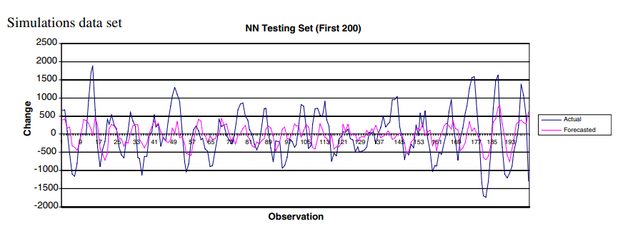

1. Simulations testing data set results.

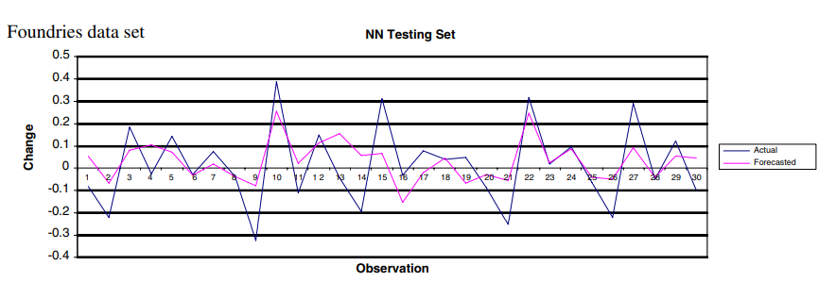

1. Foundries testing data set results.

# Results

Supply chains contribute significantly to user satisfaction, budget control

# Discussion / Conclusion

This purpose was to investigate the efficacy of sophisticated quasi-machine learning approaches in anticipating the deformed demand indications in the broader supply chain. The conclusions are significant for supply chain circumstances in which parties might communicate for the reasons explained at the commencement of the study. In such situations, the possibility of increasing forecasting performance would result in reduced expenses and enhanced satisfaction among customers due to more delivery products. And although advanced technologies produced superior results worldwide, they did not significantly outperform more "conventional procedures" (as indicated by the MLR model) for the model parameters set. Nonetheless, with actual foundry data, increasingly sophisticated data mining technologies (offer more significant enhancements. Recurrent Neural Networks (RNN) produce the highest scores on the metal smelting test set. Furthermore, designers understand that tendency estimate and naive projection are the poorest types of demanding communication systems, as they have the maximum error rate.

Consequently, researchers can infer that the application of algorithms for machine learning and MLR for estimating distorted consumption indications in the broader supply chain results in more weather predictions than traditional estimation methods (such as naive, trend, and moving average). Researchers did not observe. However, machine methodologies consistently outperform the regression model. In reality, the slight reliability improvement of RNN models must be evaluated against the intellectual and computation simplicity of the model for linear regression. The study seeks to investigate the effects of intelligence exchange on prediction accuracies, such as through the Internet and other e-business technologies, as a way for businesses to collaborate choices with their many counterparties), integration of strategic planning will continue to be constrained so long as impediments persist. Considering our concept, such limitations may be reduced.

# Future work

There are numerous applications of machine learning in the management of supply chains. Therefore, designers highlight the ones that supply chain executives find most valuable. Managing suppliers, facilities, and global logistics partnerships can challenge supply chain management. However, machine learning and artificial intelligence technology can aid in all phases of managing a supply chain. Machine learning mechanisms will accurately predict demand, enhance logistics processes, decrease documentation, and automate human procedures. Consequently, you will have end-to-end information into your production process, ensuring that it operates more smoothly, incurs fewer expenses, and is less susceptible to disturbances. For fraud detection and prevention, machine learning systems can evaluate vast volumes of data and identify trends for every corporation. ML makes it easier to identify suspicious charges, minimize credentials exploitation, improve enforcement actions, and automate anti-fraud activities, for illustration, in the supply chain. In addition, ML enables supply chain workers to systematize the process of determining if all components and completed goods match quality or protection criteria. From a strategic viewpoint, machine learning gives insightful information that simplifies and accelerates decision-making. It allows senior managers to examine the optimum and worst-case situations rapidly. Machine learning employs intricate algorithms to provide ideal answers to company management, allowing them to make informed choices.

##### References

Ackerson, J. M., Dave, R. and Seliya, N. (2021) ‘Applications of recurrent neural network for biometric authentication \& anomaly detection’, *Information*, 12(7), p. 272.

Akb\iy\ik, H. and Yavuz, H. (2021) ‘Artificial neural network application for aerodynamics of an airfoil equipped with plasma actuators’, *Journal of Applied Fluid Mechanics*, 14(4), pp. 1165–1181.

Akbari, M. and Do, T. N. A. (2021) ‘A systematic review of machine learning in logistics and supply chain management: current trends and future directions’, *Benchmarking: An International Journal*.

Almiani, M. *et al.* (2020) ‘Deep recurrent neural network for IoT intrusion detection system’, *Simulation Modelling Practice and Theory*, 101, p. 102031.

Apaydin, H. *et al.* (2020) ‘Comparative analysis of recurrent neural network architectures for reservoir inflow forecasting’, *Water*, 12(5), p. 1500.

Aria, M. and Cuccurullo, C. (2017) ‘bibliometrix: An R-tool for comprehensive science mapping analysis’, *Journal of informetrics*, 11(4), pp. 959–975.

Akbari, M. and Do, T.N.A. (2021) ‘A systematic review of machine learning in logistics and supply chain management: current trends and future directions’, *Benchmarking: An International Journal* [Preprint].

Abdi, H. and Williams, L.J., 2010. Principal component analysis. *Wiley interdisciplinary reviews: computational statistics*, *2*(4), pp.433-459.

Aria, M. and Cuccurullo, C. (2017) ‘bibliometrix: An R-tool for comprehensive science mapping analysis’, *Journal of informetrics*, 11(4), pp. 959–975.

Bals, L. and Turkulainen, V. (2017) ‘Achieving efficiency and effectiveness in Purchasing and Supply Management: Organization design and outsourcing’, *Journal of Purchasing and Supply Management*, 23(4), pp. 256–267.

Biau, G. and Scornet, E., 2016. A random forest guided tour. *Test*, *25*(2), pp.197-227.

Borges, A.F.S. *et al.* (2021) ‘The strategic use of artificial intelligence in the digital era: Systematic literature review and future research directions’, *International Journal of Information Management*, 57, p. 102225.

Bertolini, M., Mezzogori, D., Neroni, M. and Zammori, F., 2021. Machine Learning for industrial applications: A comprehensive literature review. *Expert Systems with Applications*, *175*, p.114820.

Bals, L. and Turkulainen, V. (2017) ‘Achieving efficiency and effectiveness in Purchasing and Supply Management: Organization design and outsourcing’, *Journal of Purchasing and Supply Management*, 23(4), pp. 256–267.

Bandte, H. (2007) *Komplexität in Organisationen: organisationstheoretische Betrachtungen und agentenbasierte Simulation*. Springer-Verlag.

Banerjee, I. *et al.* (2019) ‘Comparative effectiveness of convolutional neural network (CNN) and recurrent neural network (RNN) architectures for radiology text report classification’, *Artificial intelligence in medicine*, 97, pp. 79–88.

Bishop, C. M. (1994) ‘Neural networks and their applications’, *Review of scientific instruments*, 65(6), pp. 1803–1832.

Borges, A. F. S. *et al.* (2021) ‘The strategic use of artificial intelligence in the digital era: Systematic literature review and future research directions’, *International Journal of Information Management*, 57, p. 102225.

Box, G. E., Jenkins, G. M. and Reinsel, G. (1970) ‘Time series analysis: forecasting and control Holden-day San Francisco 1970’.

Burges, C. J. C. (1998) ‘A tutorial on support vector machines for pattern recognition’, *Data mining and knowledge discovery*, 2(2), pp. 121–167.

Čerka, P., Grigien\.e, J. and Sirbikyt\.e, G. . (2015) ‘Liability for damages caused by artificial intelligence’, *Computer law \& security review*, 31(3), pp. 376–389.

Chen, J. *et al.* (2019) ‘Gated recurrent unit based recurrent neural network for remaining useful life prediction of nonlinear deterioration process’, *Reliability Engineering \& System Safety*, 185, pp. 372–382.

Chu, Y. *et al.* (2018) ‘Multilayer hybrid deep-learning method for waste classification and recycling’, *Computational Intelligence and Neuroscience*, 2018.

Chu, Y., Fei, J. and Hou, S. (2019) ‘Adaptive global sliding-mode control for dynamic systems using double hidden layer recurrent neural network structure’, *IEEE transactions on neural networks and learning systems*, 31(4), pp. 1297–1309.

Collin, J., Eloranta, E. and Holmström, J. (2009) ‘How to design the right supply chains for your customers’, *Supply Chain Management: An International Journal*.

Akbari, M. and Do, T.N.A. (2021) ‘A systematic review of machine learning in logistics and supply chain management: current trends and future directions’, *Benchmarking: An International Journal* [Preprint].

Abdi, H. and Williams, L.J., 2010. Principal component analysis. *Wiley interdisciplinary reviews: computational statistics*, *2*(4), pp.433-459.

Aria, M. and Cuccurullo, C. (2017) ‘bibliometrix: An R-tool for comprehensive science mapping analysis’, *Journal of informetrics*, 11(4), pp. 959–975.

Bals, L. and Turkulainen, V. (2017) ‘Achieving efficiency and effectiveness in Purchasing and Supply Management: Organization design and outsourcing’, *Journal of Purchasing and Supply Management*, 23(4), pp. 256–267.

Biau, G. and Scornet, E., 2016. A random forest guided tour. *Test*, *25*(2), pp.197-227.

Borges, A.F.S. *et al.* (2021) ‘The strategic use of artificial intelligence in the digital era: Systematic literature review and future research directions’, *International Journal of Information Management*, 57, p. 102225.

Bertolini, M., Mezzogori, D., Neroni, M. and Zammori, F., 2021. Machine Learning for industrial applications: A comprehensive literature review. *Expert Systems with Applications*, *175*, p.114820.

Castro, R.P.L.D., Armayor, D.P., Gómez, J.M., Mosquera, I.S. and Batista, J.A.D., 2009, September. Semantic supported modeling and orchestration of logistic integrated processes, with focus on supply chain: Framework design. In *International Conference on ICT Innovations* (pp. 285-294). Springer, Berlin, Heidelberg.

Čerka, P., Grigien\.e, J. and Sirbikyt\.e, G.. (2015) ‘Liability for damages caused by artificial intelligence’, *Computer law \& security review*, 31(3), pp. 376–389.

Collin, J., Eloranta, E. and Holmström, J. (2009) ‘How to design the right supply chains for your customers’, *Supply Chain Management: An International Journal* [Preprint].

Dalmolen, S., Moonen, H.M., van Hillegersberg, J., Stoter, A.J.R. and Cornelisse, E., 2015, May. Supply chain orchestration and choreography: Programmable logistics using semantics. *In 2015 4th International Conference on Advanced Logistics and Transport (ICALT)* (pp. 76-81). IEEE.

Gholamian, M.R. and Taghanzadeh, A.H. (2017) ‘Integrated network design of wheat supply chain: A real case of Iran’, *Computers and Electronics in Agriculture*, 140, pp. 139–147.

Han, C. and Zhang, Q. (2021) ‘Optimization of supply chain efficiency management based on machine learning and neural network’, *Neural Computing and Applications*, 33(5), pp. 1419–1433.

Hauser, F., Pomponne, V., Jiang, Z., Lamothe, J. and Benaben, F., 2017, June. Processes orchestration for preventing and managing shortages in a supply chain a dermo-cosmetics use case. *In 2017 International Conference on Engineering, Technology and Innovation* (ICE/ITMC) (pp. 1227-1234). IEEE.

Dhruv, P. and Naskar, S. (2020) ‘Image classification using convolutional neural network (CNN) and recurrent neural network (RNN): a review’, *Machine learning and information processing*, pp. 367–381.

Doebling, S. W. *et al.* (1996) ‘Damage identification and health monitoring of structural and mechanical systems from changes in their vibration characteristics: a literature review’.

Eastwood, C. and Rue, B. Dela (2020) ‘Developing decision-support systems for pasture and rangeland management’, in *Improving data management and decision support systems in agriculture*. Burleigh Dodds Science Publishing, pp. 279–310.

Falah, F. *et al.* (2019) ‘Artificial neural networks for flood susceptibility mapping in data-scarce urban areas’, in *Spatial modeling in GIS and R for Earth and Environmental Sciences*. Elsevier, pp. 323–336.

Fan, C. *et al.* (2019) ‘Assessment of deep recurrent neural network-based strategies for short-term building energy predictions’, *Applied energy*, 236, pp. 700–710.

Forrester, J. W. (1961) ‘Industrial Dynamics Cambridge MA’. Productivity Press.

Garner, A. J. *et al.* (2021) ‘Juvenile idiopathic arthritis: a review of novel diagnostic and monitoring technologies’, in *Healthcare*, p. 1683.

Gholamian, M. R. and Taghanzadeh, A. H. (2017) ‘Integrated network design of wheat supply chain: A real case of Iran’, *Computers and Electronics in Agriculture*, 140, pp. 139–147.

Grossman, I. *et al.* (2022) ‘Can machine learning improve small area population forecasts? A forecast combination approach’, *Computers, Environment and Urban Systems*, 95, p. 101806.

Guo, K. *et al.* (2020) ‘Optimized graph convolution recurrent neural network for traffic prediction’, *IEEE Transactions on Intelligent Transportation Systems*, 22(2), pp. 1138–1149.

Han, C. and Zhang, Q. (2021) ‘Optimization of supply chain efficiency management based on machine learning and neural network’, *Neural Computing and Applications*, 33(5), pp. 1419–1433.

Hughes, T. W. *et al.* (2019) ‘Wave physics as an analog recurrent neural network’, *Science advances*, 5(12), p. eaay6946.

Ibragimova, O. *et al.* (2021) ‘A new ANN based crystal plasticity model for FCC materials and its application to non-monotonic strain paths’, *International Journal of Plasticity*, 144, p. 103059.

Jha, S. *et al.* (2020) ‘Recurrent neural network for detecting malware’, *computers \& security*, 99, p. 102037.

Kempener, R. and others (2008) ‘From Organisational Behaviour to Industrial Network Evolutions: Stimulating Sustainable Development of Bioenergy Networks in Emerging Economies’.

Kern, S. *et al.* (2020) ‘Artificial neural networks for quantitative online NMR spectroscopy’, *Analytical and bioanalytical chemistry*, 412(18), pp. 4447–4459.

Kerwin, S., De Soto, B. G. and Adey, B. T. (2019) ‘Performance comparison for pipe failure prediction using artificial neural networks’, in *Proc., 6th Int. Symp. on Life-Cycle Civil Engineering*, pp. 1337–1342.

Khan, S. and Green, R. (2021) ‘Gravitational-wave surrogate models powered by artificial neural networks’, *Physical Review D*, 103(6), p. 64015.

Kim, D.-Y. and Fortado, B. (2021) ‘Outcomes of supply chain dependence asymmetry: a systematic review of the statistical evidence’, *International Journal of Production Research*, 59(19), pp. 5844–5866.

Kitsios, F. and Kamariotou, M. (2021) ‘Artificial intelligence and business strategy towards digital transformation: A research agenda’, *Sustainability*, 13(4), p. 2025.

Koo, S., Shin, D. and Kim, C. (2021) ‘Application of principal component analysis approach to predict shear strength of reinforced concrete beams with stirrups’, *Materials*, 14(13), p. 3471.

Kim, D.-Y. and Fortado, B. (2021) ‘Outcomes of supply chain dependence asymmetry: a systematic review of the statistical evidence’, *International Journal of Production Research*, 59(19), pp. 5844–5866.

Kitsios, F. and Kamariotou, M. (2021) ‘Artificial intelligence and business strategy towards digital transformation: A research agenda’, *Sustainability*, 13(4), p. 2025.

Kochak, A. and Sharma, S., 2015. Demand forecasting using neural network for supply chain management. *International journal of mechanical engineering and robotics research*, 4(1), pp.96-104

Kramer, O., 2013. K-nearest neighbors. In *Dimensionality reduction with unsupervised nearest neighbors* (pp. 13-23). Springer, Berlin, Heidelberg.

Luo, T. and Yu, J. (2019) ‘Friends along supply chain and relationship-specific investments’, *Review of Quantitative Finance and Accounting*, 53(3), pp. 895–931.

Likas, A., Vlassis, N. and Verbeek, J.J., 2003. The global k-means clustering algorithm. *Pattern recognition*, *36*(2), pp.451-461.

Lemmens, A. and Croux, C., 2006. Bagging and boosting classification trees to predict churn. *Journal of Marketing Research*, *43*(2), pp.276-286.

Lara-Ben\’\itez, P., Carranza-Garc\’\ia, M. and Riquelme, J. C. (2021) ‘An experimental review on deep learning architectures for time series forecasting’, *International Journal of Neural Systems*, 31(03), p. 2130001.

Li, S. *et al.* (2018) ‘Independently recurrent neural network (indrnn): Building a longer and deeper rnn’, in *Proceedings of the IEEE conference on computer vision and pattern recognition*, pp. 5457–5466.

Liehr, S. *et al.* (2019) ‘Real-time dynamic strain sensing in optical fibers using artificial neural networks’, *Optics express*, 27(5), pp. 7405–7425.

Lin, J. C.-W. *et al.* (2021) ‘ASRNN: A recurrent neural network with an attention model for sequence labeling’, *Knowledge-Based Systems*, 212, p. 106548.

Luo, T. and Yu, J. (2019) ‘Friends along supply chain and relationship-specific investments’, *Review of Quantitative Finance and Accounting*, 53(3), pp. 895–931.

Makridakis, S. and Hibon, M. (2000) ‘The M3-Competition: results, conclusions and implications’, *International journal of forecasting*, 16(4), pp. 451–476.

Makridakis, S., Spiliotis, E. and Assimakopoulos, V. (2020) ‘The M4 Competition: 100,000 time series and 61 forecasting methods’, *International Journal of Forecasting*, 36(1), pp. 54–74.

Masciotta, M. G. *et al.* (2019) ‘An overview on structural health monitoring: From the current state-of-the-art to new bio-inspired sensing paradigms’.

Mentzer, J. T. *et al.* (2001) ‘Defining supply chain management’, *Journal of Business logistics*, 22(2), pp. 1–25.

Mogale, D. G., Kumar, S. K. and Tiwari, M. K. (2020) ‘Green food supply chain design considering risk and post-harvest losses: A case study’, *Annals of Operations Research*, 295(1), pp. 257–284.

Moghar, A. and Hamiche, M. (2020) ‘Stock market prediction using LSTM recurrent neural network’, *Procedia Computer Science*, 170, pp. 1168–1173.

Mugnini, A. *et al.* (2020) ‘Performance assessment of data-driven and physical-based models to predict building energy demand in model predictive controls’, *Energies*, 13(12), p. 3125.

Mukherjee, S., Osuna, E. and Girosi, F. (1997) ‘Nonlinear prediction of chaotic time series using support vector machines’, in *Neural Networks for Signal Processing VII. Proceedings of the 1997 IEEE Signal Processing Society Workshop*, pp. 511–520.

Müller, K.-R. *et al.* (2018) ‘An introduction to kernel-based learning algorithms’, in *Handbook of Neural Network Signal Processing*. CRC Press, pp. 1–4.

MathWorks, I. 2000. Using MATLAB, Version 6, MathWorks, Inc

Mentzer, J.T. *et al.* (2001) ‘Defining supply chain management’, *Journal of Business logistics*, 22(2), pp. 1–25.

Mogale, D.G., Kumar, S.K. and Tiwari, M.K. (2020) ‘Green food supply chain design considering risk and post-harvest losses: A case study’, *Annals of Operations Research*, 295(1), pp. 257–284.

Nayal, K. *et al.* (2021) ‘Are artificial intelligence and machine learning suitable to tackle the COVID-19 impacts? An agriculture supply chain perspective’, *The International Journal of Logistics Management* [Preprint].

Ni, D., Xiao, Z. and Lim, M.K. (2020) ‘A systematic review of the research trends of machine learning in supply chain management’, *International Journal of Machine Learning and Cybernetics*, 11(7), pp. 1463–1482.

Nayal, K. *et al.* (2021) ‘Are artificial intelligence and machine learning suitable to tackle the COVID-19 impacts? An agriculture supply chain perspective’, *The International Journal of Logistics Management*.

Ni, D., Xiao, Z. and Lim, M. K. (2020) ‘A systematic review of the research trends of machine learning in supply chain management’, *International Journal of Machine Learning and Cybernetics*, 11(7), pp. 1463–1482.

de Oliveira Neto, R. R. *et al.* (2022) ‘Estimation of Eucalyptus productivity using efficient artificial neural network’, *European Journal of Forest Research*, 141(1), pp. 129–151.

Palagi, L. *et al.* (2019) ‘Machine Learning for the prediction of the dynamic behavior of a small scale ORC system’, *Energy*, 166, pp. 72–82.

Pang, Z., Niu, F. and O’Neill, Z. (2020) ‘Solar radiation prediction using recurrent neural network and artificial neural network: A case study with comparisons’, *Renewable Energy*, 156, pp. 279–289.

Papacharalampous, G. *et al.* (2022) ‘Massive feature extraction for explaining and foretelling hydroclimatic time series forecastability at the global scale’, *Geoscience Frontiers*, 13(3), p. 101349.

Plus, S. (2002) ‘Markets, Basic Statistics, Date and Time Management’.

Pang, Q., Yang, T., Li, M. and Shen, Y., 2017. A fuzzy-grey multicriteria decision making approach for green supplier selection in low-carbon supply chain. *Mathematical Problems in Engineering*, *2017*.

Quaranta, G., Lacarbonara, W. and Masri, S. F. (2020) ‘A review on computational intelligence for identification of nonlinear dynamical systems’, *Nonlinear Dynamics*, 99(2), pp. 1709–1761.

Riahi, Y. *et al.* (2021) ‘Artificial intelligence applications in supply chain: A descriptive bibliometric analysis and future research directions’, *Expert Systems with Applications*, 173, p. 114702.

Robinson, J.L. *et al.* (2018) ‘Achieving integration: a dual pathway model of supply chain orientation and organizational identification’, *The International Journal of Logistics Management*, 29(4), pp. 1306–1324.

Rumelhart, D.E., Hinton, G.E. and Williams, R.J., 1985. Learning internal representations by error propagation. *California Univ San Diego La Jolla Inst for Cognitive Science*.

Randiligama, S. M. C. M. *et al.* (2021) ‘Damage assessment in hyperbolic cooling towers using mode shape curvature and artificial neural networks’, *Engineering Failure Analysis*, 129, p. 105728.

Rathod, U. H., Kulkarni, V. and Saha, U. K. (2022) ‘On the Application of Machine Learning in Savonius Wind Turbine Technology: An Estimation of Turbine Performance Using Artificial Neural Network and Genetic Expression Programming’, *Journal of Energy Resources Technology*, 144(6).

Riahi, Y. *et al.* (2021) ‘Artificial intelligence applications in supply chain: A descriptive bibliometric analysis and future research directions’, *Expert Systems with Applications*, 173, p. 114702.

Robinson, J. L. *et al.* (2018) ‘Achieving integration: a dual pathway model of supply chain orientation and organizational identification’, *The International Journal of Logistics Management*, 29(4), pp. 1306–1324.

Romera, Á. J., Neal, M. and Bos, B. (2019) ‘Use of reflexive interactive design to address challenges to New Zealand dairy farming’, *Animal Production Science*, 60(1), pp. 121–126.

Scholkopf, B. *et al.* (1997) ‘Comparing support vector machines with Gaussian kernels to radial basis function classifiers’, *IEEE transactions on Signal Processing*, 45(11), pp. 2758–2765.

Shahiri Tabarestani, E. and Afzalimehr, H. (2021) ‘Artificial neural network and multi-criteria decision-making models for flood simulation in GIS: Mazandaran Province, Iran’, *Stochastic Environmental Research and Risk Assessment*, 35(12), pp. 2439–2457.

Shainline, J. M. *et al.* (2018) ‘Superconducting optoelectronic neurons III: Synaptic plasticity’, *arXiv preprint arXiv:1805.01937*.

Shang, K. *et al.* (2021) ‘Haze prediction model using deep recurrent neural network’, *Atmosphere*, 12(12), p. 1625.

Sharfuddin, A. A., Tihami, M. N. and Islam, M. S. (2018) ‘A deep recurrent neural network with bilstm model for sentiment classification’, in *2018 International conference on Bangla speech and language processing (ICBSLP)*, pp. 1–4.

Shen, Z., Bao, W. and Huang, D.-S. (2018) ‘Recurrent neural network for predicting transcription factor binding sites’, *Scientific reports*, 8(1), pp. 1–10.

Song, G. and Song, S. (2021) ‘Fostering supply chain integration in omni-channel retailing through human resource factors: empirical study in China’s market’, *International Journal of Logistics Research and Applications*, 24(1), pp. 1–22.

Song, Y.Y. and Ying, L.U., 2015. Decision tree methods: applications for classification and prediction. *Shanghai archives of psychiatry*, *27*(2), p.130.

Song, G. and Song, S. (2021) ‘Fostering supply chain integration in omni-channel retailing through human resource factors: empirical study in China’s market’, *International Journal of Logistics Research and Applications*, 24(1), pp. 1–22.

Shmilovici, A., 2009. Support vector machines. In *Data mining and knowledge discovery handbook* (pp. 231-247). Springer, Boston, MA.

Tountopoulos, V., Kavakli, E. and Sakellariou, R., 2018, October. Towards a cloud-based controller for data-driven service orchestration in smart manufacturing. *In 2018 Sixth International Conference on Enterprise Systems (ES)* (pp. 96-99). IEEE.

Turkulainen, V. and Swink, M.L. (2017) ‘Supply chain personnel as knowledge resources for innovation—a contingency view’, *Journal of Supply Chain Management*, 53(3), pp. 41–59.

Werbos, P.J., 1990. Backpropagation through time: what it does and how to do it. *Proceedings of the IEEE*, *78*(10), pp.1550-1560.

Tan, K. and Wang, D. (2018) ‘A convolutional recurrent neural network for real-time speech enhancement.’, in *Interspeech*, pp. 3229–3233.

Tang, T. A. *et al.* (2018) ‘Deep recurrent neural network for intrusion detection in sdn-based networks’, in *2018 4th IEEE Conference on Network Softwarization and Workshops (NetSoft)*, pp. 202–206.

Turkulainen, V. and Swink, M. L. (2017) ‘Supply chain personnel as knowledge resources for innovation—a contingency view’, *Journal of Supply Chain Management*, 53(3), pp. 41–59.

Vapnik, V., Golowich, S. and Smola, A. (1996) ‘Support vector method for function approximation, regression estimation and signal processing’, *Advances in neural information processing systems*, 9.

Wang, Y. *et al.* (2022) ‘Predrnn: A recurrent neural network for spatiotemporal predictive learning’, *IEEE Transactions on Pattern Analysis and Machine Intelligence*.

Wolstenholme, E. and McKelvie, D. (2019) ‘The Challenges Facing Health and Social Care and the Relevance of Dynamic Models’, in *The Dynamics of Care*. Springer, pp. 1–21.

Wu, Q., Ding, K. and Huang, B. (2020) ‘Approach for fault prognosis using recurrent neural network’, *Journal of Intelligent Manufacturing*, 31(7), pp. 1621–1633.

Würtz, D. *et al.* (1996) ‘Analyse und Vorhersage von Finanzmarktdaten’, in *Finanzmarktanalyse und-prognose mit innovativen quantitativen Verfahren*. Springer, pp. 253–298.

Yang, F. *et al.* (2019) ‘State-of-charge estimation of lithium-ion batteries based on gated recurrent neural network’, *Energy*, 175, pp. 66–75.

Zerroug, E., Belaidi, S. and Chtita, S. (2021) ‘Artificial neural network-based quantitative structure--activity relationships model and molecular docking for virtual screening of novel potent acetylcholinesterase inhibitors’, *Journal of the Chinese Chemical Society*, 68(8), pp. 1379–1399.

Zhang, D., Pee, L. G. and Cui, L. (2021) ‘Artificial intelligence in E-commerce fulfillment: A case study of resource orchestration at Alibaba’s Smart Warehouse’, *International Journal of Information Management*, 57, p. 102304.

Zhang, S. *et al.* (2016) ‘ha’, *Expert Systems with Applications*, 65, pp. 87–99.

Zupan, J. and Gasteiger, J. (1999) *Neural networks in chemistry and drug design*. John Wiley \& Sons, Inc.

Zhang, D., Pee, L.G. and Cui, L. (2021) ‘Artificial intelligence in E-commerce fulfillment: A case study of resource orchestration at Alibaba’s Smart Warehouse’, *International Journal of Information Management*, 57, p. 102304.

Zhang, S. *et al.* (2016) ‘ha’, *Expert Systems with Applications*, 65, pp. 87–99.

Zhou, Z.H., 2009, June. When semi-supervised learning meets ensemble learning. *In International Workshop on Multiple Classifier Systems* (pp. 529-538). Springer, Berlin, Heidelberg