1. **What is SDLC?**
2. SDLC is stand for software devlopment life cycle.

Types of SDLC…

(1) Requirement gathering

(2) Analysis

(3) Design

(4) Implementation

(5) Testing

(6) Maintenance.

**2. What is software testing?**

A. Software testing is process used to identify correctness, completeness and quality of devloped computer sodtware and web sites.

1. **What is agile methodology?**
2. Agile model is combination of iterative and incremental process models. agile model is suitable for fixed and changing requirement.
3. **What is SRS?**
4. SRS is stand for software requirements specification.

**5.What is oops?**

A. Object oriented programming is a concepts of object , class , abstaction , encapsulation , inheritance and polymorphism.

**6. Write basic concepts of oops**

A. There are six types are here….

1) Object

2) Class

3) Abstraction

4) Encapsulation

5) Inheritance

6) Polymorphism

**7. What is object?**

A. object is any entity which has own state and behaviour is called object.

**8. What is class?**

A. class is a collection of objects.

**9. What is encapsulation?**

A. encapsulation is wrapping of data or binding a data.

**10. What is inheritance?**

A. when one objects acquire all the properties and behaviour of parent class is called inheritance.

**11. What is polymorphism?**

A. polymorphism is allows different objects to respond to the same message in different ways.

**12. Draw usecase on online book shopping.**

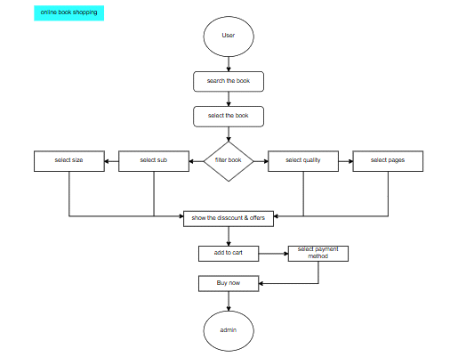

**13. Draw usecase on online bill payment system.**

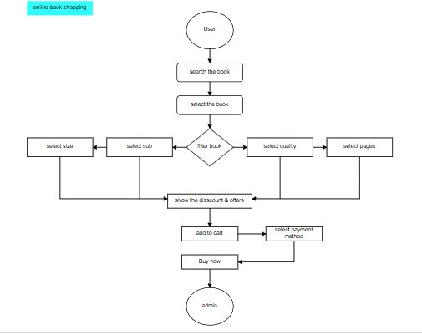

**14. Write SDLC phases with basic introduction**

**A.** Requirement gathring -customer needs

Analysis -model data anlysis

Design -model specification and designed

Implementation -data implement and model solution

Testing -software testing and solution

Maintenance -defect repair and requirement solution

**15. Explain phases of the waterfall model**

A. There are the phases of the waterfall model

- Requirments - this includes client's need and requriments.

- Analysis - this includes detailed requirements of document.

- Design - this create the technical plan as blueprint.

- Implementation - the design is developed and tested individually during this.

- Testing - this includes testing for faults and perfomance issues.

- Maintenance - this phase is for ongoing support and bug fixes.

**16. Write phases of spiral model**

**A.** there are the phases of the spiral model

- Planning - determination of objective,alternatives and constaraints.

- Risk analysis - analysis of alternatives and identification of risks.

- Engineering - development of the next level product.

- Customer evolution - assessment of the results of engineering.

**17. Write agile manifesto principls**

**A.** - Customer satisfaction and delivery

- Avoid of requirement features

- Working software deliver

- Collobration the business developers

- Successful comunication

- Enable face to face interaction

- Agile processes to support a consistent development.

**18. Explain working methodology of agile model and also write pros and cons.**

**A.** Requirments analysis -> Design -> Development -> Quality assurance -> Deployment.

- Agile model pros and cons:

* Pros:

- Increase flexibility

- Faster time to market

- Higher satisfaction

- Improved collaboration

- Better risk management

- Best product quality

* Cons:

- Reduce predictrability

- Lack of comprehensive documentation

- Potential scope creepe

- Not for every project

**19. Draw usecase on online shopping product using COD.**

**A.**

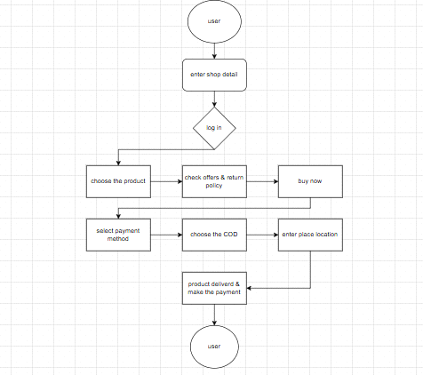

**20. Draw usecase on online shopping product using payment gateway.**

A.

