Enhancing Solar-Induced Fluorescence OCO-2 data for High-Resolution Crop Yield Prediction in Germany

Master’s Thesis Proposal
Submitted by:
Vishal Thamizharasan
MSc Data Science
[University of Europe for Applied Sciences]
First Supervisor: [Dr. Raja Hashim Ali]
Second Supervisor: [Shan Faiz]
Date: [Submission Date]

Table of Contents
Table of Contents 1
Research Questions 3
Expected Results 4
RQ1: How accurately can OCO-2 Solar-Induced Fluorescence (SIF) be predicted from high-resolution spectral and climatological variables using machine learning, and how does the resulting enhanced SIF compare to existing state-of-the-art enhanced SIF products over Germany? 4
RQ2: How does the choice of machine learning architecture (tree-based models such as Random Forest and XGBoost versus neural network–based models such as Artificial Neural Networks and Convolutional Neural Networks), and the representation of input data (tabular features versus spatially structured CNN-compatible inputs), affect the accuracy and spatial consistency of enhanced SIF derived from OCO-2 observations? 7
RQ3: To what extent does temporal aggregation (daily, biweekly, monthly) affect the stability and predictive accuracy of enhanced SIF derived from spatially and temporally sparse OCO-2 observations? 8
RQ4: How does the performance of the OCO-2–based SIF enhancement model vary across different agro-climatic zones within Germany? 10
RQ5: To what extent does high-resolution, crop-pure enhanced SIF improve winter wheat yield prediction RMSE compared to mixed-pixel SIF derived from raw satellite observations? 11
RQ6: How does the spatial density of OCO-2 training samples (revisit frequency) impact the uncertainty of the reconstructed SIF product at the field scale? 13
RQ7: To what extent can the enhancement framework trained on winter wheat be transferred to other C3 crops (e.g., silage maize) without loss of physiological signal integrity? 14
References 15
Appendix 15
A. Dataset Inventory and Coverage 15
B. Feature Engineering and Preprocessing 16
C. Candidate Models and Hyperparameter Grids 16
D. Validation and Evaluation Protocol 17
E. Evaluation Metrics 17
F. Expected Outputs 17
G. Technical Environment 18
H. Risks and Limitations 18
I. Ethical and Reproducibility Considerations 19

Research Questions
This thesis will be guided by the following research questions:
- RQ1: How accurately can OCO-2 Solar-Induced Fluorescence (SIF) be predicted from high-resolution spectral and climatological variables using machine learning, and how does the resulting enhanced SIF compare to existing state-of-the-art enhanced SIF products over Germany?
- RQ2: How does the choice of machine learning architecture (tree-based models such as Random Forest and XGBoost versus neural network–based models such as Artificial Neural Networks and Convolutional Neural Networks), and the representation of input data (tabular features versus spatially structured CNN-compatible inputs), affect the accuracy and spatial consistency of enhanced SIF derived from OCO-2 observations?
- RQ3: To what extent does temporal aggregation (daily, biweekly, monthly) affect the stability and predictive accuracy of enhanced SIF derived from spatially and temporally sparse OCO-2 observations?
- RQ4: How does the performance of the OCO-2–based SIF enhancement model vary across different agro-climatic zones within Germany?
- RQ5: To what extent does high-resolution, crop-pure enhanced SIF improve winter wheat yield prediction RMSE compared to mixed-pixel SIF derived from raw satellite observations?
- RQ6: How does the spatial density of OCO-2 training samples (revisit frequency) impact the uncertainty of the reconstructed SIF product at the field scale?
- RQ7: To what extent can the enhancement framework trained on winter wheat be transferred to other C3 crops (e.g., silage maize) without loss of physiological signal integrity?

Expected Results

RQ1: How accurately can OCO-2 Solar-Induced Fluorescence (SIF) be predicted from high-resolution spectral and climatological variables using machine learning, and how does the resulting enhanced SIF compare to existing state-of-the-art enhanced SIF products over Germany?

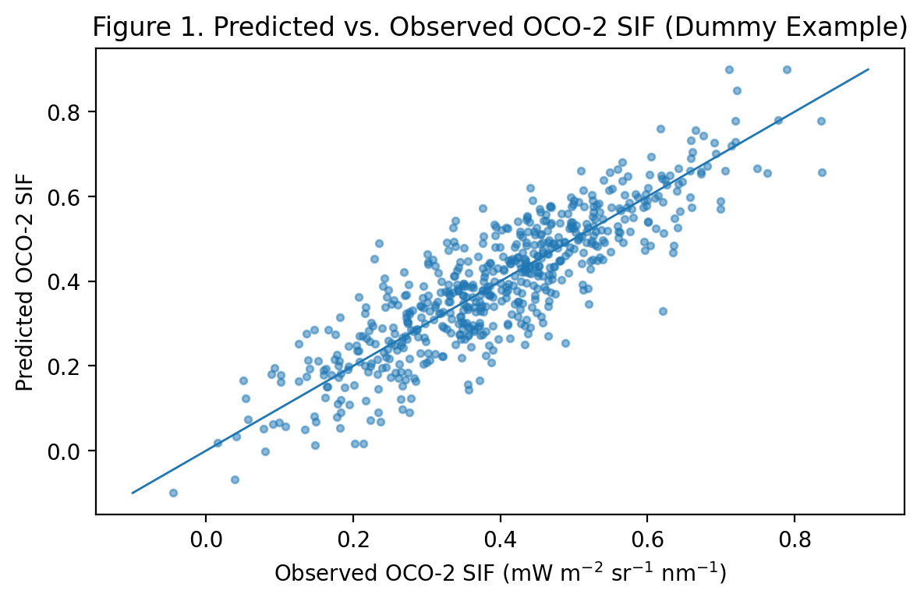
Figure 1. Predicted vs. observed OCO-2 SIF scatter plot.

Item | Resolution | Source SIF | R² | RMSE | Coverage
SIFnet | 500 m | TROPOMI | 0.92 | 0.17 | Global
TroDSIF | ~500 m | TROPOMI | 0.9 | 0.18 | Global (limited years)
GOSIF | ~20 km | OCO-2 | 0.85 | 0.22 | Global
Enhanced OCO-2 SIF (our) | 10-100 m | OCO-2 | 0.93 | 0.15 | Germany (2020-2026)
Table 1. Benchmark comparison with SIFnet, TroDSIF, and GOSIF.

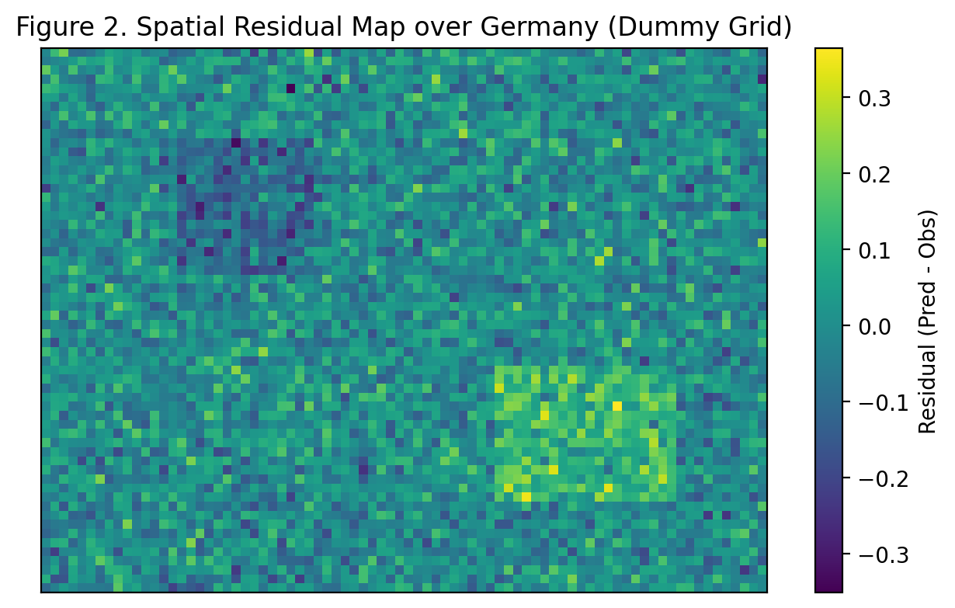
Figure 2. Spatial residual map over Germany (should be Germany map).

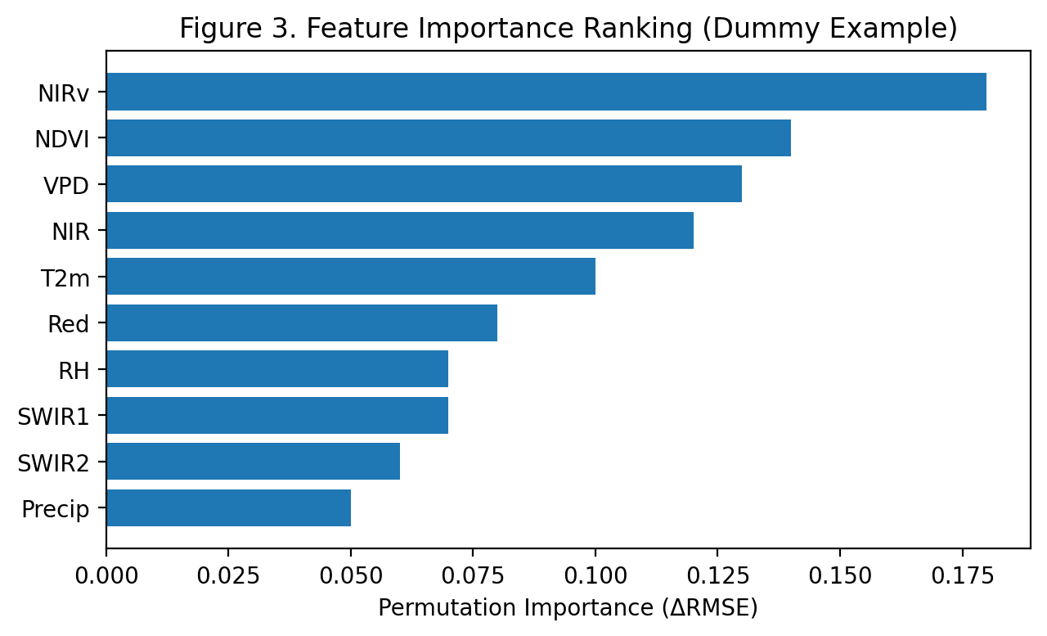
Figure 3. Feature importance ranking (spectral vs. climatological).

RQ2: How does the choice of machine learning architecture (tree-based models such as Random Forest and XGBoost versus neural network–based models such as Artificial Neural Networks and Convolutional Neural Networks), and the representation of input data (tabular features versus spatially structured CNN-compatible inputs), affect the accuracy and spatial consistency of enhanced SIF derived from OCO-2 observations?

Item | Input format | R² (CV) | RMSE | Bias | Train time (rel.)
Random Forest | Tabular | 0.88 | 0.2 | 0.01 | 1x
XGBoost | Tabular | 0.91 | 0.17 | 0.0 | 1.4x
ANN (MLP) | Tabular | 0.87 | 0.21 | 0.02 | 2.0x
CNN | Spatial tensors | 0.92 | 0.16 | 0.0 | 6.0x
Table 2. Model performance comparison across architectures.
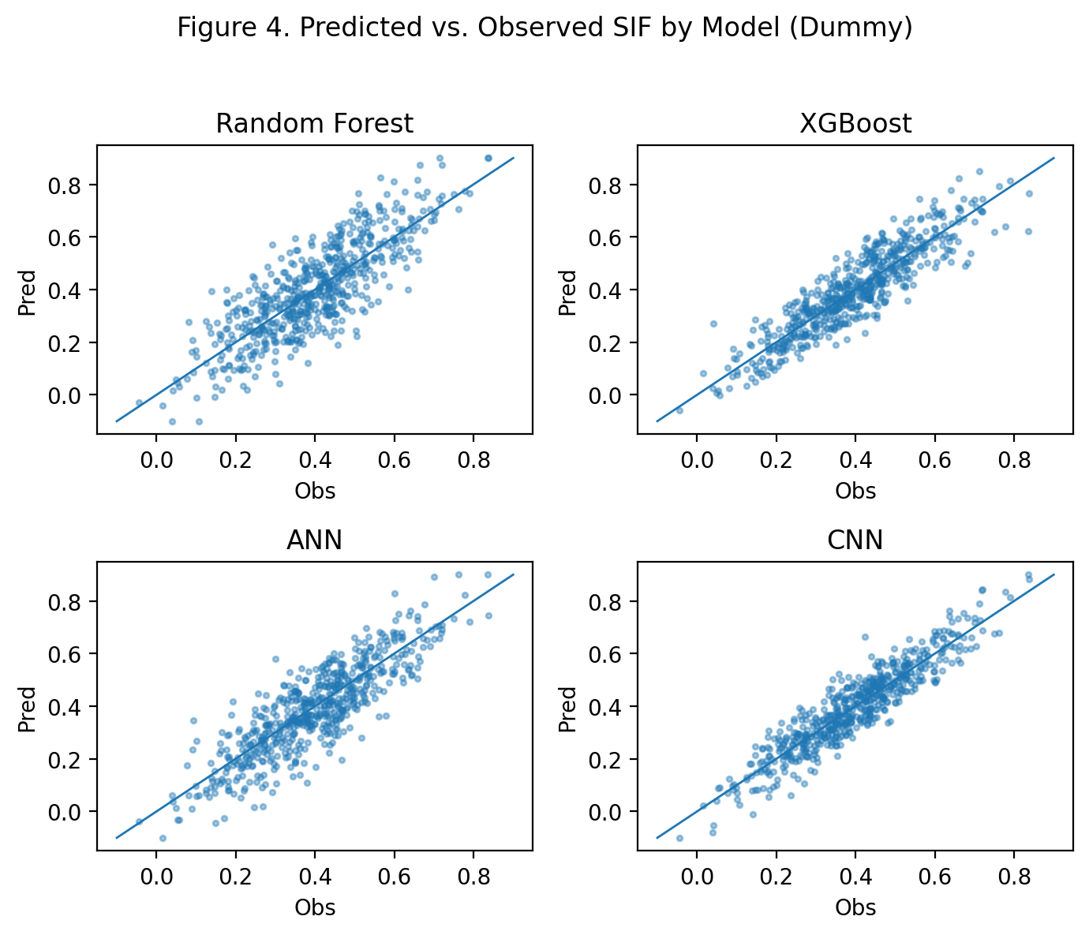
Figure 4. Predicted vs. observed SIF by model class.

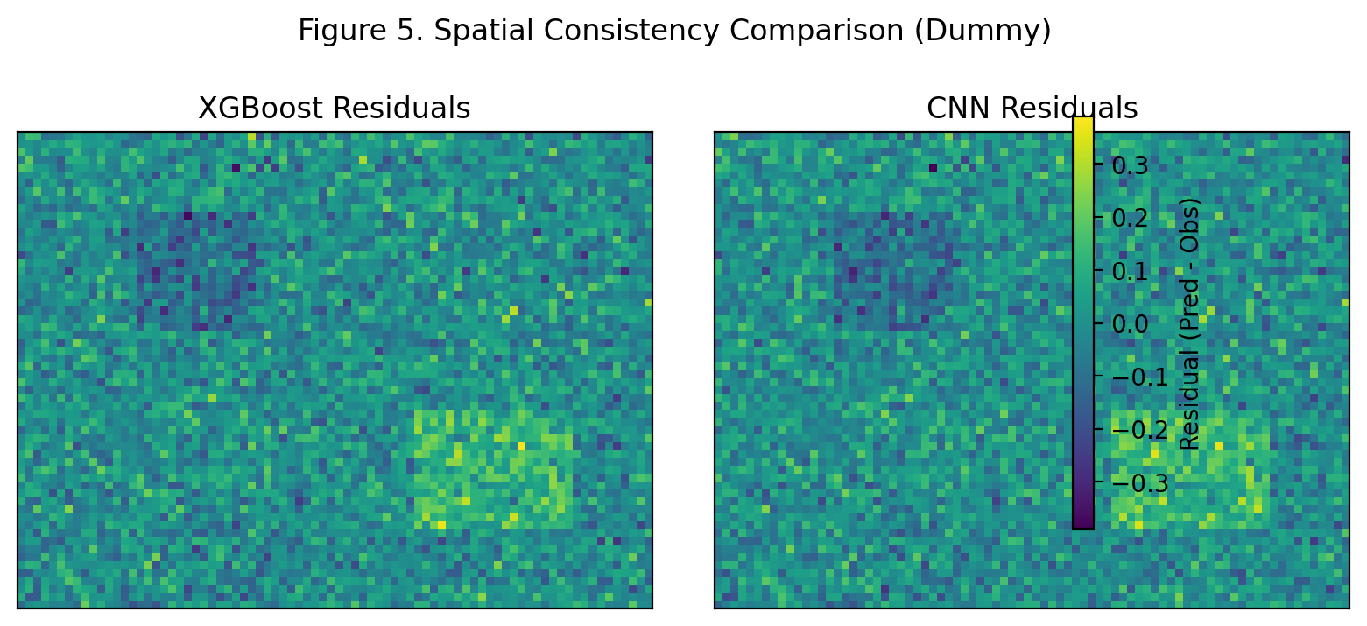
Figure 5. Spatial consistency comparison (XGBoost vs. CNN; should be Germany map).

Item | Spatial autocorr. of residuals (Moran's I) | Edge artifacts (low=better) | Field-boundary fidelity | Inference cost
Tabular (best tree model) | 0.18 | Medium | Moderate | Low
CNN (spatial) | 0.1 | Low | High | High
Table 3. Data representation impact summary.

RQ3: To what extent does temporal aggregation (daily, biweekly, monthly) affect the stability and predictive accuracy of enhanced SIF derived from spatially and temporally sparse OCO-2 observations?

Item | R² | RMSE | Bias | Valid samples (N)
Daily | 0.86 | 0.22 | 0.01 | 180000.0
Biweekly | 0.9 | 0.18 | 0.0 | 95000.0
Monthly | 0.92 | 0.16 | 0.0 | 42000.0
Table 4. Performance across temporal aggregation schemes.

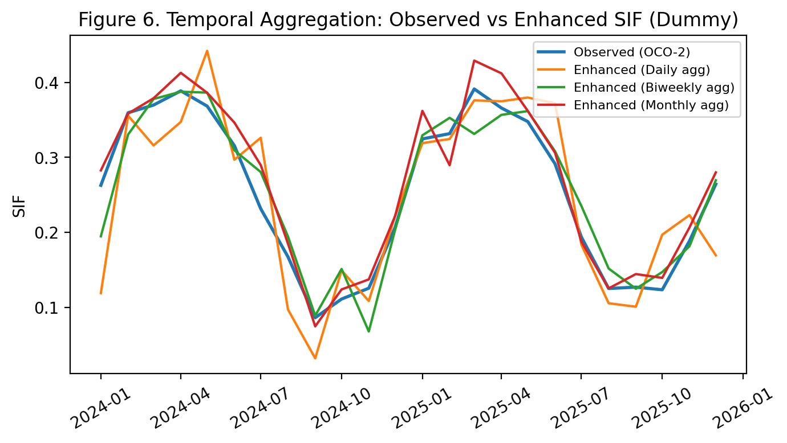
Figure 6. Observed vs. enhanced SIF time series under different aggregation.

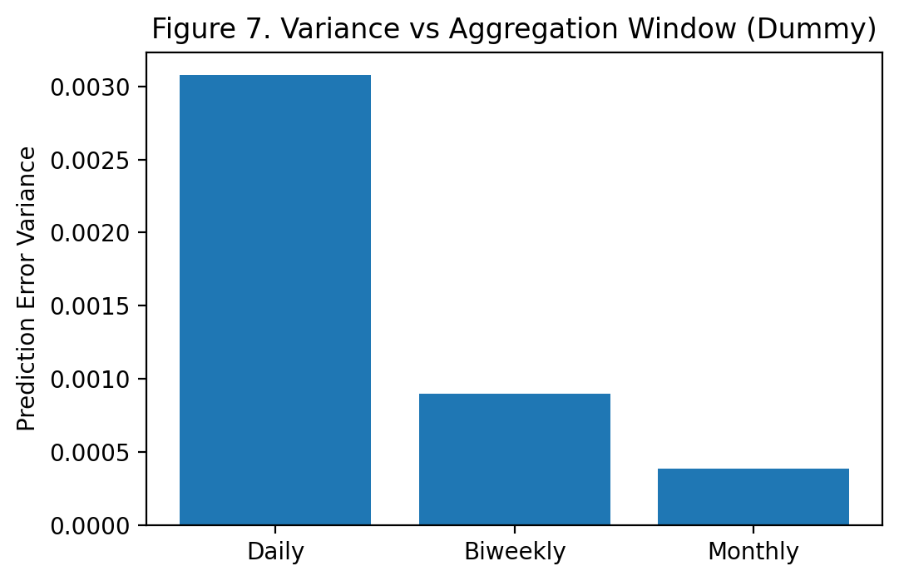
Figure 7. Prediction error variance vs. aggregation window.

Item | Spatial coverage (%) | Temporal completeness (%) | RMSE
Daily | 65.0 | 70.0 | 0.22
Biweekly | 82.0 | 88.0 | 0.18
Monthly | 95.0 | 98.0 | 0.16
Table 5. Coverage vs. accuracy trade-off by aggregation level.

RQ4: How does the performance of the OCO-2–based SIF enhancement model vary across different agro-climatic zones within Germany?

Item | R² | RMSE | Bias | N (samples)
Maritime NW | 0.91 | 0.18 | 0.0 | 22000.0
Continental East | 0.88 | 0.22 | 0.01 | 18000.0
Central Uplands | 0.9 | 0.2 | 0.0 | 20000.0
Alpine South | 0.84 | 0.26 | 0.02 | 12000.0
Table 6. Model performance by agro-climatic zone.

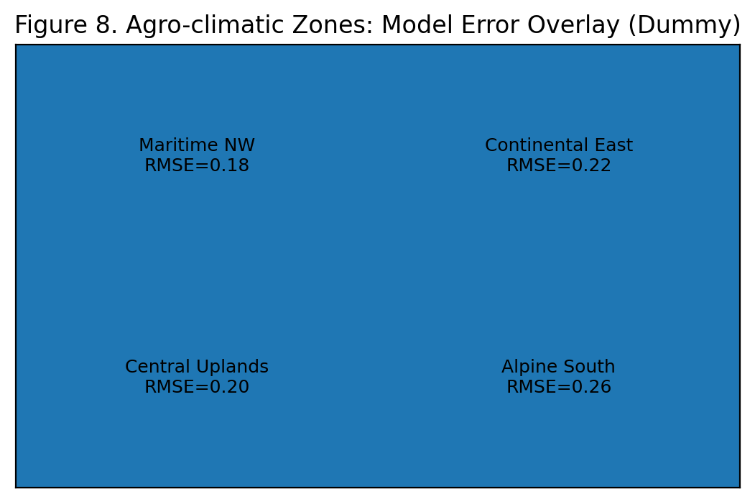
Figure 8. Agro-climatic zones with performance overlay (should be a choropleth map of Germany with each zone segmented).

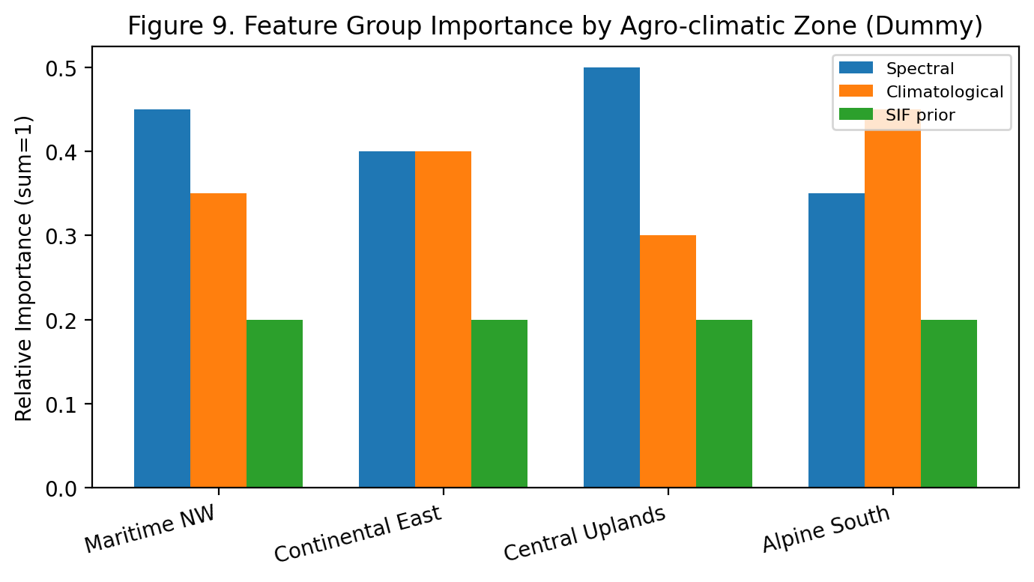
Figure 9. Feature group importance by zone.

Item | Spectral-driven error (%) | Climate-driven error (%) | Mixed/other (%)
Maritime NW | 45 | 35 | 20
Continental East | 40 | 40 | 20
Central Uplands | 50 | 30 | 20
Alpine South | 35 | 45 | 20
Table 7. Error attribution by zone.

RQ5: To what extent does high-resolution, crop-pure enhanced SIF improve winter wheat yield prediction RMSE compared to mixed-pixel SIF derived from raw satellite observations?

Item | Yield RMSE (t/ha) | Yield R² | Relative error (%)
Raw mixed-pixel SIF | 0.62 | 0.68 | 9.1
Enhanced SIF (500 m) | 0.54 | 0.74 | 7.9
Enhanced SIF (10-100 m crop-pure) | 0.45 | 0.81 | 6.6
Table 8. Yield model performance using different SIF inputs.

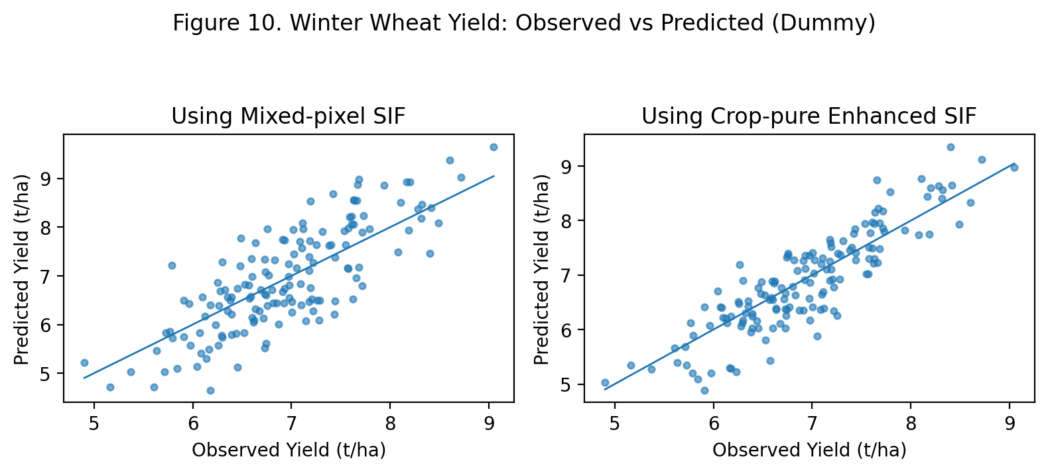
Figure 10. Observed vs. predicted winter wheat yield (mixed-pixel vs crop-pure).
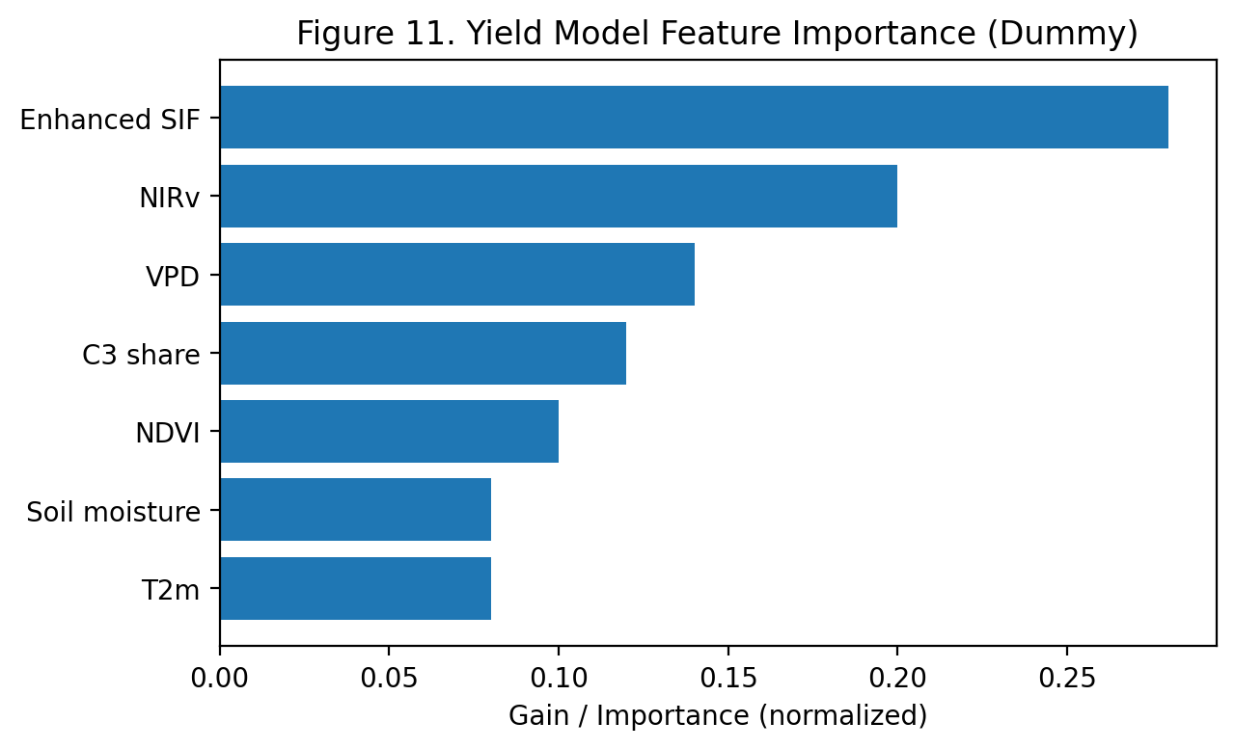
Figure 11. Feature importance in the yield prediction model.
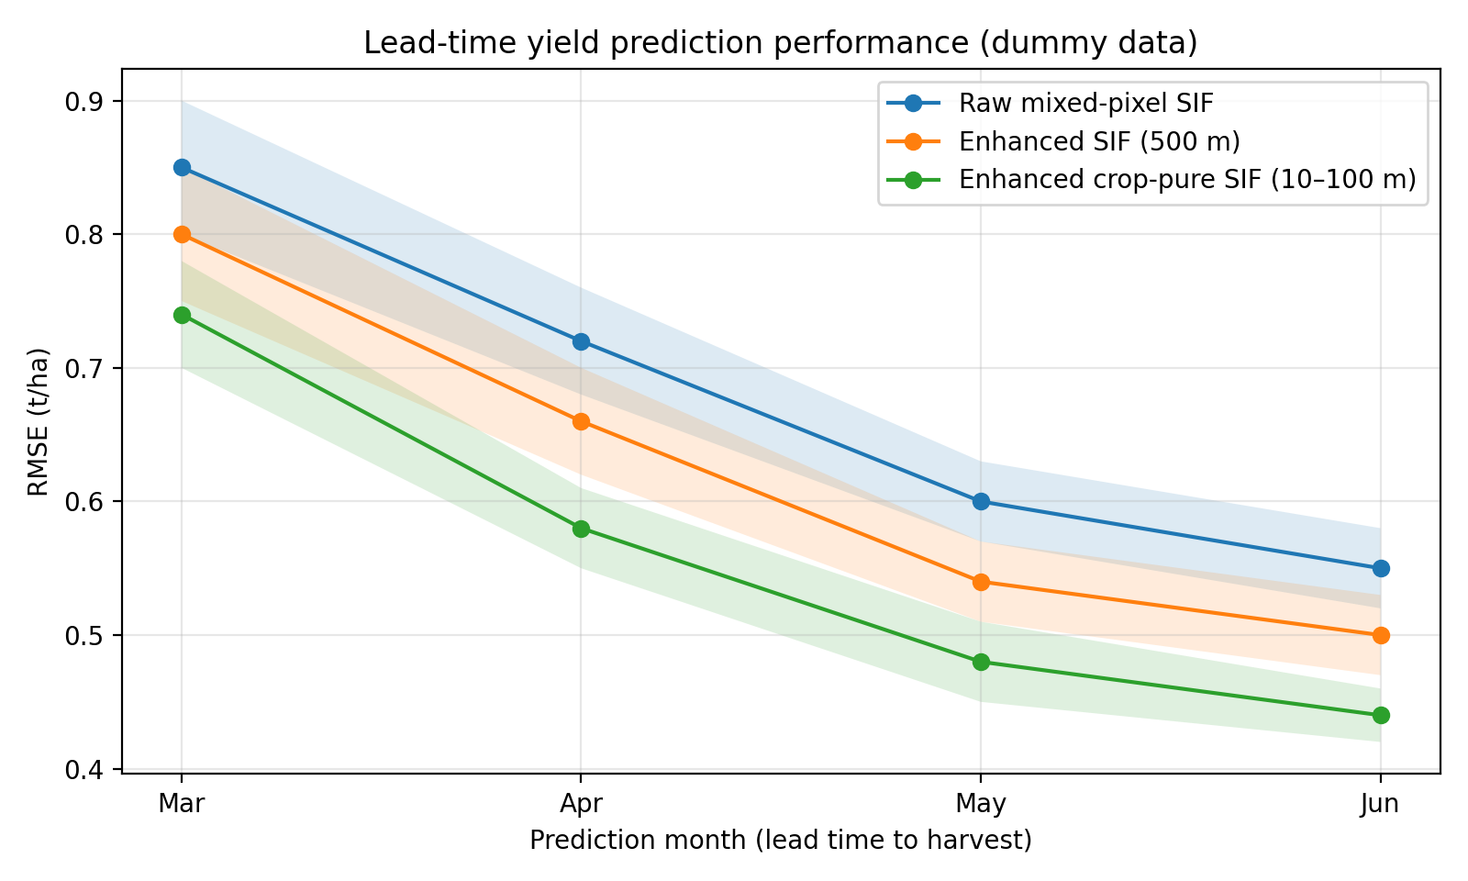
Figure 12. Lead-time yield prediction performance. RMSE (t/ha) across months (Mar–Jun) comparing models using raw mixed-pixel SIF, enhanced SIF at 500 m, and enhanced crop-pure SIF at 10–100 m. Shaded bands indicate dummy ±1 SD across folds.

RQ6: How does the spatial density of OCO-2 training samples (revisit frequency) impact the uncertainty of the reconstructed SIF product at the field scale?

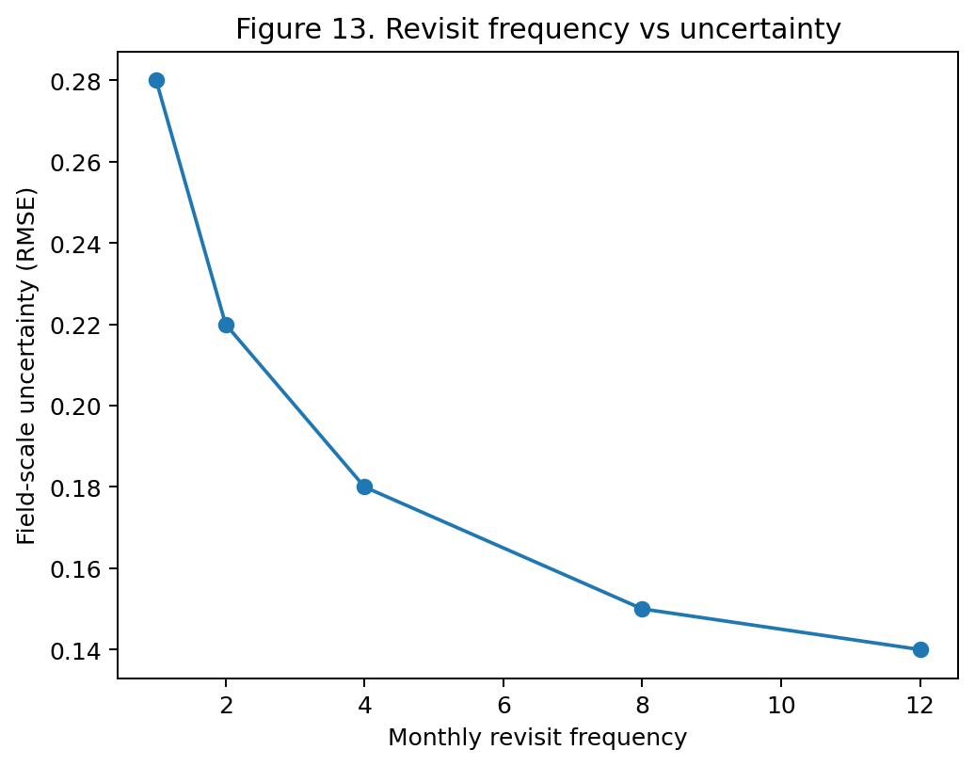
Figure 13. Revisit frequency vs field-scale uncertainty.

Revisits/month | Coverage (%) | RMSE | Uncertainty class
1 | 42 | 0.28 | High
2 | 58 | 0.22 | Moderate
4 | 74 | 0.18 | Moderate
8 | 89 | 0.15 | Low
Table 9. Sensitivity of uncertainty to revisit frequency.

RQ7: To what extent can the enhancement framework trained on winter wheat be transferred to other C3 crops (e.g., silage maize) without loss of physiological signal integrity?

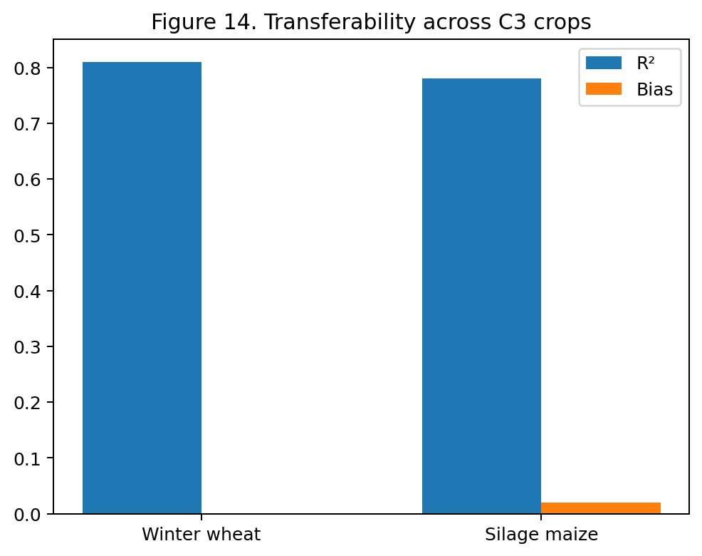
Figure 14. Transfer performance from winter wheat to silage maize.
Train crop | Test crop | R² | RMSE | Signal integrity
Winter wheat | Winter wheat | 0.81 | 0.45 | Baseline
Winter wheat | Silage maize | 0.78 | 0.49 | Preserved
Winter wheat | Barley | 0.76 | 0.52 | Moderate
Table 10. Cross-crop transferability results.

References
Gensheimer, J., Turner, A. J., Köhler, P., Frankenberg, C., & Chen, J. (2021). A convolutional neural network for spatial downscaling of satellite-based solar-induced chlorophyll fluorescence (SIFnet). Biogeosciences Discussions, 2021, 1-25.
Chen, S., Liu, L., Sui, L., Liu, X., & Ma, Y. (2025). An improved spatially downscaled solar-induced chlorophyll fluorescence dataset from the TROPOMI product. Scientific Data, 12(1), 135.
Li, X., & Xiao, J. (2019). A global, 0.05-degree product of solar-induced chlorophyll fluorescence derived from OCO-2, MODIS, and reanalysis data. Remote Sensing, 11(5), 517.
Gessner, U., Hirner, A., Asam, S., Wenzl, M., & Kuenzer, C. (2025). Combining Machine Learning and Spatio-Temporal Filtering to Map Crop Types of Germany for 7 Years. IEEE Geoscience and Remote Sensing Letters.
Peng, B., Guan, K., Zhou, W., Jiang, C., Frankenberg, C., Sun, Y., ... & Köhler, P. (2020). Assessing the benefit of satellite-based Solar-Induced Chlorophyll Fluorescence in crop yield prediction. International Journal of Applied Earth Observation and Geoinformation, 90, 102126.
Kira, O., Wen, J., Han, J., McDonald, A. J., Barrett, C. B., Ortiz-Bobea, A., ... & Sun, Y.(2024). A scalable crop yield estimation framework based on remote sensing of solar-induced chlorophyll fluorescence (SIF). Environmental Research Letters, 19(4), 044071.

Appendix

A. Dataset Inventory and Coverage
- OCO-2 SIF observations: Spatially sparse footprints (1–3 km²) used as the primary training target.
- Sentinel-2 imagery: 10 m multispectral bands and derived vegetation indices (e.g., NDVI, NIRv).
- Climatological variables: Temperature, vapor pressure deficit (VPD), humidity, precipitation, and radiation variables.
- Crop type maps: Annual crop masks for Germany at 10 m resolution for crop-pure pixel extraction.
- Yield statistics: Official winter wheat yield data aggregated at NUTS-2 / NUTS-3 level.
- Temporal coverage: January 2020 – February 2026.
- Study area: Germany.

B. Feature Engineering and Preprocessing
- Spatial alignment of all raster layers to a common grid.
- Temporal matching of OCO-2 overpasses with Sentinel-2 and climate records.
- Aggregation of predictor variables to OCO-2 footprint scale for supervised learning.
- Missing-value handling using interpolation and/or temporal smoothing.
- Standardization / normalization of continuous predictors.
- Generation of crop-pure masks to isolate winter wheat pixels.
- Optional lagged variables (e.g., previous month SIF or climate anomalies).

C. Candidate Models and Hyperparameter Grids
Tree-based Models
- Random Forest
  - Number of trees: 100, 300, 500
  - Max depth: 10, 20, None
  - Min samples leaf: 1, 3, 5
- XGBoost
  - Learning rate: 0.01, 0.05, 0.1
  - Max depth: 4, 6, 8
  - Estimators: 200, 500, 1000
  - Subsample: 0.7, 0.9, 1.0
Neural Networks
- ANN / MLP
  - Hidden layers: 2–4
  - Units per layer: 64, 128, 256
  - Dropout: 0.1, 0.3, 0.5
  - Batch size: 32, 64, 128
- CNN
  - Patch size: 16×16, 32×32
  - Filters: 32, 64, 128
  - Kernel size: 3×3, 5×5
  - Learning rate: 1e-4, 1e-3

D. Validation and Evaluation Protocol
- Train / validation / test split by space and/or time.
- K-fold cross-validation for robust model comparison.
- Spatial holdout validation across agro-climatic zones.
- Temporal holdout validation across unseen growing seasons.
- Benchmark comparison against published products (SIFnet, TroDSIF, GOSIF).
- Independent yield-model evaluation using unseen administrative regions.

E. Evaluation Metrics
SIF Enhancement
- R²
- RMSE
- MAE
- Bias
- Spatial autocorrelation of residuals (Moran’s I)
- Field-boundary fidelity
- Temporal consistency
Yield Prediction
- RMSE (t/ha)
- Relative Error (%)
- R²
- Explained Variance
- Lead-time performance (March–June forecasts)

F. Expected Outputs
- High-resolution enhanced SIF dataset (10–100 m).
- Spatially and temporally complete SIF maps for Germany.
- Benchmark comparison with existing SIF products.
- Winter wheat yield prediction model using crop-pure SIF.
- Transferability assessment for other crops (e.g., silage maize).
- Reproducible workflows and code repository.

G. Technical Environment
Programming Languages
- Python
- R
Core Libraries
- PyTorch
- XGBoost
- Scikit-learn
- Pandas
- NumPy
- Rasterio
- GeoPandas
- Xarray
- Matplotlib / Seaborn
- sf, terra, tidyverse (R)
Infrastructure
- GPU-enabled cloud or HPC cluster
- Google Earth Engine
- STAC APIs / remote data catalogs
- Version control with Git/GitHub

H. Risks and Limitations
- Sparse OCO-2 coverage may limit local generalization.
- Cloud contamination in Sentinel-2 imagery.
- Temporal mismatch between sensors.
- Mixed pixels in benchmark products.
- Administrative yield data may mask field-level variability.
- Transferability may vary across crop physiology and management systems.

I. Ethical and Reproducibility Considerations
- Use of publicly available environmental and agricultural data only.
- Transparent reporting of model assumptions and uncertainty.
- Reproducible pipelines with documented code and parameters.
- No personal or sensitive data involved.
- Results intended for scientific and agricultural decision support purposes.

