

# Appl Containerization and Orchestration

**Experiment 3**

**AIM: Working with Docker Volume**

**Submitted by- Submitted to:**

**Akhand Pratap Singh Mr. Hitesh Kumar Sharma**

**Steps to Complete:**

1. **View all Volume in Docker**

**Command :** docker volume ls

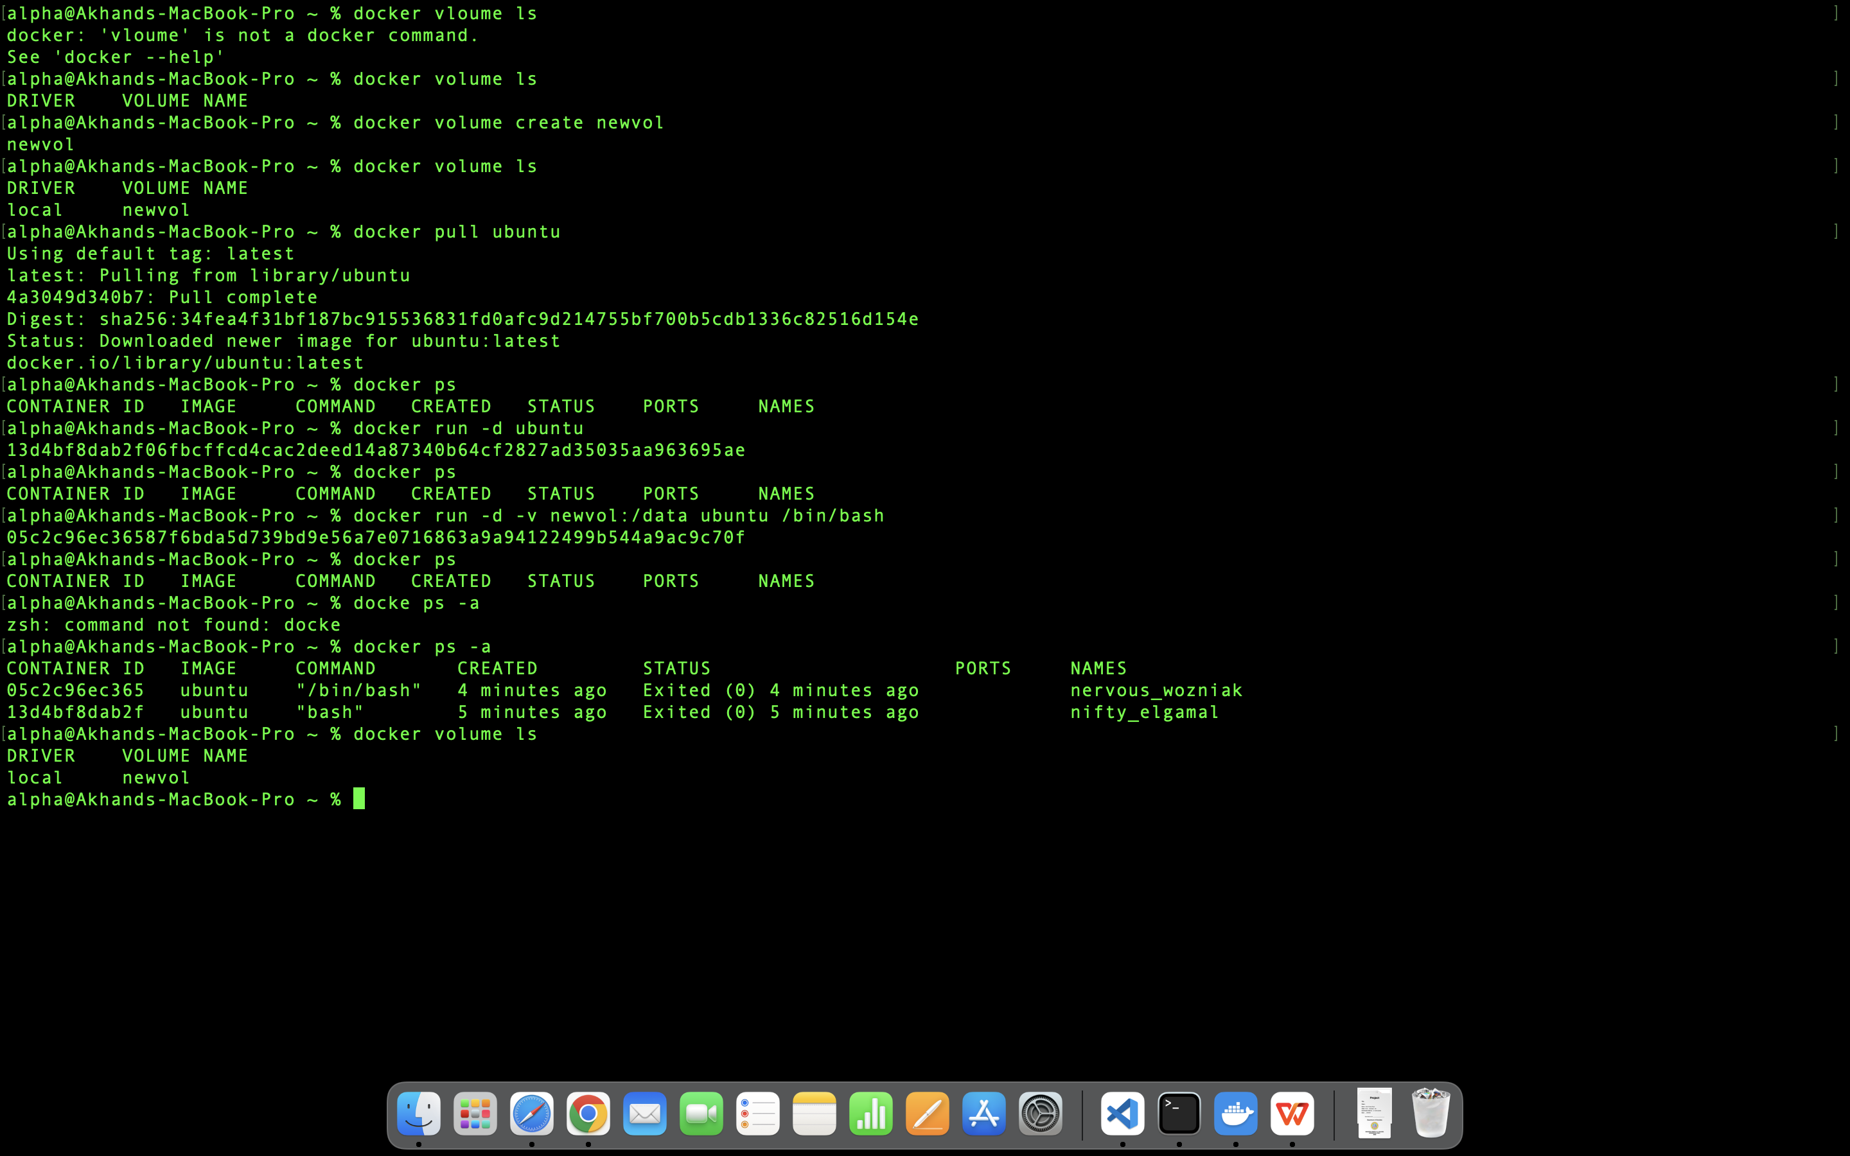

1. **Create a new Volume**

**Command :** docker volume create newvol

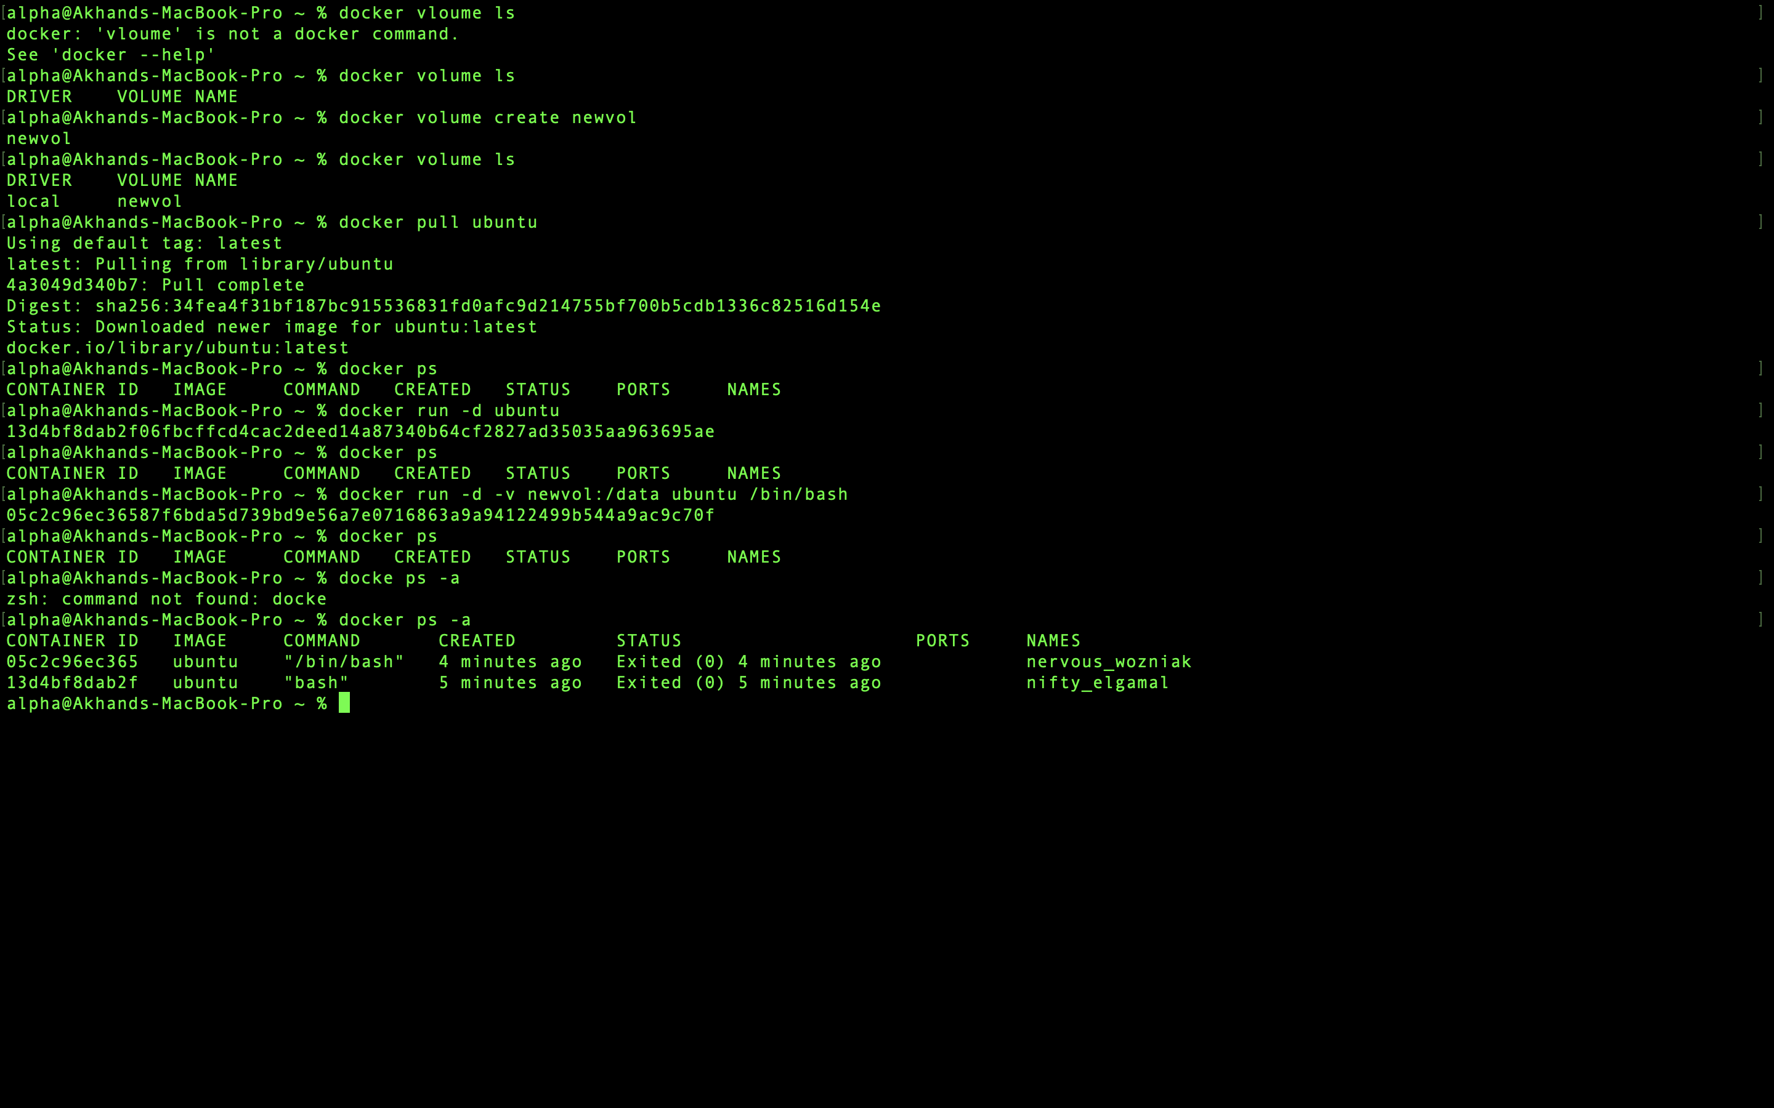

1. **Mount a Volume with a container**

**Command :** docker run -d -v newvol:/data ubuntu /bin/bash



1. **Create another container and Mount with the same Volume**

**Command :** docker run -d -v newvol:/data ubuntu /bin/bash



1. **See the complete working of container**

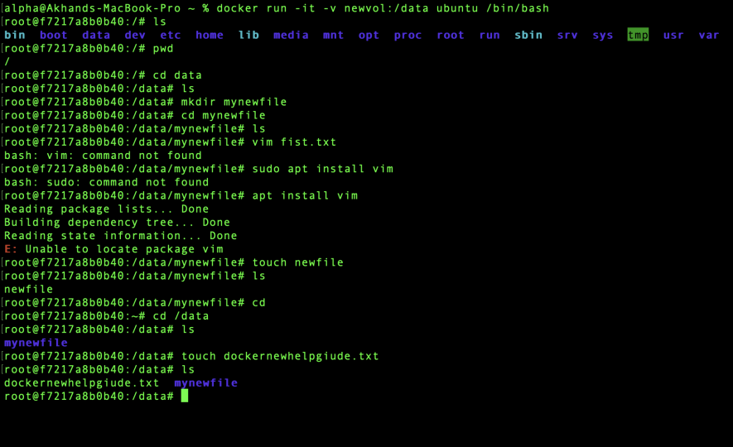

1. **Exited from container and restart again to see the persistent of Docker Volume**

**Command :** Dokcer start <container ID>

Docker attach <container ID>

