EduWallet

Tamper-Proof Academic Certificates on Blockchain,
with Institutional Recovery for Lost Wallets
Final Project Report
Submitted by: ______________________________
Roll number: ______________________________
Programme: ______________________________
Department: ______________________________
Institution: ______________________________
Supervisor: ______________________________
25 October 2026

Contents
1. Abstract
2. The Problem
3. What EduWallet Is
4. Existing Solutions and the Gaps They Leave
5. How EduWallet Works
6. Step-by-Step Demonstration
7. Testing and Results
8. Security Analysis
9. Limitations
10. Conclusion and Future Work
11. References

1. Abstract
A printed degree certificate is easy to fake and slow to check. An employer who wants to confirm it has to email the university and wait, sometimes for weeks. Putting the certificate in a university database makes checking faster, but the employer now has to trust whoever runs that database.
EduWallet removes that need for trust. When a university issues a certificate, the system takes all the facts on it, reduces them to a single fingerprint, and the university's digital key signs that fingerprint. Anyone checking the certificate can work backwards from the signature to find out which key signed it. If even one character of the certificate is changed afterwards, the fingerprint no longer matches and the check fails.
The certificate is also recorded on the Polygon blockchain as a token that can never be transferred or sold, so a qualification cannot be bought from someone who earned it. Importantly, the signature check works even when the blockchain cannot be reached, so verification never depends on the network being available.
The system also solves the problem that has stopped similar projects being used in practice: what happens when a student loses access to their account. Instead of asking students to safeguard a secret key, EduWallet lets them nominate universities as guardians. If a student loses access, those guardians can move the account to a new address, but only if enough of them agree and only after a 24-hour delay during which the student alone can cancel it.
The finished system was checked with 77 smart contract tests, 179 application tests and a 20-step end-to-end test run against a live blockchain. All of them pass.

2. The Problem

2.1 How certificates are checked today
A paper certificate contains nothing that lets an outsider check it. There is no way for an employer to confirm that the named university actually issued it, that nobody has altered it since, or that it has not been withdrawn. The only option is to contact the university and ask.
That takes days. It depends on the university still existing and still holding good records. Meanwhile, modern printing makes a convincing fake cheap to produce. Recent work on this subject points to forged engineering degrees and fake diplomas as a live and growing problem [1].

2.2 Why a database does not fix it
The obvious answer is to put certificates in an online database that employers can search. This makes checking fast, but it moves the trust rather than removing it. The employer now has to believe that the database operator is honest, has not been hacked, and has not quietly changed a record. If the operator shuts down, every certificate in it becomes uncheckable.

2.3 Why blockchain projects have not caught on
Blockchain has been proposed as the answer for years, and many systems have been built. A 2025 systematic review of blockchain work in higher education found that despite a decade of proposals, adoption remains limited and the same obstacles keep appearing [1]. A 2025 study of decentralised identity projects in the real world reached a similar conclusion: the barriers are not technical but practical, to do with how systems are deployed and used [6].
One obstacle stands out. Blockchain systems normally ask the holder to look after a private key. If the key is lost, the account is gone forever. A 2023 survey of recovery methods in this field describes the tension clearly: designers have to trade off ease of use, security, and the ability to get back in [4]. For a student holding their degree, losing the key means losing access to their own academic record, which is not an acceptable outcome.

2.4 What this project set out to do
- Make a certificate that anyone can check without trusting the website serving it.
- Make that check work even when the blockchain is unreachable.
- Stop a certificate being sold or transferred to someone who did not earn it.
- Take key management away from students without locking them in.
- Give students a safe way back in if they lose access.
- Be honest in the interface when part of the system is unavailable.

3. What EduWallet Is

3.1 In plain terms
EduWallet is a web application with three kinds of user. A university issues certificates. A student collects them and shares them. An employer checks them, without creating an account.
Behind the scenes, every certificate gets a digital signature from the university that issued it, and a copy is recorded on a blockchain. The student never sees a key or a seed phrase unless they ask for one.

3.2 The two guarantees
Every certificate carries two things that an employer can check for themselves.
Guarantee | What it means | What it stops
A fingerprint of the contents | All the facts on the certificate are combined, in a fixed order, into one short code. Changing anything changes the code. | Someone editing a grade, a name or a date after the certificate was issued
A signature from the university | The university's key signs that code. A checker can work out which key signed it. | Anyone, including the people running EduWallet, inventing a certificate
Table 1: The two guarantees on every certificate
Both of these work offline. The blockchain adds a third, independent record, but the certificate is still provable without it.

3.3 Who uses it
User | Needs an account? | What they do
University staff | Yes | Issue certificates, singly or a whole year group at once; withdraw mistakes; see who is checking
Student or graduate | Yes | Keep certificates, share them with employers, control who sees their name
Employer or verifier | No | Check one certificate, once, in under a minute
Table 2: The three kinds of user

4. Existing Solutions and the Gaps They Leave

4.1 What has been tried before
Several approaches exist, each better than paper in some way and lacking in another.
Approach | How it is checked | Who you must trust | Main weakness
Paper certificate | Phone or email the university | The university's records office | Easy to forge; takes days
University database | Search an online portal | Whoever runs the portal | Records can be changed or lost; dies with the operator
Signed PDF | Open it in a reader | A certificate authority | No way to show it was later withdrawn
Certificate hash on a blockchain | Compare a hash on the chain | The blockchain being reachable | Fails when the network is down; proves a file existed, not who issued it
EduWallet | Check the signature, the fingerprint and the chain | Only the university's key | The university must look after its key
Table 3: Comparison of approaches to certificate checking
Real systems of this kind have been built and published. ShikkhaChain, for example, is a 2025 system for Bangladesh that issues, verifies and revokes certificates using smart contracts and distributed file storage [3]. Work of this kind shows that the basic idea is sound and deployable.

4.2 What the research says is still missing
A 2026 study of blockchain credential systems sets out three gaps that most existing work leaves open. It states that such systems tend to record certificate fingerprints without tying them to a checkable identity, without any way to establish that the issuing institution is genuine, and without a way to correct or withdraw a certificate once it has been issued [2].
Two further gaps come from the wider literature. Surveys of decentralised identity note that the standards are mature but real deployments are rare, largely because of practical problems rather than technical ones [5][6]. And the recovery survey makes the point that losing a key is a normal event that these systems have to plan for [4].

4.3 How EduWallet addresses each gap
Gap | Source | How EduWallet addresses it
Fingerprints are stored without being tied to a checkable identity | [2] | The student's wallet address is part of the signed fingerprint, and the certificate is minted as a token that is permanently bound to that address
No way to withdraw or correct a certificate after issue | [2] | A university can withdraw a certificate with a written reason, which appears immediately on every link already shared, on the chain as well as off it
No way to establish that the issuing institution is genuine | [2] | Partly addressed. A university must be authorised on the contract before it can issue, so not just anyone can mint. Deciding which universities deserve that authorisation is left as future work
Losing a key means losing the account permanently | [4] | Universities act as guardians and can move an account to a new address, subject to an agreement threshold and a delay the student can cancel within
Verification stops working when the network is unavailable | [1][6] | The signature and fingerprint checks run entirely offline. The blockchain is an extra record, not the proof
Systems look reliable while quietly running in a degraded state | [6] | The interface reports what is actually available, including when nothing is being recorded on the chain
Table 4: Gaps identified in the literature and how this project addresses them

5. How EduWallet Works

5.1 Issuing a certificate
When a university fills in the issuing form and presses the button, five things happen in order.
- The student's account is found and checked.
- The certificate details are stored on IPFS, a distributed file system. If that is unavailable, the details are kept locally instead and the certificate says so.
- The certificate is given a number. The numbering cannot produce duplicates even if two certificates are issued at the same instant.
- The fingerprint is calculated and the university's key signs it. This is the step that makes the certificate real.
- The certificate is recorded on the blockchain.
Only the fourth step has to succeed. If file storage or the blockchain is unavailable, the certificate is still issued, still signed and still checkable, and the interface says which parts did not complete rather than hiding it.

5.2 Checking a certificate
Checking answers three separate questions, and shows each answer on its own rather than merging them into a single tick.
Check | Question it answers | How it is done
Signature | Did this university really issue it? | The signing key is worked out from the signature and compared with the university's published address
Contents | Has anything been changed since? | The fingerprint is recalculated from the stored certificate and compared with the one that was signed
Status | Has it since been withdrawn? | The withdrawal record is read, along with the reason given
Table 5: The three checks and what each one proves
The result is one of four answers. Valid means genuine and in force. Withdrawn means genuinely issued but since cancelled, with the reason shown; the signature still passes, because the document really was issued. Tampered means the contents no longer match the signature, which is the most serious answer and takes priority over everything else. Not found usually means the link was cut short when it was pasted.

5.3 Why a certificate cannot be sold
The certificate is recorded as a token that follows the soulbound standard, meaning it is permanently attached to the person it was issued to. Every method that would move it to another account is blocked at the contract level, including the methods that marketplaces use to list items for sale. The token can only be created and, if necessary, marked as withdrawn. It can never change hands.

5.4 Getting back in after losing access
This is the part that most similar systems leave unsolved. A student chooses between two and five universities as guardians, and decides how many of them must agree before the account can be moved.
Step | Who does it | What happens
1 | The student, in advance | Chooses guardians and sets how many must agree
2 | A guardian | Starts a request naming the student's new address. This counts as the first agreement
3 | Other guardians | Agree, until the required number is reached
4 | Nobody | A 24-hour wait begins
5 | The student, if they wish | Cancels. Only the student can do this
6 | A guardian or the student | Completes the move, once the agreements and the wait are both satisfied
Table 6: The recovery process
The 24-hour wait is the safeguard. For its whole duration the request is visible to the student with a cancel button, and only the student can use it. That is what stops guardians working together to take an account. A request that nobody completes expires after seven days.
When the move completes, the account keeps a record of its old address. This matters: the signature on an existing certificate covers the address it was issued to, so that address cannot be rewritten. Instead, the system looks up certificates under every address the account has ever held, so nothing is lost and old links keep working.

5.5 What is stored where
On the blockchain | In the application database
Who owns which certificate | Names, email addresses and account details
Which universities may issue | Searching, filtering and statistics
Whether a certificate is withdrawn | Share links and their expiry dates
Guardian lists and recovery requests | The record of who checked what, and when
Table 7: Division between the blockchain and the application database
The rule followed throughout is that a database entry is never treated as proof that something happened on the blockchain. The system waits for confirmation and reads the contract back before reporting a certificate as recorded.

6. Step-by-Step Demonstration
This chapter walks through the whole system in the order a new user would meet it. Every image is the working application with a live blockchain connected. The certificates are genuinely signed and the transaction references are real.

6.1 Before you start
Start the blockchain, put the contracts on it, and start the application.
npm run contracts:compile
npm run contracts:deploy:local
npm run dev
Open the address the application prints, normally localhost on port 3000. The badge beside the logo shows whether the blockchain is connected. If it says off-chain, everything still works except recording on the chain.
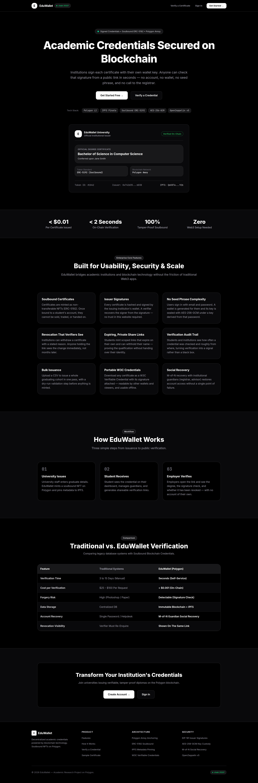
Figure 1: The home page. The badge beside the logo reports the live blockchain connection

6.2 Creating the two accounts
You need one university account and one student account.
- Choose Get Started, then University Staff.
- Enter the institution name. This appears on every certificate it issues, so type it carefully.
- Enter a name, an email address and a password of at least eight characters.
- Submit. You are signed in and a wallet has been created for you automatically.
- Sign out, then repeat as a Student with a different email address.
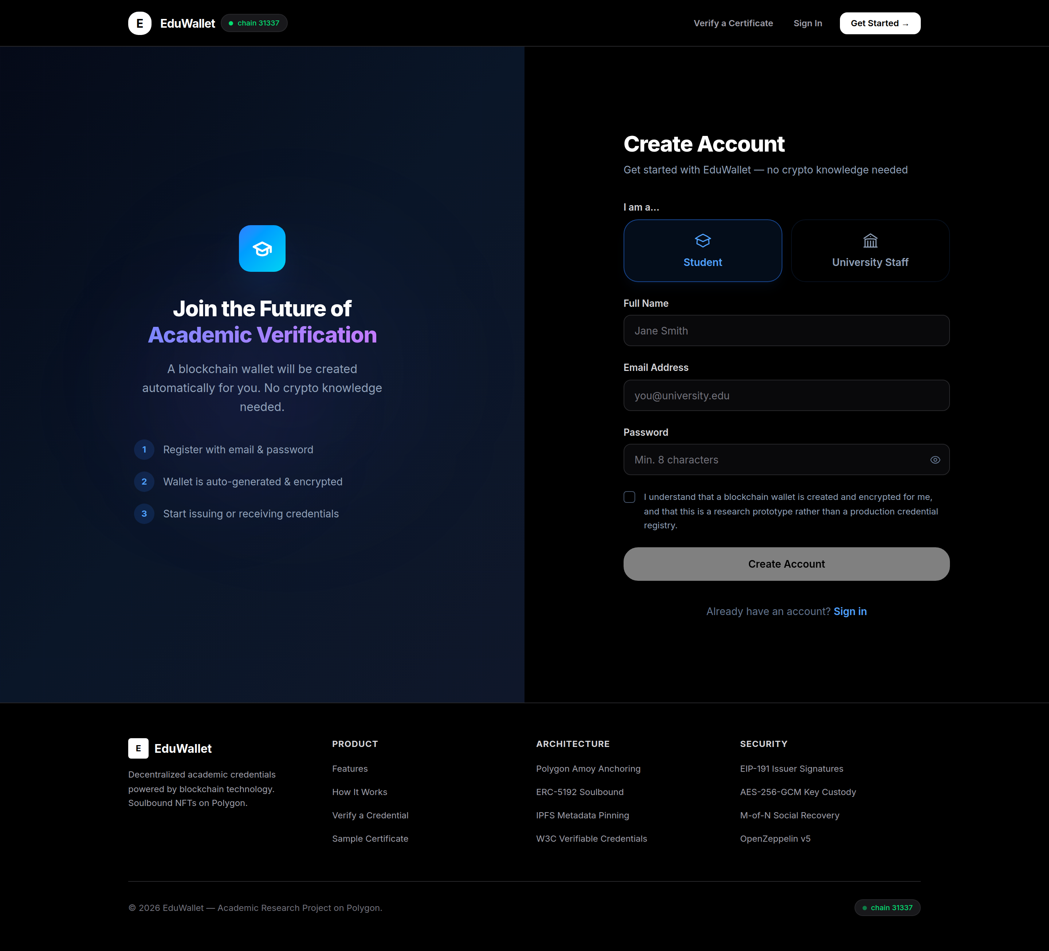
Figure 2: Registration starts with the choice of role, which changes the rest of the form
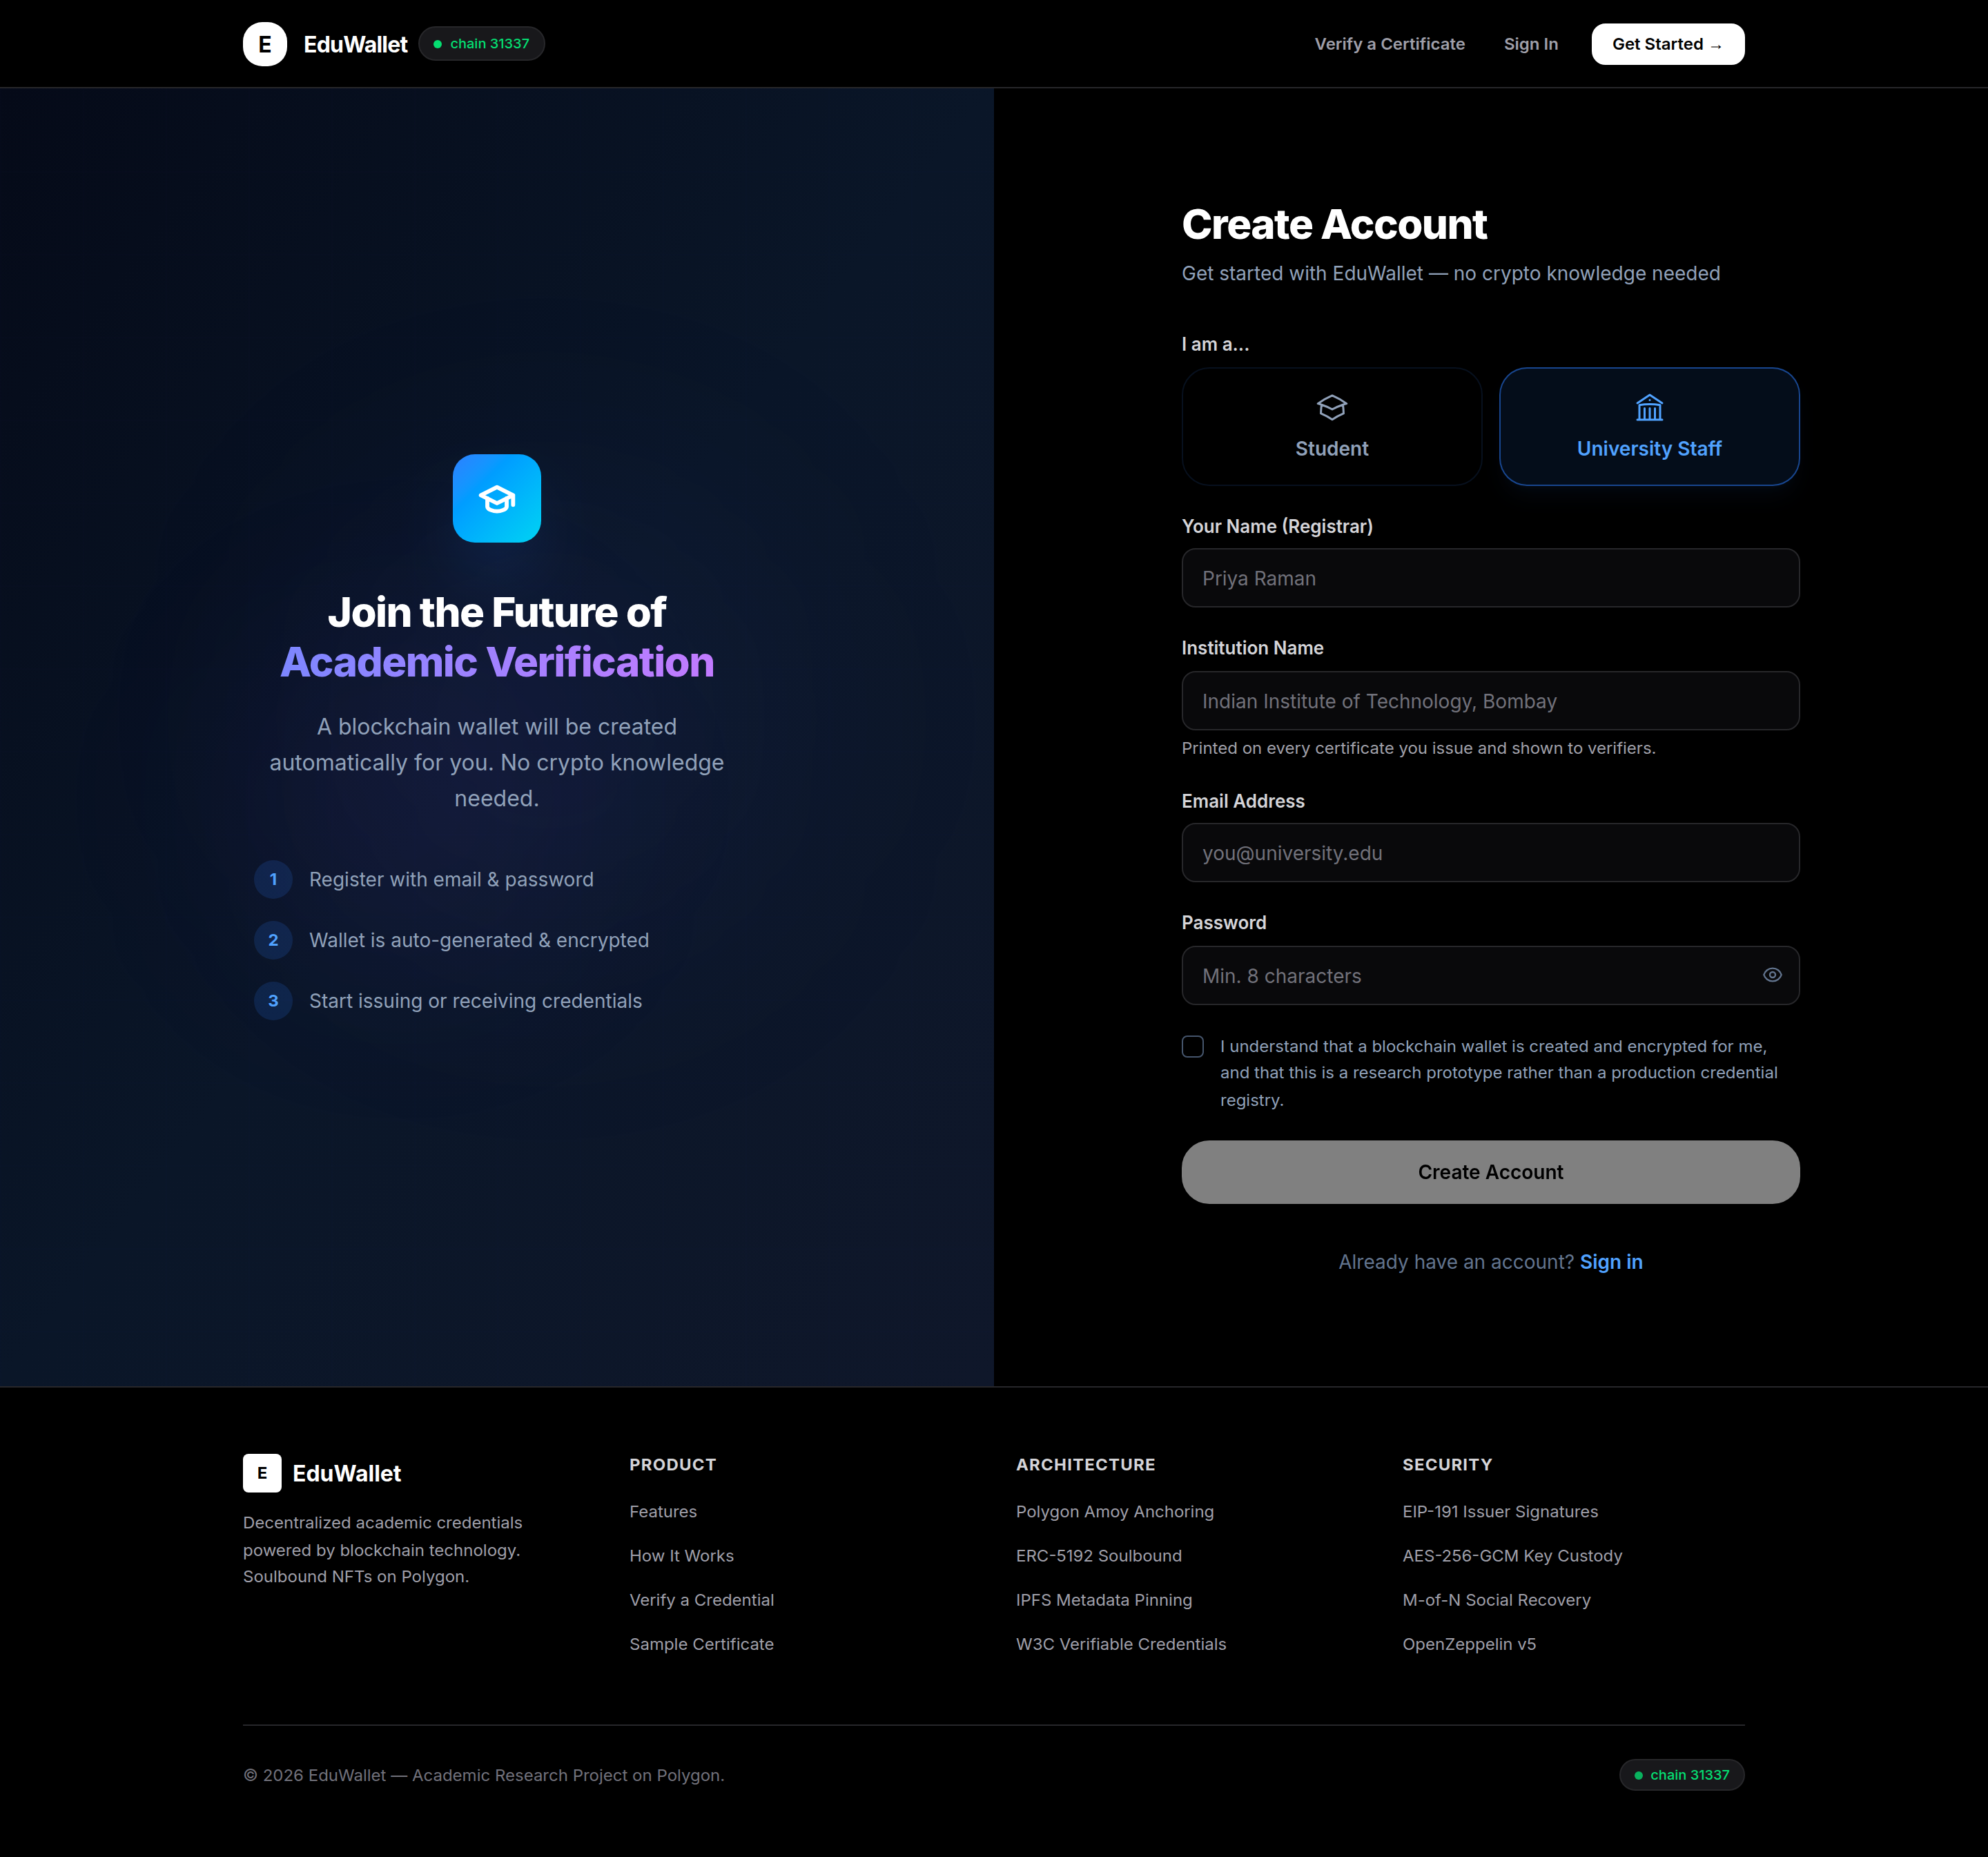
Figure 3: The university form asks for an institution name
No seed phrase appears, and nothing needs to be installed. The wallet is created and locked with the password behind the scenes.

6.3 Issuing a single certificate
- Sign in as the university.
- On the issue tab, enter the student's email address exactly as they registered it.
- Enter the student's name, the degree, and the subject. Grade and completion date are optional.
- Press issue and confirm.
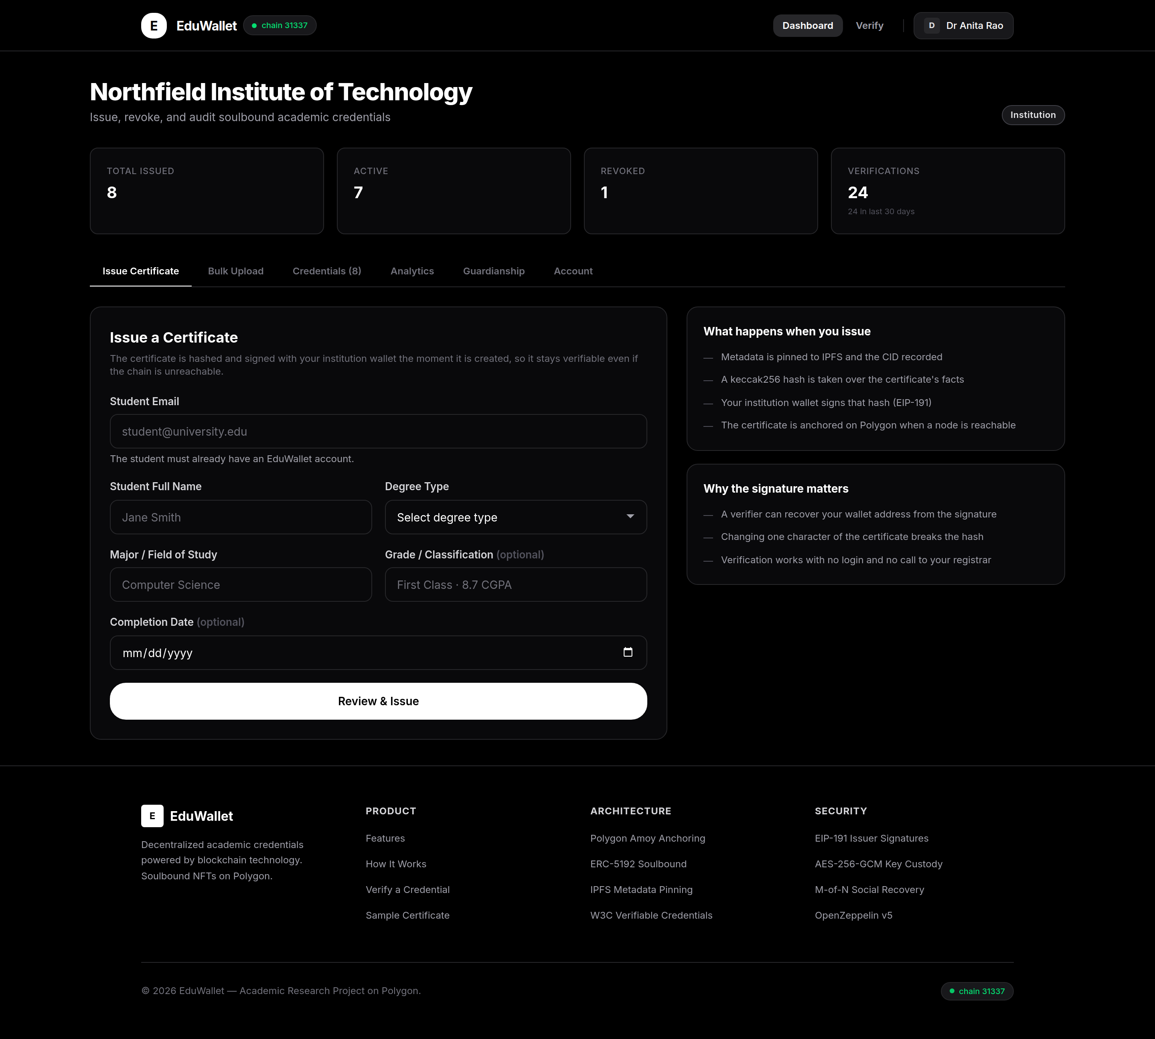
Figure 4: The issuing form, with the institution's running totals above it
A confirmation appears with the certificate number. If the blockchain is connected the certificate is recorded on it at the same time. The first time a university issues anything, the system automatically gives its wallet permission to do so and provides the small amount of currency needed to pay the network fee. This happens once and needs no action.

6.4 Issuing a whole year group
Issuing hundreds of certificates one at a time is not realistic, so there is a bulk tab that accepts a spreadsheet file.
- Open the bulk upload tab.
- Paste or upload a file with a heading row. Email, name, degree and subject are required; grade and completion date are optional.
- Press validate first. This checks the file and reports any problems by row number without issuing anything.
- Fix any rows it complains about, then issue.
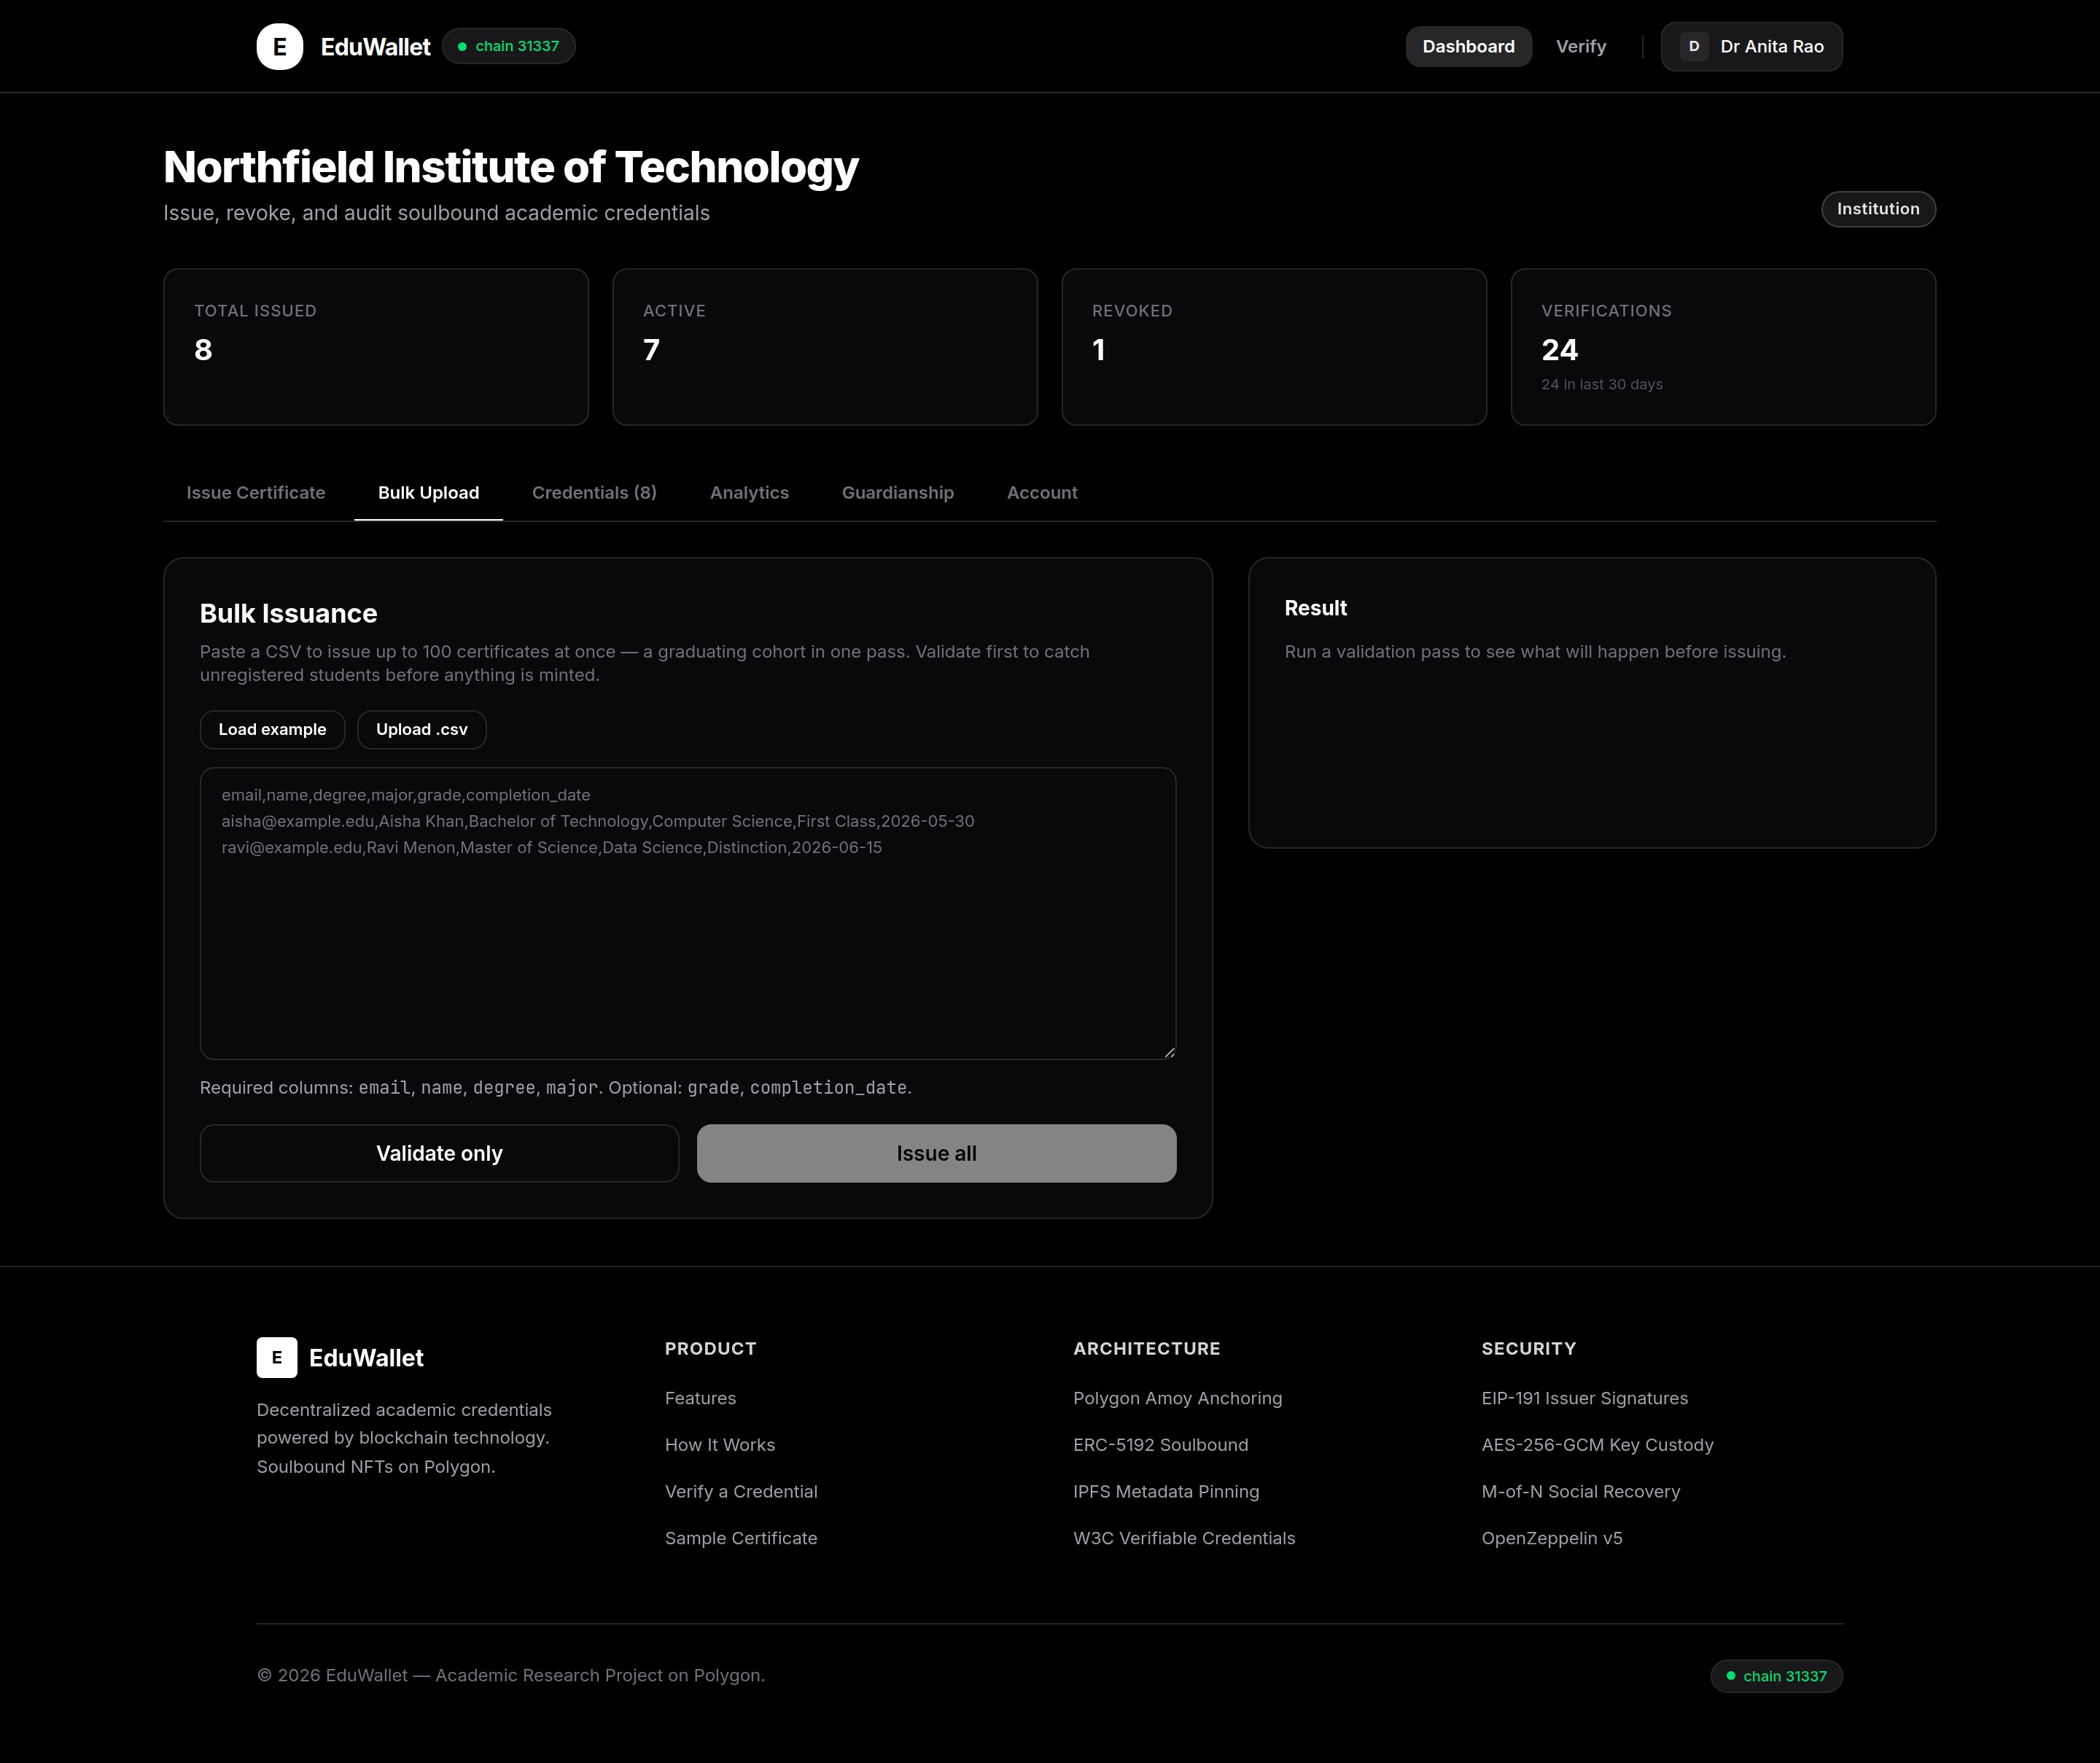
Figure 5: Bulk issuing, with a validation pass before anything is issued
email,name,degree,major,grade,completion_date
daniel.okafor@student.edu,Daniel Okafor,Bachelor of Science,Physics,Upper Second,2026-06-12
sofia.marino@student.edu,Sofia Marino,Bachelor of Arts,Economics,First Class,2026-06-12
If row seven fails, rows one to six are still issued. The report lists exactly which rows worked and why each failure failed. The limit is 100 rows per upload.

6.5 Managing and withdrawing certificates
- Open the credentials tab to see everything the university has issued.
- Search by student name or filter by active and withdrawn.
- To withdraw one, choose withdraw and type a reason. A reason is required.
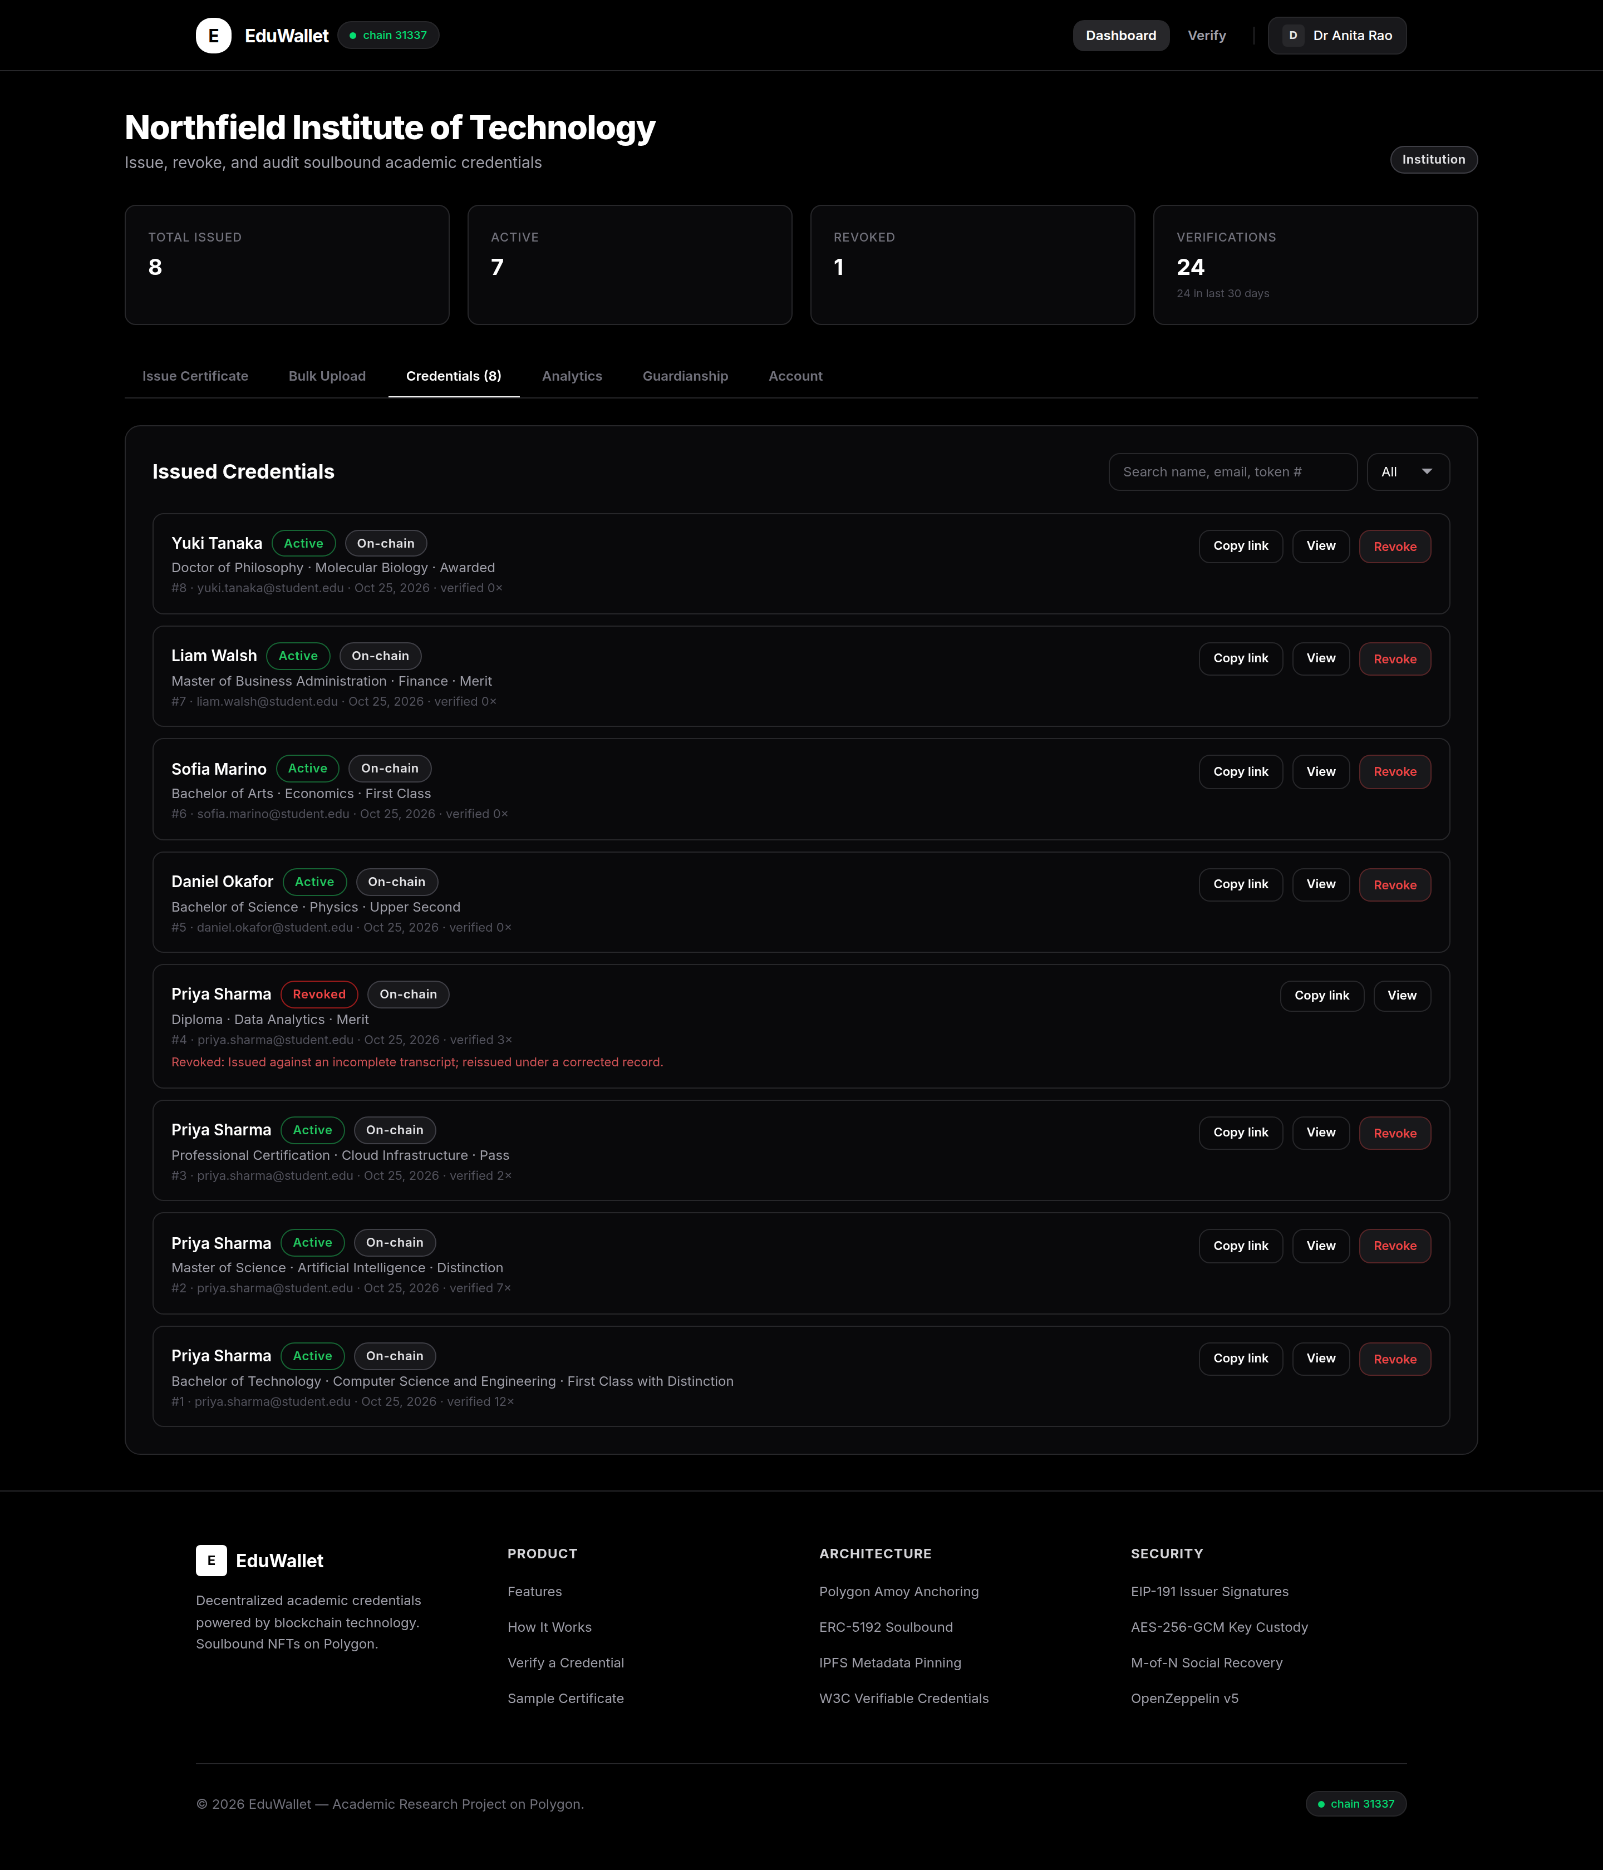
Figure 6: Issued certificates, searchable, with a count of how often each has been checked
The reason is shown to anyone who checks the certificate afterwards, including on links the student has already sent out. There is nothing to recall: the change appears the next time any of those links is opened.

6.6 Seeing who is checking
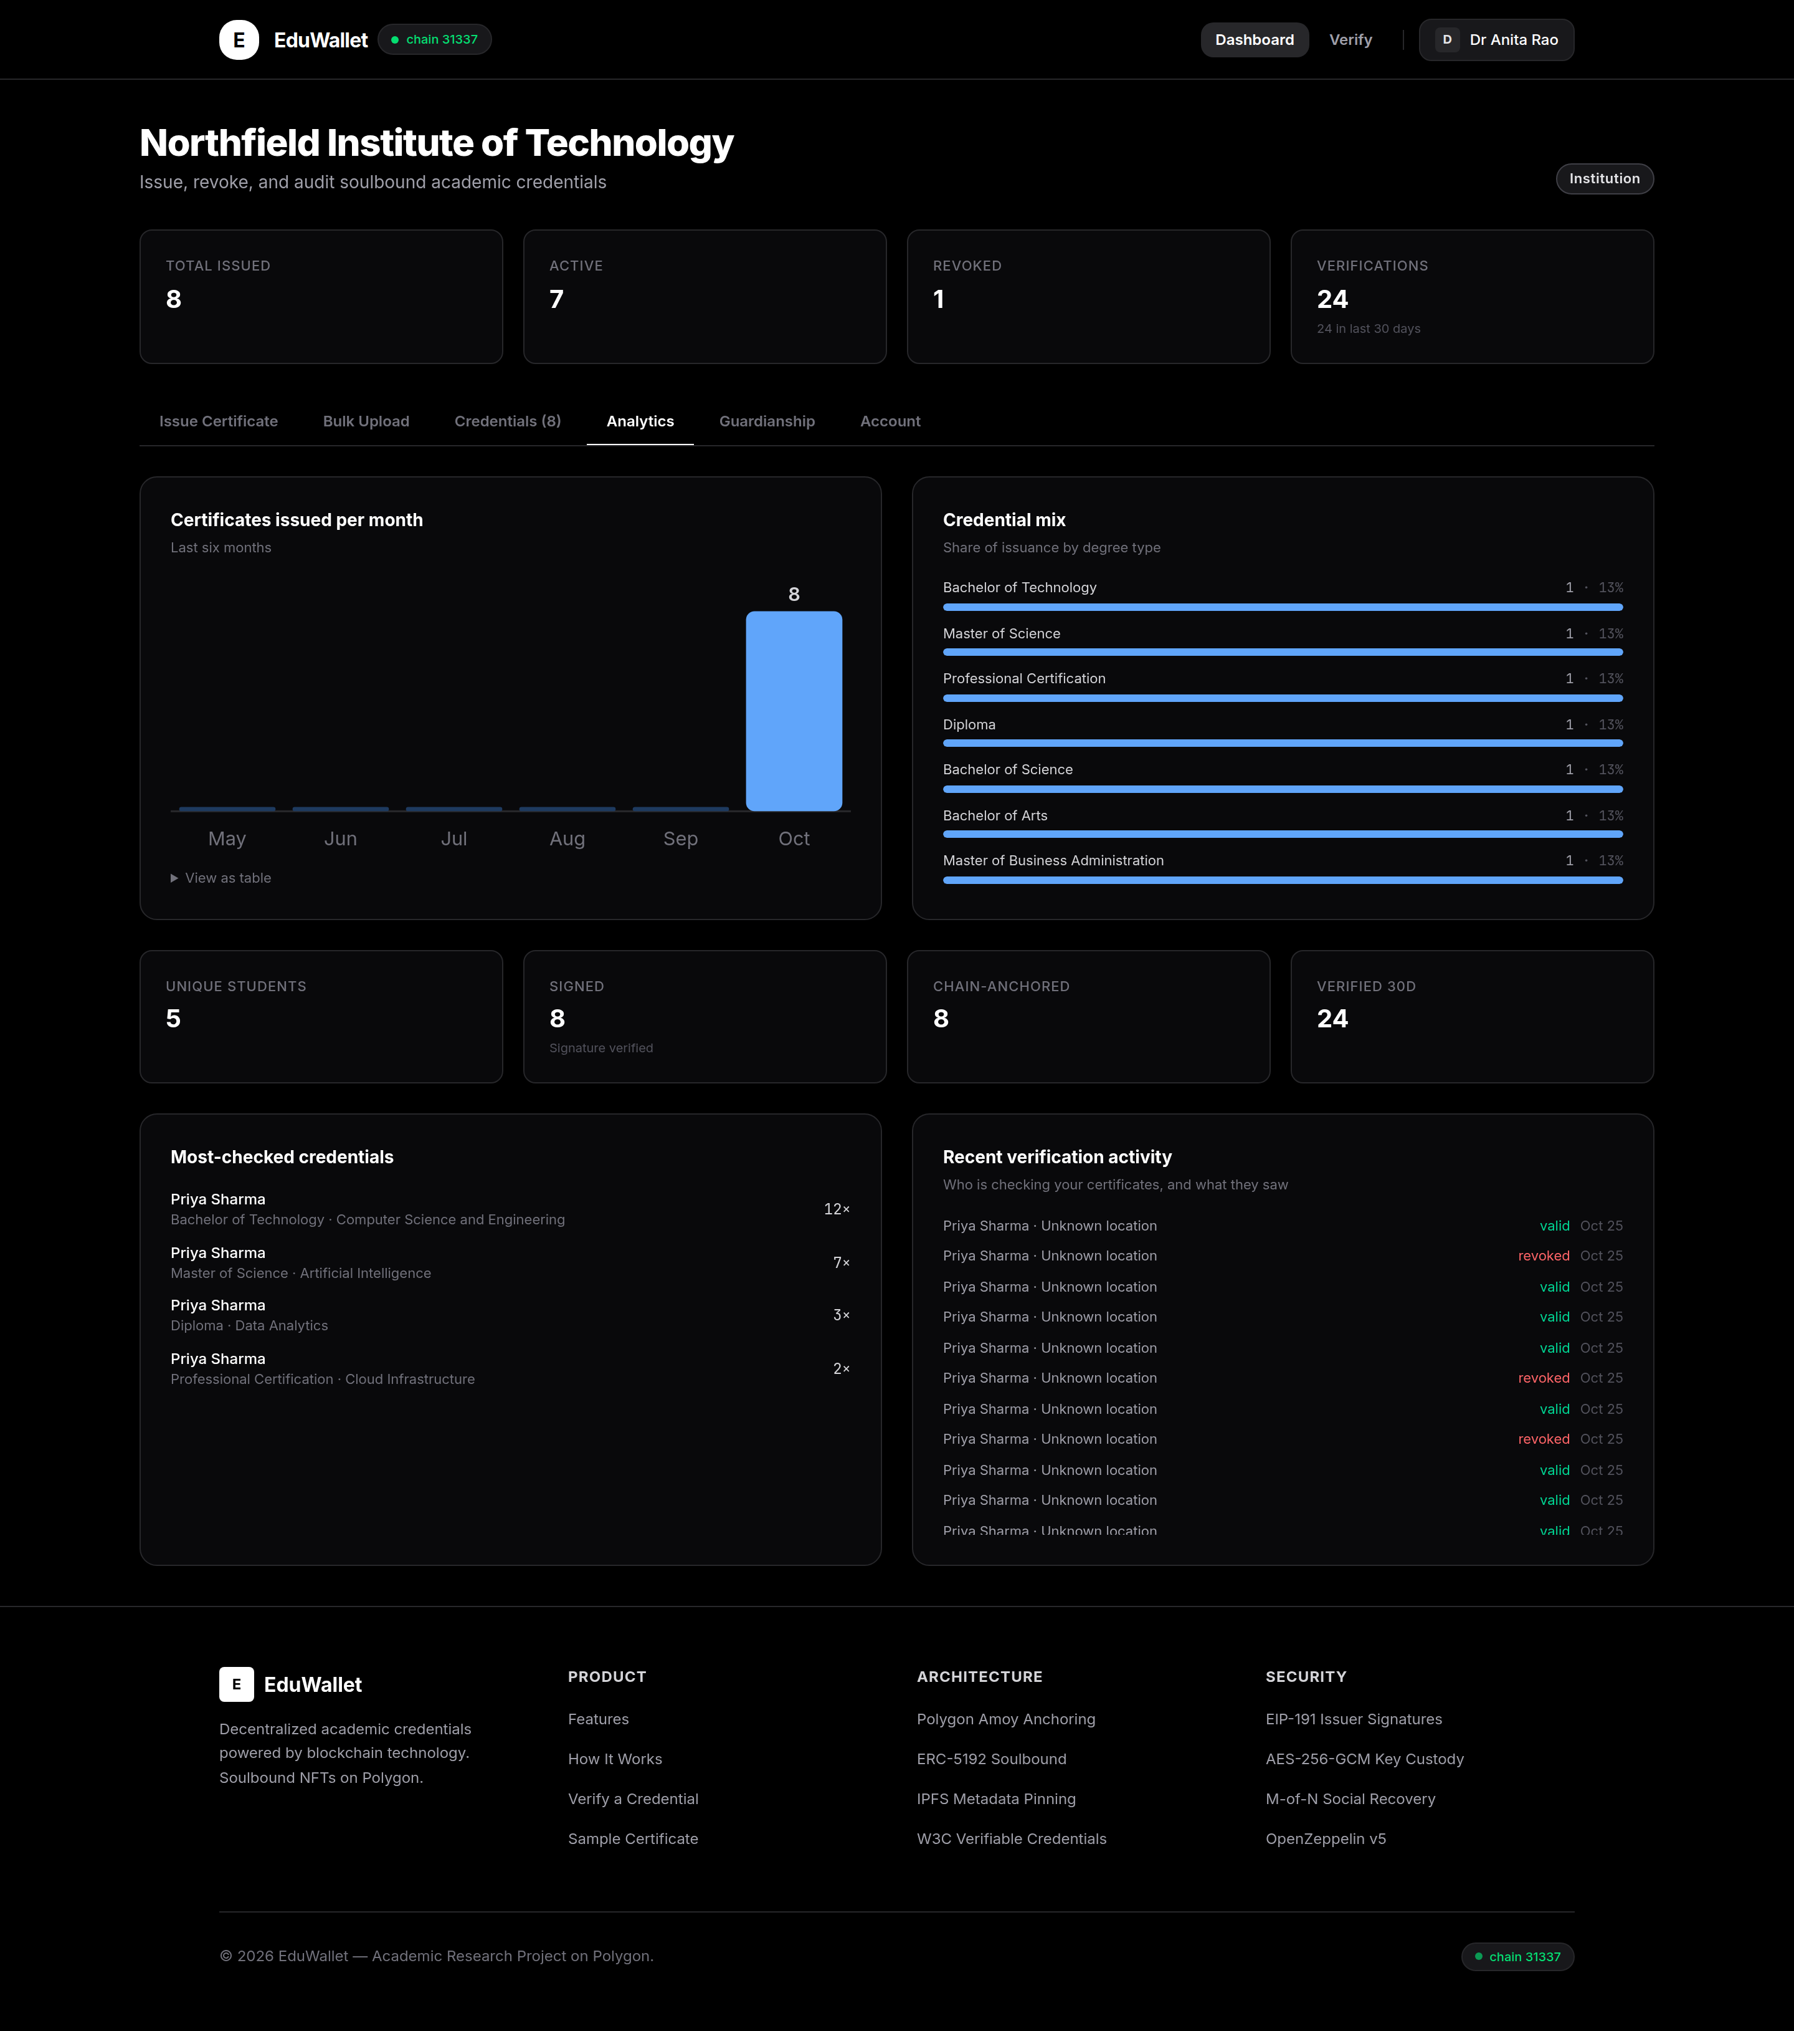
Figure 7: Certificates issued per month, the mix of qualifications, and recent checking activity
The most useful figure here is usually the checking activity, which shows which graduates are job-hunting and which qualifications employers actually verify. Locations are recorded only as a city and country, never as an exact address.

6.7 The student's view
Sign out and sign in as the student.
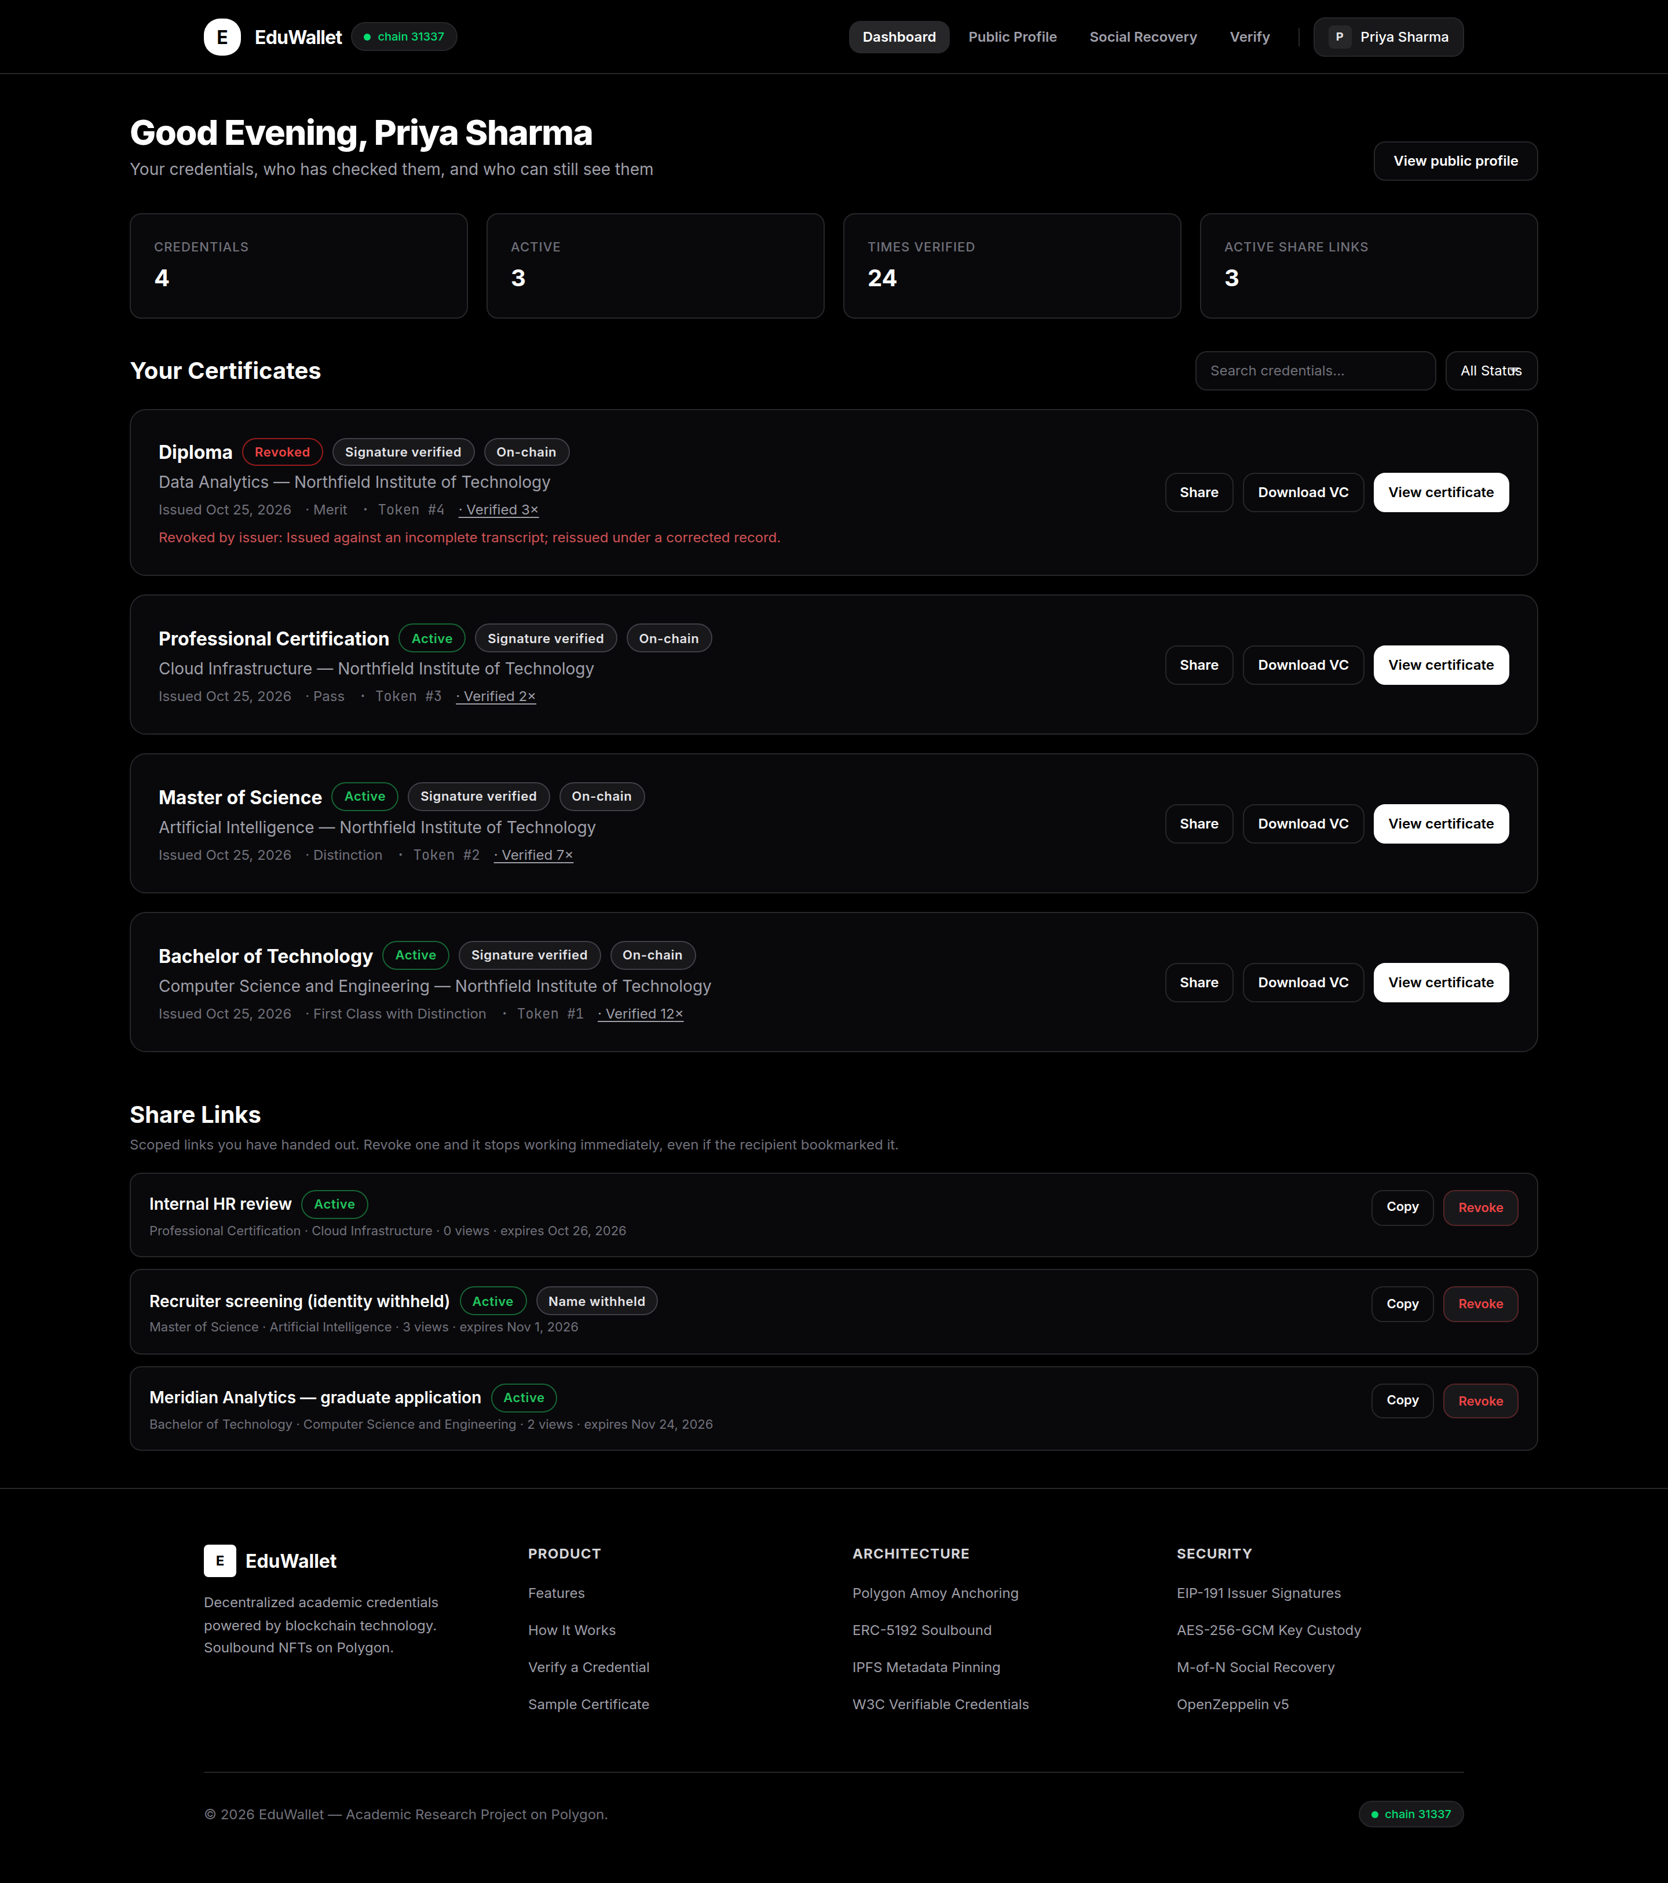
Figure 8: The student's certificates, share links and checking history
Each certificate shows whether it is valid, whether its signature checks out, and whether it is on the blockchain. A certificate can also be downloaded as a standard credential file that opens in other applications and keeps working even if EduWallet disappears.

6.8 Sharing a certificate with an employer
- Choose share on a certificate.
- Give the link a label so you remember who you sent it to.
- Choose how long it should last: 24 hours, 7 days, 30 days, or forever.
- Decide whether to hide your name and wallet address.
- Create the link and copy it.
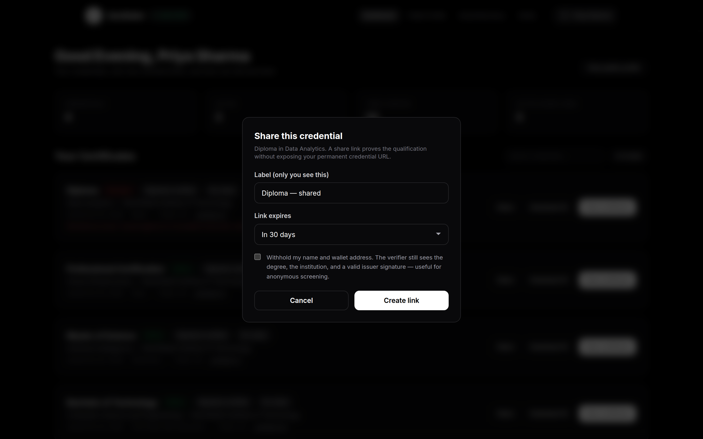
Figure 9: Creating a share link with a label, an expiry and an option to hide your identity
Hiding your identity is useful when a recruiter is screening candidates. They see the degree, the subject, the grade, the university and a valid signature, but not who it belongs to. Any link can be cancelled instantly, and the dashboard shows how many times each has been opened.

6.9 Checking a certificate as an employer
An employer needs no account. They open the verify page and paste whatever they were given: a link, a certificate number, or the student's wallet address.
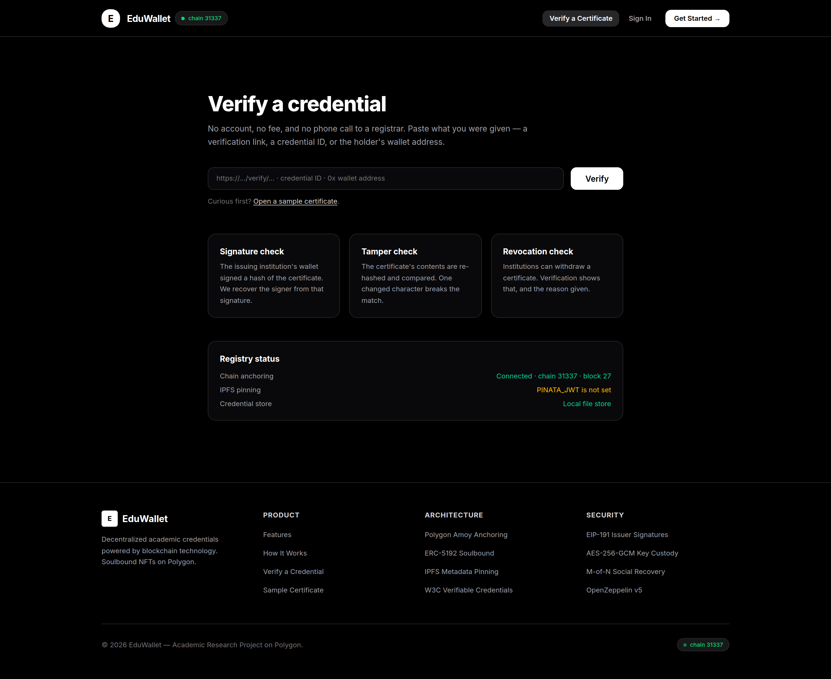
Figure 10: The checking page accepts a link, a certificate number or a wallet address
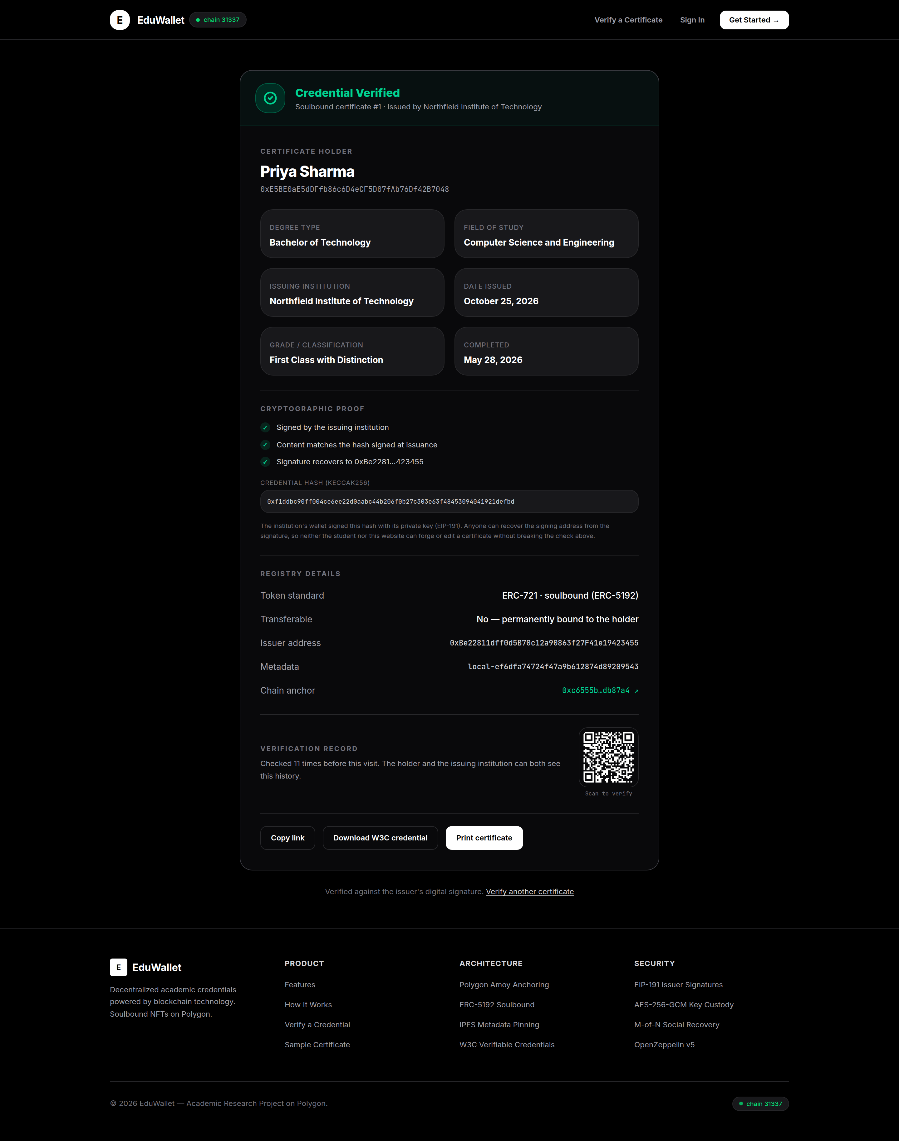
Figure 11: A certificate that passes. The three checks are listed separately, with the fingerprint and the blockchain record
Read it from the top. The answer comes first, then the details of the qualification, then the evidence. The three checks are shown one by one so a reader can see exactly what passed. Below them is the blockchain record, which links out to a public explorer, and a count of how many times the certificate has been checked before.
If the blockchain cannot be reached, the three checks still pass and only the blockchain line changes. That is a weaker claim, not a failure, and the page says so in those words.

6.10 A withdrawn certificate
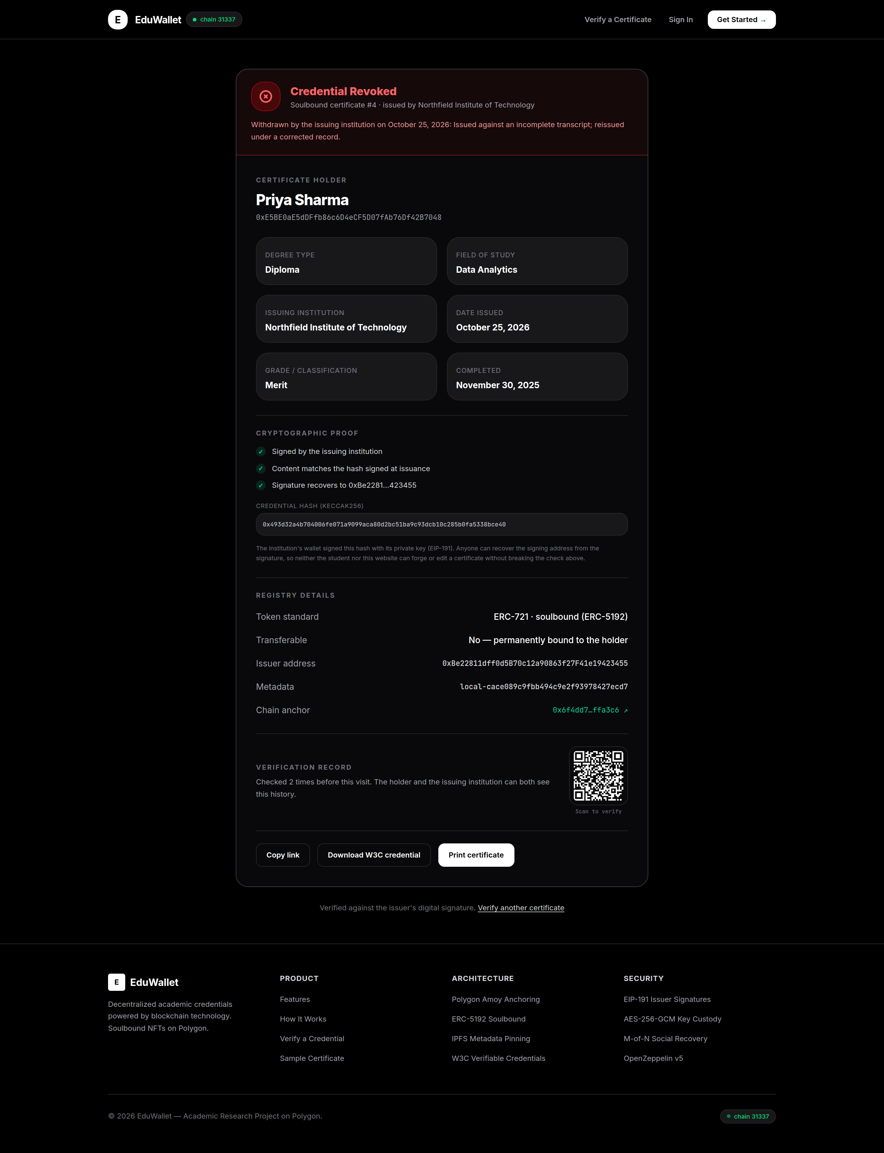
Figure 12: A withdrawn certificate, showing the university's stated reason
Notice that the signature still passes. The document genuinely was issued and later withdrawn, which is a different thing from a forgery, and the page lets a reader tell them apart.

6.11 A certificate shared without a name
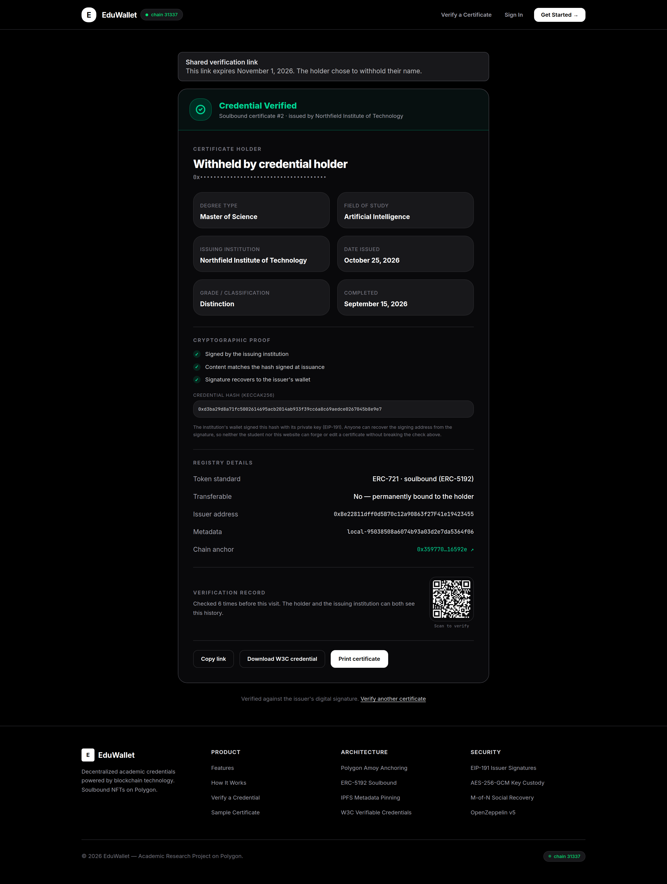
Figure 13: A link that proves the qualification without naming the holder

6.12 A student's public page
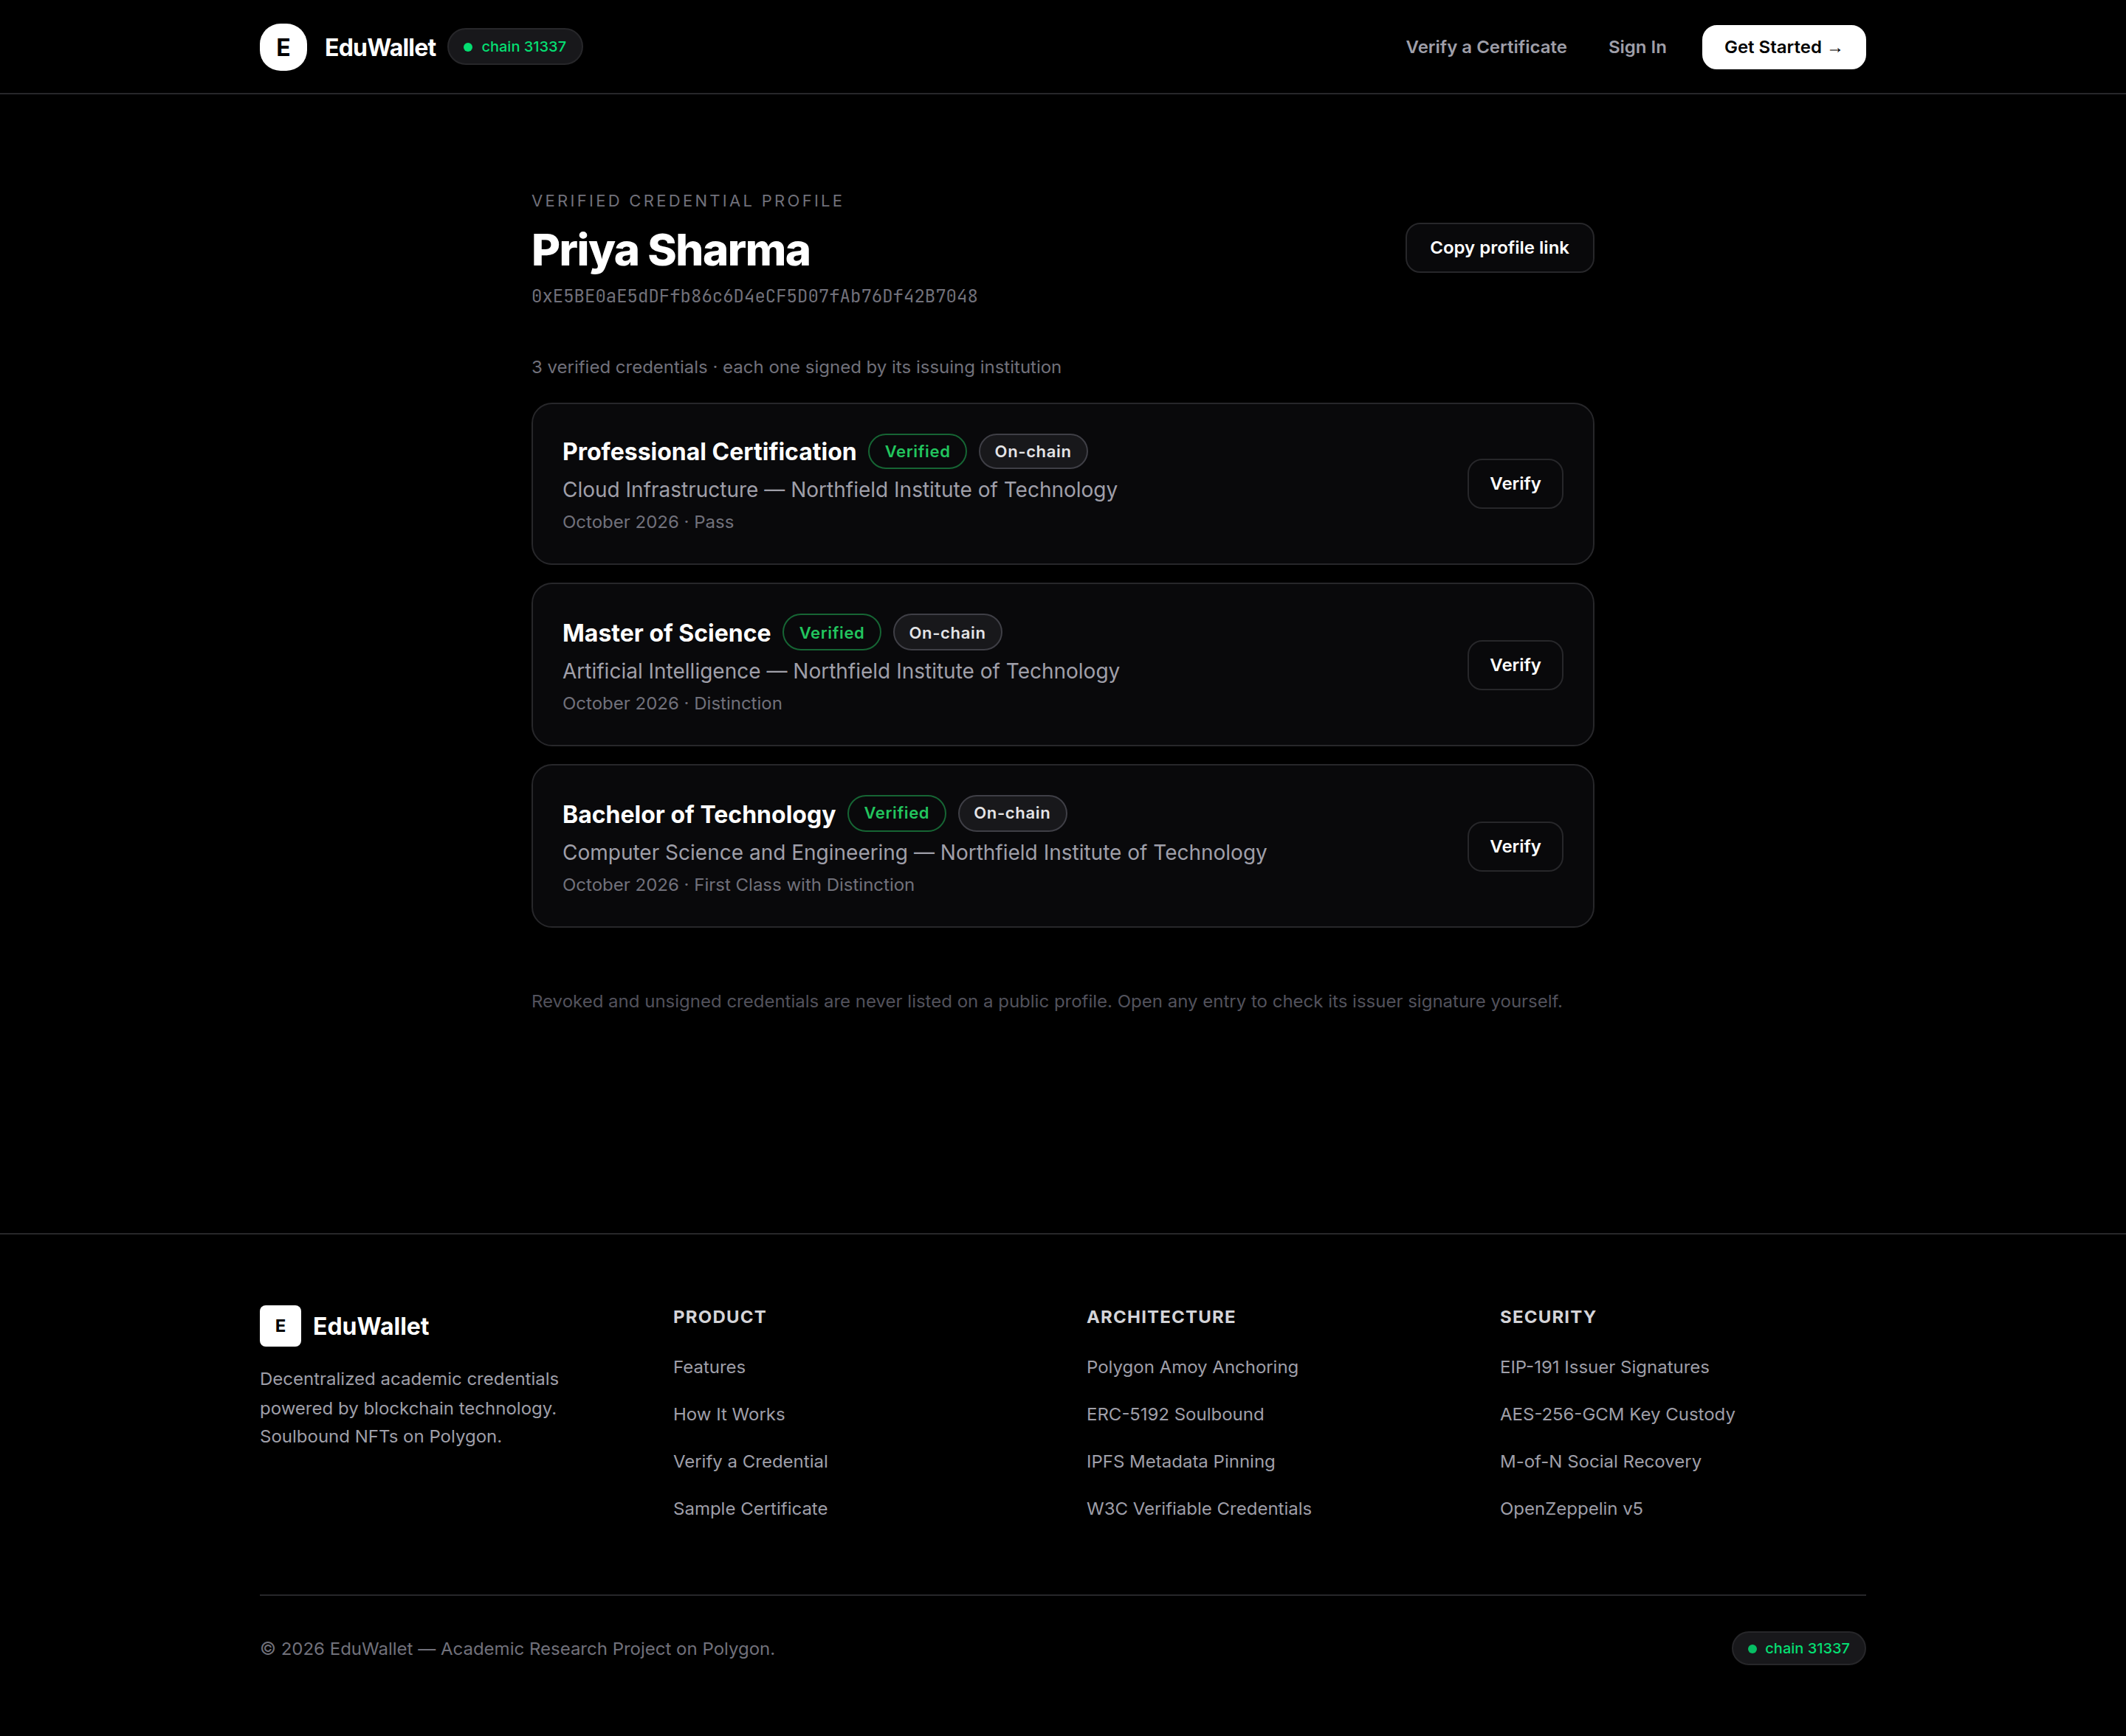
Figure 14: A public page listing a student's valid certificates
Every student has a public page at their wallet address that works like a verifiable CV. Only certificates that are both in force and cryptographically sound appear on it. Their email address never does.

6.13 Setting up recovery guardians
- As the student, open the recovery page.
- Add the email addresses of between two and five university accounts.
- Choose how many of them must agree before the account can be moved.
- Save. The guardian list is recorded in the application and on the blockchain.
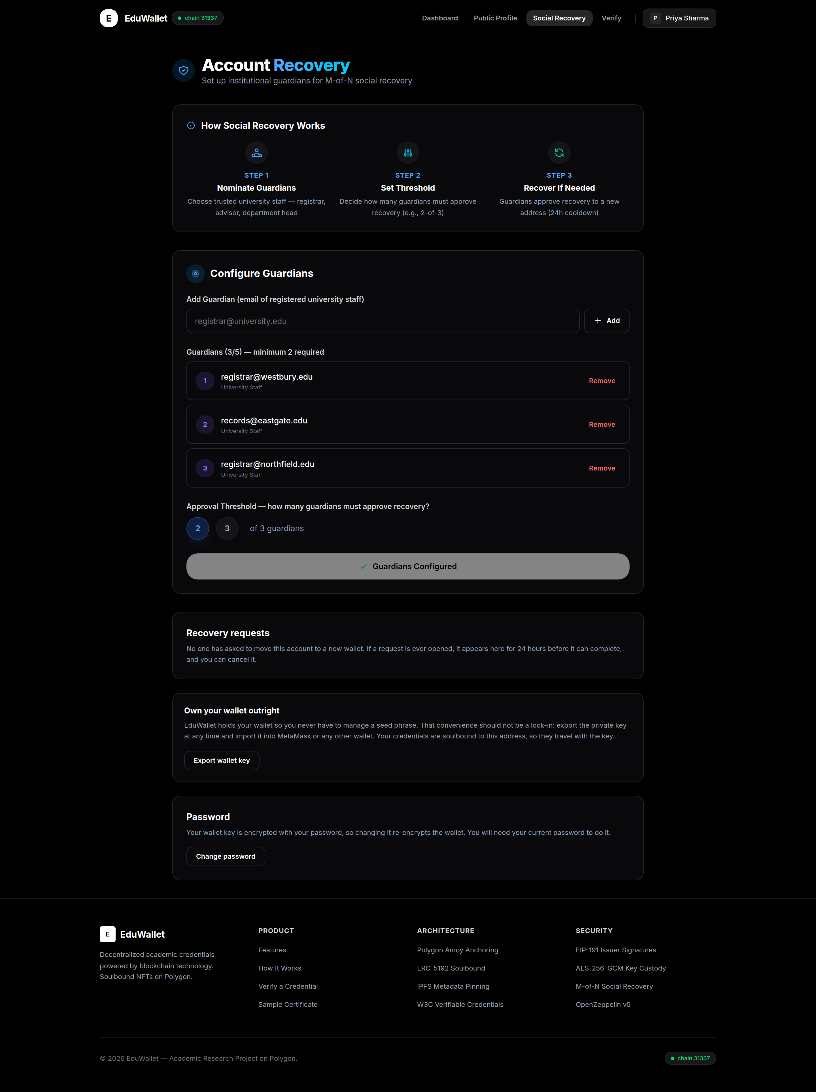
Figure 15: Choosing guardians and setting how many must agree

6.14 Recovering a lost account
Suppose the student loses access. A guardian starts the process.
- As a guardian university, open the guardianship tab and start a request, giving the student's email address and their new wallet address.
- Sign in as a second guardian and approve it.
- Wait. A 24-hour delay now runs, and the complete button stays disabled throughout.
- After the delay, any guardian or the student can complete the move.
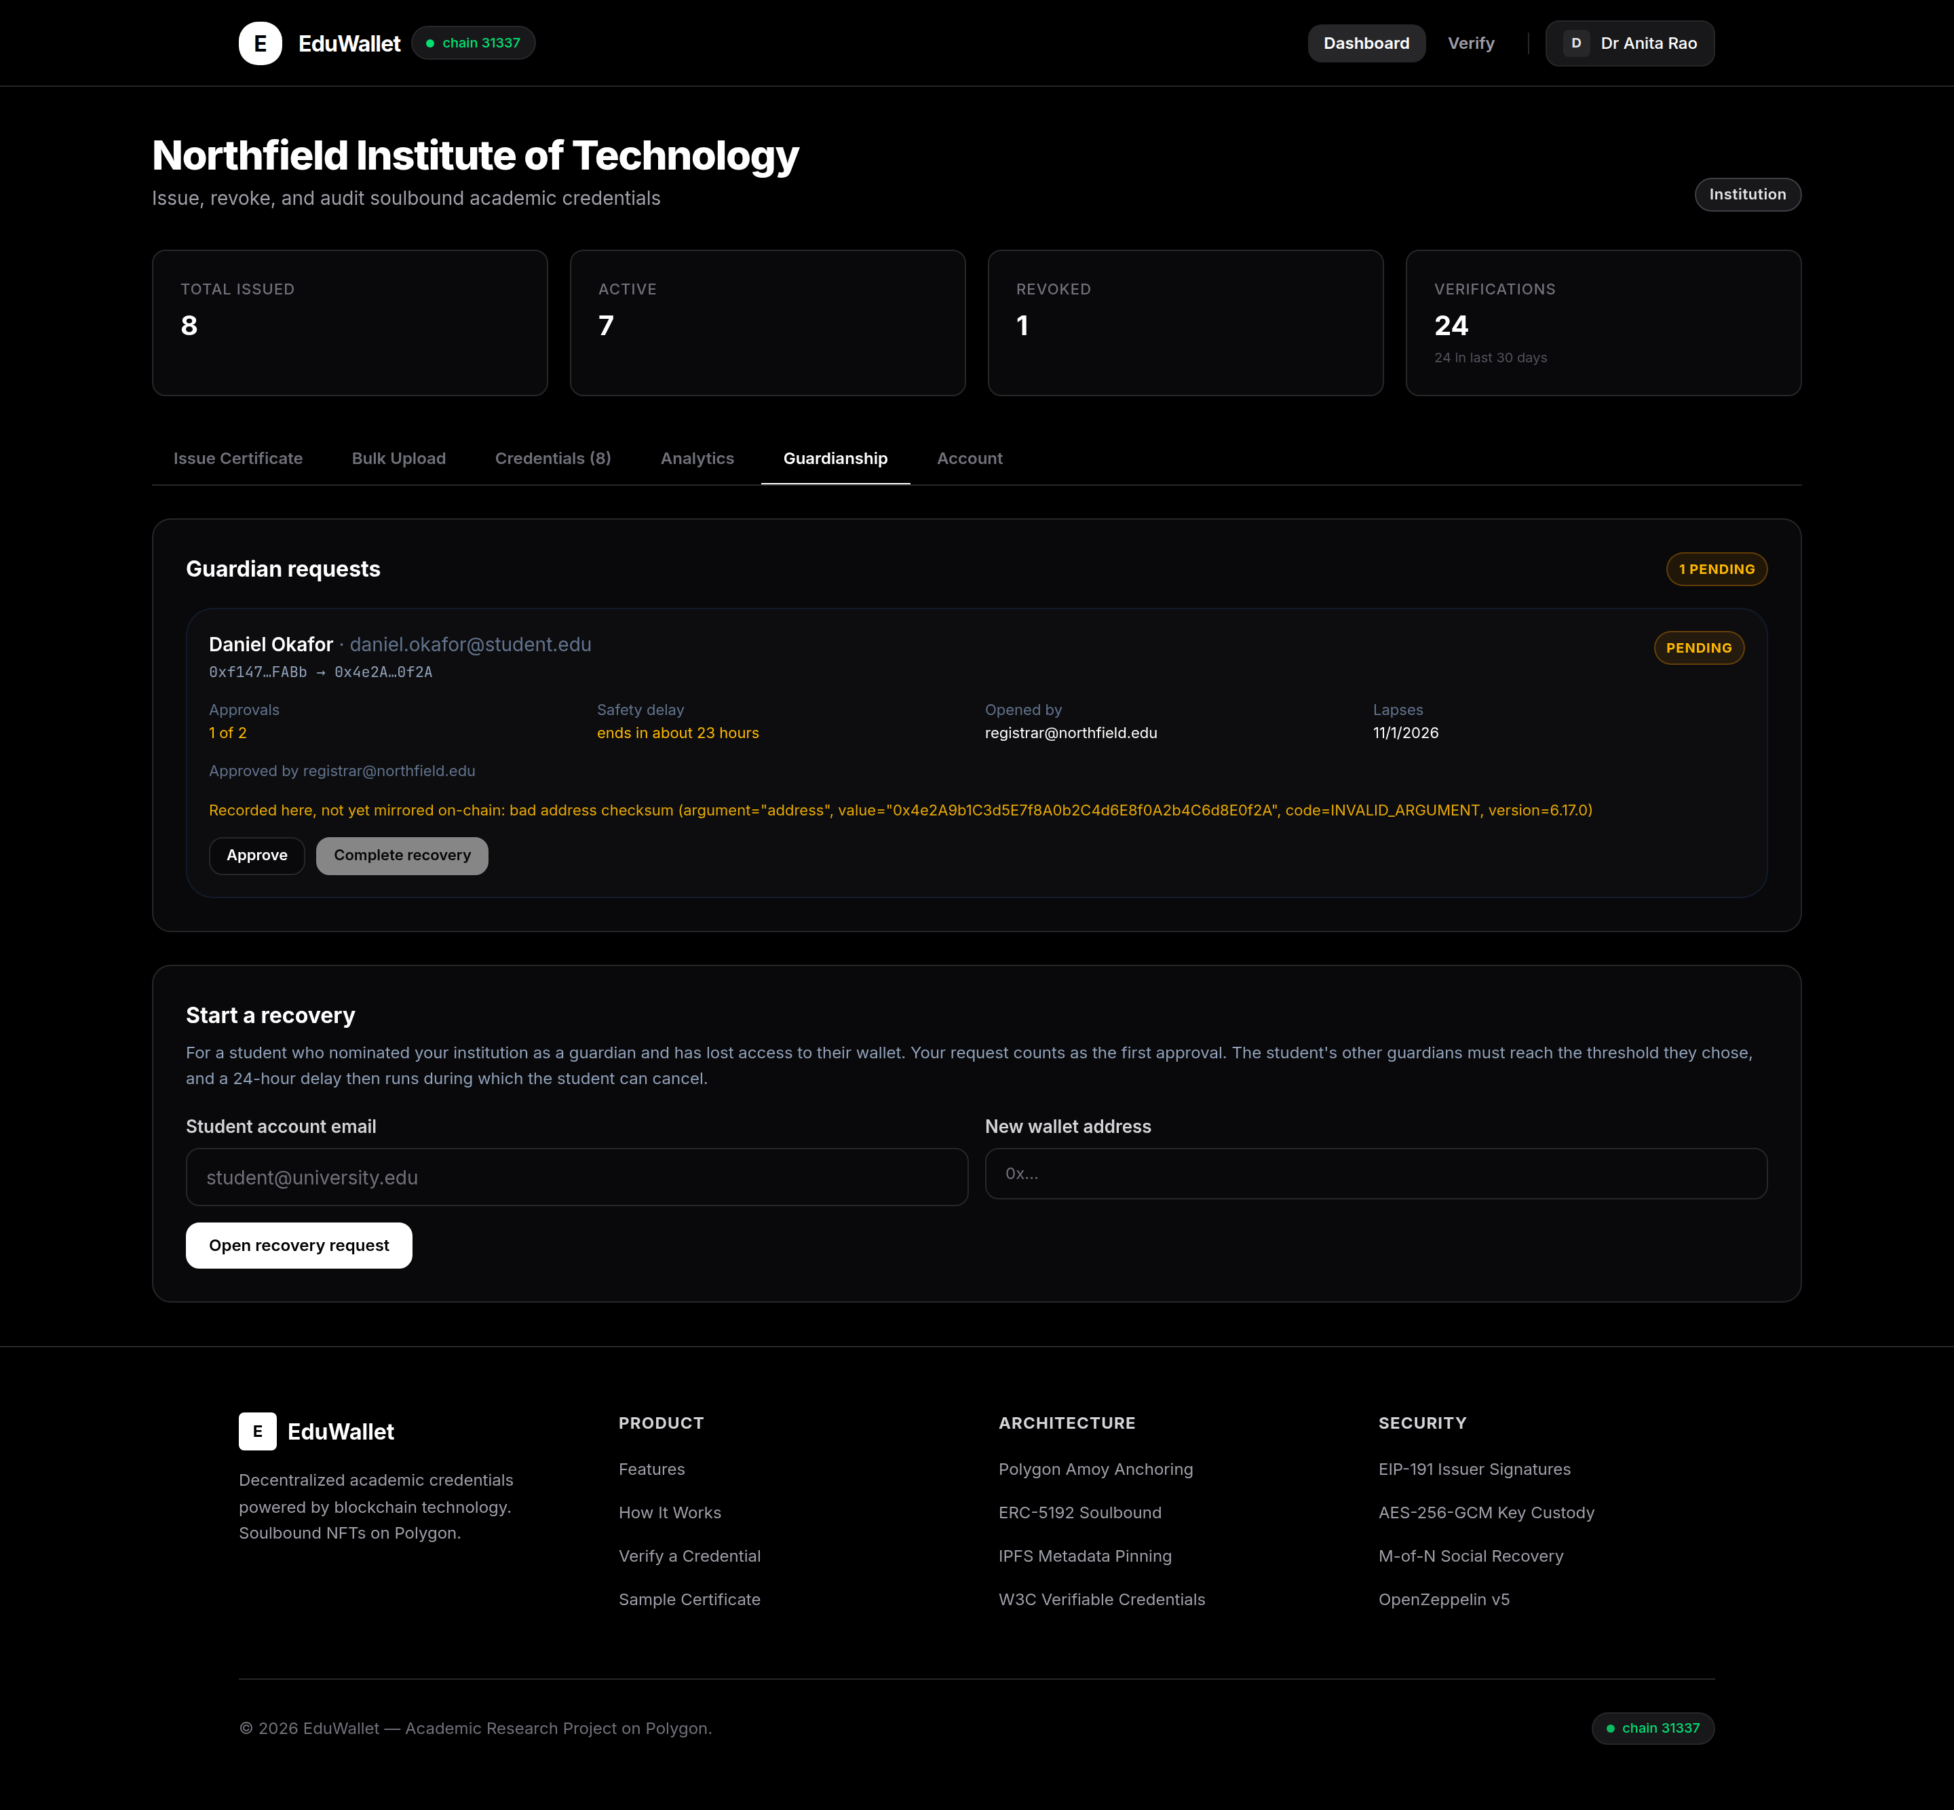
Figure 16: The guardian's queue. Completing stays unavailable until enough guardians agree and the delay has passed
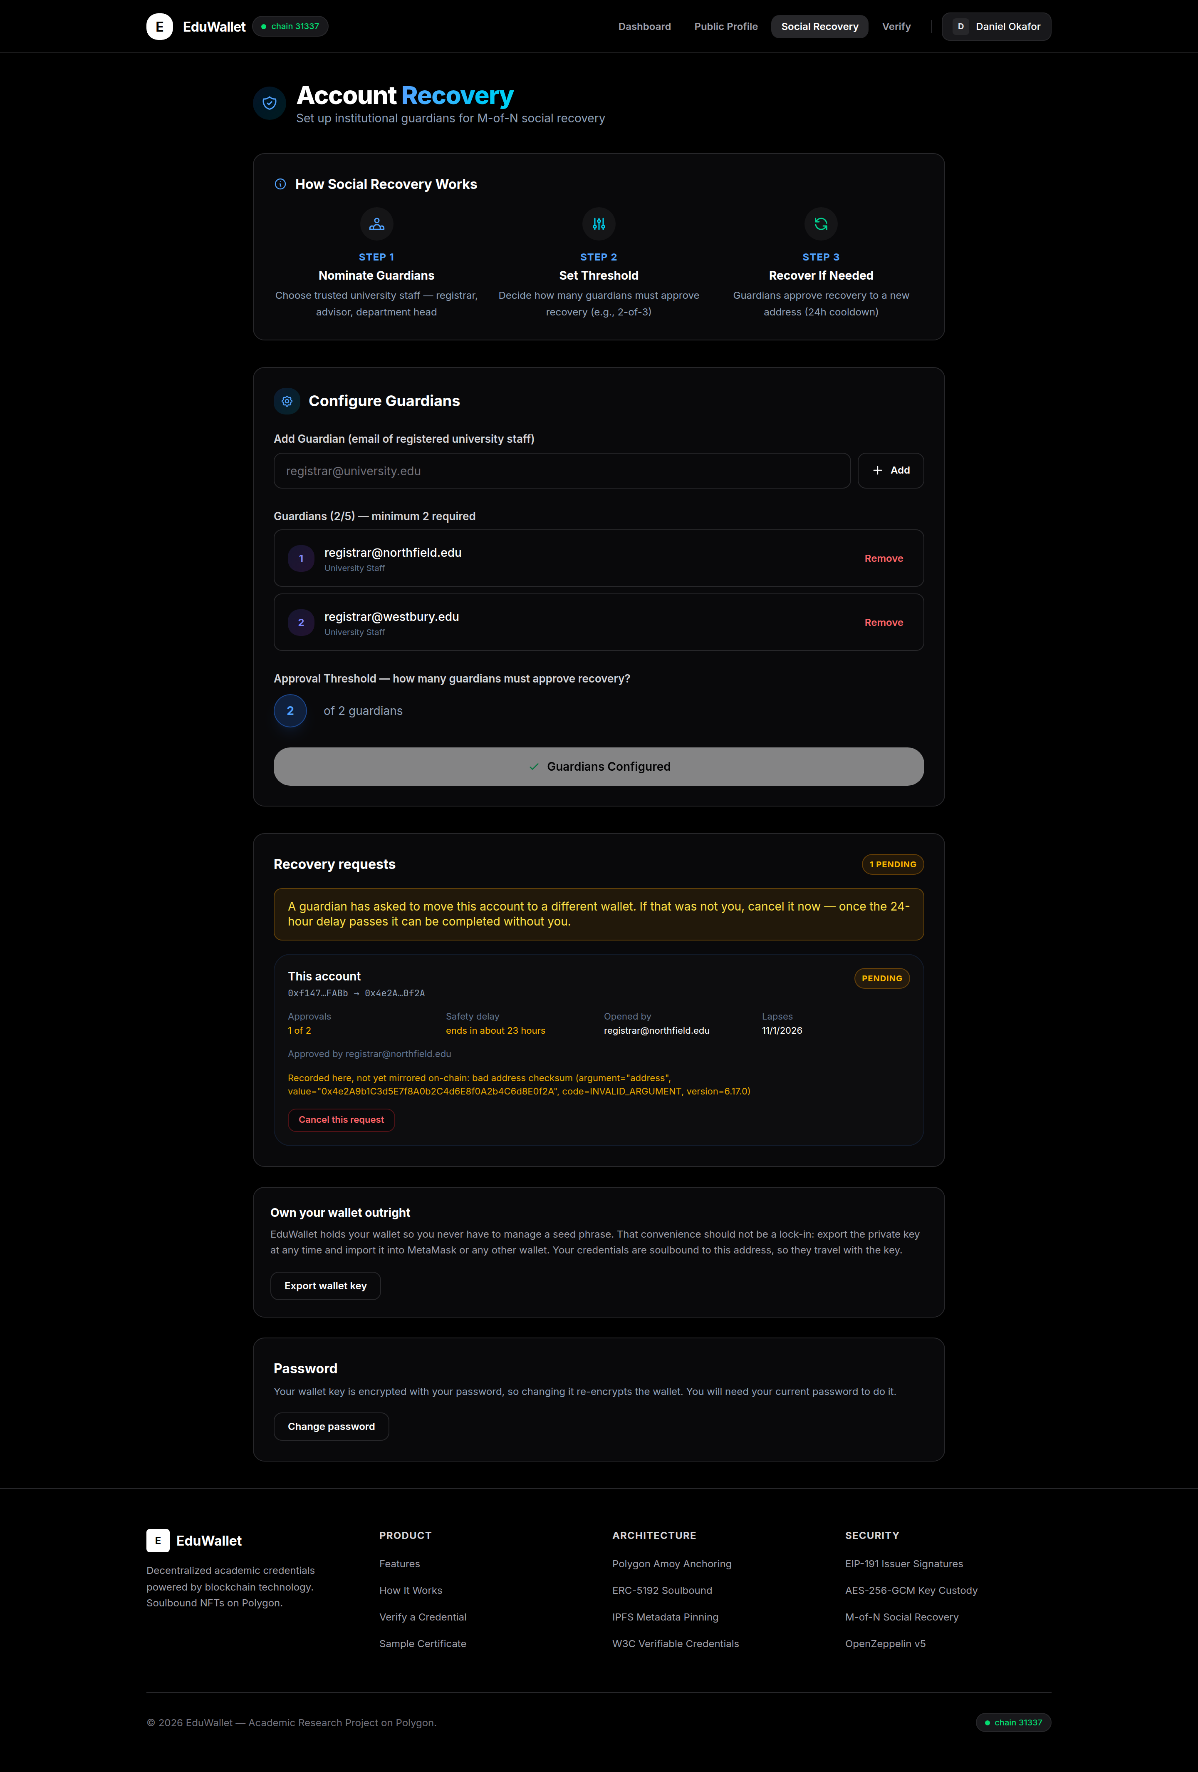
Figure 17: What the student sees during the delay, including the cancel button only they can use
If the student did not ask for this, they cancel it and nothing happens. A guardian cannot cancel. After a successful move the account uses the new address, and all the old certificates still check out because the system remembers the previous address.

6.15 Taking your wallet with you
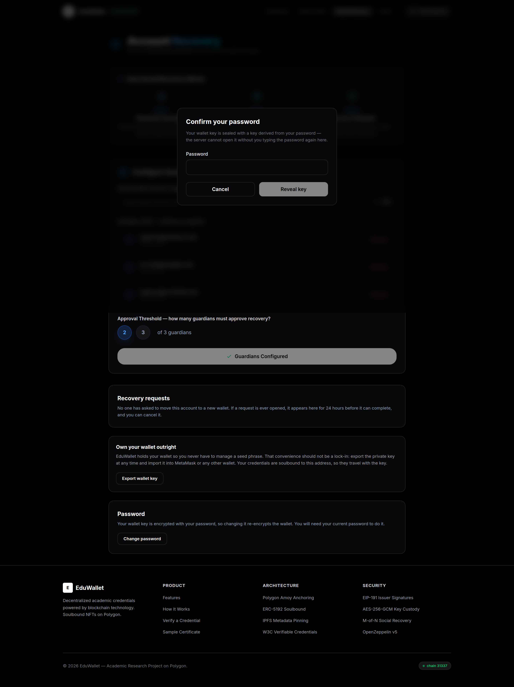
Figure 18: Revealing the wallet key, after re-entering the password
A common objection to systems that hold keys for users is that the user never really owns anything. This is the way out. The student re-enters their password and the key is shown once. It is not emailed, logged or stored anywhere after that. With it they control the wallet holding their certificates, independently of this application.

6.16 On a phone
Students usually open the application on a phone, and employers often open a link from an email on one.
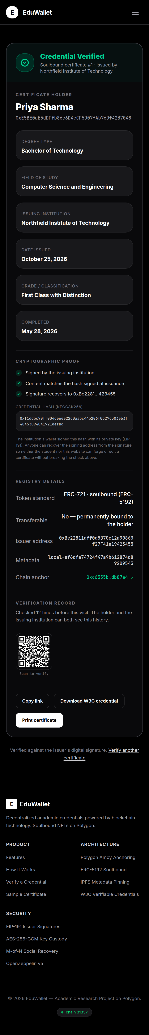
Figure 19: Checking a certificate on a phone
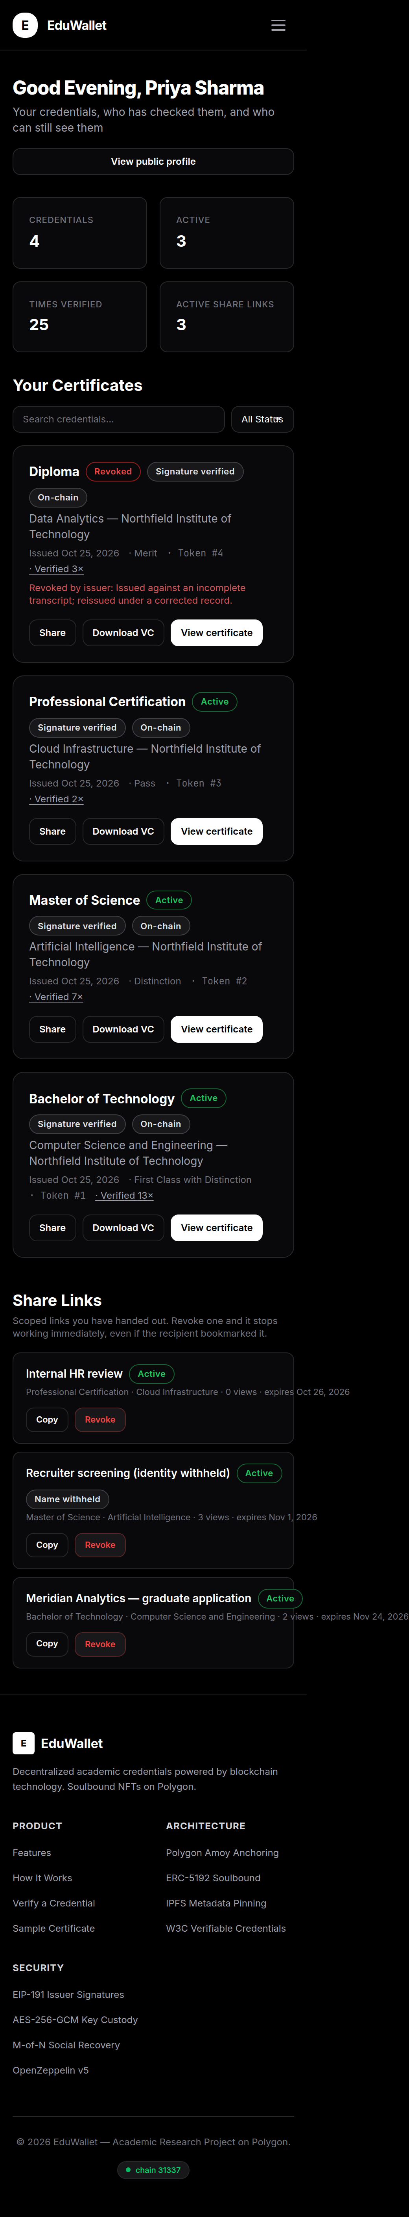
Figure 20: The student's certificates on a phone

7. Testing and Results

7.1 How it was tested
Testing was done at three levels. The smart contracts were tested directly on a local blockchain. The application was tested through its own interfaces against a real database rather than imitations, so the storage, permissions and cryptography all genuinely ran. Finally, a complete run drove the live application against a real blockchain and then read the contracts back, to confirm that what the application reported had actually happened.
Level | Number | What it covers | Result
Smart contracts | 77 | Permissions, state changes, rejections, events, random inputs, and properties that must always hold | All pass
Application logic | 89 | Fingerprinting, signing, validation, file parsing, the recovery rules, limits | All pass
Application end to end | 65 | Every interface against a real database | All pass
Storage and integrations | 25 | The shared database, file storage, host detection | All pass
Live blockchain run | 20 steps | Issuing, recording, withdrawing and a full recovery | All pass
Table 8: Test results

7.2 Beyond ordinary tests
The contract tests include runs with randomly generated inputs, and checks on properties that must hold no matter what order things happen in. For example: the lists of certificates per student and per university must always add up to the total issued; withdrawing a certificate must never change who issued it, who holds it or when; and the number of guardian agreements must only ever go up and never exceed the number of guardians.

7.3 Problems found and fixed
Testing found several real faults, two of which made whole features silently useless.
Fault | Effect | Fix
Nothing ever gave a university permission to issue on the blockchain | Every attempt to record a certificate failed, and it was quietly logged as pending forever. The blockchain side of the system did nothing at all | Universities are now given permission and the fee money automatically on their first issue
Consecutive blockchain transactions clashed with each other | The registry entry for each certificate silently failed to be written | Transactions are now queued and numbered correctly
The history of who checked a certificate was capped across the whole system | One frequently checked certificate pushed every other student's history out, and the statistics undercounted | The limit now applies per certificate
Only one hosting provider was recognised as having temporary storage | On other providers the system claimed data was safe while every update wiped it | Detection extended, and a mounted disk can now be named explicitly
A file storage reply with no reference was accepted as success | An empty reference would be put on the certificate and signed into it | Now treated as a failure, falling back to local storage
A first-time guardian setup reported itself as an update | The wrong event was published on the blockchain | The previous state is now read before it is changed
Table 9: Significant faults found during testing

8. Security Analysis
Threat | How it is prevented
Making up a certificate | Requires the university's key. A checker works out the signing key independently of this website
Changing a certificate after issue | Any change breaks the fingerprint comparison and is reported as tampering
Selling or giving away a qualification | Every method of moving the token is blocked in the contract, including the ones marketplaces use
Withdrawing someone else's certificate | Both the contract and the application require the original issuer
Reading another student's certificates | Ownership is checked on the server for every request. Hiding a button is not treated as security
Guardians conspiring to seize an account | A 24-hour delay in which only the student can cancel, plus a minimum of two guardians who must agree
Changing guardians during a recovery | Blocked while a request is open
Guessing passwords in bulk | Repeated attempts from the same source are slowed down
Finding out which emails have accounts | A wrong password and an unknown email give exactly the same response
Keys leaking | Keys are never included in data sent to the browser. Revealing one needs the password and happens once
Table 10: Threats and how they are prevented
Passwords are stored using a slow, salted hashing method so that stealing the database does not reveal them. Each wallet key is encrypted twice: once with a key derived from the user's password, which the server cannot open, and once with a server key, which is what lets a certificate be signed at the moment it is issued without the registrar retyping their password each time.

9. Limitations
- Deciding which universities are genuine is outside this project. Anyone can register as an institution in the current system; in real use this would need an accrediting body.
- The server holds a copy of each university's key so it can sign certificates without a registrar being present. This is a deliberate trade-off for usability, and students can always take their own key and leave.
- A certificate can only be issued to someone who has already registered.
- Records are written as whole groups rather than individually, so two people writing at the same instant could in principle overwrite one another. Certificate numbering is exempt from this.
- The limit on repeated password attempts applies to each server copy separately, which raises the cost of an attack without being an absolute guarantee.
- The system has been run on a test network only. It has not been used with real students or real money.

10. Conclusion and Future Work
This project set out to make an academic certificate that an employer can check without trusting the website showing it to them, and to do so without asking students to become key managers. Both were achieved.
A certificate carries a fingerprint of its own contents and a signature from the university that issued it. Either can be checked offline, so verification does not depend on a blockchain being reachable at that moment. Where it is reachable, the certificate is also recorded as a token that can never be sold. Students who lose access get their accounts back through universities they already trust, protected by a delay that only they can act within.
Throughout, the system reports what is actually true rather than presenting a confident face over a feature that is not working. That principle found several real faults during development, including one that had made the entire blockchain side of the system inert.

Future work
- Proving something about a certificate without revealing the certificate, for example that a degree is above a given classification.
- An accrediting body that decides which institutions may issue, which this project leaves open and which the literature identifies as a gap [2].
- Issuing a whole year group in a single blockchain transaction, to cut costs.
- A study with real students measuring how usable the system is compared with an ordinary wallet.
- Storing records individually so that simultaneous writes cannot interfere.

11. References
[1] Silaghi, D. L. and Popescu, D. E. (2025). A Systematic Review of Blockchain-Based Initiatives in Comparison to Best Practices Used in Higher Education Institutions. Computers, 14(4), 141. https://doi.org/10.3390/computers14040141
[2] Frutuoso, G., Rodrigues, D., Francisco, A. P. and Vaz, C. (2026). Identity-Bound Academic Credentials on Blockchain: On-Chain Issuer Accreditation with ERC-3643 and OnchainID. arXiv:2607.16383.
[3] Farabi, A., Khandaker, I., Ahsan, J., Shanto, I. K., Jahan, N. and Khan, M. J. (2025). ShikkhaChain: A Blockchain-Powered Academic Credential Verification System for Bangladesh. arXiv:2508.05334.
[4] Chatzigiannis, P., Chalkias, K., Kate, A., Mangipudi, E. V., Minaei, M. and Mondal, M. (2023). SoK: Web3 Recovery Mechanisms. Cryptology ePrint Archive, Report 2023/1575.
[5] Mazzocca, C., Acar, A., Uluagac, S., Montanari, R., Bellavista, P. and Conti, M. (2025). A Survey on Decentralized Identifiers and Verifiable Credentials. arXiv:2402.02455.
[6] Schumm, D., Müller, K. O. E. and Stiller, B. (2025). Are We There Yet? A Study of Decentralized Identity Applications. arXiv:2503.15964.
[7] World Wide Web Consortium (2025). Verifiable Credentials Data Model v2.0. W3C Recommendation.
[8] Entriken, W., Shirley, D., Evans, J. and Sachs, N. (2018). ERC-721: Non-Fungible Token Standard. Ethereum Improvement Proposals.
[9] Pandurov, T. et al. (2022). ERC-5192: Minimal Soulbound NFTs. Ethereum Improvement Proposals.
[10] Buterin, V. (2016). ERC-191: Signed Data Standard. Ethereum Improvement Proposals.
[11] OpenZeppelin (2024). OpenZeppelin Contracts v5 Documentation.
[12] Dworkin, M. (2007). Recommendation for Block Cipher Modes of Operation: Galois/Counter Mode and GMAC. NIST Special Publication 800-38D.
[13] Kaliski, B. (2000). PKCS #5: Password-Based Cryptography Specification Version 2.0. RFC 2898.

