ITRACK DOCUMENTATION
ABBREVIATIONS

* - required

API OUTPUT

{
“status”: true or false,
“msg”: “Appropriate message here”
“data”: [] or {} depending upon in output with concerned data to be consumed by frontend
}

USER REGISTRATION
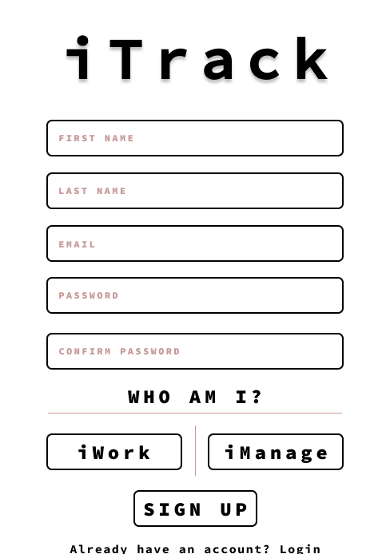
INPUTS

- firstname*
- lastname*
- email*
- password*
- confirm password*
- Role* – (manager/resource)

CONSTRAINTS

- firstname should have min 1 chars and max 50 chars
- lastname should have min 1 chars and max 50 chars
- email should be a valid email address as it is going to be validated using a confimation email
- password should contain minimum eight characters, at least one uppercase letter,one lowercase letter, one number and one special character
- confirm password needs to be same as password (front-end as well as backend verification required here)
- Role can be either manager or resource (Only one of the buttons can be selected at a time)

OUTPUT

If the constraint aren’t satisfied or the user exists, Registration is unsucessful

If the user is able to submit the information successfully he’ll be greeted with a Message on a Page that says “Please check your Email for verifying your account” with a Login Hyperlink underneath.

TECHNICAL DETAILS

A User will be created in Database with first name, last name, email, role_id and password along with a is_verified status of 0(since the verification is pending) and a default value of Null in Organisation id(since he’s not linked with any organisation at signup, we’ll do a check at login if the user has an organisation id, if not the user will be greeted with organisation selection).

An email with verification link will be sent to the user for verification of his/her account.

If a manager signs up, he should be asked to register his organisation, he may select an organisation already registered by another manager in his team. There’s an option to register the organisation on the Homepage and is available only once to the manager. After registration, the button goes away.

DATABASE FIELDS REQUIERD

In User Model:
first_name, last_name, email, password, role_id, is_verified, organisation_id

USER LOGIN

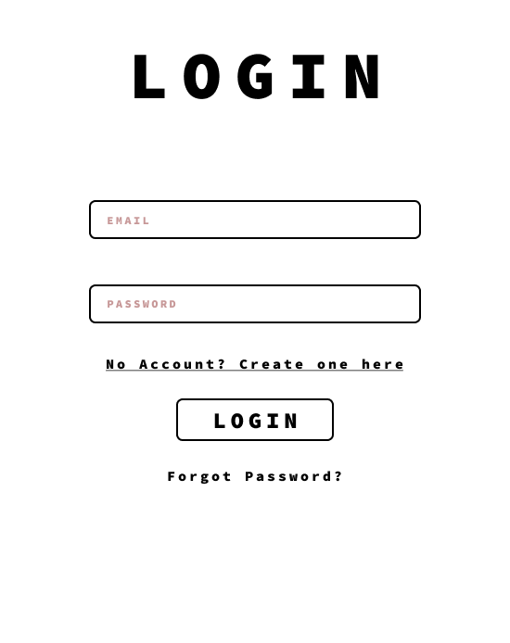
INPUTS

- email*
- password*

CONSTRAINTS

- email should be a valid email address
- password field cannot be null

OUTPUT

If the provided email and password are validated against an entry in database and login is successful else the user is greeted with the same login page with error “Invalid user name or password combination”.

Post the database check, the user is checked for the email verification(is_verified is 1), if is_verified is 0, the user is greeted with a message “Please complete your verification”

Post all the checks, the user is asked to provide the organisation id and the passcode generated by their manager which are sent to them via email, if the combination is not valid, user is asked to enter the details again.

Finally the user is logged in and redirected to the dashboard, the API will issue a token after successful login.

API OUTPUT

{
“success”: true,
“msg”: “User is not verified/User not in organisation/Login sucessful”,
“data”: {
“is_verified: true/false,
“is_in_organisation: true/false,
“token”: “hashed token containing user_id”/null
}
}

ORGANISATION SELECTION

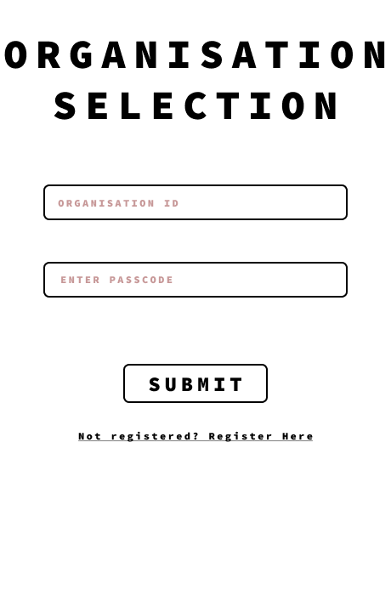
INPUTS

- organisation id*
- organisation passcode*

OUTPUT

if the user enters the organisation id and passcode correctly, the user is associated with the particular organisation else the user is greeted with a message “Invalid organisation id or passcode combination”

TECHNICAL DETAILS

Using the details provided by the user, the organisation will be identified, the organisation id will be passed on to be associated with the user.

The organisation id column of the User which was null initially will be populated with the organisation id that was identified in the first step.

The not registered hyperlink will be visible only to managers.

REGISTER ORGANISATION

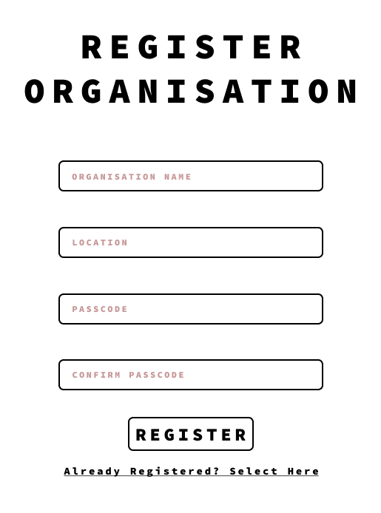
INPUTS

- organisation name*
- location*
- passcode*
- confirm passcode*

OUTPUT

If the organisation name is registered before return a message “that organisation is already registered, please contact the admin or your manager to get the organisation id and passcode”

Passcode and Confirm Passcode should be the same

TECHNICAL DETAILS

Validations to be placed for all the fields as required. Passcode needs validation on frontend as well as backend.

Organisation details fetched using the form will be used to create an entry in the Organisation table.

(Permission) Only managers are allowed to create organisations.

The manager who creates an organisation will be automatically associated with it.

An email will be sent to the manager containing organisation id and the passcode which he can share with his team members.

PROJECTS DASHBOARD

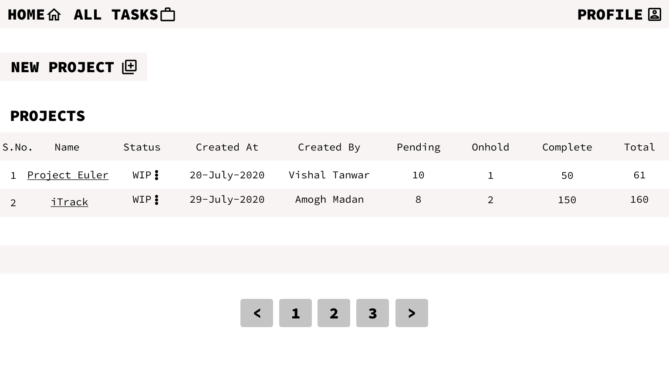

INPUTS

- home button
- my tasks button
- profile button
- new project
- Project Tasks Hyperlink(Project Name itself)
- Change Status Ellipses(Change them to triangles facing down)
- Project description Hyperlink on the project number

OUTPUT

Home Button will take the user to the Projects Page itself

My Tasks Button will show all the tasks related to a user (All Projects)

Profile button will show user’s profile

(Permission) New project can only be created by a manager using the New Project button(Visible to managers only).

(Permission) Only managers can change the status of a Project.

All the projects will be listed in the Projects Table Which can have maximum 15 entries.(Pagination required).

TECHNICAL DETAILS

All Tasks button should list all the tasks assigned to user (In paginated format)

New Project button will create a new entry in the project table with relevant details like created by, created on, org_id.

The triangle with status updates the status of a particular project.

Clicking on project name will open up a new page with details such as View Project Description/History & The tasks under that project in a tabular format(Paginated)

TASKS DASHBOARD

INPUTS

- The navbar buttons
- Project timeline button
- new task button
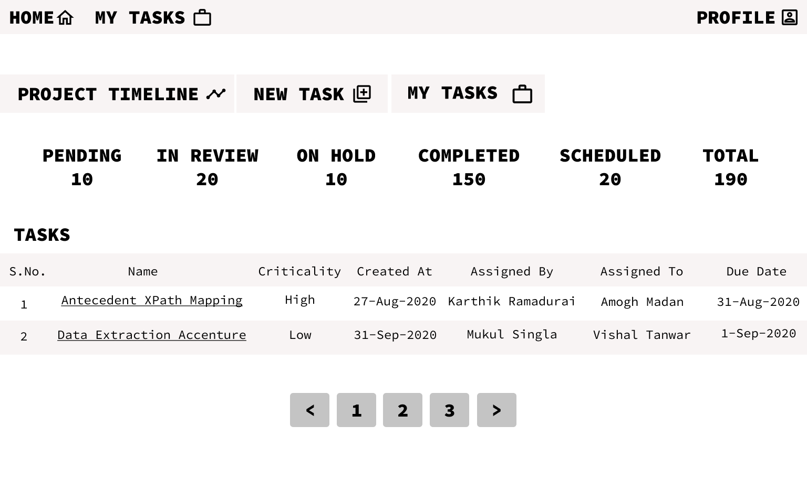
- my tasks button
- Task Hyperlink
- Pagination

TECHNICAL DETAILS

The projects timeline button will display the timeline of the project(the project history, description, remarks added by all the users in a paginated fashion)

The new task button will create a new task using a form asking for relevant details like name of the task, the user this task will be assigned, a due date and severity of the task along with description of the task and initial remarks if any.

My Tasks button will show all the tasks of a user in this project.

Sorting tasks using the header like sorting using name, using criticality etc.

The Task hyperlink will take the user to a page where the details of that specific task such as task descrption and all the remarks(comments) are stored.

Count of Task Type Will be shown on the page and it’ll contain hyperlink to only those type of tasks. In review tasks will be visible to all but action can only be taken by managers.

As soon as a task is opened the status will change from assigned to WIP

PROJECT TIMELINE

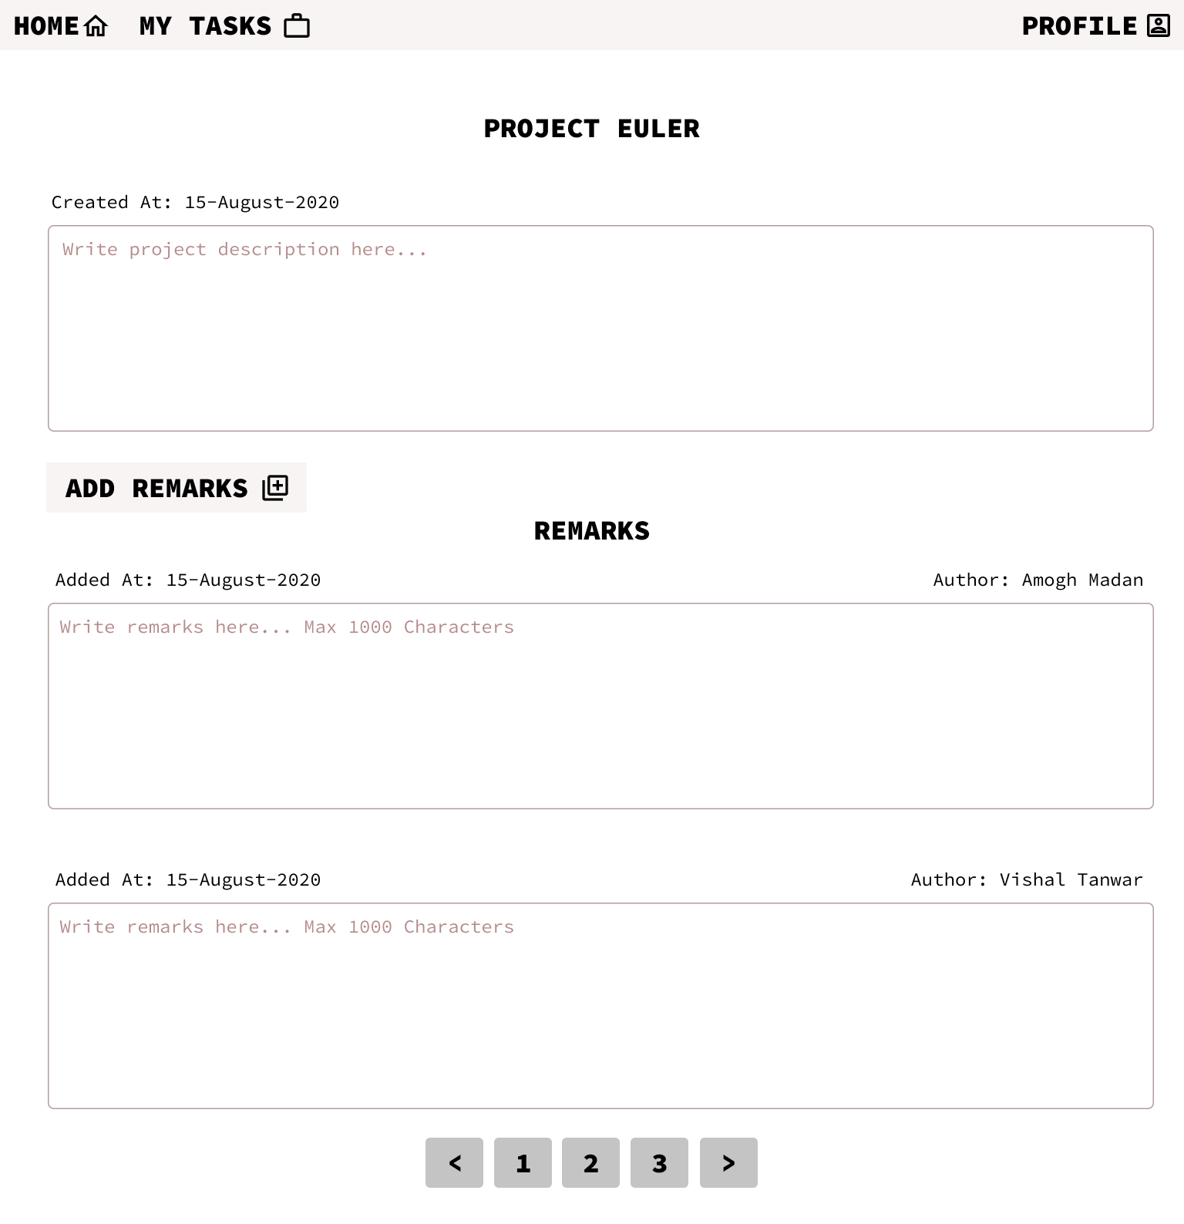
INPUTS

- project description
- add remarks
- pagination

TECHNICAL DETAILS

(Permission)Project description can only be changed by Managers.

Remarks can be added by anyone. A Form will open up asking users for the remarks(comment).

A User can only add remarks. Editing is not allowed.

TASK DETAILS

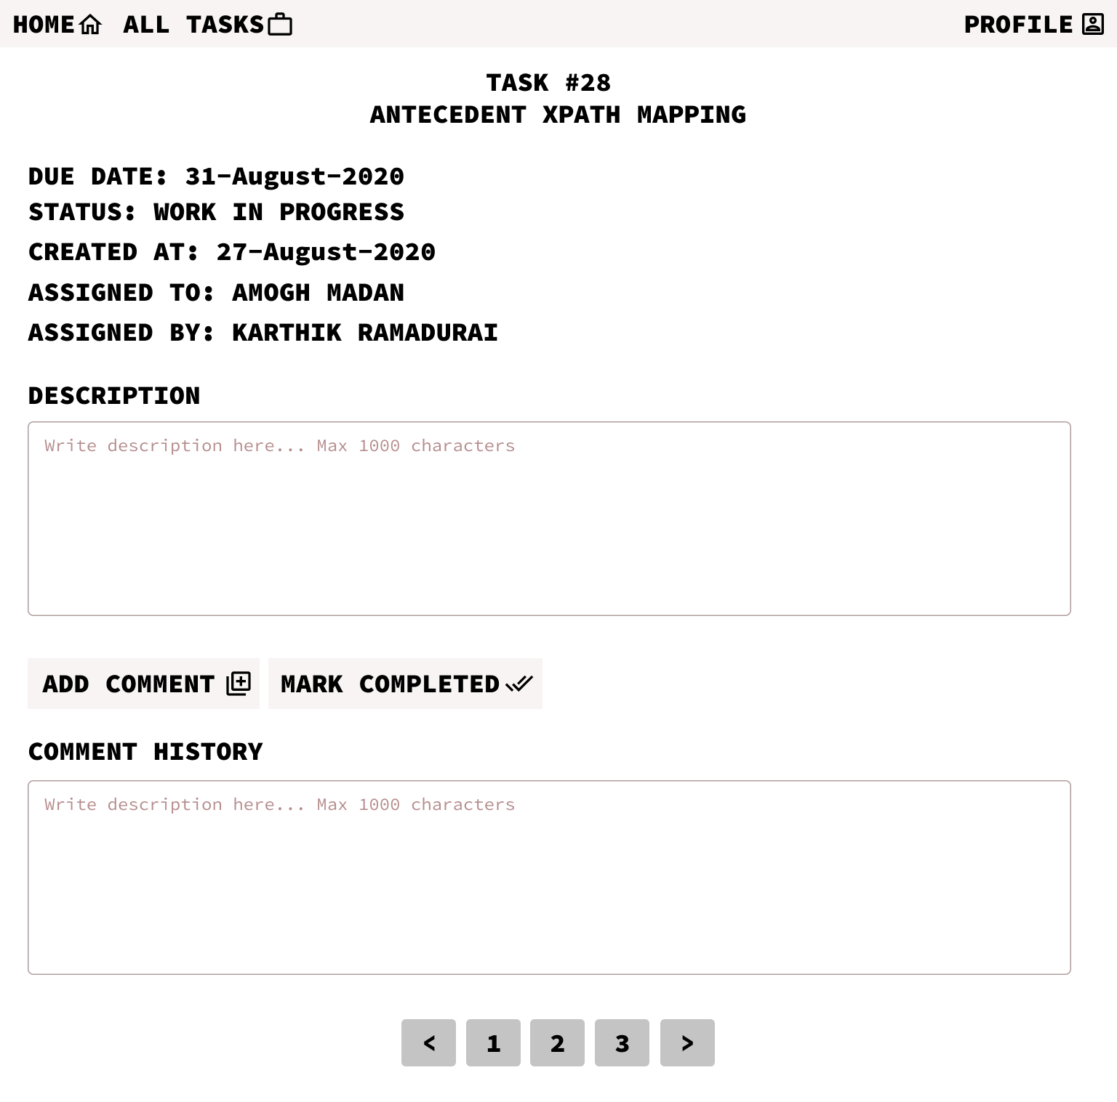
INPUTS

- Task Description
- Add comment button
- Mark Completed Button
- Add comment Button
- Pagination

TECHNICAL DETAILS

(Permission) Description of the Task can only be added by a manager.

(Permission) Description of a task can only be edited by a manager.
Only the user(to whom the task is assigned) or Manager can mark the task as completed. Should be disabled for everyone else.

Anyone can add comments in comment history.

TODO: Add photos along with comments.
TODO: Scheduled Tasks
TODO: Task Completion Review Screen
TODO: Refresh button for all the metrics shown on screen.
TODO: Add Status ‘In Review’
TODO: Add Logging app wide

