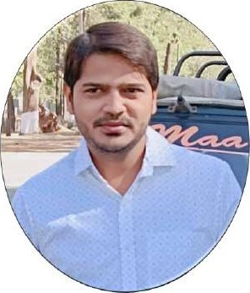

Vishal Upadhyay

Full Stack Developer Vupadhvap1993@qmail.com

7903511479 , 7389989297

# Address

Mata ji mandir khandwa road limbodi indore (mp)

## SKILLS

* Python
* Django

 DRF

* Html

• Css

* JavaScript
* Bootstrap
* Jquery
* Devops
* Mysql

Node.js

### Extra Skills

* Postman
* Thunder Client
* GitHub

Visual Studio , Sublime

* Windows

Curriculum Vitae

Professional Summary :

Enhancing my knowledge in develop and deploying applications and learning in- depth knowledge of the core field and advance skills such as Python Django-rest_framework , Create Api.

Experince:

 Python ,Django Intenship From Livewire 04/03/2020 to 05/06/2020  Worked as Python Developer in RobotroniX India PVT.LTD 01/08/2020 to 01/08/2021

* Infograins Software Solutions Pvt Ltd 07/08/2022 to 10/03/2023

PROJECT:

Email Marketing Application

Application provides their franchise for different owners all over the world to manage those marketing and provide services to the customers providing multiple Packages and Memberships as per the criteria.

PLA TFORMS - Super Admin, and Custom

Portals ROLE-

 Responsible for structuring the project including Backend Development, Frontend integration for the Admin and customer portal using Django,Bootstrap Database and deployment on A WS .  Responsible for client handling and support to complete the  tasks within the dedicated hours and schedule meetings for the updates on the tasks.

## protects

Omkar Development and Management



Ornkar Development is based on Management of warehouses and their services , basically it is developedfor reducing the paper work of client where he can maintain the contract of their warehouses gala's created with users.

. Technology

Front-end -> React

Back-end -> Python ,Django Rest Framework , Advanced ORM,

• Role

Worked on Web Portal of admin

Responsible for making APIs of admin side for the owner to easily surfover the portal and making it work dynamically

Code-Ready MarketPIace

Description

Code-Ready Marketplace is developedfor the authors who can sell their items directly to the customer's . Here Authors upload

Their works and normal users can buy their items and license them and the authors gets earnings from sold items.

. Technology

Front-end -> react

Back —end -> python, Django Rest Framework , Advance ORM

## . Role

Responsible for the Seller part of the project

Responsible for creating APIs for seller section to make it dynamically work

ACADEMIC QUALIFICANTIONS:



* Graduation From S. V.C.E Indore, Year of Passing 2016 Division 2 nd BE(MechanicaI Engineering)
* I.scfrom B.S. E. B. Patna, Year of Passing 2010, Division 2nd
* Matriculation from C.B.S.E. Board, Year of Passing 2008, Division 2nd

PERSONAL DETAILS :

Father's Name : Mr. Rajendra Upadhyay

Date of Birth : 14 th oct 1993

Gender : Male

Marital Status : - Unmarried

Nationality : - Indian

Language Known : Hindi & English

Hobbies : - Studying, Net suffering , cooking , gardening , petcare

Correspondence address :- S/O Rajendra Upadhyay Raja Bazar BV College Shiv Mandir path patna Pin code - 800014

DECLARATION:

I hereby declare that the above information is true to the best of my knowledge Belief.

Place: - (Indore) M.P Signature-vishal Kumar