**­­­FIFO:**

import java.io.*;

public class FIFO {

public static void main(String[] args) throws IOException

{

BufferedReader br = new BufferedReader(new InputStreamReader(System.in));

int frames, pointer = 0, hit = 0, fault = 0,ref_len;

int buffer[];

int reference[];

int mem_layout[][];

System.out.println("enter the number of Frames:");

frames = Integer.parseInt(br.readLine());

System.out.println("enter the length of the Reference string:");

ref_len = Integer.parseInt(br.readLine());

reference = new int[ref_len];

mem_layout = new int[ref_len][frames];

buffer = new int[frames];

for(int j = 0; j < frames; j++)

buffer[j] = -1;

System.out.println("enter the reference string:");

for(int i = 0; i < ref_len; i++)

{

reference[i] = Integer.parseInt(br.readLine());

}

System.out.println();

for(int i = 0; i < ref_len; i++)

{

int search = -1;

for(int j = 0; j < frames; j++)

{

if(buffer[j] == reference[i])

{

search = j;

hit++;

break;

}

}

if(search == -1)

{

buffer[pointer] = reference[i];

fault++;

pointer++;

if(pointer == frames)

pointer = 0;

}

for(int j = 0; j < frames; j++)

mem_layout[i][j] = buffer[j];

}

for(int i = 0; i < frames; i++)

{

for(int j = 0; j < ref_len; j++)

System.out.printf("%3d ",mem_layout[j][i]);

System.out.println();

}

System.out.println("The number of Hits: " + hit);

System.out.println("Hit Ratio: " + (float)((float)hit/ref_len));

System.out.println("The number of Faults: " + fault);

}

}

**Output:**

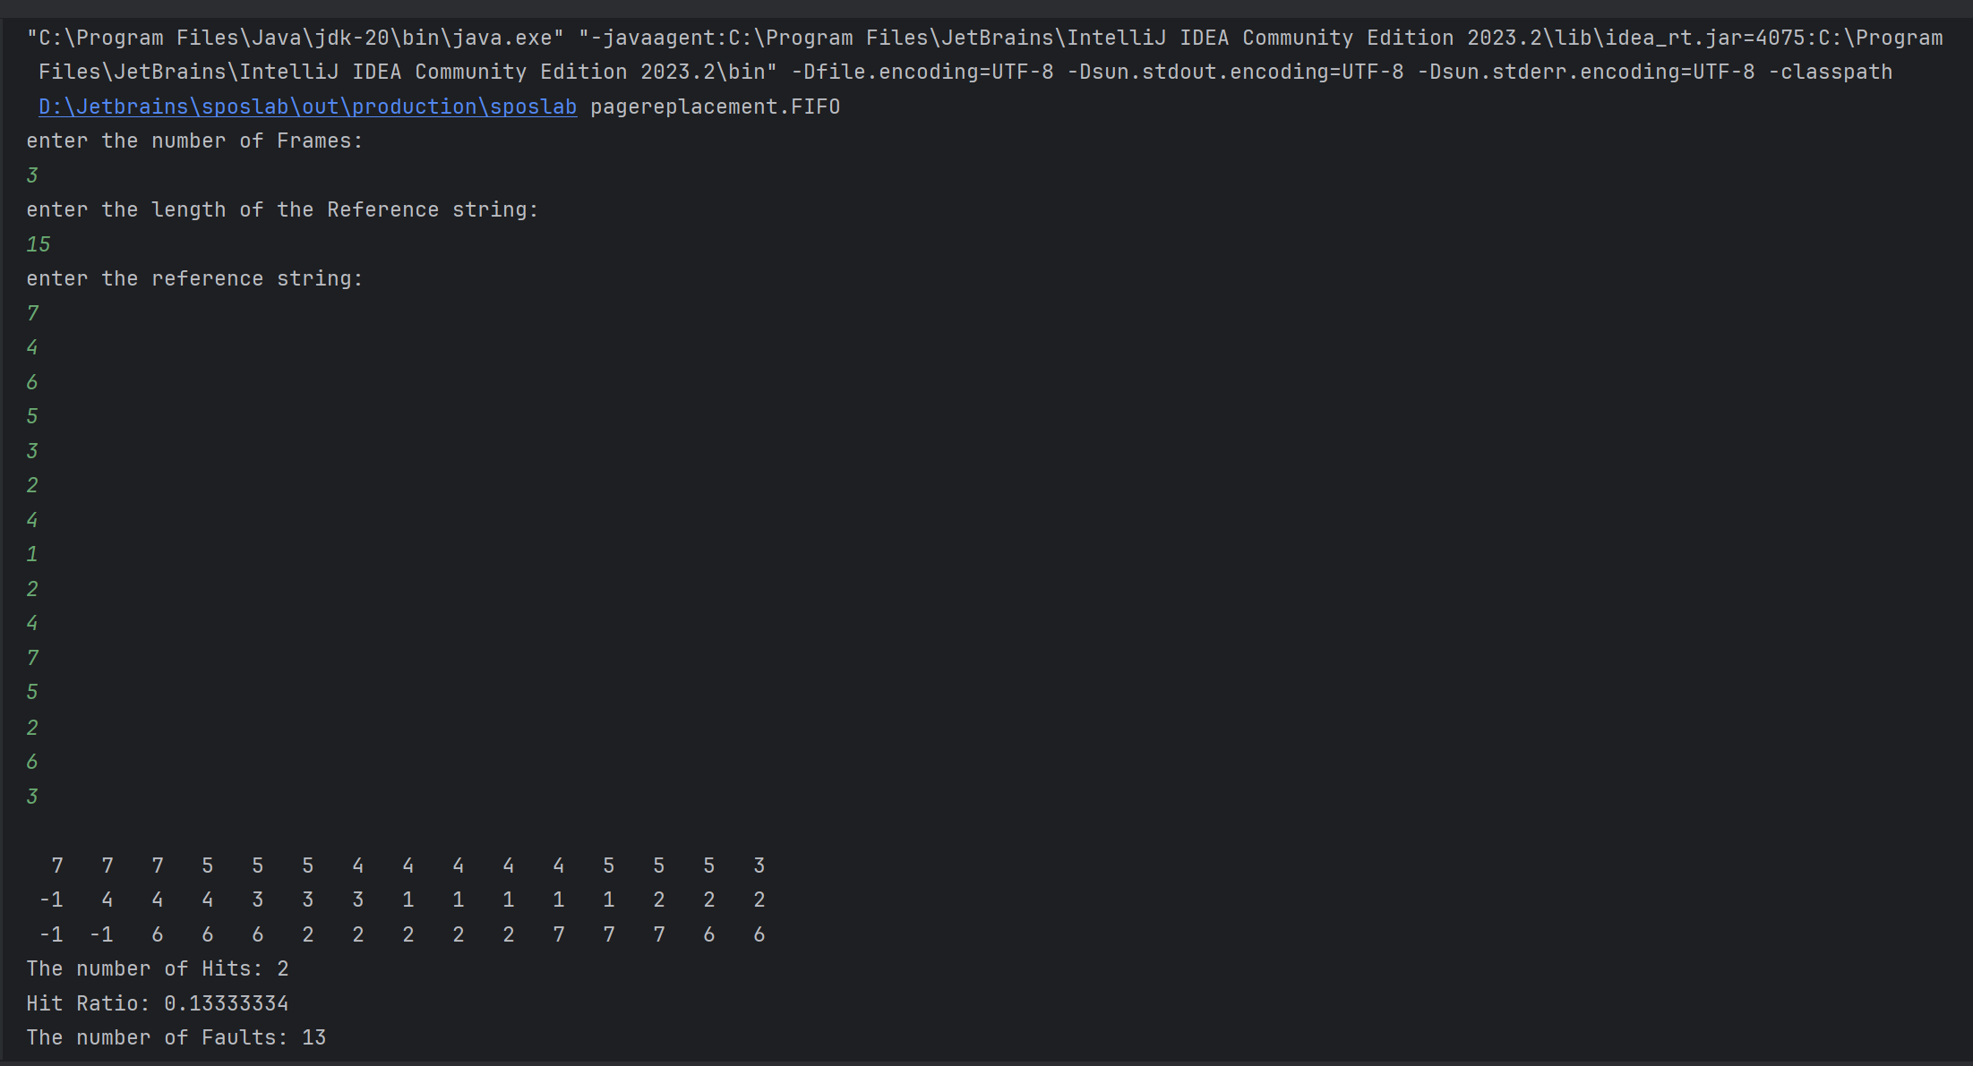

**LRU:**

import java.io.*;

import java.util.*;

public class LRU {

public static void main(String[] args) throws IOException

{

BufferedReader br = new BufferedReader(new InputStreamReader(System.in));

int frames,pointer = 0, hit = 0, fault = 0,ref_len;

Boolean isFull = false;

int buffer[];

ArrayList<Integer> stack = new ArrayList<Integer>();

int reference[];

int mem_layout[][];

System.out.println("Please enter the number of Frames: ");

frames = Integer.parseInt(br.readLine());

System.out.println("Please enter the length of the Reference string: ");

ref_len = Integer.parseInt(br.readLine());

reference = new int[ref_len];

mem_layout = new int[ref_len][frames];

buffer = new int[frames];

for(int j = 0; j < frames; j++)

buffer[j] = -1;

System.out.println("Please enter the reference string: ");

for(int i = 0; i < ref_len; i++)

{

reference[i] = Integer.parseInt(br.readLine());

}

System.out.println();

for(int i = 0; i < ref_len; i++)

{

if(stack.contains(reference[i]))

{

stack.remove(stack.indexOf(reference[i]));

}

stack.add(reference[i]);

int search = -1;

for(int j = 0; j < frames; j++)

{

if(buffer[j] == reference[i])

{

search = j;

hit++;

break;

}

}

if(search == -1)

{

if(isFull)

{

int min_loc = ref_len;

for(int j = 0; j < frames; j++)

{

if(stack.contains(buffer[j]))

{

int temp = stack.indexOf(buffer[j]);

if(temp < min_loc)

{

min_loc = temp;

pointer = j;

}

}

}

}

buffer[pointer] = reference[i];

fault++;

pointer++;

if(pointer == frames)

{

pointer = 0;

isFull = true;

}

}

for(int j = 0; j < frames; j++)

mem_layout[i][j] = buffer[j];

}

for(int i = 0; i < frames; i++)

{

for(int j = 0; j < ref_len; j++)

System.out.printf("%3d ",mem_layout[j][i]);

System.out.println();

}

System.out.println("The number of Hits: " + hit);

System.out.println("Hit Ratio: " + (float)((float)hit/ref_len));

System.out.println("The number of Faults: " + fault);

}

}

**Output:**

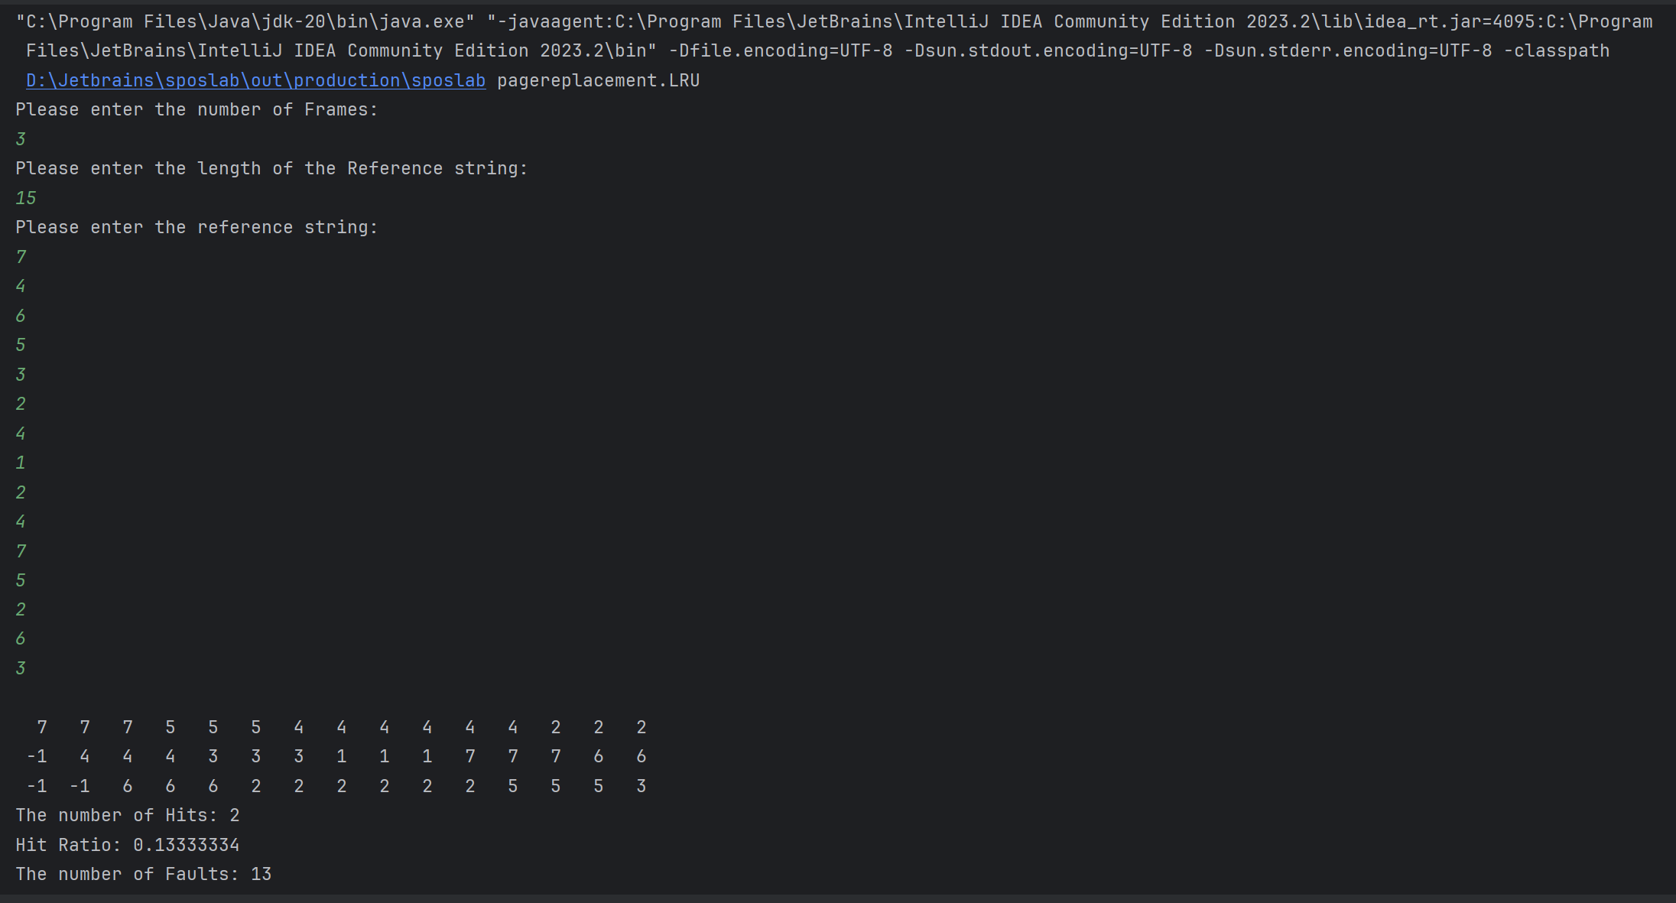

**Optimal:**

import java.io.*;

public class optimal {

public static void main(String[] args) throws IOException

{

BufferedReader br = new BufferedReader(new InputStreamReader(System.in));

int frames, pointer = 0, hit = 0, fault = 0,ref_len;

boolean isFull = false;

int buffer[];

int reference[];

int mem_layout[][];

System.out.println("enter the number of Frames:");

frames = Integer.parseInt(br.readLine());

System.out.println("enter the length of the Reference string:");

ref_len = Integer.parseInt(br.readLine());

reference = new int[ref_len];

mem_layout = new int[ref_len][frames];

buffer = new int[frames];

for(int j = 0; j < frames; j++)

buffer[j] = -1;

System.out.println("enter the reference string:");

for(int i = 0; i < ref_len; i++)

{

reference[i] = Integer.parseInt(br.readLine());

}

System.out.println();

for(int i = 0; i < ref_len; i++)

{

int search = -1;

for(int j = 0; j < frames; j++)

{

if(buffer[j] == reference[i])

{

search = j;

hit++;

break;

}

}

if(search == -1)

{

if(isFull)

{

int index[] = new int[frames];

boolean index_flag[] = new boolean[frames];

for(int j = i + 1; j < ref_len; j++)

{

for(int k = 0; k < frames; k++)

{

if((reference[j] == buffer[k]) && (index_flag[k] == false))

{

index[k] = j;

index_flag[k] = true;

break;

}

}

}

int max = index[0];

pointer = 0;

if(max == 0)

max = 200;

for(int j = 0; j < frames; j++)

{

if(index[j] == 0)

index[j] = 200;

if(index[j] > max)

{

max = index[j];

pointer = j;

}

}

}

buffer[pointer] = reference[i];

fault++;

if(!isFull)

{

pointer++;

if(pointer == frames)

{

pointer = 0;

isFull = true;

}

}

}

for(int j = 0; j < frames; j++)

mem_layout[i][j] = buffer[j];

}

for(int i = 0; i < frames; i++)

{

for(int j = 0; j < ref_len; j++)

System.out.printf("%3d ",mem_layout[j][i]);

System.out.println();

}

System.out.println("The number of Hits: " + hit);

System.out.println("Hit Ratio: " + (float)((float)hit/ref_len));

System.out.println("The number of Faults: " + fault);

}

}

**Output:**

