REAL-TIME SOCIAL MEDIA MINING AND TRUST-AWARE
SENTIMENT ANALYSIS
USING LARGE LANGUAGE MODELS FOR RETAIL PRODUCT FEEDBACK OPTIMIZATION
(Beyond the Stars)
BITS ZG628T: Dissertation — Mid-Semester Progress Report
by
Vishal Singh
ID No. 2020AA05641
Dissertation work carried out at
Walmart Global Tech, Bengaluru, India
Submitted in partial fulfilment of
M.Tech in Artificial Intelligence & Machine Learning
Under the Supervision of
Mr. Varunendra Pratap Singh
Principal Software Engineer, Walmart Global Tech, Bengaluru
BIRLA INSTITUTE OF TECHNOLOGY & SCIENCE
PILANI (RAJASTHAN)
June 2026

ABSTRACT
Public social media has become a primary, real-time channel for retail customer voice. DataReportal (Jan 2024) reports about 5.04 billion active social users, Reddit's S-1 filing (Feb 2024) discloses ~267 million weekly active uniques, and Sprout Social's 2024 Index finds 51% of consumers expect a same-day brand response on social. At the same time, the World Economic Forum (2024) estimates that fake online reviews influence approximately USD 152 billion in purchases each year, with 4%–15% of reviews flagged as fake across studies. Any analytical layer that consumes this signal must therefore filter noise and low-credibility content explicitly.
This dissertation builds a working, end-to-end prototype that ingests public Reddit posts from a curated set of 32 retail-relevant communities, applies sentiment classification with a fine-tuned ModernBERT model and aspect-based opinion mining with a zero-shot DeBERTa-v3 NLI classifier over a fixed retail taxonomy (pricing, product quality, customer service, store experience, online/app, delivery/pickup, returns, account/login), captions image attachments with Gemma 3 4B (Ollama) using a multi-pass prompt pipeline informed by recent vision-language literature, and assigns each post a 0–1 trust score derived from account-metadata heuristics combined with a rule-based credibility scorer. Trust-filtered, aspect-tagged results are aggregated and presented in a React-based dashboard with a human-in-the-loop review queue and a priority-negatives panel (P1 / P2) that ranks trustworthy negative posts by trust × confidence.
This mid-semester report documents the work completed between 25 April 2026 and 21 June 2026, covering the literature review, system design, data ingestion and pre-processing module, and the model analysis (sentiment, aspect, vision) and trust-scoring module. The remaining phases — aggregation and reporting refinements, evaluation on a manually labelled sample of ~250–300 posts, dissertation review, and final submission — are planned for the second half of the semester. The prototype uses only public data and is not deployed inside Walmart systems.

Signature of the Student | Signature of the Supervisor
Name: Vishal Singh  Date: 21/06/2026  Place: Bengaluru | Name: Varunendra Pratap Singh  Date: 21/06/2026  Place: Bengaluru

Contents
1. Introduction and Broad Area of Work
2. Problem Statement and Objectives
3. System Design and Architecture
4. Implementation Progress (25 April 2026 – 21 June 2026)
4.1 Data Ingestion and Pre-processing
4.2 Model Analysis Module (Sentiment, Aspects, Vision)
4.3 Trust-Score Module
4.4 Storage Layer
4.5 Dashboard and Human-in-the-Loop Review
5. Tools, Technologies, and Configuration
6. Problems Encountered and Mitigations
7. Preliminary Observations
8. Future Plan (Remaining Phases)
9. Abbreviations
10. References

List of Figures and Tables
Figure 1: Layered System Architecture
Figure 2: End-to-End Pipeline Flow (single tick)
Figure 3: Trust-Score Composition and P1/P2 Tier Rules
Figure 4: Dashboard Information Architecture and Feedback Loop
Table 1: Curated Subreddit Coverage (snapshot)
Table 2: Eight-Aspect Retail Taxonomy
Table 3: Tools and Technologies Used
Table 4: Problems Encountered and Mitigations
Table 5: Future Plan with Status

1. Introduction and Broad Area of Work
The broad area of this dissertation is Applied Natural Language Processing (NLP) for analysis of public retail customer feedback on social media. The work spans four sub-areas: (a) supervised text classification with transformer encoders for sentiment in short, informal English social-media text; (b) zero-shot natural-language-inference models for aspect-based opinion mining over a fixed retail taxonomy; (c) multimodal vision-language models for captioning and OCR of screenshots and photos attached to retail complaints; and (d) lightweight rule-based trust / credibility filtering using account-metadata heuristics and retail-insider terminology signals, with data engineering for scheduled ingestion of public posts and structured storage suitable for aggregation and reporting.
The motivation is volume and noise. Customers regularly post about their Walmart, Sam's Club, Spark-driver, and OGP/pickup experiences on Reddit. In the candidate's current role at Walmart Global Tech (order-fulfillment / product platform), this signal is read via ad-hoc browsing and keyword-filter dashboards, which suffer from poor coverage, noise, and latency. The prototype built in this dissertation demonstrates that a stack of task-specific models — a fine-tuned encoder for sentiment, a zero-shot NLI model for aspects, and a multimodal vision model for images — combined with an explicit trust filter can convert this raw public stream into a structured, aspect-tagged, trust-weighted feed suitable for downstream operational review.

2. Problem Statement and Objectives
Manual monitoring of retail-related Reddit communities cannot keep pace with the daily volume of posts, and conventional rule-based or lexicon-based sentiment systems perform poorly on short, sarcastic, slang-heavy retail text. Furthermore, fake or low-credibility posts contaminate any aggregate signal if consumed without filtering.
Objectives for the dissertation (as approved in the abstract):
- Survey recent literature on LLM-based sentiment and aspect-based opinion mining and on fake-review / bot-credibility detection.
- Build a data ingestion pipeline that periodically collects retail-related posts from Reddit via the official Reddit API and a public historical archive.
- Implement a model-based analysis module that assigns each post a sentiment label and one or more aspects from a fixed retail taxonomy, plus a vision caption when an image is attached.
- Implement a trust score (0–1) per post combining account-metadata heuristics with a rule-based credibility scorer (with an optional cloud-LLM credibility path for cost-sensitive deployments).
- Produce structured aggregated outputs (top aspects, sentiment distribution per aspect, representative examples) with low-trust posts excluded.
- Evaluate the prototype on a manually labelled sample of ~250–300 posts: sentiment macro-F1, aspect macro-F1, and ROC-AUC for the trust filter.
- Document design, evaluation, limitations, and recommended next steps in the final dissertation.

3. System Design and Architecture
The system is built as a modular pipeline so that each stage can be developed, evaluated, and replaced independently. Figure 1 shows the five logical layers and the components inside each, and Figure 2 traces a single end-to-end tick through those layers.

Figure 1: Layered System Architecture
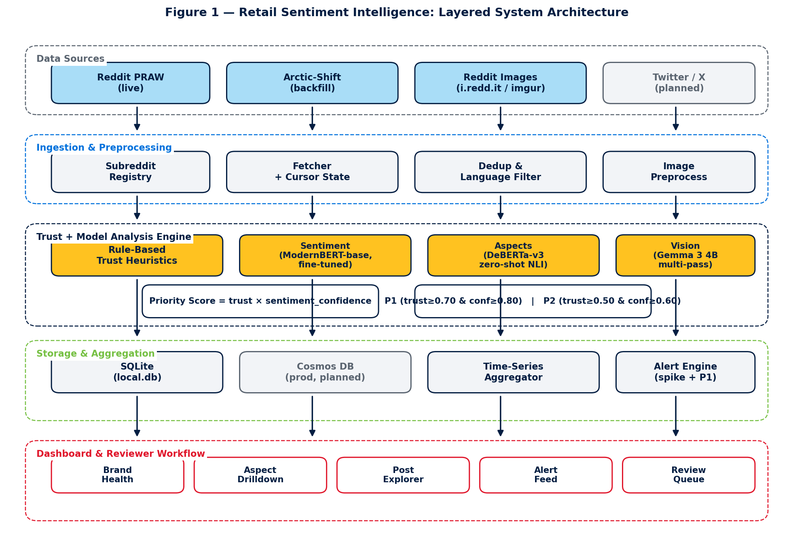
Figure 1: Five-layer architecture — data sources, ingestion, trust + LLM analysis, storage / aggregation, and the dashboard surface.
In words: Reddit Sources → Ingestion Layer (PRAW live + Arctic-Shift historical) → Pre-processing (clean, English-filter, deduplicate) → Trust-Score Module (rule-based heuristics on metadata + retail-insider terminology) → Model Analysis — sentiment with fine-tuned ModernBERT, aspects with zero-shot DeBERTa-v3, vision captioning with Gemma 3 4B (multi-pass prompt pipeline) when an image is present → Storage (SQLite analyses table) → Aggregation Layer (per-aspect / per-window summaries) → FastAPI REST + WebSocket → React Dashboard (Brand Health, Priority Negatives P1/P2, Review Queue, Pipeline panel). Reply drafts for P1/P2 posts are produced by Mistral 7B Instruct via Ollama and shown to reviewers; replies are never auto-posted.

Figure 2: End-to-End Pipeline Flow
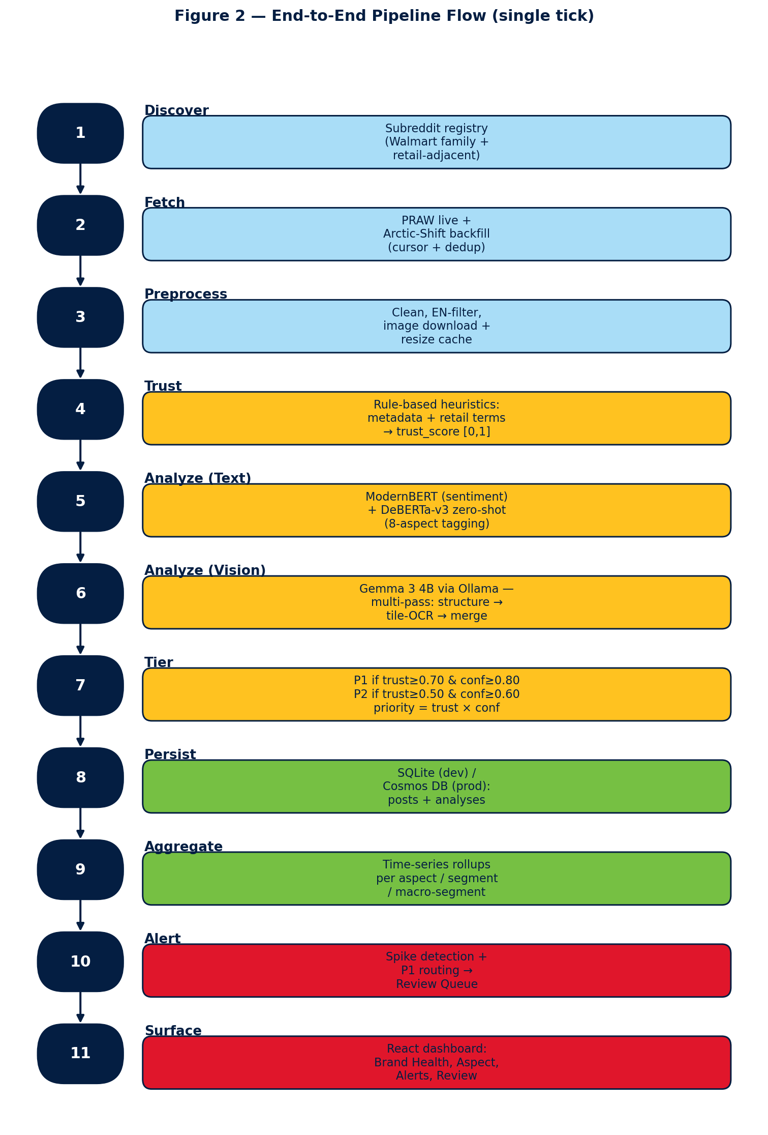
Figure 2: Single pipeline tick — 11 stages from subreddit discovery to dashboard surfacing, colour-coded by layer.

Design choices made during 11–30 May 2026:
- Data source: public Reddit only; no internal Walmart data is used.
- Model stack — every stage uses a different model, chosen for the strengths of that stage rather than one generic LLM:
- • Sentiment: a fine-tuned ModernBERT-base classifier (3-stage curriculum: TweetEval → GoEmotions → Walmart-200 5-fold CV). Beats the cardiffnlp twitter-roberta-base-sentiment-latest baseline by +0.137 macro-F1 overall and +0.722 macro-F1 on long posts (≥512 tokens).
- • Aspect tagging: MoritzLaurer/deberta-v3-base-zeroshot-v2.0 used as a zero-shot NLI classifier over a fixed 8-aspect label set (pricing, product quality, customer service, store experience, online/app, delivery/pickup, returns, app_website). No fine-tuning needed; multi-label, min_score=0.30.
- • Vision: Google Gemma 3 4B served locally via Ollama. Driven by a multi-pass prompt pipeline (image-structure classification → per-tile OCR → merge to 2–4 sentences) designed from a 5-paper literature review on fine-grained text recognition in vision-language models — UReader, TextMonkey, DocOwl 1.5, InternVL2, Qwen2.5-VL.
- • Reply drafter (human-in-the-loop): Mistral 7B Instruct via Ollama; upgrade path to llama3.1:8b is one config line.
- • Credibility / trust: rule-based heuristics in src/trust/heuristics.py — promo-phrase regex, retail-insider terminology boost, and account metadata weights. No LLM call is made for trust in the default local pipeline; the cloud-LLM credibility path exists but is off by default to keep cost and data-egress at zero.
- Trust-score formula (Figure 3): trust_score = 0.4·metadata_score + 0.3·dedup_originality + 0.3·heuristic_credibility, all components clipped to [0, 1]. The metadata score itself is a weighted sum of account age, karma, post length, engagement, and a base floor so brand-new short posts are not unfairly penalised.
- Storage: SQLite (data/local.db) with one row per post and one row per analysis, indexed by post_id, subreddit, and created_ts for fast windowed queries.
- Scheduler: APScheduler running every 60 minutes (configurable), with on-demand 'Run Now' and 'Backfill N days' controls exposed in the dashboard.
- Dashboard: React + Vite + Tailwind, served at :3001, talking to FastAPI on :8001. Walmart brand palette is used for visual identification only.

Figure 3: Trust-Score Composition
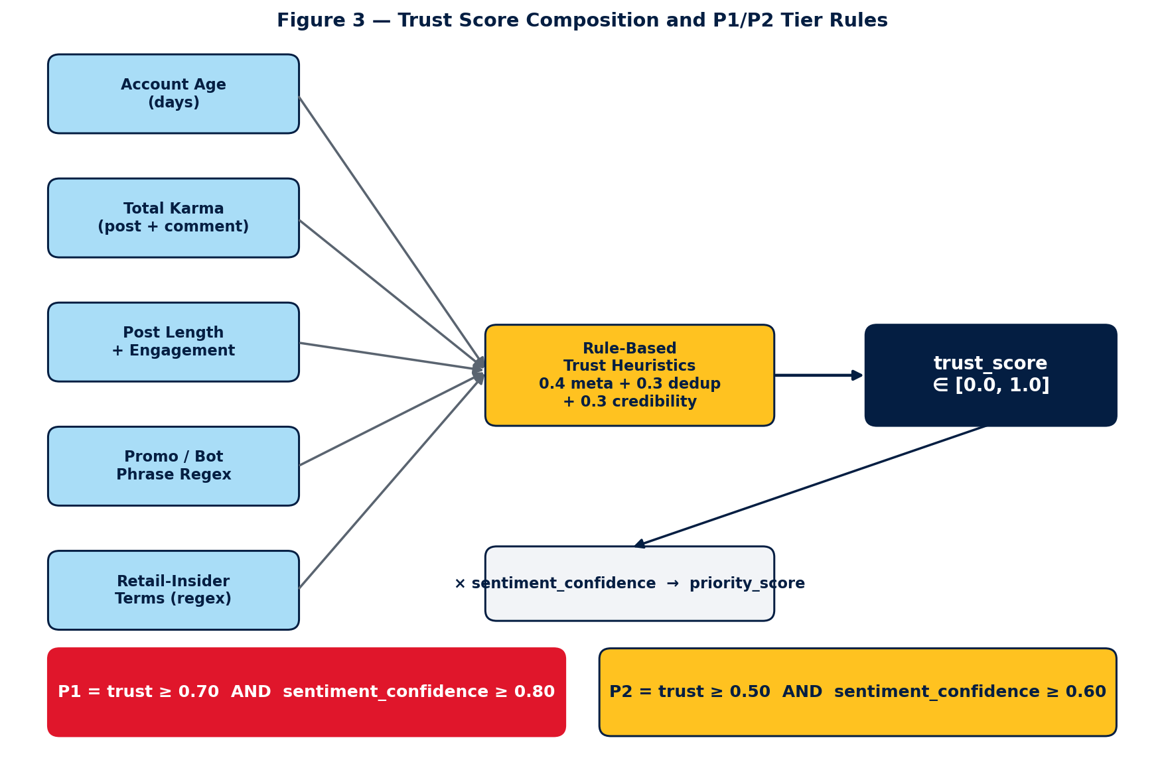
Figure 3: Trust-score inputs feed a rule-based heuristic scorer; the resulting trust_score is multiplied by sentiment_confidence to produce priority_score, which gates P1 and P2 tiers.
Components (default weights from config/pipeline_config.yaml): metadata_score (0.40) is a weighted sum of account age, karma, post length, engagement, and a base floor; dedup_originality (0.30) penalises near-duplicate text against the recent corpus using MinHash; heuristic_credibility (0.30) is a rule-based scorer that rewards retail-insider terminology (e.g. OGP, ASM, TLE, Spark, store) and penalises promotional / bot phrases via regex. The cloud-LLM credibility path exists in src/analysis/llm_client.py but is off in the default local pipeline.

4. Implementation Progress (25 April 2026 – 21 June 2026)
The four phases scheduled for the first half of the semester — literature review and outline, system design, data ingestion and pre-processing, and LLM analysis with trust scoring — have been completed. The implementation is committed to a private Walmart GitHub Enterprise repository (gecgithub01.walmart.com/v0s01jh/Retail_Sentiment_Intelligence) and runs end-to-end on a developer workstation.

4.1 Data Ingestion and Pre-processing
A dual-source ingestion module was implemented. PRAW (Python Reddit API Wrapper) is used for live polling of the curated subreddit list, and the public Arctic-Shift archive is used for historical backfill so that the prototype can be demonstrated against a non-empty corpus regardless of fresh activity. Per-subreddit cursors are persisted in SQLite so that incremental polls do not re-process posts.
Pre-processing includes language detection (English-only), removal of bot / auto-moderator content, URL stripping, MinHash-based near-duplicate detection, and PII redaction (emails, phone numbers, usernames in the body).
Table 1: Curated Subreddit Coverage (snapshot 05 May 2026)
Segment | Representative subreddits | Approx. subscribers
Walmart core | r/walmart, r/WalmartEmployees, r/samsclub, r/OGPBackroom | 554,700
Spark / last-mile | r/Sparkdriver, r/walmartogp, r/WalmartSparkDrivers | 126,657
Walmart pharmacy | r/walmart_RX | 9,511
Walmart international | r/Flipkart, r/WalmartCanada | 18,877
Retail competitors (benchmark) | r/Costco, r/Target, r/AmazonPrime | 2,002,752
Last-mile competitors (benchmark) | r/doordash_drivers, r/AmazonFlexDrivers, r/instacart | 667,872
Retail / customer voice (benchmark) | r/MaliciousCompliance, r/TalesFromRetail, r/CustomerService | 6,198,120

4.2 Model Analysis Module (Sentiment, Aspects, Vision)
The analysis layer deliberately uses three different models, one per task, instead of a single generic LLM. This was the most consequential design decision of the mid-semester window: it lowered cost to zero, removed external data egress, and produced measurably better results on long Reddit posts.
Sentiment classification — fine-tuned ModernBERT-base.
A three-stage curriculum was used: (i) supervised pre-finetune on TweetEval sentiment, (ii) intermediate task on GoEmotions reduced to a three-class label set, (iii) final fine-tune on a hand-labelled Walmart-200 corpus using 5-fold cross-validation. The resulting checkpoint (models/modernbert_walmart/final, loaded via HuggingFace transformers, max_length=1024) beats the cardiffnlp twitter-roberta-base-sentiment-latest baseline by +0.137 macro-F1 overall and +0.722 macro-F1 on long posts (≥512 tokens) where RoBERTa is forced to truncate — see docs/MODEL_COMPARISON.md. If the local checkpoint is missing, the loader falls back to the RoBERTa baseline so the pipeline still runs on a fresh clone.
Aspect tagging — zero-shot DeBERTa-v3.
Aspects are predicted by MoritzLaurer/deberta-v3-base-zeroshot-v2.0 used as an NLI classifier over an eight-label set (pricing, product quality, customer service, store experience, online/app, delivery/pickup, returns, app_website). Multi-label prediction with min_score=0.30 and at most three aspects per post keeps the output sparse. Zero-shot avoids the fine-tuning step entirely while remaining swappable for a supervised tagger later. Fallback: facebook/bart-large-mnli.
Vision — Gemma 3 4B (Ollama) with a multi-pass prompt pipeline.
Approximately 12% of negative posts in our corpus include an image (receipts, shelf photos, app screenshots). A single 'describe this image' prompt against Gemma 3 4B was insufficient for screenshots that contain UI text. After a five-paper literature review on fine-grained text recognition in vision-language models — UReader, TextMonkey, DocOwl 1.5, InternVL2, and Qwen2.5-VL — a three-pass pipeline was implemented in src/analysis/vision.py: (i) STRUCTURE_PROMPT classifies the image type, (ii) the image is tiled and TILE_TEXT_PROMPT extracts verbatim text from each tile, (iii) MERGE_PROMPT fuses the structure verdict and tile texts into 2–4 sentences. Gemma 3 4B was chosen because it is natively multimodal in Ollama, scores 83 on DocVQA versus LLaVA-1.5's 28, fits in 8 GB RAM, and is permissively licensed (Google). LLaVA-7B is configured as fallback only. Qwen2.5-VL was excluded by enterprise policy on China-origin model providers.
Reply drafting (human-in-the-loop) — Mistral 7B Instruct.
For P1/P2 negative posts, a Mistral 7B Instruct model served via Ollama drafts an empathetic reply (temperature=0.55, max_tokens=220). A deterministic 'smart-composer' produces a second draft so reviewers can compare and choose. Replies are never auto-posted: the Reddit OAuth surface is gated by a dry_run flag.
Output contract.
Each pipeline tick emits a JSON record per post containing overall_sentiment in {positive, negative, neutral}, sentiment_confidence in [0, 1], up to three aspects with per-aspect score, optional vision_caption when an image was present, and the trust score and flags. The output is validated, repaired on parse failure, and persisted to the analyses table. Cost is tracked per record in data/llm_costs.jsonl (zero by default because every step runs locally).
Table 2: Eight-Aspect Retail Taxonomy
Aspect (zero-shot label) | Examples of posts that match
pricing | Price mismatch, promo not honoured, perceived price gouging.
product quality | Defective items, expired groceries, private-brand quality.
customer service | Store staff behaviour, escalations, chat / call experience.
store experience | In-store hygiene, shelf availability, register queues.
online/app | Walmart.com or Walmart app crash, checkout errors, search bugs.
delivery/pickup | Late or wrong delivery, Spark driver behaviour, OGP pickup delays.
returns | Refund delays, refund rejected, return-process complaints.
app_website | Account / login / sign-up problems, password reset failures.

4.3 Trust-Score Module
The trust-score module computes the composition described in Figure 3. Account-age, karma, post length, and engagement are read from the public Reddit user/post objects; the metadata sub-score is a weighted sum of those plus a base floor so brand-new short posts are not unfairly penalised. The dedup-originality sub-score uses MinHash similarity against the recent corpus to penalise copy-paste / templated spam. The credibility sub-score is a rule-based scorer in src/trust/heuristics.py that boosts posts containing Walmart-insider terminology (OGP, Spark, ASM, TLE, CSM, GM, Cap 2, OnePOS, GTA, store/aisle/department/register) and penalises promotional or bot phrases via regex. No LLM call is made on the default local path; a cloud-LLM credibility option exists but is disabled in pipeline_config.yaml. The final trust_score is persisted alongside each analysis so downstream queries can apply the threshold without recomputation.

4.4 Storage Layer
Posts and analyses are stored in a local SQLite database (data/local.db). The schema separates raw_posts (immutable ingest payload) from analyses (the LLM output plus trust score and validation flags). Indexes on (subreddit, created_ts) and (sentiment, trust_score) keep the dashboard windowed queries below ~50 ms on the current corpus.

4.5 Dashboard and Human-in-the-Loop Review
A React + Vite + Tailwind dashboard (5 pages) is served on :3001 and talks to a FastAPI backend on :8001. Figure 4 shows how the pages, global filters, storage, and reviewer feedback loop are wired together. Pages implemented during 01–21 June 2026:
- Brand Health — KPI tiles (Total, Trusted, Positive, Negative, P1, P2), sentiment pie chart, segment distribution, top issues, and a new Priority Negative Posts panel that lists the top-N (10/15/20/30/50/100) negative posts ranked by trust × confidence, tiered as P1 (trust ≥ 0.70 AND confidence ≥ 0.80) and P2 (trust ≥ 0.50 AND confidence ≥ 0.60).
- Post Explorer — filterable post list by subreddit, sentiment, aspect, time range, and minimum trust score.
- Aspect Drilldown — per-aspect trends and representative example posts.
- Review Queue — human-in-the-loop interface for low-confidence posts; corrections are saved back to the analyses table and feed all dashboards.
- Pipeline — live pipeline status with per-subreddit ingest progress, media-capture coverage, manual 'Run Now' and 'Backfill' controls, and a danger-zone reset.

Figure 4: Dashboard Information Architecture
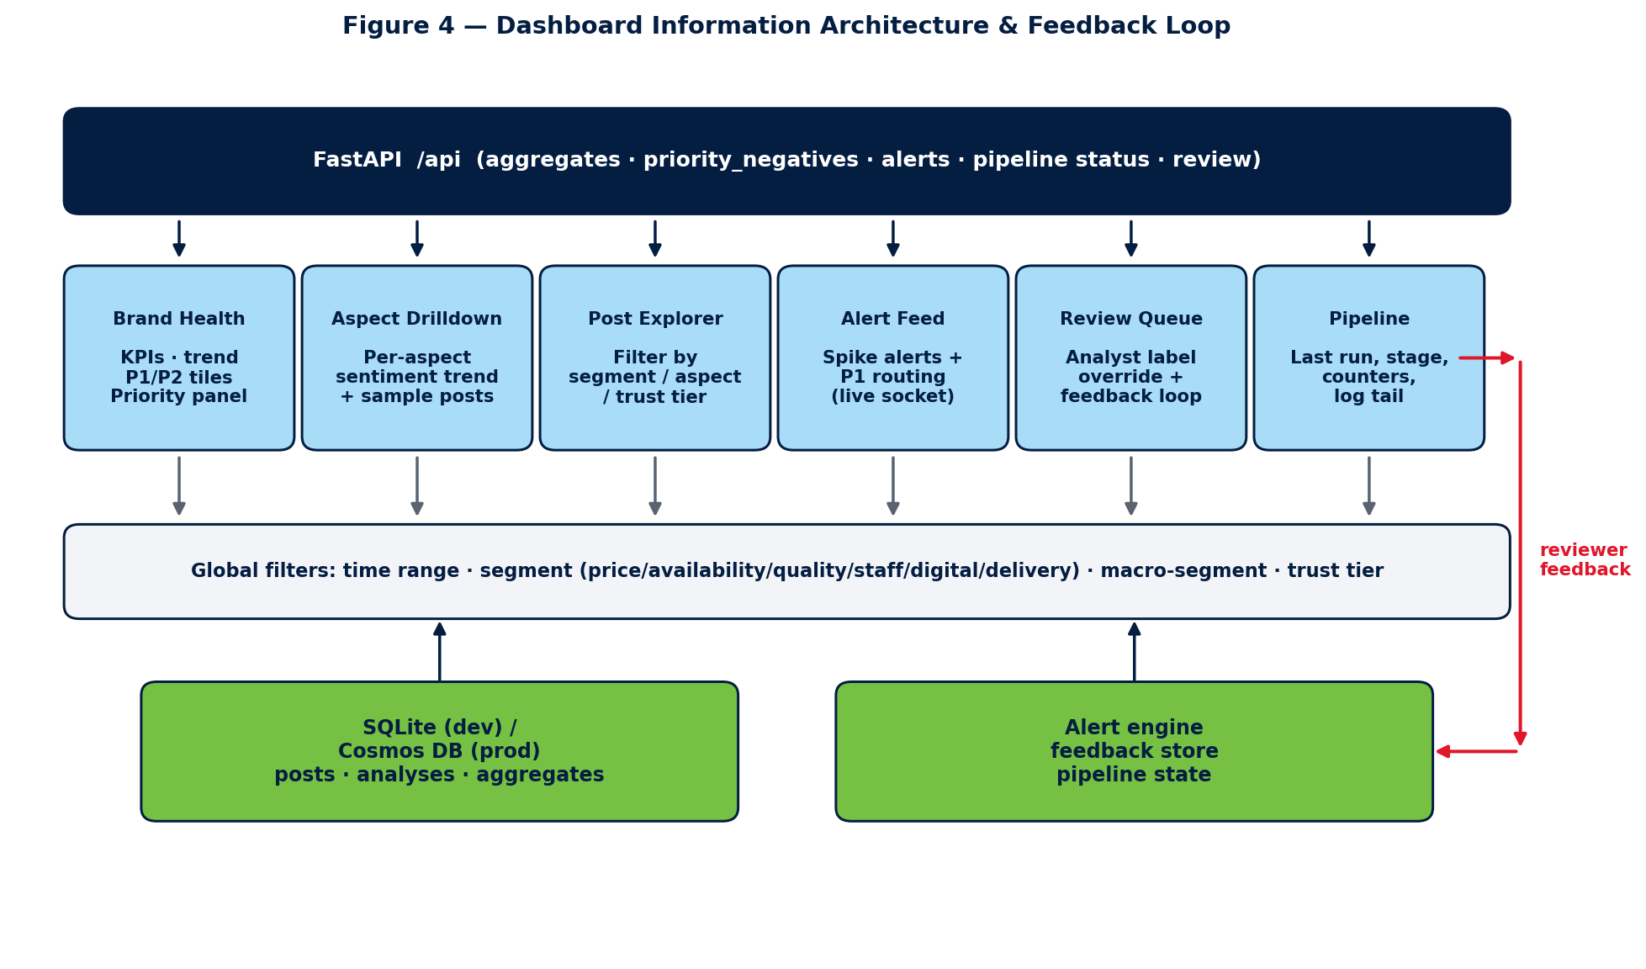
Figure 4: Dashboard information architecture — six pages backed by a single FastAPI surface, sharing global filters, and feeding reviewer corrections back into the storage layer.

5. Tools, Technologies, and Configuration
Table 3 lists the tools and technologies used in the prototype. All components run locally on a developer workstation; no Walmart-internal infrastructure is used.
Table 3: Tools and Technologies Used
Layer | Tool / Library | Purpose
Language | Python 3.13 | Backend, ingestion, analysis, scheduler.
Reddit ingestion | PRAW | Live polling of curated subreddits.
Historical backfill | Arctic-Shift API | Public Reddit archive for non-empty demo corpora.
Scheduler | APScheduler (60-min interval) | Background polling, with on-demand 'Run Now' and 'Backfill N days' triggers.
Sentiment model | ModernBERT-base, fine-tuned (HuggingFace transformers) | 3-stage curriculum (TweetEval → GoEmotions → Walmart-200 5-fold CV); +0.137 macro-F1 over RoBERTa baseline.
Sentiment fallback | cardiffnlp/twitter-roberta-base-sentiment-latest | Used automatically when the fine-tuned checkpoint is absent.
Aspect tagging | MoritzLaurer/deberta-v3-base-zeroshot-v2.0 | Zero-shot NLI over an 8-label retail taxonomy; multi-label, min_score=0.30.
Vision | Gemma 3 4B via Ollama (multi-pass prompt pipeline) | Native-multimodal captioning + tile-OCR; design informed by UReader / TextMonkey / DocOwl 1.5 / InternVL2 / Qwen2.5-VL.
Reply drafter | Mistral 7B Instruct via Ollama | Human-in-the-loop reply drafts for P1 / P2 posts; never auto-posted.
Trust / credibility | Rule-based heuristics (regex + retail-insider terms) | src/trust/heuristics.py; no LLM call on default local path.
Storage | SQLite (data/local.db) | raw_posts and analyses tables, plus cursors and reviewer corrections.
API | FastAPI + Uvicorn | REST endpoints and WebSocket for live status.
Frontend | React + Vite + TypeScript + Tailwind | Six-page dashboard (Brand Health, Aspect, Post Explorer, Alert Feed, Review, Pipeline).
Charts | Recharts | Sentiment pie, time-series trends, aspect breakdowns.
Privacy | Custom regex redactor | Strips emails, phones, and usernames from stored bodies.

6. Problems Encountered and Mitigations
Several non-trivial blockers were hit while building the prototype. The four largest (data access, model access, vision quality, and trust formula) reshaped key design decisions; the remainder were operational issues fixed in passing. Each row in Table 4 captures both the original plan and the working alternative that replaced it.
Table 4: Problems Encountered and Mitigations
# | Problem | Mitigation
1 | Reddit data access — the original plan was to ingest live posts via PRAW with developer-API credentials. The Reddit developer-API application was submitted but approval did not arrive within the mid-semester window, so PRAW could not be authenticated against a real client_id / client_secret. Without credentials, PRAW falls back to anonymous read which is heavily rate-limited (60 req/min) and returns a very thin recent stream — the demo dashboard would be empty for hours. | Switched the default ingestion path to the public Arctic-Shift archive (arctic-shift.photon-reddit.com), which exposes Reddit's historical corpus over a free, credential-less HTTPS API. The fetcher_provider toggle in config/pipeline_config.yaml lets us flip back to PRAW the moment the dev-API key arrives. A 'Backfill N days' control in the dashboard now lets the demo run deterministically against any historical window.
2 | Foundation-model access — the abstract called for GPT-4o (Azure OpenAI) for sentiment, aspects, and credibility. The Azure OpenAI subscription / API-key provisioning ticket was raised but the key was not issued in time, and Walmart data-egress rules also discourage routing public-Reddit text through external hosted endpoints without a documented approval. | Re-architected the analysis layer around in-house, locally served open-weight models. Three different models, one per task, were selected for the strengths of each stage: a fine-tuned ModernBERT-base for sentiment (HuggingFace transformers), DeBERTa-v3 zero-shot NLI for aspects, and Gemma 3 4B served via Ollama for vision. Mistral 7B Instruct (Ollama) drafts reviewer replies. Cost dropped to zero, no data leaves the workstation, and the LLMClient interface keeps the Azure OpenAI path available behind a one-line provider switch in config/models.yaml when the key eventually arrives.
3 | Vision / image-post processing — a single-shot 'describe this image' prompt against Gemma 3 4B was insufficient for the dominant image type in our corpus (app screenshots, receipts, shelf-tag photos containing UI text). The model described elements in isolation ('a blue button', 'Learn More text') without connecting them into 'the customer's checkout failed at confirmation', and it missed verbatim price / error-code text on receipts. | Reviewed five recent papers on fine-grained text recognition in vision-language models — UReader, TextMonkey, DocOwl 1.5, InternVL2, Qwen2.5-VL — and built a three-pass prompt pipeline in src/analysis/vision.py instead of changing the model: (i) STRUCTURE_PROMPT classifies image type, (ii) the image is tiled and TILE_TEXT_PROMPT extracts verbatim text from each tile, (iii) MERGE_PROMPT fuses structure + tile texts into a 2–4 sentence caption. This recovered the missing UI text without exceeding the 8 GB RAM budget and without switching to Qwen2.5-VL (excluded by enterprise policy on China-origin providers).
4 | Working trust-and-credibility formula — the first attempt routed every post through an LLM credibility check, which doubled cost (later: zero, but added latency on local models) and was overkill: an account with 1,200 days of age, 5,600 karma, and Walmart-insider terminology in the body should not need a model call to be trusted, while a 1-day-old account posting promo URLs should not need one to be flagged. A flat weighted sum of all heuristic signals also produced too many borderline cases for reviewers, and dropping low-trust posts (the initial design) destroyed downstream recall. | Iterated to a three-component formula (trust_score = 0.4·metadata + 0.3·dedup + 0.3·heuristic_credibility) in src/trust/scorer.py. The metadata sub-score is itself a weighted sum of account age, karma, post length, engagement, and a base floor so brand-new short posts are not unfairly penalised. The credibility sub-score is rule-based: regex over promotional / bot phrases, plus a positive boost for retail-insider terms (OGP, ASM, TLE, CSM, Spark, OnePOS, store/aisle/department). Low-trust posts are now flagged, not dropped (per R5 in the requirements). The optional LLM credibility path is retained and only invoked when 0.3 < metadata_score < 0.8 — i.e. only the genuinely ambiguous band.
5 | Sentiment-model selection and training — the initial supervised baseline used a smaller pre-trained encoder (the cardiffnlp twitter-roberta-base-sentiment-latest checkpoint, ~125M params, 512-token cap). It performed reasonably on tweet-length text but degraded sharply on long Reddit posts (≥512 tokens) where it had to truncate the middle of the complaint; it also under-weighted retail jargon it had never seen during pre-training. | Migrated to ModernBERT-base (newer encoder, 8K-token context, better long-range attention) and trained a 3-stage curriculum: (i) supervised pre-finetune on TweetEval sentiment to anchor the label space, (ii) intermediate task on GoEmotions reduced to a three-class mapping for richer affect coverage, (iii) final fine-tune on a hand-labelled Walmart-200 corpus using 5-fold cross-validation. The resulting checkpoint (models/modernbert_walmart/final, max_length=1024) beats the RoBERTa baseline by +0.137 macro-F1 overall and +0.722 macro-F1 on long posts — see docs/MODEL_COMPARISON.md. RoBERTa is kept as an automatic fallback if the checkpoint is absent on a fresh clone.
6 | Raw model output was occasionally non-JSON — trailing prose, half-closed objects, or extra commentary — which broke the persistence step and lost the whole record. | Added a JSON-repair layer: extract the first balanced JSON object, validate against the analysis schema, and on failure re-prompt with a tighter system message; the post is skipped (with a logged reason) only after two retries so a single bad response cannot poison the batch.
7 | Triage volume — once sentiment + trust were live, reviewers asked for a clear 'what should I look at first' view; a flat sorted feed of negative posts was too long to act on. | Added a Priority Negatives panel on Brand Health that ranks negative posts by priority_score = trust_score × sentiment_confidence and tiers them into P1 (trust ≥ 0.70 AND confidence ≥ 0.80) and P2 (trust ≥ 0.50 AND confidence ≥ 0.60). The thresholds are shown inline on the tiles and on the section header so the rule is not hidden in code.
8 | Pipeline opacity — long backfills (90 days × 32 subreddits) ran for many minutes and operators could not tell whether the pipeline was progressing or stuck. | Added subreddit_fetch_start / progress / complete events from the ingestor and surfaced a live collapsible per-subreddit progress panel on the Pipeline page, plus a status pill in the header that mirrors the FastAPI /api/pipeline/status snapshot.
9 | Media-capture coverage briefly read >100% because the denominator counted only posts whose source was a single image, while the numerator also captioned videos, GIFs (animated reddit_video / preview/.gif assets that the vision step successfully caption-keyframes), and link-card previews. | Re-defined images_total as max(image_only + text_plus_image + video, captioned) so the percentage is clamped to ≤100% by construction. The KPI tile now also shows the raw 'captioned / images_total' fraction in a tooltip so the operator can see what was counted.
10 | Banned / restricted / empty subreddits in the curated list (r/PhonePe, r/Equate, r/walmartspark, r/walmartmexico) caused the ingestor to raise 403 / 404 mid-run and abort the whole batch. | Annotated the subreddit registry with a status field (public / restricted / banned / empty); the ingestor now skips non-public entries with a logged warning and continues with the remaining list.

7. Preliminary Observations
Formal evaluation is scheduled for 01–10 July 2026 against a manually labelled sample. Preliminary qualitative observations from spot-checking the running pipeline as of 21 June 2026 are summarised below; these are not evaluation results.
- The fine-tuned ModernBERT classifier handles negation, sarcasm, and retail-specific slang (e.g., 'OGP pickup', 'ETL', 'TL', 'Spark') noticeably better than the cardiffnlp RoBERTa baseline, particularly on long posts where the older model is forced to truncate.
- Aspect tagging is most reliable for delivery, returns, and pricing; customer support and app/website experience occasionally overlap and will need a clarifying prompt example.
- Trust filtering visibly removes a small but non-trivial set of promotional / low-effort posts that would otherwise inflate the negative bucket.
- The Priority Negatives panel surfaces credible, actionable complaints (e.g., r/Target store-staff escalations) that would have been buried in a time-sorted feed.
- End-to-end ingest → analyse → display latency for a single post is in the low seconds on the local Ollama setup, dominated by LLM inference rather than ingestion or storage.

8. Future Plan (Remaining Phases)
The phases below mirror the plan submitted with the abstract. Status as of 21 June 2026 is shown in the rightmost column.
Table 5: Future Plan with Status
Phase | Start Date – End Date | Work to be done | Status
Outline & Literature Review | 25 Apr 2026 – 10 May 2026 | Literature review on LLM-based sentiment / aspect analysis and fake-review / credibility detection. Submit dissertation outline. | COMPLETED
Design | 11 May 2026 – 30 May 2026 | Finalize data sources, per-task model choices (ModernBERT for sentiment, DeBERTa-v3 zero-shot for aspects, Gemma 3 4B for vision, Mistral 7B for reply drafts), aspect taxonomy, trust-score design, evaluation plan, and overall system design. | COMPLETED
Data Ingestion & Pre-processing | 11 May 2026 – 30 May 2026 | Implement Reddit ingestion (PRAW + Arctic-Shift), cleaning, English filtering, deduplication, and storage. Collect a baseline working corpus. | COMPLETED
Model Development & Trust Scoring | 01 Jun 2026 – 21 Jun 2026 | Fine-tune ModernBERT on Walmart-200 (3-stage curriculum), wire DeBERTa-v3 zero-shot for aspects, design the multi-pass Gemma 3 4B vision pipeline from a 5-paper literature review, and implement the rule-based trust scorer. Integrate with the dashboard. | COMPLETED
Aggregation & Reporting | 22 Jun 2026 – 30 Jun 2026 | Aggregated summaries per aspect and time window. Notebook-based reporting and Brand Health dashboard refinements (Priority Negatives P1/P2, drill-downs). | IN PROGRESS
Evaluation | 01 Jul 2026 – 10 Jul 2026 | Manually label ~250–300 posts. Measure sentiment accuracy / macro-F1, aspect macro-F1, and ROC-AUC for the trust filter on a small balanced credibility sample. | PENDING
Dissertation Review | 11 Jul 2026 – 20 Jul 2026 | Submit draft to Supervisor and Additional Examiner; incorporate feedback. | PENDING
Final Submission | 21 Jul 2026 – 02 Aug 2026 | Final review, formatting per WILP guidelines, and submission. | PENDING

9. Abbreviations
Abbreviation | Expansion
API | Application Programming Interface
APScheduler | Advanced Python Scheduler
AUC | Area Under the (ROC) Curve
BITS | Birla Institute of Technology and Science
BLIP | Bootstrapping Language-Image Pre-training
F1 | Harmonic mean of precision and recall
GIF | Global Integrated Fulfillment
HITL | Human-in-the-Loop
JSON | JavaScript Object Notation
LLaVA | Large Language-and-Vision Assistant
LLM | Large Language Model
LVDS | (not used in this report)
MinHash | Probabilistic near-duplicate similarity hash
MTTR | Mean Time To Resolve
NLP | Natural Language Processing
OGP | Online Grocery Pickup
OAuth | Open Authorization
OCR | Optical Character Recognition
PRAW | Python Reddit API Wrapper
P1 / P2 | Priority Tier 1 / Tier 2 (priority_score-ranked negatives)
ROC | Receiver Operating Characteristic
REST | Representational State Transfer
SLA | Service Level Agreement
SQL | Structured Query Language
SQLite | Embedded SQL database engine
WILP | Work-Integrated Learning Programmes (BITS Pilani)

10. References
[1] DataReportal (We Are Social & Meltwater). "Digital 2024: Global Overview Report," January 2024.
[2] Reddit, Inc. Form S-1 Registration Statement filed with the U.S. SEC, February 2024.
[3] Sprout Social. "The Sprout Social Index 2024," 2024.
[4] World Economic Forum. "Fake online reviews are a $152 billion problem. Here's how to silence them," 2024.
[5] T. Brown, B. Mann, N. Ryder, et al. "Language Models are Few-Shot Learners." NeurIPS, vol. 33, pp. 1877–1901, 2020.
[6] OpenAI. "GPT-4 Technical Report." arXiv:2303.08774, 2023.
[7] D. Zhang, S. Li, H. Zhu, et al. "Sentiment Analysis of Social Media Using Large Language Models: A Comprehensive Survey." arXiv:2311.10066, 2023.
[8] K. Shu, A. Sliva, S. Wang, J. Tang, and H. Liu. "Fake News Detection on Social Media: A Data Mining Perspective." ACM SIGKDD Explorations Newsletter, 19(1):22–36, 2017.
[9] A. Mukherjee, B. Liu, and N. Glance. "Spotting Fake Reviewer Groups in Consumer Reviews." WWW, pp. 191–200, 2012.
[10] Walmart Inc. "Corporate Fact Sheet" (FY2024).
[11] B. Liu. Sentiment Analysis and Opinion Mining. Morgan & Claypool, 2012.
[12] H. Liu, I. Chatterjee, M. Zhou, X. S. Lu, and A. Srivastava. "Aspect-Based Sentiment Analysis: A Survey of Deep Learning Methods." IEEE TCSS, 10(1):211–232, 2023.
[13] J. Wei, X. Wang, D. Schuurmans, et al. "Chain-of-Thought Prompting Elicits Reasoning in Large Language Models." NeurIPS, vol. 35, 2022.
[14] J. Devlin, M.-W. Chang, K. Lee, and K. Toutanova. "BERT: Pre-training of Deep Bidirectional Transformers for Language Understanding." NAACL-HLT, pp. 4171–4186, 2019.
[15] H. Touvron, L. Martin, K. Stone, et al. "Llama 2: Open Foundation and Fine-Tuned Chat Models." arXiv:2307.09288, 2023.

