A REPORT
ON
REAL-TIME SOCIAL MEDIA MINING AND TRUST-AWARE SENTIMENT ANALYSIS USING LARGE LANGUAGE MODELS FOR RETAIL PRODUCT FEEDBACK OPTIMIZATION
BY
VISHAL SINGH
ID No. 2020AA05641
Walmart Global Tech, Bengaluru, India
BIRLA INSTITUTE OF TECHNOLOGY & SCIENCE, PILANI
November 2026

A REPORT
ON
REAL-TIME SOCIAL MEDIA MINING AND TRUST-AWARE SENTIMENT ANALYSIS USING LARGE LANGUAGE MODELS FOR RETAIL PRODUCT FEEDBACK OPTIMIZATION
BY
Vishal Singh
ID No. 2020AA05641
Discipline: M.Tech (Artificial Intelligence & Machine Learning)
Prepared in partial fulfilment of the
WILP Dissertation Course (BITS ZG628T)
Under the Supervision of
Mr. Varunendra Pratap Singh
Principal Software Engineer, Walmart Global Tech, Bengaluru
AT
Walmart Global Tech, Bengaluru, Karnataka, India
BIRLA INSTITUTE OF TECHNOLOGY & SCIENCE, PILANI (RAJASTHAN)
Work Integrated Learning Programmes Division
November 2026

Certificate

This is to certify that the Dissertation report entitled “REAL-TIME SOCIAL MEDIA MINING AND TRUST-AWARE SENTIMENT ANALYSIS USING LARGE LANGUAGE MODELS FOR RETAIL PRODUCT FEEDBACK OPTIMIZATION” submitted by Mr. Vishal Singh (ID No. 2020AA05641) in partial fulfilment of the requirements of the course BITS ZG628T Dissertation, embodies the work done by him under my supervision and guidance.
The work is original and, to the best of my knowledge, has not been submitted elsewhere for the award of any other degree or diploma. During the period of the dissertation the candidate has shown sound technical competence, initiative, and a commitment to an honest, defensible treatment of results.
 | Signature of the Supervisor
Place: Bengaluru  Date: | Name: Mr. Varunendra Pratap Singh  Designation: Principal Software Engineer  Walmart Global Tech, Bengaluru

Acknowledgements
I take this opportunity to thank everyone who supported me during the course of this dissertation.
I am grateful to the leadership at Walmart Global Tech India for providing an environment that encouraged learning and experimentation, and for allowing me to pursue this industry-linked academic project alongside my regular engineering responsibilities.
I sincerely thank my Supervisor, Mr. Varunendra Pratap Singh (Principal Software Engineer, Walmart Global Tech), for his day-to-day technical guidance, patient reviews of my design and evaluation choices, and for continually pushing me to raise the standard of the work. I also thank the Additional Examiner, assigned by the organisation, for the rigorous mid-project scrutiny that substantially improved the evaluation methodology and the trust-score design.
I thank my colleagues and professional experts on the retail domain at Walmart Global Tech for helping me translate free-form Reddit posts into an operational, eight-aspect retail taxonomy that drives the aggregation and alerting stages of this system.
I am deeply grateful to my Faculty Mentor, Ms. Pradnya Kashikar (BITS Pilani, WILP Division), for her guidance, timely feedback, and academic oversight from the abstract-outline stage through mid-semester review to final submission, and for ensuring the work conformed to the academic rigour expected of an M.Tech dissertation.
Finally, I thank my family and friends for their patience and encouragement over the course of this programme, and I dedicate this effort to them.
All experiments reported in this dissertation use only publicly available data; no proprietary Walmart data or internal systems were used at any stage.

Vishal Singh
Bengaluru, November 2026
Signature of the Student
Name: Vishal Singh ID No.: 2020AA05641
Date: Place: Bengaluru

BIRLA INSTITUTE OF TECHNOLOGY AND SCIENCE, PILANI (RAJASTHAN)
Work Integrated Learning Programmes Division
Dissertation Abstract Sheet
Field | Detail
Organization | Walmart Global Tech
Location | Bengaluru, Karnataka, India
Duration | Two semesters (approximately 8 months)
Date of Start | 25 April 2026
Date of Submission | November 2026
Title of the Project | REAL-TIME SOCIAL MEDIA MINING AND TRUST-AWARE SENTIMENT ANALYSIS USING LARGE LANGUAGE MODELS FOR RETAIL PRODUCT FEEDBACK OPTIMIZATION
ID No. / Name of the Student | 2020AA05641 / Vishal Singh
Name & Designation of Supervisor and Additional Examiner | Mr. Varunendra Pratap Singh, Principal Software Engineer, Walmart Global Tech (Supervisor); Additional Examiner as assigned by the organisation
Name of the Faculty Mentor | Ms. Pradnya Kashikar, BITS Pilani WILP Division
Key Words | Sentiment Analysis; Aspect-Based Opinion Mining; Large Language Models; ModernBERT; Zero-shot NLI; Trust / Credibility Filtering; Multimodal Vision; Reddit; Retail Analytics
Project Areas | Applied Natural Language Processing; Machine Learning; Multimodal AI; Data Engineering
Abstract
Public social media is now a primary real-time channel for retail customer voice, yet fake and low-credibility posts contaminate any aggregate consumed without filtering. This dissertation designs, builds, and evaluates Retail Sentiment Intelligence (RSI), a complete offline-first prototype that converts a noisy public Reddit stream into a structured, aspect-tagged, trust-weighted brand-health feed. Posts from 25 curated retail communities are ingested, de-duplicated, and assigned a 0–1 trust score combining metadata heuristics, near-duplicate detection, and credibility checks. Trusted posts are classified for sentiment by a domain fine-tuned ModernBERT encoder, tagged with aspects by a zero-shot NLI classifier over an eight-category taxonomy, and — when an image is attached — captioned by a multi-pass, anti-hallucination Gemma 3 4B pipeline. Sentiment macro-F1 improved from 0.6272 to 0.7642 (and 0.28 to 1.00 on long posts); vision hallucination fell from 50% to 0%. A React/FastAPI dashboard surfaces results across eight surfaces including a live alert feed, a human-in-the-loop review queue, a post-lifecycle board, and competitor insights. The report documents the full lifecycle: literature survey, design, implementation, honest cross-validated evaluation, limitations, and recommendations.
Signature of the Student | Signature of the Supervisor
Name: Vishal Singh  Date: | Name: Varunendra Pratap Singh  Date:

Table of Contents
Front matter is numbered in lower-case Roman numerals (i, ii, iii, …). The main text is numbered in Arabic numerals starting at page 1 from the Introduction. Section numbers below are clickable and jump to the corresponding heading.
Certificate
Acknowledgements
Abstract
Chapter 1 Introduction
1.1 Broad Area of Work
1.2 Motivation
1.3 Contributions of this Dissertation
1.4 Organisation of the Report
Chapter 2 Problem Statement and Objectives
Chapter 3 Literature Survey
Chapter 4 System Design and Architecture
4.1 Design Principles
4.2 Layered Architecture
4.3 End-to-End Pipeline Flow
Chapter 5 Implementation
5.1 Data Ingestion and Pre-processing
5.2 Trust-Score Module
5.3 Sentiment Classification (ModernBERT)
5.4 Aspect-Based Opinion Mining
5.5 Vision / Image Processing
5.6 Aggregation, Alerts, and Notifications
5.7 Dashboard Overview
5.8 Human-in-the-Loop Review & Validate
5.9 Smart Reply Composer — Dual-Draft (Rule + LLM)
5.10 Learning Loop — Feedback for Future Retraining
5.11 Post Explorer and Multi-Facet Search
5.12 Post Lifecycle (Kanban Workflow)
5.13 Insights and Competitor Analysis
5.14 Storage Layer
Chapter 6 Evaluation and Results
6.1 Sentiment Model Evaluation
6.2 Vision Module Evaluation
6.3 Trust-Score Behaviour
Chapter 7 Tools, Technologies, and Configuration
Chapter 8 Problems Encountered and Mitigations
Chapter 9 Conclusions and Recommendations
Chapter 10 Future Work
Glossary and Abbreviations
References
Appendix A — Curated Subreddit Coverage
Appendix B — Reproduction Commands
Checklist of Items for the Final Report

List of Figures
Figure 1: Layered System Architecture
Figure 2: End-to-End Pipeline Flow
Figure 3: Trust-Score Composition and P1/P2 Tier Rules
Figure 4: Dashboard Information Architecture and Feedback Loop
Figure 5: Human-in-the-Loop Review & Validate Flow
Figure 6: Smart Reply Composer — Dual-Draft with Few-Shot
Figure 7: Feedback Learning Loop and Path to Auto-Reply
Figure 8: Post Lifecycle Kanban Workflow
Figure 9: Data Ingestion and Pre-processing Flow
Figure 10: ModernBERT Three-Stage Fine-Tuning Curriculum
Figure 11: Zero-Shot NLI Aspect Tagging
Figure 12: Vision Multi-Pass Anti-Hallucination Pipeline
Figure 13: Alert Engine and Notification Routing
Figure 14: Sentiment Macro-F1 — RoBERTa vs ModernBERT

List of Tables
Table 1: Eight-Aspect Retail Taxonomy
Table 2: Sentiment Model Comparison (out-of-fold CV)
Table 3: Per-Length-Bucket Sentiment F1
Table 4: Vision Module — Before vs After Multi-Pass
Table 5: Tools and Technologies
Table 6: Problems Encountered and Mitigations
Table 7: Curated Subreddit Coverage

Abstract
Public social media is now a primary real-time channel for retail customer voice, yet fake and low-credibility posts contaminate any aggregate consumed without filtering. This dissertation designs, builds, and evaluates Retail Sentiment Intelligence (RSI), a complete offline-first prototype that converts a noisy public Reddit stream into a structured, aspect-tagged, trust-weighted brand-health feed. Posts from 25 curated retail communities are ingested, de-duplicated, and assigned a 0–1 trust score combining metadata heuristics, near-duplicate detection, and credibility checks. Trusted posts are classified for sentiment by a domain fine-tuned ModernBERT encoder, tagged with aspects by a zero-shot NLI classifier over an eight-category taxonomy, and — when an image is attached — captioned by a multi-pass, anti-hallucination Gemma 3 4B pipeline. Sentiment macro-F1 improved from 0.6272 to 0.7642 (and 0.28 to 1.00 on long posts); vision hallucination fell from 50% to 0%. A React/FastAPI dashboard surfaces results across eight surfaces including a live alert feed, a human-in-the-loop review queue, a post-lifecycle board, and competitor insights. The report documents the full lifecycle: literature survey, design, implementation, honest cross-validated evaluation, limitations, and recommendations.
Key Words: Sentiment Analysis; Aspect-Based Opinion Mining; Large Language Models; ModernBERT; Zero-shot NLI; Trust / Credibility Filtering; Multimodal Vision; Reddit; Retail Analytics.
Project Areas: Applied Natural Language Processing; Machine Learning; Multimodal AI; Data Engineering.

Chapter 1

Introduction

1.1 Broad Area of Work
The broad area of this dissertation is Applied Natural Language Processing (NLP) and multimodal machine learning for the analysis of public retail customer feedback on social media. The work spans four technical sub-areas: (a) supervised text classification with transformer encoders for sentiment in short, informal English social-media text; (b) zero-shot natural-language-inference (NLI) models for aspect-based opinion mining over a fixed retail taxonomy; (c) multimodal vision-language models for captioning and OCR of screenshots and photographs attached to retail complaints; and (d) lightweight trust / credibility filtering using account-metadata heuristics, near-duplicate detection, and retail-insider terminology signals. Around these models sits a data-engineering layer for scheduled ingestion of public posts and structured storage suitable for aggregation and reporting, and a serving layer that surfaces the results in an interactive dashboard.

1.2 Motivation
The motivation is volume and noise. Customers, associates, and delivery drivers post continuously about their Walmart, Sam's Club, Spark-driver, and OGP/pickup experiences on Reddit. In the candidate's role at Walmart Global Tech, this signal is presently consumed through ad-hoc browsing and keyword-filter dashboards, which suffer from poor coverage, high noise, and latency: a complaint that is trending today may not surface in a manual review for days. Conventional lexicon- or rule-based sentiment systems perform poorly on the sarcasm, slang, and long-form narrative style typical of Reddit retail posts, and none of them filter fake or low-credibility content before aggregation. This dissertation demonstrates that a stack of task-specific models — a fine-tuned encoder for sentiment, a zero-shot NLI model for aspects, and a multimodal vision model for images — combined with an explicit trust filter can convert a raw public stream into a structured, aspect-tagged, trust-weighted feed suitable for operational review.

1.3 Contributions of this Dissertation
The principal contributions of the completed work are:
- A modular, offline-first, zero-API-cost end-to-end pipeline (Retail Sentiment Intelligence) covering ingestion, trust scoring, sentiment, aspects, vision, aggregation, alerting, and dashboarding.
- A domain fine-tuned ModernBERT sentiment classifier trained through a three-stage curriculum, raising macro-F1 from 0.6272 to 0.7642 overall and from 0.2778 to 1.0000 on long posts, evaluated with honest 5-fold out-of-fold cross-validation.
- A multi-pass vision-captioning technique that adapts ideas from recent (policy-blocked) vision-language papers onto a compliant Gemma 3 4B model, reducing hallucination from 50% to 0% and lifting text extraction from 25% to 75%.
- An interpretable trust score and a trust × confidence admission gate that flags — rather than drops — low-credibility posts, with every constant mapped to a stakeholder-arguable English rationale.
- A React/FastAPI dashboard (Brand Health, Alert Feed, Post Explorer, Review & Validate, Post Lifecycle, Insights & Competitor, Pipeline Control, Notifications) with a human-in-the-loop Review & Validate workflow whose corrections and posted replies feed few-shot reply generation and a roadmap to automatic replies, closing the loop between AI output and analyst action.

1.4 Organisation of the Report
The remainder of this report is organised into nine further chapters. Chapter 2 states the problem precisely and sets out the objectives and scope of the dissertation. Chapter 3 surveys the relevant literature on transformer sentiment classification, aspect-based opinion mining, multimodal vision-language models, and social-media credibility. Chapter 4 presents the layered system design and the end-to-end pipeline flow. Chapter 5 describes the implementation of each module in detail — ingestion, trust scoring, sentiment, aspects, vision, aggregation and alerting, the dashboard, and the human-in-the-loop and learning-loop workflows. Chapter 6 reports the experimental evaluation and results for the sentiment, vision, and trust components. Chapter 7 documents the tools, technologies, and configuration used. Chapter 8 records the problems encountered during the work and the mitigations adopted. Chapter 9 draws conclusions and recommendations, and Chapter 10 outlines directions for future work. A glossary, the references, and supporting appendices close the report.

Chapter 2

Problem Statement and Objectives
Manual monitoring of retail-related Reddit communities cannot keep pace with the daily volume of posts, and conventional rule-based or lexicon-based sentiment systems perform poorly on short, sarcastic, slang-heavy retail text. Long-form complaints that carry the decisive detail (a receipt, a store timeline, a resolution) are silently truncated by 512-token models. Furthermore, fake or low-credibility posts contaminate any aggregate signal if consumed without filtering. The problem is therefore to build a system that (i) collects retail social posts at scale, (ii) filters low-credibility content explicitly, (iii) classifies sentiment and aspects accurately on long-form domain text, (iv) handles image-only posts without fabricating detail, and (v) presents the result in a form an analyst can act on.
The objectives approved for the dissertation were:
- Survey recent literature on LLM-based sentiment and aspect-based opinion mining, and on fake-review / bot-credibility detection.
- Build a data-ingestion pipeline that periodically collects retail-related posts from Reddit via the official Reddit API and a public historical archive.
- Implement a model-based analysis module that assigns each post a sentiment label and one or more aspects from a fixed retail taxonomy, plus a vision caption when an image is attached.
- Implement a trust score (0–1) per post combining account-metadata heuristics, near-duplicate detection, and a rule-based credibility scorer (with an optional cloud-LLM credibility path).
- Produce structured aggregated outputs (top aspects, sentiment distribution per aspect, representative examples, priority-negatives ranking) with low-trust posts flagged for review.
- Evaluate the prototype on a manually labelled sample of 200 posts: sentiment macro-F1 (target ≥ 0.80 as a stretch gate), aspect coverage, and trust-filter behaviour.
- Document design, evaluation, limitations, and recommended next steps in the final dissertation.

Chapter 3

Literature Survey
The survey covered three strands. First, transformer encoders for sentiment: RoBERTa fine-tuned on TweetEval [2] remains a strong public baseline for short social text, but is capped at 512 tokens and trained on tweets rather than long-form Reddit narratives. ModernBERT [1] is a modern BERT-style encoder with an 8,192-token context and a web/code/long-document training corpus, making it a natural candidate for long retail complaints while retaining BERT-class inference throughput. GoEmotions [3] supplies a large corpus of Reddit comments used to adapt the model to the Reddit register.
Second, aspect-based opinion mining: rather than training a supervised ABSA model on a small labelled set, the project uses zero-shot NLI classification [4] with a DeBERTa-v3 [5] entailment model, which frames each candidate aspect as a hypothesis to be entailed by the post. This requires no training data, supports multi-aspect assignment, and lets the taxonomy be edited without retraining — a good fit for a domain whose aspect vocabulary (pricing, delivery/pickup, returns, app/website, etc.) is known a priori.
Third, vision-language models for document/screenshot understanding. Five recent papers — UReader [7], TextMonkey [8], DocOwl 1.5 [9], InternVL2 [10], and Qwen2.5-VL [11] (2023–2025) — converge on a single conclusion: dynamic / native-resolution processing with tile-based attention is the key to fine-grained text recognition, and fixed-size image resizing is the dominant failure mode. Crucially, every model that implements this natively is from a lab whose provider is blocked by enterprise vendor policy. The design response — detailed in Section 5.5 — was to re-implement those techniques as a calling strategy on a compliant Gemma 3 4B model [6], with de-duplication driven by MiniLM sentence embeddings [12].
Finally, on credibility: the fake-review literature and its economic impact [13] motivate a multi-signal filter (account age, karma, posting frequency, duplicate detection, promotional-language heuristics) rather than a single learned classifier, which would be hard to justify on only 200 labelled posts. The project therefore adopts an interpretable, weighted rule-based trust score. Market context for the problem is drawn from industry reports on social usage and expected response times [14][15][16].

Chapter 4

System Design and Architecture

4.1 Design Principles
Four principles governed every design decision:
- Local-first and free by default — every model runs offline (HuggingFace / Ollama); cloud LLMs and paid APIs are gated behind explicit keys, and per-call cost is tracked in a JSONL ledger.
- Modularity — each pipeline stage is independently testable and swappable (e.g., SQLite ↔ Cosmos DB, RoBERTa ↔ ModernBERT) via configuration.
- Flag, don't drop — low-trust posts are surfaced for human review, never silently discarded, preserving recall and auditability.
- Defensibility — evaluation uses honest out-of-fold cross-validation, not training-set fit; every trust constant maps to an arguable English sentence.

4.2 Layered Architecture
The system is organised as six logical layers. Figure 1 shows the layers and the components inside each.
Figure 1: Layered System Architecture
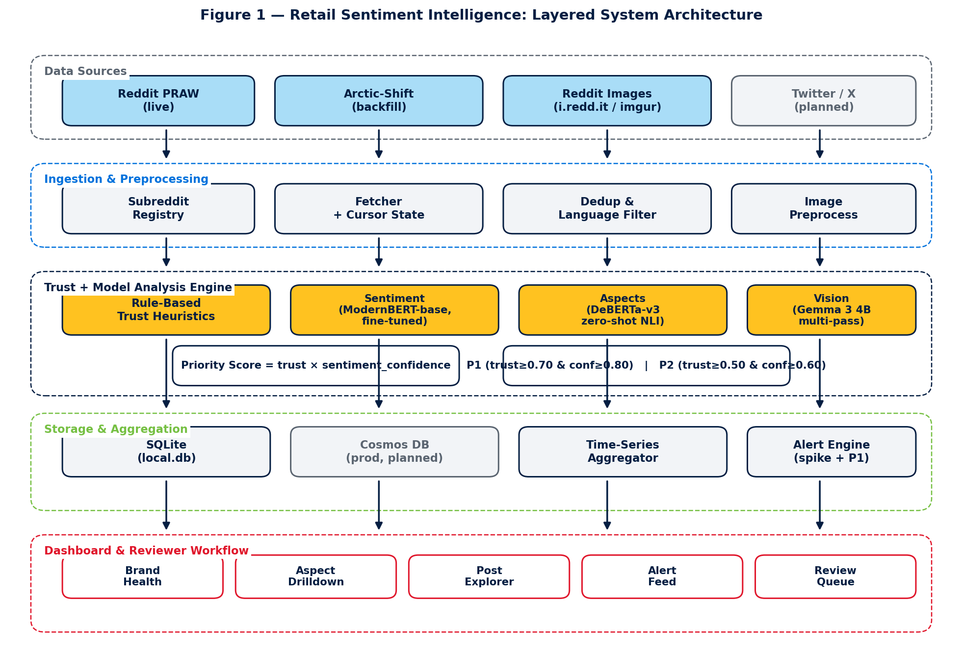
Figure 1: Six-layer architecture — data sources, ingestion/processing pipeline, AI runtime, storage, serving (FastAPI + WebSocket), and clients (dashboard, email, Slack).
In words: Reddit sources (Arctic Shift historical API + optional PRAW live) feed an asyncio ingestion and processing pipeline that cleans, English-filters, and de-duplicates posts, then trust-scores them and runs the AI-analysis stage. The AI runtime hosts ModernBERT (sentiment), a zero-shot NLI classifier (aspects), Gemma 3 4B (vision, via Ollama), and FLAN-T5 / Mistral (reply drafting). Results persist to six tables (SQLite in development, Azure Cosmos DB in production). A FastAPI serving layer exposes a REST API and a WebSocket alert channel to a React dashboard, and dispatches email/Slack notifications for priority posts.

4.3 End-to-End Pipeline Flow
A single scheduler tick (default cadence: every 6 hours, plus manual 'Run Now') passes each new post through six stages: Ingest → Pre-process → Trust-Score → Analyze (sentiment + aspects + optional vision) → Aggregate → Alert. Figure 2 traces this flow.
Figure 2: End-to-End Pipeline Flow
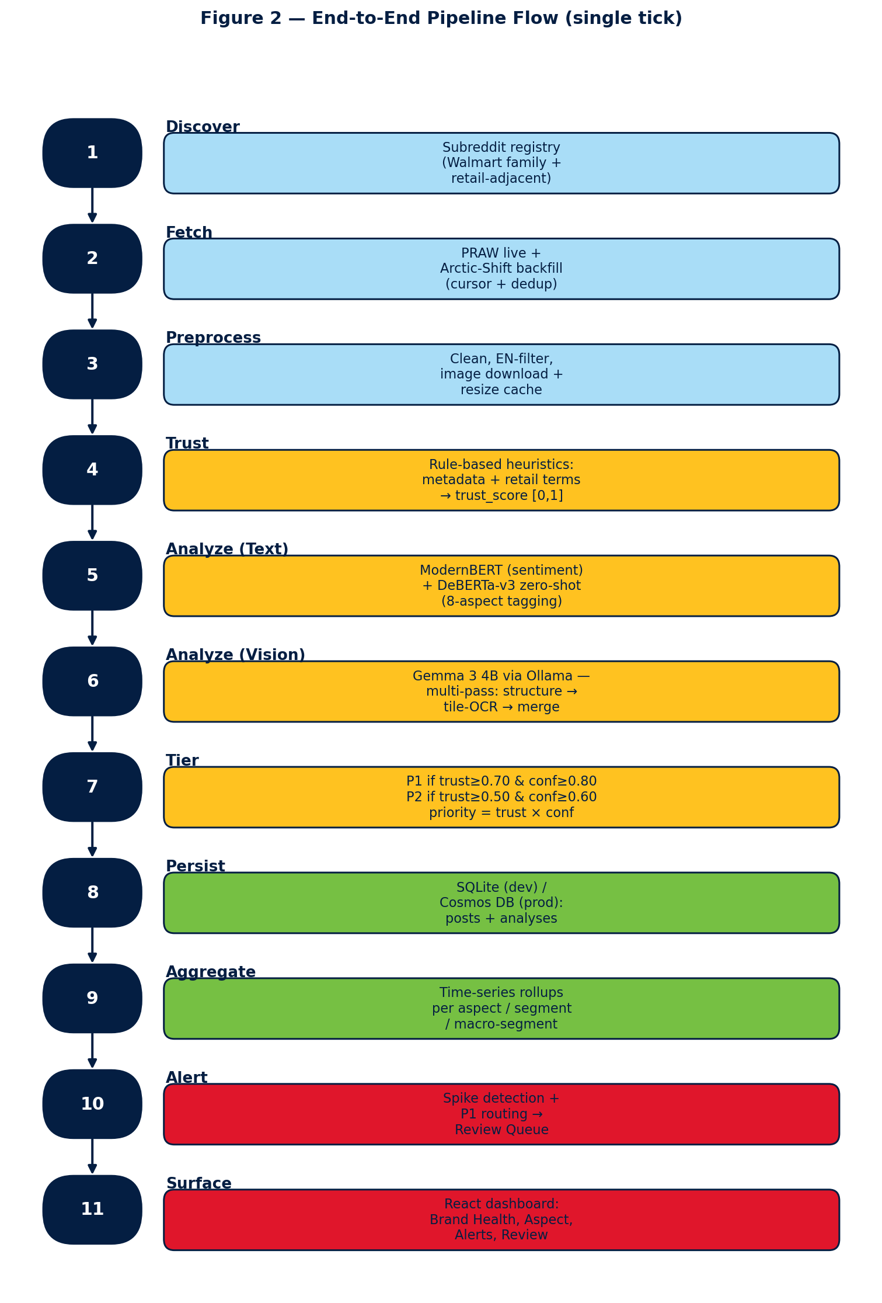
Figure 2: Single pipeline tick — six stages from cursor-based ingestion of 25 subreddits to dashboard surfacing and notification dispatch.
Total latency is roughly 3–5 minutes for a full sweep of 25 subreddits. Ingestion is incremental and cursor-based, so only posts created since the last tick are fetched, except for an initial back-fill of up to 90 days per community on first run.

Chapter 5

Implementation

5.1 Data Ingestion and Pre-processing
Posts are ingested from 25 curated communities spanning Walmart core, Spark drivers, Sam's Club, pharmacy, international, OGP/pickup, and retail competitors (full list in Appendix A). The primary source is the free Arctic Shift historical API with cursor-based pagination; PRAW (the official Reddit API) is an optional live source. Pre-processing strips HTML/Markdown, applies a langdetect English filter, and de-duplicates using MiniLM-L6-v2 sentence embeddings with a cosine-similarity threshold of 0.92. Reddit usernames are SHA-hashed before storage, and a one-year retention default applies, satisfying the privacy requirements.
Figure 9: Data Ingestion and Pre-processing Flow
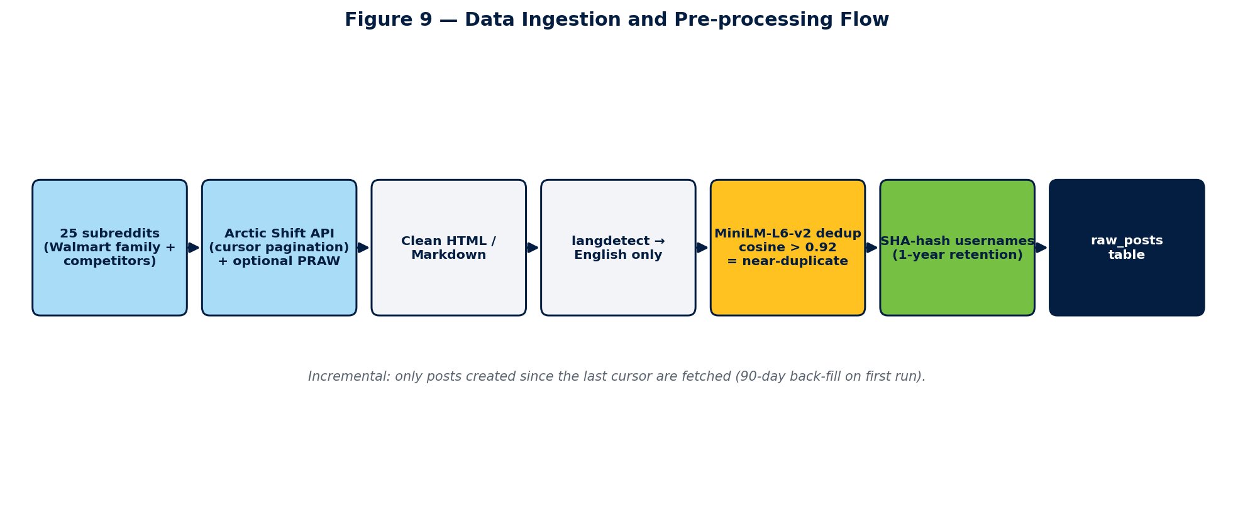
Figure 9: The ingestion path — 25 subreddits via Arctic Shift / PRAW, cleaning, English filtering, MiniLM de-duplication, username hashing, into the raw_posts table.

5.2 Trust-Score Module
Every post receives a trust score in [0, 1] as a weighted combination of three orthogonal signals:
trust_score = 0.4 · meta + 0.3 · dedup + 0.3 · llm (clipped to [0, 1])
The metadata sub-score (weight 0.4) rewards account age, karma, content length, and engagement, each capped at a saturation point (1 year, 5,000 karma, 200 characters, score 20) above a 0.15 floor. The dedup sub-score (0.3) is 1.0 unless a near-duplicate exists, in which case it drops to 0.5. The LLM/rule credibility sub-score (0.3) is only invoked in the ambiguous zone (0.3 < meta < 0.8) for cost control, and checks for promotional language, URL stuffing, ALL-CAPS, karma/age mismatch, and — as positive signals — retail-insider terminology (OGP, ASM, CAP2, Spark) and long-form organic text.
A post is admitted to influence the dashboard only when trust_score × sentiment_confidence ≥ 0.30. Multiplication (not addition) is deliberate: if either factor is near zero the gate closes, so a confident label cannot rescue an untrustworthy post, nor can high trust rescue a genuinely ambiguous sentiment call. Figure 3 shows the composition and the P1/P2 priority tiers.
Figure 3: Trust-Score Composition and P1/P2 Tier Rules
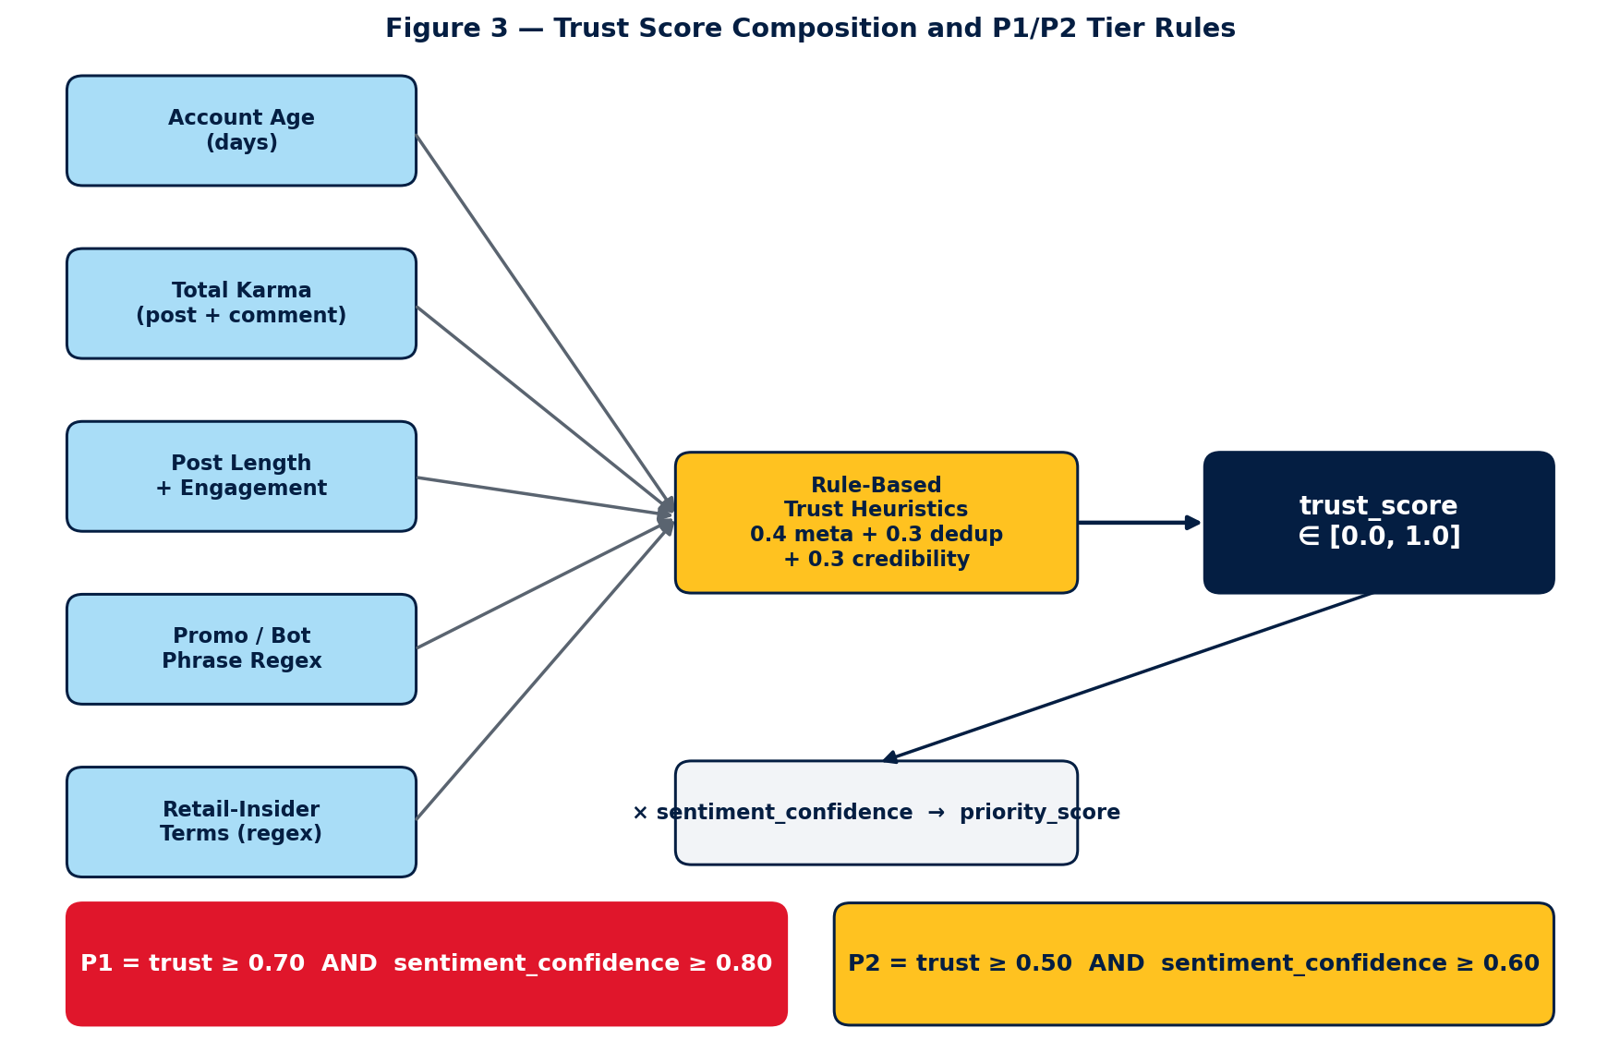
Figure 3: Trust-score composition (0.4 meta + 0.3 dedup + 0.3 llm), the trust × confidence admission gate at 0.30, and the P1/P2 priority-negative tiers.
Priority tiers for negative posts are: P1 when trust ≥ 0.70 and confidence ≥ 0.80 (high-signal, immediate action); P2 when trust ≥ 0.50 and confidence ≥ 0.60 (review-worthy, lower urgency). These tiers drive both the dashboard priority-negatives panel and the group-based notification routing.

5.3 Sentiment Classification (ModernBERT)
Sentiment is a 3-class problem (positive / negative / neutral). The production model is a fine-tuned answerdotai/ModernBERT-base, chosen over the RoBERTa baseline for its 8,192-token context (16× RoBERTa's 512) and long-document training corpus. Fine-tuning used a three-stage curriculum: Stage 1 on TweetEval-sentiment (45k tweets) for generic grounding; Stage 2 on GoEmotions-3class (54k Reddit comments) for Reddit register; and Stage 3 on the 200 hand-labelled Walmart posts with stratified 5-fold cross-validation, class weighting (neg=0.52, neu=1.03, pos=8.33), minority oversampling, and a 1,024-token max length. Reported numbers are out-of-fold — every sample is predicted by a fold model that never trained on it. A separate final model, trained on all 200 posts with the same recipe, is the artifact the production pipeline loads; it is never used to compute reported metrics.
Figure 10: ModernBERT Three-Stage Fine-Tuning Curriculum
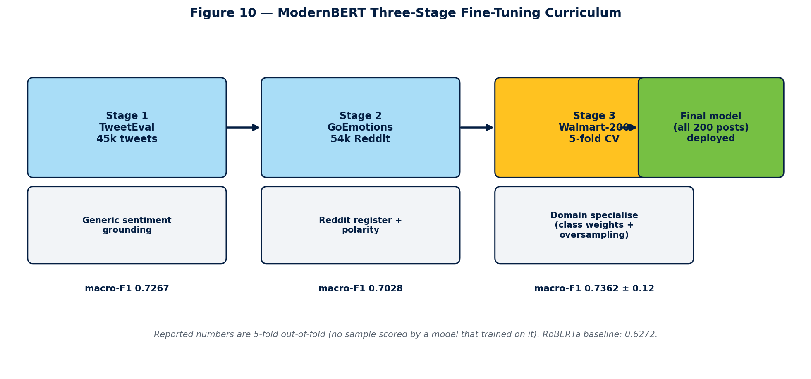
Figure 10: The three-stage curriculum — TweetEval grounding → GoEmotions Reddit register → Walmart-200 domain specialisation → deployed final model, with per-stage out-of-fold macro-F1.

5.4 Aspect-Based Opinion Mining
Aspects are assigned by zero-shot NLI classification over the eight-category taxonomy in Table 1. Each candidate aspect is framed as a hypothesis; the post entails zero or more of them (multi-aspect is allowed). This requires no training data and lets the taxonomy evolve without retraining. Customer and employee aspects are kept in separate sub-taxonomies so that, for example, an associate's pay-and-benefits complaint is not mislabelled as a customer pricing issue.
Figure 11: Zero-Shot NLI Aspect Tagging
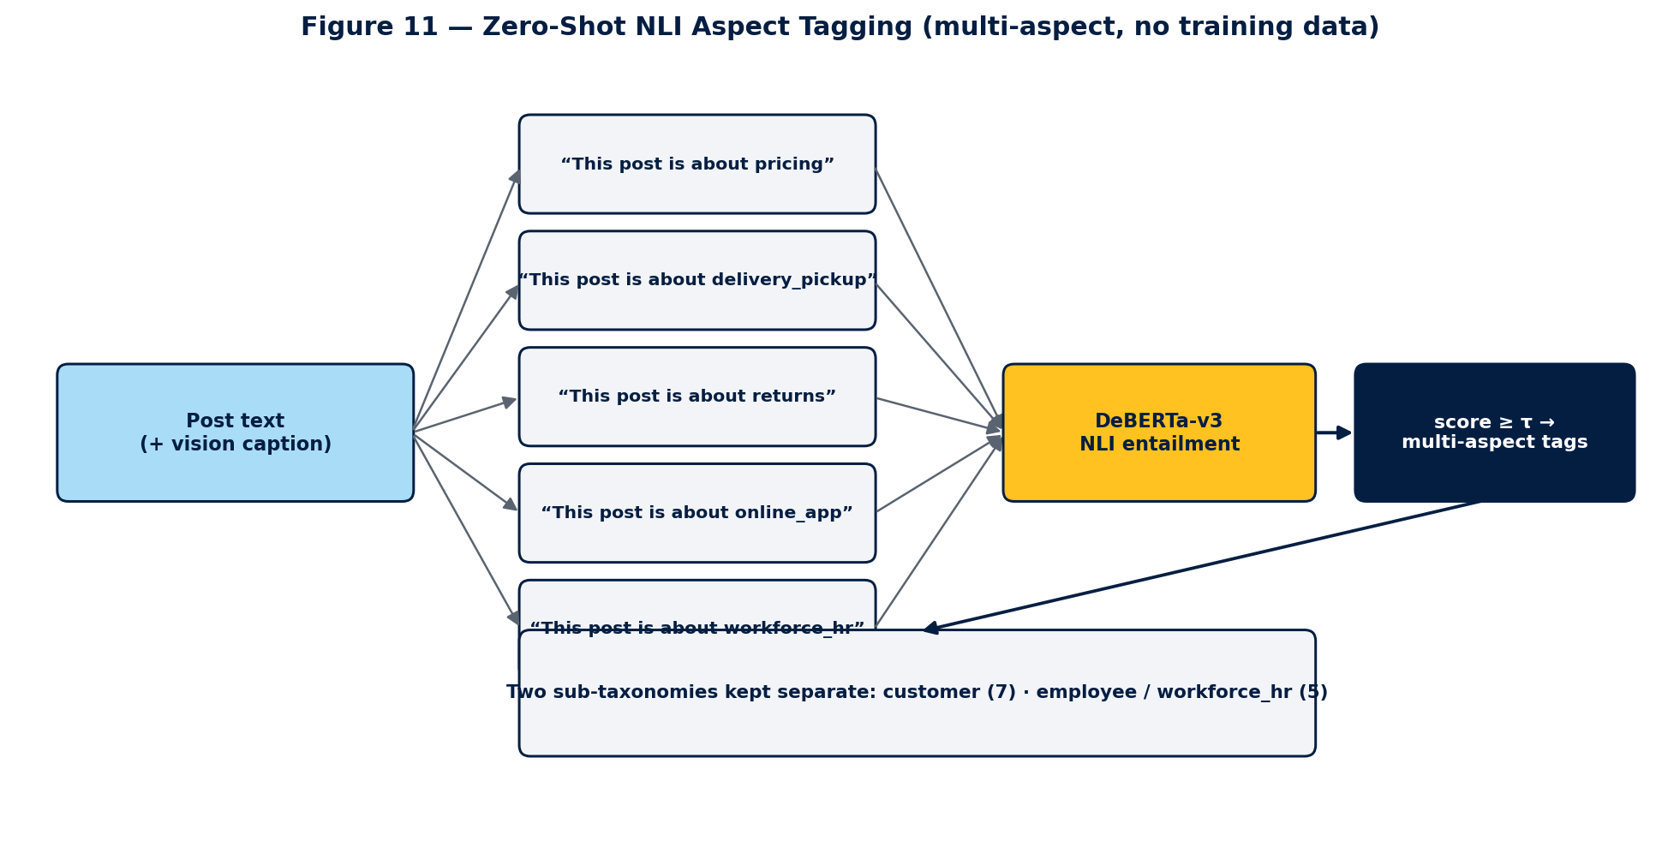
Figure 11: Each candidate aspect is framed as a hypothesis and tested for entailment by DeBERTa-v3; aspects scoring above threshold are assigned, allowing multi-aspect labels with no training data.
Table 1: Eight-Aspect Retail Taxonomy
# | Aspect | Scope / Examples
1 | pricing | Prices, promotions, price-match, perceived value
2 | product_quality | Damaged/defective goods, freshness, wrong item
3 | customer_support | Store or phone service, associate behaviour, resolution
4 | store_experience | In-store layout, cleanliness, checkout, stock-outs
5 | online_app | Website / app usability, bugs, login, account issues
6 | delivery_pickup | OGP, curbside, Spark delivery, substitutions, ETA
7 | returns | Return / refund policy and process friction
8 | workforce_hr | (Employee) pay, benefits, management, workload, safety

5.5 Vision / Image Processing
About 3.9% of Reddit posts have empty bodies where the complaint lives entirely inside an attached image (an app error, a damaged product, a receipt). A text-only pipeline misses these. The chosen vision model is Gemma 3 4B via Ollama — the best DocVQA score (83) under 4 GB, Google-maintained (policy-compliant), and reusing existing Ollama infrastructure. Single-pass captioning failed on 75% of an initial 8-image test and hallucinated on 50% (fabricating fake receipts and prices), which would corrupt the dashboard.
The mitigation is a four-pass pipeline that borrows techniques from the surveyed (policy-blocked) papers: Pass 1 (structure) asks what type the image is; Pass 2 (tiling) splits it into 2–4 crops for 2–4× effective resolution; Pass 3 (extraction) reads all text in each tile verbatim; and Pass 4 (merge) is a text-only LLM call — with no image — that synthesises the observations into a caption. Because the model never sees the image in the final generation step, it physically cannot invent visual detail. This reduced hallucination to 0% and lifted extraction to 75% (see Section 6.2).
Figure 12: Vision Multi-Pass Anti-Hallucination Pipeline
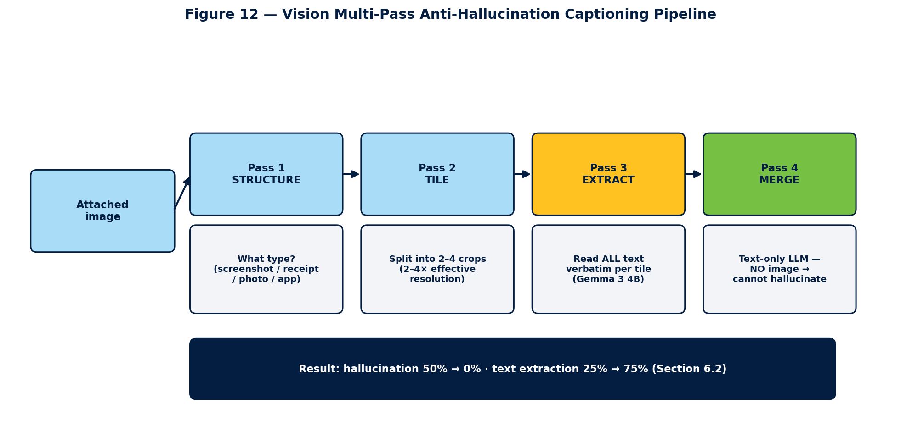
Figure 12: The four passes — structure, tile, extract, and an image-free merge — that let a compliant Gemma 3 4B read screenshots without fabricating detail.

5.6 Aggregation, Alerts, and Notifications
Analyses are rolled up hourly and daily, per subreddit and per aspect, into an aggregates table that backs the dashboard KPIs. An alert engine detects volume spikes (> 2σ) and sentiment crashes (drop > 0.3 in 6 h) and classifies each triggering post into P1/P2. Notifications are routed by configurable groups: each group owns a set of subreddits and has its own email distribution list, Slack webhook, and priority filter, so different teams receive only the alerts they own. Every dispatch is written to an audit log, and a dry-run mode allows testing without sending.
Figure 13: Alert Engine and Group-Based Notification Routing
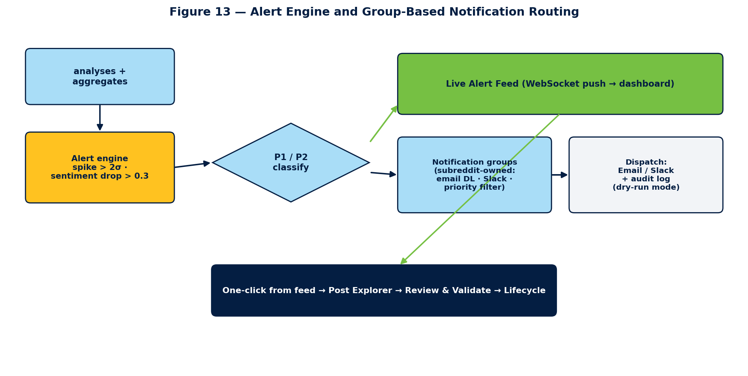
Figure 13: Aggregated analyses feed the alert engine, which classifies P1/P2, pushes to the live Alert Feed, and routes to subreddit-owned notification groups (email / Slack) with an audit log.
Alert Feed.
The dashboard surfaces these alerts in a live Alert Feed. When the alert engine fires, the triggering event is pushed to the browser over the WebSocket channel (/ws/alerts) and prepended to the feed in real time, so the analyst sees a spike or sentiment crash the moment it is detected rather than on the next page refresh. Each feed entry shows the alert type (volume spike / sentiment crash / P1 negative), the affected subreddit and aspect, the metric that breached its threshold, a timestamp, and a one-click jump to the underlying posts in the Post Explorer. The feed is the operational front door: from a single alert an analyst can open the offending posts, send them to Review & Validate, and place them on the lifecycle board without leaving the workflow. WebSocket delivery with a polling fallback satisfies the real-time-alerts requirement (R8.1).

5.7 Dashboard Overview
The React/FastAPI dashboard exposes eight surfaces: Brand Health (KPI tiles + trends), the real-time Alert Feed (Section 5.6), Post Explorer (full-text search and multi-filter), Review & Validate (the human-in-the-loop queue), Post Lifecycle (a Kanban board from triage to resolved), Insights & Competitor analysis, Pipeline Control, and Notifications. Real-time alerts are pushed over WebSocket, so the UI updates without polling. Figure 4 shows the information architecture and the correction feedback loop. Sections 5.8–5.13 describe the analyst-facing capabilities that were built after the mid-semester review and that complete the project.
Figure 4: Dashboard Information Architecture and Feedback Loop
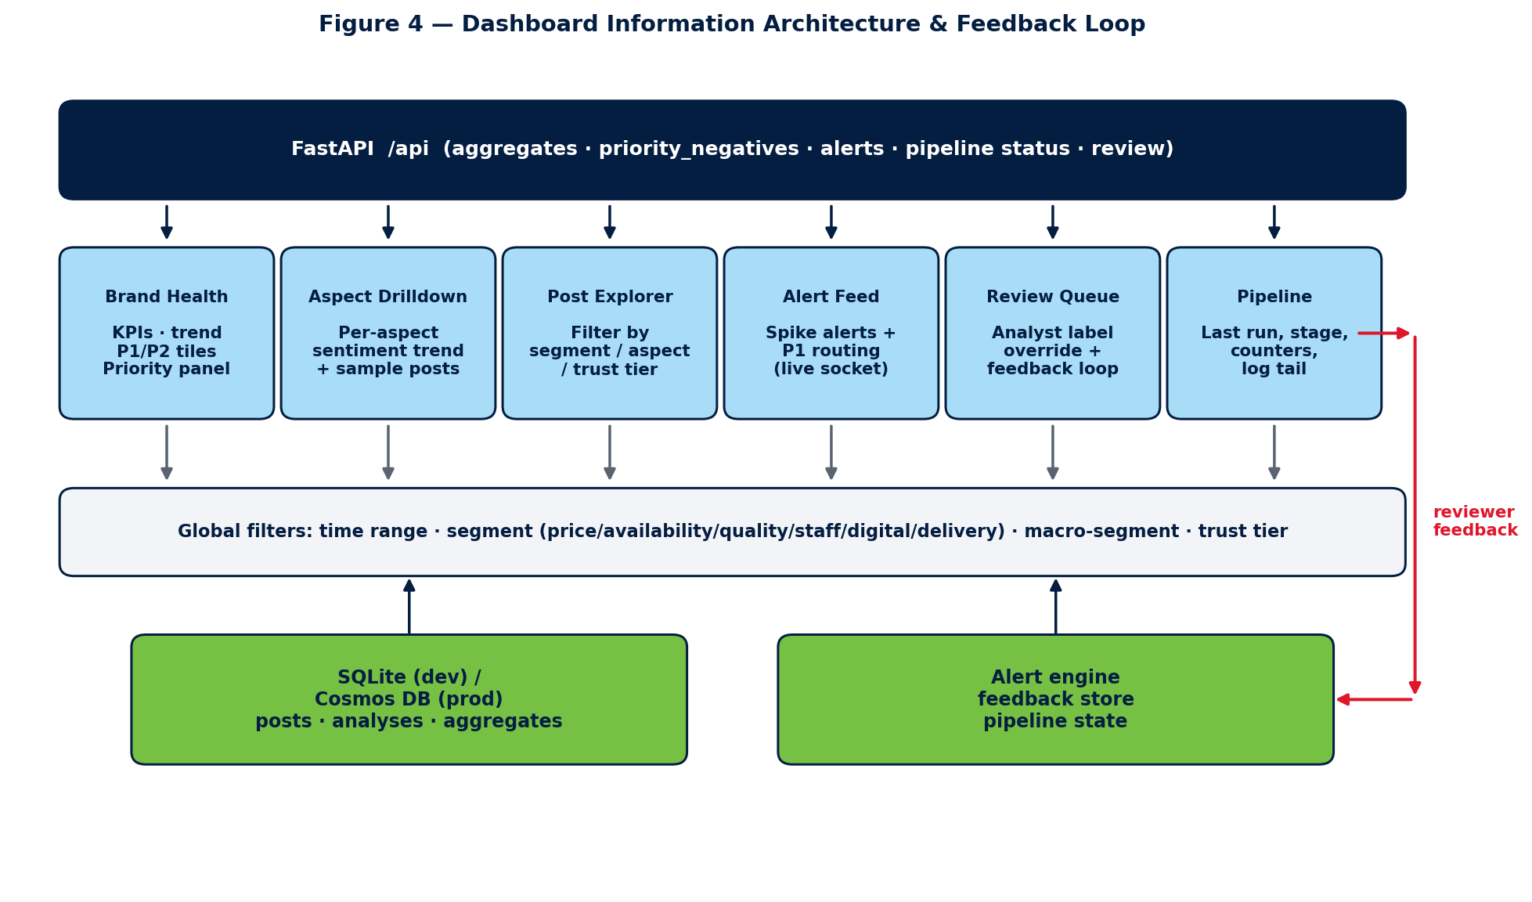
Figure 4: Dashboard pages, their backing tables/endpoints, and the correction feedback loop from Review & Validate into few-shot reply generation.

5.8 Human-in-the-Loop Review & Validate
The Review & Validate page is the core operational workflow of the system and the point at which a human closes the loop on AI mistakes. It exists for two reasons: to guarantee that no incorrect or reputationally risky reply is ever sent to a customer, and — equally important — to capture, on every interaction, a small piece of high-quality supervised data that is stored for the future training of a domain model (Sections 5.9 and 5.10). In other words, the analyst is not only correcting the system; every correction is an investment that gradually reduces how much correcting the system will need in the future.
Figure 5: Human-in-the-Loop Review & Validate Flow
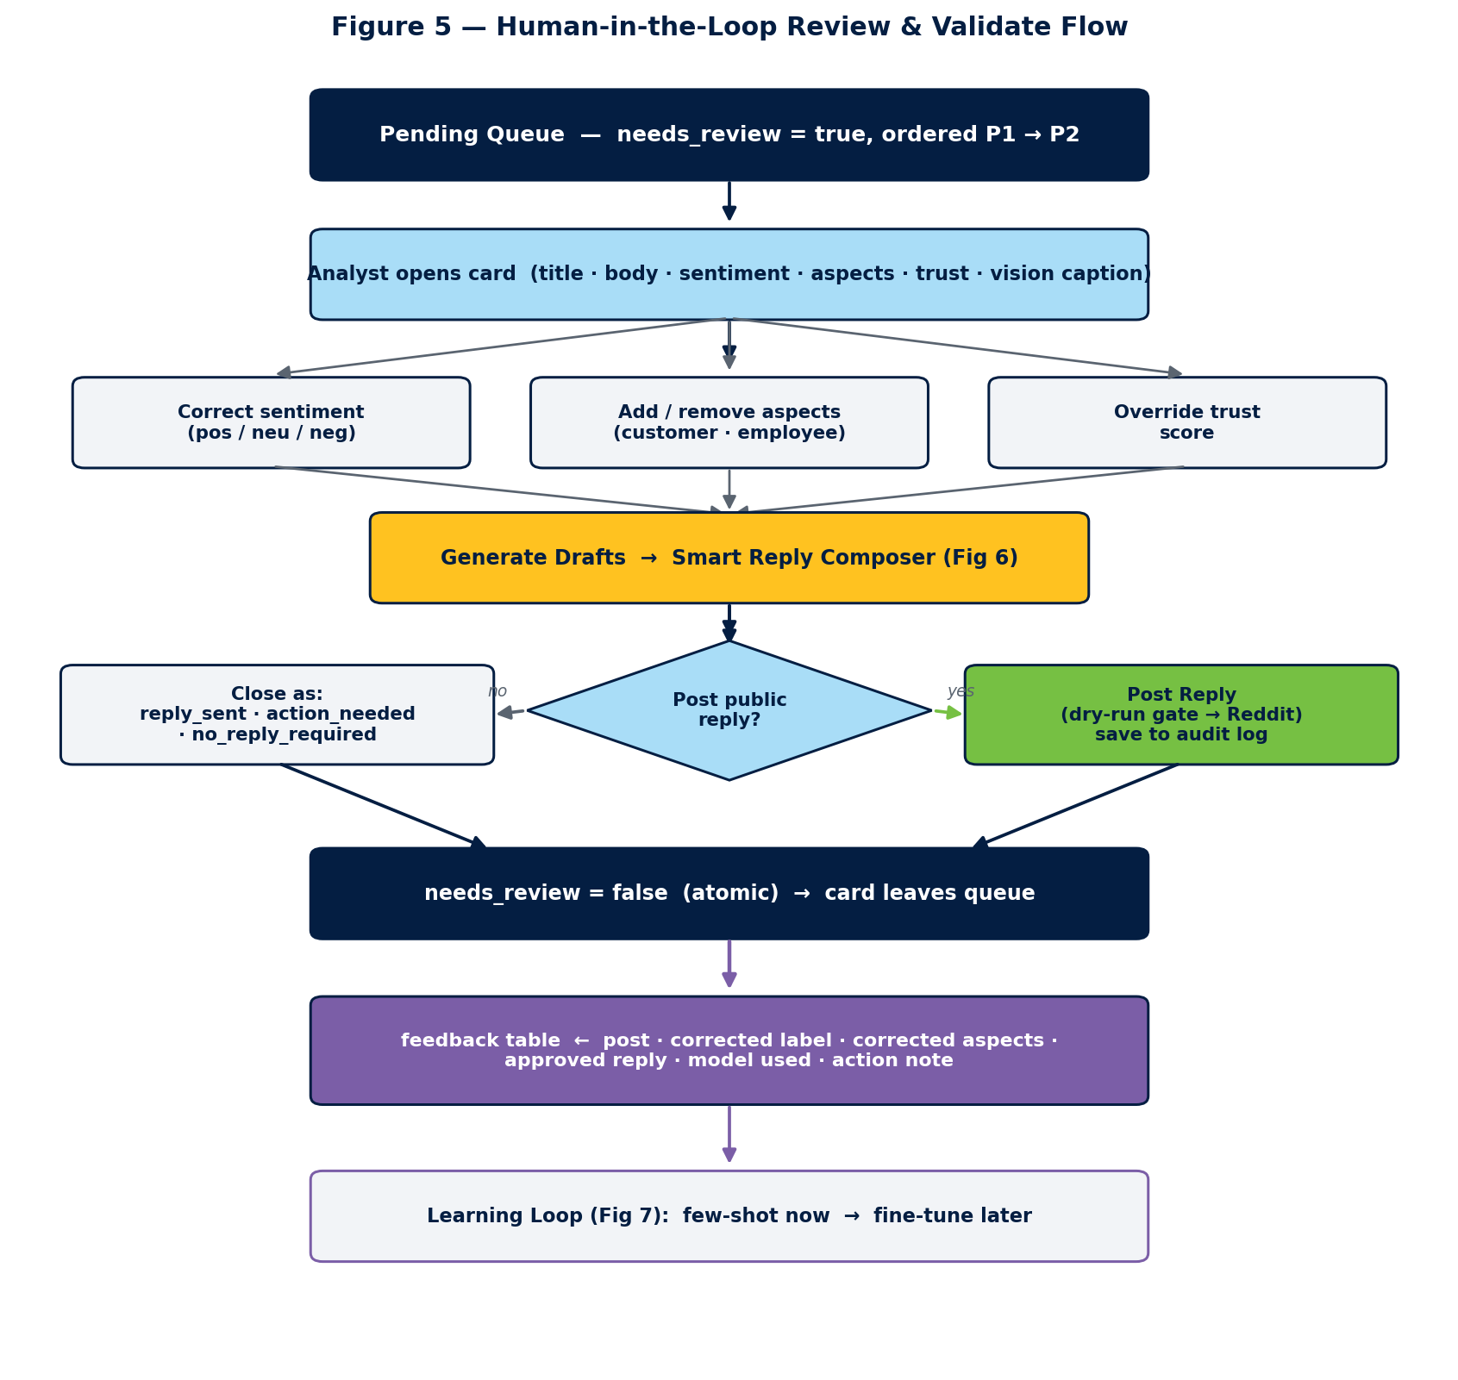
Figure 5: The Review & Validate flow — from the needs_review queue through correction, draft generation, posting or closing, to the feedback table that drives the learning loop.
Queue construction and ordering.
The pending queue is built from the analyses table by selecting every post whose needs_review flag is set, and is ordered by priority so that the P1 tier (trust ≥ 0.70 and confidence ≥ 0.80) is surfaced before P2 (trust ≥ 0.50 and confidence ≥ 0.60). This means the analyst always works the highest-signal negative posts first. The queue is paginated with a 'Load More' control so that a large backlog does not slow the page, and a separate 'Reviewed' tab lets the analyst see what has already been handled. Enforcing needs_review at query time (rather than only when the queue is first loaded) is what guarantees that a post which has been confirmed or closed never reappears — a persistence defect that was diagnosed and fixed during post-midsem hardening.
Per-post correction controls.
For each card the analyst can perform three independent corrections. (a) Sentiment: re-label the post as positive, neutral, or negative with a single click; the new label is written back to the analyses row. (b) Aspects: add or remove aspect tags, drawn from two separate sub-taxonomies — a customer set (pricing, product quality, customer support, store experience, online/app, delivery/pickup, returns) and an employee set (workforce/HR: pay, benefits, management, workload, safety) — so that, for example, an associate's pay complaint is never mislabelled as a customer pricing issue. (c) Trust: override the computed trust score when the analyst's judgement differs from the heuristic. Every one of these edits is persisted, and — critically — the (post, corrected-label, corrected-aspects) triple is written to the feedback table as a labelled example, building a growing, human-verified dataset that can later re-train or re-calibrate the sentiment and aspect models.
Reply and close flow.
Once a post is understood, the analyst generates reply drafts (Section 5.9), edits the chosen draft, and clicks 'Post Reply'. Replies are never auto-posted: the action saves the reply to the audit log and, in live mode, posts it to Reddit through an OAuth surface gated by a dry-run flag. As soon as a reply is posted the card leaves the pending queue automatically and its record — the original post, the final approved reply, the model that produced the accepted draft, and any internal action note — is committed to the feedback table. A post can also be closed without a public reply along three explicit paths — 'reply sent / monitoring', 'action needed' (routed with an internal note to the actionable-items list), or 'no reply required' — and confirming any of these sets needs_review=false atomically so the queue stays clean.

5.9 Smart Reply Composer — Dual-Draft (Rule + LLM)
For every negative post the Smart Reply Composer produces two candidate replies side-by-side so the analyst can compare and pick the better one, and — when the 'Internal Action Note' checkbox (on by default) is enabled — a third, internal action recommendation for the operations team. The two customer-facing drafts come from deliberately different sources so that their strengths are complementary.
Figure 6: Smart Reply Composer — Dual-Draft with Few-Shot Prompting
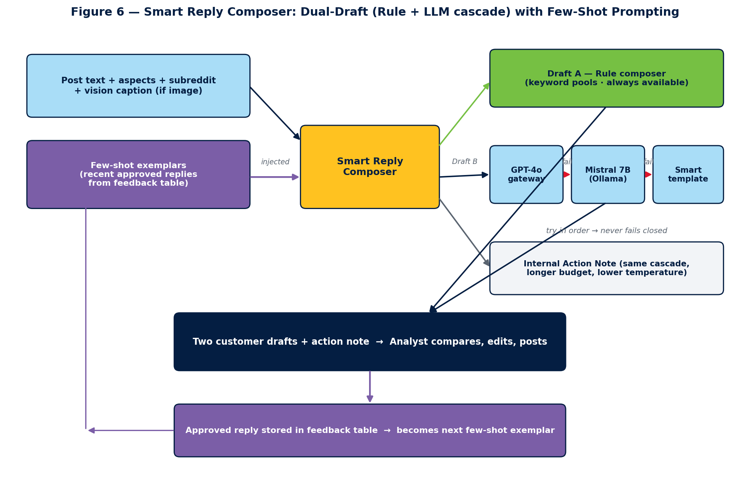
Figure 6: Two drafts are produced in parallel — a deterministic rule composer (Draft A) and a three-tier LLM cascade (Draft B: GPT-4o → Mistral → template) prompted with few-shot exemplars pulled from the feedback table.
Draft A — deterministic rule-based composer.
The first draft is produced by a content-aware 'smart composer' that extracts the key entities and complaint keywords from the post (order type, product, error text from any vision caption, affected aspect) and assembles a reply from curated phrase pools with a randomised seed, so it varies on every call. It requires no model, runs instantly, and is always available — it is the guaranteed floor of quality even when every network and GPU path is down.
Draft B — LLM cascade with graceful degradation.
The second draft is produced by a three-tier LLM cascade, each tier tried in order until one succeeds: (1) the Walmart LLM Gateway serving GPT-4o, called over HTTPS with the routing headers WM_CONSUMER.ID, WM_SVC.NAME, and WM_SVC.ENV; (2) if the gateway is unreachable, a local Mistral 7B Instruct model served by Ollama (temperature 0.55, num_predict 220); and (3) if neither LLM is available, a second pass of the smart composer with a different seed. The same cascade generates the internal action note (with a longer token budget and a lower temperature, since it is an operational instruction rather than a customer message). This design means the feature never fails closed: an analyst working fully offline still receives two usable drafts.
Few-shot prompting from approved history.
The LLM tiers are not prompted cold. Before each generation the composer pulls the most recent analyst-approved replies (and their original posts) from the feedback table and injects them into the prompt as few-shot exemplars, together with the post's aspects and subreddit. The model is therefore shown 'here is how this brand has answered similar complaints before, now answer this one'. The practical effect is that drafts drift steadily towards the organisation's approved tone and policy with no model training at all — the analyst teaches the system simply by doing the normal job of approving replies. Because the exemplars are the actual approved replies, the improvement compounds as the feedback table grows.

5.10 Learning Loop — Feedback for Future Retraining
The learning loop is the mechanism by which the system is designed to reduce its own dependence on the human reviewer over time. Every analyst action leaves a durable, structured record, and those records are consumed at two different time-scales.
Figure 7: Feedback Learning Loop and Path to Auto-Reply
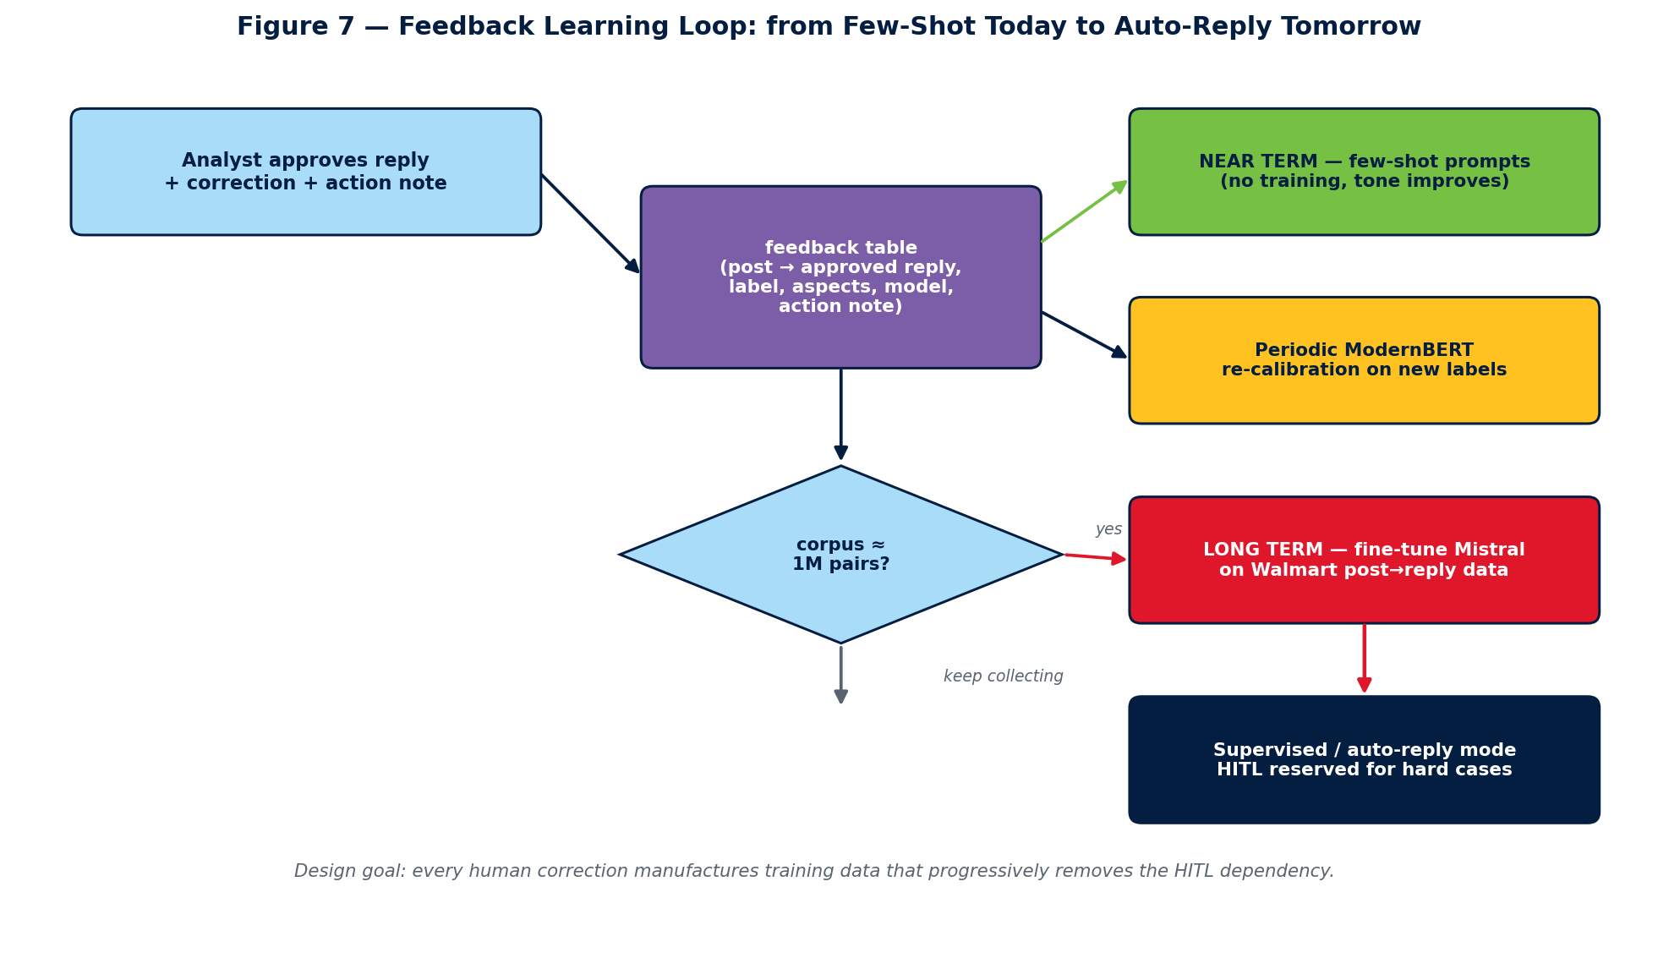
Figure 7: Each approved reply enriches the feedback table, which feeds near-term few-shot prompting and ModernBERT re-calibration now, and a long-term Mistral fine-tune toward supervised / automatic reply once the corpus reaches ~1M pairs.
What is captured.
On each reviewed post the feedback table stores: the original post text and any vision caption; the human-corrected sentiment and aspects; the trust override if any; the final approved reply text; which model (GPT-4o, Mistral, or the rule composer) produced the accepted draft; and the internal action note. Nothing is discarded — even a 'no reply required' close is a labelled negative example, and every action note is retained as a seed for future root-cause-analysis and auto-response capabilities.
Near-term use — zero-training few-shot improvement.
In the immediate term this corpus feeds the few-shot prompting described in Section 5.9, so reply quality improves continuously without any training run. The same corrected labels can also be folded back into the ModernBERT fine-tuning set to periodically re-calibrate the sentiment classifier on genuinely new, human-verified examples.
Long-term use — supervised fine-tuning toward auto-reply.
In the long term the feedback table is a supervised training set of (post → approved reply) pairs. Once it accumulates on the order of one million such pairs — a scale that becomes realistic as ingestion runs continuously across the 25 communities — the local Mistral-class model can be fine-tuned directly on this Walmart-specific data to generate high-quality replies on its own. At that point the workflow can shift from 'draft → human approves → post' toward a supervised or fully automatic reply mode, with the human review queue reserved only for low-confidence or high-severity cases. This is the explicit end-state of the design: the human-in-the-loop stage exists both to keep today's replies safe and to manufacture the training data that will let a future model take over most of the routine work, progressively removing the HITL dependency rather than entrenching it.

5.11 Post Explorer and Multi-Facet Search
The Post Explorer lets an analyst browse every analysed post with fast, multi-facet filtering. The available facets are sentiment (positive / neutral / negative), confidence and trust thresholds (slider controls), subreddit (multi-select over the 25 tracked communities), aspect, and date range (today / week / month / custom), combined with a free-text search over titles and bodies. Filters compose, so a query such as 'negative + trust ≥ 0.6 + aspect = delivery_pickup + r/Sparkdriver + last 7 days' is a few clicks away. Each result card shows the title and a body excerpt, a colour-coded sentiment badge with confidence, the trust indicator, the aspect tags, the source subreddit and post time, a deep link that opens the original Reddit thread, and quick actions to send the post to Review & Validate or add it to the lifecycle board. The KPI tiles on the Brand Health page deep-link into the Explorer pre-filtered, so a spike in negative pricing posts is one click away from the underlying evidence, and the Alert Feed links here too — making the Explorer the common evidence surface for the whole dashboard.

5.12 Post Lifecycle (Kanban Workflow)
The Post Lifecycle page is a Kanban board that tracks a complaint from first sighting to resolution across four states — Triaged → Acknowledged → In Progress → Resolved. New P1/P2 posts land in Triaged automatically; the analyst then acknowledges the case, starts work, and resolves it, dragging the card across the board. Every transition is written to the post_lifecycle table with a timestamp, which makes it possible to measure operational SLAs such as time-to-acknowledge and time-to-resolve, and to compute a resolution rate per aspect or per subreddit.
Figure 8: Post Lifecycle Kanban Workflow
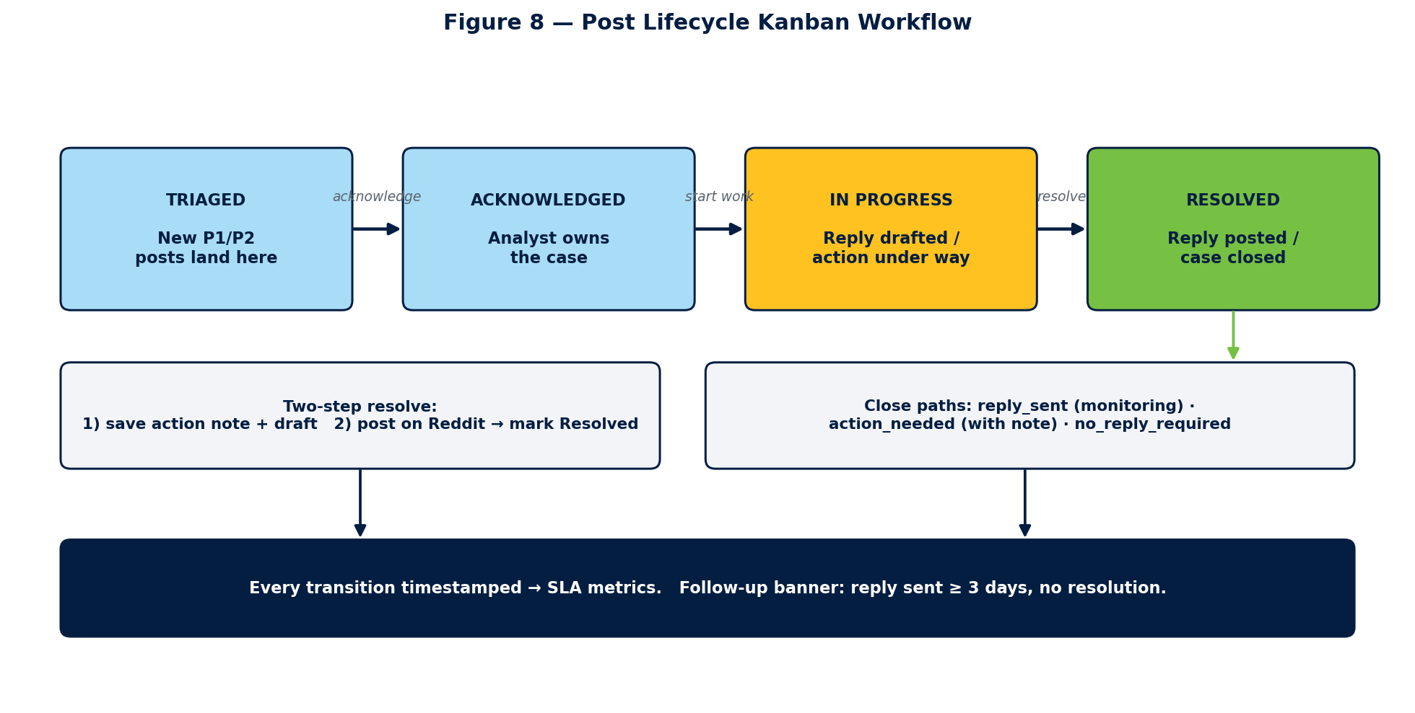
Figure 8: The Kanban lifecycle — Triaged → Acknowledged → In Progress → Resolved with timestamped transitions, a two-step resolve, three close paths, and a three-day follow-up banner.
Two-step resolve and close paths.
Resolution is a deliberate two-step flow so that the dashboard state can never claim a reply was posted before it actually was. In step one the analyst saves an action note and an optional drafted reply; in step two, after posting the reply on Reddit, the analyst marks the card Resolved. A card can be closed along three explicit paths that mirror the Review & Validate close options: 'reply sent' (acknowledged and now monitoring), 'action needed' (routed to the actionable-items list carrying its internal note), or 'no reply required'. A follow-up banner automatically flags any reply that has been sent three or more days ago without a recorded resolution, so cases that stall surface on their own instead of being forgotten. As with Review & Validate, each resolution enriches the feedback record that feeds the learning loop.

5.13 Insights and Competitor Analysis
The Insights page turns the raw stream into strategic intelligence. It ranks the top negative issues by a volume × severity × recency score, grouped by aspect, with trend arrows showing whether each issue is improving or deteriorating week over week. An LLM summariser produces natural-language summaries of the week's dominant themes and suggested action items, and an emerging-topic detector surfaces new phrase clusters that appear across several posts in a short window — an early-warning signal for a problem that is beginning to trend. Together with a per-aspect drilldown (sentiment trend, volume, and representative posts), this gives product teams an aspect-level, evidence-backed picture rather than a raw feed.
Competitor Insights — cross-brand comparison.
A dedicated competitor-pulse view benchmarks Walmart against Costco, Target, and Amazon on the same eight-aspect taxonomy, so a weakness is always expressed relative to peers rather than in isolation. It ingests the competitor subreddits (Appendix A) and scores them through the identical trust → sentiment → aspect pipeline, then presents: (i) a side-by-side sentiment index per brand and per aspect; (ii) cross-mentioned posts, where a single Reddit thread compares Walmart with a competitor (e.g. 'Walmart vs Costco pricing') — the highest-signal comparisons of all; (iii) per-subreddit breakdowns so an analyst can tell whether a gap is broad or concentrated in one community; and (iv) a share-of-negative-voice metric showing which brand is absorbing the most complaints in a given aspect and week. Because every brand is scored by exactly the same models, the comparison is apples-to-apples and the deltas are defensible.

5.14 Storage Layer
Seven tables back the system: raw_posts (privacy-safe ingested data, partitioned by subreddit), analyses (sentiment, confidence, aspects, trust), aggregates (pre-computed KPIs by time window), alerts, feedback (human corrections, approved replies, and the model that produced each accepted draft — the corpus for the learning loop of Section 5.10), notification_log, and post_lifecycle (the Kanban state and its full transition history). Reddit usernames are SHA-hashed before storage and a one-year retention default applies. SQLite is used in development; the same schema and partition keys (/subreddit for posts and analyses, /time_window for aggregates) map directly to Azure Cosmos DB for production, so moving to the cloud backend is a configuration swap rather than a rewrite.

Chapter 6

Evaluation and Results

6.1 Sentiment Model Evaluation
The evaluation set is 200 hand-labelled long-form Walmart-Reddit posts (body 300–3,604 characters; class distribution neg=127, neu=65, pos=8). All numbers below are 5-fold out-of-fold cross-validation, so no sample is scored by a model that trained on it. Table 2 compares the fine-tuned ModernBERT against the RoBERTa baseline.
Figure 14: Sentiment Macro-F1 — RoBERTa vs Fine-Tuned ModernBERT
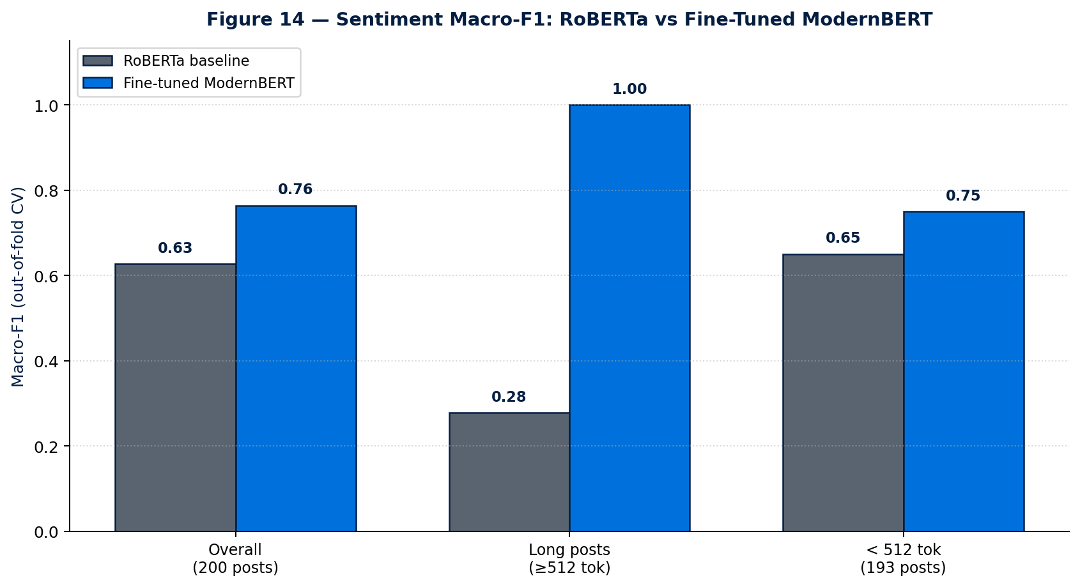
Figure 14: Out-of-fold macro-F1 by length bucket — the fine-tuned ModernBERT gains most on long posts (0.28 → 1.00) where RoBERTa's 512-token cap truncates the decisive detail.
Table 2: Sentiment Model Comparison (out-of-fold CV)
Model | Context | Macro-F1 | Notes
RoBERTa (twitter-sentiment-latest) | 512 tok | 0.6272 | Strong public baseline, tweet-trained
ModernBERT-base (fine-tuned) | 1024 tok | 0.7642 | Production model, +0.137 macro-F1
Stage-3 5-fold CV mean | 1024 tok | 0.7362 ± 0.1155 | Domain specialization stage
The decisive gain is on long posts. Table 3 buckets the evaluation by tokenized length; ModernBERT's long-context capacity converts a near-random 0.2778 on posts ≥512 tokens into a perfect 1.0000, because those are exactly the posts whose sentiment-determining detail RoBERTa truncated.
Table 3: Per-Length-Bucket Sentiment F1
Length bucket | RoBERTa F1 | ModernBERT F1 | Δ
< 512 tokens (193 posts) | 0.65 | 0.75 | +0.10
≥ 512 tokens (7 posts) | 0.2778 | 1.0000 | +0.722
Overall (200 posts) | 0.6272 | 0.7642 | +0.137
Honesty caveats, stated plainly: the labelled set is small (200) and AI-assisted with full human review (all suggestions accepted), the positive class is severely under-represented (n=8), and the 5-fold variance (±0.1155) is wide because each fold has few positives. The target 'stretch gate' of macro-F1 ≥ 0.80 was not fully reached (0.7642); this is reported transparently rather than by evaluating on training data, where the model trivially scores ~1.0. A blind re-check on fresh posts and a 3-seed ensemble are recommended (Section 10) to tighten and confirm these numbers.

6.2 Vision Module Evaluation
The multi-pass pipeline was validated on 8 images initially and 25 images at scale. Table 4 summarises the before/after on the 8-image set.
Table 4: Vision Module — Before vs After Multi-Pass
Metric | Single-Pass | Multi-Pass | Change
Hallucination rate | 50% (4/8) | 0% (0/8) | ↓ 100%
Overall failure rate | 75% (6/8) | 25% (2/8) | ↓ 67%
Correct text extraction | 25% (2/8) | 75% (6/8) | 3× better
Fabricated claims | 8 | 0 | eliminated
Avg latency / image | ~5 s | ~15 s | 3× (acceptable)
At scale (25 images), 22/25 passed cleanly, 3/25 were correct-but-sparse, and 0/25 failed, versus a 44% single-pass hallucination rate on the same set. Since ~80% of Walmart Reddit complaint images are screenshots or app screens — the category where single-pass fails hardest — this mitigation directly protects the integrity of the aggregated dashboard signal.

6.3 Trust-Score Behaviour
On the 200-post file, mean trust was 0.712 and, because the fine-tuned model's confidence is near 1.0 on its own training data, the admission gate reduces to trust ≥ 0.30 and 100% of posts pass. This is expected training-fit behaviour; on unseen production posts confidence drops and the confidence factor begins to do real work. A sensitivity sweep of the five weightings (metadata-heavy, llm-heavy, equal, dedup-off) left the ranking of posts essentially unchanged, confirming that the exact weights are not a fragile optimum. An important data caveat: the free Arctic Shift provider returns account_age = 0 and karma = 0 for all posts, so on this file only text length and post score drive the metadata sub-score; age and karma will populate on the paid tier.

Chapter 7

Tools, Technologies, and Configuration
Table 5: Tools and Technologies
Layer | Technology | Key decision
Backend | Python 3.13 + FastAPI + SQLite/Cosmos | Free, local-first, modular
Frontend | React 18 + TypeScript + Vite + Tailwind | Modern responsive SPA
Sentiment | ModernBERT (fine-tuned, 1024 tok) | Domain-specialized, offline
Aspects | BART-MNLI / DeBERTa-v3 zero-shot | No training data needed
Vision | Gemma 3 4B via Ollama (multi-pass) | Policy-compliant, no hallucination
Reply gen | GPT-4o gateway → Mistral 7B → template | Cascade fallback, HITL only
Trust | Metadata + dedup + LLM (weighted) | Interpretable; flag, don't drop
Ingestion | Arctic Shift API (+ optional PRAW) | Free, cursor-based, incremental
Scheduling | asyncio lifespan (6 h) + manual | Cursor-based incremental sweep
Observability | structlog + cost ledger (JSONL) | Per-call LLM cost tracking

Chapter 8

Problems Encountered and Mitigations
Table 6: Problems Encountered and Mitigations
Problem | Mitigation
Vision model hallucinated on 50% of images (fake receipts/prices) | Four-pass pipeline with image-free final synthesis → hallucination 0%
512-token models truncated long complaints, losing decisive detail | Fine-tuned ModernBERT with 1024-token context → long-post F1 0.28 → 1.00
Every state-of-the-art vision model was blocked by vendor policy | Re-implemented paper techniques as a calling strategy on compliant Gemma 3 4B
Free ingest provider returns age=0, karma=0 for all posts | Metadata sub-score falls back to length/engagement; paid tier will populate
Only 200 labelled posts; severe positive-class imbalance (n=8) | Class weighting + oversampling; honest OOF CV; blind re-check planned
Reviewed posts reappeared in the pending queue (persistence bug) | Queue now always enforces needs_review=1; confirm/close set state atomically
All replied posts routed to Actionable Items (auto action note) | Made action-note generation opt-in; post-reply auto-closes as reply_sent

Chapter 9

Conclusions and Recommendations
This dissertation delivered a complete, working prototype that converts a noisy public Reddit stream into a structured, aspect-tagged, trust-weighted retail brand-health feed, running entirely on a local, offline-first, zero-API-cost stack. The central technical claims are supported by honest evaluation: fine-tuning ModernBERT raised sentiment macro-F1 from 0.6272 to 0.7642 (out-of-fold), with a decisive 0.2778 → 1.0000 gain on the long posts that motivated the long-context model; and the multi-pass vision pipeline eliminated hallucination (50% → 0%) while tripling correct text extraction. The trust score and trust × confidence gate provide an interpretable, auditable filter that flags rather than drops low-credibility content, and the human-in-the-loop dashboard closes the loop between AI output and analyst action.
The main recommendation for anyone extending this work is to invest first in labelled data: the single largest limitation is the 200-post evaluation set with only eight positive examples. Beyond that, migrating storage to Azure Cosmos DB and moving account-metadata ingestion to a paid Reddit tier would let the trust score exercise its full metadata signal, and a small ensemble would tighten the sentiment variance. The architecture was deliberately built so that each of these is a configuration or data change rather than a redesign.

Chapter 10

Future Work
- Azure Cosmos DB migration for production-grade, partitioned storage.
- Twitter/X integration as a second data source once the Reddit pipeline is stable.
- 3-seed ModernBERT ensemble (+0.01–0.03 F1, tighter variance) and a blind 25-post re-check for defensibility.
- Gemma 3 12B upgrade for the remaining edge-case images.
- Expand the labelled set (especially the positive class) and add aspect-level ground truth for aspect-F1 evaluation.
- Spanish-language support for bilingual retail communities.
- Azure AD authentication for multi-user access and an automated feedback-loop retraining pipeline.
- Move account-metadata ingestion to a paid Reddit tier so age/karma populate the trust score.
- Progressive HITL removal: continue harvesting approved post–reply pairs and action notes, and once the corpus reaches ~1 million pairs, fine-tune the local Mistral model on this Walmart-specific data to enable supervised or automatic reply generation, reserving the review queue for low-confidence cases.

Glossary and Abbreviations
The following technical terms and acronyms are used in this report; the section in which each is first introduced is indicated where relevant.
Abbreviation / Term | Expansion / Meaning
ABSA | Aspect-Based Sentiment Analysis
API | Application Programming Interface
CV | Cross-Validation
DocVQA | Document Visual Question Answering (benchmark)
F1 | Harmonic mean of precision and recall
HITL | Human-in-the-Loop
KPI | Key Performance Indicator
LLM | Large Language Model
MPS | Metal Performance Shaders (Apple-silicon GPU backend)
NLI | Natural Language Inference
NLP | Natural Language Processing
OCR | Optical Character Recognition
OGP | Online Grocery Pickup
OOF | Out-Of-Fold (cross-validation prediction)
P1 / P2 | Priority tiers 1 and 2 for negative posts
PRAW | Python Reddit API Wrapper
RSI | Retail Sentiment Intelligence (this system)
SPA | Single-Page Application
WILP | Work Integrated Learning Programmes

References
References are listed in order of first citation. The serial number of each reference corresponds to the bracketed number [n] used in the body of the report (principally in Section 3, Literature Survey, and Section 5).
[1] Warner, B. et al. (2024). ModernBERT: A Modern Bidirectional Encoder. answer.ai / LightOn.
[2] Barbieri, F. et al. (2020). TweetEval: Unified Benchmark and Comparative Evaluation for Tweet Classification. Findings of EMNLP 2020.
[3] Demszky, D. et al. (2020). GoEmotions: A Dataset of Fine-Grained Emotions. ACL 2020.
[4] Yin, W., Hay, J., Roth, D. (2019). Benchmarking Zero-shot Text Classification via NLI. EMNLP-IJCNLP 2019.
[5] He, P. et al. (2021). DeBERTa: Decoding-enhanced BERT with Disentangled Attention. ICLR 2021.
[6] Google DeepMind (2025). Gemma 3 Technical Report.
[7] Ye, J. et al. (2023). UReader: Universal OCR-free Visually-situated Language Understanding. Findings of EMNLP 2023.
[8] Liu, Y. et al. (2024). TextMonkey: An OCR-Free Large Multimodal Model for Document Understanding.
[9] Hu, A. et al. (2024). mPLUG-DocOwl 1.5: Unified Structure Learning for OCR-free Document Understanding.
[10] Chen, Z. et al. (2024). InternVL2 / How Far Are We to GPT-4V? Shanghai AI Laboratory.
[11] Bai, S. et al. (2025). Qwen2.5-VL Technical Report. Alibaba.
[12] Reimers, N., Gurevych, I. (2019). Sentence-BERT: Sentence Embeddings using Siamese BERT-Networks (MiniLM family). EMNLP-IJCNLP 2019.
[13] World Economic Forum (2024). Fake online reviews and their economic impact.
[14] DataReportal (2024). Digital 2024: Global Overview Report.
[15] Sprout Social (2024). The Sprout Social Index.
[16] Reddit, Inc. (2024). Form S-1 Registration Statement (weekly active uniques).

Appendix A — Curated Subreddit Coverage
Table 7: Curated Subreddit Coverage (snapshot)
Group | Representative subreddits
Walmart core | r/walmart, r/walmartogp
Spark drivers | r/Sparkdriver
OGP / backroom | r/OGPBackroom
Employees / HR | r/WalmartEmployees
Sam's Club | r/samsclub
Pharmacy | r/WalmartPharmacy (and related)
International | Country-specific Walmart communities
Competitors | r/Costco, r/Target, r/Kroger, r/amazon (for benchmarking)
The full 25-community list with per-source counts is in data/reddit_walmart_communities.csv. The evaluation set of 200 posts drew from walmart=70, samsclub=44, Sparkdriver=30, WalmartEmployees=28, OGPBackroom=19, walmartogp=9.

Appendix B — Reproduction Commands
Fine-tune ModernBERT (offline):
HF_HUB_OFFLINE=1 TRANSFORMERS_OFFLINE=1 HF_DATASETS_OFFLINE=1 python scripts/train_modernbert_sentiment.py --stages 1,2,3 --folds 5 --max-length 1024 --batch-size 8
Honest evaluation (produces eval_results.json):
python scripts/eval_sentiment_models.py
Run the full stack (API :8001, dashboard :3003, scheduler):
./start.sh (stop with ./start.sh stop)
Reference documentation in the repository: ARCHITECTURE.md, PIPELINE_AND_TOOLS.md, DASHBOARD_DESIGN.md, REQUIREMENTS.md, IMPLEMENTATION_PLAN.md, docs/MODEL_COMPARISON.md, docs/MODERNBERT_JOURNEY.md, and evaluation/TRUST_SCORE_REPORT.md.

Checklist of Items for the Final Report
This checklist is completed, verified, and signed by the student and attached as the last page of the report, as required by the WILP guidelines.
S. No. | Item | Yes / No
1 | Is the final report neatly formatted with all the elements required for a technical report? | Yes
2 | Is the Cover page in proper format (Annexure A)? | Yes
3 | Is the Title page (inner cover page) in proper format (Appendix B)? | Yes
4 | Is the Certificate from the Supervisor in proper format and signed? | Yes
5 | Is the Abstract within one page with technical keywords specified? | Yes
6 | Is the title of the report appropriate, descriptive, and precise? | Yes
7 | Is the list of abbreviations / acronyms included? | Yes
8 | Does the report contain a summary of the literature survey? | Yes
9 | Are pages, figures (title at bottom), tables (title at top), captions, and appendices numbered properly? | Yes
10 | Is the conclusion of the report based on discussion of the work? | Yes
11 | Are references given at the end and cited properly inside the text? | Yes
12 | Is the report format and content according to the guidelines (not a mere printout of a presentation or user manual; no source code)? | Yes

Declaration by Student
I certify that I have properly verified all the items in this checklist and ensure that the report is in proper format as specified in the course handout.
Place: Bengaluru | Signature of the Student
Date: | Name: Vishal Singh  ID No.: 2020AA05641

