**Package Distribution**

%TOC%

**Overview**

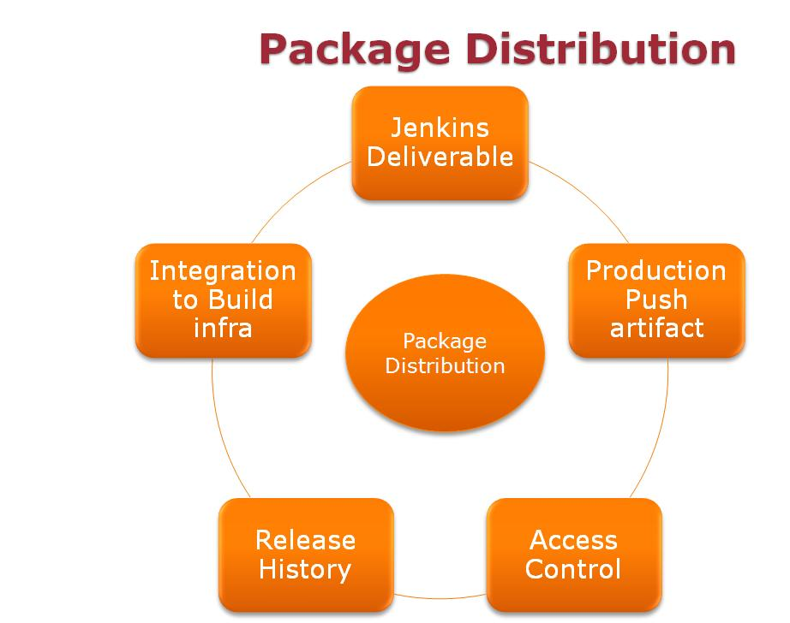

**Choices**

1. Nexus
2. Artifactory

**InMobi Use cases**

1. Deliverable/Artifact from jenkins
   1. Packages coming from jenkins in form of jar, war, zip etc.
   2. Core Features
      1. Store any type of package
      2. Act as poxy for third party jars
   3. Administration
      1. Automatic backup
      2. User inteface to manage admin activities
      3. Managing user and their roles
   4. Authentication
      1. No need to separate authentication for user to view the user dashboard and look at the repositories and download them
   5. Autorization
      1. Need separate authorization machanist for
         1. Adding artifact
         2. Deleting artifact
         3. Administration
   6. Easy onboardin
      1. Less training needed for onboarding
   7. Data Reliabilty
      1. Easy backup and restore.
      2. Ability to maintain offline repository.
   8. Data Availability
      1. High Availability for read/write access
   9. Dashboard/ UI interface
      1. User dashboard to view the repository.
      2. Service monitoring.Availability of the service
2. Production push Deliverables
   1. OS Dependent package like deb or rpm
   2. Container specific package like jar, war etc.
   3. Able to deploy with their native command.
   4. Easy roll back.

**Comparison**

%EDITTABLE{}%

|  |  |  |  |  |  |
| --- | --- | --- | --- | --- | --- |
| **Tools Vs Features** | **Easy Onboarding** | **Core Feature** | **Administration** | **Data Availability and Reliability** | **Access Control** |
| Nexus | yes | Yes | Partial | Yes | Yes |
| Artifactory | Partial | Yes | Yes | Partial | Yes |

Looking at use case, we will use Nexus as Artifact Repository.