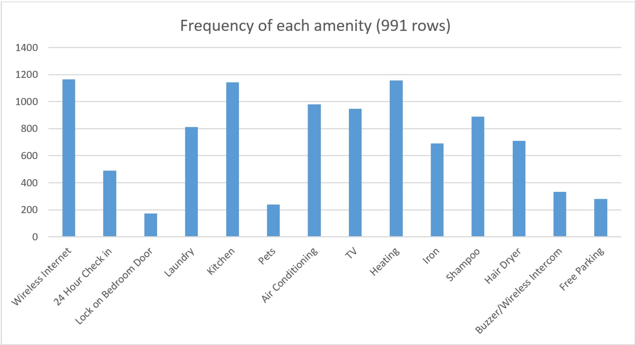

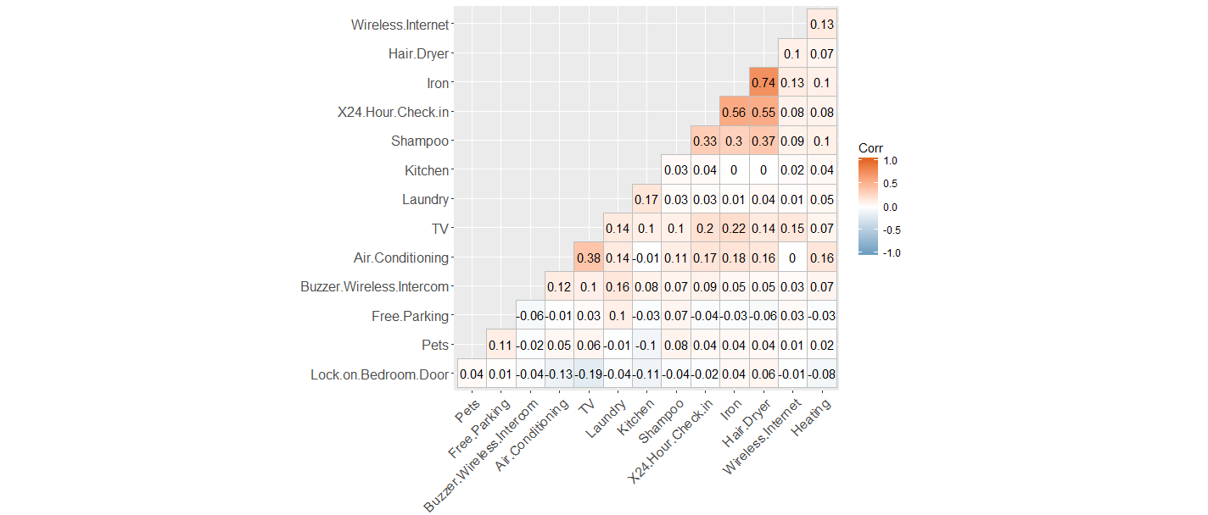

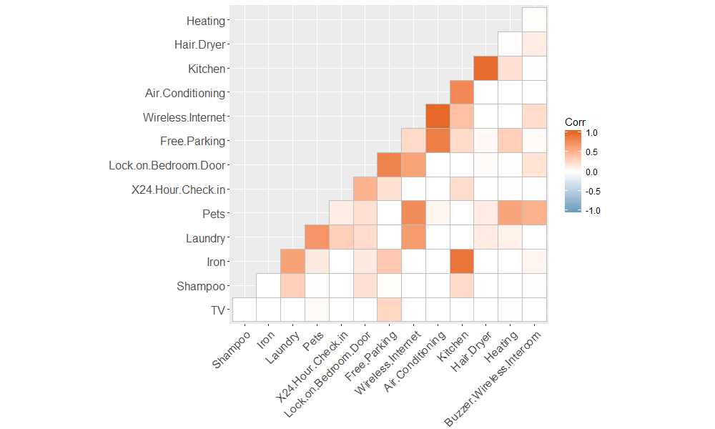

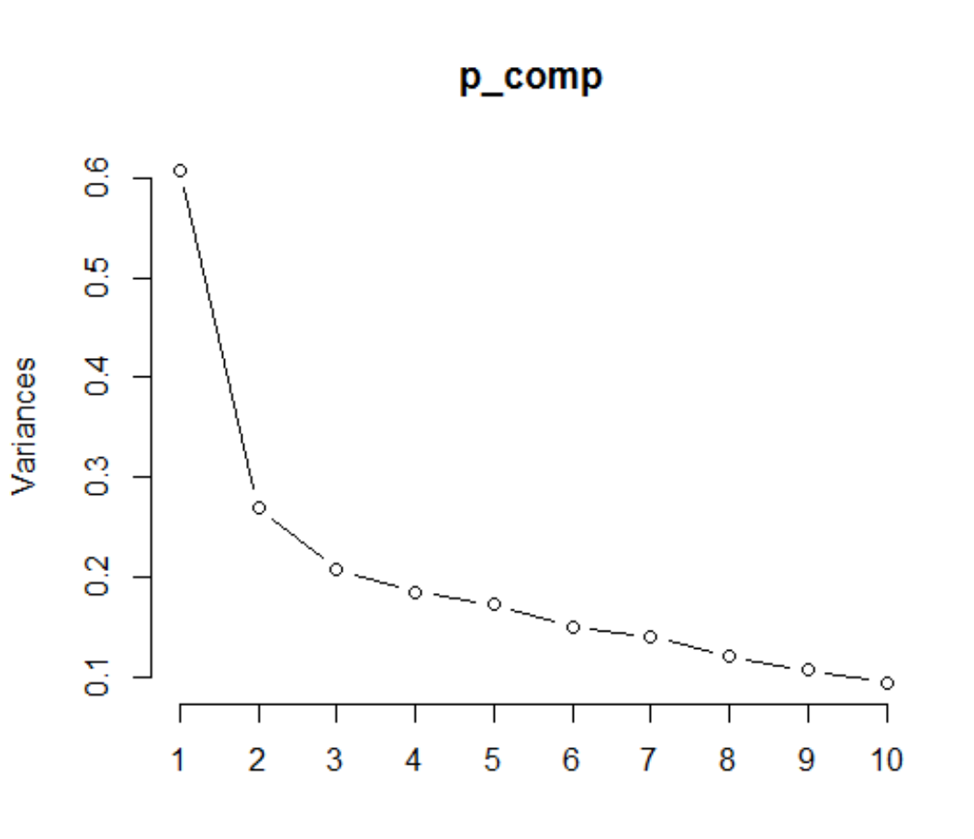

Pr_comp

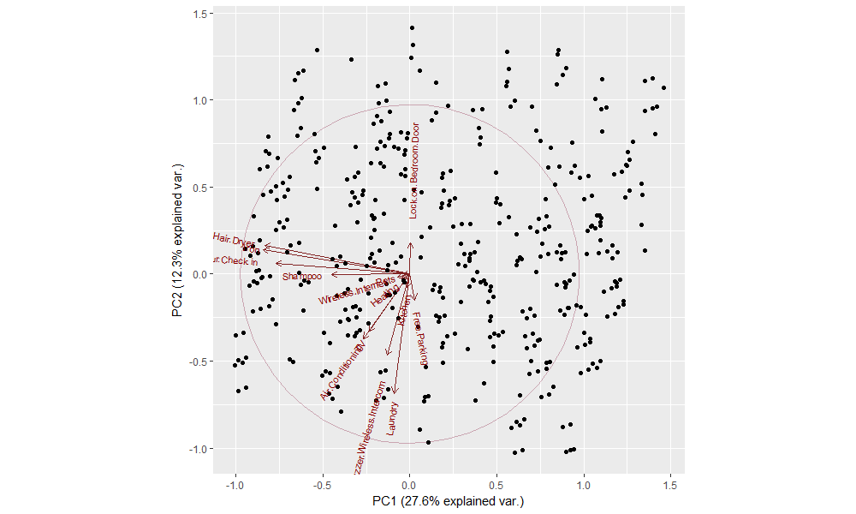

**Cleaning the final data:**

* Found a missing value hidden!

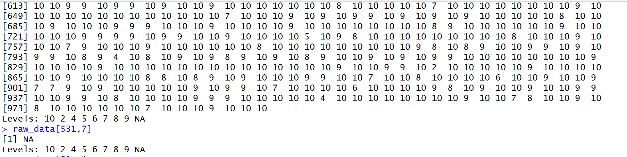

* Tried unfactor(raw_data$review_accuracy)
* Successful, but did not address the problem
* NA was a String, hence the entire column was a Factor