Python Programming notes by Harry

What is Programming ?
Just like we use Hindi or English to Communicate with each other , we use a programming language like Python to communicate with the computer.
Programming is a way to instruct the computer to perform various tasks.

What is Python ?
Python is simple and easy to understand language which feels like reading simple english. This Pseudo code nature of python makes it easy to learn and understandable by beginners.

Features of Python
- Easy to understand = less development time
- Free and Open Source
- High level language
- Portable – works on Linux/Windows/Mac

Installation
Python can be easily installed from python.org when you click on the download button, python can be installed right after you complete the setup by executing the file for your platform.

Chapter 1: Modules,Comments and pip

let’s write our very fist python program. Create a file called hello.py and paste the below code in it.

print(“Hello World”)

Execute this file (.py file) by typing python hello.py and you will see hello World printed on the screen

Modules
A module is a file containing code written by somebady else(usually) which can be imported and used in our programs

Pip
Pip is the package manager for python you can use pip to install a module on your system.

Types of Modules
There are two types of module in python
1> Built in modules --> Pre installed in Python
2> External modules --> Need to install using pip.

Some examples of built in modules are os,abc,etc.
Some examples of external modules are tensorflow, flask etc.

REPL:Read Evaluate Print Loop
Using Python as a calculator, We can use python as a calculator by typing “python + <-| on the terminal.

Comment
Comment are used to write something which the programmer does not want to execute.

Types of Comments
There are two types of comments in Python
1> Single line comments --> Writing using #
2> Multi line comments --> Writing using ‘’’ comment ‘’’

Chapter 1 -Practice Set

1> Write a program to print Twinkle twinkle little Star poem in Python.
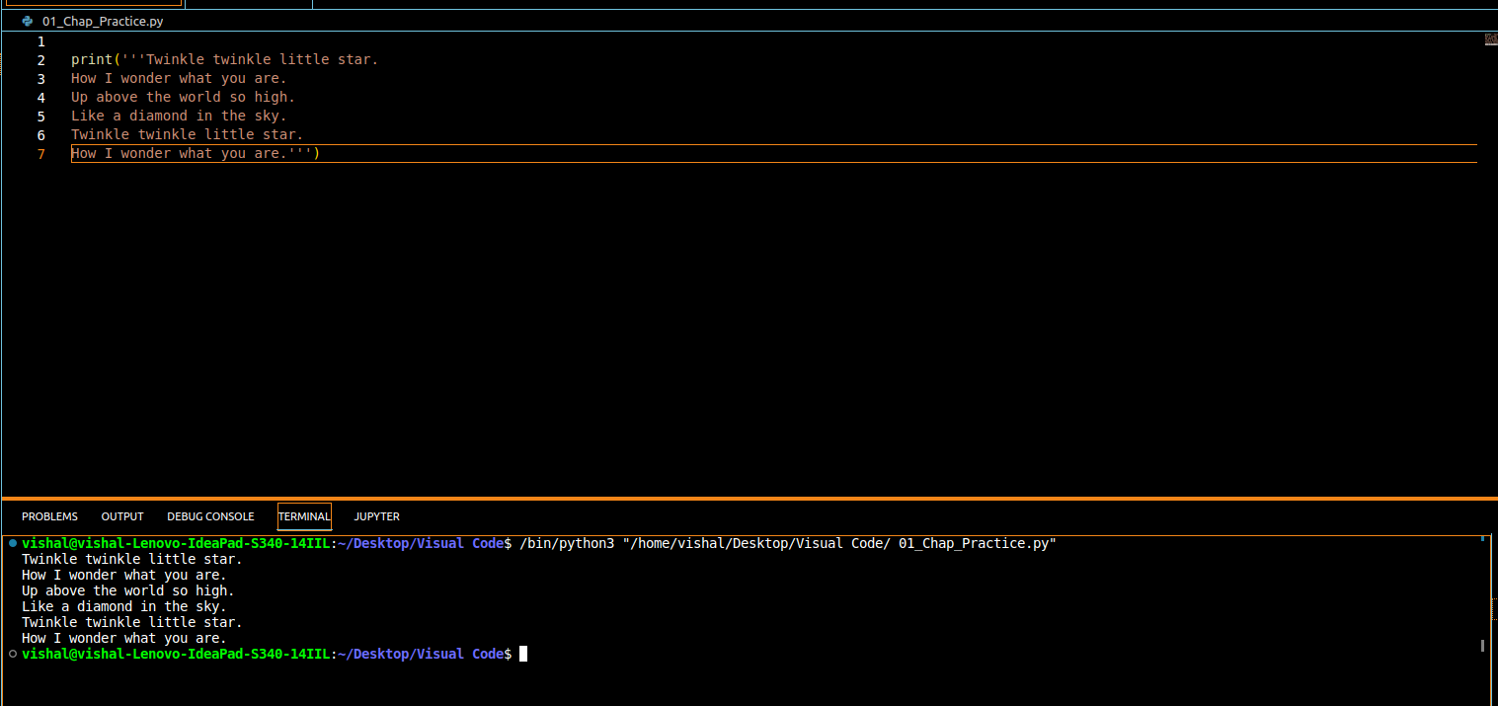
2> Use REPL and print the table of 5 using it.
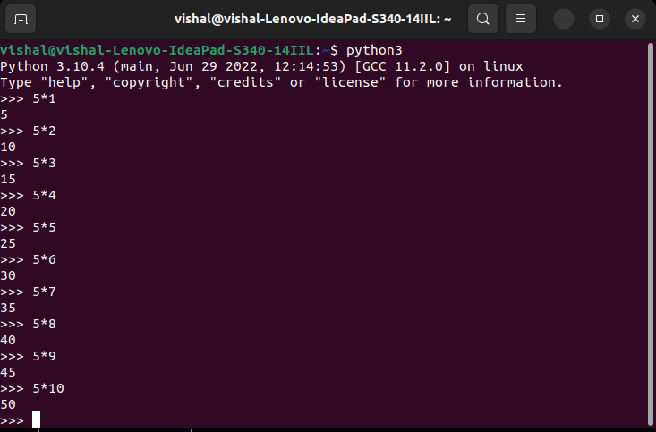
3> Install an external module and use it to perform an operation of your interest.
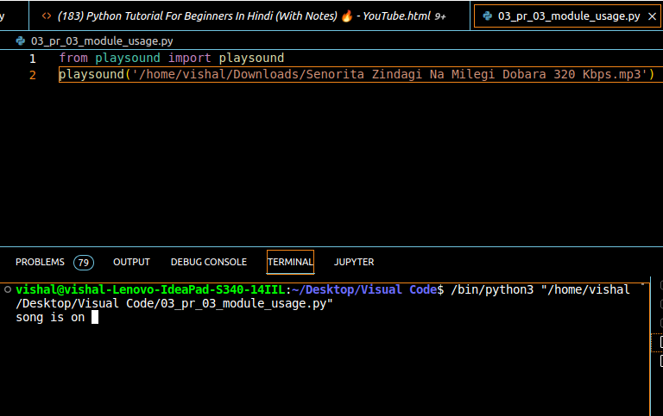
4> Write a python program to print the contents of a directory using OS module. Search online for the function which does that.
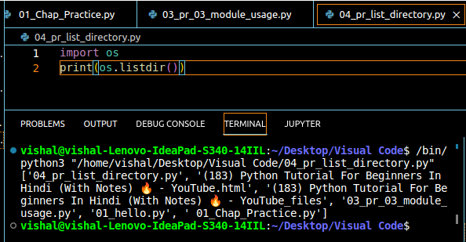
5> Label the program written in Problem 4 with comments.
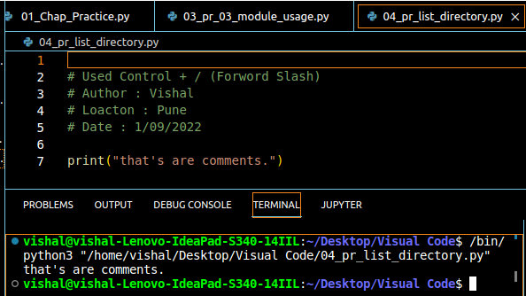

Chapter 2 : Variables and Data Types
A variable is the name given to a memory location in a program for example.
A=30 ->Variable=Container to store a value.
B=”Vishal” ->Keywords=Reserved word in Python
C=83.30 ->Identifiers=Class/Function/Variable Name

Data Types
Primarily there are following data types in Python
1>Integers
2>Floating Point Numbers
3>String
4>Booleans
5> None

Python is a fantastic language that automatically identifies the type of data for us
a=71 => Identifies a as class<int>
b=88.44 =>Identifies b as class<float>
name=”Vishal” =>Identifies name as class<string>

Rules for defining a variable name -> Also applies to other
- A variable name can contain alphabets, digits and underscores.
- A variable name can only start with an alphabet and undrscore.
- A variable name can’t start with a digit.
- No while space is allowed to be used inside a variable name.

Examples of a few variable names are :- vishal, one8, seven_, _seven etc.

Operators in Python

Following are some common operators in Python.
1> Arithmetic Operators => +, -, *, /, etc.
2> Assignment Operators => =,+=, -=, etc.
3> Comparison Operators => ==, > ,>=, <, != etc.
4> Logical Operators => and, or, not

type() fucnction and Typecasting
type function is used to find the data type of a given variable in Python.
(used to convert one data type to anther.)
a=31
type(a) => class<int>

b= ”31”
type(b) =>class<str>

A number can be converted into a string and vice versa(if possible)
There are many functions to convrt one data type into another.

Str(31) => “31” => Integer to string conversion.
Int(“32”) =>32 => String to integer conversion.
Float(32) => 32.0 => Integer to float conversion

here “31 is a string litral and 31 a numeric litral.

Input() function
This function allows the user to take input from the Keyboard as a string.

A= input(“Enter name”) => If a is “vishal”, the user entered vishal.

It is important to note that the output of input is always a string (even if the number entered).

Chapter 2 :Practice Set

1> Write a Python program to add two numbers.
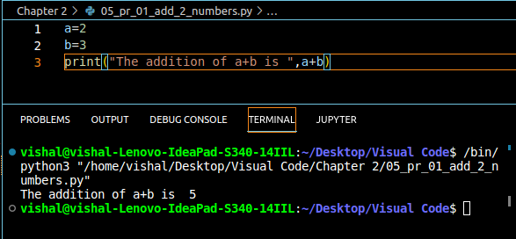
2> Write a Python program to find remainder when a number is divided by 2.
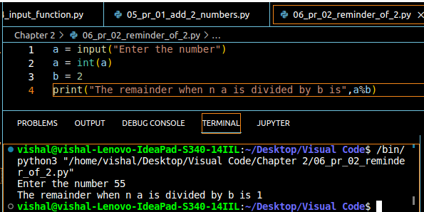
3> Check the type of the variable assigned using input() functioin.
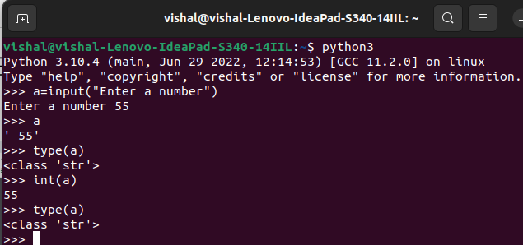
4> Use Comparison operators to find out whether a given variable a is greater than ‘b’ or not Take a=34 and b=80

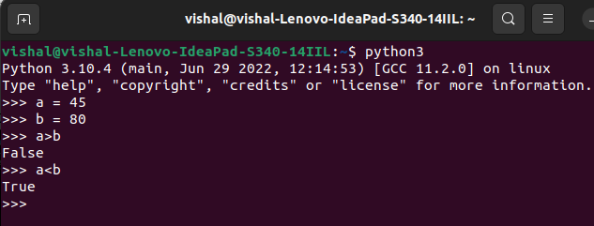
5> Write a python program to find average of two numbers entered by the user.
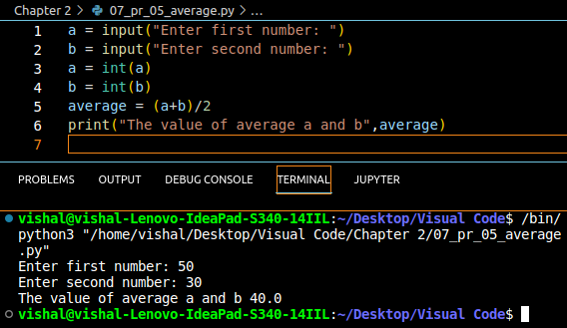

6> Write a python program to calculate square of a number entered by the user.
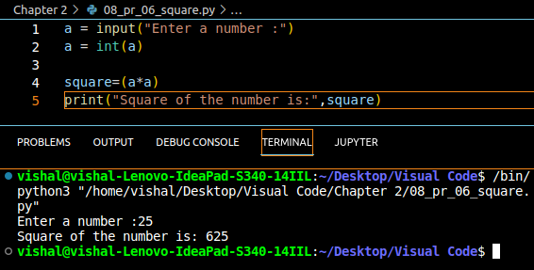

Chapter 3 :- Strings

String is a data type in Python.
String is a sequence of characters unclosed in quotes.
We can primarily, write a string in these three ways.

- Single quoted strings -> a = ‘Vishal’
- Double quoted strings -> b= “Vishal”
- Triple quoted strings -> c= ‘’’ Vishal ‘’’

String Slicing
A string in python can be sliced for getting a part of the string.
Consider the following string:

name = “YASH” length = 5 -4 -3 -2 -1
 | Y | A | S | H

The index in a string starts from 0 to (length -1) in Python.In order to slice a string, we use the following syntax.

sl=name[ind_start:ind_end]

sl[0:3] returns “Vis” characters from 0 to 3
sl[1:3] returns “is” characters from 1 to 3

Negative Indices : Negative Indices can also be used as shown in the figure above. -1 corresponds to the (length -1) index, -2 to (lenght -2)

Slicing with skip value
We can provide a skip value as a part of our slice like this:

word=”amazing”
word[1:6:2]

other advanced slicing techniques.

Word = “amaging”
word[:7] -> word[0:7] --> ‘amaging’
word[0:] -> word[0:7] --> ‘amaging’
String Functions
Some of the mostly used functions to perform operations on or manipulate String are:

1>len() fuction -> This function returns the length of the string.
len(“Vishal”) -->returns 5.
2>string.endswith(“rry”) -> This function tells whether the variable string ends with the string “rry” or not. If string is “Vishal” it returns true for “rry” since Vishal ends with rry.
3>String.count(“c”) -> Count the total number of occurence of any character.
4>String.capitalize() -> This function capitalizes the fist character of a given string.
5>String.find(word) -> This function finds a word and returns the index of first occurence of that word in the string.
6>String.replace(old word, new word)->This function replaces the old word with new word in the entire string.

Escape Sequence Characters
Sequence of characters after backslash’\’ --> Excape Sequence Characters

Escape sequence character comprises of more than one characters but represents one character when used within the strings.
Example
\n = new line
\t = Tab
\ = Single quote
\\ = backslash etc.
Chapter 3: Practice Set

1.Write a Python program to display a user entered name followed by Good Afternoon using input()
function.
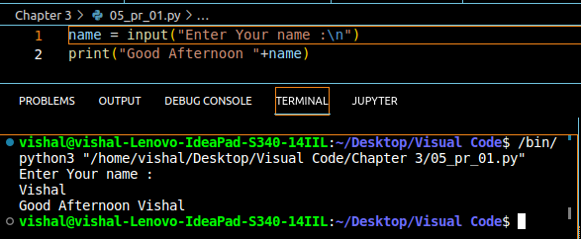
2.Write a program to fill in a letter template given below with name and date.

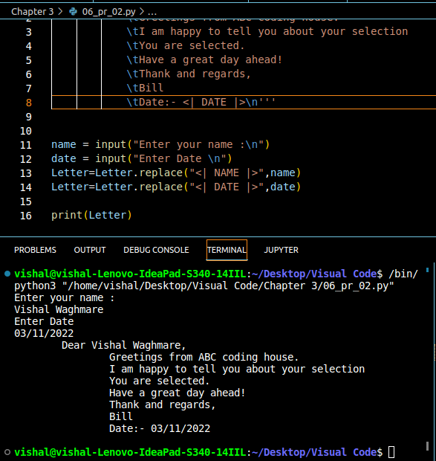
Letter = ‘’’ Dear <| NAME |>,
you are selected !
<| DATE |>’’’

3.Write a program to detect double spaces in a string.
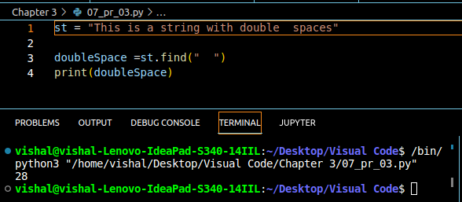
4.Replace the double spaces from Problem 3 with sing spaces
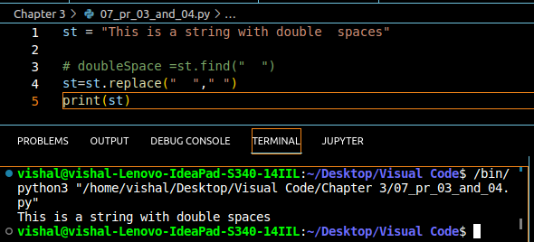
5.Write a program to format the following letter using escape sequence characters.

Letter = “Dear Vishal, This Python couse is nice. Thanks. !”
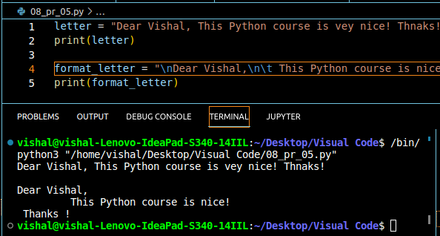

Chapter 4: List and Tuble

Python lists are containers to store a set of values of any data type.

Friends = [“Apple”,”Akash”,”Rohan”,7,False] # can store value of of any datatype.

List Indexing
A list can be indexed just like a string.

L1 = [7,9,”Vishal”]

L1[0]=>7
L1[1]=>9
L1[2]=>Error
L1[0:2]=>[7,9] =>List Slicing

List Methods
Consider the following list:

l1=[1,8,7,2,21,15]

- l1.sort():-updates the list to in accending order [1,2,7,8,15,21]
- l1.reverse():-updates the list to in decending order [21,15,8,7,2,1]
- l1.append(8):adds 8 at the end of the list.
- l1.insert(3,8):This will add 8 at 3 index.
- l1.pop(2):will delete element .
- L1.remove(21):Will remove 21 from the list.

Tuple in Python
A tuple is an immutable data type in python.(cannot change)

a=() =>Empty tuple
a=(1,) => Tuple with only one element reads a comma
a=(1,7,2) => Tuple with more than one elment

Once defined a tuple’s elements can’t be altered or manipulated.

Tuple Methods
consider the follwing tuple
a = (1,7,2)

1>a.Count(1):a.Count(1) will return number of times 1 occurs in a.
2>a.index(1):a.index(1) will return the index of first occurence of 1 in a.

Chapter 4 : Practice Set

- Write a program to store seven fruits in a list entered by the user.
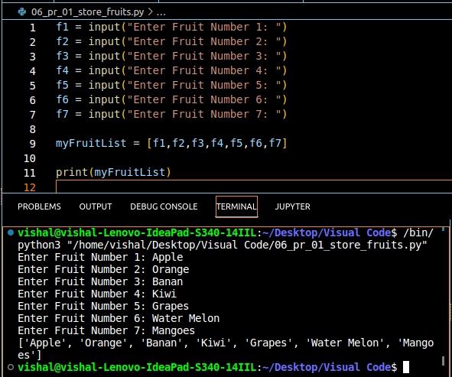
- Write a program to accept marks of 6 students and display them in a sorted manner.
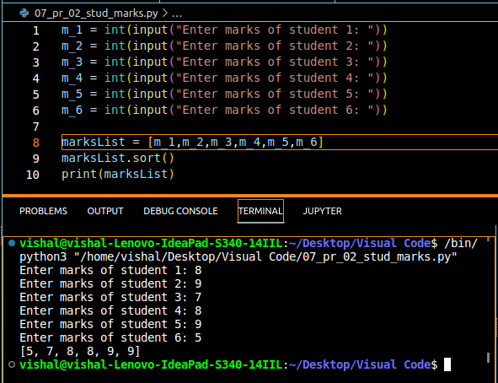
- Check that a tuple cannot be changed in python.
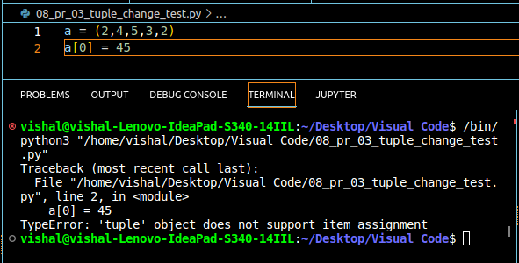
- Write a program to sum a list with 4 numbers.
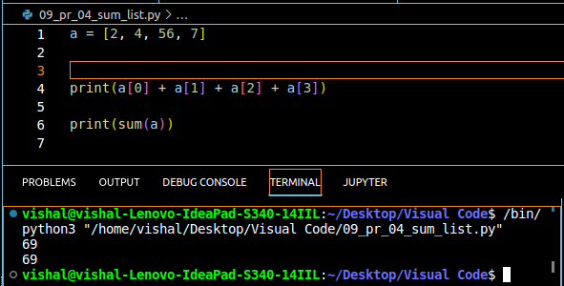
- Write a program to count the nuber of zeros in the following tuple:
t = (0,9,6,0,50,40,0,4,0,4,0,4)
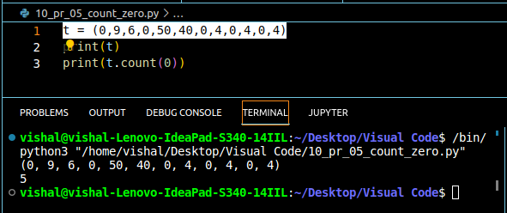

Chapter 5 :- Dictionary and Sets.

Dictionary is a collection of Key -Value pairs.
Syntax:
a={“Key”:”Value”,”Vishal”:”code”,”marks”:100,”list”:[1,2,3],”anotherDict”:{‘Vishal’:’Player’}
a[“Key”] => prints “Value”
a[“list”] => prints [1,2,3]
a[“anotherDict”][‘Vishal’]

Properties of a Python Dictionaries
- It is unordered.
- It is mutable.
- It is indesed.
- Cannot Contain duplicate Keys.

Dictionary Methods
- a.items() : returns a list of (key,value) tuples
- a.keys() : teturns a list containing dictionary’s keys.
- a.update(“friend” : “Sam”):updates the dictionary with supplied Key-Value pairs.e
- a.get(“name”) : returns the value of the specified keys (and value is returned eg. “Vishal” is returened here).

More methods are available on docs: python.org

Sets in Python.
Set is a collection of non repetitive elements.

S = set() => No repetiton allowed!
S.add(1)
S.add(2) => or Set = {1,2}

If you are a programming beginner without much Knowledge of mathematical operations on sets, you can simply look at sets in python as data types containing unique values.

Properties of Sets.
- Sets are unordered => Element’s order doesn’t matter.
- Set are unidexed => Cannot access elements by index.
- There is no way to change items in sets.
- Sets cannot contain duplicate values.
- s.remove(8) : Updates the set S and removes 8 from S.
- s.pop():Removes an ar.bitrary element from the set and returns element removed.
- s.clear().Empties the set S.
- s.union({8,11}):Returns a new set with all items from both sets. =>{1,8,2,3,11}
- s.intersection({8,11}:Returns a set which contains only items in both sets. =>{8}

Chapter 4 : Practice Set

- Write a program to create a dictionary of Hindi words with volues as their english translation. Provide user with an option to look it up!
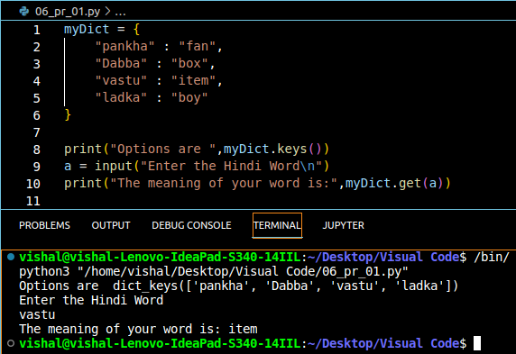
- Write a program to input eight numbers from the user and display all the unique numbers(once)
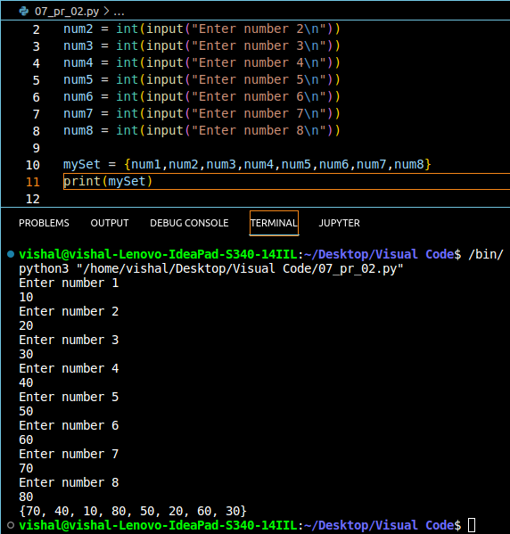
3. Can we have a set with 18(int) and “18”(str) as a values in it?=Yes
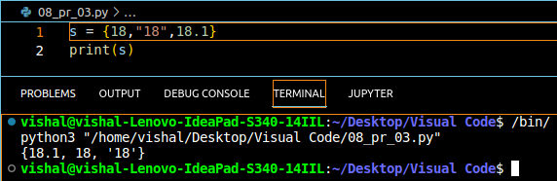
4.What will the length of follwing set S.
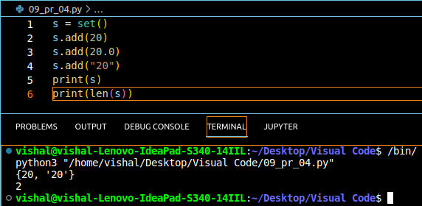
5.S={}
what is the type of S?
==> Dictionary

6.Create an empty dictionary. Allow 4 freinds to enter their favourite language as values and use keys as their nams. Assume that the names are unique.

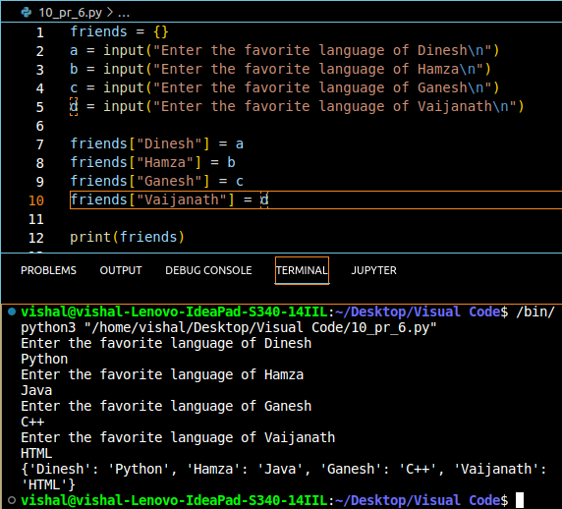
7.If names of 2 friends, are same; what will to the program in Problem 6
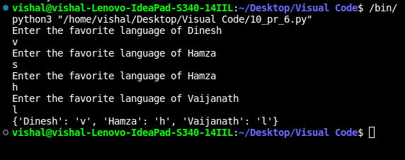
8.If languages of two friends are same; what will happen to the program in Problem 6
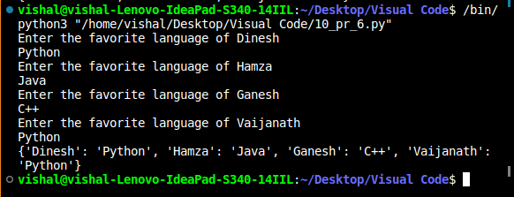
9.Can you change the values inside a list which is contained in set S
S = {8,7,12,”Vishal”,[1,2]}
# Set cannot contain list.
# we can use tuple in set but connot change.
Type error : unhashable type : ‘list’

Chapter 6 :- Conditional Expressions

Sometimes we want to play pubG on our phone, if the day is sunday.
Sometimes we order Ice-cream online if the day is sunny.
Sometimes we go hiking if our parents allow.

All these are dicisions which depends on a condition being met.
In Python programming too, we must be able to execute instructions on a condition(s) being act.
This is what conditionals are for !

If else and elif in Python
If else and elif statements are a multiway decision taken by our program due to certain conditions in our code.

Syntax:

if(condition): ==> if condition 1 is true
print(“Yes”)
elif(conditin): ==> if condition 2 is true
print(“No”)
else:
print(“My be”) ==> Otherwise

Code example:

a =22
if(a>9):
print(“Greater”)
else:
print(“Lesser”)

Quick quize: Write a program to print yes, when the age entered by the user is greater than or equal to 18.
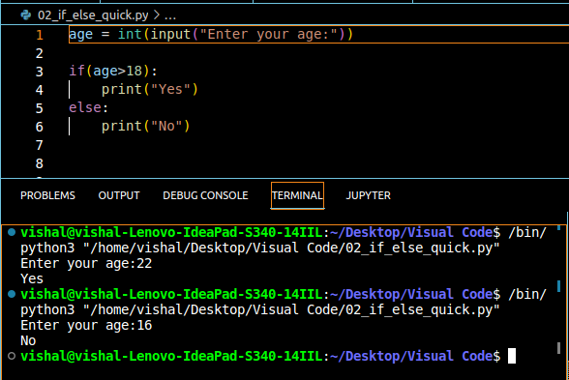
Relational Operators
Relational operators are used to evaluate conditions inside the if statements. Some examples of relational operators are :

== -> equals
>= -> greater than equal to
<= => ,etc.

Logical Operator

and -> true if both operands are true else false .
or -> true if at least one operand is true else false.
not -> inverts true to false and false to true.

Elif clouse
elif in python means [else if]. An if statement can be chained together with a lot of these elif statements followed by an else statement.

if(condition):
# code
elif(condition): => This ladder will stop once a condition in an if or elif is met.
# code
elif(condition):
# code
else:
# code

Important notes:

1. There can be any number of elif statements.
2. Last else is executed only if all the conditions inside elif’s fail.

Chapter 6 :- Practice Set

- Write a program to find greatest of four numbers entered by the user.
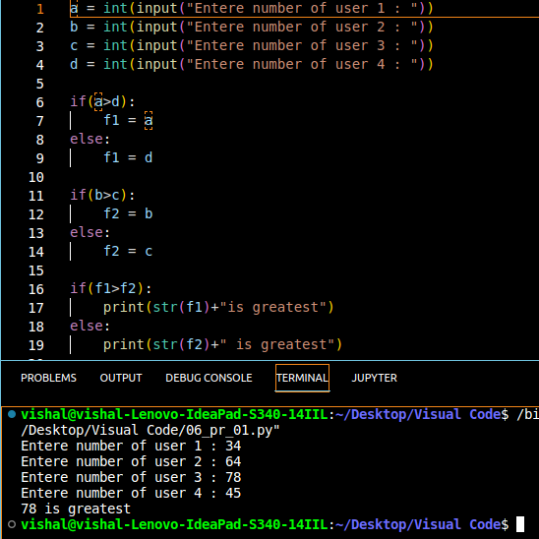
- Write a program to find out whether a student is pass or fail, if it requires total 40% and at least 33% in each subject to pass. Assume 3 subjects and take marks as an input from the user.
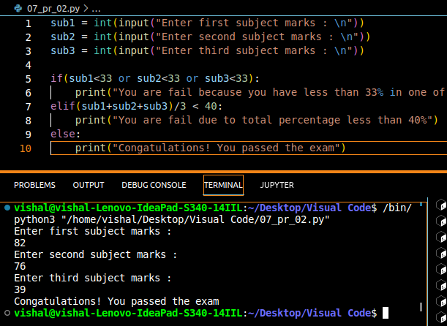
- A spam comment is definded as a text containing following keyword:
“make a lot of money”, “buy now”, “Subscribe this”, “click this”. Write a program to dele
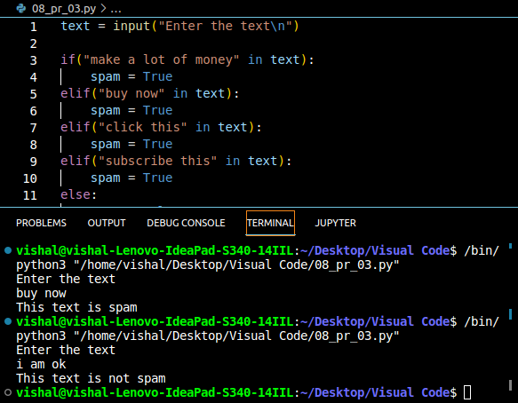
4.Write a program to find whether a given username contains less than 10 characters or not.
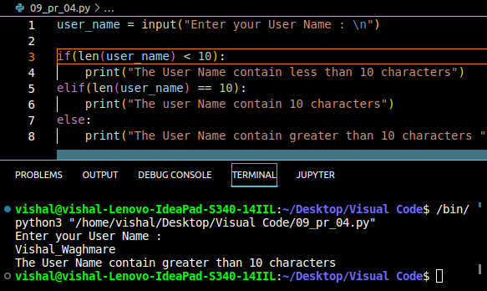
5. Write a program which finds out whether a give name is present in a list or not.
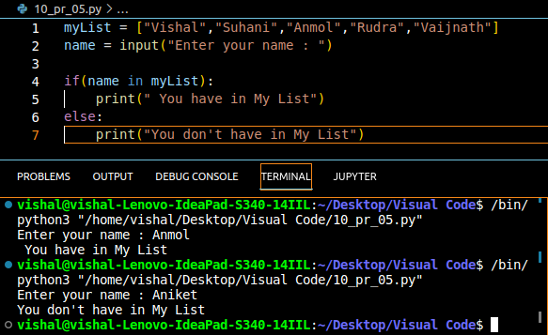
6. Write a program to calculate the grade of a student from his marks from the follwoing scheme.
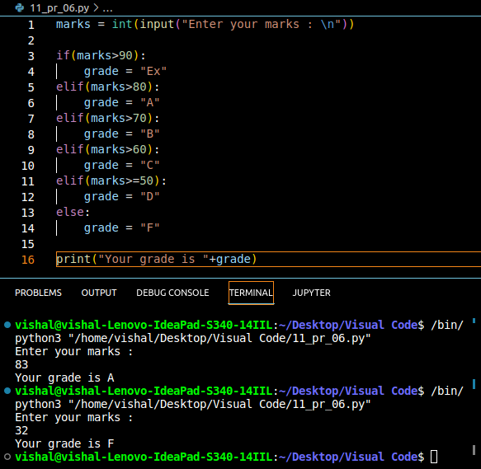

7. write a program to find out whether a given post is talking about “Harry or not”.
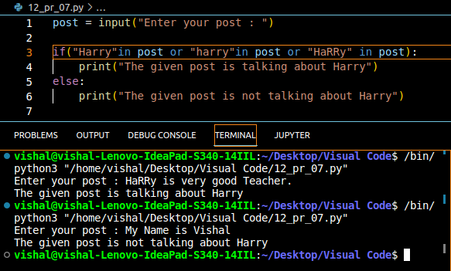

Chapter 7 :- Loops in Python

Sometimes we want to repeat a set of statements in our program. For instance: Print 1 to 1000
Loops make it easy for a programmer to tell, The computer, which set of instructions to repeat and how !

Types of loops in Python
Primarily there are two types of loops in Python
1.while loop
2.for loop

we will look into there one by one!

While loop
The syntax of a while loop looks like this:

while condition: =>The blok repeat executing until the condition is true.
#Body of the loop

In while loops, the condition is checked first. If it evaluates to true, the Body of the loop is executed, otherwise not!
If the loop is entered, the process of [Conditin check & execution] is continued until the condition becomes false

Quick Quize : Write a program to print 1 to 50 using a while loop.
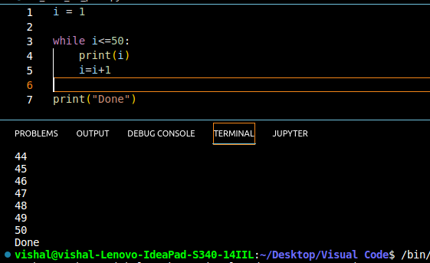

An Example

i =0
while i<5: => Prints “Vishal” – 5 times!
print(“Vishal”)
i = i+1

Note : If the condition never becomes False, the loop Repeats getting executed.

Quick quize : Write a program to print the content of a list using while loops.

For loop
A for loop is used to iterate through a sequence like li.
st, tuple or string[Iterables]

The syntax of a for loop looks like this:
l = [1,7,8]
for item in l:
print(item) ---> print 1, 7 and 8

Range Function in Python.
The range function in python is used to generate a sequence of numbers.
We can also specify the start,stop and step-size as follows.

range(start,stop,step-size) --> step size usually, not used with range()

An Example demonstrating range() function

for i in range(0,7): --> range(7) can also be used
print(i) -->prints 0 to 6

For loop with else
An optional else can be used with a for loop if the code is to be executed when the loop exhausts.
Example:
l = [1,7,8]
for item in l:
print(item)
else:
print(“Done” ---> This is printed when the loop exhausts.
Output:
1
7
8
Done

The break statement
‘break’ is used to come out of the loop when encountered, It instructs the program to – Exit the loop now

Example:

for i in range(0,80):
print(i) ---> This will print 0,1,2 and 3
if(i ==40):
break

The Continue Statement
‘continue is used to stop the current iteration of the loop and continue with the nest one, It instructs the program to “skip this iteration”used for skip the values

Example:

for i in range(4):
print(printing”)
if i == 2: ==> if i is 2 , the iteration is skipped.
continue
print(i)

pass statement
pass is a null statement in python
It instructs to “Do nothing”

Example:
l=[1,7,8]
for item in l:
pass ----> without pass, the program will throw on error.

Chapter 7 :- Practice Set

- Write a program to print multiplication table of a given of a given number using for loop.

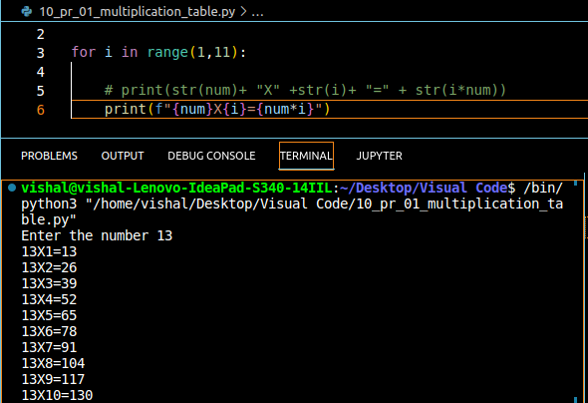
2.Write a pgram to greet all the person names stored in a list l1 and which starts with S

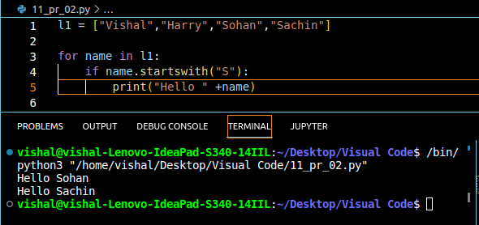

3.Attempt problem 1 using while loop.
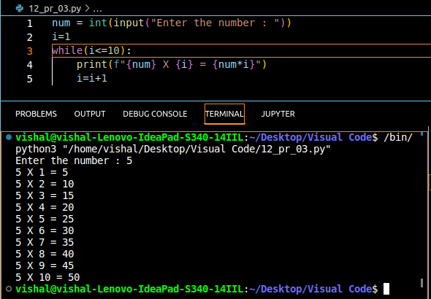
4.Write a program to find whether a given number is prime or not.

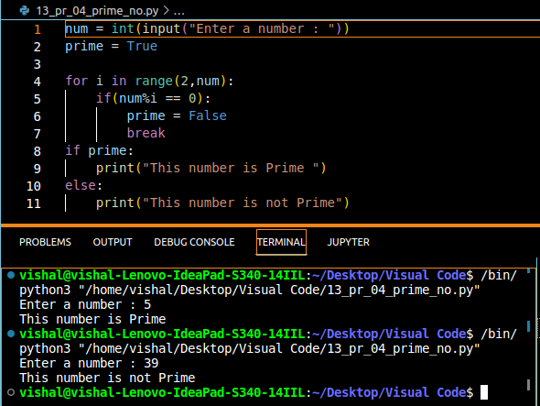

5. Write a program to find the sum of first n natural numbers using while loop.
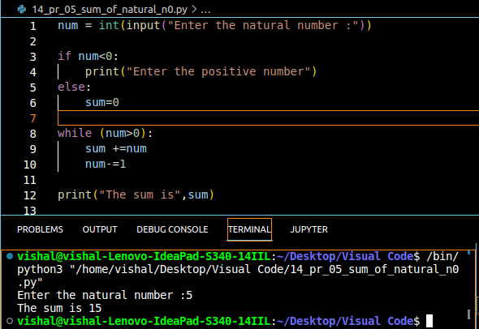
6.Write a program to calculate the factorial of a given number using for loop.
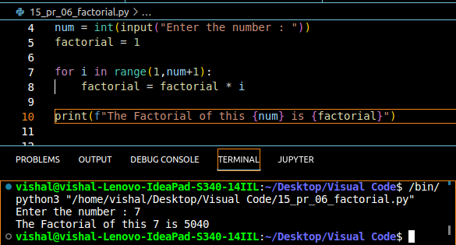
7.Write a program to print the following star pattern
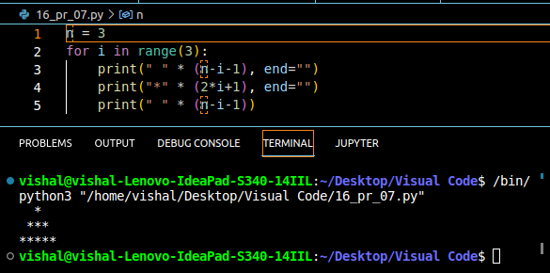
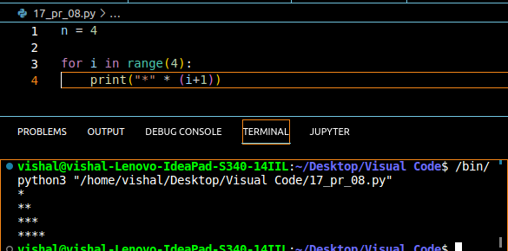
8.Write a program to print the following star patter:
9.Write a program to print the following star pattern
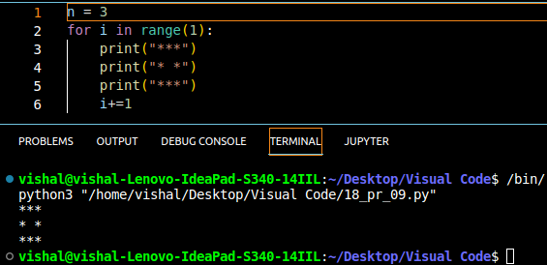
10.Write a program to print multiplication table of n using for loop in reversed order.
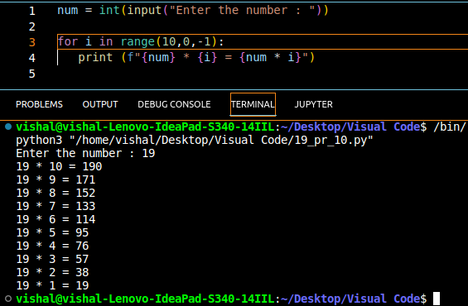
Chapter 8 :- Functions and Recursions

A function is a group of statements performing a specific task.
When a program gets bigger in size and its complexity grows, it gets difficult for a programmer to keep track on which piece of code is doing what!
A function can be reused by the programmer in a given program any number of times

Example and Syntax of a function
The syntax of a function looks as follows

def fun1():
print(“Hello”)

This function can be called any number of times, anywhere in the program.

Function Call
Whenever we want to call a function, we put the name of the function followed by parenthesis as follows:

func1() --> This is called function call

Function defination
The part containing the exact set of instructions which are executed during the function call.

Quick Quize :Write a program to greet a user with “Good day” using functions.
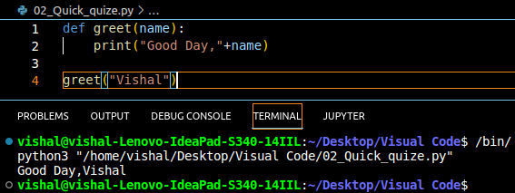

Type of functions in Python.
There are two types of functions in Python:
1.Built in functions --> Already present in Python.
2.User defined functions --> Defined by the user

Example of built in function includes len(), print(), range() etc.

The func1() function we defined is an example of user defined function.

Functions with arguments
A function can accept some values it can work with. We can put these values in the parenthesis.
A function can also return values as shown below:

def greet(name):
gr=”Hello”+name
return gr

/-> “Vishal” is passed to greet in name
a = greet(“Vishal”)
\-> a will now contain “Hello Vishal”

Default Parameter Value
We can have a value as default argument in a function.
If we specify name = “stranger” in the line containing def, this value is used when no argument is passed.

For example:
def greet(name=”stranger”):
# function body

stranger() # Name will be "stranger" in function body(default)

stranger("Harry") # None will be "Harry" in function body(passed)

Recursion:
Recursion is a function which calls itself
It is used to directly use a mathematical formula as function. For example:
factorial(n) = n*factorial(n-1)
This function can be defined as follows:

def factorial(x):
if i==0 or i==1: -> Base condition which doesn’t call
return1 The function any further
else:
return n*factorial(n-1) ->Function calling itself

This works as follows:

factorial(4):

4*factorial(3)
4*[3*factorial(2)]
4*3*[2*factorial(1)]
4*3*2*[1][function returned]

The programmer need to be extremely careful while working with recursion to ensure that the function doesn’t Infinitely keep calling itself.
Recursion is sometimes the most direct wayto code an algorithm.

Chapter 8 :- Practice Set

1.Write a program using function to find greatest of three numbers.
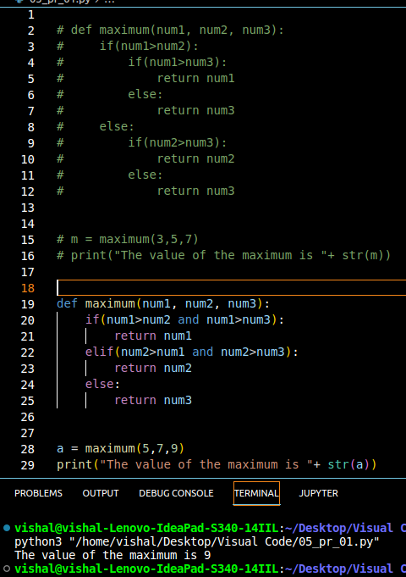
2.Write a python program using function to convert celsius to fahrenheit
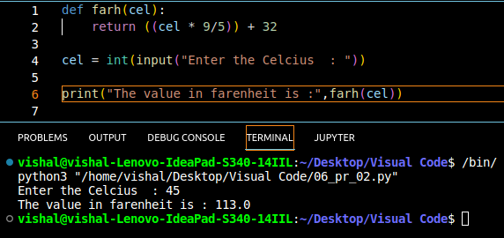
3.How do you prevent a python print() function to print a new line at the end.
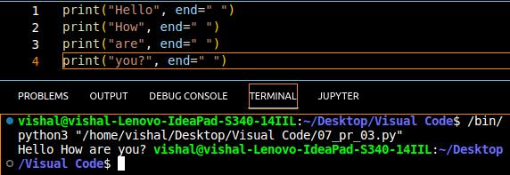
4.Write a recursive function to calculate the sum of first n natural number.
# sum(n) = sum(n-1)+n
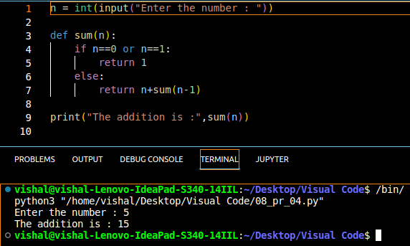
5.Write a python function to print first n lines of the pattern.
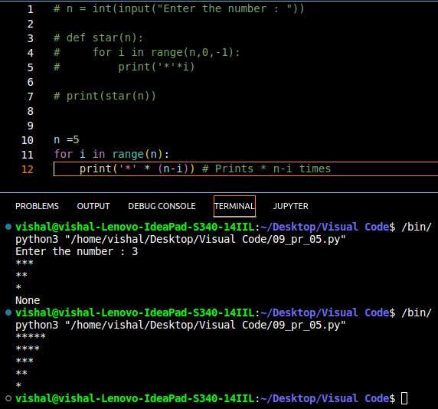
6.Write a python function which converts iches to cms.
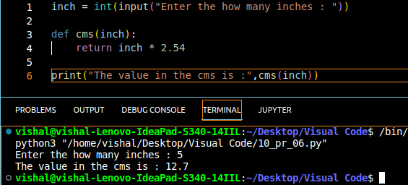
7.Write a python function to remove a given word from a string and strip it at the same time.
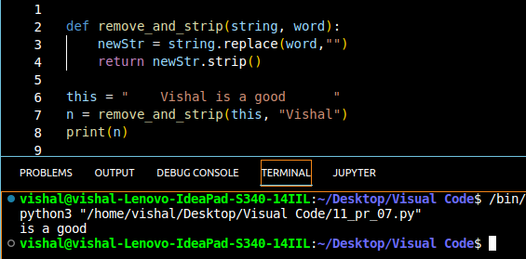
8.Write a python function to print multiplication table of a given number.
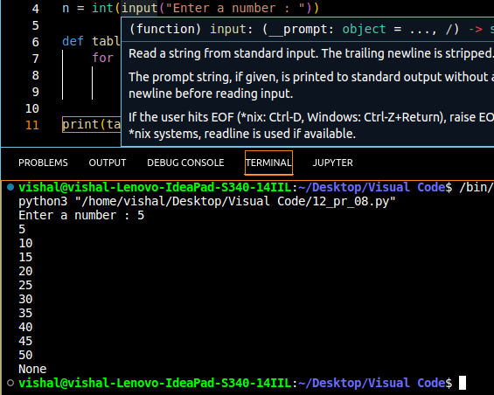

Project 1 : Snake, Water, Gun Game

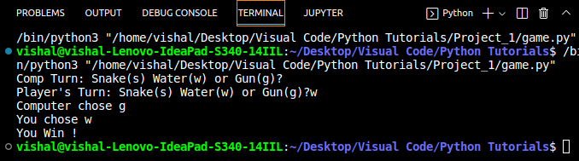

Chapter 9 : File I/O

The Random Access Memory is volatile and all its contents are lost once a program terminates.
In order to persist the data forever, we use files.
A file is data stored in a storage device. A Python program can talk to the file by reading content from it and writing content to it

RAM = Volatile
HDD = Non Volatile

Types of files
There are only 2 types of files:
1> Text file(.text, .c, etc)
2> Binary files(.jpg, .dat, etc)

Python has a lot of functions for reading , updating and deleting files.

Opening a file
Python has an open() function for opening files. It takes 2 parameters: filename and mode:
open() is built-in function in python
e.g.
open(“this.txt”,”r”)

Reading a file in python
f = open(“this.txt”,”r”) --> open the file in read mode
text = f.read() --> Read its contents
print(text) --> Print its contents
f.close() --> Close the file

We can also specify the number of characters in read() function : f.read(2) -> reads first 2 characters

Other methods to read the file
We can also use f.readline() function to read or full line at a time.

f.readline() --> Reads one line from the file

Modes of opening a file
r --> open for reading
w--> open for writing
a --> open for appending
+ --> open for updating(r+w)

‘rb’ will open for read in binary mode
‘rt’ will open for read in text mode

Writing Files in Python
In order to write to a file, we first open it in write or append mode after which, we use the python’s f.write() method to write to the file!
F = open(‘this.txt’,’w’)
F.write(“This is nice”) --> can be called multiple times
F.close()
With Statement
The best way to open and close the file automatically is the with statement

with open(“this.txt”) as f:
f.read()
|_ Don’t need to write f.close()
as it is done automatically.

Chapter 9 – Practice Set
1.Write a program to read the text from a given file ‘poem.txt’ and find out whether it contains the word ‘twinkle’
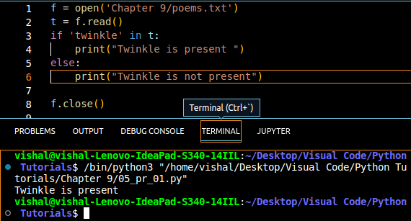
2.The game() function in a program lets a user play a game and returns the score as an integer . You need to read a file ‘Hiscore.txt’. Which is either blank or contains the previous Hi-Score
You need to write a program to update the Hi-score whenever game() breaks the Hi-score.

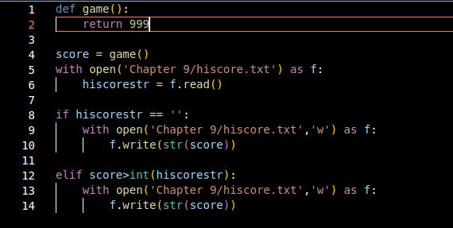
3. Write a program to generate multiplication tables form 2 to 20 and write it to the different files. Place these files in a folder for a 13 year old.
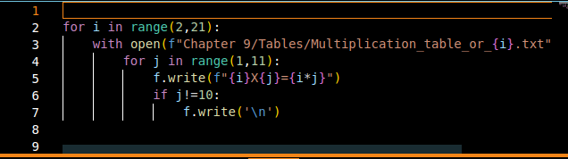

4.A file contains a word “Donkey” multiple times . You need to write a program which replace this word with ##### by updating the same file
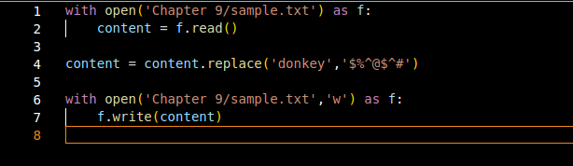
5.Repeat program 4 for a list of such words to be censord.
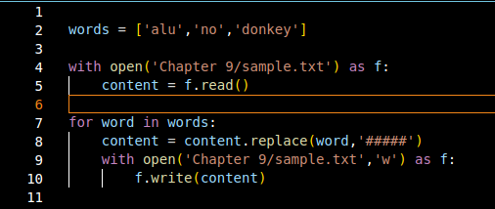
6.Write a program to mine a log file and find out whether it contains ‘python’
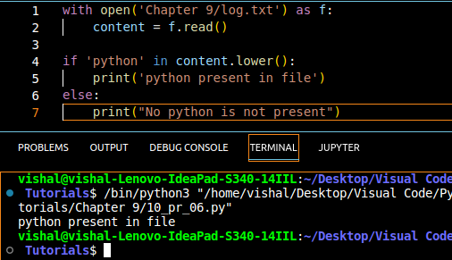
7.Write a program to find out the line number where python is present from question 6
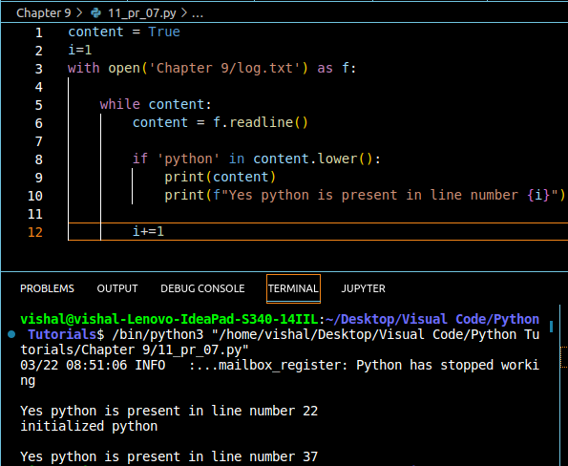
8.Write a program to make a copy of a text file “this.txt”
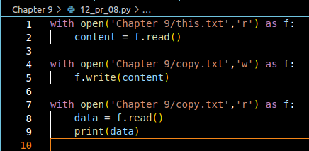
9.Write a program to find out whether a file is identical and matches the content fo another file.
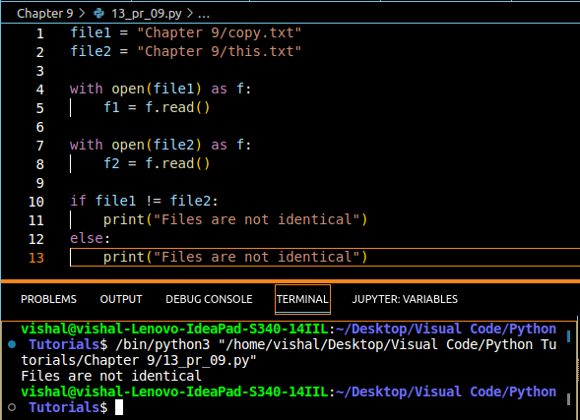
10. Write a program to wipe(remove all content) out the contents of a file using python.
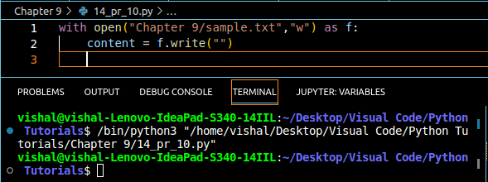
11.Write a python program to rename a file to “renamed_by_python.txt”
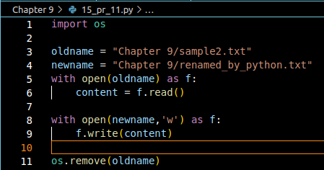
Chapter 10 :- Object Oriented Programming
Solving a problem by creating objects is one of the most popular approaches in programming. This is called Object Oriented Programming.

This concept focuses on using reusable code.
|_> Implements DRY (Do not Repeate Your Self) Principle

Class
A class is a blueprint for creating objects.

Combins info to creat a valid Application
Filled by => Student =>
Blank Form
Object
Class
Application of the student
Object Instantation
=> =>

Class is only write in PascalCase

PascalCase
EmployeeName --> PascalCase
# The First letter in Capital

camelCase
isNumeric, isFloat --> camelCase
# The first letter in lower case

Class Employee:
# methods and variables

Object:
An object is an instantiation of a class. When class is defined, a template (info) is defined. Memory is allocated only after object instantiation.

Objects of given class can invoke the methods available to it without revealing the implementation details to the user. --> Abstraction & Encapsulation!

Modelling a problem in OOPs
We identify the following in our problem

Noun --> Class --> Employee
Adjective -- > Attributes --> name, age, salary
Verbs --> Methods --> getSalry(), Increment()

Class Attributes
An attribute that belongs to the class rather than a particular object.

Example:

Class Employee:
company = “Google” ---> [Specific to each class]

vishal = Employee() ---> object instantiation
vishakha = Employee()
print(vishal.company)
print(vishakha.company)

Employee.company = “You Tube” ---> changing class attribute
print(vishal.company)
print(vishakha.company)

Instace Attributes
An attribute that belongs to the Instace (object)
Assuming the class from the previous example:

vishal.name = “Vishal”
vishal.salary = 50k ===> adding instance attributes

Note : Instance attributes take preference over class attributes during assignment 5 retrival

vishal.attributes -> 1. It attribute 1 present in object?
-> 2. It attribute 1 present in class ?

‘Self’ parameter
Self refer the instance of a class
It is automatically passed with a function cell from the object

vishal.getSalary() --> here self is vishal
\_> equivalent to Employee,getSalary(vishal)

The function getSalary is defined as:

class Employee:
company = “Google”
def getSalary(self):
print(“salary is not there “)

Static Method
Sometimes we need a function that doesn’t use the self parameter. We can define a static method like this:

@staticmethod --->decorator to meake greet as a static method
def greet():
print(“Hello user”)

_ _ init _ _ ( ) Constructor
_ _ init _ _ ( ) is special method which is first run as soon as the object is created.
_ _ init _ _ ( ) method is also known as constructor

It takes self argument and can also take further arguments.
For Example:

class Employee:
def __init__(self,name):
self.name = name
def getSalary(self)
.......

vishal = employee(“Vishal”)
\-> Object can instantiated using constructor like this!

Chapter 10 :- Practice Set

1.Create a class programmer for stroring information of few programmers working at microsoft.
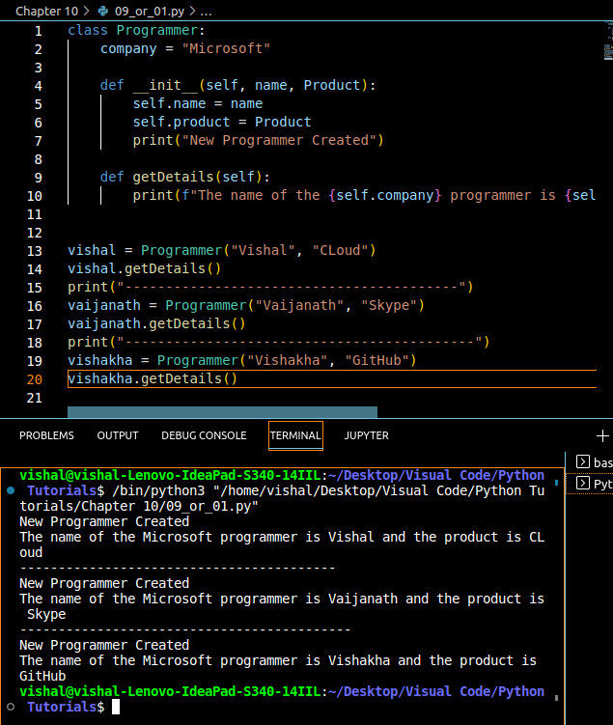
2.Write a class Calculator capable of finding square, cube and squareroot of a number
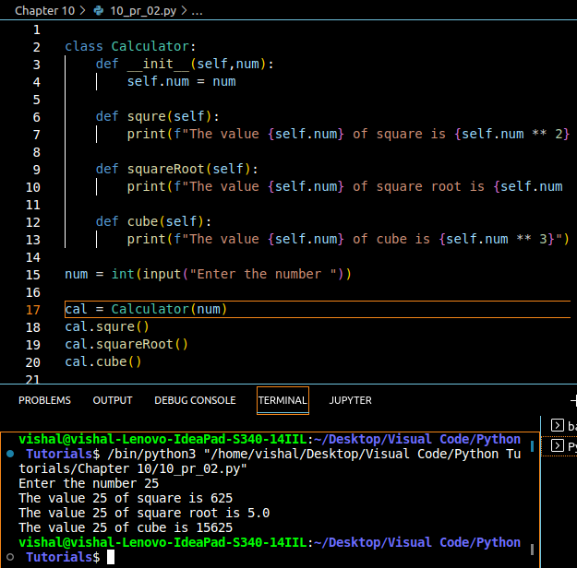
3.Create a class with a class attribute a; create an object from it and set a directly using object.a =0 Does this change the class attribute? ==> NO
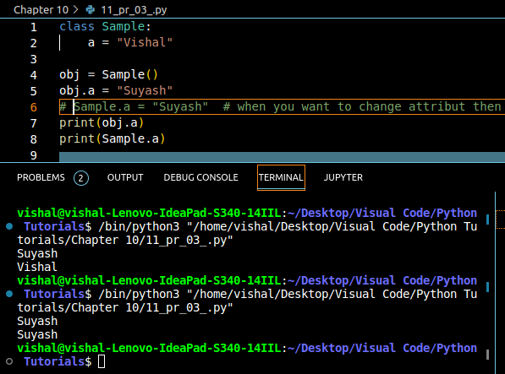
4.Add a static method in problem in problem 2 to greet the user with hello.
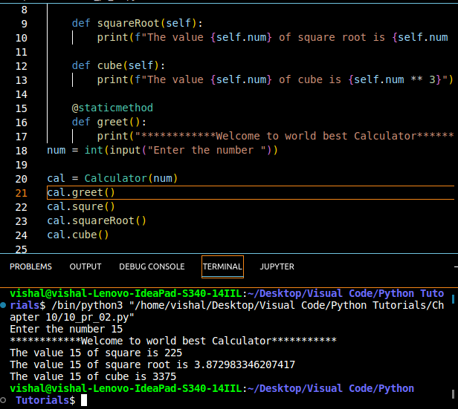
5.Write a class Train which has methods to book a ticket, get status(no of sets) and get fare information of trains running under Indian Railaways.
Code:
class Train:
def __init__(self, name, fare, seats):
self.name = name
self.fare = fare
self.seats = seats

def getStatus(self):
print("---------------------------------------------")
print(f"The name of the train is {self.name}")
print(f"The seats available in the tain are {self.seats}")
print("---------------------------------------------")

def fareInfo(self):
print(f"The price of the ticket is : Rs {self.fare}")

def bookTicket(self):
print("---------------------------------------------")
if (self.seats>0):
print(f"You ticket has been booked! Your seat number is {self.seats}")
self.seats = self.seats-1
else:
print("Sorry this train is full! Kindly try in tatkal")
print("---------------------------------------------")
def cancleTicket(self):
if(self.seats>self.seats-1):
print(f"Your Ticket is Cancled")
self.seats =self.seats+1

intercity = Train("Intercity Express: 14015",90,2)
intercity.getStatus()
intercity.fareInfo()
intercity.bookTicket()
intercity.getStatus()
intercity.bookTicket()
intercity.getStatus()
intercity.bookTicket()
intercity.getStatus()
intercity.cancleTicket()
intercity.getStatus()
intercity.cancleTicket()
intercity.getStatus()
Output:
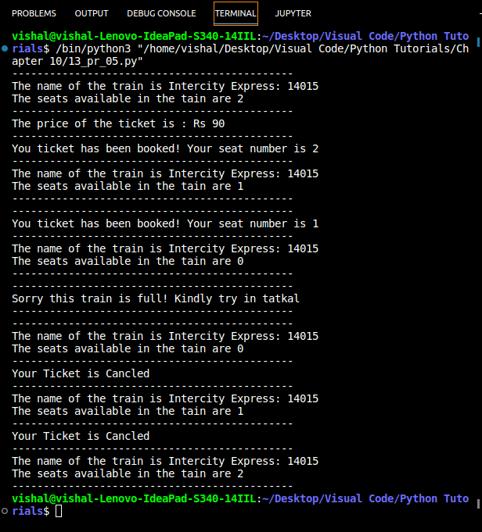

6.Can you change the self parameter inside a class to something else (say “harry”). Try changing self to “slf” or “harry” and see the effects.
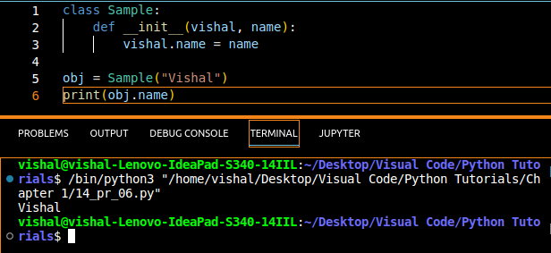
@ Self Work as Parameters. You can write anything on place of self

Chapter 11 :- Inheritance & more on OOPs

Inheritance is a way of creating a new class from an exsting class.

Syntax:

Class Employee: ---> Base Class
# Code
........

Class Programmer(Employee): ---> Derived or Child Class
# Code

We can use the methods and attributes of Employee in Programmer object.
Also, we can overwrite or add new attributes and methods in Programmer class.

Types of Inheritance

1.Single Inheritance
2.Multiple Inheritance
3.Multilevel Inheritance

Single Inheritance
Single Inheritance occurs when child class inherits only a single parent class

Base Class

Derive Class

Multiple Inheritance
Multiple inheritance occurs when the child class inherits from more than one parent class.

Parent 1
Parent 2
child

Multilevel Inheritance
When a child class becomes a parent for another child class

Parent
Child 2
Child 1

Super() method
super method is used to access the methods of a super class in the derived class.

Super( ). _ _ init( ) _ _ ( )
-->calls constructor of the base class

class methods
A class method is a method which is bound to the class and not the object of the class.
@classmethod decorator is used to create a class method.

Syntax to create a class method:

@classmethod
def(cls,p1,p2):

........................
@property decorators
consider the following class

class Employee:
@propery
def name(self):
return self.name

if e = Employee() is an object of class employee, we can print(e.name) to print the e.name/call name() function.

@ getters and @setters
The method name with @property decorator is called getter method
We can define a function+@name.setter decorator like below:

@name.setter
def name(self,value):
self.ename = value

Operator overloading in Python
Operators in Python can be overloaded using dunder methods.
These methods are called when a given operator is used on the objects.
Operators in python can be overloaded using the following methods.

P1 + p2 ---> p1.__add__(p2) P1 - p2 ---> p1.__sub__(p2)
P1 * p2 ---> p1.__mul__(p2) P1 / p2 ---> p1.__truediv__(p2)
P1 // p2 ---> p1.__floordiv__(p2)

Other dunder/magic methods in python
_ _ str _ _( ) --> used to set what gets displayed upon calling str(obj).

_ _ len _ _( ) --> used to set what gets displayed
upon calling _ _ len _ _( ) or len(obj)

Chapter 11 :- Practice Set
1.Create a class E2dvector and use it to create another class representing a 3-d vector.
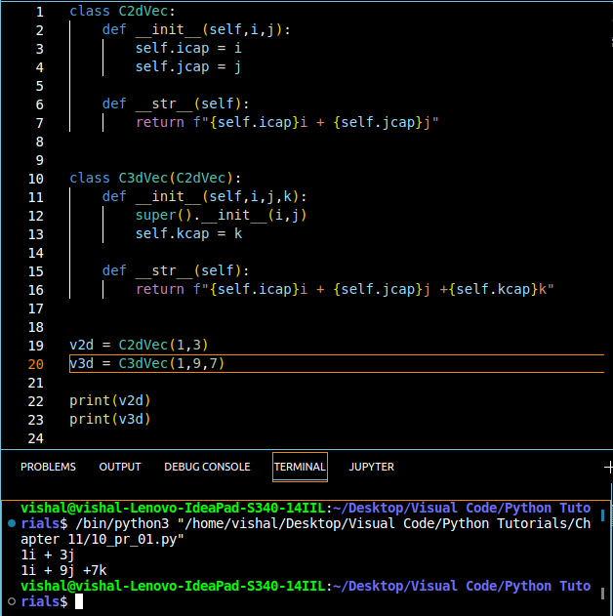
2.Create a class pets from a class Animals and further create class Dog from pets. Add a method bark to class Dog.
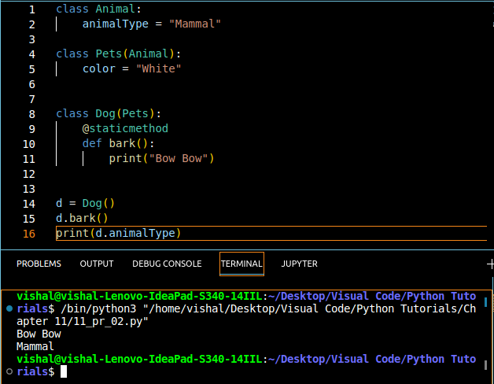
3.Create a class Employee and add salry and increment properties to it.
Write a method salaryAfterIncrement method with a @property decorator with a setter which changes the value of increment based on the salary
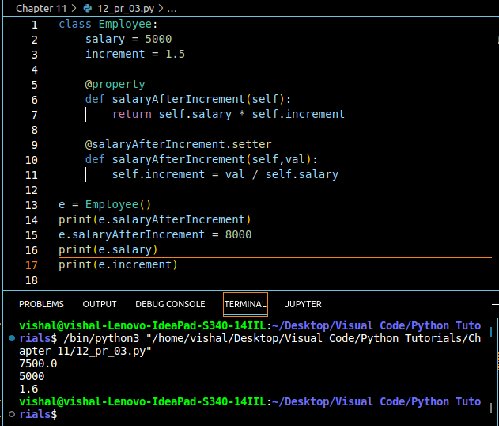
4.Write a class Complex to represent complex numbers, along with overloaded operators + and * which add and multiplies them.
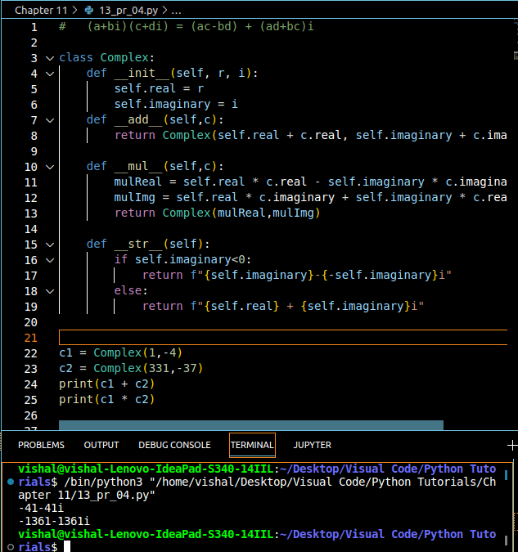
5.Write a class vector representing a vector of n dimension. Overload the + and * operator which calculates the sum and the dot product of them.
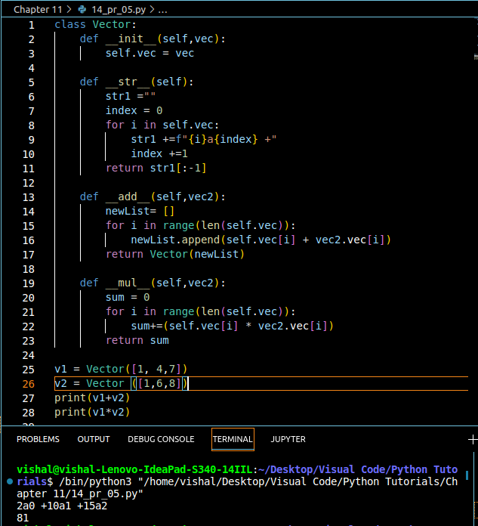
6. Write __str__() method to print the vector as follows:
7i^ + 8j^ +10k^
Assume vector of dimension 3 for this probem
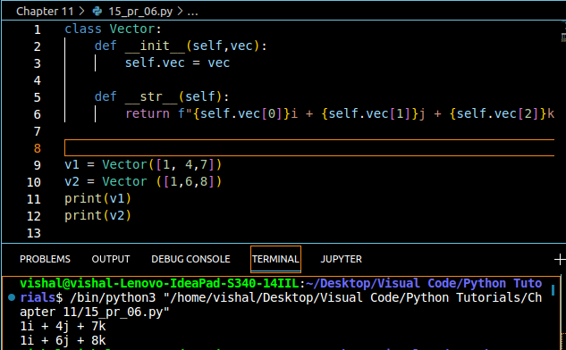
7.Override the __len__() method on Vector of problem 5 to display the dimension of the vector.


